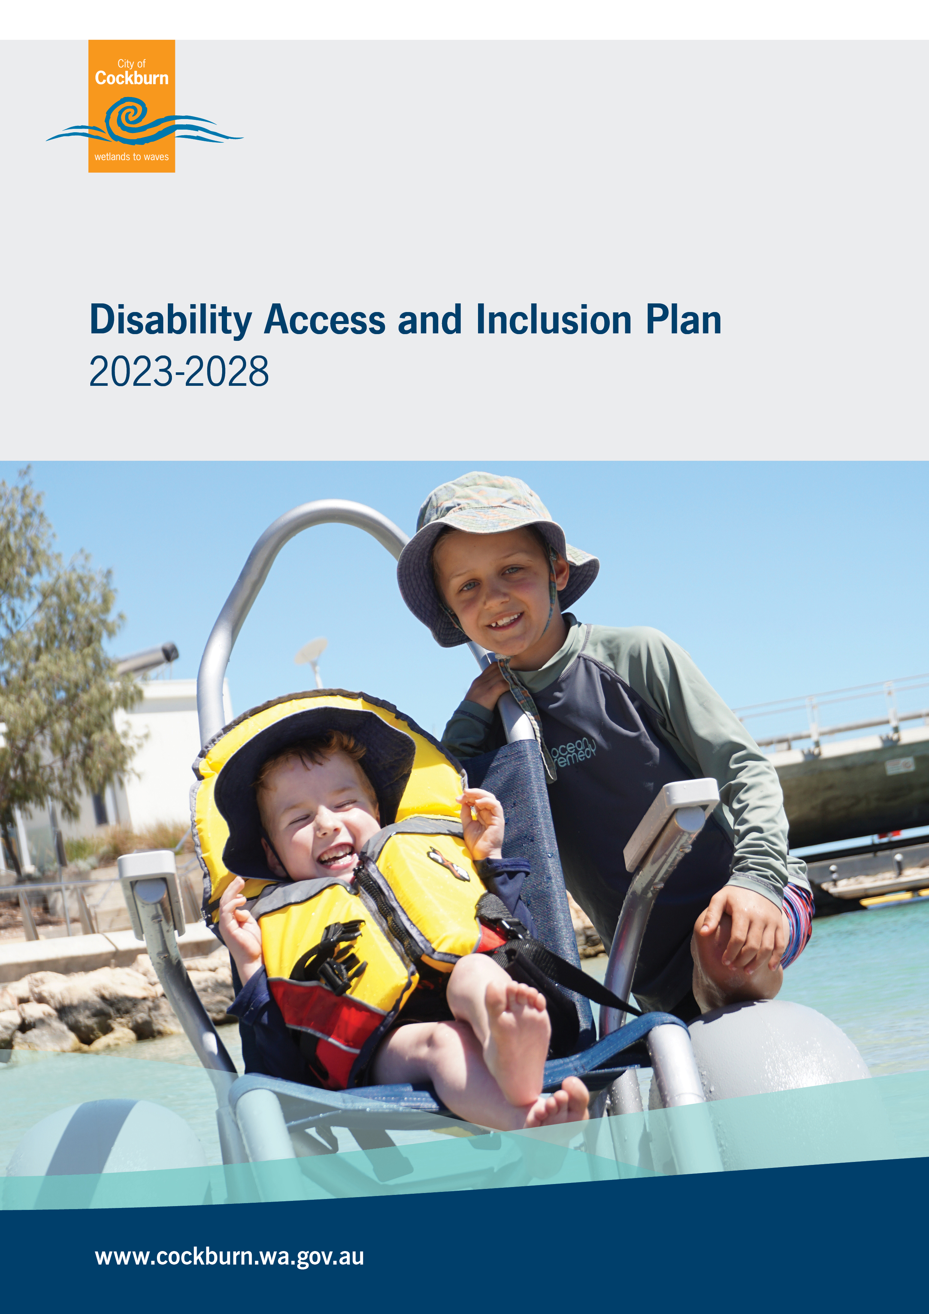

Table of Contents
Table of Contents 1
Foreword 2
Introduction 3
Review of Achievements to Date 3
Links to the Vision and Strategic Community Plan 2020 - 2030 4
Initiatives 2023 - 2028 6
Summary of Community Consultation 9
Resourcing the DAIP 11
Implementing the DAIP 12
Reporting 12
Demographic Information 13
References 13
Contact Us 13

Foreword
The Best Place to Be starts our journey of understanding, valuing, and respecting that we are all different – different in so many ways that need to be reflected in the City’s Disability Access & Inclusion Plan 2023 – 2028. As the pages of this Plan are turned the challenge for each of us is to make it functionally active, inclusive, equitable and focused to positively address universal access needs and expectations for our community and those who choose to visit our great City.

As we empower our people to be the very best they can be, it is in the knowledge of achievement, recognition, and celebration that we come together for the common good. People power can and does deliver as we work collaboratively to resolve the complex challenges of an increasingly diverse world.

Audacious goal setting, the application of informed resources and daring to challenge the ‘norm’ should be at the forefront of our mindset as we strive to make Cockburn the best place to be.

His Worship the Mayor
Logan K Howlett JP

Introduction
The City of Cockburn is committed to creating an accessible and inclusive community for everyone. The aim of this Disability Access and Inclusion Plan (DAIP) is to help the City with the coordination of planning and activities to ensure all community members have equal access to:
- Services and events
- Facilities and buildings
- Information
- Customer service
- Complaints processes
- Public consultations
- Employment opportunities at the City

Review of Achievements to Date
The City of Cockburn has made considerable progress over the years to provide or improve access for people with a disability. Progress against the City’s 2017 – 2022 DAIP has been reported annually to the Department of Communities. Examples of achievements include:
- Accessible events checklist for event organisers developed and annual reminders posted
- Accessible events module delivered in staff training
- Equipment purchases including portable hearing loops and speakers, beach wheelchairs and beach walker
- Funding was secured through grants for Safe Talk workshops (mental health first aid) and the event for International Day of Persons with Disability.
- Procurement review completed and more stringent requirements placed on projects to consider access and inclusion including an Access Consultant involved in projects over $70k
- Feedback forms updated to include improving accessibility or inclusion in library events
- Review of signage and wayfinding at Cockburn Health and Community Facility undertaken and improvements implemented.
- Touch and digital screens installed at the Cockburn Aquatic Recreation Centre (ARC), libraries, Cockburn Youth Centre, and administration building.
- Social Inclusion forum held
- Access audit of Cockburn ARC completed
- Budget allocated for building improvements and some modifications made; e.g., to steps in administration building, toilets (Ngarkal Beach), parks (Botany Park, Southwell Park, Mellor Park, Princeton, Aubin Gove, Monaco, Duffield, Tempest, Perena Rocchi, Blackthorne) and signage
- Disability Reference Group (DRG) and Disability Access and Inclusion Officer consulted regularly on projects, parks, and upgrades
- New Employee Onboarding Checklist includes development of Personal Emergency Evacuation Plans (PEEPs) as required for staff with permanent or temporary disability
- ACROD parking campaign codesigned with DRG and National Disability Services and implemented
- Communications staff offered training in creating accessible docs and websites (5-day certificate level digital accessibility course)
- Access and Equity Policy developed and adopted
- Auslan interpreted video created and shared on social media and Comment on Cockburn to raise awareness about providing feedback and right to request an interpreter
- Disability Awareness Training added to Learning Management System (online).
- Compliments, Feedback and Complaints Policy developed with further detail about accessibility and adopted
- Complaints and Compliments module (online) implemented by Human Resources.
- A list of accessible venues for holding public consultations, including options for portable equipment such as augmented hearing devices, developed for event organisers
- Community Engagement Guidelines updated to allow more time for consultations
- Community Engagement Framework created and included consideration of alternative communication strategies to meet the needs of all community members
- Person with disability employed on traineeship on 18-month contract

Links to the Vision and Strategic Community Plan 2020 - 2030
The DAIP supports the City’s vision of Cockburn, the best place to be.
The City’s Access and Equity Policy describes the City’s commitment to maintain and improve the quality of life of its residents by creating an accessible and inclusive community in which information, services, resources, facilities, decision-making processes, and other activities are equitably accessible, welcoming, and inclusive to all residents.
Specific DAIP initiatives contribute to the City’s overarching work in meeting the themes and objectives of the City’s Strategic Community Plan.
Community Strategic Plan Themes | DAIP initiative links
Local Economy: A sustainable and diverse local economy that attracts investment and provides local employment. | 6.1, 6.2, 6.3
Environment Responsibility: A leader in environmental management that enhances and sustainably manages our local natural areas and resources. | 3.2
Community, Lifestyle and Security: A vibrant, healthy, safe, inclusive, and connected community. | 1.1, 1.2, 1.3  2.1, 2.2, 2.3, 2.4
City Growth and Moving Around: A growing City that is easy to move around and provides a great place to live. | 2.1, 2.2, 2.3, 2.4
Listening and Leading: a community focused, sustainable, accountable, and progressive organization. | 3.1, 3.2, 3.3  4.1, 4.2  5.1, 5.2, 5.3, 5.4  6.1

Initiatives 2023 - 2028
The following initiatives address the outcomes mandated in the WA Disability Services Act (1993) amended in 2004 and 2014. They are not in order of priority and all are equally important.

Outcome 1 - People with disability have the same opportunities as others to access the services of, and any events organised by, the City of Cockburn.
Initiatives
1.1 | Develop the capacity and capability of staff and community to support and deliver accessible and inclusive events, services, and programs within the City of Cockburn.
1.2 | Continue the provision of new and existing free and low-cost inclusive activities by the City of Cockburn.
1.3 | Investigate options to enable people with disabilities of all ages to access and utilize an inclusive meeting place within the City of Cockburn.

Outcome 2 - People with disabilities have the same opportunities as other people to access the buildings and other facilities of the City of Cockburn.
Initiatives
2.1 | Ensure new buildings and facilities, including significant upgrades, exceed minimum disability access require;ments where possible.
2.2 | Implement an accessible features description page to the City of Cockburn website for all facilities and public spaces.
2.3 | Expand the accessible facilities in the City of Cockburn including accessible playgrounds, changing facilities and storage facilities for mobility devices.
2.4 | Continue to improve the accessibility of the City’s transport network, cycleways, footpaths, and parking.

Outcome 3 – People with disability receive information from City of Cockburn in a format that will enable them to access the information as readily as other people.
Initiatives
3.1 | Continue to improve website and mobile accessibility in line with recommendations from the World Wide Web Consortium (W3C).
3.2 | Review and update the corporate style guide and other relevant policies and procedures to include best practice in accessible communications.
3.3 | Include accessibility in the usability assessment when procuring new software, hardware, or systems for the City of Cockburn.

Outcome 4 - People with disability receive the same level and quality of service from the staff of the City of Cockburn as other people.
Initiatives
4.1 | Further develop the learning and development framework to enhance the delivery of disability awareness training.
4.2 | Develop an information hub for staff on the intranet that provides guidance on accessibility, inclusion, and protocols.

Outcome 5 – People with disability have the same opportunities as other people to provide feedback, make complaints and participate in any public consultation at the City of Cockburn.
Initiatives
5.1 | Improve the feedback and complaints process to better capture and inform projects, programs and initiatives offered through the City of Cockburn.
5.2 | Ensure contractors involved in community engagement consider accessibility in their deliverables, including the provision of materials in alternative formats on request.
5.3 | Explore the use of new methods and technologies that may improve the ease and access of participation in community engagement.
5.4 | Seek opportunities to consult the City of Cockburn’s reference groups to better understand the diverse needs within the community.

Outcome 6 – People with disability have the same opportunities as other people to obtain and maintain employment with the City of Cockburn.
Initiatives
6.1 | Build a workplace culture that embraces diversity, equity, inclusion and belonging to assist in the attraction and retention of people of all abilities in employment at the City of Cockburn.
6.2 | Review the way the City communicates vacant positions, and the application and interview process, to make the experience more accessible and encourage more people with disability to apply for positions within the City of Cockburn.
6.3 | Explore employment opportunities for people with disability in the City through traineeships, job carving and role creation, as well as volunteering and work experience pathways.

Summary of Community Consultation
As part of the review and development of the DAIP, a consultation was carried out with City of Cockburn staff and community members to identify barriers to access and inclusion as well as potential initiatives to be incorporated into the new DAIP.
Meetings were held with the Youth Advisory Group, Disability Reference Group and Age Friendly Reference Group. Staff and community members could also have their say by:
- Completing an online or hard copy survey
- Phoning, texting or emailing feedback
- Attending an online or in person community forum
- Contributing feedback informally at various events including Disability Sports Day at the Cockburn ARC; booth at Treeby Community Centre event; morning tea at Cockburn Care

Promotion of the consultation included:

- Advertising on the City’s website over September/October 2022
- Advertising in the Perth Now Cockburn Gazette on 13th October 2022
- Advertising in community newsletters mailed out to residents
- Direct communications to stakeholders in the community with an interest in disability or potential staff or clients with disability

A total of 281 submissions were received during the consultation including:

- Community surveys x 96
- Staff surveys x 114
- Text message or email x 2
- Disability Reference Group x 11
- Age Friendly Reference Group x 11
- Youth Advisory Group x 6
- Community forums x 17
- Cockburn Care social club/morning tea x 15
- Informal feedback at Cockburn ARC x 7
- Informal feedback at Treeby event x 2

Demographic information was only requested in the surveys and some respondents preferred not to answer these questions.
25 respondents to the community survey said they had a disability and 42 said they were a family member, carer, or advocate of a person with disability. Community surveys came from service providers and people from a variety of age groups and cultural backgrounds.
Four respondents to the staff survey said they had a disability and 17 said they were a family member, carer, or advocate of a person with a disability. Staff survey respondents came from various City of Cockburn work areas as well as one contractor.
69% of community survey respondents and 71% of staff respondents said that they agreed or strongly agreed that the City of Cockburn is welcoming and inclusive of people with disabilities.
Suggestions to improve access and inclusion for people with disability to programs services and events included:
- Actively promote inclusion through communications and actions; e.g., advertising, events, training
- More services, supports and programs specifically targeting people with disability; e.g., rebates, respite, activities, social groups, facilities
- Inform people about accessible and inclusive programs and services
- Improve access to events and more events targeted at particular age groups
- Improve access to Cockburn ARC including programs and facilities
Suggestions to improve access and inclusion for people with disability to buildings, facilities, outdoor environments, and other public spaces included:
- Embed access considerations into policy and planning
- Improve wayfinding
- Improve access to buildings and facilities; e.g., ramps, audits, hearing loops, parking for gophers, lighting
- Improve pedestrian routes; e.g., pathways, kerbs, ramps, footbridges
- Improve access to beaches, parks, and playgrounds
- More changing rooms for adults with disability
- Review and improve availability of ACROD parking; e.g., at Cockburn ARC, library

Suggestions to improve access and inclusion for people with disability to written/printed information included:
- Clear commitment to accessible information; e.g., contemporary language, style guide
- Improve access to website for people with disability and from culturally and linguistically diverse backgrounds
- Accessible meetings and videos; e.g., captions, Auslan/interpreters
- Accessible signage; e.g., tactile, audio
- Accessible documents; e.g., hard copy, easy read, large print

Suggestions to improve the level and quality of services from staff included:
- Start with leadership knowledge and commitment to access and inclusion
- Celebrate staff knowledge and awareness; e.g. share successes, disability aware badge
- More training and support for staff; e.g. on impact of different disabilities and ways to assist including technology

Suggestions to improve access and inclusion for people with disability to opportunities to provide feedback or make complaints included:
- Consult more with people with disability; e.g. use existing reference groups, go via disability groups
- Use accessible communication methods; e.g. face to face, alternative formats

Suggestions to improve access for people with disability to employment opportunities in City of Cockburn workplaces included:
- Commit to employing more people with disability
- Flexible and supportive employment; e.g., customised roles, job carving
- Support people with disability in their own businesses
- Support local employers to employ people with disability; e.g., incentives, training

Resourcing the DAIP
DAIP is to be resourced through normal operational funding. Opportunities to secure external incomes such as grants will also be sought.

Implementing the DAIP
An internal implementation plan has been developed for delivery by all the City’s business units.
It will be reviewed quarterly by the City to track the progress and achievements of DAIP and assist with the annual reporting to the Department of Communities. Updates on DAIP progress will be posted on the City’s website.

Promoting the DAIP
The City of Cockburn will promote the availability of the new DAIP by:
- Notice in the Cockburn Gazette local newspaper
- On the City of Cockburn and Comment on Cockburn websites
- To all staff via email and intranet notification
- Directly to the DAIP Steering Group and Disability Reference Group
A summary document of the City of Cockburn DAIP 2023 – 2028 will also be made available.

Agents and Contractors
The City of Cockburn is required under the Act to inform agents and contractors of their obligations to the DAIP. The City achieves this by:
- Including a note in contract agreements that Contractors are expected to conduct their business in line with the City’s DAIP.
- Contractors are required to submit a Contractors DAIP report to the City (on completion of the Contract by the 1st of June) annually whilst the contract is in place.
- Grant recipients are required to complete a ‘Disability Access and Inclusion Plan Checklist’ with their applications, outlining how their grant will meet DAIP requirements.

Reporting
It is a requirement of the WA Disability Services Act (1993), amended in 2004 and 2014, that all public authorities develop and implement a Disability Access and Inclusion Plan (DAIP) that outlines the ways in which the authority will ensure that people with disability have equal access to its facilities and services. The DAIP must be lodged with the Department of Communities, reported annually by 30 June each year, and reviewed at least every five years.

Demographic Information
Australian Bureau of Statistics (ABS) conducts a survey of Disability, Ageing and Carers every five years. Data from the 2018 survey estimated that 17.7% of the Australian population have a disability. If you add to that the estimated 2.65 million Australians who are carers, then disability impacts approximately one third of the population.
A more recent ABS census asked specifically about a person’s need for assistance with one or more of the core activities of self-care, communication, and mobility due to disability, long-term health conditions or the effects of old age. This census found that the percentage of people needing assistance with at least one of the core activities had increased from 5.1% to 5.8% (an increase of 1.2 million people).
In relation to the City of Cockburn, the estimated resident population is 122,211 so approximately 21,631 residents plus carers are likely to be impacted by disability. Of these approximately 7,088 will need help in their day to day lives.

References
Disability, Ageing and Carers, Australia: Summary of Findings, 2018 | Australian Bureau of Statistics (abs.gov.au)
Cockburn Community Profile | Population, Trends | REMPLAN

Contact Us
City of Cockburn
9 Coleville Crescent, Spearwood WA 6163
PO Box 1215, Bibra Lake DC Western Australia 6163
Telephone: 08 9411 3444 Fax: 08 9411 3333
Email: customer@cockburn.wa.gov.au
City of Cockburn website: cockburn.gov.wa.au

