Tender Title: |  | HOSE AND FITTING SERVICES - Service and Repair of Fleet Vehicles
Request ID: |  | 79348
Tender Description: |  | The City of Cockburn is seeking a suitably qualified and experienced contractor to provide Hose and Fitting services to its fleet. The successful contractor will be responsible for maintaining, repairing, new installations, and (upon request) inspecting repairs to the Principal’s fleet assets, to ensure they are functioning in accordance with manufacturers’ guidelines and specifications. The extent of services covers all the Principal’s Fleet; and the Contractor is expected to provide scheduled, 24 hour on-call and ad-hoc services.
Advert Approval: |  | Decision to Advertise: Director Infrastructure Services  Decision Date: Wednesday, 13 May 2026
Closing Date and Time: |  | 2:00PM (AWST) Thursday, 28 May 2026
Opening Date and Time: |  | 2:00PM (AWST) Thursday, 28 May 2026
 | Tenderer’s Name:
1 | Inlook Holdings Pty Ltd trading as Total Connections
2
3
4
5
6
7
8
9
10

Advertisement
Method 1: City of Cockburn website | Method 2: City of Cockburn Libraries Public Noticeboards
Method 3:  The Western Australian, Wednesday, 13 May 2026 | Tender Awarded by:
Copy of Statewide Notice:  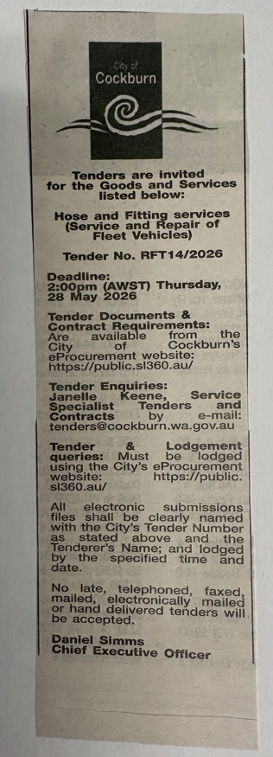 | Director Infrastructure Services  Choose an item.  Friday, 26 June 2026
 | Date of Council Meeting:
 | N/A
Name of Successful Tenderer(s): | Inlook Holdings Pty Ltd trading as Total Connections
Amount of Successful Tender(s): (ex GST) | $250,000.00

