Tender Title: |  | RFT 18/2022  Closed Circuit Television (CCTV – Supply & Install)
Request ID: |  | 46547
Tender Description: |  | The City of Cockburn is seeking a suitably qualified and experienced contractor for the supply and installation of closed-circuit television (CCTV) at various locations within the City.
Advert Approval: |  | Decision to Advertise: CEO  Decision Date: Wednesday, 23 November 2022
Closing Date and Time: |  | 2:00PM (AWST) Wednesday, 11 January 2023
Opening Date and Time: |  | 2:00PM (AWST) Wednesday, 11 January 2023
 | Tenderer’s Name:
1 | ARA Security Services Pty Ltd
2 | Blue Force Pty Ltd
3 | CMAK Technologies
4 | Zenien
5
6
7
8
9
10

Advertisement
Method 1: City of Cockburn | Method 2: Yammer
Method 3:  The Western Australian,  Wednesday, 30th November 2022 | Tender Awarded by:
Copy of Statewide Notice:  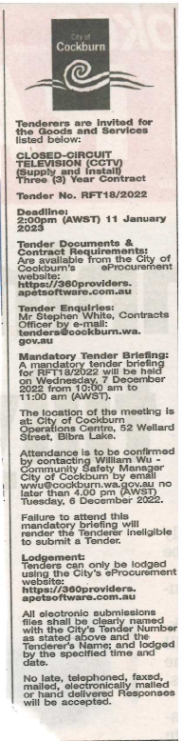 | OCM  Thursday, 9 March 2023
 | Date of Council Meeting:
Thursday, 9 March 2023
Minutes: 0046
Item No: 14.1.3

Name of Successful Tenderer(s): | Blue Force Pty Ltd
Amount of Successful Tender(s): (ex GST) | $887,013.49

