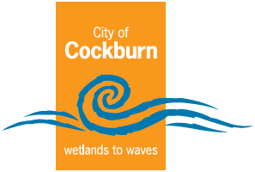
City of Cockburn

Annual Report
2024 - 2025
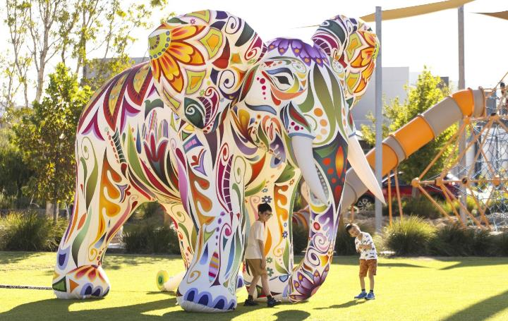
Cockburn, the best place to be
City of Cockburn: www.cockburn.wa.gov.au
December 2025

Acknowledgement of Country
The City of Cockburn acknowledges the Nyungar people of Beeliar Boodjar. Long ago, now and in the future they care for Country.
We acknowledge a continuing connection to Land, Waters and Culture and pay our respects to Elders, past and present.
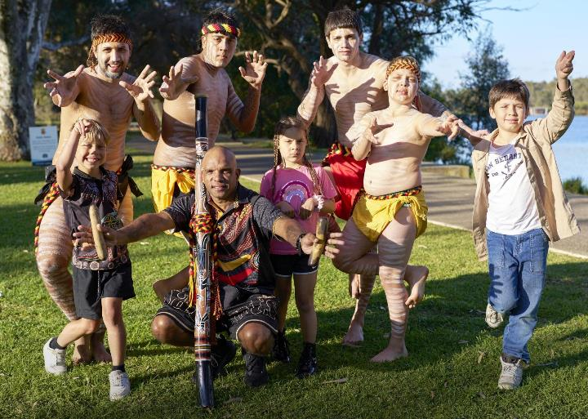Image: Yaakin Moorditj Beeliar Boodjar (Standing Strong on Beeliar Country). Moort Kaartdijin Dandjoo Koorliny (Families and Culture coming together).
Front cover: Mosaic Festival - March 2025.

Contents
Acknowledgement of Country 2
Message from the Mayor 7
Message from the CEO 9
Our Strategic Framework 11
Our Strategy on a Page 13
Our Values 14
What is an Annual Report 15
Our City 18
Looking back at Cockburn’s history 18
Cockburn Today 22
About our City 23
Community Facilities and Key Events Map 36
Brief Year in Review 40
Local Economy 40
Environmental Responsibility 41
Community, Lifestyle and Security 42
City Growth and Moving Around 43
Listening and Leading 43
Shaping Tomorrow 44
Our Budget 47
How services are funded 47
How your money is spent 48
Financial Performance 51
Capital Grants, Subsidies and Contributions 54
Trading Undertakings 54
Land Transactions 55
Our Assets 56
Our Council and Elected Members 59
Mayor 59
Cockburn Wards 60
Central Ward 62
East Ward 63
West Ward 65
Elected Members’ demographics 67
Council structure and purpose 69
Elected Member attendance 70
Elected Members, fees, expenses and allowances 77
Governance Report 79
Compliance 79
Freedom of information 79
Elected Member breaches/complaints 80
Our Organisation 81
Directorates and Office of the CEO 85
Chief Executive Officer 85
Infrastructure Services 88
Corporate and System Services 90
Community and Place 94
Sustainable Development and Safety 97
Our People 100
Staff overview 100
Remuneration of Employees 103
Our People Approach 105
Diversity and Inclusion 107
Employee Value Proposition 108
Promoting a Safe and Respectful Workplace 109
Reward and Recognition 110
Organisational Development 111
Health and Safety 112
Delivering Our Outcomes 114
Community Satisfaction 116
2025 PlaceScore Service Satisfaction Survey 116
2024 PlaceScore Liveability Survey 121
Local Economy Outcomes 124
Local Economy 2024-25 125
Community satisfaction 131
Plan for the future 132
Environmental Responsibility Outcomes 133
Environmental Responsibility 2024-25 135
Climate Change and Sustainability Snapshot 2024-25 145
Community, Lifestyle and Security Outcome 157
Community, Lifestyle and Security 2024-25 159
City Growth and Moving Around Outcome 193
City Growth and Moving Around 2024-25 194
Building and Development Applications 201
Listening and Leading Outcome 209
Listening and Leading 2024-25 210
Community Engagement 216
Working Together 218
Record Keeping 224
Risk Management 226
Awards and Grants 228
Responsible Operations and Civic Contribution 231
Community satisfaction 232
Plan for the future 234
Corporate Business Plan Progress Report 235
Local Economy - Projects/activities 235
Environmental Responsibility - Projects/activities 239
Community, Lifestyle and Security - Projects/activities 244
City Growth and Moving Around - Projects/activities 251
Listening and Leading - Projects/activities 257
The Year Ahead 261
Our Economy – Projects/activities 2025-26 261
Our Environment – Projects/activities 2025-26 262
Our Community – Projects/activities 2025-26 263
Our Places – Projects/activities 2025-26 268
Annual Financial Report 272
Contact Us 273

Message from the Mayor
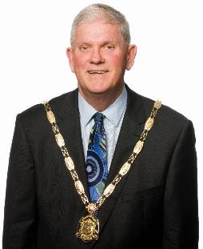
As Mayor of the City of Cockburn, I am proud to reflect on a year that has truly embodied our vision of being “the best place to be.” In 2024-25, our community came together with energy, compassion and innovation to build a more inclusive, vibrant and sustainable Cockburn.
This year, we proudly completed and opened the Malabar Park BMX & Community Facility, an outstanding addition to our community infrastructure that promotes both physical activity and mental wellbeing. We’ve also made remarkable progress at our state-of-the-art recreation facility, Cockburn ARC. The significantly expanded gym area and other upgrades are nearing completion, with the enhanced facility set to open in July 2025. In addition, we’ve continued to improve our transport infrastructure, resurfacing numerous roads and upgrading footpaths across Cockburn to ensure safer and more accessible travel for our Community.
We also deepened our commitment to environmental stewardship. From the thriving marine biodiversity at Port Coogee Marina to the planting efforts in our nature reserves, Cockburn residents have shown that caring for Country is a shared responsibility. The installation of new “Cockitroughs” for endangered black cockatoos and the expansion of our Turtle Tracker program are just two examples of how our community is protecting precious wildlife for future generations.
Our cultural calendar was richer than ever. Events like the Multicultural Mosaic Festival, NAIDOC Week, and the ANZAC Youth Parade brought thousands together in celebration, remembrance and connection. These moments remind us of the strength found in diversity and the importance of honouring our heritage.
We continued to invest in community wellbeing, with an exciting Cockburn Live line-up of events, and expanded our youth services, making a real difference in people’s lives. Our volunteers, who contributed over 25,000 hours this year, remain the heart of Cockburn. Their dedication inspires us all.
As we look ahead, I am confident that Cockburn will continue to thrive, guided by community values, driven by collaboration and united in purpose. Thank you to every resident, volunteer, business owner and partner who helped make this year extraordinary. Thank you to our Elected Members; Daniel Simms, Chief Executive Officer; the Executive team; and all members of staff.

His Worship the Mayor
Logan K. Howlett, JP

Message from the CEO
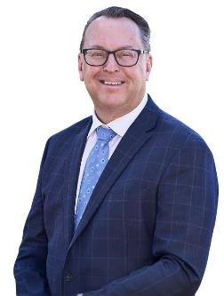
The 2024-25 financial year marked a period of strategic growth, operational excellence and forward-thinking innovation for the City of Cockburn. As CEO, I am pleased to report on the progress we’ve made in delivering high-quality services, infrastructure and governance for our community.
Operationally, we achieved major milestones across all five Strategic Community Plan outcomes. Our infrastructure team delivered over $82 million in capital works including critical drainage upgrades, road safety improvements, upgrades to the Henderson Waste Recovery Park and the completion of the Malabar Park BMX & Community Facility, now hailed as WA’s best BMX track. These projects reflect our commitment to building resilient, accessible and future-ready public assets.
We modernised our planning framework with the endorsement of the Local Planning Strategy and the rationalisation of older structure plans. This work ensures Cockburn is well prepared to accommodate 40,000 new residents by 2036, with sustainable development and liveable neighbourhoods at the core.
Internally, we embraced digital transformation. The migration to TechnologyOne’s cloud environment and the deployment of 600 new laptops and desktops in a mobility focused rollout allows our staff to be mobile and always connected. Our Customer Contact Centre now benefits from smart routing and sentiment analysis, reducing wait times and enhancing responsiveness.
We also strengthened our governance and workforce. The adoption of the Strategic Community Plan 2025-2035 followed extensive engagement, and our updated risk management systems and financial controls were praised in external audits. Staff wellbeing and leadership development remained priorities, with new frameworks and training programs supporting a positive, inclusive workplace culture.
Innovation was a stand-out this year. From AI-powered road condition assessments to award-winning irrigation retrofits that saved water and reduced costs, our teams showcased how operational ingenuity can deliver sustainable, high-impact solutions.
Looking ahead, we remain focused on continuous improvement, regional collaboration and delivering value for our community. I thank our dedicated employees, Elected Members, volunteers, community and partners for their contributions, and I look forward to another year of impactful service.
This year, we celebrated the transformational announcement of the Commonwealth Defence Precinct at Henderson, a milestone that has the potential to create a significant number of local jobs and new opportunities for our residents and business community. Our advocacy and community readiness have positioned Cockburn as a key player in Australia’s maritime future, and I commend the many local businesses already stepping up to be part of this exciting journey.
These achievements would not be possible without the dedication and commitment of every team and volunteer at the City of Cockburn together with the leadership provided by our Mayor and Councillors, for which I extend my appreciation. Cockburn is definitely the best place to be, with a very exciting future.
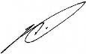
Daniel Simms
Chief Executive Officer

Our Strategic Framework
Our Local Government operates within an Integrated Planning and Reporting Framework (IPRF). This framework, mandated by the Western Australian Government, ensures a structured and transparent approach to planning and decision-making.
The IPRF connects the long-term vision of our Strategic Community Plan with our current plans and strategies. It guides how we identify community needs, set strategic objectives, allocate resources, and ultimately measure our success in achieving those goals. Through the IPRF, we strive to deliver effective services, manage finances responsibly, and remain accountable to the community we serve.
The following diagram illustrates the City’s Integrated Planning and Reporting Framework and shows the City’s strategies and plans within the framework.
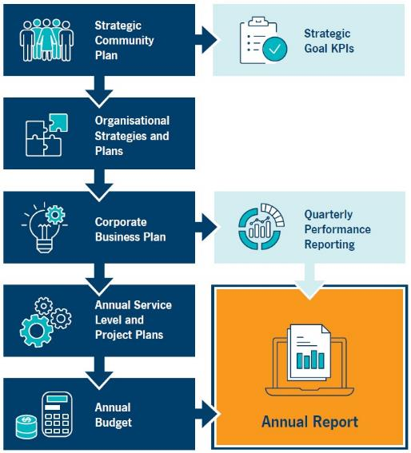
Transcriber’s Note: The diagram above is a flow chart with eight labelled boxes linked by arrows. At each step, arrows point forward to one or more boxes. The flow chart is presented below as lists in which the possible next steps are listed beneath each box label.
- Strategic Community Plan
  - forward to Strategic Goal KPIs
  - forward to Organisational Strategies and Plans
- Organisational Strategies and Plans
  - forward to Corporate Business Plan
- Corporate Business Plan
  - forward to Quarterly Performance Reporting
  - forward to Annual Service Level and Project Plans
- Quarterly Performance Reporting
  - forward to Annual Report
- Annual Service Level and Project Plans
  - forward to Annual Budget
- Annual Budget
  - forward to Annual Report

Our Strategy on a Page
This page presents the vision for Cockburn, highlighting our driving purpose. It also outlines our strategic objectives and outcomes as detailed in our Strategic Community Plan.
Vision: Cockburn, the best place to be
Purpose: Support our communities to thrive by providing inclusive and sustainable services which reflect their aspirations
Our Outcomes and Our Strategic Objectives:
1. Local Economy | 2. Environmental Responsibility | 3. Community, Lifestyle and Security | 4. City Growth and Moving Around | 5. Listening and Leading
1A. Increased investment, economic growth and local employment | 2A. Protection and enhancement of our natural areas | 3A. Accessible and inclusive community, recreation and cultural services and facilities that enrich our community | 4A. An attractive, socially connected and diverse built environment | 5A. Best practice governance, partnerships and value for money
1B. Thriving local commercial centres, local businesses and tourism industry | 2B. Sustainable resource management including waste, water and energy | 3B. A safe and healthy community that is socially connected | 4B. Cockburn Central as the capital of the South Metro Region | 5B. High-quality and effective community engagement and customer service experiences
1C. A city that is ‘easy to do business with’ | 2C. Address Climate Change | 3C. Aboriginal and Torres Strait Islander cultures and heritage are recognised and celebrated | 4C. An integrated, accessible and improved transport network | 5C. Employer of choice focusing on equity, innovation and technology

Our Values
At the City of Cockburn, our organisational values are the foundation of our culture and the compass that guides our actions. These values shape how we work together, how we serve our community, and how we interact as both individuals and an organisation.
We care deeply for our people, community and environment
This value reflects our commitment to nurturing respectful relationships, protecting our natural surroundings and supporting the wellbeing of our residents and staff. It drives our inclusive approach to service delivery and our dedication to sustainability.
We are empowered to be our whole selves and flourish
We believe that when people feel safe, respected and valued, they thrive. Our workplace culture encourages authenticity, celebrates diversity, and supports personal and professional growth. This empowerment fosters resilience and innovation across all levels of the organisation.
We foster innovation by being informed and collaborative
We embrace curiosity and continuous learning. By working together and sharing knowledge, we create space for new ideas and smarter solutions. This collaborative spirit enables us to respond effectively to challenges and deliver high-quality services to our community.
These values are more than words – they are embedded in our daily practices, our decision-making and our interactions. We expect all employees to uphold these principles, ensuring that our workplace remains respectful, dynamic and purpose driven. Together, they help us to deliver exceptional customer service to our community and implement progressive programs tailored to our unique social context, ensuring we continue to be the best place to be.
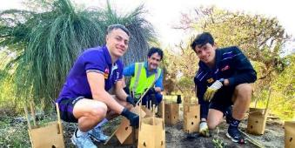
Image: Planting day at Bibra Lake – July 2024. (Left to Right) City Environmental Officer Adam Harris with Fremantle Football Club players Cooper Simpson and Bailey Banfield.

What is an Annual Report
Welcome to the City of Cockburn Annual Report 2024-25.
We are pleased to present the City of Cockburn’s Annual Report for 2024-25. This comprehensive document provides a snapshot of our organisation’s performance against key performance indicators set by Council, our achievements, challenges and financial results.
The Annual Report is a cornerstone of our commitment to transparency, accountability and community engagement. It reflects our dedication to delivering exceptional services, fostering a vibrant community and achieving measurable success.
Key features of our Annual Report:
- Aligned Vision: Our report aligns with the City’s strategic vision, ensuring that our actions contribute to a thriving community.
- Community-Driven Focus: We are committed to serving the needs of our community, and our annual report highlights our efforts to engage residents and businesses in decision-making processes. Our community-driven approach is evident in the projects we deliver and the services we provide.
- Financial Responsibility: We are dedicated to responsible financial management, and our report provides a detailed overview of our financial performance.
- Measurable Success: We track and report on our performance against key indicators, demonstrating our commitment to accountability and results.
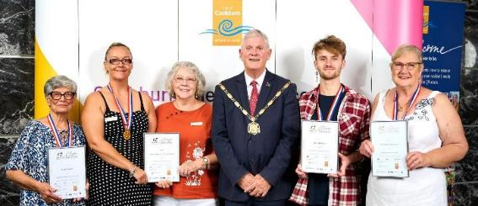
Image: Australia Day Community Citizen of the Year Awards – January 2025. (Left to Right) Lucia Scata; Lani Slaughter and Helen Miskell, Treeby Community Association; Mayor Logan Howlett; Atlas Pillinger; and Maureen Fisher-Sim.
What you’ll find in this report:
The Annual Report is divided into several key sections:
- Leadership Insights: Our Mayor and CEO provide their perspectives on the year’s accomplishments and challenges
- Our City in Focus: Learn about Cockburn, our Council and the services we offer
- Progress Towards Strategic Community Plan Outcomes: An evaluation of our progress toward the goals and objectives outlined in our Corporate Business Plan, highlighting our successes, recognitions and challenges, categorised by the Strategic Community Plan outcomes
- Governance, Legal and Community Inclusion: Information on governance practices, legal compliance, and development activity, and an update on our Disability Access and Inclusion Plan
- Financial Performance: A detailed analysis of our financial position and performance
- Looking Ahead: Discover our plans for the future and how we're working to address emerging challenges and opportunities.
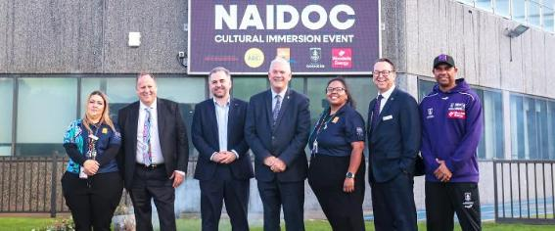
Image: Ahead of National NAIDOC Week at Cockburn ARC, Cockburn Central – June 2024. (Left to Right) Kathleen Turtur, City First Nations Community Development Officer; Hon Don Punch MLA, Minister for Aboriginal Affairs; David Scaife MLA; Mayor Logan Howlett; Amanda King, City First Nations Support Officer; Daniel Simms, Chief Executive Officer; and Roger Hayden, Fremantle Male NGA and Game Development Coach and former Australian rules footballer.
Connecting the dots...
The Annual Report, Corporate Business Plan and Strategic Community Plan
The Annual Report serves as a valuable tool for understanding how our activities contribute to the broader goals outlined in our Strategic Community Plan. While the Annual Report looks back on the past year, the Corporate Business Plan provides a forward-looking perspective, outlining our plans for the future. Together, these documents provide a comprehensive picture of our organisation’s performance and direction.

Our City

Looking back at Cockburn’s history
Today Cockburn is a busy, multicultural city of 135,000 people. It stretches from the coast (Derbal Nara or Cockburn Sound) to the wetlands of North Lake (the Nyungar name is Coolbellup), Thomson’s Lake (Jilbup) and beyond.
As is so often the case, in these names and places are the echoes of earlier landscapes and people. Cockburn Sound was named after a senior British naval administrator, Sir George Cockburn, by Captain James Stirling on his 1827 exploration of the Swan River.
Derbal Nara, Coolbellup, Walyabup (Bibra Lake) and Jilbup are Nyungar names that reflect traditional connections to this place. The custodians for the Cockburn area are the Beeliar Nyungar people, whose leaders Midgegooroo and his son Yagan are well-known in the early history of WA. The wetlands, especially Walyabup, have long been significant to Beeliar people. Many Nyungar people today retain strong connections to Cockburn and have shared memories of living and practicing culture in the area, particularly through oral histories and guided walks.
Convicts came to Western Australia from 1850, and in the 1860s, 32 convicts worked for Charles Manning. They most likely built the Davilak homestead, now in ruins near Azelia Ley Homestead Museum in Manning Park. With the convicts came Pensioner Guards, former British servicemen who had been pensioned out of the army after a war. In return for guarding convicts on the ship they could acquire land in the colony. In the 1870s, some Pensioner Guards built houses at Lake Coogee, and the remains can be seen on a walk around the western side of the lake.
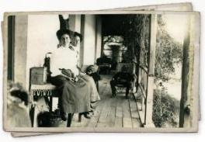
Image: Miss Olivia Manning and others at Davilak homestead early 1900s. ALP.00139
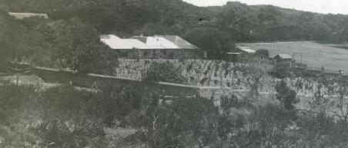
Image: Davilak homestead and vineyard, early 1900s. ALP.00114
Woodman Point quarantine station reflects the practice of isolating people suffering or at risk of catching infectious diseases such as smallpox, cholera, influenza and the plague. In fact, Australia’s oldest crematorium was built there and can still be seen on a tour of the quarantine station.
Not many people know that Rottnest Island is also part of the City of Cockburn, with its history of salt mining, Aboriginal prison, holiday making and more recent truth-telling to acknowledge a history as the site of Australia’s largest number of Aboriginal deaths in custody.
To assist the P&O mail steamers access Fremantle through Cockburn Sound (well before Fremantle Harbour was built), there is a navigation marker on the high point above Cockburn Road, which was built in the early 1870s. Then in 1902 the current lighthouse and lighthouse keepers’ cottages were built nearby.
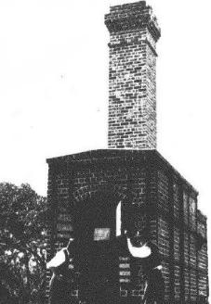
Image: Crematorium at Woodman Point. Western Mail, August 1902.
A tall chimney in North Coogee harks back to the days when travellers had to wind up car windows as they drove south past the skin drying sheds. This location, and others nearby, were the sites of government and private abattoirs at Robb Jetty and Coogee. Cattle were shipped here from the Kimberley from the late 1800s. Aboriginal boys were sometimes brought with them, finding respect and a place in the community; for example, the suburb of Wandi just south of Cockburn is named after the Aboriginal man Wandi Dixon.
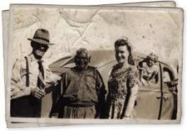
Image: Wandi Dixon (deceased) in centre with Harry Outram and Kathy Hall, 1940s. Denyce Willis is looking out the car window. ALP.00164
Much of the Cockburn district, especially along the coast, was grazing land for the cattle and sheep destined for the abattoirs. Some paddocks remain, though many have given way to housing developments.
The Naval Base Shacks in Henderson sit on the edge of the earliest European settlement in Cockburn: Clarence, or Peel Town. Led by Thomas Peel, three ships brought settlers and their goods to makeshift camps on the beach, where Peel Town was established as a private settlement in 1829. Difficulty in obtaining supplies and a lack of leadership by Peel led to the settlement’s abandonment shortly after.
Traces of our building history can be seen in the lime kilns on Cockburn Road in Coogee. Lime burning supplied mortar for buildings in Perth from the early 1900s until as late as the 1950s. Local stone was also quarried for buildings.
Remnants of market gardens give an inkling of the extensive vegetable, fruit and flower growing industries which once spread over much of the Cockburn area. Halls, such as the South Coogee Hall, now home to the Jervoise Bay Sea Scouts, held dances, political meetings and the annual shows where residents displayed produce and competed for prizes.
By 2025, half of Cockburn’s residents were born overseas or have parents who were born overseas. Early migrants from Europe, such as Italy and Croatia as well as Britain, and other parts of Australia established many of the district’s market gardens. Many streets in our suburbs now carry their names. A number of men from China also worked market gardens at Bibra Lake in the early 1900s, and Hilory Street in Coolbellup remembers a well-known resident, Hi Lory.
Eliza Ponds is a recent housing development on the site of a well-known industrial company, Watsonia. This company produced goods such as bacon, other meats and butter for more than 100 years. The site redevelopment, named after Eliza Watson, wife of the original owner, incorporates elements of the former factories, ponds and the steps to the family home.
The City of Cockburn began as the Fremantle District Roads Board in 1871, when the first local governments in Western Australia were established. It became the Cockburn District Roads Board in 1955, the Shire of Cockburn in 1961, the Town in 1971, and in 1979 the City of Cockburn. Along with the increase in residents, the scope of the Council’s work has expanded, as you will see reading this annual report. For example, back in 1951 there were 11 outside staff and 4 inside staff who managed the much more limited business of local government at that time.
The Historical Society of Cockburn, established in 1975, is supported by Council to preserve and display artefacts from Cockburn’s history at the Azelia Ley Homestead Museum, established in 1983. Cockburn’s Local History collection is based at Spearwood Library.
To read more Cockburn history, stories and photographs, visit Cockburn History: history.cockburn.wa.gov.au
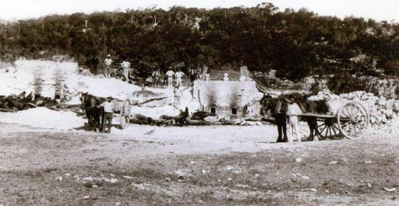
Image: Lime kilns at Coogee Beach, 1914. ALP.00310

Cockburn Today
Welcome to the City of Cockburn – a place we’re proud to call home. From our sunlit beaches to our vibrant parks, from the bustling local businesses to the friendly faces of our neighbours, Cockburn is more than a city – it’s our community.
Picture yourself starting the day with a walk along Coogee Beach, where the waves meet golden sands. Or maybe it’s a family picnic at Bibra Lake, surrounded by the sounds of nature. With hundreds of parks and reserves and kilometres of stunning coastline, Cockburn is a haven for outdoor lovers. These are the spaces where we connect, where our kids laugh in local playgrounds, and where we take a moment to appreciate the beauty of our surroundings.
Cockburn isn’t just where we live; it’s where we grow. Our city has seen incredible progress, with a population of more than 135,000 today and expected to grow to nearly 190,000 by 2045. Together, we’ve built a diverse and welcoming community, with people from all walks of life coming together to make Cockburn what it is: a place of opportunity and belonging.
Our local economy is thriving, contributing billions of dollars to the Australian economy every year. With thousands of local businesses, many of them small enterprises, Cockburn is a place where ambition turns into action. Whether you’re running your own business or supporting local shops, our community is built on shared success.
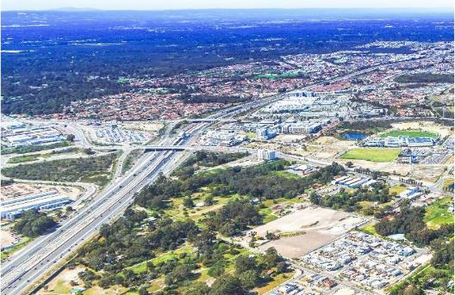
Image: Cockburn Central.
What truly defines Cockburn is its vibrant community spirit and fantastic lifestyle amenities. With numerous active local clubs, bustling community centres hosting diverse programs, and state-of-the-art recreational facilities like the Cockburn ARC, there’s always something happening. We pride ourselves on fostering connections through popular local events and providing outstanding parks and accessible beaches where families and friends gather, making Cockburn a lively and engaging place to call home.
As we look to the future, our city is ready to grow with us. With plans for new housing, better roads and evolving services, Cockburn is set to remain a place where everyone – families, young people and seniors – can thrive. We’re building a city that works for all of us, one step at a time.
Cockburn is more than just a place on a map; it’s the heart of everything we do. It’s the sporting fields where we cheer for our teams, the libraries where we learn and share stories, and the arts and cultural spaces where our creativity shines.
This is our Cockburn – our home, our story, and the best place to be. Together, we’re writing the next chapter. From its historical beginnings to its bright future, it invites you to be part of its journey.

About our City

Local Economy
Jobs located in:
- Cockburn: 64,763
- Western Australia: 1,577,949
- Australia: 14,193,107
(Source: Australian Bureau of Statistics 2025)
Cockburn accounts for 4 per cent of Western Australia’s total jobs, making it a significant contributor to the state’s economy and providing employment opportunities for both local residents and commuters.
Home ownership rate in:
- Cockburn: 72.5
- Western Australia: 69.2%
- Australia: 66%
(Source: City of Cockburn, 2021 Census, Australian Bureau of Statistics)
Cockburn boasts a significantly higher home ownership rate than the national average, with 72.5 per cent of households owning their homes compared to 66 per cent. This trend is further reflected in the housing stock, with a greater prevalence of freestanding homes and a lower proportion of apartments in Cockburn than across Australia.
Households renting in:
- Cockburn: 25.4%
- Western Australia: 27.3%
- Australia: 30.6%
(Source: City of Cockburn, 2021 Census, Australian Bureau of Statistics)
Weekly median household income in:
- Cockburn: $1,988
- Western Australia: $1,815
- Australia: $1,746
(Source: City of Cockburn, 2021 Census, Australian Bureau of Statistics)
Businesses operating in:
- Cockburn: 9,919
- Western Australia: 246,661
- Australia: 2,662,998
(Source: Australian Bureau of Statistics 2025)
Cockburn’s business ecosystem comprises approximately 9,919 businesses, the majority of which are small-scale enterprises. This accounts for roughly 4 per cent of the total businesses operating in Western Australia.
GRP, GSP and GDP:
- Gross Regional Product (GRP) in Cockburn to the Australian economy: $11.23 billion
- Gross State Product (GSP) in Western Australia: $455.7 billion
- Gross Domestic Product (GDP) in Australia: $2.7 trillion
(Source: REMPLAN 2024)
Cockburn contributes 4.5 per cent of the total value added by the Greater Perth region and represents 2.4 per cent of Western Australia’s $456 billion value added, demonstrating its role as a key driver of economic growth and improved living standards for Western Australians.
Cockburn development:
- Number of development applications received: 936
- Total value of development approvals: $438 million
(Source: City of Cockburn Statistics 2025)

Environmental Responsibility
(Source: City of Cockburn Statistics 2025)
Seedlings planted in winter revegetation works: 49,000
Tree canopy cover in the City of Cockburn: 26%
The City actively participates in environmental conservation through initiatives like winter revegetation, planting 49,000 seedlings. Cockburn also maintains a significant tree canopy cover of 26 per cent, contributing to the overall health and biodiversity of the area.
Number of parks and reserves: 406
Biodegradable dog bags dispensed annually: 3,072,000
Average annual carbon emissions generated by City operations (tonnes of carbon dioxide equivalent): 38,235 tCO2e
Annual average solar energy generated from City facilities (megawatts): 1,185MW
The City generates an average of 38,200 tonnes of carbon dioxide equivalent annually from its operations. To offset this, Cockburn generates solar energy, producing an average of 1,185 megawatts annually from its facilities.
City-managed coastline:15km
Total hectares of parks and reserves: 1,584.6ha
Hectares of bush reserves: 1074.6ha
With a total of 406 parks and reserves, encompassing 1,585 hectares, Cockburn offers ample green spaces for its residents. Of these, 1,074.61 hectares are designated as bush reserves, preserving the City’s natural environment.

Community, Lifestyle and Security
Number of sporting reserves/fields: 32
Number of sporting clubs in Cockburn: ~120
(Source: City of Cockburn Statistics 2025)
With 32 sporting reserves/fields and an estimated 120 sporting clubs, Cockburn offers a variety of opportunities for residents to participate in physical activities.
Number of playgrounds: 215
Number of arts and cultural facilities: 2
Number of libraries: 3
(Source: City of Cockburn Statistics 2025)
Median age:
- Cockburn: 37
- Western Australia: 38
- Australia: 38
(Source: REMPLAN 2024)
Aboriginal and Torres Strait Islander people population: 
- Cockburn: 1.9%
- Western Australia: 3.3%
- Australia: 3.2%
(Source: REMPLAN 2024)
Although Cockburn has a smaller percentage of Aboriginal and Torres Strait Islanders compared to the national average (1.9 per cent vs 3.2 per cent), the City recognises the importance of this population.
Couple families with children:
- Cockburn: 47%
- Western Australia: 44.6%
- Australia: 43.7%
(Source: City of Cockburn, 2021 Census, Australian Bureau of Statistics)
Cockburn is a popular choice for families. Nearly half of all residents (47 per cent) belong to couple families with children. With 215 playgrounds scattered throughout the City, there’s always a fun spot for kids to explore.
Proportion of population born in:
Australia: 
- Cockburn: 61.7%
- Western Australia: 65%
- Australia: 66%
United Kingdom: 
- Cockburn: 8%
- Western Australia: 8.9%
- Australia: 4.4%
New Zealand: 
- Cockburn: 2.7%
- Western Australia: 2.8%
- Australia: 2.1%
Philippines: 
- Cockburn: 2.4%
- Western Australia: 1.4%
- Australia: 1.2%
India: 
- Cockburn: 1.9%
- Western Australia: 2.3%
- Australia: 2.6%
South Africa: 
- Cockburn: 1.7%
- Western Australia: 1.7%
- Australia: 0.7%
Italy: 
- Cockburn: 1.4%
- Western Australia: 0.7%
- Australia: 0.6%
(Source: REMPLAN 2024)
While the majority of residents were born in Australia (61.7 per cent), Cockburn boasts a diverse population with significant representation from the United Kingdom (8 per cent), New Zealand (2.7 per cent), and a growing Asian community (including Philippines and India).
Population with a university degree:
- Cockburn: 24%
- Western Australia: 24%
- Australia: 26%
(Source: City of Cockburn, 2021 Census, Australian Bureau of Statistics)

City Growth and Moving Around
Description | 2025 Population | 2045 Population
Preschool (0-4 years) | 8,443 (6.2%) | 9,969 (5.3%)
School-age (5-14 years) | 17,155 (12.6%) | 20,492 (10.8%)
Youth (15-24 years) | 16,362 (12%) | 22,147 (11.7%)
Young Workers (25-34 years) | 20,235 (14.8%) | 25,887 (13.6%)
Workers (35-49 years) | 30,981 (22.7%) | 39,593 (20.9%)
Older Workers (50-64 years) | 24,029 (17.6%) | 35,614 (18.8%)
Retired (65-79 years) | 14,631 (10.7%) | 25,158 (13.3%)
Elderly (80+) | 4,552 (3.3%) | 10,823 (5.7%)
Total | 136,388 | 189,683
Estimated population in 2025: 136,388
Projected population by 2045: 189,683
(Source: REMPLAN 2024)
Cockburn’s population is projected to experience a shift in age demographics. While the working-age population (25-64 years) is expected to grow, the proportion of older residents (65+) is also projected to increase. This indicates a growing demand for age-appropriate services and infrastructure.
Estimated dwellings in 2025: 52,063
Projected dwellings by 2045: 74,692
(Source: REMPLAN 2024)
Cockburn is experiencing significant growth, with the population projected to increase by nearly 40 per cent: from 136,388 in 2025 to 189,683 in 2045. This growth is reflected in the housing market, with the number of dwellings expected to rise from 52,063 to 74,692 over the same period.
Total kilometres of City-managed roads: 909.6km
Total kilometres of City-managed footpaths: 905.6km
(Source: City of Cockburn Statistics 2025)
Cockburn’s land area of 168.1 square kilometres is home to a population density of 811 people per square kilometre, indicating a relatively high concentration of residents. The City maintains a vast network of roads (910 kilometres) and footpaths (906 kilometres), ensuring connectivity and accessibility.
Land area: 168.1km²
(Source: City of Cockburn Statistics 2025)
Percentage of people who drove to work:
- Cockburn: 65.1%
- Western Australia: 62.1%
- Australia: 52.7%
(Source: City of Cockburn, 2021 Census, Australian Bureau of Statistics)
Percentage of households with two motor vehicles or more:
- Cockburn: 63.5%
- Western Australia: 61.5%
- Australia: 56.6%
(Source: City of Cockburn, 2021 Census, Australian Bureau of Statistics)
Cars are the primary mode of transportation for Cockburn residents, with 65.1 per cent driving to work, compared to 62.1 per cent in Western Australia and 52.7 per cent nationally. A significant portion of households (63.5 per cent) own two or more motor vehicles, reflecting a reliance on private transportation. Public transport usage currently stands at 7.9 per cent, with most Cockburn residents commuting by train.
Percentage of people who travelled to work by public transport:
- Cockburn: 7.9%
- Western Australia: 7.4%
- Australia: 4.6%
(Source: City of Cockburn, 2021 Census, Australian Bureau of Statistics)
Population density: 811 people per square kilometre
(Source: REMPLAN 2024)

Listening and Leading
Number of people reached through our social media posts: 2.58 million
City of Cockburn website views: 3.27 million
(Source: City of Cockburn Statistics 2025)
Cockburn has a strong online presence, with the official City of Cockburn website attracting 3.3 million views. The City’s social media posts reach an impressive 2.6 million people, while the Comment on Cockburn website receives 63,067 visits.
Visits to the Comment on Cockburn website: 63,067
Annual engagement responses received: 2,200
(Source: City of Cockburn Statistics 2025)
Actual capital spend (financial year 2025): $82 million
(Source: City of Cockburn Statistics 2025)
Voter turnout for the 2025 Ordinary Election: 26,069 (29.76%)
(Source: Western Australian Electoral Commission)
The 2025 Ordinary Election saw a voter turnout of 26,069 (29.8 per cent), indicating a moderate level of community participation in the democratic process.
Customer requests raised: 56,370
Calls received by the Contact Centre: 73,782
Average wait time for the Contact Centre: 251 seconds
(Source: City of Cockburn Statistics 2025)
Cockburn’s commitment to its residents is evident in its service delivery. The Contact Centre handles 73,782 calls annually, with an average wait time of 251 seconds. This demonstrates efficient and responsive service.
Average residential rates in financial year 2025:
- City of Armadale: $2,300
- City of Melville: $2,013
- City of Kwinana: $2,035
- City of Rockingham: $2,020
- City of Cockburn: $1,800
- City of Canning: $1,755
(Source: City of Cockburn Statistics 2025)
Cockburn offers competitive residential rates compared to neighbouring cities. The average residential rate in the financial year 2025 was $1,800, lower than cities like Melville, Kwinana, Armadale and Rockingham.

Community Facilities and Key Events Map
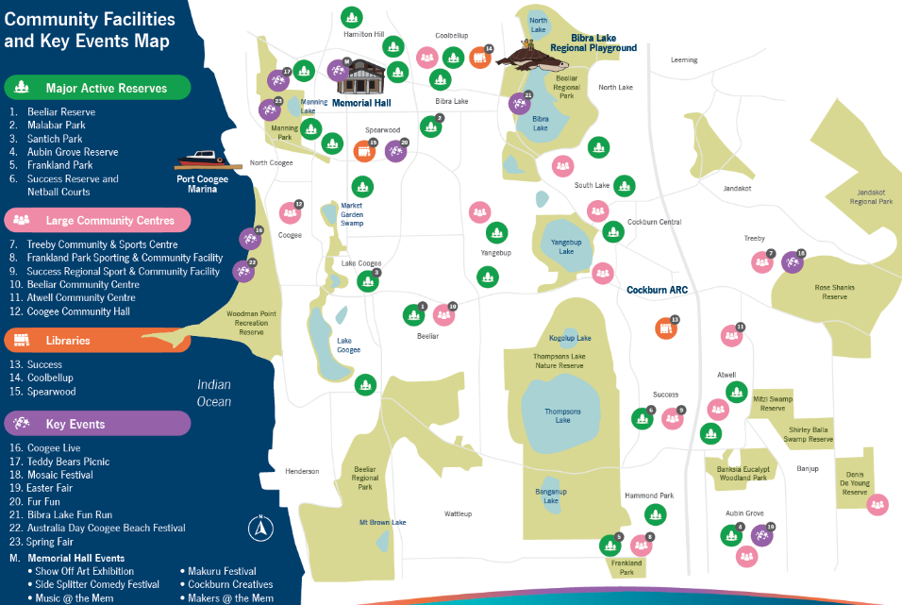
Transcriber’s Note: The map above shows the locations of active reserves (marked in green on the map), community centres (marked in pink), libraries (marked in orange), and key events (marked in purple) within the City of Cockburn. Please contact City of Cockburn for more information or clarification.
Major Active Reserves:
There are 24 reserves marked on the map; however the following major active reserves are labelled:
- Beeliar Reserve – located at Lakefront Avenue, Beeliar; next to Beeliar Community Centre
- Malabar Park – located at Malabar Way, Bibra Lake
- Santich Park – located at Beckett Close, Lake Coogee
- Aubin Grove Reserve – located at Camden Boulevarde, Aubin Grove
- Frankland Park – located at Frankland Avenue, Hammond Park; next to Frankland Park Sporting & Community Facility
- Success Reserve and Netball Courts – located at Hammond Road, Success; next to Success Regional Sports & Community Facility
Large Community Centres:
There are 14 community centres marked on the map; however the following large community centres are labelled:
- Treeby Community & Sports Centre – located at Torwood Avenue, Treeby; next to Treeby Reserve
- Frankland Park Sporting & Community Facility – located at Frankland Avenue, Hammond Park, next to Frankland Park
- Success Regional Sport & Community Facility – located at Hammond Road, Success; next to Success Reserve
- Beeliar Community Centre – located at Lakefront Avenue, Beeliar, next to Beeliar Reserve
- Atwell Community Centre – located at Lombe Gardens, Atwell
- Coogee Community Hall – located at Arlington Loop, Coogee
Libraries:
There are three libraries marked on the map:
- Success – located at Cockburn Health and Community Facility, Wentworth Parade, Success
- Coolbellup – located at Coolbellup Community Hub, Cordelia Avenue, Coolbellup
- Spearwood – located at City of Cockburn Administration Centre, Coleville Crescent, Spearwood
Key Events:
There are eight key event locations marked on the map:
- Coogee Live – held at Coogee Beach
- Teddy Bears Picnic – held at Manning Park in Hamilton Hill
- Mosaic Festival – held at Treeby Reserve
- Easter Fair – held at Aubin Grove Reserve
- Fur Fun – held at MacFaull Park in Spearwood
- Bibra Lake Fun Run – held at Bibra Lake
- Australia Day Coogee Beach Festival – held at Coogee Beach Reserve
- Spring Fair – held at Manning Park in Hamilton Hill
M. Memorial Hall Events – held at the corner of Carrington Street and Rockingham Road in Hamilton Hill
- Show Off Art Exhibition
- Side Splitter Comedy Festival
- Music @ the Mem
- Makuru Festival
- Cockburn Creatives
- Makers @ the Mem

Brief Year in Review
The City of Cockburn’s 2024-25 Annual Report reflects a year of meaningful progress across our five strategic outcomes. From economic innovation and environmental leadership to community wellbeing, infrastructure growth, and transparent governance, we’ve delivered initiatives that make Cockburn “the best place to be.”
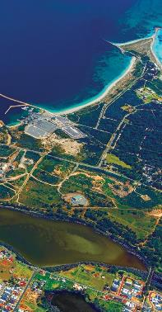
Image: Woodman Point, Coogee.

Local Economy
Cockburn’s local economy flourished through strategic partnerships, industry advocacy, and grassroots support. A landmark Memorandum of Understanding with UWA’s Oceans Institute positioned Cockburn as a leader in the blue economy, focusing on marine technology, offshore renewable energy, and coastal resilience. The announcement of a Commonwealth Defence Precinct at Henderson was a game changer, promising 10,000 jobs and reinforcing Cockburn’s role in national shipbuilding and maritime innovation.
Small businesses were empowered through networking forums, business development workshops, and the City’s Business Grants Program. Entrepreneurs benefited from scholarships to the Curtin Ignition program, while events like the Speed Networking Sundowner and “Find Your Why” workshop fostered collaboration and leadership. Cockburn Global 2024 connected local businesses with Southeast Asian trade opportunities, and the City’s export guide and partnerships with federal agencies helped firms prepare for international growth.
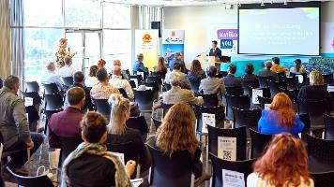 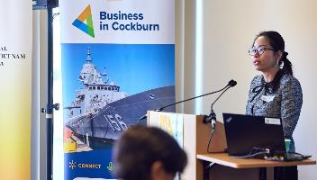
Images: Cockburn Global – October 2024.

Environmental Responsibility
Cockburn continued to lead in environmental stewardship. Port Coogee Marina maintained its Clean Marina Level 3 status and earned “Fish Friendly” accreditation, with 180 marine species thriving in its waters. The Roe 8 Corridor restoration saw 5,953 native seedlings planted, and the Beeliar Woodland Walk opened with interpretive signage celebrating local biodiversity and Noongar culture.
Community engagement was central to our success. Over 270 volunteers participated in planting days, and Nature Discovery events introduced families to local bushland. The Native Plant Subsidy Scheme and 1,650 new street trees expanded our urban canopy. The City doubled its fox control budget and participated in a regional monitoring program to protect the endangered Yaakan turtle, supported by dozens of trained Turtle Trackers.
Climate resilience was advanced through the expansion of the North Coogee artificial reef, reducing wave energy and boosting marine biodiversity. The City is developing a Coastal Hazard Risk Management and Adaptation Plan and finalized its Greenhouse Gas Inventory, setting a path toward net zero emissions by 2030. Water conservation efforts earned Cockburn the National Water Efficiency Management Award, and community-level initiatives like Sustainability Grants and megaphone-guided snorkel tours promoted grassroots climate action.
Waste reduction was a standout achievement. Coogee Live 2025 achieved a 75% waste recovery rate and zero contamination, thanks to reusable serve ware and staffed waste sorting stations. The Zero Waste Refill Station at Cockburn ARC offered residents a zero-waste alternative for household products. Workshops on waste-free holidays and repair cafés empowered residents to reduce landfill. Operational improvements included optimized bin collection routes, a new leachate pond at Henderson Waste Recovery Park, a temporary transfer station for our trailer pass holders and upgraded safety protocols.

Community, Lifestyle and Security
Cockburn invested in inclusive services, vibrant events and safe infrastructure. A pilot program embedded a social worker at Success Library, offering drop-in support for residents facing financial or housing stress. The Cockburn Youth Centre saw record attendance, and the Youth Pride Ball celebrated diversity with over 200 participants. Seniors benefited from refreshed programming at the Cockburn Seniors Centre, and Cockburn Care ensured continuity of essential services during national reforms.
Infrastructure highlights included the $8.9 million Malabar Park BMX & Community Facility, praised by Olympic athletes and now hosting state-level competitions. The Beale Park redevelopment and Success Regional Sport & Community Reserve Master Plan will deliver modern facilities for growing communities. CoSafe transitioned to an in-house model, improving response times and safety outcomes, while bushfire preparedness was strengthened through updated plans and new equipment for volunteer brigades.
Community events brought people together. NAIDOC Week featured cultural celebrations and tree planting with the Fremantle Dockers. The Multicultural Mosaic Festival showcased global performances and inclusive spaces. The ANZAC Youth Parade involved over 1,350 students in a moving tribute. Volunteers were honored at the Recognition Sundowner, and the Community Citizen of the Year Awards celebrated local heroes. Memorial Hall’s centenary was marked with exhibitions, music, and the launch of Cockburn’s Arts Hall of Fame.
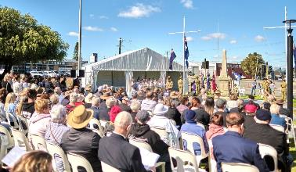
Image: ANZAC Day at Memorial Hall, Hamilton Hill – April 2025.

City Growth and Moving Around
Cockburn managed growth with strategic planning and smart infrastructure. The Local Planning Strategy was endorsed, guiding development for 40,000 new residents by 2036. The Coogee Beach Master Plan balanced heritage and recreation, with community-backed improvements to access, amenities and cultural recognition.
Road upgrades included Hamilton Road, Rockingham Road and Spearwood Avenue, while Black Spot safety improvements in Bibra Lake reduced crash risks. Major drainage works in Hamilton Hill and Spearwood protected homes from flooding. AI technology assessed road conditions across 700 km, informing future rehabilitation. Footpath links, shade sails and playground renewals improved neighbourhood amenity, and 1,650 new trees enhanced streetscapes.
The METRONET Thornlie-Cockburn rail extension opened, connecting Cockburn Central to Perth’s southeast and enabling transit-oriented development. The City responded to housing affordability challenges by supporting diverse housing types and leveraging $6.7 million in Development Contribution Plans to fund community infrastructure.

Listening and Leading
Cockburn deepened community trust through award-winning engagement and strong governance. The City was named IAP2 Australasian Organisation of the Year for public participation, and the Strategic Community Plan 2025-2035 was adopted after consultation with over 1,800 residents. Council led policy reform, including early superannuation for elected members and updates to entitlements.
Internally, “The Cockburn Way” code of conduct was launched, and staff engagement improved through forums, recognition programs, and leadership development. Safety culture strengthened with new inductions and a 20% increase in hazard reporting. Financial stewardship kept rates below the metro average while delivering a $82 million capital works program.
Digital transformation included migrating to TechnologyOne SaaS, rolling out Microsoft Teams Calling and upgrading the Customer Contact Centre. CoSafe officers received mobile dispatch tools, and a new GIS mapping tool improved public access to local information. Advocacy efforts secured $20 million for the Wally Hagan Centre, and financial counsellors helped residents waive $640,000 in debts.
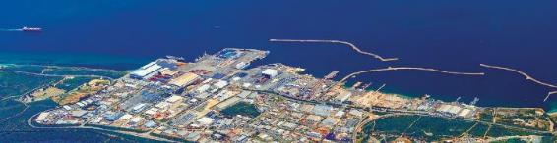
Image: Australian Marine Complex, Henderson.
Together, these achievements reflect a year of purposeful action and community collaboration. The City of Cockburn remains committed to delivering high-quality services, fostering innovation and building a resilient, inclusive future. For more detailed information on all our achievements, initiatives and performance highlights, please refer to the “Delivering Our Outcomes” section of the Annual Report.

Shaping Tomorrow
In 2025-26, the City of Cockburn will continue delivering on the priorities outlined in our new Strategic Community Plan 2025-2035, with a strong focus on community wellbeing, sustainability, economic growth and good governance. Across all five updated strategic outcome areas, Our Economy, Our Environment, Our Community, Our Places, and Our Governance, we are investing in projects that respond to community needs, support sustainable growth and enhance quality of life. The City will also be aligning its reporting with relevant United Nations Sustainable Development Goals to demonstrate how local actions are contributing to social, environmental and economic progress on a global scale.

Our Economy
The City will launch a new Business Engagement Plan to support local entrepreneurs and small businesses through grants, events and tailored training. A Blue Economy and Defence Innovation Hub will open in Henderson, positioning Cockburn as a leader in marine and defence industries. This facility will foster collaboration between industry, research, and training partners, creating high-quality jobs and attracting investment. The City will also implement an Investment Attraction Plan, including the release of a new investor prospectus. These initiatives respond directly to community feedback calling for more local jobs, unique businesses, and a stronger evening economy. The Destination Cockburn Plan will continue to promote the City as a vibrant visitor destination, with industry workshops and cross-promotion of local attractions.

Our Environment
Cockburn will build on its reputation for environmental leadership. Major road corridors will be enhanced with landscaping and tree planting, creating greener, more attractive streetscapes. The City will adopt the Henderson Waste Recovery Park Master Plan, guiding the closure and future use of the landfill site. Climate resilience remains a key focus, with finalisation of the Coastal Hazard Risk Management and Adaptation Plan, preparation of a Trails Closure Plan for Manning Park, continued urban greening initiatives, and expanded waste reduction programs. These projects reflect the community’s strong support for protecting natural areas and promoting sustainability.

Our Community
The City will invest in inclusive, healthy, and connected neighbourhoods. Construction will begin on the $15 million Beale Park Redevelopment, delivering upgraded playing fields, a new clubhouse and improved lighting and amenities. Planning will progress for the Wally Hagan Recreation Centre upgrade and a new oval and clubrooms at Cockburn Coast will move into its planning phase. The City will also upgrade playgrounds and floodlighting at key reserves to support active lifestyles. Community safety will be enhanced through expanded CoSafe patrols, new CCTV installations and emergency preparedness workshops. A new Reconciliation Action Plan will be developed, and the City will continue to celebrate diversity through events such as NAIDOC Week and the Multicultural Mosaic Festival.
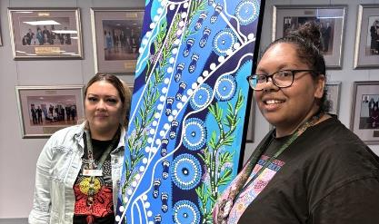 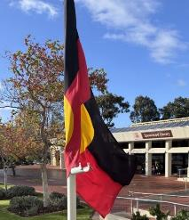
Images: NAIDOC Week at Administration building, Spearwood – July 2024. Kathleen Turtur, First Nations Community Development Officer and Amanda King, First Nations Support Officer with artwork ‘Footprints on the Waters’ by Aboriginal Elder Neta Knapp.

Our Places
The City will manage growth and improve connectivity through a range of infrastructure and planning projects. The Hammond Road Duplication project stage 1 (Russell Rd to Frankland) will move into design phase with construction planned to commence in FY2027, easing congestion and improving safety in Success and Hammond Park. Traffic signals design will be completed and construction commencing at Beeliar Drive and Dunraven Drive, improving safety and access for drivers, pedestrians and cyclists in a high-traffic area near local shops and schools. The updated Cycling and Walking Network Plan will be finalised and implemented, with new shared paths and signage improving access to schools, shops and public transport. The City will also review its Public Open Space Strategy to guide future park planning and upgrades. These projects ensure Cockburn remains connected, accessible and liveable as our population grows.

Our Governance
The City will continue to strengthen leadership, innovation and accountability. Core enterprise systems will be updated, improving efficiency, cybersecurity and customer service. A new Project Management Governance Framework will be rolled out to improve oversight and delivery of capital projects. Community engagement will be enhanced through updated policies and digital tools, ensuring residents have a voice in shaping local decisions. Internally, the City will continue to invest in its workforce through training, safety leadership and flexible work arrangements, ensuring it remains an employer of choice.
For more detailed information on all our upcoming projects next financial year, please refer to “The Year Ahead” section of the Annual Report.
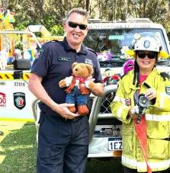 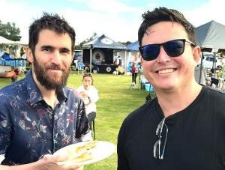
Image 1: Teddy Bears Picnic, Manning Park – October 2024. Cr Philip Eva JP and Cr Carol Zhang. Image 2: The Local Farmers Market Cockburn, Yangebup – September 2024. Cr Michael Separovich and Cr Tom Widenbar.

Our Budget

How services are funded
The City of Cockburn is committed to delivering high-quality services to our community. To achieve this, we rely on a diverse range of funding sources. Our primary revenue comes from property rates, which contribute significantly to the overall budget. However, other sources, such as fees and charges, grants and interest earnings, play a crucial role in supporting our operations.

FY2025 Adopted budget (on 1 July 2024)
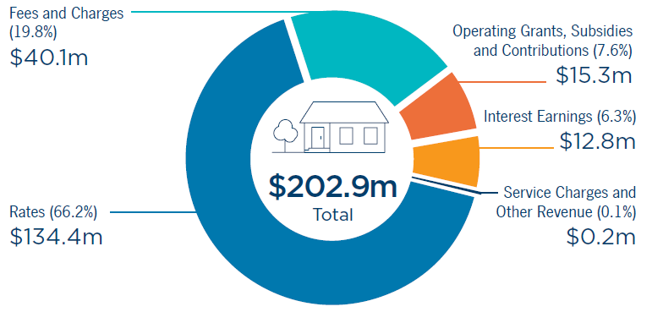
Transcriber’s Note: The pie chart above illustrates the adopted budget revenue for FY2025:
- Rates (66.2%): $134.4 million
- Fees and Charges (19.8%): $40.1 million
- Operating Grants, Subsidies and Contributions (7.6%): $15.3 million
- Interest Earnings (6.3%): $12.8 million
- Service Charges and Other Revenue (0.1%): $0.2 million
- Total: $ 202.9 million

FY2025 Actual position (on 30 June 2025)
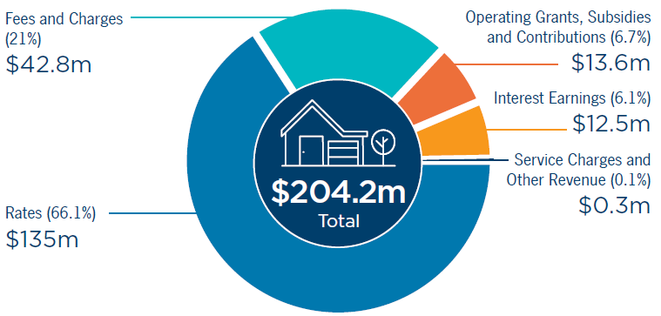
Transcriber’s Note: The pie chart above illustrates the actual revenue position for FY2025:
- Rates (66.1%): $135 million
- Fees and Charges (21%): $42.8 million
- Operating Grants, Subsidies and Contributions (6.7%): $13.6 million
- Interest Earnings (6.1%): $12.5 million
- Service Charges and Other Revenue (0.1%): $0.3 million
- Total: $204.2 million

How your money is spent
The City of Cockburn is dedicated to providing essential services and enhancing the quality of life for our community. Your rates and fees contribute to a diverse range of services, from maintaining our parks and roads to supporting local events and programs. As you can see in the chart below, the City's spending priorities align with the needs of our community. While the majority of our budget is allocated to core services like Recreation and Culture and Community Amenities, we also invest in areas such as Governance and Transport to create a vibrant and connected city.

FY2025 Adopted budget (on 1 July 2024)
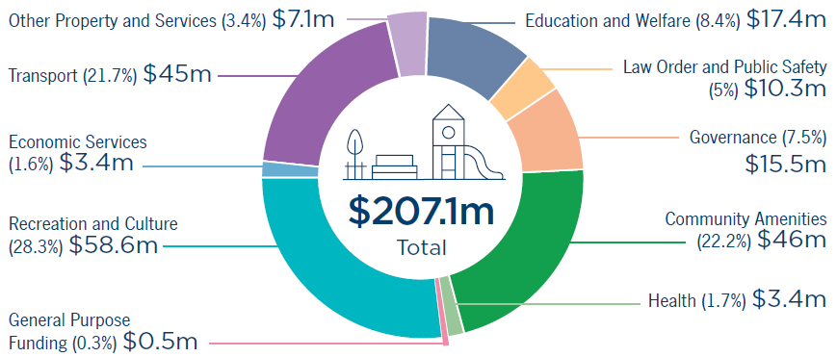
Transcriber’s Note: The pie chart above illustrates the adopted budget spend for FY2025:
- Recreation and Culture (28.3%): $58.6 million
- Community Amenities (22.2%): $46 million
- Transport (21.7%): $45 million
- Education and Welfare (8.4%): $17.4 million
- Governance (7.5%): $15.5 million
- Law Order and Public Safety (5%): $10.3 million
- Other Property and Services (3.4%): $7.1 million
- Health (1.7%): $3.4 million
- Economic Services (1.6%): $3.4 million
- General Purpose Funding (0.3%): $0.5 million
- Total: $207.1 million

FY2025 Actual spend (on 30 June 2025)
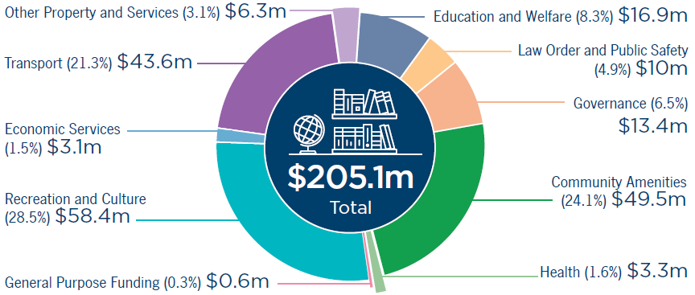
Transcriber’s Note: The pie chart above illustrates the actual spend in FY2025:
- Recreation and Culture (28.5%): $58.4 million
- Community Amenities (24.1%): $49.5 million
- Transport (21.3%): $43.6 million
- Education and Welfare (8.3%): $16.9 million
- Governance (6.5%): $13.4 million
- Law Order and Public Safety (4.9%): $10m
- Other Property and Services (3.1%): $6.3 million
- Health (1.6%): $3.3 million
- Economic Services (1.5%): $3.1 million
- General Purpose Funding (0.3%): $0.6 million
- Total: $205.1 million

Financial Performance
The accompanying charts illustrate the City’s financial performance over FY2021 to FY2025, highlighting income sources and expenditure allocations.

Actual Income Categories
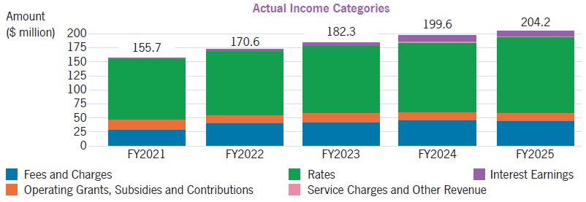
Transcriber’s Note: The bar graph above shows the income received between FY2021 and FY2025, inclusive:
- FY2021: $155.7 million
- FY2022: $170.6 million
- FY2023: $182.3 million
- FY2024: $199.6 million
- FY2025: $204.2 million
The graph also illustrates the proportion of total revenue received from each income source, i.e.
- Fees and Charges
- Operating Grants, Subsidies and Contributions
- Rates
- Services Charges and Other Revenue
- Interest Earnings
Income has grown steadily from $155.7 million in FY2021 to $204.2 million in FY2025 to cover increased expenditure, driven primarily by rates, which account for around 65-70 per cent of total revenue. Fees and Charges contribute about 20-23 per cent, while Operating Grants and Subsidies provide 7-10 per cent. Interest earnings increased notably in later years, reaching over 6 per cent by FY2024, largely due to higher interest rates boosting returns on reserve balances. This mix ensures a stable financial base with some diversification.

Actual Expenditure Categories FY2021 to FY2025
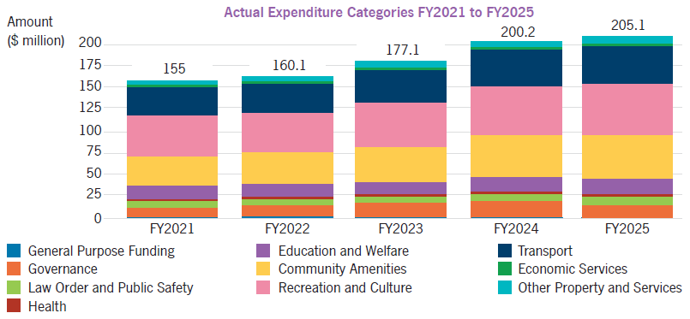
Transcriber’s Note: The bar graph above shows the actual expenditure between FY2021 and FY2025, inclusive:
- FY2021: $155 million
- FY2022: $160.1 million
- FY2023: $77.1 million
- FY2024: $200.2 million
- FY2025: $205.1 million
The graph also illustrates the proportion of total expenditure spent on each category, i.e.
- General Purpose Funding
- Governance
- Law Order and Public Safety
- Health
- Education and Welfare
- Community Amenities
- Recreation and Culture
- Transport
- Economic Services
- Other Property and Services
Expenditure rose from $155 million in FY2021 to $205.1 million in FY2025, reflecting investment in services and infrastructure. Recreation and Culture and Community Amenities make up nearly half of total spend, while Transport accounts for 19-21 per cent, supporting road and infrastructure upgrades. Governance, Education and Welfare, and Law, Order and Public Safety remain important for administration and community safety.

Cost Pressures
The increase in expenditure since the COVID19 pandemic is driven by significant cost pressures, including rising construction and maintenance costs, inflationary impacts on materials and services, and higher labour expenses associated with attracting and retaining skilled staff. These pressures have required careful financial management to maintain service levels while delivering on strategic priorities. The City continues to monitor these trends and implement efficiency measures to mitigate their impact.

Capital Grants, Subsidies and Contributions
As per regulation 19BE of the Local Government (Administration) Regulations 1996, below are the amounts of capital grants, subsidies and contributions received by the City of Cockburn in the last four financial years for replacing and renewing assets.
- Financial year 2024-25: $35,877,284
- Financial year 2023-24: $25,328,715
- Financial year 2022-23: $18,950,495
- Financial year 2021-22: $11,713,792

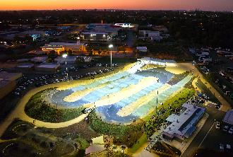 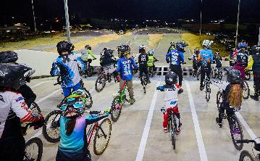
Images: Malabar Park BMX & Community Facility opening – June 2025.

Trading Undertakings
There is no information about trading undertakings to be included in the Annual Report in accordance with regulation 19BB of the Local Government (Administration) Regulations 1996.

Land Transactions
There is no information about land transactions to be included in the Annual Report in accordance with regulation 19BC of the Local Government (Administration) Regulations 1996.
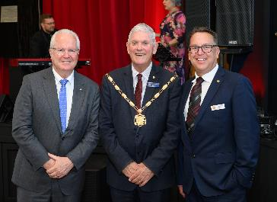 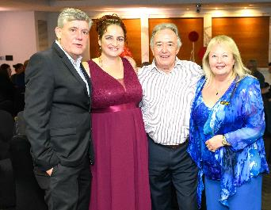
Image 1: Memorial Hall turns 100 event – March 2025. (Left to Right) Governor General Chris Dawson; Mayor Logan Howlett; and Daniel Simms, Chief Executive Officer. Image 2: Annual Civic Function – December 2024. (Left to Right) Gary Hitch, ARK (AUS) Pty Ltd; Deputy Mayor Chontelle Stone; Cr Kevin Allen; and Cr Carol Reeve-Fowkes.
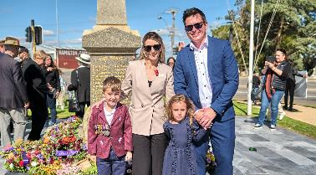 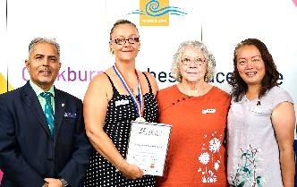
Image 1: ANZAC Memorial at Memorial Hall, Hamilton Hill – April 2025. Jessica Widenbar, Cr Tom Widenbar and their two children. Image 2: Citizen of the Year Awards – January 2025. (Left to Right) Cr Tarun Dewan; Lani Slaughter, Treeby Community Association; Helen Miskell, Treeby Community Association; and Cr Carol Zhang.

Our Assets
The City of Cockburn thrives on a strong foundation of infrastructure. From the roads we travel to the parks we enjoy, our assets are essential for maintaining a high quality of life for residents and businesses.
The City takes a proactive approach to asset management, ensuring these assets are well-maintained, function efficiently and deliver long-term value.
We’ve compiled key highlights about our City’s assets with a replacement value of over $2.5 billion. A pie chart accompanying this section provides a visual breakdown of asset value by class.
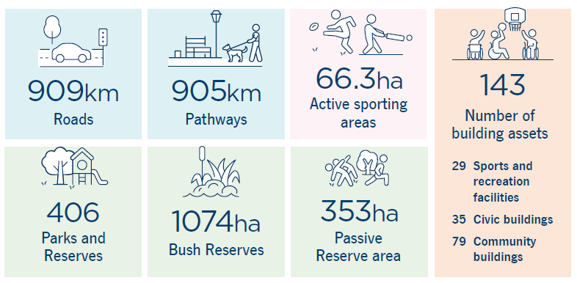
Transcriber’s Note: The infographic above highlights key statistics about the City of Cockburn’s assets:
- 909 kilometres – Roads
- 905 kilometres – Pathways
- 66.3 hectares – Active sporting areas
- 406 – Parks and reserves
- 1074 hectares – Bush reserves
- 353 hectares – Passive Reserve area
- 143 – Number of building assets
  - 29 Sports and recreation facilities
  - 35 Civic buildings
  - 79 Community buildings
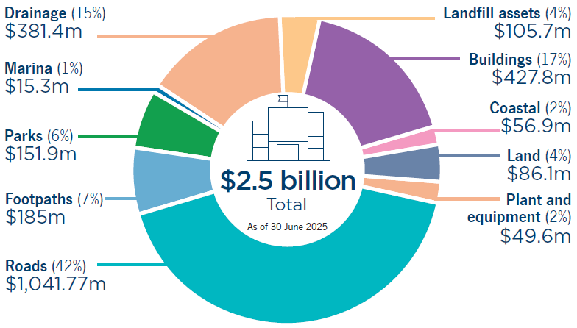
Transcriber’s Note: The pie chart above provides a breakdown of the value of City of Cockburn’s assets by class:
- Roads (42%): $1,041.77 million
- Buildings (17%): $427.8 million
- Drainage (15%): $381.4 million
- Footpaths (7%): $185 million
- Parks (6%): $151.9 million
- Landfill assets (4%): $105.7 million
- Land (4%): $86.1 million
- Coastal (2%): $56.9 million
- Plant and equipment (2%): $49.6 million
- Marina (1%): $15.3 million
- Total (As of 30 June 2025): $2.5 billion

Our Council and Elected Members

Mayor
Logan K. Howlett, JP, His Worship the Mayor
Logan has been the Mayor of Cockburn since 2009, serving five terms. He and his wife Pat, have been active community members for decades, deeply committed to Cockburn’s history, diversity and future.
Logan’s role involves extensive community engagement and a focus on achieving positive outcomes for the growing community. He prioritises trust, respect, honesty, integrity, inclusiveness, and personal engagement in his work.
Logan is passionate about Cockburn’s development and is committed to maintaining its strong reputation for service delivery and community wellbeing. He believes that strong community connections are essential for building resilience, sustainability and peace of mind.
Mayor since: September 2009 | Term ends: October 2025 | Phone: 0407 337 650 | Email: EMoffice@cockburn.wa.gov.au
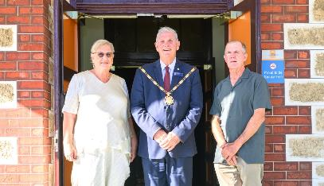
Image: Memorial Hall 100th anniversary – March 2025. (Left to Right) Maureen Fisher-Sim; Mayor Logan Howlett; and Mark Santich.

Cockburn Wards
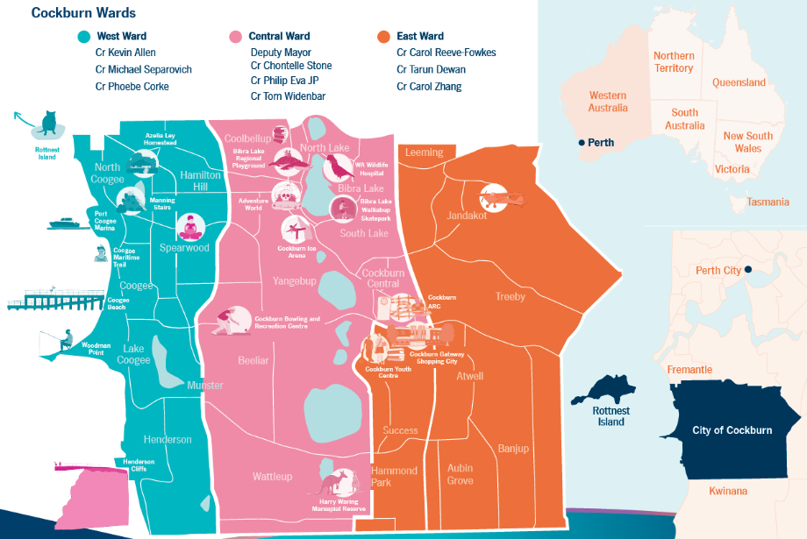
Transcriber’s Note: The map above is of the City of Cockburn, divided into three colour-coded wards. Please contact City of Cockburn for more information or clarification.
West Ward is highlighted in blue on the map. It includes the suburbs of North Coogee, Coogee, Lake Coogee, Henderson, Munster, Spearwood, and Hamilton Hill, as well as Rottnest Island off the coast of Western Australia. Landmarks in West Ward include Azelia Ley Homestead, Manning Stairs, Port Coogee Marina, Coogee Maritime Trail, Coogee Beach, Woodman Point, and Henderson Cliffs.
Elected members representing West Ward: Cr Kevin Allen; Cr Michael Separovich; and Cr Phoebe Corke.
Central Ward is highlighted in pink on the map. It includes the suburbs of Coolbellup, North Lake, Bibra Lake, South Lake, Yangebup, Hamilton Hill, Spearwood, Beeliar, Munster, Wattleup, and Cockburn Central. Landmarks in Central Ward include Bibra Lake Regional Playground, Adventure World, WA Wildlife Hospital, Bibra Lake Walliabup Skatepark, Cockburn Ice Arena, Cockburn Bowling and Recreation Centre, Cockburn ARC, Cockburn Youth Centre, Cockburn Gateway Shopping City, and Harry Waring Marsupial Reserve.
Elected members representing Central Ward: Deputy Mayor, Cr Chontelle Stone; Cr Philip Eva, JP; and Cr Tom Widenbar.
East Ward is highlighted in orange on the map. It includes the suburbs of Jandakot, Leeming, Treeby, Atwell, Success, Hammond Park, Aubin Grove, and Banjup. Landmarks in East Ward include Jandakot Airport.
Elected members representing East Ward: Cr Carol Reeve-Fowkes; Cr Tarun Dewan; and Cr Carol Zhang.
Inset maps are included beside the main map, to show the City’s location within a larger context. City of Cockburn is located in Perth, Western Australia, and is situated south of Perth City and the Swan River, in between Fremantle and Kwinana.

Central Ward
Chontelle Stone, Deputy Mayor and Councillor, Central Ward
Chontelle is a dedicated community leader with a background in business and a passion for environmental sustainability, social justice and equality. She has been serving on Cockburn City Council since 2017 and has a proven track record of improving services and infrastructure in her community.
As a councillor, Chontelle has been actively involved in various committees and reference groups, focusing on governance, organisational performance and expenditure review. She has also chaired the Cockburn Bushfire Advisory Reference Group and is involved in several other community organisations.
Chontelle’s commitment to her community is evident in her dedication to improving public safety, supporting local businesses, and advocating for equity and justice. With her experience, vision and passion, she is committed to continuing to make a positive impact in Cockburn.
Term ends: October 2025 | Phone: 0411 612 382 | Email: cstone@cockburn.wa.gov.au
Tom Widenbar, Councillor, Central Ward
Tom has a passion for environmental management and public service. He was first elected in 2019, and was Deputy Mayor in 2021 for a two-year period. Tom brings experience from his corporate role as an environmental professional along with his board experience as Deputy Chair of Perth in Natural Resource Management (NRM). Tom is deeply involved in a number of community initiatives aimed at improving the local environment while fostering a sense of place. He is committed to advocating for better infrastructure, promoting youth development programs, and supporting local businesses. Tom is a resident of Beeliar and is actively involved in various community groups and sporting activities. He is dedicated to making Cockburn the best place to be and is committed to serving the community with passion and dedication.
Term ends: October 2025 | Phone: 0437 002 021 | Email: twidenbar@cockburn.wa.gov.au
Philip Eva, JP, Councillor, Central Ward
Philip has been serving the City of Cockburn since 2014 and is an enthusiastic community leader. He has a strong background in public service and community involvement, having previously worked in the building industry and served as a senior advisor in the Department of the Premier and Cabinet.
As a Justice of the Peace, Philip has contributed significantly to the community by providing legal services and volunteering with the South Coogee Volunteer Bush Fire Brigade. He is also actively involved in various local organisations, including the Cockburn Wetlands Centre, Cockburn RSL, and Spearwood Dalmatinac Sport and Community Club.
Throughout his time on the Council, Philip has been dedicated to advocating for the residents of Cockburn. He has been actively involved in all Council committees and continues to serve the community through his committee work and community engagements.
Term ends: October 2027 | Phone: 0410 274 000 | Email: peva@cockburn.wa.gov.au

East Ward
Carol Reeve-Fowkes, Councillor, East Ward
Carol has been a committed Councillor for Cockburn since 2007 and served as Deputy Mayor for two terms. A Cockburn local for the last 32 years and educated in London, UK, she brings a grounded and balanced approach to Council meetings and decision-making.
Currently serving on the Governance Committee, Audit and Risk Committee, and Expenditure Review Committee, with particular interest in Local Emergency Management and Bush Fire Prevention, Carol brings tangible local knowledge to her position, based on experience including roles with WA Police and South Metropolitan Health Department.
Carol is a strong advocate for our community; this is evident in her involvement with multiple residents’ associations and environmental groups. Carol remains focused on ensuring a better, safer and more sustainable future for Cockburn families while maintaining a responsible budget.
Term ends: October 2027 | Phone: 0435 900 236 | Email: creevefowkes@cockburn.wa.gov.au
Tarun Dewan, Councillor, East Ward
Tarun is a dedicated full-time East Ward Councillor who works full-time to serve the needs of Cockburn residents and businesses. With his engineering background, he uses his analytical skills to help the Council make smart decisions and ensure the City provides the best policies and services for everyone.
He puts the interests of residents first, working closely with various community groups to listen to their concerns and find solutions. Tarun has been elected as a Presiding Member for several key committees, including the Joint Development Assessment Panel and the Expenditure Review Committee.
Known for his thorough preparation, Tarun actively shares his views and concerns during meetings to support better decision-making for the community.
Term ends: October 2025 | Phone: 0433 875 350 | Email: tdewan@cockburn.wa.gov.au
Carol Zhang, Councillor, East Ward
Carol has a strong background in nursing and healthcare and is devoted to supporting our community. She has been actively involved in various community initiatives, including volunteering and organising local events.
Her experience as a healthcare professional brings a unique perspective to her role as a councillor, allowing her to approach issues with analytical thinking and evidence-based decision-making.
Carol is committed to working collaboratively with the Mayor, fellow councillors, and community members to address local concerns such as traffic congestion, antisocial behaviour and improving community infrastructure.
Term ends: October 2027 | Phone: 0411 738 554 | Email: czhang@cockburn.wa.gov.au

West Ward
Kevin Allen, Councillor, West Ward
Kevin is a longstanding resident of Cockburn and has been actively involved in community issues for over 40 years. He has served as a West Ward Councillor since 2000 and was also employed in the private sector as a State Manager in the financial industry.
Prior to his election to Council, Kevin was actively involved in community initiatives, serving as President of the Coogee Beach Progress Association and representing the community on the State Government’s Coogee Master Plan committee. He is passionate about all things sports, especially encouraging and developing junior sports, and encouraging business and employment opportunities into Cockburn.
Term ends: October 2025 | Phone: 0419 901 735 | Email: kallen@cockburn.wa.gov.au
Michael Separovich, Councillor, West Ward
Michael is a lifelong resident of Cockburn and has been serving on Council since 2017. He has a strong connection to the West Ward community through his family’s involvement in local businesses and education.
As a councillor, Michael has been actively involved in various committees, including those focused on policies, audit, strategic finance, and CEO performance and is the presiding member of the Governance Committee. He also represents the City on external committees related to environmental issues and development.
Michael is committed to ensuring the City operates efficiently and effectively, with a focus on responsible use of ratepayer funds, high-quality services, and fair and reasonable policies and procedures.
Term ends: October 2025 | Phone: 0432 653 369 | Email: mseparovich@cockburn.wa.gov.au
Phoebe Corke, Councillor, West Ward
Phoebe has strong commitment to sustainability, cultural heritage, and community wellbeing. She has been serving on Council for several years and is actively involved in numerous community groups and committees.
As a councillor, Phoebe prioritises protecting the natural environment, preserving canopy and biodiversity, acknowledging and respecting culture and heritage, and looking after residents’ interests by improving safety, services and facilities while maintaining low rates. She is known for her responsiveness to community concerns, her strong work ethic and her commitment to ethical and transparent governance.
With a background in journalism, arts, and law, Phoebe – currently working as a tutor at Notre Dame University – brings a wealth of knowledge and experience to her role as a councillor.
Term ends: October 2027 | Phone: 0407 606 696 | Email: pcorke@cockburn.wa.gov.au

Elected Members’ demographics

Gender
4 Female 
6 Male 

Age
- 25-34 years: 1
- 35-44 years: 2
- 45-54 years: 1
- 55-64 years: 4
- Over 64 years: 2

Linguistic background
8 English 
1 Mandarin 
1 Hindi 
1 identifies as Aboriginal and Torres Strait Islander 

Country of birth
5 Australia 
1 China 
1 India 
3 England 
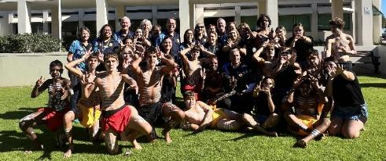
Image: National Reconciliation Week at City of Cockburn Admin Building – June 2025. (Featuring in no particular order) Cr Phoebe Corke; Amanda King, First Nations Support Officer; Mayor Logan Howlett; Barbara Freeman, Reconciliation Lead; Sonia Farr, Administration Officer; Daniel Simms, Chief Executive Officer; Hannah Coleman, Administrative Officer; Kerri Mulford, Youth Development Officer; Deb Rigby, Library Engagement Coordinator; Kathleen Turtur, First Nations Community Development Officer; Jennifer Crowther, Disability Access and Inclusion Officer; Evan Hillman, Service Manager Community Development; Kylie Johnson, Director Community and Place; Ella Hetherington, Creative Producer; Timmy Kelly, Nyungar Cultural Performer and Community member; Cr Tarun Dewan; and dancers from Fremantle College.

Council structure and purpose
The City of Cockburn Council has a popularly elected Mayor and nine Councillors, making ten council members in total. The city is divided into three wards for elections, with three Councillors from each ward.

Council elections
Local elections are held every two years on the third Saturday in October. About half of the Councillors are elected each time. The Mayor is elected every four years. Members serve four-year terms. Any eligible resident can nominate. Voting is by those on the State Electoral Roll who are eligible electors. Ownership or occupancy of property can qualify a person to be on the roll as an owner/occupier. Voting is not compulsory. The Deputy Mayor is chosen by the Council at the first meeting after elections and serves for two years.

Role of Elected Members
Elected Members work together with the community, the CEO and the Administration to set the city’s direction, create policies and monitor performance. Elected Members represent residents, provide leadership, help communication between the community and the Council, and take part in decision-making at meetings and committees.

Role of the Mayor and Deputy Mayor
Mayor: The Mayor leads meetings as required by the Local Government Act 1995, provides guidance to the community, performs ceremonial and civic duties on behalf of the local government, represents the local government in public, and liaises with the CEO on the performance of the functions of the administration.
Deputy Mayor: The Deputy Mayor takes over the Mayor’s duties when allowed by the Act (section 5.34).
Together, the Mayor and Deputy Mayor, with the Councillors and City staff, help shape Cockburn’s future by guiding decisions that affect daily life, services, and the community’s long-term wellbeing.
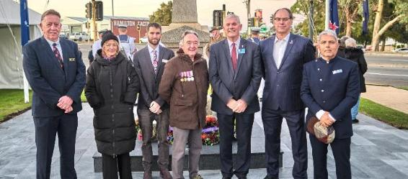
Image: ANZAC Memorial at Memorial Hall, Hamilton Hill – April 2025. (Left to Right) Cr Philip Eva JP; Cr Phoebe Corke; Cr Michael Separovich; Cr Kevin Allen; Mayor Logan Howlett; Daniel Arndt, Director Sustainable Development and Safety; and Cr Tarun Dewan.

Elected Member attendance
This section outlines the attendance rates of all Councillors at Council meetings and Committee meetings. This information is essential for ensuring our elected representatives are fulfilling their roles effectively and representing the interests of our community.

Council (total of 11 held)
Elected Members | Attended | Electronic attendance | Apology | Leave of absence
Mayor Logan Howlett | 8 | N/A | 3 | N/A
Deputy Mayor Chontelle Stone | 10 | 1 | N/A | N/A
Cr Kevin Allen | 7 | 2 | 1 | 1
Cr Michael Separovich | 11 | N/A | N/A | N/A
Cr Phoebe Corke | 10 | 1 | N/A | N/A
Cr Carol Reeve-Fowkes | 11 | N/A | N/A | N/A
Cr Carol Zhang | 10 | N/A | 1 | N/A
Cr Tarun Dewan | 11 | N/A | N/A | N/A
Cr Tom Widenbar | 11 | N/A | N/A | N/A
Cr Phil Eva | 9 | N/A | 1 | 1

Special Council Meetings (total of four held)
Elected Members | Attended | Electronic attendance | Apology | Leave of absence
Mayor Logan Howlett | 4 | N/A | N/A | N/A
Deputy Mayor Chontelle Stone | 4 | N/A | N/A | N/A
Cr Kevin Allen | 2 | N/A | 2 | N/A
Cr Michael Separovich | 4 | N/A | N/A | N/A
Cr Phoebe Corke | 2 | N/A | 2 | N/A
Cr Carol Reeve-Fowkes | 4 | N/A | N/A | N/A
Cr Carol Zhang | 3 | N/A | 1 | N/A
Cr Tarun Dewan | 4 | N/A | N/A | N/A
Cr Tom Widenbar | 4 | N/A | N/A | N/A
Cr Phil Eva | 4 | N/A | N/A | N/A

Committee meetings
There are four committees that meet five times a year.
- Audit Risk and Compliance Committee (ARC)
- Expenditure Review Committee (ERC)
- Governance Committee (GovCo)
- Organisational Performance Committee (OPCo)
The membership and attendance of committee meetings are as follows:

Mayor Logan Howlett
Committee | Member | Attended | Electronic attendance | Apology | Leave of absence
ARC | Yes | 3 | N/A | 2 | N/A
ERC | Yes | 2 | N/A | 3 | N/A
GovCo | Yes | 5 | N/A | N/A | 1
OPCo | Yes | 5 | N/A | N/A | N/A

Deputy Mayor Chontelle Stone
Committee | Member | Attended | Electronic attendance | Apology | Leave of absence
ARC | Yes | 3 | N/A | 2 | N/A
ERC | Yes | 4 | N/A | 1 | N/A
GovCo | Yes | 4 | N/A | 1 | 1
OPCo | Yes | 4 | N/A | 1 | N/A

Cr Kevin Allen
Committee | Member | Attended | Electronic attendance | Apology | Leave of absence
ARC | Yes | 4 | N/A | N/A | 1
ERC | Non-member | 2 | N/A | N/A | N/A
GovCo | Non-member | N/A | N/A | N/A | N/A
OPCo | Non-member | N/A | N/A | N/A | N/A

Cr Michael Separovich
Committee | Member | Attended | Electronic attendance | Apology | Leave of absence
ARC | Yes | 5 | N/A | N/A | N/A
ERC | Yes | 5 | N/A | N/A | N/A
GovCo | Yes | 4 | N/A | N/A | N/A
OPCo | Yes | 5 | N/A | N/A | N/A

Cr Phoebe Corke
Committee | Member | Attended | Electronic attendance | Apology | Leave of absence
ARC | Yes | 5 | N/A | N/A | N/A
ERC | Yes | 5 | N/A | N/A | N/A
GovCo | Yes | 4 | N/A | 1 | N/A
OPCo | Yes | 4 | N/A | 1 | N/A

Cr Carol Reeve-Fowkes
Committee | Member | Attended | Electronic attendance | Apology | Leave of absence
ARC | Yes | 4 | N/A | 1 | N/A
ERC | Yes | 4 | N/A | 1 | N/A
GovCo | Yes | 5 | N/A | N/A | N/A
OPCo | Yes | 5 | N/A | N/A | N/A

Cr Carol Zhang
Committee | Member | Attended | Electronic attendance | Apology | Leave of absence
ARC | Non-member | 3 | N/A | N/A | N/A
ERC | Non-member | 2 | N/A | N/A | N/A
GovCo | Yes | 4 | N/A | N/A | N/A
OPCo | Non-member | 2 | N/A | N/A | N/A

Cr Tarun Dewan
Committee | Member | Attended | Electronic attendance | Apology | Leave of absence
ARC | Yes | 5 | N/A | N/A | N/A
ERC | Yes | 5 | N/A | N/A | N/A
GovCo | Non-member | 2 | N/A | N/A | N/A
OPCo | Yes | 5 | N/A | N/A | N/A

Cr Tom Widenbar
Committee | Member | Attended | Electronic attendance | Apology | Leave of absence
ARC | Non-member | N/A | N/A | N/A | N/A
ERC | Non-member | 1 | N/A | N/A | N/A
GovCo | Yes | 5 | N/A | N/A | N/A
OPCo | Yes | 5 | N/A | N/A | N/A

Cr Phil Eva
Committee | Member | Attended | Electronic attendance | Apology | Leave of absence
ARC | Non-member | N/A | N/A | N/A | N/A
ERC | Non-member | N/A | N/A | N/A | N/A
GovCo | Non-member | N/A | N/A | N/A | N/A
OPCo | Non-member | N/A | N/A | N/A | N/A

Warwick Gately (Independent Member)
Committee | Member | Attended | Electronic attendance | Apology | Leave of absence
ARC | Yes | 3 | N/A | 2 | N/A

Andrew Kandie (Independent Member)
Committee | Member | Attended | Electronic attendance | Apology | Leave of absence
ARC | Yes | 4 | 1 | /A | N/A

Elected Members, fees, expenses and allowances
In accordance with r29C(2)(f) of the Local Government (Administration) Regulations 1996, the City is required to publish the fees, expenses and allowances paid to Elected Members during the financial year. Below is a list of fees, expenses and allowances that have been paid to the Mayor and Councillors for the 2024-25 financial year. Figure amounts in the table are in Australian dollars ($ AUD).
Elected Members | Mayoral / Deputy Mayoral allowance | Annual Meeting Attendance fee | Mileage expenses | Childcare expenses | Information and Communication Technology allowance | Other Approved expenses | Total
Mayor Logan Howlett | 97,115.04 | 51,411.96 | N/A | N/A | 3,500.00 | N/A | 152,027.00
Deputy Mayor Chontelle Stone | 24,278.76 | 34,278.00 | 307.32 | N/A | 3,500.00 | N/A | 62,364.08
Cr Kevin Allen | N/A | 34,278.00 | 138.32 | N/A | 3,500.00 | 790.34 | 38,706.66
Cr Michael Separovich | N/A | 34,278.00 | 89.38 | N/A | 3,500.00 | N/A | 37,867.38
Cr Phoebe Corke | N/A | 34,278.00 | 1,109.92 | N/A | 3,500.00 | N/A | 38,720.21
Cr Carol Reeve-Fowkes | N/A | 34,278.00 | 534.84 | N/A | 3,500.00 | 345.39 | 38,658.23
Cr Carol Zhang | N/A | 34,278.00 | 694.66 | N/A | 3,500.00 | N/A | 38,472.66
Cr Tarun Dewan | N/A | 34,278.00 | 633.86 | N/A | 3,500.00 | N/A | 38,848.10
Cr Tom Widenbar | N/A | 38,411.86 | 1,212.94 | 3,988.50 | 3,500.00 | N/A | 42,309.07
Cr Phil Eva | N/A | 34,278.00 | 140.97 | N/A | 3,500.00 | 98.00 | 38,016.97

Governance Report

Compliance
The Compliance Audit Return (CAR), mandatory for all local governments in Western Australia since 2000, was submitted to the Department of Local Government, Sport and Cultural Industries on 28 March 2025. The CAR 2024 indicated a conformity rating by the City of 93 per cent for the year. The CAR sets out each area of non-conformance that has been identified and provides officer comment in relation to that item.
The City intends to conduct an Integrity Maturity Self-Assessment as part of the WA Government’s Integrity Strategy for Public Agencies.
Completion of the Self-Assessment will result in development of an Integrity Strategy for the City of Cockburn as recommended by the Public Sector Commission.
The outcome of the Integrity Maturity Self-Assessment and the draft Integrity Strategy will be reported to the Audit Committee and will assist the City to improve its approach to compliance management.
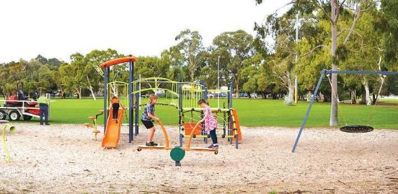
Image: Anning Park, South Lake.

Freedom of information
The Freedom of Information Act 1992 (FOI) gives members of the public the right to access documents held by local governments, subject to limitations. The City prepared, as required by section 96 of the FOI Act, an up-to-date information statement and made it available to the public. The City received 24 FOI requests during the 2024-25 financial year.

Elected Member breaches/complaints
During FY2025 there were no minor breach complaints and no complaints to be reported.

Our Organisation
The City of Cockburn’s organisational structure is designed to deliver on our vision of creating a vibrant, sustainable, and inclusive city – the best place to live, work, and play.
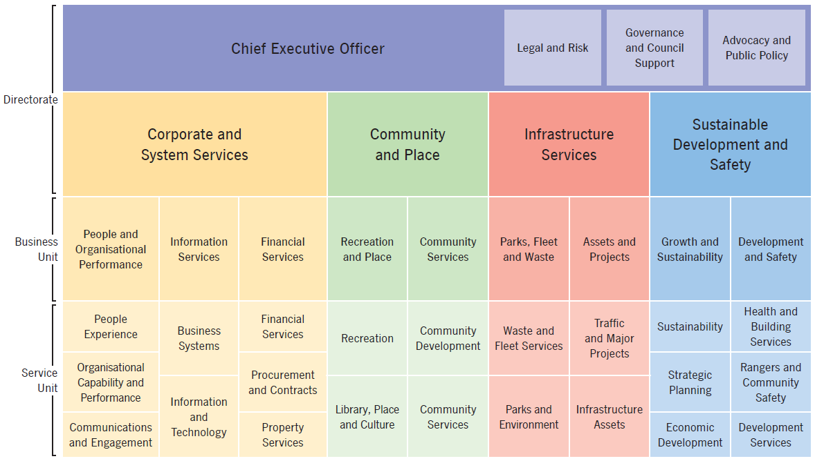
Transcriber’s Note: The diagram above is a chart showing the organisational structure of the City of Cockburn. There are three levels, from top to bottom: Chief Executive Office and Directorates, Business Units, and Service Units. The chart is presented below as a series of nested lists. Please contact City of Cockburn for more information.
- Chief Executive Officer
  - Legal and Risk
  - Governance and Council Support
  - Advocacy and Public Policy
- Corporate and System Services (Directorate)
  - People and Organisational Performance (Business Unit)
    - People Experience (Service Unit)
    - Organisational Capability and Performance (Service Unit)
    - Communications and Engagement (Service Unit)
  - Information Services (Business Unit)
    - Business Systems (Service Unit)
    - Information and Technology (Service Unit)
  - Financial Services (Business Unit)
    - Financial Services (Service Unit)
    - Procurement and Contracts (Service Unit)
    - Property Services (Service Unit)
- Community and Place (Directorate)
  - Recreation and Place (Business Unit)
    - Recreation (Service Unit)
    - Library, Place and Culture (Service Unit)
  - Community Services (Business Unit)
    - Community Development (Service Unit)
    - Community Services (Service Unit)
- Infrastructure Services (Directorate)
  - Parks, Fleet and Waste (Business Unit)
    - Waste and Fleet Services (Service Unit)
    - Parks and Environment (Service Unit)
  - Assets and Projects (Business Unit)
    - Traffic and Major Projects (Service Unit)
    - Infrastructure Assets (Service Unit)
- Sustainable Development and Safety (Directorate)
  - Growth and Sustainability (Business Unit)
    - Sustainability (Service Unit)
    - Strategic Planning (Service Unit)
    - Economic Development (Service Unit)
  - Development and Safety (Business Unit)
    - Health and Building Services (Service Unit)
    - Rangers and Community Safety (Service Unit)
    - Development Services (Service Unit)

Directorates and Office of the CEO

Chief Executive Officer
Daniel Simms, Chief Executive Officer

Directorate purpose
To provide strategic leadership and support to the City of Cockburn, ensuring effective governance, a positive workplace culture, and the delivery of high-quality services to the community.

Director Summary
Daniel is a proud Western Australian born and bred in Perth. He is passionate about working in local government and believes that partnerships with community, stakeholders and other levels of government are what achieves results.
He has vast experience in local government, having worked in both rural and regional Western Australia, and was CEO at the City of Wanneroo for over a decade before taking up the position of CEO at the City of Cockburn. Daniel enjoys the challenges of working to enable growth council areas to reach their potential and has a keen interest in planning. He is Chairman of the Growth Areas Perth and Peel and is an executive member of the National Growth Areas Alliance.
Local government is the closest level of government to the community and Daniel is a strong advocate for the role local government plays to support the community and local businesses to thrive.
Daniel has strong experience and a keen interest in business investment and the local economy, which he says makes this a very exciting time to be in Cockburn. Cockburn provides around 30 per cent of the employment for the south-west area of Perth and is poised to become a major national and global centre, especially for the shipbuilding and maritime defence industries. Cockburn has a long history and an exciting future.

Chief Executive Officer
- Legal and Risk
- Governance and Council Support
- Advocacy and Public Policy
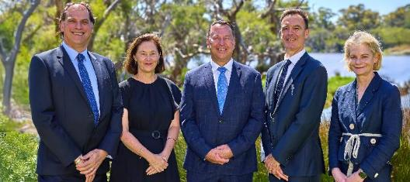
Image: (Left to Right) Dan Arndt, Director Sustainable Development and Safety; Kylie Johnson, Director Community and Place; Daniel Simms, Chief Executive Officer; Anton Lees, Director Infrastructure Services; and Carissa Bywater, Director Corporate and System Services.

Team overview

General Counsel, Governance and Legal Services
This business unit provides expert legal advice and governance support to ensure the City operates with integrity, transparency and compliance. It oversees statutory obligations, risk management and corporate governance frameworks, safeguarding the organisation’s reputation and enabling sound decision-making.

Advocacy and Public Policy
This team leads strategic advocacy and policy development to represent the City’s interests at regional, state, and national levels. By building strong partnerships and influencing public policy, the unit ensures that community priorities are recognised and supported, driving outcomes that benefit residents and the broader region.

Directorate year in review
The Office of the CEO strengthened governance through successful audits and proactive policy reviews, navigated challenges such as legislative reforms and system changes, and advanced integrity and innovation with new strategies and technology solutions, positioning the City for continued success in the year ahead. For a comprehensive overview of the City’s accomplishments and progress, please refer to the “Delivering Our Outcomes” section.
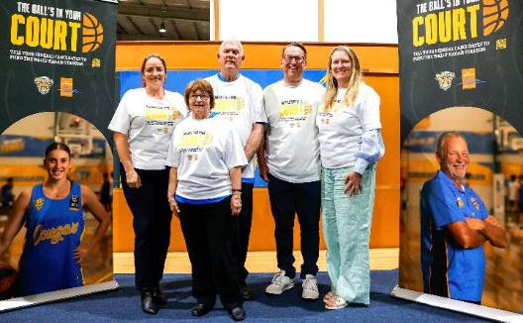
Image: Wally Hagan Stadium, Hamilton Hill – April 2025. (Left to Right) Deputy Mayor Chontelle Stone; Mayor Logan Howlett and his wife, Pat; Daniel Simms, Chief Executive Officer, and his wife, Debbie.

Infrastructure Services
Anton Lees, Director Infrastructure Services

Directorate Purpose
To deliver essential infrastructure services that contribute to a thriving community by effectively managing our assets, delivering necessary projects, and ensuring the sustainability of our infrastructure.

Director Summary
Anton Lees brings over 25 years of local government experience to his role as Director of Infrastructure Services. Anton joined the City of Cockburn in 2010 and has since been instrumental in driving high-quality service delivery models along with new infrastructure to meet community needs.
Anton has a diverse background, with qualifications in business administration, management, accounting and horticulture. His experience in the private sector has also provided him with valuable insights into management and service delivery. As Director Infrastructure, Anton is responsible for overseeing the City of Cockburn’s waste, parks, roads, facilities, project design and delivery along with other infrastructure assets. He is committed to providing high-quality infrastructures service and assets to the community.

Infrastructure Services
Parks, Fleet and Waste
- Waste and Fleet Services
- Parks and Environment
Assets and Projects
- Traffic and Major Projects
- Infrastructure Assets
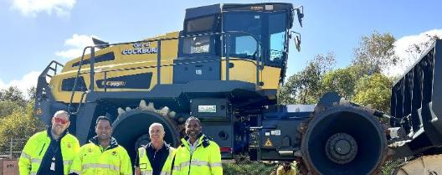
Image: Bomag BC773RB Landfill Compactor at Henderson Waste Recovery Park (HWRP) – September 2024. (Left to Right) Craig Marshall, Fleet Manager; John Mahauariki, HWRP Supervisor; Lou Vieira, Head of Operations and Maintenance; and Roger Haripersad, HWRP Manager.

Team overview

Parks, Fleet and Waste
The Parks, Fleet and Waste Business Unit delivers essential services that maintain and enhance the City’s public spaces and operational capacity. This includes managing parks, environmental areas and streetscapes to create vibrant, sustainable community spaces. The unit oversees waste services and the Henderson Waste Recovery Park, ensuring efficient waste disposal and recycling practices that support environmental sustainability. Additionally, fleet services provide reliable transport and equipment for City operations, enabling timely service delivery and supporting the maintenance of critical infrastructure.

Assets and Projects
The Assets and Projects Business Unit plays a pivotal role in managing and developing the City’s physical assets and infrastructure. It encompasses asset management and facility management, ensuring that buildings and resources are maintained to high standards and remain fit for purpose. The unit also oversees civil infrastructure and traffic and transport, driving improvements that enhance connectivity and community safety. Major Projects is responsible for delivering significant pieces of key City infrastructure, ensuring large-scale developments are completed efficiently and to a high standard. These efforts collectively support long-term growth, sustainability and the City’s strategic objectives.
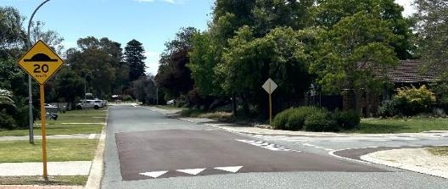
Image: Raised safety platform at the intersection of Colonial Drive and Needwell Road – April 2025.

Directorate year in review
Infrastructure Services delivered a wide range of capital works and renewal projects, including road upgrades, drainage improvements, playground renewals and enhanced waste management initiatives, all aimed at improving community amenity and sustainability. The directorate responded to increased service demands and weather-related challenges, such as higher-than-average rainfall and staffing shortages, by trialling new technologies, refining project management and strengthening collaboration with contractors and stakeholders. Looking ahead, Infrastructure Services is exploring AI-driven asset management, expanding planned maintenance and investing in innovative solutions to further enhance service delivery and resilience across the City. For a comprehensive overview of the City’s accomplishments and progress, please refer to the “Delivering Our Outcomes” section.

Corporate and System Services
Carissa Bywater, Director Corporate and System Services

Directorate purpose
To drive operational excellence and support community-facing services by providing effective financial management, technology, corporate strategic planning, communication, and added value to the customer experience.

Director Summary
Carissa Bywater brings over 25 years of experience in local government, having worked across Western Australia and New South Wales in a range of leadership roles. She joined the City of Cockburn in 2024 as Director of Corporate and System Services, where she leads a passionate team delivering the City’s core business functions – from finance and technology to communications, procurement and customer experience.
Carissa is a qualified accountant and holds a Bachelor of Business, a Master of Business Administration, and a Master of Leadership. She’s also a CPA and a graduate of the Australian Institute of Company Directors. Known for her collaborative and values-led approach, Carissa is deeply committed to supporting people to do their best work and helping the City deliver services that genuinely make a difference. For her, it’s a privilege to serve the Cockburn community and contribute to a future-focused, inclusive organisation.

Corporate and System Services
People and Organisational Performance
- People Experience
- Organisational Capability and Performance
- Communications and Engagement
Information and Technology
- Business Systems
- Information Services
Financial Services
- Financial Services
- Procurement and Contracts
- Property Services
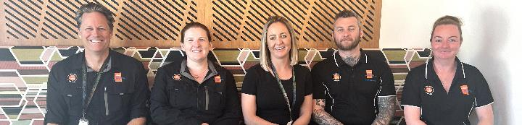
Image: Work Health and Safety – October 2024. (Left to Right) John Thornton, Megan Mason, Tanya Battye, Scott Hunt and Marion Heraty.

Team overview

People and Organisational Performance
The People and Organisational Performance Business Unit is dedicated to fostering a safe, inclusive, and high-performing workplace. It encompasses critical functions such as Human Resources, Work Health and Safety, and Organisational Development, ensuring that the City attracts, develops, and retains skilled employees. Through initiatives in Culture and Engagement, Integrated Planning and Reporting, and Community Engagement and Stakeholder Management, the unit promotes collaboration and transparency. Additionally, the Communications and Marketing team provides strategic oversight and clear communication, supporting organisational goals and enhancing community trust.

Information Services
The Information Services Business Unit underpins the City’s digital transformation and operational efficiency. It manages Information Technology infrastructure, Information Management, and Business Systems, ensuring secure and reliable services. The unit also drives innovation through GIS (Geographic Information Systems) and Customer Experience initiatives, enabling data-driven decision-making and improved service delivery. These efforts collectively enhance accessibility, streamline processes, and support the City’s strategic objectives.

Financial Services
The Financial Services Business Unit safeguards the City’s financial sustainability and accountability. It oversees Budgeting and Costing, Accounting and Reporting, and Rates and Revenue, ensuring compliance and transparency in financial operations. The unit also manages Property and Leasing and Procurement and Contracts, optimising resources and delivering value for money. Through robust financial planning and governance, this team supports long-term community development and ensures public funds are managed responsibly to meet the City’s priorities.
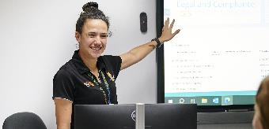 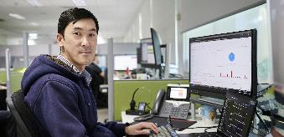
Image 1: Amy Hacking, Senior Management Accountant. Image 2: Michael Lee, Systems Support Officer.

Directorate year in review
Corporate and System Services delivered major improvements in organisational capability, digital transformation and community engagement. Key achievements included the successful migration to cloud-based enterprise systems, enhanced cybersecurity training, and the rollout of new devices and business process automation, all supporting greater efficiency and resilience. The directorate strengthened workplace culture through leadership development, diversity and inclusion initiatives, and a revised code of conduct, while navigating challenges such as organisational restructure and evolving communication needs. Looking ahead, Corporate and System Services is exploring AI-driven solutions and new partnerships to further improve service delivery and support the City’s strategic goals. For a comprehensive overview of the City’s accomplishments and progress, please refer to the “Delivering Our Outcomes” section.

Community and Place
Kylie Johnson, Director Community and Place

Directorate purpose
To foster a vibrant, inclusive, and resilient community by providing exceptional services, fostering cultural enrichment, and promoting active lifestyles and community wellbeing.

Director Summary
Kylie Johnson brings over 20 years’ experience in local government executive leadership to her role as Director of Community and Place. She joined the City of Cockburn in October 2024 and has continued the excellence and innovation for which our range of community programs and services have become recognised.
Kylie has diverse experience in leadership roles across all aspects of local government, with qualifications in economics, accounting and human resource management.
As Director, Kylie is responsible for overseeing a wide range of community initiatives, including recreation, arts, culture, and social services. She is committed to creating a vibrant and inclusive community for all residents.

Community and Place
Recreation and Place
- Recreation
- Library, Place and Culture
Community Services
- Community Development
- Community Services
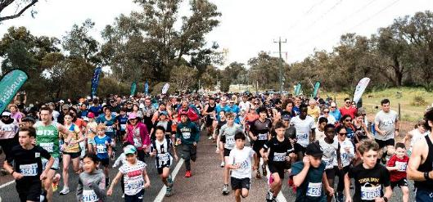
Image: Bibra Lake Fun Run, Bibra Lake – September 2024.

Team overview

Recreation and Place
The Recreation and Place Business Unit collectively enrich the Cockburn community by fostering wellbeing, identity and engagement. Library Services promote learning and creativity through access to information, digital resources and inclusive programs, while Events and Cultural Services preserve local history and celebrate events through arts and cultural initiatives. Civic Services recognise community milestones and ensure the amenity and security of the City’s Administration Building. Recreation Services support active lifestyles by providing facilities and events, backing local sporting clubs and planning community infrastructure. Key assets such as Cockburn ARC and Port Coogee Marina offer aquatic, fitness, and leisure opportunities, contributing to a healthy, connected and vibrant community. Together, these services strengthen Cockburn’s cultural and recreational landscape and enhance its sense of place.

Community Services
The Community Services business unit plays a vital role in supporting the wellbeing, development and resilience of the Cockburn community. Seniors Services and Cockburn Care provide recreational, educational and in-home support programs that promote independence and social connection for older adults. Childcare Services ensure quality early childhood education and care for local families, while Family and Community Services offer a range of support programs tailored to diverse community needs. Community Development fosters engagement and inclusion through youth programs, reconciliation initiatives and support for Aboriginal and Torres Strait Islander peoples. Additionally, Community Grants empower individuals and organisations to lead local projects and events that strengthen community bonds. These services form the heart of Cockburn’s commitment to building a connected, compassionate and forward-looking community.
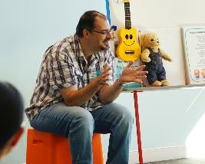 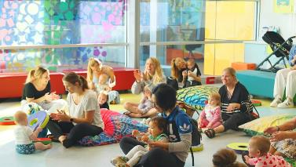
Images: David’s weekly Pram Jam (often called Rhyme Time at other libraries), Success Library – July 2024.

Directorate year in review
The Community and Place Directorate achieved significant milestones, including launching new initiatives and supporting community programs and services. Key achievements include the introduction of the inaugural Arts Hall of Fame, adoption of the Community Infrastructure Plan, Malabar Park BMX & Community Facility redevelopment, establishment of new programs, continued increased library usage, successful community events, the 100 year celebration of Hamilton Hill Memorial Hall, and expansion of Cockburn ARC. For a comprehensive overview of the City’s accomplishments and progress, please refer to the “Delivering Our Outcomes” section.

Sustainable Development and Safety
Dan Arndt, Director Planning and Sustainability

Directorate purpose
To shape a sustainable, resilient, safe and thriving Cockburn by encouraging responsible development, protecting the environment, and promoting economic prosperity, ensuring that our city remains a desirable place to live, work and play.

Director Summary
Dan Arndt has been a driving force in Cockburn’s planning and development for over 15 years. As the Director of Sustainable Development and Safety, he plays a key role in shaping the City’s future. With a career in local government spanning over three decades, Dan has a wealth of experience in managing urban growth and development.
He has worked in several metropolitan councils, including Swan, Armadale, Mandurah, Fremantle and Nedlands, gaining valuable insights into the challenges and opportunities facing our region. Dan is passionate about creating sustainable communities and has been instrumental in developing Cockburn’s long-term plans. As the Director of Sustainable Development and Safety, Dan oversees the City’s ongoing development, health, building, community safety, coastal and environmental initiatives, and its economic growth. He is committed to ensuring the City is the best place to live, work and invest.

Sustainable Development and Safety
Growth and Sustainability
- Sustainability
- Strategic Planning
- Economic Development
Development and Safety
- Health and Building Services
- Rangers and Community Safety
- Development Services
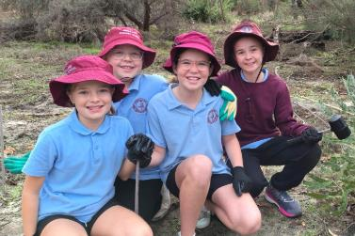 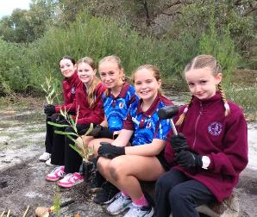
Images: Tree planting, Bibra Lake – July 2024. Bibra Lake Primary School students.

Team overview

Growth and Sustainability
The Growth and Sustainability Business Unit focuses on shaping the City’s future through strategic planning and sustainable practices. It manages strategic land use planning, ensuring that development aligns with long-term community needs and environmental considerations. The unit also leads sustainability initiatives and drives economic and business development, fostering a resilient economy and promoting responsible growth. These efforts support the creation of vibrant, liveable neighbourhoods and contribute to the City’s vision for sustainable development.

Development and Safety
The Development and Safety Business Unit ensures that growth occurs in a safe, compliant and well-structured way. It oversees statutory planning and building services, guiding development approvals and construction standards. The unit also manages environmental health and development compliance, safeguarding public health and ensuring adherence to regulations. Through ranger services, emergency management, CoSafe operations and parking services, the team provides proactive safety measures, rapid response capabilities and effective management of public spaces. These combined efforts create a secure, accessible, and welcoming environment for residents and visitors.
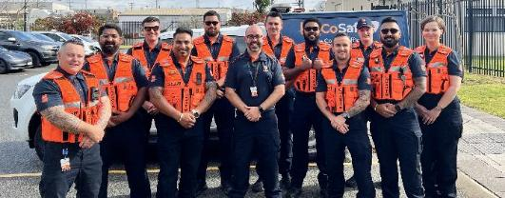
Image: CoSafe team – October 2024. (Left to Right) Daniel, Shakeb, Robert, Deep, Jason, Luke, Tolga, Chayce, Aaron, Owen, Gagan and Sylvia.

Directorate year in review
Sustainable Development and Safety delivered major planning milestones, including the endorsement of the Coogee Beach Land Use Master Plan and finalisation of the Local Planning Strategy, while advancing environmental initiatives such as the Coogee Community Battery launch, Gold Waterwise Council status, and significant conservation and education programs. The directorate responded to complex challenges in urban growth, climate change and regulatory reform and strengthened community safety through proactive patrols, bushfire management and health promotion. For a comprehensive overview of the City’s accomplishments and progress, please refer to the “Delivering Our Outcomes” section.

Our People

Staff overview
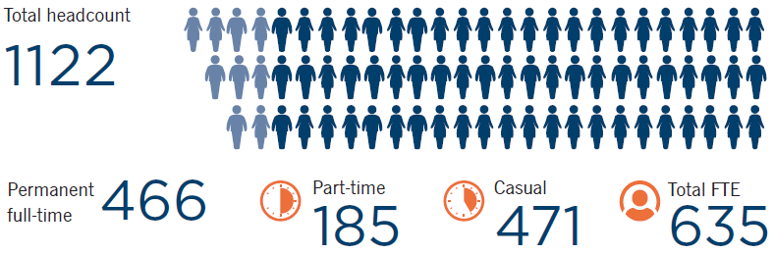
- Total headcount: 1122
- Permanent full-time: 466
- Part-time: 185
- Casual: 471
- Total FTE: 635

Staff age groups
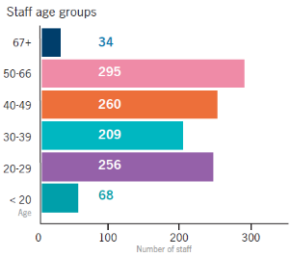
Transcriber’s Note: The bar graph above shows the number of City of Cockburn staff in each age group. This data is presented in the following table.
Staff age groups | Number of staff
Under 20 years | 68
20-29 years | 256
30-39 years | 209
40-49 years | 260
50-66 years | 295
67 years and above | 34

Employee’s gender
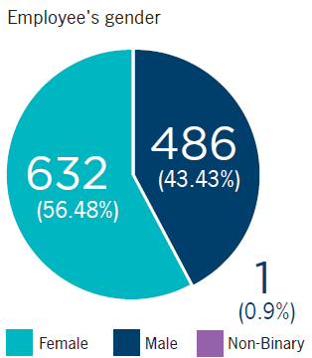
Transcriber’s Note: The pie graph above shows the number and proportion of City of Cockburn staff of each gender. This data is presented in the following table.
Employee’s gender | Number of staff
Female | 632 (56.48%)
Male | 482 (43.43%)
Non-Binary | 1 (0.9%)

Length of service (including casuals)
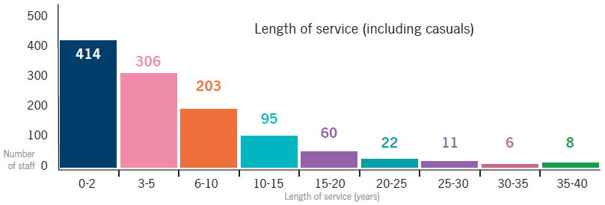
Transcriber’s Note: The bar graph above shows the length of service of City of Cockburn staff, including casual employees. This data is presented in the following table.
Length of service | Number of staff
0-2 years | 414
3-5 years | 306
6-10 years | 203
10-15 years | 95
15-20 years | 60
20-25 years | 22
25-30 years | 11
30-35 years | 6
35-40 years | 8

Remuneration of Employees
Number of employees of the City entitled to an annual salary of $130,000 or more.
Annual Salary Range ($) | Number of Employees
130,000 – 139,999 | 21
140,000 – 149,999 | 3
150,000 – 159,999 | 9
160,000 – 169,999 | 3
170,000 – 179,999 | 8
180,000 – 189,999 | 3
190,000 – 199,999 | 7
200,000 – 209,999 | 4
210,000 – 219,999 | 0
220,000 – 229,999 | 0
230,000 – 239,999 | 0
240,000 – 249,999 | 0
250,000 – 259,999 | 4
260,000 – 269,999 | 0
270,000 – 279,999 | 0
280,000 – 289,999 | 0
290,000 – 299,999 | 0
300,000 – 309,999 | 0
310,000 – 319,999 | 0
320,000 – 329,999 | 0
330,000 – 339,999 | 0
340,000 – 349,999 | 0
350,000 – 359,999 | 0
360,000 – 369,000 | 1
370,000 – 379,999 | 0
Total | 63
The total remuneration paid to the CEO during 2024-25 was $421,268.64 including superannuation. The Chief Executive Officer, Daniel Simms, began at the City on 2 October 2023.

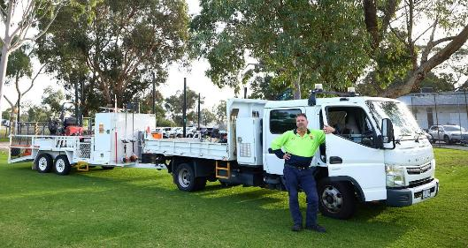
Image: Anning Park, South Lake. Joel Danby, Parks Supervisor.

Our People Approach

Organisational Transformation
In February 2024, the City initiated a comprehensive Organisational Review to evaluate current work practices and processes against the Australian Business Excellence Framework (ABEF). This review involved extensive consultation across the organisation, including focus groups with the Executive Committee, Senior Leadership Team and team members.
Following the review, a three-year implementation plan was developed to address identified opportunities for improvement. Key outcomes of this plan include:
- Establishing a leadership structure that is fit for purpose now and into the future
- Promoting cross-functional collaboration through the development and deployment of key deliverables
- Realigning services and functions to reconnect workflows
- Fostering a shared sense of purpose and accountability for organisational outcomes
- Reviewing end-to-end processes to ensure alignment, system integration and effective management
- Building capability and accountability within Leadership Teams.
As part of this transformation, the City successfully delivered:
- A revised Executive and functional structure, effective from 15 April 2024.
- A revised Senior Leadership and functional structure, with most changes effective from 4 March 2025.
- The final phase of leadership and functional structure changes, effective from 30 June 2025.
- Corporate Accountabilities across all leadership layers, clearly defining roles, responsibilities and accountabilities.
Throughout this transformation, the wellbeing of our people remained a priority. The program was delivered with organisation-wide engagement and significant consultation, ensuring optimal outcomes in both performance and morale.
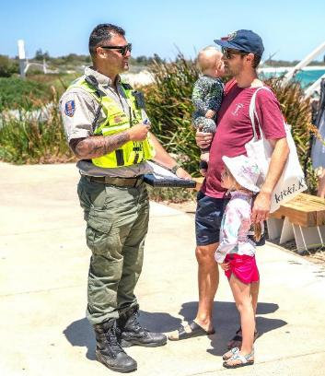
Image: Coogee Maritime Trail stairs – Coogee. Rick Wheeler, Ranger Team Leader, with members of the public.

Diversity and Inclusion
In 2024, the City launched its first Diversity and Inclusion Plan to strengthen our commitment to creating a workplace that is inclusive, equitable and reflective of the community we serve. The Plan is guided by six core objectives, and each objective has a series of specific activities listed to help us achieve our goals.

Our Progress
In the first year, we made strong progress across all objectives. Key achievements included:
- More inclusive recruitment practices, with unconscious bias training being introduced
- Education and awareness, with more than 130 employees completing Respect in the Workplace, LGBTQIA+ Allyship and Inclusive Practices (unconscious bias in hiring) training
- Recognition of community celebrations, including Reconciliation Week, NAIDOC Week, Harmony Week, International Women’s Day, Pride Month and the International Day of Persons with Disabilities
- Leadership commitment, with staff’s perception of diversity and inclusion being important to the Executives increasing by over 16 per cent, with over 52 per cent of those surveyed citing it as very or extremely important to the Executives
- Ongoing monitoring, with the annual report and recommendations being endorsed by the Executives and shared with all employees.

Positive Change
Our first review of the Plan showed a significant uplift in employee sentiment, with staff reporting notable improvements in workplace culture, including:
- 10% increase in staff feeling that colleagues treat each other with respect
- 11% increase in staff believing people of all ages are valued equally
- 11% increase in staff agreeing people of diverse sexualities are readily accepted.

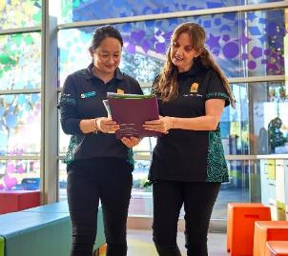
Image: Xuelin LI, Library Officer, and Michaela Shepherdson, Librarian, at Success Library, Success.

Next Steps
In year two, we will continue to strengthen leadership development in marginalised cohorts through targeting our development approach. We will pilot a Women with Disability leadership mentoring program and we are investigating the feasibility of a First Nations reference group and leadership stream.
The City is committed to creating a workplace that is inclusive, equitable, and reflective of our diverse community.

Employee Value Proposition
The City strives to be an employer of choice within the Local Government sector in Western Australia and launched a revised Employee Value Proposition (EVP), ‘make an impact’. The EVP aims to target all audiences as motivators for making an impact vary from candidate to candidate and the diversity of the roles within the City of Cockburn affords opportunity for everyone to come and make an impact. In addition, as individuals and the collective workforce, all of our people make an impact, fostering sense of belonging and shared purpose.
The EVP has been launched across all recruitment and section collateral, including job advertisements and position descriptions.
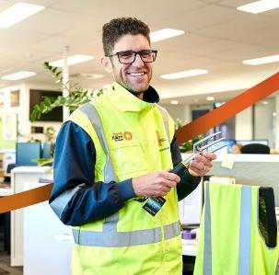
Image: Neil Dumais, Service Lead Parks at Cockburn Operations Centre, Bibra Lake.

Promoting a Safe and Respectful Workplace
During the reporting period, Cockburn continued its commitment to fostering a safe, respectful and inclusive workplace through the implementation of the Respect in the Workplace Program, delivered by Curtin University.
The workshop style session equips staff with the skills and confidence to recognise and safely intervene in situations of sexual harassment, bullying and other inappropriate workplace behaviours. By empowering individuals to act as proactive bystanders, the initiative directly supports the City’s obligations under anti-discrimination and workplace safety legislation, including the positive duties outlined in the Sex Discrimination Act 1984 and guidance from the Respect@Work Review. Research cited by the Australian Human Rights Commission suggests workplace interventions can serve as a primary prevention measure against sexual harassment and violence. These interventions not only reduce risks within the workplace but can also have broader community impacts by interrupting escalation pathways and improving outcomes socially within our communities.
Key outcomes from the program during this period include:
- Fifty-one leaders trained in active bystander strategies to intervene early on bullying or sexual harassment behaviours.
- Increased staff awareness of respectful workplace behaviours and intervention techniques, with a 10 per cent increase in employees agreeing that ‘Staff treat each other with respect’ in the Annual Employee Engagement Survey.
- Enhanced organisational culture and alignment with the corporate values of empowering team members to be their whole selves, caring deeply for our people, and being informed and collaborative.
- Recognition of the program’s contribution to creating a safer workplace environment, with an 8% increase in staff surveyed feeling comfortable to speak with their supervisors about harassment or discrimination.
The Respect in the Workplace Program forms part of a broader suite of initiatives designed to uphold human rights, workplace safety and inclusive practices under our Diversity and Inclusion Plan, demonstrating Cockburn’s commitment to embedding respectful behaviour across all levels of the organisation.

Reward and Recognition
During the year, we advanced several initiatives to strengthen how we value and support our people. A revised Employee Awards Eco System was developed and implemented at both organisational and directorate levels, ensuring recognition practices are authentic and embedded across the City. Looking ahead, a key milestone for year four of this plan is to cascade the Awards Eco System to the team level, fostering recognition at every layer of the organisation.
We also began bargaining for a new Industrial Agreement, with a strong focus on maintaining our position as an industry leader. The agreement aims to deliver highly competitive salaries within the local government sector and provide exceptional entitlements that reinforce the value we place on our people.
To support career growth, we introduced Career Development User Guides for employees and leaders. These resources enable meaningful conversations about career aspirations and provide actionable planning tools to recognise and reward exceptional talent.
To create a sense of belonging, we also delivered the Hearts and Minds program, designed to strengthen cross-functional connections and prioritise team-building initiatives. This program plays a vital role in fostering collaboration and creating a positive, inclusive workplace culture.
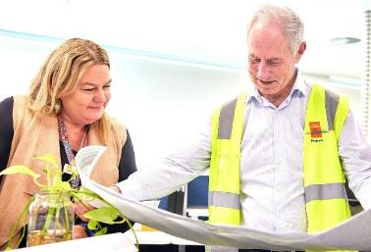
Image: Kathleen Koelen, Project and Business Analyst, and Peter McCullagh, Senior Project Manager.

Organisational Development
In response to feedback received through engagement platforms, the City has invested in organisational development and culture programs aimed at improving efficiency, enhancing employee engagement and fostering a values-driven, innovative and adaptive culture.
Key initiatives delivered include:
- A review of ‘The Cockburn Way’ (Code of Conduct), which outlines minimum behavioural expectations.
- Deployment of revised Corporate Accountabilities for each leadership layer.
- Continuation of the monthly pulse survey to provide regular engagement insights to the Senior Leadership Team.
- Development of Career Development User Guides for employees and leaders to support meaningful career conversations and planning.
- Introduction of a Leadership Capability Framework, setting behavioural and competency expectations for City leaders.
- Launch of the City’s first Change Management Framework, deployed across three key projects to assess organisational maturity.
- Ongoing enhancement of the compliance-based People Experience Management Framework, supporting effective management of workplace behaviours.
- Implementation of a quarterly insights program, enabling deep-dive analysis and action planning with the Executive based on monthly pulse survey outcomes.
- Revitalisation of Senior Leadership Forums to focus on professional development, collaboration and knowledge sharing.
- Creation of a three-year implementation plan aligned with ABEF findings to improve organisational processes and structure.
- Establishment of a City-wide Training Needs Analysis (TNA) process to identify development opportunities.
- Centralisation of all training and development budgets under Organisational Development to ensure a structured and consistent approach to professional growth.

Health and Safety
 The City continued its focus on Work Health and Safety with an emphasis on setting expectations to foster a positive and empowering safety-first culture where continuous improvement is not only valued, but also expected. The key areas of opportunity have been on improving awareness and capability of the leadership group and wider workforce regarding work health and safety, with our programs aiming to strengthen training, compliance, induction and overall employee wellbeing. The City also continued with its safety branding of ‘Everybody, be safe, Everyday’. This has helped to redefine the narrative around workplace health and safety at the City to be one in which safety is the responsibility of everyone within the workplace.
The following strategies were also deployed:
- Development and deployment of risk-based pre-employment medical program to ensure appropriate workplace modifications are made prior to commencement and risk can be mitigated
- Development and deployment of revised Employee and People Leader induction program that highlights key accountabilities and responsibilities in relation to Work Health and Safety at the City and provides guidance of safe methods of work and relevant procedures and processes
- Establishment and implementation of a comprehensive Safety Leadership Program for the Senior Leadership Team. This initiative aimed to equip the leadership team with the necessary skills to effectively support the workforce in all aspects of safety and leadership
- Deployment of campaigns that raises awareness of the importance of reporting hazards, including an increase in workplace inspection schedules, to ensure risks are captured and mitigated before they cause harm
- Focus on upskilling contract owners in relation to site inspections and quality assurance in relation to health and safety on contractor sites
- Continuation of regular training and induction were required for all medium to high-risk work tasks.
- Introduction of targeted, role-based manual handling training and techniques and increased task rotation with repetitive tasks to reduce repetitive strain injuries
- Continued focus on training and development to improve understanding of risk assessments and hazard identification
- Streamlined return-to-work support and processes to improve timeframes for injured employees returning to meaningful work and appropriate duties
- Continue to foster a workplace safety culture in which all team members are empowered to be proactive in relation to all facets of health and safety
- Empowering all team members to call a stop work and review safety processes and procedures before continuing, to enhance daily on-the-job safety in the workplace.
Collectively, these initiatives reflect the City’s unwavering commitment to cultivating a proactive and inclusive safety culture. By embedding safety into every facet of our operations, from recruitment and induction to leadership development and daily work practices, we continue to empower our people to take ownership of their wellbeing and that of their colleagues. The City remains dedicated to evolving its Work Health and Safety practices, ensuring that ‘Everybody, be safe, Everyday’ is not just a slogan, but a lived value across our organisation.

Delivering Our Outcomes
The City of Cockburn is a thriving community of over 130,000 residents and 9,500 businesses. Guided by a clear vision outlined in our Strategic Community Plan, we strive to achieve five key outcomes and 15 strategic objectives.
To translate our Strategic Community Plan into action, we have a dedicated team of 1,122 staff across four Directorates, each overseeing specialised Business Units. These Business Units manage 22 Service Units, ensuring services reach everyone.
Our Annual Report provides a comprehensive overview of our achievements aligned with the strategic goals in the Strategic Community Plan and Corporate Business Plan. This year, we focused on 43 key projects and activities that have significantly contributed to shaping Cockburn’s future. Through these initiatives, we have made substantial progress in enhancing our community’s quality of life, promoting sustainable development, and fostering a vibrant and inclusive environment.
This graphic illustrates the structured approach we take to make Cockburn a fantastic place to live, work and play. Discover how we used financial and human resources to deliver impactful projects and activities across our diverse community.
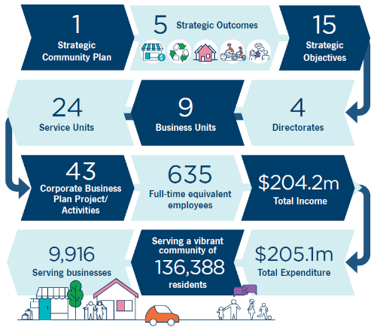
- 1 Strategic Community Plan
- 5 Strategic Outcomes
- 15 Strategic Objectives
- 4 Directorates
- 9 Business Units
- 24 Service Units
- 43 Corporate Business Plan Project/Activities
- 635 Full-time equivalent employees
- $204.2 million Total Income
- $205.1 million Total Expenditure
- Serving a vibrant community of 136.388 residents
- Serving 9.916 businesses

Community Satisfaction

2025 PlaceScore Service Satisfaction Survey
The City of Cockburn conducted a 2025 Service Satisfaction Survey to measure community satisfaction with its services and guide future priorities. This new survey forms part of the City’s commitment to Western Australia’s Integrated Planning and Reporting (IPR) Framework, ensuring that community feedback informs the Strategic Community Plan and continuous improvement efforts. The survey’s purpose was twofold:
- Measure how satisfied residents are with a broad range of City services
- Identify which service areas the community considers most important for future improvement. Below is an overview of the survey methodology, key performance results and priority areas.

Methodology
- 650 residents and ratepayers surveyed.
The City partnered with PlaceScore to conduct the survey primarily online. Participants were recruited through three different methods. Over 550 residents were randomly selected and invited by email. Around 77 additional people, particularly younger and harder-to-reach groups, were engaged via social media ads and posts. For those less tech-connected, paper surveys were provided at the Seniors Centre with 14 responses received.
The survey achieved a demographically representative sample of 650 residents and ratepayers. This sample size provides a maximum sampling error of plus or minus 3.8 per cent at 95 per cent confidence, meaning results are statistically reliable.
This 2025 survey introduced a new methodology and questionnaire structure (covering 50 specific service areas across five broad service dimensions). As such, results are not directly comparable to previous years’ surveys. However, where possible, data from the City’s 2023 Community Scorecard has been integrated for high-level comparison. The City plans to repeat this Service Satisfaction Survey biennially (next in 2027) to track trends and progress.

Overall satisfaction trends and benchmarks
- 89% satisfaction.
Cockburn’s community continues to report very high overall satisfaction with Council services. In 2025, 89 per cent of respondents said they were at least somewhat satisfied (rating very good, good, or average) with the City’s performance. This outcome is virtually unchanged from 2023, indicating that satisfaction levels have remained stable and strong over the last two years. The methodological change in 2025 did not disrupt the overall trend; residents maintained a similar confidence in services to that shown in the earlier Community Scorecard.
Cockburn’s 89 per cent satisfaction notably exceeds the benchmarks for local government performance. In Metropolitan Perth (WA), the average overall satisfaction was about 85 per cent (2024 benchmark), and the Western Australian statewide average was around 82 per cent. Cockburn’s result is also higher than the national average for Australian local governments, at 84 per cent. In other words, Cockburn residents are more satisfied with their council’s services than residents in most other councils across the metro area and state.

Service performance across key dimensions
The survey assessed five broad service dimensions, each encompassing ten specific service areas. All five dimensions performed strongly, with satisfaction levels of 81 per cent or above, indicating a well-rounded delivery of services across the City.

Community places
This dimension received the highest satisfaction rating, with 91 per cent of respondents expressing positive views. It includes services such as libraries, beaches, parks, and playgrounds. Satisfaction levels in this area were significantly higher than those reported across Metropolitan Western Australia, highlighting Cockburn’s strength in providing well-maintained and accessible community spaces.

Community programs and services
This dimension achieved 90 per cent satisfaction and includes social programs, health services, youth engagement and cultural events. The City’s efforts in community wellbeing and inclusion were well received, with scores well above state averages.

Management and communications
With an 86 per cent satisfaction rate, this dimension includes governance, financial management, customer service and communication. Notably, Cockburn exceeded the Metro WA benchmark by 24 per cent, indicating high community confidence in the City’s professionalism and responsiveness.

Transportation, waste and water
Scoring 82 per cent satisfaction, this dimension covers roads, paths, traffic management and waste services. Residents particularly appreciated the efficiency of rubbish collection and the condition of public infrastructure. Cockburn outperformed the Metro WA benchmark by 16 per cent, reflecting strong delivery in essential services.

Planning for the future
Although this dimension recorded the lowest satisfaction (81 per cent), it still performed well. It encompasses strategic planning, sustainability and development. The results suggest room for improvement in how the City communicates and delivers long-term planning initiatives.
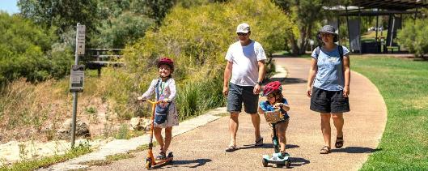
Image: Bibra Lake Reserve, Bibra Lake.

Top-Performing Service Areas
Seventeen of the fifty service areas surveyed received satisfaction ratings of 90 per cent or higher, demonstrating exceptionally strong community endorsement.
Service Area | Satisfaction Rating
Library facilities, services and programs | 99%
Swimming pools (e.g. Cockburn ARC) | 97%
Beach and waterways services | 96%
Sport and recreation facilities and programs | 95%
Provision and maintenance of community facilities, buildings and/or halls | 95%
Rubbish collection and waste management | 95%
Volunteers and community groups | 94%
Services and programs for older residents | 94%
Community wellbeing | 94%
Disability access and inclusion | 93%
These results reflect the City’s success in delivering both essential services and valued community amenities. High satisfaction with libraries, recreation centres and waste management underscores the importance of maintaining these services at current standards.

Priority Areas for Improvement
While overall satisfaction was high, the survey identified several service areas that are important to the community but received lower performance ratings. These areas represent opportunities for targeted improvement.
Service Area | Importance | Performance Rating
Providing value for money from rates | 76% | 5.9
Council making decisions in the community’s interest | 54% | 5.7
Planning for future community needs | 53% | 5.5
Road maintenance and condition | 47% | 5.6
These services are rated important by the community but are underperforming in comparison to other areas.

Community Feedback Themes
In addition to quantitative data, the survey collected 453 open-ended responses about the City’s future focus. These were grouped into nine thematic areas aligned with Council strategies.
Key themes:
- Safety and Security: 41% of ideas related to improving safety in public spaces, especially at night.
- Infrastructure and Maintenance: Calls for better road conditions, footpath safety and graffiti removal.
- Environmental Sustainability: Strong support for climate action, green space preservation and resilience planning.
- Communication: Desire for clearer updates on Council initiatives and more accessible engagement channels.
These themes reinforce the survey’s findings and provide qualitative insight into community priorities.
The City will repeat the survey in 2027 to track progress and ensure services continue to meet evolving community needs.
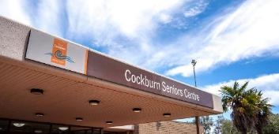 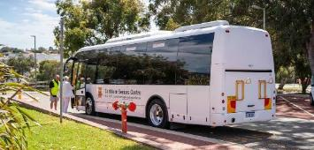 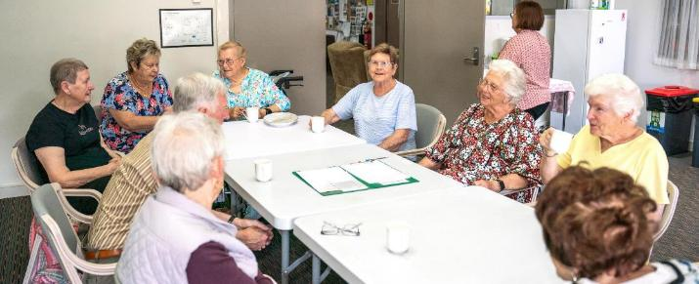
Images: Cockburn Seniors Centre, Spearwood.

2024 PlaceScore Liveability Survey
The City of Cockburn is pleased to partner with PlaceScore, a leader in community perception surveys, to gather insights that shape our community’s future. PlaceScore’s rigorous data collection and analysis allow us to gauge local sentiment accurately and align our objectives with the values and needs of residents. This collaboration informs our Strategic Community Plan (SCP) and ensures our planning and investment are guided by what matters most to our community.
In the 2024 Cockburn Liveability Survey, more than 1,800 residents participated, providing over 1,600 ratings on their neighbourhoods and sharing nearly 1,400 ideas for local improvement.
Below is a summary of the key results, with further details and analysis for each outcome provided in the following outcome sections of the Annual Report.
Local Economy 
- Cockburn: 6.0
- Western Australia: 6.5
- Australia: 6.4
Environmental Responsibility 
- Cockburn: 6.9
- Western Australia: 7.0
- Australia: 6.6
Community Lifestyle and Security 
- Cockburn: 6.6
- Western Australia: 6.7
- Australia: 6.7
City Growth and Moving Around 
- Cockburn: 7.1
- Western Australia: 7.1
- Australia: 6.9
Listening and Leading 
- Cockburn: 6.2
- Western Australia: 6.6
- Australia: 6.0
The City’s overall liveability score of 66 aligns closely with state and national averages of 67, demonstrating solid performance across most areas. Environmental Responsibility and City Growth and Moving Around emerged as our strongest outcomes, while Local Economy and Listening and Leading indicate areas for improvement. These scores reflect alignment with state and national benchmarks, while also highlighting specific opportunities for improvement. Detailed findings are provided within each relevant outcome area in the sections that follow.

Local Economy Outcomes
Cockburn is dedicated to building a thriving local economy that benefits everyone. Three key objectives guide this commitment: attracting investment and creating jobs, supporting vibrant commercial centres and a flourishing tourism industry, and streamlining processes to make Cockburn a city that’s 'easy to do business with'.
Strategic outcome 1. Local Economy:
A sustainable and diverse local economy that attracts increased investment and provides local employment.
Strategic objectives:
- Increased investment, economic growth and local employment
- Thriving local commercial centres, local businesses and tourism industry
- A city that is ‘easy to do business with’
Key statistics:
Number of projects: 5
Number of services: 1
Full-time equivalent employees: 5
Total cost: $1.26 million
Services:
- Business and Economic Development
Strategies, Plans and Frameworks:
- Economic Development Framework Action Plan
Image: Industrial area in Henderson.

Local Economy 2024-25
The City of Cockburn made significant strides in strengthening its local economy in 2024-25, with a focus on innovation, industry partnerships, small business support and job creation. Through strategic collaborations and community-driven programs, the City reinforced its reputation as a vibrant hub for the blue economy, defence industry and entrepreneurial growth. The year’s efforts have laid a strong foundation for sustained economic prosperity in Cockburn, benefiting local businesses, residents and the wider region.

Driving the Blue Economy and Innovation
A highlight of the year was the City’s active leadership in the blue economy, the sustainable use of ocean resources for economic growth. In August, the City of Cockburn signed a landmark Memorandum of Understanding (MoU) with The University of Western Australia’s Oceans Institute, formalising a partnership to foster marine-based innovation and industry. This collaboration leverages UWA’s world-class research in oceanography, ecology, and engineering to drive sustainable development of Cockburn’s coastal industries. By sharing knowledge and resources, the City and UWA are focusing on marine technology, offshore renewable energy and coastal resilience initiatives that will attract investment and generate local employment.

Boosting the Defence and Maritime Industry
Cockburn’s strategic advocacy for the defence sector paid historic dividends this year. In October 2024, the Federal Government announced a Commonwealth owned Defence Precinct at Henderson, a project set to create 10,000 jobs over the next two decades. The City of Cockburn applauded this decision, having long championed Henderson as Western Australia’s premier shipbuilding and maritime hub. The new precinct will include vital infrastructure such as a large dry dock and common-user facilities to support maintenance of Australia’s future nuclear-powered submarine fleet under the AUKUS partnership.
Mayor Logan Howlett hailed the announcement as “transformational for our community,” noting it will unleash a wave of benefits for Cockburn. These include thousands of local jobs in shipbuilding, engineering, and support services; new training opportunities in cutting-edge fields like robotics and analytics; and increased demand for local suppliers and contractors. The growth of Henderson’s defence industry will have strong ripple effects for the wider economy: more apprenticeships and TAFE courses (particularly aligned with AUKUS advanced technologies), a boost for supporting businesses (from manufacturing to hospitality), and the potential expansion of local education facilities.
To ensure the community shares in these benefits, the City has been proactive. We endorsed the concept of a Defence and Maritime Innovation Hub at Henderson in 2023, advocating for a centre that fosters research and development and collaboration in areas like marine technology and AUKUS Pillar II initiatives. We also sent City representatives to join a 12-day mission to the United States with the Perth South West Metropolitan Alliance, gathering insights on managing the anticipated influx of personnel and activity as US and UK submarines begin rotating to WA in 2027. These insights are informing the City’s long-term planning for housing, transport and community services to accommodate growth while maintaining our quality of life.
Cockburn’s existing maritime businesses felt the momentum too. In August, the City hosted a delegation from Japan’s Mitsubishi Heavy Industries – led by a senior naval shipbuilding executive – to showcase local capabilities. More than 40 representatives from local defence contractors, including welders, engineers and marine maintenance firms, attended an industry briefing at the City’s offices. Mayor Howlett noted it was “encouraging to hear established businesses discuss adapting their solutions to the defence sector,” emphasising Cockburn’s readiness for forthcoming State and Federal investments in maritime defence. Such engagements strengthen international ties and position our local enterprises for future contracts in large naval programs.

Empowering Small Businesses and Entrepreneurs
Cockburn’s local economy thrives on the success of small businesses, and in 2024-25 the City delivered a suite of programs to nurture entrepreneurship, innovation and business resilience. A key achievement was expanding networking and skill-building opportunities for our many micro and home-based businesses. The Cockburn Micro Business Networking Group continued to grow, meeting monthly to help small-business owners forge connections and swap expertise. Over 35 entrepreneurs regularly attended breakfast meet-ups, finding inspiration and practical tips from guest speakers. In one dynamic session on utilising LinkedIn for business, a social media coach demonstrated how to navigate the platform, make strategic introductions, and even generate a personal QR code to boost networking reach. Another session focused on wellbeing and decluttering for business owners, featuring local experts who shared strategies for building resilience and maintaining a healthy work-life balance. The energy in the room at these events was palpable, with many participants reporting new contacts and collaborations as a result of the meet-ups. Due to their popularity, the City has committed to continuing these free networking forums, recognising that peer support is invaluable to small-business success.
- Over 35 entrepreneurs regularly attended breakfast meet-ups.
To spur entrepreneurial innovation, the City offered two fully funded places (worth $3,750 each) in the acclaimed Curtin Ignition program, a weeklong intensive course that helps aspiring entrepreneurs turn ideas into viable businesses. Through a competitive process, two Cockburn innovators secured scholarships and joined the Ignition 2024 cohort. There they received guidance on refining their business models and crafting growth plans. This investment in local talent paid off: both scholarship recipients have since progressed their startups, armed with new skills, investor connections, and the confidence to take the next step in their commercialisation journey. The City also promoted the Ignition program to our community of creators and founders via workshops and social media, encouraging broader participation in this opportunity to “advance your entrepreneurial ambitions”.
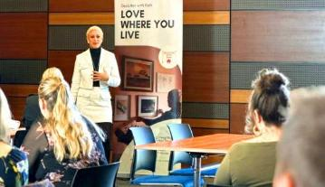 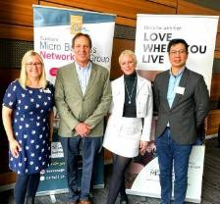
Image 1: Micro Business Networking, Declutter with Kiah – August 2024. Image 2: Micro Business Networking – August 2024. (Left to Right) Lisa Kniebe, Business Engagement Officer; John Tedesco, Business Growth Consultant; Kiah, Owner of Declutter with Kiah; and Alfonso Soliano, Repurposed Property Investor and volunteer.
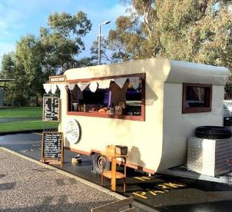
Image: Local business – Sweet Betty.
Small businesses in Cockburn benefited directly from City funding as well. We continued our annual Business Grants Program, which provides a $100,000 support pool to help local enterprises “level up” in key areas such as digital technology, cybersecurity, professional development and business innovation. Nearly 300 local businesses have received City grants over the years, translating into tangible improvements and growth. One standout example this year was Sweet Betty, a mobile coffee van owned by local entrepreneur Shaani Richards. As Shaani’s business boomed – beloved by Cockburn’s coffee lovers for its quality brew (and even a friendly sausage-dog barista mascot, “Chorizo”!), her digital payment system struggled to keep up with demand. She successfully applied for a City grant to upgrade to a more robust, efficient payment platform. Now transactions are as smooth as her lattes, helping her serve customers faster and grow her operation. The Sweet Betty story, featured on the City’s social media, is just one of many illustrating how Cockburn’s business grants turn ideas into success stories. Other grant recipients this year included a local kite-surfing school expanding into adaptive programs for people with disabilities, made possible by technology upgrades funded through the grants. By investing in our entrepreneurs, the City is not only supporting individual businesses but also creating local jobs and diversifying the range of services available to residents.
- $100,000 support pool to help local enterprises.
The City’s business development workshops were another pillar of support. In June, Cockburn hosted “Find Your Why”, a special one-day workshop aimed at helping business owners and startup founders rediscover their core purpose and values as a driver for long-term growth. Internationally recognised brand strategist Mike Edmonds – author of Truth, Growth, Repeat. – led the interactive session, guiding participants through exercises to articulate their mission and integrate it into their business strategy and culture. The workshop was heavily subsidised by the City, reflecting our commitment to affordable professional development for locals. Attendees, ranging from non-profit leaders to tech startup founders, left inspired with new insights into authentic leadership, many commenting that the experience would help them “authentically guide businesses and inspire others”.
Perhaps nothing showcased Cockburn’s enterprising spirit better than the Speed Networking Sundowner the City organised last November. This high-energy event brought dozens of local business owners together for ten rapid-fire networking rounds. Expertly facilitated by a professional business coach, the sessions challenged participants to deliver their elevator pitch succinctly and make as many new contacts as possible. The room was abuzz as entrepreneurs swapped business cards and LinkedIn details in a friendly race against the clock. By the end of the evening, countless new connections were formed and potential partnerships, client leads, and peer mentoring relationships were sparked in a matter of hours. Feedback from attendees was overwhelmingly positive, with many excited to follow up on “those valuable connections” and asking when the next speed networking event would be. These creative networking formats underline Cockburn’s role in facilitating a collaborative business community where knowledge is shared and local enterprise thrives.

Expanding Opportunities through Trade and Investment
In an increasingly global economy, Cockburn is helping its businesses look outward and seize opportunities beyond our city borders. This year the City hosted Cockburn Global 2024, an ambitious one-day conference designed to demystify exporting and encourage local enterprises to engage with international markets. Held in October at the Jakovich Centre in Henderson, the event was a resounding success. More than 80 local business owners, industry professionals and government representatives spent the day gaining insights and connections related to trade with Southeast Asia. The conference format featured three value-packed sessions: “Know Your Network,” “Get Export Ready,” and “Gain Insider Insights”. Attendees heard directly from heavy-weight experts including the Export Council of Australia, Export Finance Australia, Austrade, and the Consuls General of Indonesia and Vietnam and the Deputy High Commissioner of Singapore. They were briefed on everything from the fundamentals of exporting logistics and financing, to market-specific tips about doing business in Indonesia, Vietnam and Singapore, three dynamic markets on Cockburn’s doorstep.
Local success stories took centre stage as well. Cockburn entrepreneurs who have “cracked the international market” shared candid lessons on what it takes to grow beyond Australia. Experts also emphasised doing thorough homework on trade agreements, intellectual property protection and cultural etiquette. By day’s end, it was clear that exporting need not be daunting. The event closed with lively networking over delicious Southeast Asian-inspired cuisine, accompanied by a didgeridoo performance that beautifully blended local culture with the international theme. Cockburn Global 2024 forged new connections and left attendees excited to embark on their own global ventures, with many already planning follow-up meetings with contacts made at the conference.
- 80+ local business attended our Cockburn Global event.
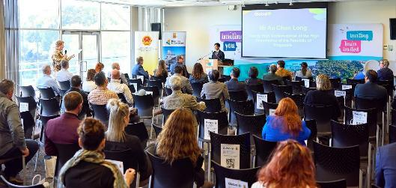
Image: Cockburn Global – October 2024.
In addition to the conference, the City ran supporting initiatives to build export readiness among local firms. We published a “Business Export Basics” guide, a handy online resource outlining first steps in researching foreign markets, understanding export documentation and finding government support programs. This guide was made freely available on our website and heavily promoted in the lead-up to Cockburn Global, so businesses could come primed with questions. The City also facilitated introductions between interested local companies and federal trade agencies.
Cockburn’s civic leadership actively champions trade and investment opportunities as well. In partnership with Business News, the City co-hosted a high-profile Politics & Business breakfast in March 2025. The event attracted local leaders, entrepreneurs and community figures to discuss economic development in our region. Attendees heard reflections from WA Attorney General John Quigley – who was interviewed about his long career fighting for justice and how stable, safe communities underpin economic growth. It was a morning of lively ideas and underscored the City’s commitment to fostering dialogue between government and business. Also during the year, Cockburn’s Economic Development officers worked closely with organisations like Melville Cockburn Chamber of Commerce (MCCC) to support local enterprise. A warm welcome was given to the MCCC’s new Business Development Manager, and joint events (such as the Hello Monday Level-Up program for women entrepreneurs launched during our International Women’s Day celebration) emerged from these partnerships.
- Co-hosted Politics and Business breakfast with Business News.
Through all these efforts, from global conferences to grassroots networking mornings, the City has maintained a clear purpose: to empower Cockburn businesses to grow, innovate and connect to new opportunities. The past year’s economic development initiatives have not only provided immediate benefits (like new contracts, skills and jobs) but also built capacity for the future. The local economy outcome area of our Strategic Community Plan has truly come to life in 2024-25, with Cockburn’s collaborative, forward-looking approach ensuring that our community shares in economic success. The City will continue leveraging its partnerships with industry, government and academia to keep Cockburn’s economy diverse, resilient and thriving – “the best place to do business,” as well as the best place to be.
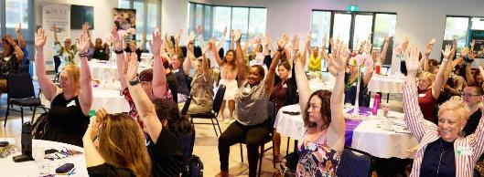
Image: International Women’s Day event – March 2025.

Community satisfaction
The Local Economy outcome remains a priority for the Cockburn community, with residents expressing appreciation for convenient shopping options but noting a desire for more local businesses that offer unique products and services. There is also a strong community call for an expanded evening economy, with greater opportunities for dining, entertainment and social activities within Cockburn’s neighbourhoods. The current performance in “things to do in the evening” ranks 10 per cent below the WA average, and the availability of accessible local employment options also scored below community expectations. This feedback has positioned the Local Economy as fourth in importance among Cockburn’s five strategic outcomes.
Residents highlighted the importance of locally owned businesses, with 44 per cent rating them as highly valued. Many respondents also voiced a desire for the presence of more local cafes, bars and family-friendly venues, indicating that an expanded range of businesses would support Cockburn’s overall economic vibrancy and sense of community.
Local Economy
- Cockburn: 6.0
- Western Australia: 6.5
- Australia: 6.4
Local Economy outcome metrics | Community satisfaction rating
Local businesses that provide for daily needs (grocery stores, pharmacy, banks, etc.) | 7.2
General condition of private open space (verges, driveways, etc.) | 6.6
Locally owned and operated businesses | 6.5
Local education options (from elementary to adult education) | 6.1
Evidence of recent private investment (renovations, landscaping, painting, etc.) | 6.0
Local employment opportunities (within easy commute) | 5.7
Things to do in the evening (bars, dining, cinema, live music, etc.) | 4.1

Plan for the future
A resilient and innovative local economy will depend on Cockburn’s ability to adapt to slower national growth while leveraging Western Australia’s economic strength. Although global growth remains fragile and Australia’s economy is cooling, Western Australia continues to outperform the nation, driven by resources, population growth and record state investment. For Cockburn, this context creates both opportunity and complexity. The City sits at the epicentre of transformative economic change, with the $12 billion AUKUS naval precinct at Henderson poised to reshape the local industrial landscape and generate thousands of skilled jobs over the coming decades. This project will stimulate demand for housing, education, logistics and transport but will also intensify pressure on the labour market and local infrastructure.
The City’s economic priorities over the next period will focus on enabling and managing this transition. Strategic partnerships with government, education and industry will be critical to build a skilled workforce, attract supporting enterprises and ensure benefits flow to local residents and small businesses. WA’s diversification into renewable energy, defence manufacturing, and critical minerals also presents an opportunity for Cockburn’s industries to innovate and participate in a low-carbon economy. Local businesses can further benefit from digital transformation – using automation, AI and data to increase productivity and reach broader markets.
In this evolving landscape, Cockburn’s challenge is to balance growth with affordability and resilience. Sustained inflation and workforce shortages continue to raise costs for households and business, requiring careful financial management.
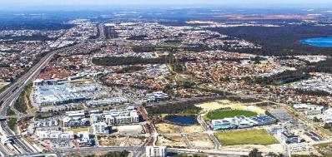 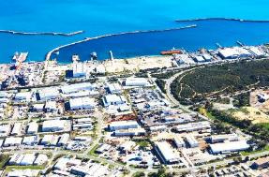
Image 1: Cockburn Central. Image 2: Henderson.

Environmental Responsibility Outcomes
Protecting our natural environment is a top priority for the City of Cockburn. A comprehensive approach to environmental responsibility focuses on preserving natural areas, promoting sustainable resource management and addressing the challenges of climate change.
Strategic outcome 2. Environmental Responsibility:
A leader in environmental management that enhances and sustainably manages our local areas and natural resources.
Strategic objectives:
- Protection and enhancement of our natural areas
- Sustainable resource management including waste, water and energy
- Address Climate Change
Key statistics:
- Number of projects: 9
- Number of services: 3
- Full-time equivalent employees: 149.4
- Total cost: $72.4 million
Services:
- Sustainability
- Environment, Parks and Streetscapes
- Waste and Fleet Services
Strategies, Plans and Frameworks:
- Climate Change Strategy 2020-2030
- Coogee Beach Foreshore Management Plan 2020-2070
- Natural Area Management Strategy 2012-2022
- Urban Forest Plan 2018-2028
- Waste Strategy 2020-2030
- Waterwise Council Action Plan 2021-2026
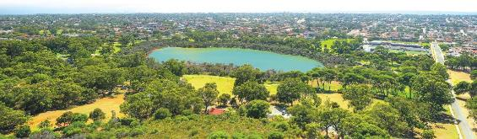
Image: Manning Park, Hamilton Hill.

Environmental Responsibility 2024-25
In 2024-25, the City of Cockburn reinforced its reputation as a leader in environmental stewardship, delivering a wide range of initiatives to protect natural habitats, reduce waste, conserve water and tackle climate change. Guided by our commitment to sustainability and the objectives of our Strategic Community Plan, we achieved significant milestones in conservation, climate resilience, and community engagement. From rolling out green infrastructure and cutting-edge environmental trials to mobilising volunteers and students in hands-on projects, Cockburn demonstrated that environmental responsibility is a shared journey, one that yields tangible benefits for our community and ecosystems.

Protecting Biodiversity and Natural Habitats
Preserving Cockburn’s rich biodiversity is at the heart of our environmental efforts. Over the past year, the City took active steps to enhance local habitats and safeguard native species. At Port Coogee Marina, our ongoing monitoring program revealed an encouraging sign of marine biodiversity: 180 species of non-fish marine fauna are now thriving in the marina’s sheltered waters. Detailed underwater surveys conducted from 2023 to 2024 identified a kaleidoscope of marine life, from molluscs like the Southern Hammer Oyster and the vibrant Gem Doris nudibranch to arthropods such as Decorator crabs and chordates like Lightbulb Sea Squirts. Even rare visitors have been recorded, including a Green Turtle and a swordfish in past years, indicating the marina’s improving environmental health. Port Coogee Marina has proudly maintained its International Clean Marina Level 3 accreditation since 2018, and in 2024 it earned additional recognition as a “Fish Friendly Marina”, scoring 98.4, a testament to the City’s high standards in marina management. Our installation of Western Australia’s first Seabin (a floating rubbish collection device) continues to capture plastics and debris, keeping the water clean for marine life. Mayor Logan Howlett noted that these efforts “provide a healthy environment where sea life can thrive...these tiny critters play an important role in keeping our marina clean and healthy”. The fresh survey data, meticulously logged on the public iNaturalist database, will guide future marine conservation actions and community awareness programs around our coast.
On land, the City continued one of its most ambitious habitat restoration projects to date in the Rehabilitating Roe 8 Corridor, transforming the former road reserve into a flourishing ecological asset. In 2024-25, we celebrated the completion of the Beeliar Woodland Walk, a limestone trail now stretching the length of the corridor, complete with interpretive signage to educate visitors about local flora, fauna and Whadjuk Noongar culture. This trail and a companion virtual wildflower walking tour were promoted online, making the area more accessible while protecting sensitive bushland. Over the past three years, under the leadership of our Rehabilitating Roe 8 Project Manager, the City and community planted 68,000 native seedlings in the corridor, dramatically enhancing habitat for wildlife.
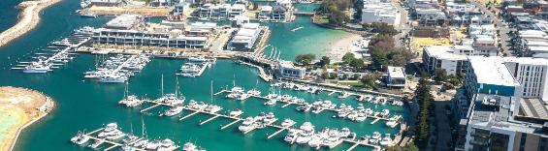
Image: Port Coogee Marina, North Coogee.
Outside of the Rehabilitating Roe 8 Corridor, the regular fauna surveys are yielding exciting results. In 2024 a Western False Pipistrelle (Falsistrellus mackenziei) was recorded in our Banksia Eucalypt Woodland Reserve in Aubin Grove, the first sighting of this rare microbat species in Cockburn in 32 years. This remarkable find, following years of careful habitat management, underscores the long-term benefits of consistent environmental restoration. Larger fauna are flourishing too. Our annual surveys have noted healthy populations of quenda (southern brown bandicoots) across several reserves, Western Grey Kangaroos in patches of urban bushland, and an impressive variety of birdlife including Carnaby’s and Forest Red-Tailed Black-Cockatoos, Rainbow Bee-eaters, and even a Peregrine Falcon pair nesting in a communications tower. These indicators show that Cockburn’s mosaic of conservation areas, more than 80 reserves in all, are providing vital refuges for wildlife amidst urban development. We also became a recognised “Owl Friendly City”, pledging not to use second-generation rodenticides at City facilities to protect local birds of prey, an initiative sustainability staff enthusiastically championed.
- 270 dedicated residents helped us plant 49,000 seedlings.
Community involvement has been crucial to our biodiversity success. In winter 2024, around 270 dedicated residents donned gloves and joined planting days across Cockburn’s nature reserves. Together they planted 49,000 native seedlings in degraded areas, helping to restore ecosystems while deepening their connection to nature. At our Nature Discovery Day events, introduced for the first time in 2023, families explored local bushland (like Bolderwood Reserve in South Lake) through guided walks, eco-craft activities and even a community planting of 120 seedlings. Feedback from participants was glowing: parents remarked how “rare it is to find community events with low barriers to entry – everything was free and accessible, which meant lots of diversity and fun”, praising the City for making it “warm, easy, accessible and joyful”. These events, delivered in partnership with The Wetlands Centre and local Friends groups, are fostering a new generation of environmental stewards. Similarly, the City’s Native Plant Subsidy Scheme had a record year. We distributed more local native seedlings than ever before to residents for their gardens, thanks to a new online registration system that made it easier to participate. Each native tree or shrub planted in a Cockburn garden adds up to a larger urban forest that supports birds, insects and cooler neighbourhoods. It complements our public realm efforts: in 2024-25 the City planted 1,650 new street and reserve trees across our suburbs, contributing to shade, beauty and biodiversity in the urban environment.
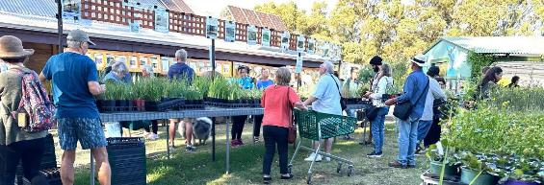
Image: Native Plant Subsidy at Apace.
The City also took decisive action to protect threatened species. Following a devastating incident in early 2024 when foxes predated over 100 long-necked turtle hatchlings at Bibra Lake after an unusually dry summer, Cockburn Council moved to substantially boost our fox control program. At the March 2025 Council meeting, we approved increasing the annual fox management budget from $20,000 to $50,000 (effective 2025-26) and committing a one-time $40,000 contribution to a regional fox monitoring project coordinated with neighbouring councils. This regional approach, under the Perth South-West Metropolitan Alliance, ensures fox control efforts are consistent across council boundaries, since foxes know nothing of our borders. Our Director of Sustainable Development and Safety, Dan Arndt, explained that Cockburn had actually doubled its fox control spend in 2024-25 to $40,000 even before these decisions, reflecting how urgent the City views the issue. He noted our allocation is now more than twice that of comparable local governments. We are determined to give the vulnerable Southwestern Snake-Necked Turtle, a culturally significant species known as Yaakan or Booyi to the Nyungar people, the best chance of survival. In spring 2024 we again recruited dozens of volunteer “Turtle Trackers”, equipping them with training and support to monitor nesting females around Market Garden Swamp, Boodjar Mooliny, Yangebup, Little Rush, Eco Park, Harmony, Bibra and Manning Lakes. These volunteers patrolled during peak nesting season (September–November), logging turtle movements, deterring predators and protecting nests. Their contributions, alongside our staff’s habitat restoration works (e.g. managing weeds to give turtles better nesting cover and restoring wetland habitat through revegetation), are vital to the species’ long-term survival. The City’s information night for aspiring Turtle Trackers was fully booked, demonstrating our community’s shared passion to save this emblematic species. Mayor Howlett summed it up: “Our City has been a steadfast supporter of saving our endemic turtle for many years. We do all we can to educate the community and inspire them to join us...Turtle Trackers play a key role in saving a species challenged by the urban environment”. This collective effort, from increased fox control to public education and citizen science, illustrates Cockburn’s holistic approach to biodiversity protection.
- $50,000 annual fox management budget, up from $20,000 (effective 2025-26).
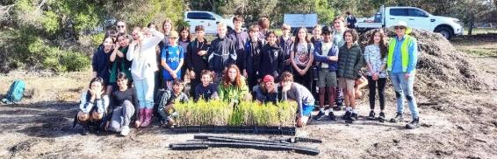
Image: Planting seedlings at Bibra Lake Reserve – August 2024. South Coogee Primary School and Vicky Hartill, Environmental Education Officer.

Leading in Climate Action and Coastal Resilience
As a coastal city on the frontline of climate change, Cockburn is proactive in building resilience to environmental challenges. A major focus this year was coastal protection and adaptation continuing its pioneering coastal engineering trial at North Coogee. An artificial fringing reef, the first of its kind in Western Australia, was expanded in late 2024, doubling the number of modular reef units to 270. Preliminary research from UWA indicates the reef has reduced wave height by 10 per cent and wave energy reaching the shore by 20 per cent, helping to combat erosion at C.Y. O’Connor Beach. The reef has also blossomed into a popular snorkelling site, now teeming with marine life; 57 fish species were observed, up from 29 before installation. This nature-inspired solution not only protects our coastline but boosts eco-tourism and marine research opportunities. “The reef project demonstrates how partnerships between local government, industry and universities can deliver innovative solutions to climate challenges while creating educational and recreational value,” said Mayor Logan Howlett. The City’s leadership in this arena positions Cockburn and Western Australia at the forefront of coastal innovation in Australia.
Alongside the extension of our North Coogee artificial reef, we continued traditional beach management to combat erosion. Sand nourishment, trucking in sand to replenish beaches, remained an important tool, especially at North Coogee’s C.Y. O’Connor Beach where natural sand drift is insufficient. However, the need for more sustainable, long-term measures is clear as sea levels rise and storms intensify. That’s why the City launched the development of a comprehensive Coastal Hazard Risk Management and Adaptation Plan (CHRMAP). Once completed, this plan will provide a strategic road map for managing our 23km of coastline against worsening erosion and inundation risks. It will evaluate a mix of solutions, from continued sand nourishment at vulnerable spots to nature-based approaches like dune restoration to hard engineering where necessary, and prioritise actions based on detailed hazard modelling.
- 20% reduction in wave energy thanks to the expansion of WA’s first artificial fringing reef.
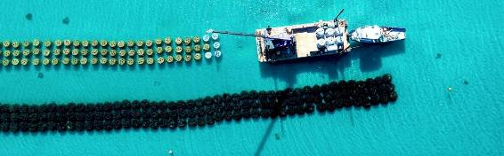
Image: Engineered fringing reef, C.Y. O’Connor Beach.
In parallel, we strengthened our internal capacity to respond to climate risks. The City finalised its FY2025 Greenhouse Gas Inventory in partnership with specialist consultants, giving us an accurate baseline as we work towards our target of net zero corporate emissions by 2030. This inventory accounts for both direct emissions (like fleet fuel use) and indirect emissions (from electricity, etc.), and we are now expanding our accounting to include supply-chain (Scope 3) emissions in line with evolving national standards. We maintained our Gold Waterwise Council status for the tenth consecutive year, reflecting continued excellence in water conservation, a critical aspect of climate adaptation in our drying region. The City’s parks and environment team demonstrated innovation by upcycling irrigation infrastructure to improve water efficiency. They converted old electrical cabinets into housing for 19-litre wetting agent dosing tanks, allowing precise soil treatments over 19 hectares of turf. This clever retrofit saves significant groundwater by improving moisture retention in soils (verified by our network of 60+ soil moisture sensors) and even combats pests like turf nematodes by promoting healthier grass. The initiative was so successful it earned the City the National Water Efficiency Management Award 2024 from Irrigation Australia. It’s a prime example of how Cockburn is innovating from within to meet external climate challenges and saving money, too (approximately $6,000 saved per cabinet repurposed).
We also took community-level climate action. Recognising growing anxiety among residents about climate impacts on our cherished natural areas, the City launched new ways for people to be part of the solution. We implemented a trial of megaphone-guided snorkel tours at the Coogee Maritime Trail (home of the Omeo shipwreck) to educate visitors on protecting reef ecosystems. We continued the highly popular Sustainability Grants program, awarding funding to seven local projects led by day cares, schools, a community garden and even green-thumbed households. These grants supported everything from community gardens and recycling initiatives to solar panel installations, empowering the community to cut emissions and waste at the grassroots level.
Cockburn continued to show climate leadership on the regional stage as well. We actively participated in the Western Australian Local Government Association’s Climate Change Collaborative, sharing our experiences on urban forest protection and coastal adaptation. In 2024, Council approved extensive community consultation to help inform a significant Tree Protection Planning Policy on private property, a first for Cockburn. This draft policy introduces the concept of “regulated trees,” large trees of eight metres or more, or those on our Significant Tree Register that cannot be removed without development approval. The aim is to curb the loss of mature trees on private land, with developers needing to consider whether new developments can incorporate these large trees into their proposals. Hundreds of submissions were received on the draft policy, which will be reported back for Council’s decision in late 2025. Our urban forest received another boost via partnerships with Curtin University. Cockburn proudly sponsored the 2024 Curtin Sustainability Challenge, where student teams developed creative strategies to increase urban tree canopy in cities. The winning ideas ranged from community tree adoption programs to high-tech mapping of heat islands.
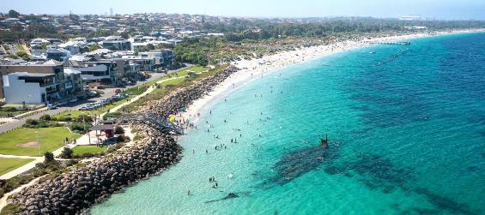
Image: Coogee Maritime Trail, North Coogee.

Tackling Waste and Emissions through Innovation
The City made great progress in 2024-25 toward its vision of reducing waste and creating a circular economy. Key to this was engaging residents in practical, enjoyable ways to reduce, reuse and recycle. A highlight of the year’s environmental calendar was Coogee Live 2025, our marquee community festival, which proved that large events can be run with minimal waste. Thanks to the City’s ongoing Waste Wise Events Policy, Coogee Live achieved a record-breaking 75 per cent waste recovery rate. With the roughly 21,000 people who attended the two-day beach festival in March, only 115kg of waste went to landfill – that’s less than five grams of rubbish per person! This extraordinary result was made possible by replacing disposable items with reusables and compostables at every turn. We partnered with Go2Cup to provide 34,000 reusable cups, plates and cutlery for food vendors, eliminating tens of thousands of single-use plastics. Attendees got on board too: instead of standalone rubbish bins, we set up staffed waste sorting stations where patrons could correctly separate compostables, recyclables, Containers for Change deposit bottles, and the tiny amount of true “waste”. As a result, over 190kg of organic waste was diverted to composting by our local partner WRITE Solutions, and St. Patrick’s Community Support Centre raised funds by collecting more than 2,000 drink containers. Perhaps most impressively, zero waste contamination was detected in any bin, a first for an event of this size. This means attendees sorted their waste perfectly, an encouraging sign that our community is embracing the waste-wise culture. Coogee Live was also certified carbon-neutral for the second year running, with all event emissions offset by native tree planting across WA. This shining example will inspire all future City events (and indeed other councils) as Mayor Howlett said, “Coogee Live shows that reducing waste is not only vital, but achievable”. We’re proud that Cockburn is demonstrating leadership in sustainable events and that our community has responded with such enthusiasm.
- 75% waste recovery at Coogee Live 2025. Only 115kg went to landfill — less than five grams of rubbish per person.
Beyond events, the City expanded facilities to help residents cut everyday waste. In April 2025, Cockburn became the first local government in WA to install a permanent zero-waste refill station at a public facility. Located at Cockburn ARC, our popular recreation centre, the Zero Waste Refill Station allows anyone to refill their own containers with a range of eco-friendly household liquids, from laundry and dish detergent to shampoo, conditioner, and body wash. This innovative self-service station, operated in partnership with a local social enterprise, offers high-quality products made in WA’s southwest at affordable prices, minus the single-use plastic packaging. Instead of buying a new bottle of shampoo every time (contributing to the 2.4 million tonnes of plastic Australians throw away each year), residents can now top up the same bottle again and again. To encourage uptake, the City has introduced a refill reward rebate for Cockburn residents. The early response has been fantastic: within weeks of the program's launch, hundreds of litres of product had been dispensed and many users commented on the convenience of incorporating waste reduction into their routine “pre or post-workout” at the ARC. The ARC refill station complements our existing network of Battery, E-waste, and Household Hazardous Waste drop-off points, making Cockburn a one-stop shop for sustainable living practices.
The community’s appetite for creative reuse was also on display during the festive season. In late 2024, the City hosted a series of Waste-Free Christmas Workshops that embodied the spirit of giving without the waste. About 30 residents participated in hands-on sessions where they upcycled discarded materials into beautiful, reusable holiday decorations and gifts. One popular workshop saw attendees transform a pile of illegally dumped wooden pallets into unique, reusable Christmas trees. With guidance from the Cockburn Community Men’s Shed, everyone built and took home their own timber tree, decorated to taste. Another workshop focused on sewing skills for a sustainable Christmas, turning donated fabric offcuts into gift bags, bunting and cloth wraps as alternatives to single-use wrapping paper. These initiatives, supported by an $8,400 Waste Authority Community Education grant, diverted hundreds of kilograms of wood and textiles from landfill. More importantly, they equipped participants with skills and ideas to continue waste-free traditions at home. As Mayor Howlett noted, Australians generate extraordinary waste each Christmas, from excess packaging to unwanted gifts, so providing fun, community-driven ways to celebrate sustainably helps people “create special memories while also practising sustainability”. Given the positive feedback, the City plans to expand these workshops and similar community education programs on topics like composting and repair café sessions (building on our successful spring 2024 Repair Café events where volunteers fixed household items for free, keeping them in use longer).
Our waste management operations themselves got a boost through innovation and efficiency improvements. To better service our growing population (and uneven growth across suburbs), the City undertook a major optimisation of waste collection routes in 2024. Rapid development in Treeby and Hammond Park had led to some collection days handling far more bins than others. A project team rebalanced all five days of pickup schedules, designing 15 new collection rounds with more even workloads between areas. Approximately 10,000 households had their bin day changed as a result, and the City executed a comprehensive public communication plan to ensure a smooth transition. Teams walked the affected streets tagging bins with reminder stickers and dropping pamphlets to explain the changes. While there was a small uptick in missed-bin calls initially (as expected), within weeks the new schedule settled in and is now performing well, with 90% of the City’s 11,946 waste collection requests completed within three days. Balancing the rounds has improved service reliability and will accommodate future growth for years to come. The project did highlight the importance of contingency planning – when the City’s initial contractor struggled to deliver the notification materials on time, our staff rolled up their sleeves and personally went door-to-door in Cockburn Central’s industrial area to keep the rollout on track. This dedication ensured the success of an initiative that residents ultimately appreciated for making collections more timely and consistent citywide.
In parallel, we rolled out new digital tools to improve waste services. A convenient online “Damaged Bin” self-service form was launched so residents can request bin repairs or replacements through our website anytime. Internally, our waste truck fleet’s telematics system was upgraded with turn-by-turn navigation for drivers, boosting efficiency and reducing the chance of missed streets. At the Henderson Waste Recovery Park (HWRP), the City commissioned a massive new 85-million-litre leachate pond. This critical infrastructure significantly improves our management of landfill leachate (the liquid run-off from decomposing waste piles), ensuring we protect groundwater and meet environmental compliance. The HWRP team also implemented a new traffic light and radio communication procedure on the active landfill face to enhance safety. Now, waste trucks must stop at a red light and get explicit radio clearance before approaching tipping areas – a simple but effective measure that, after an initial adjustment period, has achieved near 100% compliance and a safer work environment for staff and customers.
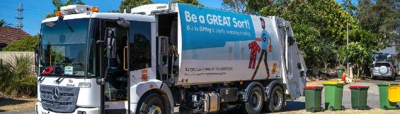
Finally, Cockburn’s commitment to environmental sustainability extended to community education and recognition programs. We continued our partnership in the “Keep Carnaby’s Flying, Ngoolarks Forever” project with BirdLife Australia and others, guided by the new Black Cockatoo Conservation Action Plan. One of the plan’s key actions led to the City installing three new solar-powered water troughs (“Cockitroughs”) at known black-cockatoo foraging sites in Coolbellup and Spearwood. By summer 2024, we had five watering stations operating (two existing, plus the three new), each within 1km of major roosts at places like Manning Park and Bibra Lake. These water sources are crucial, as Carnaby’s and red-tailed black-cockatoos must drink twice daily, and natural freshwater is scarce in urban areas. The cockatoos quickly found the new water points, which feature safe perches, and their presence has been celebrated by the community. The project not only helps an endangered species survive the hot, dry months, but it has raised awareness citywide about our feathered friends’ needs. In November 2024, the City also ran its inaugural Waterwise Verge Competition to commend residents who embrace native gardens and water-saving landscaping. Winners in categories such as Best Waterwise Verge and Most Biodiverse Verge were announced, showcasing beautiful front gardens lush with native shrubs, wildflowers and habitat features instead of lawn. These local champions, like Bruce from Hamilton Hill, whose verge is now a thriving mini-ecosystem of drought-tolerant plants, demonstrate how individual efforts contribute to a greener, cooler neighbourhood. The competition, supported by the Water Corporation, inspired many others to rethink their verge, and the City will reopen applications for our Waterwise Verge Rebate Program in future to encourage more sustainable gardening.
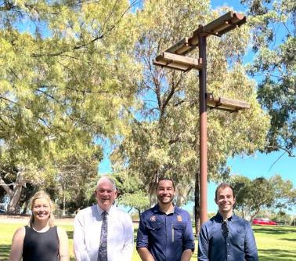
Image: Bird watering station, Administration Centre in Spearwood – December 2024. (Left to Right) Lauren Andrews, Environmental Officer; Mayor Logan Howlett; Lachlan McDonald, Service Lead City Greening; and Rory Garven, Service Manager Sustainability.
In summary, 2024-25 saw the City of Cockburn significantly advance its Environmental Responsibility goals. We protected more wildlife, planted more trees, reduced more waste, saved more water and engaged more people. These achievements are a credit to the dedication of the City’s Council and staff, the enthusiasm of our volunteers and community groups, and the support of our partners in government, academia and industry. Challenges remain, from managing urban growth in an environmentally sensitive way to navigating emerging complexities in carbon accounting and renewable energy technology. However, Cockburn is well-positioned to meet these challenges head-on. By combining scientific innovation with community collaboration, we are ensuring that Cockburn’s natural environment, the wetlands, bushland, coast and wildlife that make our City special is protected and enhanced for generations to come.

Climate Change and Sustainability Snapshot 2024-25

Climate Change Strategy
Endorsed by Council in September 2020, the Climate Change Strategy 2020-30 is informed by the Climate Change Risk Assessment 2020 and community consultation. The Strategy's Climate Resilience Road Map has 14 objectives and aspirational targets which are supported by a detailed action plan.

Vision
The City of Cockburn will continue to be a leader in climate resilience and sustainability. We aim to be a future carbon-neutral City and take pride in working together to adapt to our changing climate, now and into the future.

Climate Resilience Roadmap
Transcriber’s note: This section includes progress pie charts without specific numerical data; approximate percentages have been listed instead. Please contact City of Cockburn for more information.

Objective/Target 1. Strong Leadership
Progress:
- ≈ 25% ongoing
- ≈ 55% complete
- ≈ 20% in progress
Achievements:
- $1.2 million transferred to Climate Change Mitigation Reserve in FY2024-25.
- As of May 2025, 20 per cent ($51.31 million) of the City’s investment portfolio is allocated to non-fossil fuel industries.

Mitigation: Objective/Target 2. Net Zero Emissions
Progress:
- ≈ 16.7% ongoing
- ≈ 16.7% complete
- ≈ 16.7% to be commenced
- ≈ 50% in progress
Achievements:
- Corporate emissions increased 19 per cent in 2023-24, including a 16 per cent increase in natural gas, a seven per cent increase in water, and an eight per cent increase in landfill waste emissions.
- Sent a letter to DWER offering assistance with Sectoral Emissions Reduction Strategy implementation.

Mitigation: Objective/Target 3. 100% Renewable Energy
Progress:
- ≈ 60% ongoing
- ≈ 40% in progress
Achievements:
- Solar PV installation ongoing.
- Secured 25 per cent renewable electricity for the City’s 50 contestable sites.

Mitigation: Objective/Target 4. Zero Waste to Landfill
Progress:
- ≈ 30% ongoing
- ≈ 70% in progress
Achievements:
- Voluntary National Greenhouse and Energy Reporting Scheme report 2024-25 complete.
- 24 per cent decrease in tonnes of waste to landfill (2024-25).
- Waste to energy expected to commence in the coming months with commissioning of the Rockingham Plant.

Mitigation: Objective/Target 5. Reduce Energy Consumption
Progress:
- ≈ 10% ongoing
- ≈ 45% in progress
- ≈ 45% to be commenced
Achievements:
- Events team, with support from the Sustainability team, committed to offsetting the City’s community events.
- Energy monitoring continued via integrated platform.
- Lessees supported with sustainability initiatives (such as solar panels).

Mitigation: Objective/Target 6. Zero Emission Fleet
Progress:
- ≈ 12.5% ongoing
- ≈ 50% complete
- ≈ 12.5% in progress
- ≈ 25% to be commenced
Achievements:
- Fleet emissions offsets ceased in 2023-24; funds redirected to fleet transition to EVs.
- ELT endorsed City’s role to facilitate fast EV chargers on City land, through specialist providers
- Approximately $30K invested in battery-powered equipment (chainsaws, trimmers, whipper snippers) for the Parks team.

Mitigation: Objective/Target 7. Smart City Innovation
Progress:
- ≈ 30% ongoing
- ≈ 30% complete
- ≈ 10% in progress
- ≈ 30% to be commenced
Achievements:
- City represented on OneOneFive Waterwise Exemplar Group, supporting smart water and heat monitoring.
- Coogee community battery launched to capture excess rooftop solar PV energy. Additional batteries in design with two Atwell sites confirmed.
- EV charging sites to be identified on City land/road reserves.

Objective/Target 8. Education and Collaboration
Progress:
- ≈ 60% ongoing
- ≈ 25% complete
- ≈ 15% in progress
Achievements:
- Education for Sustainability Plan in development (FY2025-26).
- Pilot Sustainable Home Rebate delivered, alongside workshops, resources and subsidies. The rebate was very popular, with all available funding being spent.

Adaptation: Objective/Target 9. Waterwise City
Progress:
- ≈ 30% ongoing
- ≈ 60% complete
- ≈ 10% to be commenced
Achievements:
- Gold Waterwise status maintained.
- Parks scheduled annually for irrigation renewal and hydrozoning programs (ongoing).
- Energy and Water audit conducted at Administration Building, Seniors Centre and Spearwood Library.

Adaptation: Objective/Target 10. Conserve Biodiversity
Progress:
- ≈ 50% ongoing
- ≈ 50% complete
Achievements:
- Review of Natural Area Management Strategy underway with two new reserves to join City portfolio in 2025-26.
- Comprehensive monitoring program delivered (fauna, vegetation, wetlands, pests), with new turtle and frog surveys to begin.

Adaptation: Objective/Target 11. Coastal Adaptation
Progress:
- ≈ 60% ongoing
- ≈ 10% complete
- ≈ 30% in progress
Achievements:
- Coastal Hazard Risk Mapping and Adaptation Planning (CHRMAP) review underway (final report due April/May 2026) with ongoing coastal monitoring.
- Special Control Area for coastal hazards to be included in future planning scheme.
- City secured grants for Coastal Hazard Risk Management and Adaptation Plan and fringing reef, with advocacy a future focus.

Adaptation: Objective/Target 12. Increase the Urban Forest
Progress:
- ≈ 60% ongoing
- ≈ 40% complete
Achievements:
- Citywide street tree program continues, but no new park trees this year due to available resources.
- Council adopted draft Tree Protection Policy and Scheme Amendment (Nov 2024) for the purpose of public advertising until August 2025.

Adaptation: Objective/Target 13. Protect Community Infrastructure
Progress:
- ≈ 40% ongoing
- ≈ 30% complete
- ≈ 30% in progress
Achievements:
- City continues to meet State Planning Policy bushfire management requirements.
- Part-time Bushfire Risk Mitigation Coordinator appointed to address high-risk areas.

Adaptation: Objective/Target 14. Enhance Health and Wellbeing
Progress:
- ≈ 30% ongoing
- ≈ 30% complete
- ≈ 40% in progress
Achievements:
- Local Public Health Plan 2025-30 in preparation.
- Shade sails added to capital works, targeting hottest parks.
- The City participated in a community disaster resilience baseline assessment project in partnership with Department of Fire and Emergency Services and the cities of Rockingham and Kwinana.

Action Plan Progress 2024-2025
A few actions advanced to ‘In Progress’ or ‘Complete’ status during 2024-25 compared to the previous year; however, more work is required to achieve the overall targets.
- 36% Ongoing
- 30% Complete
- 25% In progress
- 9% To be commenced

Climate Change Strategy - Action Plan Progress 2023-24 to 2024-25
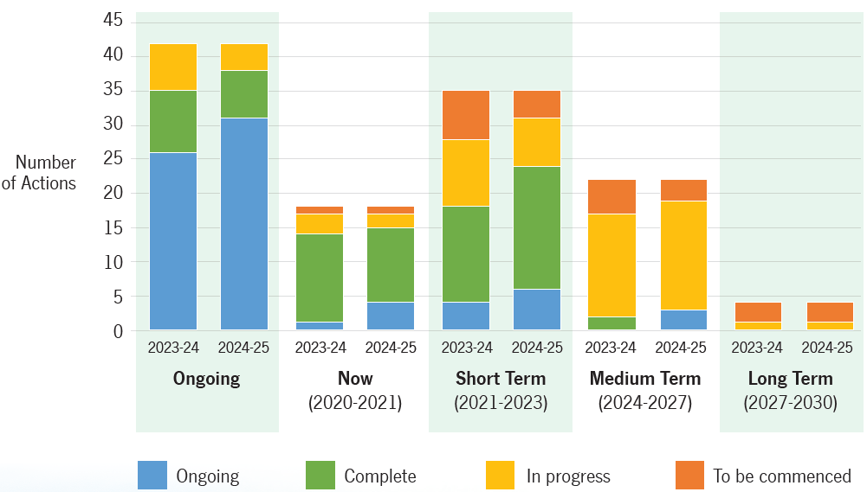
Transcriber’s Note: The bar graph above shows the number of actions and the statuses of these actions from 2023-24 to 2024-25. The graph uses a linear scale that defines intervals of five; numbers of actions that fall between these intervals have been inferred. This data is presented in the following tables. Please contact City of Cockburn for more information.

Ongoing Actions – Total number of actions: 42
Financial year | Ongoing | Complete | In progress | To be commenced
2023-24 | 26 | 9 | 7 | N/A
2024-25 | 31 | 6 | 5 | N/A

Now (2020-2021) – Total number of actions: 18
Financial year | Ongoing | Complete | In progress | To be commenced
2023-24 | 1 | 13 | 3 | 1
2024-25 | 4 | 9 | 2 | 1

Short Term (2021-2023) – Total number of actions: 35
Financial year | Ongoing | Complete | In progress | To be commenced
2023-24 | 4 | 14 | 10 | 7
2024-25 | 6 | 18 | 7 | 4

Medium Term (2024-2027) – Total number of actions: 22
Financial year | Ongoing | Complete | In progress | To be commenced
2023-24 | N/A | 2 | 15 | 5
2024-25 | 3 | N/A | 16 | 3

Long Term (2027-2030) – Total number of actions: 4
Financial year | Ongoing | Complete | In progress | To be commenced
2023-24 | N/A | N/A | 1 | 3
2024-25 | N/A | N/A | 1 | 3
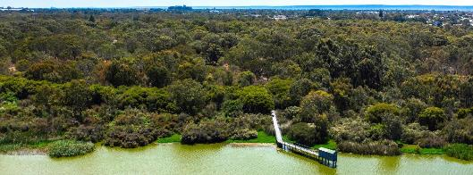
Image: Bibra Lake Boardwalk and Bird Hide, Bibra Lake.

Community satisfaction
The Environmental Responsibility outcome is closely aligned with the community’s vision for a sustainable future, with local residents placing great value on the protection of natural areas, the quality of public open spaces and the addition of green landscaping throughout Cockburn. In the 2024 Liveability Survey, residents ranked natural elements such as vegetation, water and wildlife as their top priority (74 per cent), and 68 per cent identified well-maintained public spaces – parks, footpaths, and verges – as essential for their ideal neighbourhood.
The City’s current performance reflects positive efforts in these areas, yet there are key opportunities to enhance the community’s connection to the natural environment and foster long-term sustainability. Recommendations include expanding tree canopies, increasing the number of street trees, and preserving native flora and fauna to further enrich Cockburn’s outdoor spaces. Sustainable urban design initiatives are also encouraged, with younger demographics (ages 25-44) showing strong interest in projects that support climate resilience, energy efficiency and water conservation.
Cockburn’s Environmental Responsibility outcome ranks second in importance among the community’s five strategic outcomes, reinforcing the City’s commitment to an environmentally sustainable future. By responding to the community’s call for nature-focused spaces and sustainability projects, Cockburn can enhance the liveability of its neighbourhoods while protecting and nurturing its natural resources for generations to come. This ongoing investment in our environment supports not only ecological health but also the wellbeing of all Cockburn residents.
Environmental Responsibility
- Cockburn: 6.9
- Western Australia: 7.0
- Australia: 6.6
Environmental Responsibility outcome metrics | Community satisfaction rating
Amount of public space (footpaths, verges, parks, etc.) | 7.7
Elements of natural environment (natural features, views, vegetation, topography, water, wildlife, etc.) | 7.3
Quality of public space (footpaths, verges, parks, etc.) | 7.2
General condition of public open space (street trees, footpaths, parks, etc.) | 7.1
Landscaping and natural elements (street trees, planting, water features, etc.) | 7.0
Neighbourhood spirit/resilience (from external impacts, storms, economic downturns, etc.) | 7.0
Protection of the natural environment | 6.9
Sustainable behaviours in the community (water management, solar panels, recycling, etc.) | 6.5
Sustainable urban design (water-sensitive design, transport-oriented design, sustainable-building design, density, etc.) | 5.7

Plan for the future
Cockburn’s future environmental resilience will depend on how effectively the City responds to the accelerating impacts of climate change and biodiversity loss. Rising sea levels, hotter and drier conditions in Western Australia’s south-west, and the intensifying effects of extreme heat are already reshaping the local environment. Coastal erosion in low-lying areas and increasing storm surges around Cockburn Sound highlight the need for proactive adaptation. The City will continue to invest in coastal protection, dune restoration and flood mitigation while expanding the use of green infrastructure to manage heat and enhance urban resilience.
The preservation of Cockburn’s natural ecosystems will remain a defining priority. These biodiverse habitats and our urban canopy are under pressure from habitat fragmentation, invasive species such as the polyphagous shot-hole borer, and shifting rainfall patterns. The City will seek to strengthen biodiversity corridors, continue native revegetation, and collaborate with the community and environmental organisations to restore and protect natural areas. Water availability will also be an ongoing challenge as declining winter rainfall reduces surface inflows. Sustainable water use, groundwater management and innovative irrigation technologies will underpin the City’s approach to managing parks and public open spaces in a drying climate.
National and state efforts toward decarbonisation and renewable energy transition align closely with Cockburn’s goals. By integrating renewable energy systems, supporting circular economy initiatives, and embedding sustainability into planning and procurement, the City can lead by example. Community education and engagement will be central to building resilience and fostering shared responsibility for climate action. Through collaboration, innovation and evidence-based planning, Cockburn aims to protect its natural heritage, secure water and energy resources, and build an environment capable of sustaining future generations.
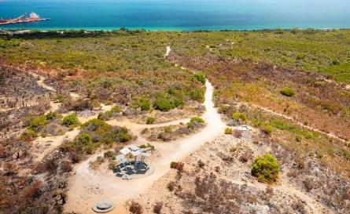
Image: Mount Brown Lookout, Henderson

Community, Lifestyle and Security Outcome
Cockburn envisions a safe, healthy and inclusive community where everyone feels welcome. Key objectives include fostering accessible and well-maintained community facilities, promoting a safe and secure environment for all residents, and celebrating the rich cultural heritage of Aboriginal and Torres Strait Islander communities. This fosters a strong sense of community spirit and belonging for all.
Strategic outcome 3. Community, Lifestyle and Security:
A vibrant, healthy, safe, inclusive and connected community.
Strategic objectives:
- Accessible and inclusive community, recreation and cultural services and facilities that enrich our community
- A safe and healthy community that is socially connected
- Aboriginal and Torres Strait Islander cultures and heritage are recognised and celebrated
Key statistics:
- Number of projects: 14
- Number of services: 5
- Full-time equivalent employees: 216.4
- Total cost: $64.8 million
Services:
- Library, Place and Culture
- Recreation Services
- Community Services
- Community Development
- Health and Building Services
- Rangers and Community Safety
Strategies, Plans and Frameworks:
- Age Friendly Strategy 2016-2021
- Animal Management Exercise Plan 2020-2025
- Bushfire Risk Management Plan 2023-2028
- Community Development Strategy 2021-2025
- Community Safety and Crime Prevention Plan 2022-2027
- Community Infrastructure Plan 2024-2041
- Disability Access and Inclusion Plan 2023-2028
- Grant and Fee Funded Human Services Strategic Plan 2013-2018
- Library Service Strategy 2020-2025
- Local Emergency Management Arrangements
- Master Plans and Revitalisation Strategies
- Public Open Space Strategy 2014-2024
- Reconciliation Action Plan 2023-2025
- Volunteer Strategy 2021-2025
- Youth Services Strategy 2017-2022

Community, Lifestyle and Security 2024-25
This past year, the City of Cockburn continued to foster an inclusive, safe and vibrant community, delivering a broad range of programs and facility upgrades that improve quality of life for residents of all ages and backgrounds. In 2024-25, our focus on community development, lifestyle amenities and public safety resulted in more engaged neighbourhoods, enhanced recreation opportunities and stronger social support networks. From celebrating cultural diversity and heritage to expanding services for youth and seniors to investing in parks and community infrastructure – Cockburn worked hard to ensure our City remains “the best place to be” for everyone.

Healthy and Resilient Lifestyles
The City of Cockburn is devoted to providing facilities and services that promote healthy, active lifestyles and personal wellbeing. During 2024-25 we expanded popular recreation programs and invested in new facilities so that residents have ample opportunities to stay fit, learn new skills, and enjoy themselves close to home.
Our library services continued to flourish and adapt to community needs. Cockburn’s three libraries (Success, Spearwood and Coolbellup) welcomed 367,000 visits during the year, a slight increase from last year, and issued over 657,000 loans, including a growing proportion (27 per cent) of ebooks and digital resources as reading habits evolve. Libraries are not just about books, though, and 2024 saw an exciting new chapter in how we support community wellbeing: in a first-of-its-kind pilot program, the City embedded a Social Worker in Success Library. Developed in partnership with Curtin University and CommuniCare, this “Cockburn Connect” social work program offered free, drop-in advice and referral services to library patrons who may be experiencing challenges like financial stress, housing insecurity or mental health issues. The pilot has been tremendously successful; over the program's initial months, the library social worker assisted dozens of individuals and families, linking them with services such as emergency housing, counselling or our own Cockburn Financial Counselling team. The program has been warmly received by the community (and even profiled on ABC News as an innovative approach to community health). We hope to continue and expand this model to other locations in future as part of our commitment to “libraries as community hubs” where residents can access a wide spectrum of help and connection. Meanwhile, Cockburn libraries delivered free events and programs over the year – from early literacy Baby Rhyme Time sessions to coding workshops for kids to author talks and local history mornings – attracting 38,700 participants of all ages. A milestone was the tenth birthday of Success Library in September 2024. To celebrate, we hosted a full day of family festivities which drew over 2,000 people to the library near Cockburn Gateway. The event included storytelling sessions, face painting, live music from local school choirs, and even a mini petting zoo, truly reflecting how beloved and well-used this award-winning library has become in its first decade. We were delighted that in a time of fast-paced digital change, membership of our libraries grew again, with over 6,160 new members joining in the year. It shows that our libraries remain trusted, welcoming spaces where community members can learn, relax and connect with one another.
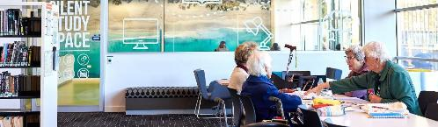
Image: Success Library, Success.

Cockburn Libraries
Cockburn Libraries serve as vibrant community hubs across the City of Cockburn, with branches located in Coolbellup, Spearwood and Success. These libraries offer:
- Free access to books, magazines, DVDs and comics
- Digital resources including ebooks, audiobooks and streaming media
- Public computers, free wi-fi, printing and photocopying services
- A rich calendar of programs and events for children, teens and adults
- Local history archives and cultural engagement initiatives
- Membership is free and open to all residents, supporting lifelong learning, digital inclusion and community connection.

Annual Performance Summary

Total Library Visits by Financial Year
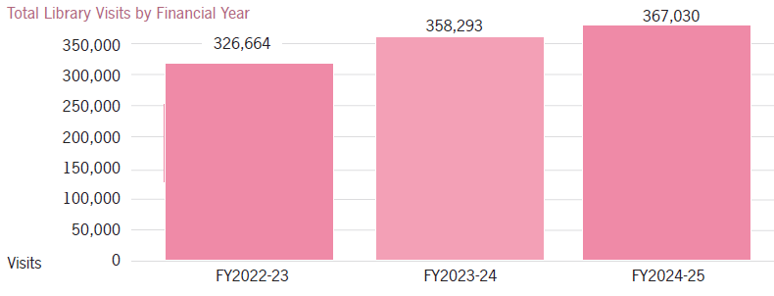
Transcriber’s Note: The bar graph above shows the total number of visits to Cockburn Libraries in each financial year. This data is presented in the following table.
Financial Year | Total Library Visits
FY2022-23 | 326,664
FY2023-24 | 358,293
FY2024-25 | 367,030
The number of visitors has steadily increased, reflecting the libraries’ continued relevance and accessibility.

Library Memberships by Financial Year
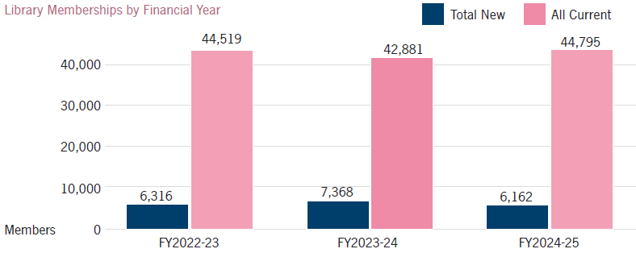
Transcriber’s Note: The bar graph above shows the number of new and current library memberships at Cockburn Libraries in each financial year. This data is presented in the following table.
Financial Year | Total New Membership | All Current Memberships
FY2022-23 | 6,316 | 44,519
FY2023-24 | 7,368 | 42,881
FY2024-25 | 6,162 | 44,795
Membership levels remain strong, with consistent new registrations and a stable base of active members.

Loans by Type by Financial Year
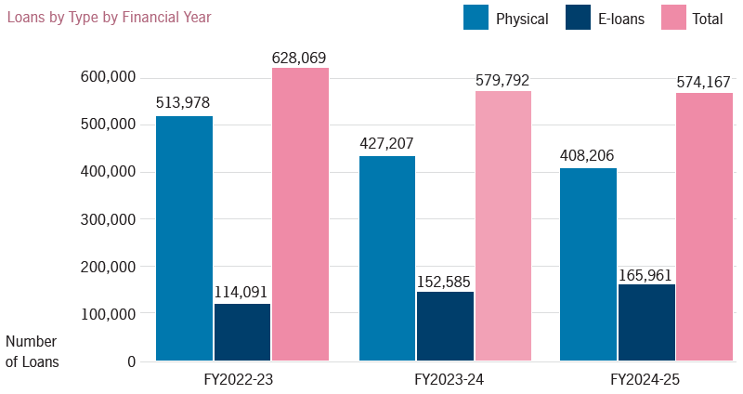
Transcriber’s Note: The bar graph above shows the number of library loans by type at Cockburn Libraries in each financial year. This data is presented in the following table.
Financial Year | Physical Loans | E-loans | Total Loans
FY2022-23 | 513,978 | 114,091 | 628,069
FY2023-24 | 427,207 | 152,585 | 579,792
FY2024-25 | 408,206 | 165,961 | 574,167
While physical loans have declined slightly, e-loans have grown significantly, indicating a shift toward digital engagement.

Programs/Events Participants by Type and Financial Year
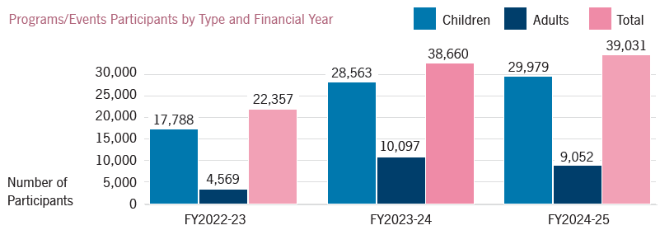
Transcriber’s Note: The bar graph above shows the number of participants who attended library programs/events in each financial year. This data is presented in the following table.
Financial Year | Children’s Program Participants | Adults Program Participants | Total Number of Participants
FY2022-23 | 17,788 | 4,569 | 22,357
FY2023-24 | 28,563 | 10,097 | 38,660
FY2024-25 | 29,979 | 9,052 | 39,031
Participation in library programs has surged, especially among children, with adult engagement also showing strong growth.
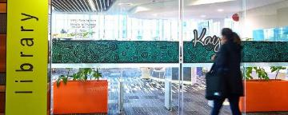 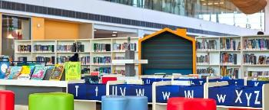
Images: Success library, Success.

Building Community Across Ages
Youth services in Cockburn reached new heights of engagement. The Cockburn Youth Centre in Success has become a vibrant second home for many of our young people, with an average of 65 youth visiting per day for recreation, workshops and socialising. Throughout the year, the centre recorded 17,693 attendances – a record number, reflecting program diversity from after-school drop-in fun to structured activities like art classes and drama club. We continued our tradition of the Youth “Outrage” School Holiday Program, offering affordable excursions during holidays, which ran at an impressive 93 per cent capacity on average. Whether it was paintball, trampolining or a day at Adventure World, hundreds of teens enjoyed safe, supervised thrills and new friendships each school break. A jewel in our youth events calendar, the Youth Pride Ball, saw its seventh iteration in October, with over 200 LGBTQIA+ young people and allies dressed in their fabulous best to celebrate diversity in a supportive space. With music, dancing and plenty of rainbow decorations, the Pride Ball has grown to be the largest event of its kind in the region, highlighting Cockburn Youth Services’ commitment to inclusion and wellbeing for our young community. The year also brought external recognition for our youth: members of the Cockburn Youth Advisory Collective (YAC) were finalists and winners in several awards, including one member named a Young Carer of the Year finalist for Western Australia. These young leaders meet regularly to advise the City and initiate projects; for instance, they helped design content for the youth zone at the Spring Fair, volunteered at NAIDOC and Reconciliation Week events and had input in the Strategic Community Plan 2025-2035.
- 17,693 attendances at the Cockburn Youth Centre.
To broaden support for at-risk youth, the City successfully obtained a State Government grant to extend the Youth Outreach Program until 2027. Our Youth Outreach team does vital work engaging with vulnerable or disengaged young people in public spaces, helping connect them to education, training or counselling. The extra funding ensures continuity of this service, which has been credited with reducing antisocial behaviour and improving outcomes for dozens of local youths.
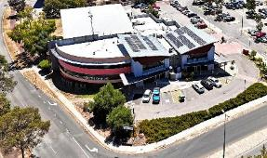 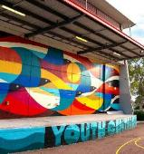 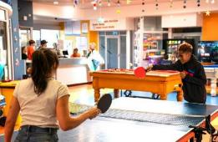
Images: Cockburn Youth Centre, Success.
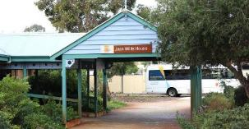
Image: Cockburn Care, Hamilton Hill.
For our older residents, Cockburn continued to offer a wide array of services to keep seniors active, social and supported. The Cockburn Seniors Centre in Spearwood saw 44,933 attendances this year after a refresh of its programming. We reviewed the activity schedule and introduced new classes aligned with changing member interests. This responsiveness resulted in higher utilisation of the Centre’s spaces and consistently strong participation in health workshops, technology lessons and excursions. Meanwhile, Cockburn Care (the City’s aged care service) underwent a major transition in response to national reforms. The City made the carefully considered decision to withdraw from Home Care Package and NDIS services in mid-2024. Our priority was a smooth, client-centred transition: Cockburn Care staff worked closely with each senior and their family to find alternate quality providers, and the Department of Health praised our transition plan for providing "person-centred approaches". Cockburn Care continues to deliver on key areas such as social support, transport, respite, domestic assistance and centre-based group activities including dementia-specific social groups.
- 44,933 attendances at Cockburn Seniors Centre.
The City’s Financial Counselling service also had a significant win, advocating on behalf of struggling households and small businesses. Our skilled financial counsellors managed to negotiate over $640,000 in waived debts and bills for Cockburn residents over the year, a lifeline for many facing hardship in the current economic climate.
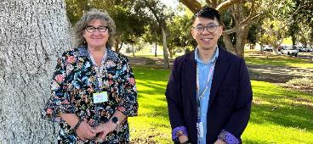
Image: Colleen Crowley, Coordinator Cockburn Financial Counselling; and Andre Chung-Wei Chan, Financial Counsellor.

Cockburn ARC
Cockburn ARC (Aquatic and Recreation Centre) is a state-of-the-art sport and leisure facility located in Cockburn Central, Western Australia. As one of the largest and most advanced centres of its kind in the country, it serves as a vibrant hub for health, fitness and community engagement across Perth’s southern metropolitan region.
The facility features:
- A 50-metre outdoor heated pool and a 25-metre indoor heated pool
- An expanded fully equipped gym with dedicated studios for group fitness, mind-body, and group cycling classes
- Wellness lounge, hosting a warm water pool, spa, sauna and steam room
- A six-court indoor sports stadium
- Interactive water play areas and water slides
- The Swim ARCademy, offering year-round swimming lessons for all ages
- Specialist amenities including a crèche, indoor play centre, and birthday party rooms
- Meeting rooms and a centrally located café
- Cockburn ARC is also home to the Fremantle Dockers’ training and administration headquarters, further enhancing its profile as a premier destination for sport and recreation.

Annual Performance Summary

Total ARC Visits
The centre continues to attract a growing number of visitors each year, reflecting its popularity and the value it provides to the community.
This steady increase in visitation highlights Cockburn ARC’s role as a key community asset, supporting active lifestyles and social connection.
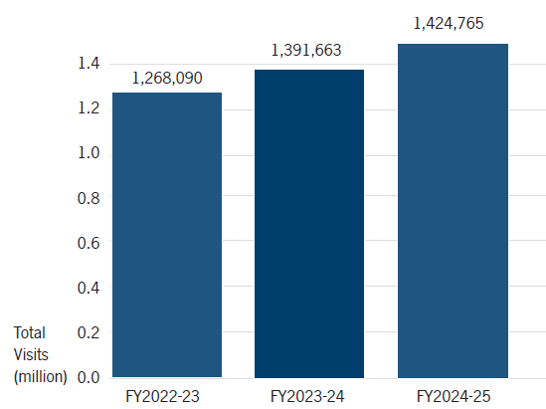
Transcriber’s Note: The bar graph above shows the total number of visits to Cockburn ARC in each financial year. This data is presented in the following table.
Financial Year | Total ARC Visits
FY2022-23 | 1,268,090
FY2023-24 | 1,391,663
FY2024-25 | 1,424,765

Health and Fitness Memberships
Membership growth in the Health and Fitness category demonstrates the centre’s strong appeal and the effectiveness of its programs and facilities.
The 15 per cent growth over three years reflects sustained interest and satisfaction among members.
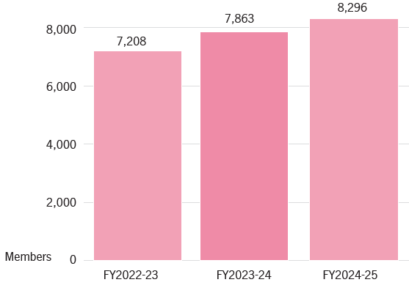
Transcriber’s Note: The bar graph above shows the number of Health and Fitness members in each financial year. This data is presented in the following table.
Financial Year | Members
FY2022-23 | 7,208
FY2023-24 | 7,863
FY2024-25 | 8,296

Swim School Memberships
The Swim ARCademy continues to be a cornerstone of the centre’s offerings, with consistent growth in enrolments.
This upward trend underscores the importance of accessible, high-quality aquatic education for families in the region.
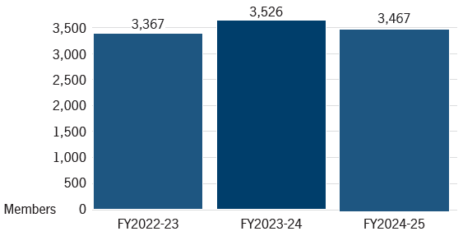
Transcriber’s Note: The bar graph above shows the number of Swim School members in each financial year. This data is presented in the following table.
Financial Year | Members
FY2022-23 | 3,367
FY2023-24 | 3,526
FY2024-25 | 3,467
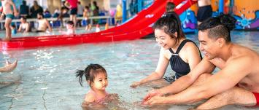 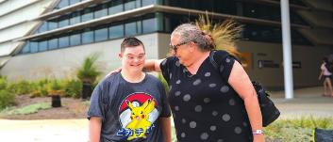
Images: Cockburn ARC, Cockburn Central.

Investing in Sports, Recreation and Safety Infrastructure
The City knows that quality infrastructure underpins great communities. In 2024-25 we made significant investments in sporting facilities, parks and safety improvements, to enhance community wellbeing. A major project completion was the Malabar Park BMX & Community Facility redevelopment in Bibra Lake, a multi-year $8.9 million project delivered in late 2024. After five years without a home track, the Cockburn BMX Club finally moved into this state-of-the-art venue, which includes a Union Cyclist International (UCI) championship-standard BMX racing track, a five metre start ramp for training and events, new floodlighting and a spacious clubroom shared with community group Friends of the Community Inc. The surrounding public open space has been revamped with a free-access pump track, playground, BBQ area and amenities, making it a family-friendly recreation hub even outside of BMX training times. The facility was quickly lauded as “the best BMX track in WA” by riders, even attracting visits from Olympic BMX medallists Saya Sakakibara and Romain Mahieu, who praised the track’s quality and its suitability for all skill levels, from beginners to elite. Since the park's opening, the Cockburn BMX Club’s membership has surged, and the club is already planning to host state and national BMX competitions, which will bring tourism and economic benefits to the City. This project is an example of Council’s commitment to cater for diverse sports and to activate community spaces; it also showcases successful collaboration, with $100,000 in State grants and a contribution from the club assisting the City’s funding.
Our ongoing program of park improvements also saw nine playgrounds renewed across various suburbs in the City. Wherever possible, we incorporated inclusive and innovative design, ensuring people of all abilities can enjoy these spaces.
Upgrades to local sporting facilities progressed as part of our Community Infrastructure Plan 2024-2041. One notable achievement was completing the design and tender preparation for the Beale Park redevelopment in Spearwood, a $15 million project to modernise this important community facility. Following extensive community consultation and planning, Cockburn Council approved the master plan and funding, including a $1 million state grant. The redevelopment will deliver a brand-new, larger clubhouse with six unisex changing rooms, upgraded spectator areas, seven reconfigured pitches with improved drainage, and more parking. This will support the growing Cockburn City Soccer Club and broader resident use. Early works begin in late 2025, aiming for completion by the 2027 season. Similarly, in Success, we endorsed a $26 million Success Regional Sport & Community Reserve Master Plan, which outlines staged upgrades including additional netball courts, a new multipurpose community building, rugby field enhancements and new parking bays. This plan, developed with input from local clubs and residents, will guide development of the Success sports complex as the surrounding population grows, ensuring facilities keep pace with demand.
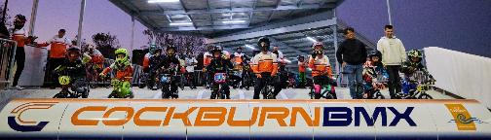
Image: Malabar Park BMX & Community Facility opening – June 2025.
The City completed refurbishment of the Memorial Hall forecourt and World War I memorial in Hamilton Hill. This included cleaning and restoring the cenotaph, installing new up-lighting, and expanding the paved area to safely accommodate the hundreds of attendees who gather there for ANZAC Day and Remembrance Day services. The upgrades were finished just in time for Memorial Hall’s 100th anniversary celebrations in March 2025, where the Governor of WA joined the Mayor and community in marking the occasion. The spruced-up space has not only enhanced the dignity of our commemorations but also provides a lovely civic plaza for markets and community events year-round.
Community safety infrastructure received a boost as well. In October 2024, the City’s community safety service CoSafe completed its transition from a contracted model to a fully in-house City-run team. This change has allowed for better trained officers, improved responsiveness and a more integrated approach with WA Police and our CCTV network. With stable staffing and a focus on professional development, CoSafe delivered outstanding results, attending over 33,000 requests during the year (ranging from patrols to responding to incidents), with an average response time of just 18 minutes and a customer satisfaction rating of 9.1 out of 10. Residents have commented on feeling safer with CoSafe’s visible presence, whether it’s the 423 targeted patrols conducted around schools at pick-up/drop-off time (a 350% increase on the previous year) to deter unsafe driving, or the late-night coastal patrols that successfully reduced illegal camping along our beaches by 90% (from around 20 caravans at any one time to just one or two). The City also collaborated with WA Police on community safety forums and Neighbourhood Watch initiatives, promoting messages like home security and reporting suspicious activity, emphasising that safety is a shared responsibility and safety in numbers yields results.
- 33,000+ CoSafe requests handled, with an average 18-minute response time and 9.1/10 satisfaction rating.
In emergency preparedness, Cockburn’s Bushfire Risk Management team updated the City’s Bush Fire Response Plan and successfully rolled out the new Bush Fire Brigades Local Law 2025, reflecting modern best practices and clear requirements for property owners in bushfire zones. We constructed a much-needed storage and equipment shed for the Jandakot Volunteer Bush Fire Brigade, improving their readiness and response time for incidents in our semi-rural eastern areas. And in an example of regional cooperation, Cockburn hosted a joint training forum with the Kwinana Industries Council and neighbouring cities to plan for industrial emergency scenarios, a proactive step in protecting community safety around the south-west metropolitan corridor.
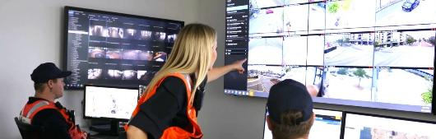
Image: CoSafe Control Room, Bibra Lake.

An Inclusive and Connected Community
Cockburn’s rich social fabric was strengthened through numerous initiatives celebrating diversity, improving accessibility and encouraging civic participation. Following input from our Aboriginal and multicultural advisory groups, the City introduced new events and programs to ensure everyone feels a sense of belonging. NAIDOC Week 2024 was a particular highlight: over ten days in July, the City hosted a diverse program embracing the theme “Blak, Loud and Proud”. We kicked off NAIDOC with a flag-raising ceremony at City offices attended by staff, community members and Whadjuk Noongar Elders, including a Welcome to Country from Mitchell Garlett and a moving performance of the Nyungar hymn “Keep the Fire Burning”. Throughout the week, more than 60 Aboriginal and non-Aboriginal women came together for our Annual Women’s Day Luncheon, where influential First Nations speakers like Robyn Collard shared stories of strength and progress. The Mayor used the occasion to announce “Hello Monday Level-Up”, a new City-sponsored entrepreneurial mentoring program for local businesswomen (see Local Economy section) a fitting tribute during NAIDOC to the empowerment of Aboriginal and Torres Strait Islander women in Cockburn. Other NAIDOC events included children’s storytime sessions in our libraries, featuring Noongar language songs and dances for the little “djidi djidi” (willy wagtails) in our community and a special youth art project. The Fremantle Dockers AFL club even joined City staff for a tree-planting morning at Bibra Lake, planting 800 native seedlings as part of our revegetation efforts and symbolising our shared commitment to Country. The enthusiasm and turnout at NAIDOC events this year were outstanding, reflecting Cockburn’s pride in its Aboriginal heritage and the progress we are making together.
Multicultural inclusion was another priority. In March, during Harmony Week, Cockburn held its second annual Multicultural Mosaic Festival, now a signature event in our calendar. Treeby Reserve came alive with the sights, sounds and flavours of the many cultures that call Cockburn home. Several thousand people attended the free festival, enjoying an array of international food stalls and a nonstop lline-up of cultural performances from around the world. Highlights on stage included vibrant Bollywood and Latin dance troupes, an Italian community choir, traditional Vietnamese lion dancers, and the City of Cockburn Pipe Band showcasing Scottish heritage. Between performances, families strolled through a global marketplace of crafts and displays, children got henna paintings and tried origami, and our Youth Disability Advocacy Network set up a well-received Low Sensory Chill-out Zone, ensuring the festival was welcoming for people with sensory sensitivities. Mayor Howlett addressed the crowd to reaffirm that “everyone belongs in Cockburn”, aligning with the festival’s mission to celebrate diversity and foster cross-cultural understanding. The Multicultural Reference Group, comprised of local residents from various backgrounds, played a big role in planning the event. The City continued to invest in access and inclusion for people with disabilities. A major achievement was partnering with tech innovators Cérge to audit and promote the accessibility of four key City facilities (Cockburn ARC, Bibra Lake Regional Playground, Success Library and Cockburn Youth Centre). Cérge’s platform provides detailed “know before you go” information via a companion app and website, describing features like wheelchair access, quiet spaces, or Auslan-friendly services at each venue. By late 2025, these venues will be live on Cérge, enabling residents and visitors with disabilities to plan their visits to our facilities with confidence. This initiative was born from our Disability Access and Inclusion Plan, complementing physical improvements we’ve made, like installing an inclusive all-abilities carousel at Bibra Lake playground so children in wheelchairs can play side by side with others. It also adds to our inclusive programming, such as dedicated sensory-friendly sessions at events (like the Mosaic Festival’s quiet zone). We were proud to support events like the Cockburn Community Disability Expo in June 2025, where our staff and many service providers came together to showcase support options, equipment, and social groups for people with disabilities and their families. Dozens of attendees made new connections at the expo, illustrating the power of bringing community and services into one space. These actions reinforce Cockburn’s commitment to being an inclusive community where everyone can participate.
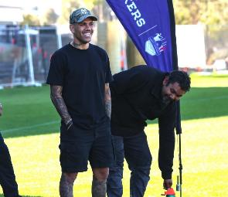 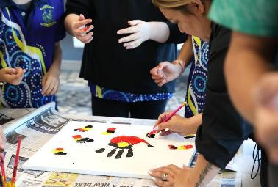
Image 1: NAIDOC Week with First Nations Fremantle Dockers player Michael ‘Sonny’ Walters and Aboriginal Reference Group chair Rev Mitchell Garlett at Beeliar Boodjar. Image 2: NAIDOC Week diverse range of activities – July 2024.
The vibrancy of community life in Cockburn was evident in the huge range of community events and celebrations held throughout the year. We brought back many much-loved traditions – often to record crowds. The Cockburn LIVE events season (September 2024-April 2025) attracted large crowds across 12 successful events, with an impressive 80 percent+ satisfaction rating from attendees. Building on previous years, sustainability efforts, all 12 Cockburn LIVE events achieved carbon neutrality and waste-wise practices. A diverse range of activities were offered including Side Splitter Comedy Festival, Fur Run, Mosaic Festival, and Coogee Live.
- 80+% attendee satisfaction across 12 Cockburn LIVE events.
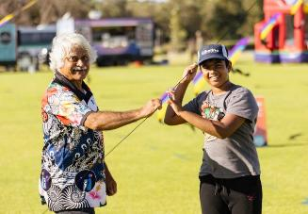 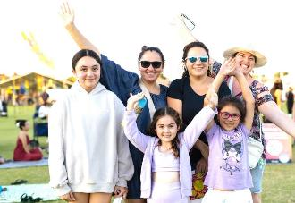
Images: Mosaic Festival – March 2025.
We reimagined familiar favourites and introduced new experiences, all free or low-cost for families feeling cost-of-living pressures. Some highlights included:
Teddy Bears’ Picnic:
Thousands of parents and children (and their favourite stuffed toys) filled Manning Park for this beloved annual outing in October. We had free entertainment from Sesame Street characters (Elmo was a huge hit), face painting, pony rides, an animal farm and toddler games. Our “Hello Baby” corner provided new parents with info on local parenting support services.
Makuru Arts Festival:
The inaugural Makuru Arts Festival brought art and life to Memorial Hall in June, presenting ten events spanning theatre, film, live music, immersive experiences and exhibitions. The festival celebrated the highest quality of Western Australian art with a mission to make the arts accessible for all. Across the program, attendance averaged 95 per cent, employing 55 artists, including 17 local to Cockburn. Proving a popular new event on the calendar, Makuru will return in 2026.
- Over 70,000 people enjoyed free family events, from Teddy Bears’ Picnic to Beeliar Sun Sets.
Cockburn Rotary Spring Fair & FROSH Youth Festival:
Manning Park was packed on 27 October for the Spring Fair’s 25th anniversary, run in collaboration with the Rotary Club of Cockburn. Families enjoyed an old-fashioned fair day with market stalls, sideshow alley rides, delicious food trucks, and live local bands. The evening culminated in a spectacular drone light show under the night sky, which left the crowd in awe. Importantly, the event is a fundraiser: Rotary raised around $16,000, which goes straight back into community projects like school literacy programs and local Christmas appeals. Adjacent to the main fair, our FROSH Youth Festival offered free activities for teenagers – a silent disco, gladiator inflatables, a dunk tank and circus skills workshops kept young people entertained and engaged in a safe, supervised setting. This partnership event embodies community spirit at its best, with the City supporting Rotary’s charitable work while providing an inclusive, fun day out for everyone.
Cockburn LIVE:
Cockburn LIVE is the City of Cockburn’s flagship events program, delivering a diverse calendar of free, family-friendly, and culturally enriching experiences across the community. From large-scale festivals to intimate concerts and themed gatherings, Cockburn LIVE celebrates local talent, fosters community connection, and enhances the vibrancy of public spaces throughout the year.
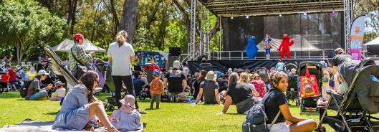
Image: Teddy Bears Picnic at Manning Park, Hamilton Hill – October 2024.

Annual Performance Summary
Despite challenges posed by COVID-19 restrictions in the earlier years, the Cockburn LIVE series has shown strong recovery and growth. Below is a summary of attendance across key events over the past four seasons.

Cockburn Live Series Attendance by Events and Year
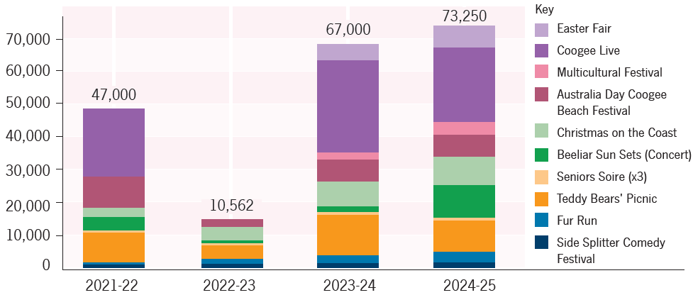
Transcriber’s Note: The bar graph above shows the attendance at Cockburn Live series events in each financial year. The following events are counted: Easter Fair; Coogee Live; Multicultural Festival; Australia Day Coogee Beach Festival; Christmas on the Coast; Beeliar Sun Sets (Concert); Seniors Soire (×3); Teddy Bears’ Picnic; Fur Run; Side Splitter Comedy Festival. The graph also provides a visual breakdown of attendance at each event in each year; however, as a linear scale with intervals of 10,000 is used and specific numerical data has not been included, we have opted to list the four most popular events (or five where there appeared to be a tie) in each year. This data is presented in the following table. Please contact City of Cockburn for more information.
Financial Year | Total Attendance | Top 4 Events
2021-22 | 47,000 | - Coogee Live  - Australia Day Coogee Beach Festival  - Teddy Bears’ Picnic  - Beeliar Sun Sets (Concert)
2022-23 | 10,562 | - Christmas on the Coast  - Teddy Bears’ Picnic  - Australia Day Coogee Beach Festival  - Fur Run / Side Splitter Comedy Festival
2023-24 | 67,000 | - Coogee Live  - Teddy Bears’ Picnic  - Christmas on the Coast  - Australia Day Coogee Beach Festival
2024-25 | 73,250 | - Coogee Live  - Teddy Bears’ Picnic  - Beeliar Sun Sets (Concert)  - Easter Fair / Australia Day Coogee Beach Festival
Cockburn LIVE will return with an exciting line up for the 2025-26 financial year, and residents can subscribe to the Soundings newsletter for updates or visit the website.
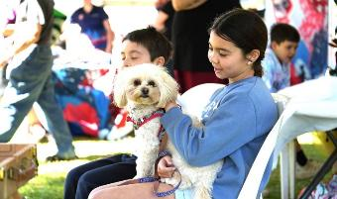 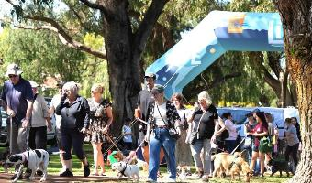 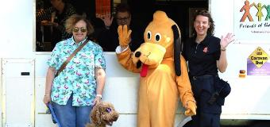 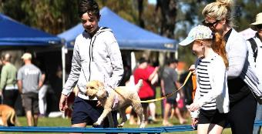
Images: Fur Run at MacFaull Park, Spearwood – September 2024.

ANZAC Youth Parade & Service
A particularly poignant event was our ANZAC Youth Parade in April 2025, the twenty-fourth year we have held this unique tribute. More than 1,350 students from 35 local schools marched proudly through Spearwood to RSL Memorial Park alongside teachers, parents, and veterans. The students then participated in a commemorative service and laid wreaths at the Field of Poppies. This event, recognised as the largest dedicated ANZAC youth parade in Australia, instils respect and remembrance in our young people. It involves massive coordination, road closures, rehearsals with school captains, and collaboration with the RSL, but the sight of our youth honouring service and sacrifice makes it profoundly worthwhile. Adding to the experience, the crowd was treated to stirring music from the Scotch College and Cockburn Pipe Bands and the emotional sound of a bugler playing the Last Post. Fostering intergenerational connections and civic pride, the ANZAC Youth Parade is a cornerstone of Cockburn’s community calendar.

Thanking our volunteers
We also took the time to honour the volunteers and unsung heroes who make our community strong. On 5 December 2024 (International Volunteer Day), the City hosted a Volunteer Recognition Sundowner that brought together 131 volunteers from 40 different Cockburn community groups. This special evening, attended by Council members and the CEO, gave thanks to those who coach our kids’ sports, plant trees in our parks, run community pantries, support seniors, and so much more. Heartfelt speeches and certificates of appreciation highlighted stories like those of Maureen Fisher-Sim, a lifelong volunteer whose contributions span decades and was later named Cockburn’s Citizen of the Year in January 2025. In the lead-up to WA Day, we also announced the 2025 Community Citizen of the Year Awards, celebrating exceptional individuals and groups. From a passionate youth advocate improving life for LGBTQIA+ young people to a Spearwood senior who has volunteered at a social centre for 32 years to the hardworking Treeby Community Association (winners of the Active Citizenship – Group award) combating social isolation with free events, their stories were shared widely to inspire others. Cockburn’s volunteers contribute over 25,000 hours of service annually. By publicly recognising their efforts through awards, local media, and our own communications, we hope they feel valued and motivated to continue and that others are encouraged to step up and volunteer too. The City’s Cockburn Volunteer Centre remains a key resource, having this year streamlined volunteer management processes to better connect people with opportunities across our community.
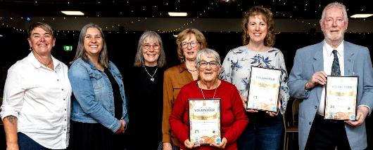
Image: Cockburn Volunteer Awards – May 2025. (Left to Right) Robyn Walsh; Kylie Hosking; Christine Duckham; Helen Peerless, Sally Marsh; Leanne Stickland; and Mike Graham.

Celebrating Heritage and Culture
Cockburn’s commitment to community extends to honouring our heritage and cultural life, recognising that a community’s soul is in its history and shared stories. In 2024-25 we undertook several initiatives to celebrate Cockburn’s cultural heritage and to support creative expression.
Memorial Hall in Hamilton Hill, our iconic arts and culture venue turned 100 years old in 2025. To commemorate this centenary, the City organised a suite of activities: on 21 March (exactly 100 years since the laying of the foundation stone by community champion Maud Winfield in 1925) we held a community High Tea and Heritage Exhibition. A special centenary plaque was unveiled by the Governor of WA, the Honourable Chris Dawson, alongside the Mayor. Guests marvelled at a display of historical photos and memorabilia, including the original program from the hall’s grand opening in 1925 and a community-embroidered tablecloth was on display.
The weekend continued with a Friday Night Music event welcoming the wider community and a Saturday program of History Talks reflecting on the hall’s enduring legacy. The celebrations were by a commissioned photographic exhibition, The Wisdom Keepers, featuring 11 Cockburn residents, honouring their stories and contributions to the community.
This exhibition, produced by photographer Nic Duncan and writer Meg Anderson, was a beautiful tribute to our local keepers of wisdom whose stories were captured in accompanying text, and drew admiration from visitors. The hall’s centenary also coincided with the launch of the City’s inaugural Arts Hall of Fame. After years of planning and community input, the Hall of Fame was established to honour Cockburn’s outstanding contributors to the arts from visual artists and musicians to actors and writers. Announcing the City’s inaugural Arts Hall of Fame inductees as part of the Makuru Festival in June was a fitting way acknowledge to their contribution to the arts in Cockburn.
The City’s annual Show Off Art Exhibition which provides a professional showcase for local artists marked its own milestone: 2025 was the 20th edition of Show Off. Fittingly, it was our largest exhibition yet, featuring 92 Cockburn artists and craftspeople across all disciplines. This included works by internationally acclaimed painter Trevor Vickers, a Hamilton Hill resident who has exhibited every year since Show Off began in 2003. The City’s support for local art continued beyond the exhibition walls too: we facilitated four new community murals in Bibra Lake, Hamilton Hill and Atwell this year, working with residents’ groups and talented artists like the “Lora Flora” collective to bring colour and storytelling to public spaces. Depicting themes from native wildlife to historical figures, these murals have brightened public spaces and community centre facades, and instilled pride in those neighbourhoods. We backed these projects with over $62,000 in cultural grants, empowering the community to drive beautification of their local areas.
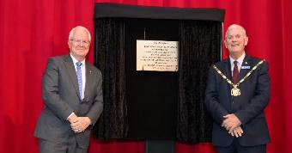 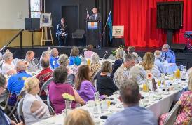
Images: Memorial Hall turns 100 event – March 2025. Governor General Chris Dawson and Mayor Logan Howlett.
The Azelia Ley Museum attracts over 1,500 visitors each year, offering an engaging insight into the region’s rich heritage. Housed within the historic Azelia Ley Homestead, the museum showcases a diverse collection of artefacts, photographs and stories that reflect the early life and development of the local community. Each year, around 110 people attend the popular annual High Tea, held as part of the National Trust WA Heritage Festival, further highlighting the museum’s role as a vibrant cultural hub celebrating history, tradition and community connection.
The City of Cockburn’s Local History Service plays a vital role in preserving and sharing the region’s rich heritage. To date, the service has recorded 13 oral histories and collected a further seven, capturing the stories and experiences of local residents. The collection also includes approximately 5,414 historical photographs, among them a significant archive of around 5,000 photos and videos documenting the Roe 8 protests – an important chapter in Cockburn’s contemporary history.
The City also upheld civic traditions that bind the community. We hosted 12 Australian Citizenship Ceremonies, welcoming hundreds of new citizens from dozens of countries who have chosen to make Cockburn their home. The biggest ceremony took place on Australia Day 2025 at the City of Cockburn administration building, a moving event where 97 individuals and their families celebrated becoming an Australian citizen. Our Australia Day program also included festivities at Coogee Beach and the Community Citizen of the Year Awards, where everyday heroes received deserved accolades from the City and their peers.
Finally, to promote community health and safety awareness, we delivered numerous free workshops and pop-ups. The City’s Health Promotion team offered 1,166 free health checks at events throughout the year – these quick screenings for blood pressure, cholesterol, and diabetes risk (using Diabetes Australia’s criteria) served as a friendly check-in on residents’ wellbeing. Many attendees were grateful to discover health issues early or get referrals to free local exercise classes. The City’s Community Safety and Emergency Management teams engaged residents through forums on topics like bushfire preparedness, home security and storm season readiness. In May, we partnered with our Resident Groups Network to run a scenario-based workshop on local emergency risk management, which sparked keen interest and promises of future collaborative planning with community leaders.
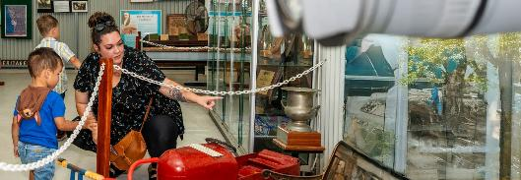
Image: Azelia Ley Homestead Museum, Manning Park, Hamilton Hill.
In conclusion, the City’s work in the Community, Lifestyle and Security outcome area this past year has been comprehensive and impactful. We have strengthened community bonds through inclusive events and recognition programs, enhanced wellbeing with new services and thriving facilities, and improved safety and amenity via targeted infrastructure and outreach. We have listened to our community – whether youth or seniors, business owners or cultural groups – and responded with initiatives that reflect their aspirations. By doing so, we continue to build a Cockburn that is safe, healthy, caring and fun – a community where everyone can live their best life.

Disability Access and Inclusion Plan (DAIP)

Implementation Report
The Disability Services Act 1993 (WA) requires all WA local governments to develop a Disability Access and Inclusion Plan (DAIP). The progress of the DAIP is reported annually to the Department of Communities. Please see the City of Cockburn Disability Access and Inclusion Plan at: www.cockburn.wa.gov.au/DAIPlan
The City’s current DAIP 2023-28 shows our commitment to creating an accessible and inclusive community for everyone. The DAIP provides a framework for addressing six outcome areas:
- Services and events
- Facilities and buildings
- Information
- Customer service
- Complaints and public consultation
- Employment opportunities

Outcome 1: People with disability have the same opportunities as other people to access the services of, and any events organised by, the City of Cockburn.
Initiative | Action
International Day of People with Disability | The City of Cockburn continues to celebrate International Day of People with Disability (IDPwD).  On Saturday 7 December 2024, the event came to life with vibrant performances by artists with disability and showcased microenterprises led by individuals with disability, including a stunning community art piece created by local artist Courtney Smith. A young person with disability took on the role of MC, guiding the day with confidence and enthusiasm. The event also highlighted the success of the City’s inclusive music program, Wicked Wednesdays, which has been steadily growing since its launch in late 2022. The day served not only as a celebration but as a powerful reminder of the creativity, capability and contributions of people with disability within the community.
Wicked Wednesdays | The City offers an inclusive music program that continues to grow, with group members enjoying the opportunity to build their strengths in songwriting and production.
Wondermums | The City continues to support Wondermums, a community-led peer-to-peer group to support mothers of children with disability.
Major events | The City continues to provide Auslan interpreters at flagship events such as Cockburn LIVE, Beeliar Sun Sets Live Music, and Stitches comedy show. In 2024, the City enhanced inclusion by offering a number of low-sensory zones at major events; these were visited by a Lived Experience organisation, Youth Disability Advocacy Network (YDAN).

Outcome 2: People with disability have the same opportunities as other people to access the buildings and other facilities in the City of Cockburn.
Initiative | Action
Accessibility information | The City engaged with Cérge Companion Website and Companion App to develop information on the accessibility of four of our venues:  - Cockburn ARC  - Bibra Lake Regional Playground  - Success Library  - Cockburn Youth Centre.  Cérge is an innovative operating system that empowers venues to enhance accessibility for people with disability. Through its Companion Website and Companion App, Cérge provides structured, “know before you go” information. Cérge currently offers seven applications:  - AI wayfinding  - 360° virtual tour  - Audio guide  - Accessibility guide  - Visual story and sensory guide  - Communication board  - Keyword sign board.  By addressing systemic barriers, Cérge fosters a welcoming environment, ensuring everyone can confidently participate in community life, tourism and leisure activities. The venues will go live on the website and app in late 2025.
Bibra Lake Regional Playground | The City continues to expand the accessible facilities in the City of Cockburn including accessible playgrounds, changing facilities and storage facilities for mobility devices. In 2024-25 the City purchased an accessible rocker which is located at Bibra Lake Regional Playground.
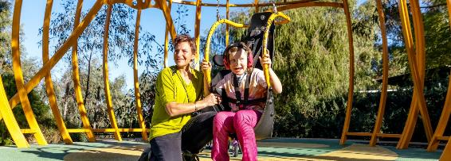
Image: Bibra Lake Regional Playground, Bibra Lake.

Outcome 3: People with disability receive information from the City of Cockburn in a format that will enable them to access the information as readily as other people.
Initiative | Action
Accessible information | The City continues to update documents on our website to ensure they are accessible to people with disability.  The City’s Disability Access and Inclusion Officer and Service Manager Communications and Engagement also held several ad hoc training sessions on accessible communication, including presenting to the Group Managers team.
Digital accessibility | The City continues to involve staff in the City’s website on WCAG standards. In 2025 the staff attended VisAbility’s Web Accessibility Camp.
Style Guide | The City’s Style Guide has been updated to include the most current information on making information accessible.

Outcome 4: People with disability receive the same level and quality of service from the staff of the City of Cockburn as other people.
Initiative | Action
Learning and development | The City of Cockburn enhanced disability awareness through a combination of mandatory and bespoke training, resulting in positive cultural and practice changes. Mandatory sessions, delivered by lived experience advocate Ben Sgherza, improved staff confidence in engaging with people with disability. Bespoke training for leaders, Rangers, recreational program delivery staff, and Co-Safe staff addressed inclusive communication, assistance animals, and accessible service delivery.  A key innovation was a lived experience panel on hidden disabilities, attracting over 70 staff and supported by co-designed learning resources. This authentic, person-led approach deepened understanding and empathy.  Training outcomes included increased awareness, confidence and satisfaction, with staff applying learnings to workplace practices and requesting further training, including requests to look specifically at engaging people with psychosocial disability.
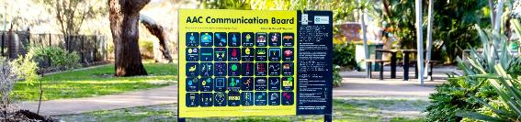
Image: AAC communication board at Bibra Lake Regional Playground.

Outcome 5: People with disability have the same opportunities as other people to provide feedback, make complaints and participate in any public consultation at the City of Cockburn.
Initiative | Action
Disability Reference Group | The City continues to support the Disability Reference Group (DRG). In 2024-2025 the DRG was able to provide feedback on:  - Strategic Community Plan and Public Open Space Engagement  - Draft Coogee Beach Land Use Master Plan  - Bicycle and Walking Network Plan.
Customised employment | The City is currently exploring employment opportunities for people with disability in the City through traineeships, job carving and role creation.

Outcome 6: People with disability have the same opportunities as other people to obtain and maintain employment with the City of Cockburn.
Initiative | Action
Diversity and Inclusion | The City continues to implement the Diversity and Inclusion Plan, with information provided to staff on employment for people with disability to mark International Day of People with Disability.
Customised employment | The City introduced training on customised employment to people leaders.
Volunteering | The City’s Volunteer and Resource Centre works from a person-centred perspective, working 1:1 with people with disability to create a customised role that is matched to their strengths and interests. The City has experienced remarkable success with this approach, with volunteers moving from being supported in the role to working independently.
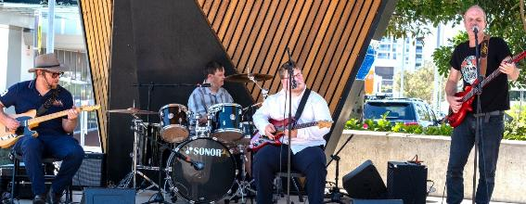
Image: International Day of People with Disability – December 2024. Wicked Wednesday Band (Left to Right) Ben, Paul, Caleb and Carus.

Community Satisfaction
The Community, Lifestyle, and Security Strategic Outcome is of utmost importance to the Cockburn community, reflecting its commitment to safety, belonging and vibrant communal spaces. Residents place a high value on having accessible areas for activities such as dog parks, BBQs and exercise, which foster connections among neighbours.
Feedback from the community highlights a strong desire for enhanced neighbourhood safety and personal security, both of which are critical to improving liveability. Currently, the metrics related to these areas are below the desired levels. Addressing these concerns through improved security measures and expanded social infrastructure, such as recreational facilities and community programs, will help create a safer and more inclusive environment for all residents. Through collaborative efforts and targeted initiatives, we can enhance the community’s overall quality of life and sense of security.
Community Lifestyle and Security
- Cockburn: 6.6
- Western Australia: 6.7
- Australia: 6.7
Community, Lifestyle, and Security Strategic outcome metrics | Community satisfaction rating
Welcoming to all people | 7.7
There are people like me (age, gender, interests, ethnic backgrounds, etc.) | 7.6
Mix or diversity of people in the area | 7.4
Spaces suitable for specific activities or special interests (entertainment, exercise, dog park, BBQs, etc.) | 7.4
Free places to sit comfortably by yourself or in small groups | 7.2
Spaces for group or community activities and/or gatherings (sports, picnics, performances, etc.) | 7.0
Sense of belonging in the community | 6.9
Access to shared community and commercial assets (library, bike/car share, sport facilities/gyms, etc.) | 6.8
Spaces suitable for play (from toddlers to teens) | 6.7
Sense of connection to/feeling support from neighbours or community | 6.7
Physical comfort (including noise, smells, temperature, etc.) | 6.6
Child services (child care, early learning, after school care, medical, etc.) | 6.5
Sense of personal safety (for all ages and genders, day or night) | 6.5
Local community groups and organisations | 6.4
Family and community services (aged, disability and home care; protection and support services; etc.) | 6.2
Evidence of community activity (volunteering, gardening, art, community-organised events, etc.) | 6.1
Sense of neighbourhood safety (from crime, traffic, pollution, etc.) | 6.0
Cultural and/or artistic community | 5.3
Local history, historic buildings or features | 4.8
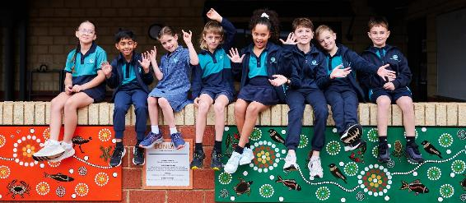
Image: Success Primary School students, Success.

Plan for the future
Cockburn’s community is at the heart of a rapidly changing social landscape. Western Australia’s population has surpassed three million and continues to grow faster than any other state, largely through migration. This growth brings cultural diversity, vibrancy, and economic opportunity but also amplifies pressure on housing and health, and social services. The City’s challenge is to plan inclusively for a population that is both expanding and ageing, ensuring infrastructure and services evolve to meet diverse community needs. As national housing affordability tightens, Cockburn will continue working with partners to facilitate affordable housing, promote accessible neighbourhood design, and ensure that growth supports liveability and wellbeing.
Cultural diversity is one of Cockburn’s defining strengths, and the City will build on this through targeted community engagement, inclusive communication, and celebration of shared identity. Programs supporting newcomers, multicultural events, and community leadership initiatives will strengthen cohesion and belonging. As technological change reshapes society, Cockburn will also expand digital inclusion and access to services to ensure all residents can participate in civic and economic life.
Community wellbeing will remain a core focus. The rise in cost-of-living pressures, mental health challenges, and social isolation seen nationally highlight the need for strong local networks, public spaces and recreation programs. The City will continue investing in active recreational facilities, community spaces and places, and social programs that encourage participation, volunteerism and connection. Through collaboration with local organisations and residents, Cockburn aims to nurture a community that is inclusive, connected and resilient – one where all people can live well and contribute to the City’s shared future.
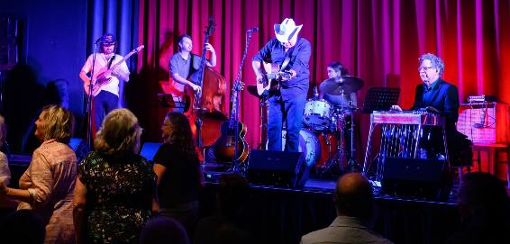
Image: Music @ The Mem (Memorial Hall), Hamilton Hill – November 2024.

City Growth and Moving Around Outcome
As Cockburn continues to grow, strategies ensure the City's infrastructure keeps pace. Key objectives include developing an attractive and connected built environment, establishing Cockburn Central as a major regional hub, and implementing an integrated and accessible transportation network.
Strategic outcome 4. City Growth and Moving Around:
A growing City that is easy to move around and provides great places to live.
Strategic objectives:
- An attractive, socially connected and diverse built environment
- Cockburn Central as the capital of the South Metro Region
- An integrated, accessible and improved transport network
Key statistics:
- Number of projects: 10
- Number of services: 4
- Full-time equivalent employees: 121.7
- Total cost: $50.9 million
Services:
- Infrastructure Assets
- Traffic and Major Projects
- Strategic Planning
- Development Services
Strategies, Plans and Frameworks:
- Citywide Infrastructure Plan
- Housing Affordability and Diversity Strategy 2018
- Integrated Transport Strategy 2020-2030
- Local Commercial and Activites Centres Strategy
- Local Planning Scheme
- Local Planning Strategy
- Master Plans and Revitalisation Strategies
- Parking Plan 2018-2028
- Road Safety Management Plan 2021-2030
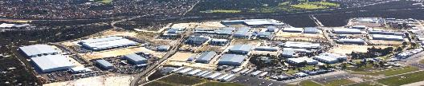
Image: Jandakot Airport, Jandakot.

City Growth and Moving Around 2024-25
In 2024-25, the City of Cockburn managed a period of dynamic growth with careful planning and major investments in infrastructure. Guided by our Strategic Community Plan outcome of “City Growth and Moving Around,” we focused on sustainable development, improved transport and connectivity, and maintaining our assets to a high standard. Despite challenges such as rapid urban expansion and evolving State planning reforms, Cockburn achieved important milestones: we delivered significant road upgrades, progressed long-term land use plans, and set the stage for future urban growth areas. Our approach balances development with liveability, ensuring new suburbs are well-planned, existing areas are renewed, and people can move around easily and safely.

Strategic Planning for Sustainable Growth
A major accomplishment this year was finalising the City’s Local Planning Strategy (LPS), the blueprint that will guide Cockburn’s development over the next decade and beyond. After extensive research and community engagement, the Local Planning Strategy was formally endorsed by the WA Planning Commission and published. This is the first comprehensive update to our land use strategy since the late 1990s and lays out a clear vision for accommodating approximately 40,000 new residents by 2036 in a sustainable way. Key features of the strategy include identified areas for infill housing (with a focus on transit-oriented development around Cockburn Central and Aubin Grove stations); new residential estates in remaining greenfield sites like Treeby; the strategic importance of major existing and emerging employment centres in Bibra Lake, Jandakot, Wattleup (Latitude 32) and Henderson; and the preservation of significant environmental areas and linking corridors.
The LPS seeks to provide a diversity of housing types aligning with our community’s changing needs and addresses infrastructure staging so that community facilities, parks and transport infrastructure keep pace with development. With the strategy in place, the City immediately began implementing its recommendations. One priority action was to simplify its local planning framework by rationalising old Structure Plans covering established suburbs. This recognised the significant growth experienced in recent decades with the purpose of these planning tools now being complete. Cockburn was one of the first councils to tackle this, after changes to State planning regulations meant that approximately 70 Structure Plans (all more than 10 years old) needed to be reviewed, extended or revoked. This required 17 scheme amendments to integrate relevant zonings and development controls into the City’s Local Planning Scheme, plus State Government approval to a further 30 Structure Plan extensions.
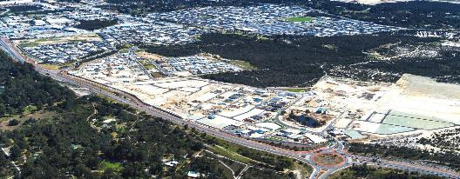
Image: Treeby.
This enormous task was done well ahead of the State Government’s imposed deadline. The Department for Planning Lands and Heritage even used our approach as a best-practice template to initially guide other local governments, before using it to inform the preparation of formal guidelines. This behind-the-scenes work ensures our planning framework remains efficient, up-to-date and user-friendly, making it easier to deliver quality development. It has also heavily informed our next major task: being to deliver a new planning scheme that further embraces opportunities to consolidate planning requirements and streamlines the development approval process wherever possible.
Building on the LPS, the City has also progressed master plans for specific locales. A notable achievement was delivering the Coogee Beach Land Use Master Plan after extensive community input. This plan, endorsed by Council in June 2025, sets 10 and 30-year visions for the popular Coogee Beach foreshore (Poore Grove to Peri End). During two phases of engagement, over 630 community members shared ideas and aspirations. The resultant plan balances protecting natural dunes and heritage (like the old Coogee hotel and lime kilns) with amenities the community wants, such as improved parking, safer pedestrian crossings on Cockburn Road, better cycle paths and lighting, and new recreational facilities. It also identifies sites for a Changing Places accessible restroom and a Nyungar “yarning circle” gathering space to honour First Nations culture. Short-term actions (costing ~$23 million) were mapped out, including replacing the aging Powell Road beach entry with a safer signalised intersection at Cockburn Road and Beach Road, which the City will advocate for as a priority with Main Roads WA. Medium-term, the plan envisions reconfiguring the holiday park and loop road to open up more public parkland by 2050. The Coogee Beach Master Plan provides a clear, community-backed blueprint to ensure this well-loved destination continues to meet recreational needs without spoiling its coastal character.
- 6 Road intersection safety upgrades completed in Bibra Lake, fully funded by State grants.
In managing development applications, the City maintained strong performance despite high volumes. We processed 936 development applications and 147 subdivision referrals. Hamilton Hill saw the highest level of infill housing development, indicating our revitalisation efforts in older suburbs are bearing fruit with sensitive medium-density projects. Nearly all applications were determined within statutory timeframes thanks to process improvements. The City also proactively initiated a planning scheme amendment to incorporate new State planning rules for short-term rentals (Airbnb-style accommodation). Cockburn was likely the first WA local government to draft such an amendment after the State announced new Short-Term Rental Accommodation regulations, demonstrating our agility in tackling emerging issues. Once gazetted, these scheme changes will bring it into alignment with new State-wide regulations that clarify when development approval is required, in addition to requiring holiday-home operators to register and meet management standards, providing the City with better data and means to encourage continued investment in a manner that minimises amenity impacts in residential areas.
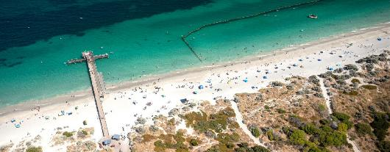
Image: Coogee Beach, Coogee.

Infrastructure Upgrades and Road Safety Improvements
The City made significant investments in transport infrastructure this year, upgrading roads and drainage to improve safety and cater for growth. Utilising external grants and careful project management, our Civil Infrastructure team successfully completed five major road rehabilitation projects co-funded through the State Metropolitan Regional Road Grants (MRRG) program. These included sections of Hamilton Road (Phoenix to Rockingham Rd), Rockingham Road (Marvell Ave to Troode St), Spearwood Avenue (Sudlow Dr to Cocos Dr), and North Lake Road (two segments south of Farrington Rd). Worn-out road surfaces were resurfaced, kerbs upgraded and intersections refreshed, extending the life of these key arterial roads and providing smoother, safer travel for thousands of motorists each day. By delivering all MRRG projects on time and within budget, Cockburn maintained its strong reputation with Main Roads WA, positioning us well for future funding support.
In addition, the City implemented six Low-Cost Urban Road Safety Program (Black Spot) upgrades in Bibra Lake fully funded by State Black Spot grants. These works, completed in mid-2025, installed raised safety platforms at five residential intersections with a history of accidents: Hope Rd and Gilchrist Ave, Parkway Rd and Dowell Pl, Parkway Rd and Homestead Ave, Parkway Rd and Marlene Way, and Colonial Dr and Needwell Rd. The raised plateaus at these intersections act as gentle speed humps, significantly reducing vehicle speed and helping eliminate the risk of right-angle crashes (which often occurred when drivers fail to stop). Early indications show driver compliance with the new platforms is high, and residents have reported feeling much safer walking or cycling through these intersections now. These targeted interventions exemplify how Cockburn is using data-driven approaches to improve road safety at a low cost. The City’s ability to leverage 100 per cent external funding is a great outcome for the community. Maintenance of existing assets was not neglected either. The City repaired over 390 potholes during the year, more than double the average of recent years. A particularly wet winter led to an uptick in road pavement damage, but our works crews responded promptly, often within 24 hours of a report. We proactively trialled new “crack mat” patching materials to better seal pothole repairs as a preventive measure. We also noted challenges like an increased volume of emergency call-outs for stormwater flooding and some contractor shortages; these are being addressed by scheduling more preventive maintenance before winter like extra road reseals and gully clearing. The City’s improved QR code reporting system at facilities (launched this year) is similarly helping identify issues like light outages or hazards faster; residents and staff can scan a posted QR code and instantly notify our maintenance team.
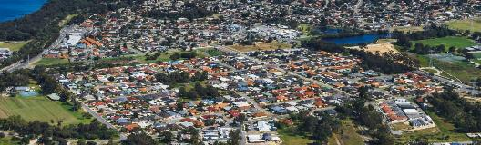
Image: South Lake.
A major focus was upgrading stormwater drainage in flood-prone areas to protect homes and improve climate resilience. The City completed a complex drainage expansion in Hamilton Hill (Stratton St and Hurford St), installing about 500m of new piped drains and multiple soakwell pits to achieve 1-in-100 year flood protection for that catchment. This $2.1 million project (with $1.04 million from the federal Roads to Recovery fund) was finished in October 2024. It not only solved chronic street flooding that regularly affected adjacent properties in winter but also upgraded aging infrastructure (several old asbestos cement pipes encountered were safely removed and replaced). Similarly, new high-capacity drainage pipes were constructed along Edeline Street and Hobley Way in Spearwood (approximately 360m total) after those areas experienced severe flooding in 2021. These works significantly increase stormwater capture and direct it to a retrofit stormwater basin at Scales Way, reducing flood risk to dozens of homes. In Spearwood’s Marvell Avenue area, where flash floods had occurred, the City installed 513m of new drainage pipes, 33 additional drainage pits and an underground stormwater detention system holding 657kL (equivalent to nine backyard swimming pools). These measures can contain intense rainfall runoff and release it slowly, preventing inundation of streets. As climate change brings more erratic heavy rain events, such upgrades are crucial for community safety.

Infrastructure Maintenance
On top of capital works, the City’s Transport and Traffic service handled daily demands of a growing city. They responded to 438 customer requests on matters like parking issues, speeding concerns and traffic signals. They also conducted numerous site investigations, resulting in measures like new line markings, traffic calming devices or warning signs where needed. The City updated and adopted a new Road Safety Management Plan to systematically address hazards and guide future black spot submissions. Efforts to promote active transport continued: we undertook community consultation for a new Bike and Walk Plan (integrated with a district traffic study), which will identify missing links and high-priority paths to encourage cycling and walking. We also saw the opening of the METRONET Thornlie-Cockburn rail line extension in July 2025 – a transformational public transport project connecting Cockburn Central to Perth’s southeastern suburbs.
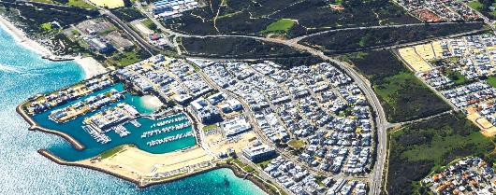
Image: North Coogee.
One particularly innovative trial was the use of artificial intelligence (AI) to assess road conditions. We equipped a City vehicle with high-resolution cameras and vibrations sensors and drove the entire 700km of our road network. The AI software automatically detected cracks, potholes and surface roughness, producing an objective condition score for each road segment. The results fed into our road rehabilitation program planning for next year. This technology, combined with local knowledge from our engineers, means we can better prioritise which streets need resurfacing versus which can wait, ensuring we direct funds to where they’re needed most. It’s also more efficient and safer than the old method of having staff manually walk or drive every street to note defects. Cockburn is one of the early adopters of this approach in WA, and it illustrates how we’re leveraging smart city tools to care for our assets.
Beyond asphalt and drains, City Growth is also about making Cockburn’s neighbourhoods more attractive and accessible. Our Parks and Environment teams planted 1,650 new street trees this year focusing on suburbs with low canopy cover like Treeby, Hammond Park and Spearwood. These plantings often coordinated with new footpath projects or road upgrades, and as they mature they will provide much-needed shade, reduce the urban heat island effect, and beautify local streetscapes. Tree requests have actually been so popular that we experienced minor delays keeping up with demand. To address this, we recruited additional arborists and set up a dedicated watering crew for young trees to ensure they survive summertime. We also completed several streetscape enhancement projects, including median gardens along major roads like Beeliar Drive, Discovery Drive and Farrington Road being rejuvenated with mulch to help beautify tired verges. These not only look more attractive but are also waterwise and low-maintenance, reflecting our sustainability values. Across Cockburn, nine local playgrounds were renewed with fresh equipment and rubber soft-fall surfaces, greatly improving play opportunities for young families. We also installed shade sails at four playgrounds (and replaced worn shade sails at two others) to ensure sun-safe play year-round. Connectivity for pedestrians and cyclists got a boost too. We built missing footpath links on several streets to create continuous walking routes to schools, shops and bus stops. These efforts contribute to our goal of a more walkable, bike-friendly city where people have real alternatives to driving.
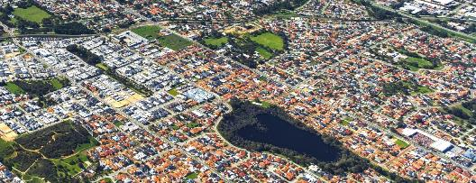
Image: Spearwood.

Managing Growth Challenges
With growth come challenges that the City is addressing head-on. Housing affordability and supply remain concerns – like much of Perth, Cockburn faces a tight housing market with low rental vacancy and rising prices. While our planning strategy provides for thousands of new dwellings, we’re mindful that economic factors (high construction costs, builder shortages) have slowed the delivery of some approved projects. We’ve responded by being flexible and solution-oriented: working with developers to stage projects more manageably, supporting modular and innovative construction methods that reduce costs, and advocating for State initiatives to stimulate building activity. We’re also pushing for diverse housing types, from apartments and townhouses to aged-care units, and our strategy encourages this mix, especially around town centres and transport hubs, to cater for young singles, families and seniors alike. To ensure new development pays its way, we made full use of our Development Contribution Plans (DCPs). Through DCPs, developers contributed over $6.7 million this year towards community infrastructure such as new ovals, roads, and community centres in growth suburbs. Notably, we delivered on promised projects like the community centre, clubrooms and oval at Frankland Reserve in Hammond Park, using DCP funds collected over recent years. We maintain transparency and rigour in utilising these contributions, upholding community trust that development growth helps fund the necessary infrastructure and doesn’t overburden existing residents.
The outlook for City Growth is forward-thinking and optimistic. With the Kwinana Freeway widening and METRONET Thornlie-Cockburn rail extension recently completed near Cockburn Central, we anticipate new transit-oriented development opportunities that will bring more housing and job options close to public transport. We’ve already seen increased interest from developers in sites around Cockburn and Aubin Grove Stations for mixed-use projects that appeal to commuters.
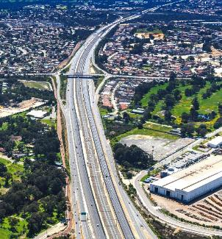
Image: Kwinana Freeway, Cockburn Central.
In summary, Cockburn balanced progress and preservation in managing city growth this year. We delivered tangible improvements in infrastructure and amenity, took strides in modernising our planning framework, and stayed responsive to community concerns about development. By continuing this integrated approach, combining hard infrastructure upgrades with sustainable planning and active community engagement, we are confident Cockburn will remain a city that’s easy to move around, pleasant to live in, and well-prepared for the opportunities and challenges of the future.

Building and Development Applications
In FY2025, the City issued 2,211 building permits with a total construction value of $645 million, reflecting a slight decrease in permit volume compared to FY2024 (2,251 permits) but a continued rise in the overall value of works. This increase was largely driven by growth in industrial developments, which more than quadrupled year-on-year. Residential activity remained steady, while commercial approvals saw a modest decline.

Building Applications
Building permit facts:
- 2,211 building permits issued
- $645 million – Total value of building works
Average issuance time for a building permit in 2024-25:
- 6 working days – Certified Building Permits
- 17 working days – Uncertified Building Permits
Year ending | Number of permits | $million Value | $million Fee | Residential | Commercial | Industrial | Other
30 June 2020 | 2,247 | 349 | 0.71 | 1,076 | 80 | 14 | 1,169
30 June 2021 | 3,444 | 616 | 1.24 | 1,993 | 121 | 9 | 1,321
30 June 2022 | 2,554 | 502 | 0.97 | 1,132 | 129 | 18 | 1,276
30 June 2023 | 2,167 | 410 | 1.42 | 832 | 225 | N/A | 1,054
30 June 2024 | 2,251 | 635 | 2.58 | 1,014 | 118 | 14 | 1,105
30 June 2025 | 2,211 | 645 | 2.70 | 1,034 | 100 | 68 | 1,009

Performance Notes
The volume of building permits issued in FY2025 remained strong and consistent with the previous year, driven primarily by residential and associated developments.
Certified building permits were processed within an average of 6 working days, and uncertified permits within 17 working days, representing a notable improvement on the previous year’s performance, despite ongoing staff shortages and high industry demand.
The City continued to meet all statutory timeframes under the Building Act 2011 (WA) and Building Regulations 2012 (WA).
A small proportion of applications exceeded the designated processing timeframes, including:
- Certified permits: 3%
- Uncertified permits: 2%

Industry Challenges
Across Western Australia, local governments continue to face a shortage of qualified building surveyors due to limited training pathways and the retirement of experienced professionals. With no accredited programs currently offered in WA, and building surveyor registration requirements under review, the industry anticipates further pressure on workforce capacity despite ongoing efforts to attract and retain talent.

Development Applications
Statutory Planning:
- 936 Development Applications Submitted
- 860 Development Applications Determined
- 698 applications were required to be determined within 60 days. The City determined 67.7% of those applications within the 60-day timeframe.
- 162 applications were required to be determined within 90 days. The City determined 60% of those applications within the 90-day timeframe.
- $438,600,925 – Total estimated development value of applications received
The City received one ‘outlier’ application worth $60 million. This coupled with the rise of construction costs and increased application numbers contributes to the marked increase in development value for this financial year.
State Government Development Assessment Panel:
- 11 Applications determined.
- 146 Days average time to determine.
- $61,449,001 – Total Estimated Value of Development Assessment Panel applications.
Subdivision Referrals:
- 147 Submitted.
- 133 Determined.
- 92 Subdivision Clearances submitted.
- 38 days – Average time to determine.
- $250,000 – Total estimated Clearance Application value.
- 1,510 – Total number of lots.
Subdivision type determined: 8 built strata, 40 green title, 85 strata title.
Application (other):
- 25 Local Development Plans received. 1
- 8 Written Planning Advice requests.
- 9 Liquor Licence Section 40 Certificates.
Technical Services:
- 29 Landscaping Plan applications received.
- 37 Civil (Engineering) drawings received.
Compliance (calendar year):
- 33 Direction notices served under the Planning and Development Act.
- 49 Proposed Building Orders issued under the Building Act.
- 17 Building Orders served.
Pool barrier inspections:
- 2,770 Inspections were conducted.
- 8,604 Pools were registered.
- 289 New pools registered.

Performance notes
The period reflected a high level of statutory planning activity, with 936 development applications submitted and 860 determined, demonstrating sustained development interest across the City. The total estimated development value exceeded $438 million, largely due to rising construction costs and a single major $60 million application at Cockburn Central.
Timeliness of decisions continues to be a key operational focus. Of the applications required to be determined within statutory timeframes, 67.7% were completed within 60 days and 60% within 90 days, indicating room for improvement but consistent with the broader regional trend of increased assessment complexity and workload.
The Development Assessment Panel (DAP) considered 11 applications with a combined estimated value of $61.4 million, taking an average of 146 days to determine, reflecting the larger and more complex nature of these projects.
In subdivision activity, 147 applications were referred and 133 determined, resulting in 1,510 new lots. The average determination time of 38 days demonstrates efficient coordination between the City and the Western Australian Planning Commission. A total of 92 subdivision clearances were processed, maintaining steady momentum in the delivery of new land supply.
Under Development Compliance, proactive enforcement continued, with 33 direction notices and 17 building orders served. The City’s pool safety inspection program remained robust, with 2,770 inspections conducted across 8,604 registered pools, including 289 new registrations.
Overall, this points to a busy and productive year for the Statutory Planning and Development Compliance, balancing a high volume of complex applications, strong development value, and consistent compliance activity.
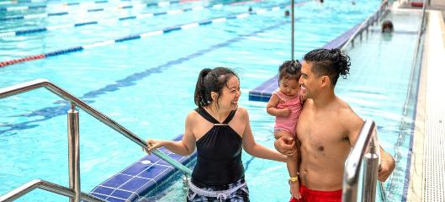
Image: Cockburn ARC, Cockburn Central.

Community satisfaction
The City Growth and Moving Around Strategic Outcome is vital to the Cockburn community, which highly values safe, accessible and well-connected neighbourhoods. While residents appreciate their proximity to local amenities and existing active transport options, there is a clear need for improved and safer access to both active and public transport. Overall, the community's feedback indicates that this outcome generally meets expectations, yet nurturing the existing strengths will further enhance ease of movement throughout the area.
Community engagement has highlighted the importance of specific attributes within this outcome, ranking it third out of five strategic priorities. Four out of the nine liveability metrics associated with this outcome were identified as key indicators of an ideal neighbourhood, with access to neighbourhood amenities and the safety of transport options being particularly valued. By acting on these insights and fostering ongoing community engagement, we can create a more liveable and connected Cockburn, enhancing the overall quality of life for all residents.
City Growth and Moving Around
- Cockburn: 7.1
- Western Australia: 7.1
- Australia: 6.9
City Growth and Moving Around outcome metrics | Community satisfaction rating
Connectivity (proximity to other neighbourhoods, employment centres, shops, etc.) | 7.6
Ease of driving and parking | 7.5
Range of housing types and sizes (houses, terraces, flats; number of bedrooms, etc.) | 7.5
Walking/jogging/bike paths that connect housing to communal amenity (shops, parks, etc.) | 7.4
Access to neighbourhood amenities (cafes, shops, health and wellness services, etc.) | 7.4
Quality of buildings (design and construction of homes, shops, schools, etc.) | 7.0
General condition of housing and other private buildings | 7.0
Access and safety of walking, cycling and/or public transport (signage, paths, lighting, etc.) | 7.0
Range of housing prices and tenures (low to high $, buy or rent, etc.) | 6.1

Plan for the future
The physical fabric of Cockburn is evolving rapidly as Western Australia transitions toward more compact, sustainable urban forms. State planning policy and the Perth and Peel @ 3.5 Million framework set ambitious infill targets, and Cockburn’s role is pivotal in accommodating higher-density housing and mixed-use precincts. The completion of the METRONET Thornlie-Cockburn Link strengthens the City’s connectivity, positioning Cockburn Central and surrounding suburbs as focal points for transit-oriented development. These opportunities bring vitality but also require careful management of infrastructure, parking, open space, and community amenity to ensure quality of life keeps pace with growth.
The City will focus on shaping places that are vibrant, inclusive and climate-responsive. Investment in public spaces, parks, plazas and community hubs will support social interaction, recreation and resilience to extreme heat. Integrating urban greening, shade will improve comfort and public health outcomes. Cockburn will also leverage smart city technologies to enhance planning, transport and utilities management, using data-driven insights to improve service delivery and reduce environmental impact.
Major state projects such as Westport in Kwinana and broader infrastructure investments will reshape the region’s industrial and transport landscape. While these will bring employment and growth, they also demand careful coordination to manage freight movement, environmental impacts and community expectations. The City’s forward planning will emphasise integration, aligning land use, transport and environmental management to deliver well-connected, resilient neighbourhoods. In doing so, Cockburn seeks to create places that reflect local identity, foster liveability, and balance economic opportunity with environmental stewardship.
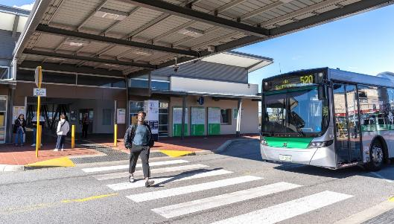
Image: Cockburn Central Station, Cockburn Central.

Listening and Leading Outcome
The City of Cockburn is committed to good governance and effective communication with residents. Best practices in governance and partnerships, high-quality community engagement, and fostering a culture of innovation and excellence within the City are core objectives.
Strategic outcome 5. Listening and Leading:
A community-focused, sustainable, accountable and progressive organisation.
Strategic objectives:
- Best practice governance, partnerships and value for money
- High-quality and effective community engagement and customer service experiences
- Employer of choice focusing on equity, innovation and technology
Key statistics:
- Number of projects: 4
- Number of services: 9
- Full-time equivalent employees: 159.1
- Total cost: $20.5 million
Services:
- Organisational Capability and Performance
- People Experience
- Communications and Engagement
- Information, Technology and Customer
- Business Systems
- Strategic Finance
- Property Services
- Procurement and Contracts
- Governance, Legal and Compliance
Strategies, Plans and Frameworks:
- Asset Management Strategy 2017-2024
- City Asset Management Plans
- Strategic Communications Framework
- Record Keeping Plan 2022
- ICT Strategies

Listening and Leading 2024-25
The City of Cockburn prides itself on practicing good governance, transparent leadership and continuous improvement, as encapsulated in our Strategic Community Plan outcome “Listening and Leading.” Over the past year, we focused on strengthening community trust through honest engagement, sound financial stewardship and a commitment to integrity in all our operations. We also invested in our people and modernised our systems to better serve the community. These efforts have solidified Cockburn’s reputation as a forward-thinking, accountable organisation – one that listens to its residents and leads by example in the local government sector.

Strong Community Engagement and Transparency
In 2024–25 the City took community engagement to new heights, ensuring residents have a real voice in shaping local decisions. After overhauling our engagement framework last year, we implemented those principles across all major initiatives – and it paid off with high participation rates and positive community sentiment. Cockburn’s approach was formally recognised when the City was named 2024 Australasian Organisation of the Year by the International Association for Public Participation (IAP2). This prestigious award chosen from entrants across Australia and New Zealand honoured Cockburn for embedding the IAP2 Core Values into our culture and projects. The judges highlighted how we genuinely empower the community, from seeking input at the earliest stages of projects to closing the loop by showing how feedback influenced outcomes. They pointed to our innovative “community engagement Olympics” exercise that trained 150 staff in best practices and our use of creative tools like the Community Quilt. (Residents contributed decorated fabric squares with their hopes for Cockburn’s future, literally weaving public input into a tangible artifact). The result has been a 92 per cent increase in residents interacting with our engagement portal since 2021, and more people feeling their voices are heard in Council decisions.
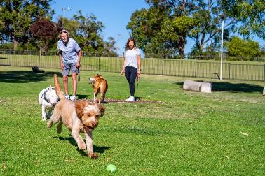
Image: Fenced dog exercise area at Jan Hammond Park, Success.
At the 19th of June 2025 Special Council Meeting, Council also adopted the City’s new Strategic Community Plan 2025-2035, our overarching blueprint for the next decade, after comprehensive community consultation efforts. We gathered input from over 1,800 residents via surveys (notably a comprehensive Liveability Study) and hosted dozens of workshops, pop-ups and even creative activities like a community quilt project, to capture the community’s vision. The resulting plan, under the banner “Cockburn: the best place to be”, reflects five key outcomes our community prioritised – Our Economy, Our Environment, Our Community, Our Places, and Our Governance – each with clear objectives and measures. To support this, we strengthened our Integrated Planning and Reporting framework, aligning the Corporate Business Plan, Long-Term Financial Plan and Workforce Plan closely with the new Strategic Community Plan.
- New Strategic Community Plan 2025–2035 adopted, shaped by strong community vision.
Elected Members demonstrated their commitment to good governance by reviewing and updating key policies. In May, Council endorsed an updated Elected Members’ Entitlements Policy to ensure Councillors have adequate support to perform their duties, reflecting contemporary expectations and recent legislative reforms. In March, Cockburn Council opted to begin payment of superannuation contributions for Elected Members ahead of the October 2025 mandatory start date, becoming one of the first councils in WA to do so. This decision, made in the spirit of fairness and to attract a diverse range of candidates to local government, will see Elected Members receive super from 1 February 2025. The City also maintained strong oversight via its Audit, Risk and Compliance Committee, which met regularly to review financial audits, the risk register, and statutory compliance returns. The year’s audits found no significant issues. Notably, an Office of the Auditor General performance audit on the City’s use of purchasing cards concluded with no evidence of misconduct or inappropriate expenditure, affirming our robust controls. We completed a triennial comprehensive review of our risk management system. Though our previous risk software vendor unexpectedly went into administration, we swiftly implemented interim solutions and are in the process of procuring a new enterprise risk system to go live next year. Throughout the transition, risk registers and incident reporting continued uninterrupted, demonstrating our resilience and focus on mitigation. Accountability to our community remains paramount. Public questions and motions from the Annual Electors’ Meeting were addressed openly and promptly.
Cockburn’s greatest asset is its people, the staff and volunteers who serve our community every day. This year, we renewed our focus on developing a positive, inclusive workplace culture that empowers our employees to do their best. We introduced “The Cockburn Way”, a refreshed Employee Code of Conduct co-created with staff input, which clearly articulates the values and behaviours expected in our workplace (integrity, teamwork, customer focus, and respect). To embed these values, we rolled out interactive training sessions and integrated the behaviours into performance discussions. Already, staff feedback shows improvement with our monthly “pulse” surveys throughout the year showing consistent gains in areas like communication, recognition, and belief in the City’s direction. In fact, an annual staff survey recorded a 12 per cent increase in employees who feel the organisation values diversity and inclusion and an 11 per cent jump in those who believe management listens to employee feedback, compared to the previous year. These metrics validate efforts we’ve put into internal engagement such as monthly all-staff forums hosted by the CEO and recognition initiatives, including annual Directorate Awards, that celebrate staff achievements, big and small.
The City also undertook a significant leadership restructure during the year, moving from seven divisions to five directorates to better balance portfolios, ensure alignment and sharpen focus on strategic priorities. While periods of change can be challenging, we managed the transition with clear communication and support. Two new Directors, Corporate and Systems Services (Carissa Bywater) and Community & Place (Kylie Johnson), were appointed, bringing fresh perspectives and complementary expertise to the Executive team. We also invested in leadership development for our existing managers and team leaders, introducing a Leadership Capability Framework and providing targeted training to build skills in areas like change management, adaptive leadership and project governance. These steps are ensuring our leaders are well-equipped to guide their teams through change while maintaining service excellence.
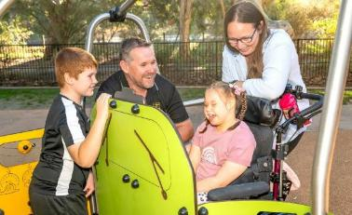 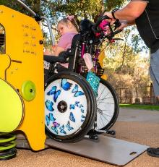
Images: Bibra Lake Regional Playground, Bibra Lake. New all-terrain vehicle springer with an integrated pull-out ramp system and room for up to eight kids, including one wheelchair user – May 2025. (Left to Right) Mathew; Ian Dalton; Hannah and Ali Dalton.
Supporting staff wellbeing remained a priority. We ran wellbeing workshops on mental health (aligned with R U OK? Day), and skin cancer checks, supported flexible work arrangements, and the City’s Diversity and Inclusion Plan continued driving positive change. We are proud that staff feel Cockburn is an inclusive workplace, our internal survey showed double-digit percentage improvements in staff agreeing that people of all ages, abilities, genders and backgrounds are valued equally here, compared to two years ago.
Our commitment to workplace health and safety yielded excellent outcomes as well. We implemented new risk-based pre-employment medicals and enhanced our new starter safety inductions, which have helped match new hires to the right roles with appropriate support. There was a strong focus on upskilling staff in hazard identification and incident reporting. Thanks to monthly safety themes and toolbox talks, we saw a 20% increase in hazard reports, giving us the chance to fix issues before they caused harm. These figures reflect a deepening safety culture where staff genuinely look out for one another and follow correct procedures.
Listening and leading also mean managing ratepayer funds responsibly and embracing innovation to improve service delivery. The City’s financial position remains sound. We kept our average residential rates increase modest, at 3.5 per cent, ensuring Cockburn’s typical rates (around $1,750 per household) stay below the metro average. At the same time, we delivered our full suite of services and a $65 million capital works program, meeting all key financial performance targets (debt levels remain low and asset renewal funding is on track). Strong budget discipline was maintained across all divisions: operating expenditure came in under budget and revenue slightly above projections due to higher facility usage and diligent cost control. We continued our policy of prioritising renew before new – investing in asset maintenance and renewal to extend the life of existing infrastructure, which is both cost-effective and ensures safety. This meant projects like resurfacing roads, replacing aging play equipment, and refurbishing community halls got precedence and were well-resourced.
The City is also embracing digital transformation to drive efficiency and better customer experience. A major milestone was the migration of our core enterprise software (finance, HR, asset management, etc.) to a modern cloud-based system (TechnologyOne SaaS). This complex transition was executed successfully with minimal downtime. The move has resulted in improved system performance and better data security and provides a foundation for more online self-service options for residents. Internally, we automated several workflows using Technology One’s Business Process Automation tool, which is already saving staff time on repetitive tasks.
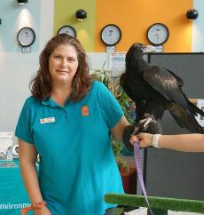 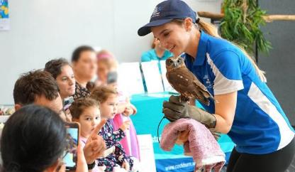
Images: Biodiversity Month at Success Library, Success – September 2024. Image 1: Rafeena Boyle, Environmental Education Officer with Micro the Wedge-tailed Eagle. Image 2: WA Birds of Prey Centre at Success Library.
We also overhauled our telephone system by rolling out Microsoft Teams Calling to all staff, replacing legacy desk phones. Now, whether in the office or working remotely, staff can make/receive calls from their City number on any device. Our Customer Contact Centre received a platform upgrade too, moving to a next-generation cloud contact centre (Genesys) with smart routing and real-time sentiment analysis. These features help us respond faster to peaks in demand and identify any emerging community concerns by analysing call trends. As a result, call wait times reduced and first-call resolution rates improved over the year. The City’s investment in ICT innovation extends to field operations. CoSafe officers were equipped with integrated mobile devices linked to our customer request system, enabling them to receive job dispatches and update jobs in real time, from the field. This has shortened response times and ensures better communication back to residents (for instance, an automatic SMS is now sent to a resident once CoSafe has checked on their concern). Our GIS team also launched a new public mapping tool on our website, allowing residents to more easily view property information, nearby amenities, and capital works in their area.
Cockburn continues to play a leading role in regional cooperation and advocacy. Mayor Howlett, now in his sixteenth year as Mayor, was honoured with a WALGA Life Membership in August, recognising over 24 years of service to local government and unwavering commitment to Cockburn. Under his leadership, and working closely with our Councillors, the City has been a strong voice on issues like outer harbour planning, public transport improvements, and securing a fair share of infrastructure funding for Perth’s south-west growth corridor. This year the City actively participated in the South West Metropolitan Alliance, collaborating with neighbouring councils (particularly around our shared industrial areas in Kwinana) and joint advocacy for freight network solutions to take trucks off suburban roads. At the local level, we updated our Advocacy Plan ahead of State and Federal elections. We focused on a handful of strategic priorities, including securing funding for the Wally Hagan Recreation Centre redevelopment.
We rallied community members and businesses to support these causes through letter-writing campaigns and by showcasing personal stories of how these investments would benefit Cockburn. By year’s end, we celebrated the State Government’s $20 million commitment for Wally Hagan, an encouraging sign that our advocacy is yielding results. Meanwhile, our financial counsellors in the Cockburn Support Service achieved extraordinary outcomes for residents in hardship – they helped local families and small-business owners secure $640,000 in waived debts and bills through advocacy with banks, utilities and government agencies. It’s these kinds of behind-the-scenes efforts that demonstrate how deeply we care for our community’s wellbeing and stability.
In conclusion, 2024-25 was a year where Cockburn truly listened and led. We listened to our community – through award-winning engagement initiatives and everyday customer interactions – and translated what we heard into action, whether adjusting plans, improving services, or amplifying the community’s voice to other levels of government. And we led – through innovative programs, regional collaboration, adopting new technologies, and upholding rigorous governance and ethical standards. As we move forward, we remain dedicated to continuous improvement and responsive leadership. With a clear strategic road map and a committed team, the City of Cockburn will continue to exemplify professional excellence and heartfelt community service, making us not just the best place to be, but also the best place to be heard and cared for.
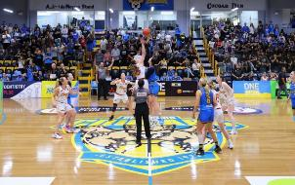
Image: Wally Hagan Stadium, home of the Cockburn Cougars Basketball Club – Photo courtesy of Cockburn Cougars Basketball Club.

Community Engagement

Community engagement at the City of Cockburn
Everything we do as a local government affects the people who live, work and recreate in Cockburn.
From big-picture planning to delivering programs and services, all our work is done on behalf of the community. As such, we have an ever-increasing need to ensure quality community engagement so that all people have the opportunity to participate in the decisions that affect their lives.
The City’s dedicated Community Engagement team has delivered a range of projects over the past twelve months to invite the community into decision-making and encourage policies, plans and projects to be guided by the views of the people they seek to serve.
Community engagement projects are hosted on the City’s online community engagement platform, Comment on Cockburn; however, a range of communication methods are used to ensure broad and widespread awareness of opportunities to give feedback. This includes letters to neighbouring houses, social media posts, signage, email newsletters and flyers in libraries, youth centres and other well-frequented areas.

Key accomplishments 2024-25

Delivering for the Community
Successfully engaged the community on 44 projects across a diverse range of areas, including:
- Playground visioning and renewals
- Coastal needs
- Master planning of infrastructure
- Road safety improvements
- Key strategic documents: including Strategic Community Plan 2025-2035 and the Public Open Space Strategy
- Strategic planning.

Strengthening Community Engagement
- Transitioned to a new engagement platform, Social Pinpoint, in September 2024 with a total membership of 13,045
- Winner of the IAP2 Australasia Core Values Awards Organisation of the Year 2024.

Delivering for the Community
- Gained 1,024 new registrations to the Comment on Cockburn platform
- Gained 746 follows to 44 projects on the Comment on Cockburn platform.
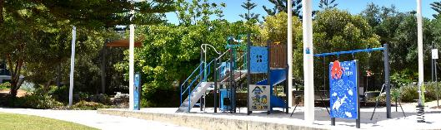
Image: Barrow Park playground, North Coogee.

Top Online Activities
- Bicycle and Walking Network Plan Quick Poll (298 contributions)
- Bicycle and Walking Network Plan Social Map (284 contributions)
- Planning Policy 5.26 – Tree Protection Survey (235 individual contributions)
- Manning Park Playground Quick Poll (195 contributions)
- Playground Equipment Renewals 2024-25 Survey (150 contributions).

In-person activities delivered on key projects including
- Strategic Community Plan 2025-2035
- Public Open Space Strategy
- Bicycle and Walking Network Plan
- Davilak Park
- Beeliar Reserve

Most-visited Projects
- Coogee Beach Land Use Master Plan (2,126 visitors)
- DAP24/010 - 1000L Berrigan Drive, Jandakot - Glen Iris Local Centre (1,748 visitors)
- Shaping Cockburn’s Future (1,571 visitors)
- Bicycle and Walking Network Plan (1,455 visitors)
- Manning Park Playground (1,132 visitors).
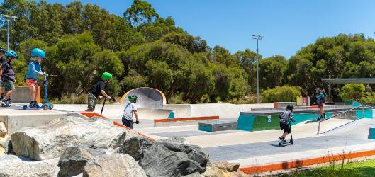
Image: Bibra Lake Skate Park.

Working Together
The City of Cockburn is committed to fostering strong partnerships and collaborative networks that support innovation, community wellbeing and sustainable development. Through formal agreements, advisory groups, reference collectives and active memberships, the City continues to work alongside local, national and international stakeholders to deliver shared outcomes.

Memoranda of Understanding (MoUs)
The City has entered into several MoUs to advance strategic priorities in research, education, industry and community development:
The University of Western Australia Ocean’s Institute:
A collaborative framework to explore marine research and innovation, focusing on marine technology, offshore renewable energy and coastal resilience.
Melville Cockburn Chamber of Commerce:
A regional partnership under review to support local business development and economic growth.
Henderson Alliance:
A strategic alliance to increase SME participation in the shipbuilding and defence industry supply chain and build sovereign manufacturing capabilities.
Curtin University WIL Program (On Hold):
A partnership to facilitate student placements within the City under Curtin University’s Work Integrated Learning framework.
Curtin University (Under Review):
A broad collaboration to enhance innovation, branding and shared outcomes across multiple sectors.

City-Led Advisory Groups
The City leads strategic groups that guide development and community outcomes:
Blue Economy Advisory Group (BEAG):
A monthly forum focused on the sustainable use of ocean resources for economic growth. Members include Austal, Civmec, Defence West, UWA Ocean’s Institute and For Blue.
Cockburn Destination Advisory Group (CDAG):
A collaborative platform to attract tourism, investment and talent. Members include Aventuur, Adventure World, Outtabounds and GPT.

Reference Groups
Eleven active reference groups ensure diverse voices guide City decisions:
- Cockburn Aboriginal Reference Group
- Cockburn Age Friendly Reference Group
- Cockburn Bushfire Advisory Reference Group
- Cockburn Children’s Reference Group
- Cockburn Crime Prevention Reference Group
- Cockburn Disability Reference Group
- Cockburn Multicultural Reference Group
- Cockburn Neighbourhood Watch Reference Group
- Cockburn Sister Cities Reference Group
- Cockburn Sustainability and Environment Reference Group
- Cockburn Youth Advisory Collective Reference Group

External Groups
The City actively participates in 15 external groups, contributing to regional planning, environmental stewardship and infrastructure development.
- Beeliar Regional Park Community Advisory Committee (BRPCAC)
- Cockburn Central Youth Centre (CCYCC)
- Cockburn Coast Liaison Group
- Cockburn Sound Management Council
- Jandakot Airport Community Aviation Consultation Group (JACACG)
- Jandakot Regional Park Community Advisory Committee (JRPCAC)
- Joint Development Assessment Panel (JDAP)
- Kwinana Community Consultative Network
- Perth Airport Municipalities Group (PAMG)
- Perth South-West Metropolitan Alliance – Environmental Forum/WCDEF
- Metropolitan Regional Road Group (MRRG) – South-West Metropolitan Sub-Group (SWMSG)
- WA Local Government Association (WALGA) South Metropolitan Zone
- Wetlands Centre Cockburn Board of Management
- Woodman Point Regional Park Community Advisory Committee (WPRPCAC)
- Woodman Point Water Resource Recovery Facility

Formal Relationships and Memberships

Sister Cities
The City maintains formal relationships with international and regional Sister Cities to promote cultural exchange and cooperation:
- City of Mobile, Alabama, USA
- City of Yueyang, China
- City of Split, Croatia
- Shire of Carnarvon, Australia (via MoU)

Allied Organisations and Joint Ventures
The City collaborates with allied organisations through formal partnerships and joint ventures. Notably, the Waste-to-Energy facility via the Eastern Metropolitan Regional Council (EMRC) represents a significant infrastructure initiative, though its classification as a joint venture or contractual arrangement is under review.
We also maintain active membership in key organisations such as WALGA, ALGA, National Growth Areas Alliance, and Growth Areas Perth and Peel, alongside paid subscriptions to industry bodies supporting governance, tourism, sustainability and community development.
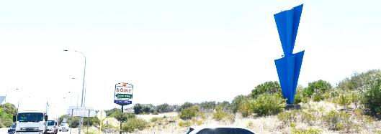
Image: Cardinal South (giant blue sculpture) by artist Tony Jones OAM at the intersection of Cockburn Road and Spearwood Avenue.

Membership organisations in which the City actively participates
The City plays an active role in the following organisations:
- National Growth Areas Alliance
- Growth Areas Perth and Peel
- WA Local Government Association (WALGA)
- Australian Local Government Association (ALGA)
- Perth South-West Metropolitan Alliance
- Henderson Alliance
- Melville-Cockburn Chamber of Commerce

Membership organisations where the City has a paid subscription
The City maintains paid subscriptions to a wide range of professional and sectoral bodies:
- Australian Children’s Education and Care Quality Authority
- Australian Institute of Management WA
- Australian Institute of Traffic Planning and Management
- Australian Library and Information Association
- Australian Sports Turf Managers Association
- Australian Standards
- Auspire – Australia Day Council WA
- Chamber of Arts and Culture
- Chamber of Commerce and Industry WA
- Children’s Book Council of WA
- Circuitwest
- Committee for Economic Development Australia
- Committee for Perth
- Destination Perth
- Diversity Council WA
- Economic Development Australia
- Engineering Australia
- Environmental Health Australia
- Events Industry Association
- Family Day Care Australia
- Family Day Care WA
- Institute of Public Works Engineering Australasia
- Irrigation Australia
- Mayors for Peace
- National Local Government Customer Service Network
- Parks and Leisure Association
- Perth Airport Municipalities Group
- Property Council of Australia (PCA)
- Public Libraries Western Australia
- Reconciliation WA
- Records and Information Management Practitioners Alliance Global
- Sister Cities Australia
- Sports Turf Association of WA
- Tourism Council WA
- Urban Development Institute of Australia
- Volunteering WA
- Waste Management and Resource Recovery Association
- Welcoming Cities
- Youth Affairs Council of WA

Record Keeping

Evaluation of Record Keeping Systems
The City’s Information Governance Framework was reviewed and updated in February 2025 to ensure it remained relevant and fit for purpose. The Framework guides the creation, use and management of the City of Cockburn’s information.
The Website Management Policy was also reviewed, updated and subsequently adopted by Council in March 2025. The purpose of the Policy is to ensure the City’s websites are appropriately managed and records of website content and transactions are retained, together with records that document the administration of the sites.

Record Keeping Training Program
All new staff are required to complete both an online Records Awareness Training (RAT) course and an online Information Governance Framework course. The interactive courses outline the record keeping roles and responsibilities of all employees at the City of Cockburn and how information should be store, used and managed at the City. Participants must undertake and pass a short assessment at the completion of the courses.
An online course outlining the specific record keeping responsibilities of Managers and Supervisors has also been implemented.
Regular training for new and existing staff is held on the use of the organisation’s electronic document and records management system, called ECM. Refresher training is also offered on an as needed basis.

Evaluation of the Record Keeping Training Program
All participants who attend ECM training are asked to complete a training feedback form. The feedback forms are regularly reviewed and suggestions for improvements are incorporated into the training program.

Record Keeping Induction Program
New staff must complete the RAT, Information Governance Framework training, and where relevant ECM training as part of their induction.
New Managers/Supervisors are also required to complete the online Record Keeping Training for Managers and Supervisors.
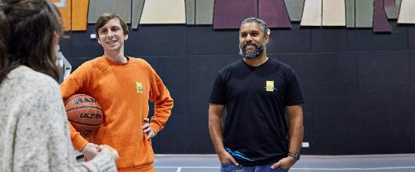
Image: Mark Armandi, Youth Centre Coordinator and Darryl Bellotti Digital Engagement Officer.

Risk Management
The Australian Standard AS ISO 31000:2018 Risk Management - Guidelines defines risk as the effect of uncertainty on objectives.
Risk is a mathematical product of likelihood and consequence. The Australian Standard defines these two elements as:
- Consequence: Outcome of an event affecting objectives.
- Likelihood: Chance of something happening.
The City of Cockburn has in place an Enterprise Risk Policy and Enterprise Risk Management Framework which are aligned with AS ISO 31000. Alignment with this standard is necessary because regulation 17 of the Local Government (Audit) Regulations 1996 requires the City of Cockburn Chief Executive Officer to review risk, control and compliance, and to report to the City’s Audit Risk and Compliance Committee (ARC) the appropriateness and effectiveness of the City’s systems and procedures in relation to risk management, internal control and legislative compliance.
An independent auditor examined this review and reported it to the 18 March 2025 ARC meeting. The independent auditor concluded the City generally has good controls and processes in place to address key risk, control and legislative compliance requirements. The CEO supports the auditor’s summary.
As was the case in the annual report last year, the City’s five highest ranked risks continue to be climate-change related and tree canopy decline as a result of the polyphagous shot-hole borer infestation in City trees. The elevated ranking of climate-related risks is replicated across Australian local governments, with Disaster, Catastrophic Events and Climate Change and Adaptation ranked in the top 10 risks impacting local government. [JLT Public Sector Risk Report, JLT Risk Solutions Pty Ltd].
The City’s Elected Members and Executive Leadership team attended a series of risk management workshops facilitated by Riskwest to review the City’s strategic risks and update its risk appetite. This has led to a comprehensive review of the City’s risk register and risk matrix.
The City is currently looking to upgrade its risk management system to an online cloud-based solution. It is anticipated that a solution will be implemented in 2026. subjected to testing to ensure the adopted plan serves the City should a disruptive event be realised.

Risk Profile 2024-25
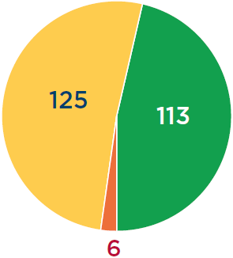
Transcriber’s Note: The pie chart above the number of low, moderate, and high risks identified for 2024-25.
- Low risks: 113
- Moderate risks: 125
- High risks: 6

Low risks: 46.3%
These are managed with adequate controls and pose minimal uncertainty to the City’s objectives.

Moderate risks: 51.2%
These are managed with adequate controls and could pose some disruption to the City’s objectives.

High risks: 2.5%
These are the least common risks, subject to at least quarterly review, and have the potential to cause critical consequences.

Awards and Grants
Award/agency and category | Outcome/project and description
2024 Core Values Awards – (IAP2) Australasia  Category: Organisation of the Year (for community engagement) | Winner: Organisation of the Year for community engagement by the city’s engagement team.  The City’s Community Engagement team has spearheaded the creation of a new internal Community Engagement Framework, and an updated Council-endorsed Community Engagement Policy, all while continuing to deliver several engagement projects.
Irrigation Australia Limited – Water Efficiency Management Awards 2024  Category: Water Efficiency Management Award (Large Business) | Winner: Water Efficiency Management Award (Large Business)  The City’s solution-focused Environment, Parks and Streetscapes team saved precious water supplies and thousands of dollars, while also improving turf conditions at local reserves, by repurposing irrigation electrical cabinets. Electrical cabinets were transformed to house 19-litre injection tanks that could dose up to 19 hectares with wetting agents, kelp products and other beneficial organisms.
Institute of Public Administration Australia WA (IPAA WA) 2024 awards  Category: Not-for-Profit sector achievement award | Winner: Financial Wellbeing Collective  The City of Cockburn’s Financial Counsellors, as part of the Financial Wellbeing Collective, won the Excellence in the Not-for-Profit Sector Achievement Award at the IPAA WA annual awards. Operating for nine years with 12 partner organisations and State Government funding, the Collective provides free, independent support to people experiencing financial hardship and stress.
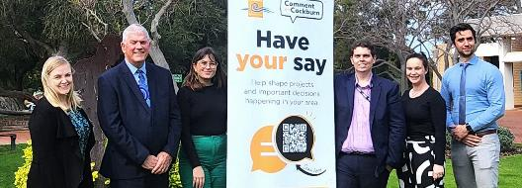
Image: 2024 Core Values Organisation of the Year Winner – September 2024. (Left to Right) Kylie Tanner, Community Engagement Officer; Mayor Logan Howlett; Zoya Yukhnevich, Community Engagement Coordinator; Daniel Newman, Manager Advocacy and Engagement; Kirsten Wood, Community Engagement Officer; and Ludovic Williams, Community Engagement Officer.

Grants

Coogee Live – Lotterywest Community Grant
Thanks to an $85,000 grant from Lotterywest, Coogee Live 2025 delivered a spectacular weekend of free entertainment, cementing its status as a national award-winning community festival. The funding helped bring nearly 200 activities and experiences to life along 1.5km of Coogee’s stunning coastline on 8-9 March 2025, under the festival’s theme of ‘Experience’. A highlight of the festival was WA debutantes Erth Divers, the Melbourne-based visual theatre trailblazers, whose mind-bending performances left audiences wondering if the performers had risen from the Indian Ocean – or arrived from another dimension entirely.

Cockburn ARC Evolution – DLGSC Grant
The next phase of the Cockburn ARC Evolution has been completed, thanks to a $1 million grant from the Department of Local Government, Sport and Cultural Industries, delivering major new community assets including AFLW changing rooms, facilities for community sporting programs, a 250-seat undercover spectator terrace, and a multipurpose space for education and community use. The $7.4 million project, jointly funded by the Fremantle Football Club, State Government, WA Football Commission and AFL, complements the City of Cockburn’s $9.6 million ARC Health Club upgrade, which expanded the gym to 1,500m2, enlarged the Mind and Body Studio, upgraded fitness and cycle studios, and repurposed spaces to further enhance the community’s health and wellbeing experience. The milestone was celebrated on 4 September 2025 with a ribbon-cutting event at the ARC’s Victor George Kailis Oval.

Baby Makes 3 – Department of Communities Grant
The City is thrilled to have been awarded a Department of Communities grant to co-design and deliver a cultural adaptation of Baby Makes 3, a group-based program that supports healthy, equal and respectful relationships for families welcoming a new baby. With approximately $200,000 in funding received this year as part of an ongoing program, the initiative will challenge outdated ideas about parenting by promoting gender equality, encouraging parents to share childcare, paid work, decision-making and household responsibilities – building stronger, healthier relationships and giving families the chance to thrive.
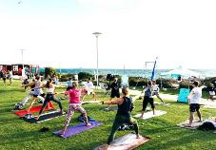 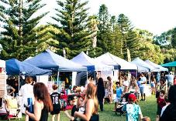 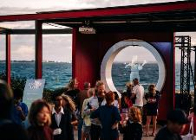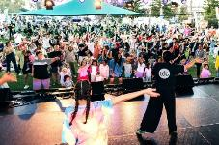 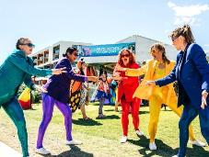 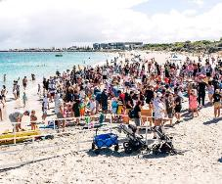
Images: Coogee Live - March 2025.

Responsible Operations and Civic Contribution

Privacy and Data Handling
The City of Cockburn continues to manage personal and sensitive data in accordance with the State Records Act 2000, the Local Government Act 1995, and other applicable legislation. No privacy breaches or data handling incidents were reported during the 2024-25 reporting period. The Information Services team maintains strong governance practices, with ongoing improvements to cybersecurity, access controls, and staff awareness through regular training programs.

Project Governance
The City’s current Project Management Framework, aligned with the PMBOK® Guide, underpins governance of major projects and ensures consistency in planning, delivery and reporting. The Project Management Office (PMO) is strengthening oversight by standardising reporting, setting a regular cadence of updates, and improving transparency for Executive Management and Council.
A review of the framework is currently in progress as part of continuous improvement, informed by a Citywide survey and stakeholder workshop. Feedback provided to date supports a more structured, accessible and consistent approach to project delivery. Key themes included clearer roles, simpler processes, stronger planning, better training and fit-for-purpose tools.
The refinement of the framework will extend these improvements across all projects, not only major ones, embedding a consistent approach to governance and delivery City-wide.

Volunteers
In 2024-25, the City of Cockburn’s Volunteer Centre supported 351 registered volunteers, an increase from 280 the previous year, reflecting the growing community spirit across the City. Volunteers played an essential role in the delivery of services and programs across the organisation, contributing their time and skills to the Seniors Centre, Cockburn Care, Community Development, Youth Centre, Libraries, Museum and Collections, Environmental teams, and Volunteer Bush Fire Brigades.
Their contributions ranged from ongoing roles such as drivers, mentors, activity leaders, and tutors, to participation in one-off events including Coogee Live, the Bibra Lake Fun Run and community tree planting days. The Cockburn Volunteer Centre hosted two annual appreciation events – the Volunteer ‘Thank You’ Sundowner and the flagship Cockburn Volunteer Awards, held in conjunction with National Volunteer Week (19-25 May 2024). This year’s awards received 75 nominations representing 53 organisations, celebrating the exceptional efforts of community members and groups. The Volunteer of the Year was awarded to Leanne Stickland for over 25 years of service to multiple community organisations; Volunteer Organisation of the Year went to Cockburn Community Wildlife Corridor Inc. Bushcare Group, recognised for more than seven years of environmental stewardship; and the Mayor’s Volunteer Award was presented to Mike Graham from Marine Rescue Cockburn, honouring his 45 years of dedicated service that have saved lives and strengthened the community.
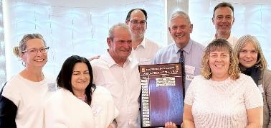
Image: Cockburn Seniors Centre Volunteer of the Year – September 2024. (Left to Right) Tracey Armstrong, Community Development Officer; Fiona Gardener, Community Development Manager; Gabriele Carrati, Seniors Centre Volunteer of the Year – Winner; Daniel Arndt, Director Sustainable Development and Safety; Mayor Logan Howlett; Anton Lees, Director Infrastructure Services; Kristine Thomson, Volunteer Centre Coordinator; and Julie MacDonald, Senior Centre Manager.

Community satisfaction
The Listening and Leading Strategic Outcome currently holds a lower priority within the Cockburn community, primarily due to a limited number of associated metrics. While the community may not rank this outcome highly, there remains a clear need for regular maintenance activities, such as street cleaning and signage upkeep. Transparent communication regarding ongoing and completed infrastructure projects would also enhance community trust and engagement. In the overall assessment, this outcome was rated fifth out of five, reflecting its lesser significance compared to other strategic outcomes.
Despite the lower prioritisation, the community's feedback indicates opportunities for improvement. The average score for metrics under this outcome stands at 6.2, which is four per cent below the WA average. The current metrics, while performing above six, do not rank among the top 15 values shared by residents, suggesting there is a disconnect between community expectations and the perceived effectiveness of Council initiatives. Key areas for focus include enhancing public satisfaction with governance and ensuring financial accountability practices.
Listening and Leading
- Cockburn: 6.2
- Western Australia: 6.6
- Australia: 6.0
Listening and Leading outcome metrics | Community satisfaction rating
Evidence of Council/government management (signage, street cleaners, etc.) | 6.5
Evidence of recent public investment (roads, parks, schools, etc.) | 6.0
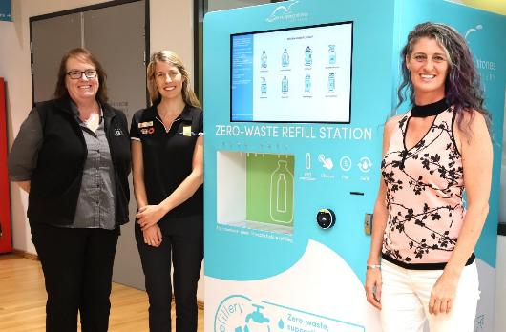
Image: Zero-waste container refill station – Skipping Stones Refillery at Cockburn ARC, Cockburn Central – May 2025. (Left to Right) Caroline Lindsay, Cockburn ARC – Customer Experience Coordinator; Clare Courtauld, Service Lead Sustainability and Climate Change; and Mia Pitassi, Skipping Stones Refillery Owner.

Plan for the future
Cockburn’s governance approach is evolving to reflect the growing complexity of local government in Western Australia. The City is strengthening how it engages, consults and makes decisions, ensuring that community voices remain central to its operations. As expectations for transparency and accountability increase, Cockburn is modernising its systems and processes to deliver decisions that are open, inclusive and grounded in evidence. The City’s ongoing commitment to good governance and ethical leadership will remain the foundation of community trust and effective service delivery.
Digital transformation is another defining feature of modern governance. As technology reshapes how services are delivered and information is managed, the City will expand its digital platforms, improve cybersecurity, and adopt smart systems that streamline processes while protecting privacy. These efforts will support greater accessibility and efficiency in service delivery. Building internal capability through training, innovation and workforce development will ensure the organisation can adapt to emerging challenges and opportunities.
In an increasingly complex geopolitical and technological landscape, Cockburn’s governance must remain agile and forward-looking. Collaboration with state and federal agencies will continue to align local priorities with broader initiatives in renewable energy, housing, infrastructure, and economic diversification. By maintaining sound financial management, strong community engagement and a culture of continuous improvement, the City will ensure its governance remains robust, transparent and equipped to meet the challenges of the future.
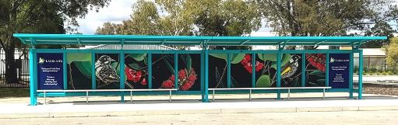 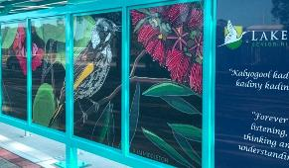 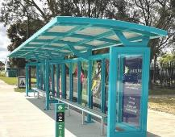
Images: Lakeland Senior High School bus shelter (super shelter) featuring a mural created by Walyalup artist Xhai Middleton – October 2024.

Corporate Business Plan Progress Report
The Corporate Business Plan Progress Report showcases our accomplishments in achieving the outcomes and objectives set out in the Strategic Community Plan. It provides an overview of each project, overall progress status, quarterly milestones, and notes explaining our achievements as of 30 June 2025. These initiatives are essential to making Cockburn, the best place to be.

Local Economy - Projects/activities

1A.01: International Engagement
Deliver Program:
This program connects local businesses with international partners and investors through trade delegations, expanding market reach, forging partnerships, and attracting investment.
Overall progress: Complete
Q1: Plan approval. Delegation implementation – Complete
Q2: Report on outcomes of delegation visit to council – Complete
Q3: Follow up outcomes of delegation visit with delegation stakeholders Cockburn Global event – Complete
Q4: Network development integrated into service delivery – Complete
Notes: Strengthened relationships with Indonesia, Vietnam and Singapore consulates to support Cockburn businesses and foster international trade.

1A.02: Investment Attraction Plan
Develop Plan:
This collaborative informing strategy targets investments in key industries to create a sustainable local economy with job growth and position Cockburn as a business-friendly location
Overall progress: Incomplete/off track
Q1: Finalise Implementation Plan – Incomplete/off track
Q2: Scope prepared for Website and prospectus development – Incomplete/off track
- Identified professional development for investment facilitation – Incomplete/off track
Q3: Contracts issued for Website and prospectus development – Incomplete/off track
Q4: Completed website and prospectus – Incomplete/off track
- Finalised Investment forum and first Investment family visit – Incomplete/off track
- Completed first round of professional development for investment facilitation – Incomplete/off track
Notes: Investment Attraction Plan completed; prospectus implementation underway. Target completion Q1–Q2 FY2025-26.

1B.01: Business Engagement Plan
Deliver Plan:
The Business Engagement Plan outlines the next 12 months, activities and engagement priorities for the micro, small, and medium enterprises business sector.
Overall progress: Complete
Q1:
- Support one blue economy event (Edge) – Complete
- Complete and report on scholarship delivery (Curtin Ignition) – Complete
- Deliver three workshops– Complete
- Deliver three Micro Business Networking events – Complete
- Publish three business newsletters. – Complete
Q2:
- Complete round one of business grants – Complete
- Deliver one international engagement event (Cockburn Global) – Complete
- Deliver two workshops – Complete
- Deliver two Micro Business Networking events – Complete
- Publish two business newsletters. – Complete
Q3:
- Deliver one major Cockburn event – Complete
- Complete and report on sponsorship program (International engagement) – Complete
- Deliver three workshops – Complete
- Deliver three Micro Business Networking events – Complete
- Publish three business newsletters. – Complete
Q4:
- Complete round two of business grants – Complete
- Complete and report on sponsorship program (Thrive) – Complete
- Deliver three workshops – Complete
- Deliver three Micro Business Networking events – Complete
- Publish three business newsletters. – Complete
Notes: Delivered Round two of business grants: 99 engagements, 56 applications, $198,136.76 requested; Thrive Program completed; three workshops, three networking events, three newsletters published.
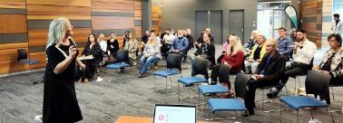 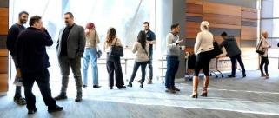
Image: Micro Business Networking event, Success.

1B.02: Cockburn Blue Innovation Hub
Fund and Deliver Hub:
The City of Cockburn’s Cockburn Blue Innovation Hub empowers 40 startups and growing businesses to develop solutions in ocean sustainability and defence supply chain (including AUKUS)
Overall progress: Incomplete/off track
Q1: Finalise Department of Jobs, Tourism, Science and Innovation Grant. Execute MoU – Incomplete/off track
Q2: Develop operational plan to determine subsequent milestones – Complete
Q3: Identify potential facility location, finalise expressions of interest for tenancy arrangements – Complete
Q4: Finalise lease/purchase. Appoint Facilities manager – Incomplete/off track
Notes: Lease expression accepted for Innovation Hub; awaiting Development WA approval; business case and fit-out planning underway. Steering Committee to finalise Innovation Hub governance and operational framework.

1B.03 Destination Plan
Develop Plan:
To establish Cockburn as a premier visitor destination
Overall progress: Complete
Q1: Scope Marketing and Communications Plan and engagement with Advisory Group members – Incomplete/off track
Q2: Scope marketing and communication and the development of a tourism/ destination brand consistent with City activities and tourism organisations – Complete
Q3: Scope marketing and communications and the establishment of business cohorts – Complete
Q4: Scope marketing and communications for targeted advertising campaign – Complete
Notes: Destination Plan scheduled for presentation to Elected Member Strategic Briefing in July 2025; feedback will guide integration into economic development framework.

Environmental Responsibility - Projects/activities

2A.01: Clementine Reserve Orchid Monitoring
Implement Monitoring:
As part of our ongoing commitment to protecting our natural environment, the City is undertaking an orchid monitoring project at Clementine Reserve
Overall progress: Complete
Q1: N/A
Q2: Survey commenced – Complete
Q3: Survey complete, recommendations provided to the City – Complete
Q4: N/A
Notes: Orchid Monitoring Report completed November 2024; Grand Spider Orchid populations remain intact; reserve maintenance ongoing.

2A.02: C.Y. O’Connor Reef Stage 2 – Installation and Monitoring
Install Reef:
Stage 2 of the C.Y. O’Connor eco-friendly fringing reef expands its size and monitors marine life colonisation and coastal protection
Overall progress: Complete
Q1: N/A
Q2: Reef installed – Complete
Q3: Monitoring commences – Complete
Q4: Monitoring ongoing – Complete
Notes: Coastal erosion project completed December 2024 with 135 modules installed; monitoring continues.

2A.03: Manning Park Playground Upgrade
Plan and Design Upgrade:
Manning Park playground is undergoing a revamp with new, inclusive play equipment to ignite imaginations for all ages and abilities
Overall progress: Complete
Q1: Engagement commenced – Complete
Q2: Engagement completed – Complete
Q3: Design development commenced – Complete
Q4: Design completed – Complete
Notes: Playground designs progressed to construction drawings; community feedback to be sought before tender.

2A.04: Urban Forest Tree Planting Program
Implement Program:
The Urban Forest Tree Planting Program is a significant initiative to beautify our streets and neighbourhoods with a canopy of new trees.
Overall progress: Complete
Q1: Planting program commences. Aim to plant 60 per cent of annual target – Complete
Q2: Planting program closes, online requests open – Complete
Q3: Online requests close – Complete
Q4: Planting program resumes. Plant reminder of annual target – Complete
Notes: Tree planting KPI achieved; winter planting continues until October 2025.

2B.01: Cockburn Resource Recovery Redevelopment
Implement Upgrades:
Cockburn modernises its Resource Recovery Precinct with planning for sustainable waste management and essential upgrades like leachate ponds, landfill capping, and transfer station relocation
Overall progress: Complete
Q1: Leachate pond construction documentation completed and market engagement commenced – Complete
Q2: Construction of leachate pond commenced with initial site establishment and civil works – Complete
Q3: Leachate pond construction progressed, 50 per cent complete – Complete
Q4: Construction of leachate ponds complete – Complete
Notes: Leachate pond works completed; approvals secured; leachate transfer commenced.

2C.01: Edeline Street - Drainage Improvements
Install Drainage:
The City of Cockburn is installing a drainage improvement project for Edeline Street
Overall progress: Complete
Q1: Market engagement commenced – Complete
Q2: Market engagement complete, construction started – Complete
Q3: Project complete – Complete
Q4: N/A
Notes: KPI met for project milestone.

2C.02: Hobley Way - Drainage Improvements
Install Drainage:
The City of Cockburn is installing a drainage improvement project for Hobley Way
Overall progress: Complete
Q1: Market engagement commenced – Complete
Q2: Market engagement complete – Complete
Q3: Construction commenced – Complete
Q4: Project complete – Complete
Notes: Project KPI achieved.

2C.03: Marvell Avenue #5 - Drainage Improvements
Install Drainage:
The City of Cockburn is installing a drainage improvement project on Marvell Avenue
Overall progress: Complete
Q1: Detailed design complete – Complete
Q2: Market engagement undertaken – Complete
Q3: Construction commenced – Complete
Q4: Project complete – Complete
Notes: Project completion scheduled for August 2025 under Council-awarded contract.

2C.04: Stratton Street - Drainage Upgrade
Install Drainage:
The City of Cockburn is installing a drainage improvement project on Stratton Street
Overall progress: Complete
Q1: Construction continues – Complete
Q2: Project complete – Complete
Q3: N/A
Q4: N/A
Notes: KPI met for scheduled works.
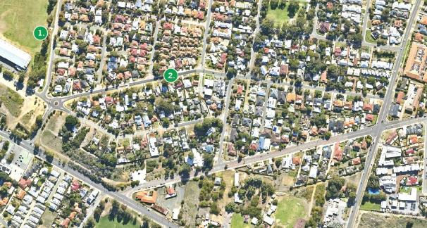
Image: Dixon Reserve (1) and Stratton Street (2), Hamilton Hill.

Community, Lifestyle and Security - Projects/activities

3A.01: Beale Park Redevelopment
Design and Implement:
Upgrade and transform Beale Park into a modern, amenity-rich hub for a wider range of sports and activities, while prioritising environmental responsibility
Overall progress: Complete
Q1: Detailed design and tender documentation complete – Incomplete/off track
Q2: Market engagement commenced – Incomplete/off track
Q3: Market engagement complete – Incomplete/off track
Q4: Contract Award (contractor) – Complete
Notes: Contract commencement meeting held June 2025; pre-start scheduled September; site works to begin October 2025.

3A.02: Beeliar Reserve Redevelopment
Plan Upgrade:
Explore the viability of improvements through a feasibility and concept design phase in 2024-25, considering technical, financial and logistical factors
Overall progress: Reforecast
Q1: Draft Needs and Site Analysis, Concept Plan and Feasibility Study presented to Council to determine upcoming milestones – Incomplete/off track
Q2: Community Engagement Round 2 and present final Needs and Site Analysis, Concept Plan and Feasibility Study to Council. Feasibility Study to determine upcoming milestones – Incomplete/off track
Q3: Concept Design Complete – Complete
Q4: Draft Needs and Site Analysis, Concept Plan and Feasibility Study presented to Council to endorse public comment – Complete
Notes: Q4 milestone complete; project to return to Council after public comment for endorsement before delivery phase.

3A.03: Cockburn ARC Expansion
Deliver Upgrades:
Energy-efficient floodlighting for extended play, a larger carpark on Shelley Way, and improvements to existing parking
Overall progress: Complete
Q1: Construction commenced – Complete
Q2: Construction program 50 per cent complete (Shelly Way car park complete) – Complete
Q3: Project complete – Complete
Q4: N/A
Notes: KPI met for scheduled works.

3A.04: Davilak Park Redevelopment
Plan Revitalisation:
The Davilak Park Revitalisation Project identifies community needs and explores options for a vibrant, sustainable park catering to all
Overall progress: Complete
Q1: Round 1 community and stakeholder engagement – Complete
Q2: Needs and site analysis complete – Complete
Q3: Develop Concept Design and Feasibility Study – Complete
Q4: Draft Needs and Site Analysis, and Feasibility Study presented to Council – Complete
Notes: Q4 milestone complete; project pending Council endorsement after public comment.

3A.05: Malabar BMX
Deliver Upgrades:
Malabar Park upgraded to a regional BMX facility with a competition-standard track, pump track, playground and new clubhouse
Overall progress: Complete
Q1: Construction – Complete
Q2: Project complete – Complete
Q3: N/A
Q4: N/A
Notes: KPI met for infrastructure upgrade.

3A.06: Port Coogee Southern Amenities Project (Omeo Park)
Deliver Amenities:
New rest rooms, changing rooms, and a shade shelter for visitors at Omeo Park exploring the Omeo Wreck and coastal surrounds
Overall progress: Complete
Q1: Construction of amenities and shade structure planned for commencement – Complete
Q2: Earthworks, concrete works, structural and services installations – Complete
Q3: Fit-out, finishes to amenities building, and installation of shade structure – Incomplete/off track
Q4: Completion, handover and defects rectification stages for remaining works – Complete
Notes: Project due for completion July 2025.

3A.07: Santich Park - Parking Upgrade and New Lighting
Implement Expansion:
Joint expansion with Fremantle Football Club, adding a bigger gym, studios, spectator seating, and community facilities for all
Overall progress: Complete
Q1: Concrete works progressing externally for extension, main structural, and internal fit-out first fix. Refurbishment fit-out works partitions and finishes progressing – Complete
Q2: Upper floor fit-out commences, refurbishment fit-out and services underway, and gym fit-out commences – Complete
Q3: Upper floor fit-out works progressing, new flooring installation and fit-out to existing gym included – Incomplete/off track
Q4: Project complete – Complete
Notes: Gym reopened 12 July 2025 following completion of City of Cockburn portion; KPI met.

3A.08: Tempest Park Floodlighting
Deliver Floodlighting:
Energy-efficient floodlighting for extended play and a wider range of activities, with minor landscaping and goal upgrades
Overall progress: Complete
Q1: Market engagement commenced – Complete
Q2: Contract awarded – Complete
Q3: Construction commenced – Complete
Q4: Project complete – Complete
Notes: KPI met for project milestone.

3A.09: Tempest Park Redevelopment
Plan Redevelopment:
Finalise the business case including Feasibility Study and Concept Design for Tempest Park redevelopment
Overall progress: Reforecast
Q1: Draft Needs and Site Analysis and Feasibility Study presented to Council to determine upcoming milestones – Incomplete/off track
Q2: Community Engagement Round 2 and present final Needs and Site Analysis, Concept Design and Feasibility Study to Council – Incomplete/off track
Q3: Concept Design Complete – Complete
Q4: Draft Needs and Site Analysis, Concept Plan and Feasibility Study presented to Council to endorse public comment – Complete
Notes: Q4 milestone complete; project pending Council endorsement after public comment.

3A.10: Wally Hagan Redevelopment
Plan Upgrade:
Finalise business case for upgrading Wally Hagan into a premier basketball facility
Overall progress: Complete
Q1: Review of draft Needs Analysis, Site Assessment and Feasibility Study – Complete
Q2: Draft business case – Complete
Q3: Ongoing advocacy actions – Incomplete/off track
Q4: Complete advocacy actions – Complete
Notes: Business case completed (Needs and Feasibility); further work required to secure funding and refine scope.

3A.11: Stage 4 Marina Expansion Business Case
Plan Expansion:
Explore financial viability, market demand for Marina expansion including berth optimisation, industry trends and community engagement
Overall progress: Incomplete/off track
Q1: Consultant procurement – Complete
Q2: Stakeholder engagement commenced – Incomplete/off track
Q3: Stakeholder engagement commenced – Complete
Q4: Business case presented to Council – Incomplete/off track
Notes: Business case delayed for quality and strategic alignment; KPI due 30 June not met; rescheduled for July Elected Member briefing and August Ordinary Council Meeting.

3B.01: Memorial Hall Centenary Celebration and Arts Hall of Fame
Implement Celebration:
Cockburn celebrates its Memorial Hall’s centenary by establishing an Arts Hall of Fame to honor local artists and their contributions
Overall progress: Complete
Q1: Research and development – Complete
Q2: Advertising and promotion (community engagement and involvement) – Complete
Q3: Advertising and promotion (community engagement and involvement) – Complete
Q4: Event delivered in March 2025 – Complete
Notes: Centenary Celebrations delivered; Arts Hall of Fame announced.

3B.02: Smart Buildings Project (Project BETTI)
Finalise implementation plan with Blue Force for FY2025 shortlisted locations. Hardware ordered by supplier
Overall progress: Reforecast
Q1: Finalise implementation plan with Blue Force for FY2025 short listed locations. Hardware ordered by supplier – Complete
Q2: Commence and complete stakeholder consultation. Arrange NBN network connections where required – Complete
Q3: Trial established – Complete
Q4: Ongoing monitoring of trial – Complete
Notes: Trial completed; funds carried forward into FY2026 for implementation of outcomes.

3C.01: Aboriginal Cultural and Visitors Centre
Finalise Design, Commence Delivery:
The Aboriginal Cultural and Visitor Centre is being built to honour traditions, share knowledge, and provide a welcoming community hub for Cockburn's First Nations peoples
Overall progress: Complete
Q1: Review design – Complete
Q2: Final design adopted by Council – Incomplete/off track
Q3: 50 per cent completion of revised detailed design – Complete
Q4: Detailed design complete – Complete
Notes: Detailed design and construction preparedness completed by end of financial year; KPI met.

City Growth and Moving Around - Projects/activities

4A.01: Coogee Beach Master Plan Review
Review Master Plan:
Review of the landscape Master Plan and a strategic vision for Coogee Beach, including former railway land and Cockburn Road upgrades
Overall progress: Complete
Q1: Commence options review – Complete
Q2: Draft Master Plan presented to Council for consent to proceed with stage 2 Community Engagement – Complete
Q3: Commence stage 2 Community Engagement – Complete
Q4: Final Master Plan (including staging plan and cost estimates) for Council endorsement – Complete
Notes: Master Plan adopted at June 2025 Ordinary Council Meeting.

4A.02: Public Open Space Strategy Review
Review Strategy:
The Cockburn Public Open Space Strategy guides future park investments and improvements to create a connected network of green spaces for a healthy and active community
Overall progress: Complete
Q1: Commence literature review (including audit of current Public Open Space Strategy) – Complete
Q2: Complete literature review – Complete
Q3: Commence planning of Phase 1 Community Engagement (current and future needs analysis) – Complete
Q4: Commence Phase 1 Community Engagement (current and future needs analysis) – Complete
Notes: Phase 1 consultation completed.

4C.01: Banjup Local Area Traffic Management (LATM)
Deliver Traffic Management:
The Banjup LATM project improves traffic flow and safety by discouraging cut-through traffics
Overall progress: Incomplete/off track
Q1: Design and Main Roads WA approval process commenced – Complete
Q2: Design and Main Roads WA approval completed – Incomplete/off track
Q3: Construction planning commenced – Complete
Q4: Project complete – Incomplete/off track
Notes: Project delayed due to lack of approvals; rescheduled for Q1 FY2025-26.

4C.02: Carrington Street and Forrest Road (Black Spot Project)
Deliver Improvements:
Funded by the Australian Black Spot Program, the Forrest Road and South Street intersection upgrade improves safety with new signals, lighting, crossings and a raised platform
Overall progress: Incomplete/off track
Q1: Detailed design complete – Complete
Q2: Market engagement commenced – Incomplete/off track
Q3: Market engagement complete and construction commenced – Incomplete/off track
Q4: Project complete – Incomplete/off track
Notes: Multi-year program delayed by Main Roads WA due to lack of approvals; grant extension approved; milestones updated for FY2025-26.

4C.03: Hammond Road Duplication - Russell Road to Rowley Road
Plan Improvements:
The City of Cockburn plans upgrades to Hammond Road, aiming to improve traffic flow, safety and amenity
Overall progress: Complete
Q1: Appointment of consultant to undertake Feasibility Study – Incomplete/off track
Q2: Feasibility Study on track for Q4 completion – Complete
Q3: Feasibility Study on track for Q4 completion – Complete
Q4: Feasibility Study completed and feasibility of project determined – Complete
Notes: Corridor Study progressing with traffic modelling and preliminary design; detailed design to follow.

4C.04: Mid-term Review - City Drainage Management Strategy
Review Strategy:
Reviews Drainage Management Strategy to ensure continued efficiency, flood risk reduction, and adaptation for future growth
Overall progress: Complete
Q1: Preparation of scope of works and appointment of consultant – Complete
Q2: Review commenced – Complete
Q3: Review on track for end of financial year completion – Complete
Q4: Review complete, recommendations identified – Complete
Notes: Mid-Term Review completed; final report issued; KPI met.

4C.05: New signals: Beeliar Drive/Dunraven Drive (Black Spot Project)
Plan Signal Upgrades:
Planning for new traffic signals to enhance safety after a history of crashes
Overall progress: Complete
Q1: Concept design complete – Complete
Q2: Detailed design commenced – Complete
Q3: 50 per cent completion of revised detailed design – Incomplete/off track
Q4: Detailed design complete – Complete
Notes: Detailed designs completed; KPI met.

4C.06: Rockingham Road and Spearwood Avenue (Black Spot Project)
Install Signal Upgrade:
The Rockingham Road and Spearwood Avenue intersection, a known crash zone, receives upgraded traffic signals with designated turn lanes, improved pedestrian crossings, and cyclist considerations to improve safety
Overall progress: Incomplete/off track
Q1: Detailed design complete – Complete
Q2: Market engagement commenced – Incomplete/off track
Q3: Market engagement complete and construction commenced – Incomplete/off track
Q4: Project complete – Incomplete/off track
Notes: Main Roads WA approvals pending for traffic signal upgrades; project to commence FY2026; Council workshop scheduled post-November 2025.

4C.07: Rockingham Road/Phoenix Road Roundabout
Install Roundabout:
Rockingham Road and Phoenix Road intersection gets a roundabout and lighting upgrades for improved safety and traffic flow
Overall progress: Complete
Q1: Detailed design complete – Incomplete/off track
Q2: Market engagement commenced – Incomplete/off track
Q3: Market engagement package complete – Complete
Q4: Market engagement commenced – Complete
Notes: Market engagement on hold pending independent viability analysis of proposed single-lane roundabout.

4C.08: Rockingham Road Improvement - Coleville Crescent to Phoenix Road
Design Road Improvement:
The Rockingham Road Revitalisation Project improves traffic flow, pedestrian and cyclist safety, and streetscape aesthetics for a vibrant and functional corridor
Overall progress: Complete
Q1: Detailed design commenced – Complete
Q2: Detailed design (50 per cent complete), commence land management – Complete
Q3: Detailed design (85 per cent complete) and land management ongoing – Complete
Q4: Detailed design complete and land management ongoing – Complete
Notes: Detailed design complete; KPI met.

Listening and Leading - Projects/activities

5A.01: Spearwood Administration Building Audit
Building Assessment:
The Spearwood Administration Building will undergo an assessment to identify short, medium, and long-term maintenance requirements
Overall progress: Incomplete/off track
Q1: Scope works for in-depth roof and HVAC inspections – Complete
Q2: Procurement process to appoint the contractors to perform the inspection and reporting work – Complete
Q3: Contractor appointed and inspections begun – Complete
Q4: Receive reports. provide recommendations to Executive, determine capital works for a future financial year – Incomplete/off track
Notes: Building condition report identified extensive works; value management exercise underway; Council discussion scheduled post-November 2025.

5A.02: Fixed Licence Plate Recognition Parking Monitoring - Investigation Project
Trail Technology:
The City of Cockburn trials Fixed Licence Plate Recognition (LPR) technology for parking management at the Community Health Building to improve efficiency and ensure fair access
Overall progress: Complete
Q1: Internally assess technology options from known providers and shortlist to a preferred product. – Incomplete/off track
Q2: Commence stakeholder consultation with the Building Management team and tenants – Complete
Q3: Begin installation and testing completed – Complete
Q4: Project close-out and installation assessment completed – Complete
Notes: Technology trial completed; qualitative data gathered; future monitoring may require comprehensive system.

5A.03: Service Review
Deliver Program:
The City of Cockburn is reviewing City services to optimise resource allocation and service delivery for a growing community
Overall progress: Complete
Q1: Introduce Service Review team to business improvement methodology and associated tools – Complete
Q2: Initiate Define stage of the business improvement methodology (gather existing information) – Complete
Q3: Identify major issues in service delivery from Define phase and initiate Measure phase in methodology – Complete
Q4: Consolidate learnings from Measure phase and initiate Analyse phase of the methodology (analyse services) – Complete
Notes: Two service reviews nearing completion; implementation planning underway; Customer Experience adopting LEAN principles.

5C.01: TechOne SaaS Migration
Upgrade Technology:
The City of Cockburn is upgrading its core TechOne software to a cloud-based SaaS model for improved service and minimal disruption
Overall progress: Complete
Q1: TechOne SaaS test environment prepared and ready for testing – Incomplete/off track
Q2: TechOne SaaS has gone live – Complete
Q3: N/A
Q4: N/A
Notes: TechOne SaaS launched November 2024; major milestone in digital transformation; new laptops and desktops rolled out, improving flexibility and performance.

5A.01: Zero Client Replacement
Building Assessmen
Deliver New Hardware
To enhance service delivery and staff flexibility, the City of Cockburn is replacing its Zero Client desktops with laptops and desktops, creating a mobile focused work environment
Overall progress: Complete
Q1:
- Procure devices – Complete
- Pilot deployment and UAT – Complete
- Deploy laptop and desktop devices – Complete
Q2:
- Measure project success – Complete
- Remediation and close-out – Complete
Q3: N/A
Q4: N/A
Notes: Zero Client replacement completed November 2024; rollout of new laptops and desktops delivered improved flexibility, performance and connectivity.
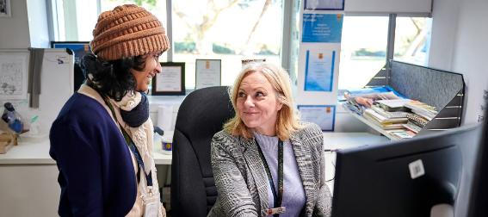
Image: Dilru Hordagoda, Senior .NET Developer and Sandy Gaskett, Digital Application Specialist.

The Year Ahead
As we look ahead to FY2026, the City of Cockburn remains committed to delivering innovative and impactful projects that enhance our community’s quality of life. The following projects represent our strategic priorities for the upcoming year, aligned with our long-term vision. For more information about these projects and their associated milestones, please refer to our Corporate Business Plan 2025-2029.

Our Economy – Projects/activities 2025-26

1A.01: Business Engagement Plan
Deliver Program:
The City of Cockburn’s Business Engagement Plan 2025-26 provides a unified framework to empower a diverse and innovative local business community through targeted support, sector-specific initiatives, and strategic engagement across six key pillars.

1C.01: International Engagement
Deliver Program:
This program supports local businesses to expand globally by facilitating international trade delegations that promote market access, strategic partnerships, and investment opportunities to drive economic growth in Cockburn.

1C.02: Investment Attraction Plan
Develop and Deliver Plan:
This strategy aims to attract targeted investment in key industries to drive sustainable economic growth, create high-quality local jobs and position Cockburn as a business-friendly destination with streamlined processes and a skilled workforce.

1C.03: Blue Economy and Defence
Fund and Deliver:
This project positions the City as a leader in the blue economy by establishing a research and innovation hub that drives sustainable growth in marine and defence industries through industry collaboration, innovation, workforce development, and business capacity-building.

1D.01: Destination Plan
Deliver Plan:
This project aims to position Cockburn as a premier visitor destination by promoting its unique attributes, aligning with stakeholder capabilities, celebrating Aboriginal heritage, supporting community aspirations, and enhancing collaboration with regional tourism partners.

Our Environment – Projects/activities 2025-26

2A.01: Increase appearance of major road streetscapes within the city
Deliver Project:
This project seeks to revitalise key arterial road corridors by enhancing streetscapes to create visually appealing, vibrant and welcoming environments.

2A.02: Natural Area Management Strategy - Tramway Trail Stage 1 and 2
Deliver Strategy:
The Tramway Trail Project aims to complete the last remaining trail from the City’s 2013 Trails Master Plan, fulfilling longstanding commitments outlined in multiple strategic and planning documents.

2B.01: Adoption of Henderson Waste Recovery Park Master Plan
Develop Plan:
The Master Plan will establish the long-term strategic framework for addressing the remaining operational lifespan of the landfill (approximately five years), including cell capping, post-closure management, and identifying future development opportunities.
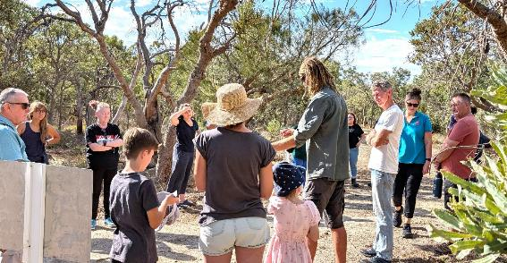
Image: Build a Nest Box with Re-Cyc-Ology (ReWild Perth), Banjup – April 2025.

Our Community – Projects/activities 2025-26

3B.01: Manning Park Playground Upgrade
Design and Deliver Upgrade:
Manning Park Playground is getting a much-needed upgrade. We’ll be replacing the aging equipment with modern and exciting play features that will spark children’s imaginations and cater to different ages and abilities.

3B.02: Atwell Reserve – Building Improvements
Design Upgrade:
This project will expand and refurbish existing sports facilities, including the addition of gender-neutral changing rooms and storage, to meet City standards and support growing, inclusive participation in local football and cricket.

3B.03: Aubin Grove Reserve Floodlight Improvements
Design Upgrade:
This project will upgrade floodlighting across the reserve to Australian standards, delivering enhanced visibility, safety and inclusivity for both organised sports and general community recreation.

3B.04: Beeliar Reserve - Beeliar Reserve Clubroom Upgrade
Plan Upgrade:
The Beeliar Reserve Community Centre redevelopment will deliver modern, inclusive and sustainable facilities – including upgraded changing rooms, multipurpose spaces and improved amenities – to meet growing community sport and recreation needs in the area.

3B.05: Cockburn Coast Clubroom and Oval
Plan Project:
The Cockburn Coast Clubroom and Oval project will deliver a new active sports and recreation space in North Coogee, supporting community participation, social connection, and the health and wellbeing of the broader Port Coogee area.

3B.06: Coogee Golf Complex
Plan Project:
This project involves comprehensive flora, fauna and heritage assessments to guide the responsible planning of the proposed Coogee Golf Complex, ensuring environmental and cultural values are preserved while optimising development potential, pending business case approval.

3B.07: Legacy Park Floodlighting
Design Upgrade:
This project will deliver energy-efficient 100-lux LED floodlighting at Legacy Park to enhance safety, accessibility and community use after dark while supporting sustainability through detailed design and cost-effective implementation.

3B.08: Success Regional Reserve Master Plan – Playing Field Floodlights
Plan Project:
This project will implement energy-efficient 100-lux LED floodlighting at Success Reserve to enhance safety, accessibility, and community use after dark while promoting sustainability through thoughtful design and cost-effective delivery.

3B.09: Success Regional Reserve Master Plan – Netball Floodlights
Deliver Upgrade:
This project will upgrade lighting at the netball facility by installing energy-efficient LED floodlights across all 20 courts, enhancing visibility, safety and usability in line with Australian sports lighting standards.

3B.10: Beale Park Redevelopment
Deliver Redevelopment:
The Beale Park Redevelopment will transform the reserve into a modern, inclusive hub for sport and community activity by delivering upgraded fields, facilities and amenities – including a new clubhouse, gender-neutral changing rooms, and improved infrastructure – to meet growing local demand.

3B.11: Beeliar Reserve - Floodlighting
Design Project:
This project will enhance floodlighting at Beeliar Reserve with energy-efficient LED systems – including 100-lux lighting for general use and 300-lux for cricket – to improve safety, accessibility, and compliance with Australian sporting standards for evening activities.

3B.12: Davilak Reserve Redevelopment
Plan Redevelopment:
This project will conduct a comprehensive review of Davilak Park – including community needs, site analysis, concept planning and feasibility – to guide sustainable upgrades that transform it into a vibrant, inclusive community and recreation hub.

3B.13: Wally Hagan Redevelopment
Plan Redevelopment:
The Wally Hagan Stadium Redevelopment will deliver a state-of-the-art, multipurpose sport and recreation hub featuring eight indoor courts, community amenities and a revitalised precinct – shaped by community input – to support the growing needs of Cockburn’s residents.

3B.14: Tempest Park Redevelopment
To ensure Tempest Park is the best fit for our community, the City is investigating upgrades to the reserve.

3B.15: Port Coogee Marina Expansion Stage 4 - Business Case
Explore financial viability and market demand for marina expansion including berth optimisation, industry trends and community engagement.

3C.01: Next RAP Development 2026 – 2029
Plan Development:
This project will provide internal resourcing to review, develop and engage on the City of Cockburn’s next Innovate Reconciliation Action Plan (RAP), ensuring a collaborative and informed strategy for reconciliation from 2025 onward, subject to Reconciliation Australia and Council approval.

3C.02: Aboriginal Cultural and Visitors Centre (Advocacy Funding)
Advocacy Funding:
The City will continue to raise the proposed Aboriginal Cultural and Visitors Centre project with relevant stakeholders and seek funding through suitable grant and philanthropic opportunities.

3D.01: Port Coogee Community Space
Plan Project:
This project aims to deliver a flexible, accessible and innovative community space in Port Coogee that supports a wide range of activities and future needs while thoughtfully integrating with the surrounding urban environment and minimising impacts on residents and businesses.

3D.02: Hosting ROYALS State Conference
Deliver Conference:
The City of Cockburn will proudly host this year’s annual conference, welcoming around 100 delegates for a weekend of events that showcase the City's unique heritage and history, with a focus on strong attendance and delegate satisfaction.

3D.03: Arts and Culture City Wide Needs Assessment
Undertake an analysis and audit of existing facilities to inform future facilities to be redesigned or developed fit-for-purpose to meet existing gaps in arts and culture provision.

3D.04: Develop a Town Teams approach to activate Cockburn Central
Design Approach:
The City will develop a high-level Arts and Culture Approach that builds on previous community consultation to guide public art, heritage and broader cultural initiatives, fostering a cohesive and vibrant cultural future.

Our Places – Projects/activities 2025-26

4B.01: Public Open Space Strategy Review
Design Strategy:
The City of Cockburn’s Public Open Space Strategy will guide the planning, improvement and creation of a connected network of parks and green spaces to support community wellbeing, environmental protection, and future recreational needs.

4C.01: Banjup Local Area Traffic Management (LATM)
Deliver Project:
The Banjup Local Area Traffic Management project aims to enhance safety and liveability by implementing traffic calming measures that deter non-local through-traffic and reduce vehicle speeds within the community.

4C.02: Cycling and Walking Plan Implementation
Design Plan:
The City of Cockburn is revising its Bicycle and Walking Network Plan to develop a long-term vision that enhances connectivity, safety and accessibility for cycling, walking and micromobility across the community for all ages and abilities.

4C.03: Elderberry Drive, Semple Court and Berrigan Drive Intersection - Semple Berrigan Roundabout
Design Project:
The City of Cockburn is upgrading the intersections of Berrigan Drive, Semple Court and Elderberry Drive with a new roundabout and improved lighting to enhance safety and traffic flow and align with the future Ngort Drive road network.

4C.04: Mid-term Review of Integrated Transport Strategy
Design Strategy:
This project will review the Integrated Transport Strategy to assess progress, identify key trends and provide updated recommendations, ensuring the City continues to deliver safe, accessible and sustainable transport solutions for the community.

4C.05: Orsino Boulevard and Pantheon Avenue Intersection
Design Project:
The City of Cockburn is upgrading the Orsino Boulevard and Pantheon Avenue intersection with a new roundabout and enhanced lighting to improve safety, traffic flow and accessibility for all road users.

4C.06: Rowley Road, De Haer Road and Liddelow Road Intersection
Design Upgrade:
The City of Cockburn is upgrading the intersections of Rowley Road, Liddelow Road, and De Haer Road by installing a new roundabout and improved lighting to enhance safety, visibility and traffic flow for all road users.

4C.07: Hammond Rd Duplication Russell Rd to Rowley - Upgrade and Extension Stage 1 - Russell to Frankland
Design Upgrade:
The City of Cockburn is upgrading Hammond Road between Russell Road and Frankland Road by duplicating the carriageway and enhancing lighting, landscaping and pedestrian infrastructure to support future traffic volumes and improve safety and accessibility.

4C.08: Beeliar Drive and Dunraven Drive Intersection (Black Spot Project)
Design and Deliver Upgrade:
The City of Cockburn is improving safety at the Beeliar Drive and Dunraven Drive intersection by installing traffic signals to reduce crashes and provide safer access for drivers, pedestrians and cyclists.

4C.09: Rockingham/ Phoenix Road Roundabout
Deliver Upgrade:
The City of Cockburn is upgrading the Rockingham Road and Phoenix Road intersection with a new roundabout and improved lighting to enhance safety, traffic flow and access for all road users.

4C.10: Rockingham Road Improvement – Coleville Crescent to Phoenix Road
Improvement Project:
The City of Cockburn is revitalising Rockingham Road through strategic upgrades to improve traffic flow, enhance pedestrian and cyclist safety, and create a more attractive, functional and vibrant streetscape.
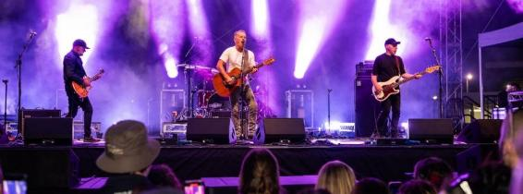
Image: Beeliar Sun Sets, Success Regional Sporting Facility – February 2025. On stage Mark Seymour and The Undertow.

5A.01: Develop Project Management Governance Framework
Develop Framework:
Development and deployment of a Project Management Governance Framework.

5D.01: Civic Facility Master Plan - Administration Building - HVAC and Roof
Plan Upgrade:
This project will renew critical components of the administration building – particularly HVAC and roof systems – to ensure continued functionality and extend the asset’s usable life into the medium term.

5D.02: Migrate GIS Systems to Hosted Cloud
Deliver Project:
Migration of GIS systems from on-premise servers to a hosted cloud environment.

5D.03: TechOne CiAnywhere Project
Deliver Upgrade:
Upgrade of TechOne modules from Ci (old platform) to a modern CiA environment.

5D.04: Service Review Program
Deliver Project:
This project involves a comprehensive review of City services to improve resource allocation and service delivery, ensuring long-term financial sustainability and the continued provision of high-quality services for a growing community.
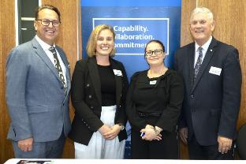 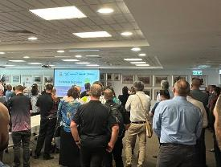
Images: Defence Supplier Yarn, Spearwood – April 2025. (Left to Right) Daniel Simms, Chief Executive Officer; Sarah Tartakowski, Babcock Australia & New Zealand; Kellie Jenkins, Babcock Australia & New Zealand and Mayor Logan Howlett.

Annual Financial Report
To delve deeper into the City of Cockburn’s financial performance for the 2024-25 financial year, please visit Corporate Strategic Planning page on our website: www.cockburn.wa.gov.au/Strategies-and-Plans
The 2024-25 Annual Financial Report will be available on the City’s website once it has been formally adopted by Council.
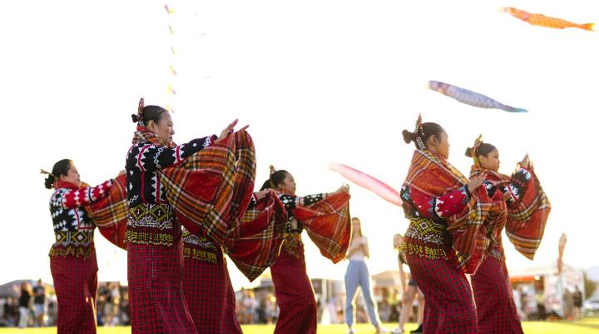
Image: Mosaic Festival - March 2025.

Contact Us
City of Cockburn
Whadjuk Boodjar
9 Coleville Crescent, Spearwood WA 6163
PO Box 1215, Bibra Lake DC WA 6965
Telephone: 08 9411 3444 | Email: customer@cockburn.wa.gov.au
City of Cockburn website: www.cockburn.wa.gov.au
City of Cockburn Facebook: www.facebook.com/CityofCockburn
City of Cockburn Instagram: www.instagram.com/cityofcockburn
City of Cockburn YouTube: www.youtube.com/CityofCockburn
City of Cockburn LinkedIn: www.linkedin.com/company/city-of-cockburn

This information is available in alternative formats upon request.

