**Policy Type**

Council

**Policy Purpose**

To protect the City's reputation by clarifying the use of the City’s corporate branding and logos and to control the use of the title ‘City of Cockburn/ Cockburn Council’.

**Policy Statement**

There are three graphic objects that represent three parts of the City: (1) the Office of the Mayor – Crest, (2) City of Cockburn – Corporate Logo and (3) Council Crest.

1. Office of the Mayor - Gold Cr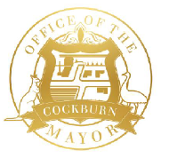est

The Office of the Mayor - Gold Crest retains the historical and ceremonial significance of the City. The crest is used on all Mayoral stationary, e-Signature, the Mayor’s name badge, the Mayoral chain, Mayoral attire, decor in and around the Mayor’s office and for other Mayoral related activities. It may also be used in combination with the City’s logo on invitations to civic events. Otherwise, the Crest is not to be used for any other purpose.

1. City of Cockburn - Corporate logo

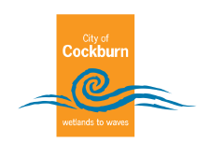

The logo represents the City of Cockburn and is given prominence and hierarchy, over other City brandmarks, that enhances awareness the City’s role in providing assets, services and communications, whether online or in hard copy.

1. Council - Crest

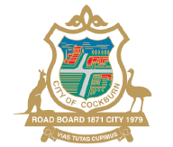

Councillors use the Council crest (not the office of the mayor crest) in all Councillor communications, including badges, e-signatures, headed paper, envelopes, business cards, the City flag (used in Civic Events).

1. Community use of the logo

In cases where the City supports an organisation financially or in kind, or is a project partner, it may be part of the agreement that the organisation must use the City’s logo or supported by the City of Cockburn logo in agreed marketing material for the duration of the agreement. The City’s Communications and Marketing team must approve the usage.

1. Cockburn Council refers to the elected Members (Mayor and Councillors).

City of Cockburn refers to the City of Cockburn as a local government authority and its employees.

1. The City of Cockburn Corporate logo, Council Crest and Office of the Mayor Crest must not be used for promoting the political interest of an Elected Member, or any candidate or Political party contesting a local, State or Federal government election.

**Bookmark 3**

|  |  |
| --- | --- |
| [Strategic Link](#Bookmark3" \o "Strategic Link – outline the Informing Strategy, Framework or Plan to provide a link to the Community Strategic Plan. Refer to the Category Index for guidance): | Communications Strategy and Action Plan |
| Category | Governance |
| Lead Business Unit: | Communications and Marketing |
| Public Consultation:  **(Yes or No)** | No |
| Adoption Date:  (Governance Purpose Only) | 11 March 2025 |
| Next Review Due:  (Governance Purpose Only) | March 2027 |
| ECM Doc Set ID:  (Governance Purpose Only) | 4133992 |