Tender Title: |  | M900013 (RFT 18/2020)  Turf Renovation Services (Parks) - Three (3) Year Contract
Request ID: |  | 36338
Tender Description: |  | Contractor to conduct Turf Renovation Services on the Principal’s Sporting Reserves. Turf renovation may include: verti-mowing, scarifying, low mowing, green waste removal, corning, topdressing, fraise mowing, surface planing, and over seeding.
Advert Approval: |  | Decision to Advertise: Director of Engineering & Works  Decision Date: Friday, 11 December 2020
Closing Date and Time: |  | 2:00PM (AWST) Wednesday, 30 September 2020
Opening Date and Time: |  | 2:00PM (AWST) Wednesday, 30 September 2020
 | Tenderer’s Name:
1 | Environmental Industries PTY LTD (Maintenance)
2 | Green Options
3 | Jerra Nominees PTY LTD & NB Norrish PTY LTD t/a State Wide Turf Services
4 | Lovegrove R & A t/a Lovegrove Turf Services
5 | The Trustee for Turfmaster Unit Trust
6 | Turf Care WA PTY LTD t/a Turfcare WA (Turfcare WA)
7
8
9
10

Advertisement
Method 1 : City of Cockburn | Method 2 : NA
Method 3 :  The West Australian | Tender Awarded by:
Copy of Statewide Notice:  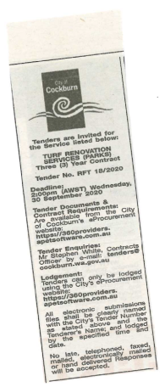 | Director of Engineering & Works  Choose an item.  Friday, 11 December 2020
 | Date of Council Meeting:
Click here to enter a date. or
Not applicable
Item No:
Name of Successful Tenderer(s): | - Jerra Nominees PTY LTD & NB Norrish PTY LTD t/a State Wide Turf Services for Verti-mowing, Scarifying. Low Mowing, Sweeping and associated works (Contract A).  - The Trustee for Turfmaster Unit Trust for Coring (Hollow & Solid Tyne) and Sweeping (Contract B)  - Lovegrove R & A t/a Lovegrove Turf Services for Top Dressing (Contract C)
Amount of Successful Tender(s): (ex GST) | - Estimated contract value of $278,250  - Estimated contract value of $68,640  - Estimated contract value of $137,400

