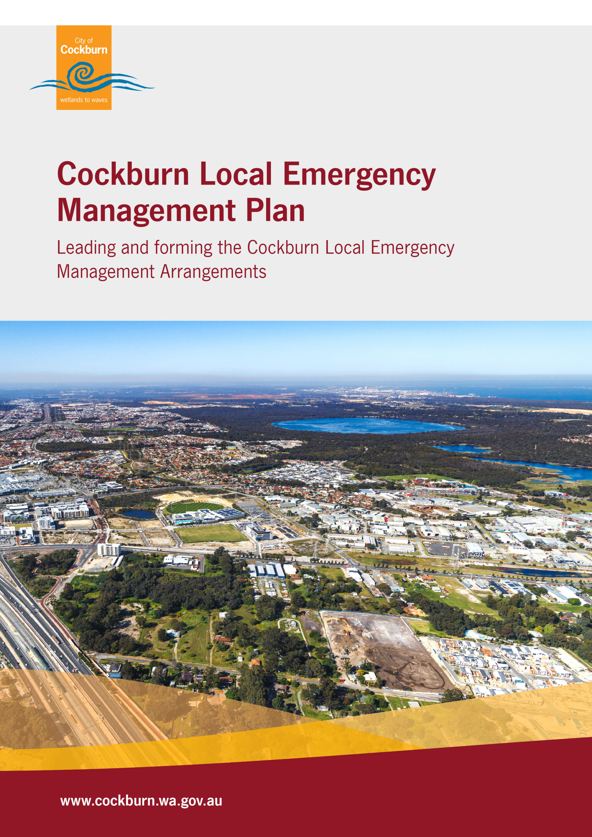
Authority
Th Local Emergency Management Plan has been produced and issued under the authority of section 41(1) of the Emergency Management Act 2005, endorsed by the Cockburn Local Emergency Management Committee and the Council of the City of Cockburn. This plan has been tabled for noting with the South Metropolitan District Emergency Management Committee and State Emergency Management Committee.
The Cockburn Local Emergency Management Committee is established under section 38 of the Emergency Management Act 2005.
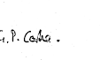 |  | 17/12/2025
City of Cockburn Deputy Mayor Phoebe Corke  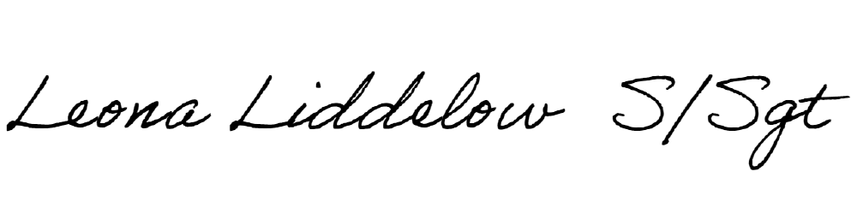  On behalf of the Mayor, Chair of the Cockburn Local Emergency Management Committee |  | Date
 |  | 17/12/2025
Deputy Chair, WA Police Senior Sergeant Leona Liddelow  Cockburn Local Emergency Management Committee |  | Date

Endorsed by Council 9 December 2025 (2025/MINUTE NO 0217)

Acknowledgement of Country
The City of Cockburn and the Cockburn Local Emergency Management Committee acknowledges the Nyungar people of Beeliar Boodjar. Long ago, now and in the future they care for Country. We acknowledge a continuing connection to Land, Waters and Culture and pay our respects to Elders, past and present.

Table of Contents
Document Distribution 4
Document Amendments 5
Part One: Setting the Scene 7
1.1 Introduction 7
1.2 Scope 8
1.3 Aim and Strategic Alignment 8
1.4 About the City of Cockburn – the Best Place to Be 9
1.5 Community Disaster Resilience Snapshot 13
1.6 Managing Risk 14
Part Two: Preparing for Emergencies and Local Emergency Management Arrangements 17
2.1 Local Emergency Management Arrangements 17
2.2 Agreements, Understandings and Commitments 18
2.3 Roles and Responsibilities 19
2.4 Cockburn Local Emergency Management Committee 21
2.5 Community Education and Emergency Planning 22
Part Three: Emergency Response and Recovery Arrangements 25
3.1 Areas of Operation 25
3.2 Local Recovery Planning 26
3.3 Animals and the Natural Environment 26
3.4 Communications 27
3.5 Evacuation and Places of Shelter 28
3.6 Local Resources for Response and Recovery 29
Part Four: Implementation and Accountabilities 31
4.1 Maturity Assessment 31
4.2 Reporting and Review 31
4.3 Exercising 32
4.4 Lessons Management 33
Appendix One – Glossary of Terms 34
Appendix Two – Cockburn Local Emergency Management Committee Terms of Reference 39

Document Distribution
List of agencies and roles to receive copies of the Local Emergency Management Arrangements in full.
Organisation | Copies
Australian Defence Force – HMAS Stirling | Digital copy
Australian Red Cross | Digital copy
Cockburn Local Emergency Management Committee members, not otherwise listed here | Digital copy
City of Cockburn – Mayor | Hard copy
City of Cockburn – Local Recovery Coordinator Kit (kept at Fire and Emergency Management Manager's desk) | Hard copy
City of Cockburn – Chief Bush Fire Control Officer | Hard copy
City of Cockburn – Deputy Chief Bush Fire Control Officer | Hard copy
Cockburn Fire and Rescue Station | Digital copy
Cockburn Police Station | Digital copy
Cockburn State Emergency Services | Digital copy
Department of Biodiversity Conservation and Attractions - Parks and Wildlife | Digital copy
Department of Communities – Emergency Relief and Support Services | Digital copy
Department of Fire and Emergency Services – District Emergency Management Advisor | Digital copy
Department of Fire and Emergency Services – Region Superintendent | Digital copy
Department of Health | Digital copy
Department of Primary Industries and Regional Development – Incident and Emergency Management | Digital copy
Fiona Stanley Hospital | Digital copy
Fremantle Police Station | Digital copy
Jandakot Volunteer Bush Fire Brigade | Digital copy
Jandakot Airport Holdings | Digital copy
Marine Rescue Cockburn | Digital copy
Murdoch Fire and Rescue Station | Digital copy
Murdoch Police Station | Digital copy
South Coogee Volunteer Bush Fire Brigade | Digital copy
State Emergency Management Committee – Executive Officer | Digital copy
South Metropolitan Police District – Superintendent | Hard copy
WA Police – Emergency Management Unit | Digital copy

Date | Amendment detail | Lead
2018 | Major Review | M.Emery
2025 | Major Review – LEMA structure revised to include a separate Local Emergency Management Plan and Local Recovery Plan for practical and strategic use, clearer structure of LEMA documents, and content updated with various new subject areas for staff use. | C.Mora

Document Amendments

A review of this Plan should be undertaken every five years. Major amendments or additions between these scheduled reviews may be required based on incident debriefs, exercising or otherwise. See Part Four: Implementation and Accountabilities for more information.



Part One: Setting the Scene

1.1 Introduction
Emergency management means the management of the adverse effects of an emergency including:
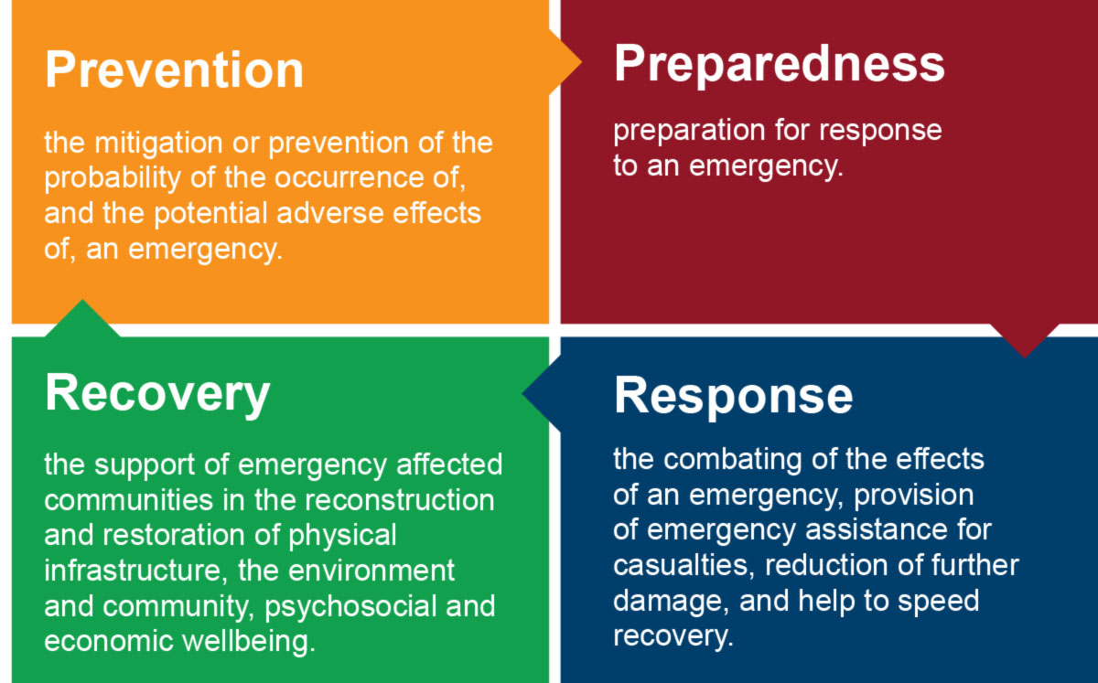

Emergency management in Western Australia is governed by the Emergency Management Act 2005 (EM Act) and the Western Australian Emergency Management Policy, Plans and Procedures, collectively known as the State Emergency Management Framework (EM Framework).
The City of Cockburn is committed to ensuring it maintains, tests and effects local emergency management arrangements that aim to build community awareness of local risks, and prioritise community safety, resilience-building and risk reduction.
This Plan was prepared by the City of Cockburn in consultation with the Cockburn Local Emergency Management Committee and City of Cockburn staff.

1.2 Scope
The Cockburn Local Emergency Management Plan (this document) is an overarching document that forms the Cockburn Local Emergency Management Arrangements, which the City of Cockburn is responsible for developing, maintaining and testing.
The Local Emergency Management Arrangements are not intended to detail the procedures for Hazard Management Agencies in dealing with an emergency. These should be detailed in the Hazard Management Agency's individual plans.
These arrangements are to serve as a guideline to be used at the local level. Incidents may arise that require action or assistance from the District, State or Federal level.

1.3 Aim and Strategic Alignment
The aim of the Local Emergency Management Arrangements is to detail the local plans and procedures for dealing with emergencies and ensure an understanding between agencies and stakeholders involved in managing emergencies within the City in accordance with the Emergency Management Framework.

The Local Emergency Management Plan, this Plan, aims to provide a framework for the implementation of activities to realise, at a local level, the key priority areas of the WA Community Disaster Resilience Strategy (CDRS 2023);
- Broaden Emergency Management
- Work Locally to Increase Preparedness
- Collaborate to Reduce Vulnerability, and
- Heal People and Communities.
This Plan also outlines the strategic intent and framework that guides local emergency management, including the establishment of the Cockburn Local Emergency Management Committee, agency roles and responsibilities, and establishing key plans and procedures for the Cockburn Local Emergency Management Arrangements.
The City of Cockburn Strategic Community Plan 2020-2030 is a roadmap to ensure we focus on achieving the highest desirable outcome and maintain the City’s vision. It reflects the priorities of our community and builds on our history and the previous plans we have to shape our community. Aligned to the Strategic Community Plan’s vision for Cockburn, the best place to be, this Plan aims to enshrine the safety of our communities, economy, and built and natural environment by taking action to plan for and reduce the severity of emergencies.
This Plan supports the Strategic Community Plan by facilitating and advocating for increased community safety and resilience by outlining the framework by which the City of Cockburn, the Cockburn Local Emergency Management Committee and other local stakeholders plan and prepare for, respond to and recover from emergencies.
“Community resilience is the ability of communities (and their members) exposed to disasters, crises and underlying vulnerabilities to anticipate, prepare for, reduce the impact of, cope with and recover from the effects of shocks and stresses without compromising their long-term prospects.” (WA CDRS 2023)
The objectives of the Local Emergency Management Arrangement documents align with the City’s Strategic Community Plan objective to promote a vibrant, healthy, safe, inclusive and connected community (Outcome 3: Community, Lifestyle and Security).

1.4 About the City of Cockburn – the Best Place to Be

Nearly 112,000 people live in the City’s 23 suburbs and this is expected to grow to over 170,000 by 2036. Cockburn is centrally located in the southern suburbs of Perth, Western Australia on Whadjuk Nyungar Boodjar (the land of the Whadjuk Nyungar people) between the coast, with Rottnest and Carnac Islands off the coast, and Jandakot Airport. Cockburn is uniquely positioned to the south of the Fremantle Port, Western Australia’s largest and busiest port, and to the north of the Kwinana Industrial Area, a resource industry hub and a major contributor to the National and International economy, and Garden Island, home to Royal Australian Navy HMAS Stirling.
Family and youth: at the time of adopting this plan, there are 31 Primary and 10 Secondary Schools, and many more childcare and aged care facilities serving the youth of Cockburn, which makes up 31.3% of the population.
Disability: There was an average of 2,889 NDIS active participants in the City of Cockburn each quarter in 24/25, and 10.7% of the Cockburn population provide unpaid assistance to a person with a disability, health condition or due to old age and 13.4% are over the age of 65. We know these statistics are likely much lower than the reality, and many considerations and experiences may make people as at greater-risk of injury or isolation during emergencies.
The many natural areas within the City of Cockburn are home to environmentally sensitive species, and there are a number of ecological linkages, which provide important movement passages for fauna and habitat for flora, in urban areas.
Two chains of wetlands run north-south through the City as part of the Beeliar Regional Park. These areas provide habitat for local flora and fauna and are a natural oasis. Many of the wetland areas have walking and cycling trails, BBQs, public amenities and playgrounds inviting interaction with the natural environment.
Cultural diversity: 50% of the residents of Cockburn are from a culturally diverse background (born overseas or have parents that were born overseas), 34.2% of people in Cockburn were born overseas, and 21.6% of people use a language other than English at home.
Cockburn Central is one of the fastest-growing communities in Perth’s south metropolitan area. Home to the Cockburn Aquatic and Recreation Centre, the Fremantle Football Club (Freo Dockers) competing in the Australian Football League, Cockburn Central Train Station and Cockburn Gateway Shopping City.
The Australian Marine Complex (AMC) in Henderson is a world-class centre servicing the defence, marine, oil and gas, and resource industries and home to one of only two naval shipbuilding locations in Australia. The area is expected to grow and attract businesses, skills and workers with the AUKUS Agreement.
The Bibra Lake Business precinct is home to 1,673 businesses ranging from large engineering companies to construction and transport businesses.
Jandakot Airport is the major general aviation airport in Western Australia and one of the busiest airfields and largest aviation training bases in Australia. The Airport precinct is home to the State’s headquarters for the Royal Flying Doctor Service, Police Air Wing, Department of Biodiversity Conservation and Attractions Aviation Fleet and Department of Fire and Emergency Services Rescue Helicopter and Aviation Fleet, plus supermarket and state utilities distribution and operation centres.
Latitude 32: At more than 1,400 hectares, Latitude 32 is one of the largest industrial zones in Australia. Perfectly located next to the Western Trade Coast and the future Westport to replace Fremantle Port, it will be a major economic driver and employer for the region.
The 15-kilometre coastline is a place of conservation, recreation and attraction for the locals and tourists alike, featuring several shipwrecks.
A comprehensive breakdown of information, trends and forecasts about the City population and economy can be viewed on the City’s online interactive demographic, economic and community tools.

Figure 1: Map of the District of the City of Cockburn
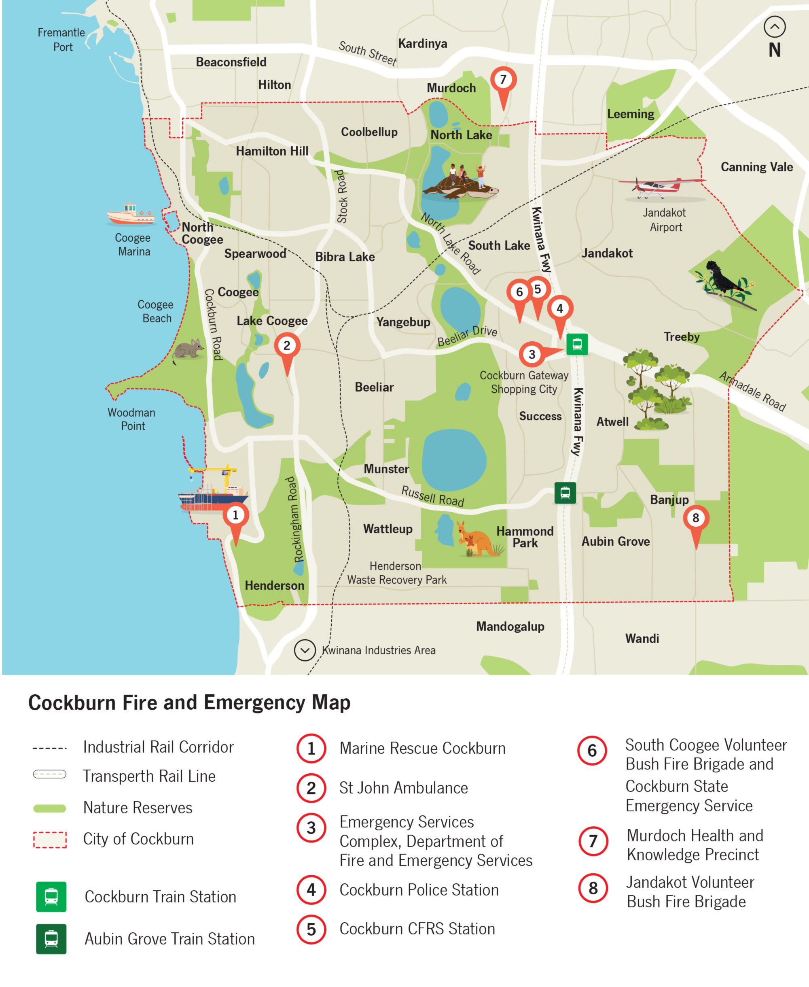

In planning for emergencies and disruptions to the community (those living, working and passing through the City of Cockburn district), there are several considerations that need to be made;
- What does the community value and how can we empower the community to drive preparedness and recovery priorities?
- There may be varying levels of support required by different individuals and cohorts in the community – how can we recognise this?
- How best is it to communicate with different groups/cohorts of the community, and how can we make communications two-way?
- Where does the target audience of the community meet and gather?
- Where does the community already find information, and look to for community leadership, i.e. elected members and community groups?

1.5 Community Disaster Resilience Snapshot
In 2025, the City participated in a trial community disaster resilience process to provide a snapshot of community sentiment in relation to six domains of disaster resilience. These domains are social, cultural, natural, built, economic, and political. This was a partnership between the Department of Fire and Emergency Services with the Cities of Cockburn, Kwinana and Rockingham.
A total of eight recommendations were made from the report, the following were adopted by the three local governments as priorities for implementation and embedding in practice;
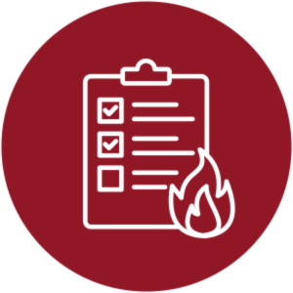 |  | Recommendation 1: Provide education and planning tools for households to become more prepared for emergency events. Focus on lesser-known local hazards including but not limited to power supply disruption, HAZMAT, maritime emergencies and heat waves.
 |  | Recommendation 5: Work with local businesses and key industries to ensure that business continuity planning and public safety plans are in place where risk is high (e.g. industrial industries, building and construction, maritime-based industries and tourism).
 |  | Recommendation 7: Review current community engagement and consultation practices and implement accessible and appropriate ways to integrate the voices of people at higher risk (before, during and after emergencies) including more out-of-hours consultation and support from translators for CALD communities.

1.6 Managing Risk
There are a number of hazards that can occur within the City of Cockburn. Increasing the awareness and understanding of these hazards will help the community to better prepare and improve their own resilience to these types of events. Some of the hazards that may impact the Cockburn community include (in alphabetical order):
- air crash  - collective trauma events  - cyclone  - heatwaves  - hazardous materials  - plant and animal biosecurity | - public health emergency  - marine emergency  - rail crash (passenger or freight)  - storms and storm surge  - tsunami
More information about hazard management can be found in Figure 2.
A snapshot of significant incidents requiring an Incident Support Group meeting between 2020-2025
When | Hazard Type | Incident Details
February 2020 – November 2022 | Human Pandemic | COVID-19/Coronavirus
December 2020 | Plant Biosecurity | Queensland Fruit Fly outbreak in Coolbellup.
August 2021 – July 2025 | Plant Biosecurity | Polyphagous Shot-Hole Borer  (declared management phase from July 2025)
December 2022 | Bushfire | Mount Brown Reserve, Henderson
December 2022 | HAZMAT | Fire on Cocos Drive, Bibra Lake
April 2023 | Fire | Pickles Auction House fire in Bibra Lake
October 2023 | HAZMAT | Chemical business fire on Cocos Drive, Bibra Lake
November 2023 | Bushfire | Started in Freeway reserve extending to bushland and properties adjacent to Hammond Park Secondary School. Significant school and daycare impacts. Hammond Park
February 2024 | Bushfire | South Lake/Bibra Lake Reserves bushfire reignition from bushfire. Impact to peat soils.
November 2024 - August 2025 | Plant Biosecurity | Queensland Fruit Fly outbreak across suburbs in Melville and Cockburn with restrictions and quarantine arrangements put in place.

Risk management is a critical component of the emergency management process. Building a sound understanding of the hazards and risks likely to impact the community will enable the Cockburn Local Emergency Management Committee members to work together to implement treatments. This process helps to build the capacity and resilience of the community and organisations which enable them to better prepare for, respond to and recover from a major emergency. The process and mandate for local governments to undertake risk management is detailed in State Emergency Management Policy section 3.2.
The increasing frequency, severity and complexity of emergencies, driven by climate change, demographic changes and other factors point towards a need to consider a systemic approach to risk. The Australian Institute for Disaster Resilience refers to systemic risks as those that ‘emerge from the interactions of climate change and natural hazards, with the complex, interdependent and interconnected networks of social, technical, environmental and economic systems’. This approach moves away from traditional hazard-by-hazard approaches to risk and requires an understanding of how systems may be interrupted, intersected or fail, and how this may change or overwhelm a society’s capacity to cope.
As a result, emergency management increasingly needs to work across sectors and with communities to help drive resilience initiatives on the ground. This not only better prepares us for frequently occurring hazards but also compounding and cascading events. This whole-of-society approach where everyone has a role to play in our collective safety is commonly referred to as the principle of shared responsibility.
Climate change has significant social, economic and legal implications for local government. Cockburn is already experiencing the effects with increased coastal erosion, higher summer temperatures, more severe heatwaves and a longer bushfire season. The City has a critical role in responding to climate change through its responsibilities for land use planning, emergency management, ownership of public infrastructure and delivery of community services. For more information, refer to the City of Cockburn Climate Change Strategy 2020-2030

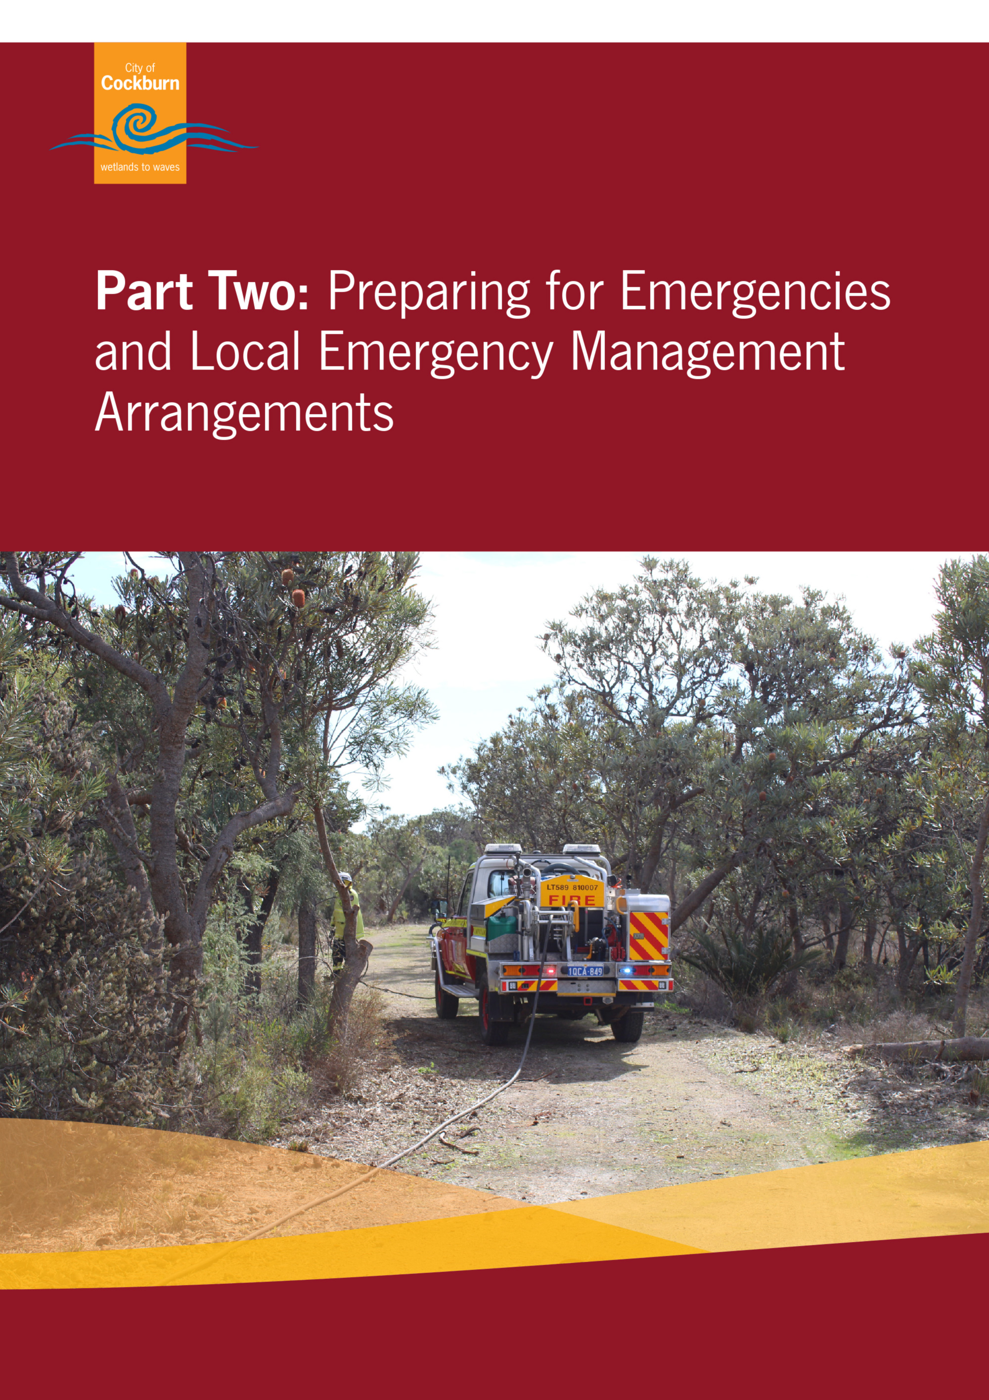

Part Two: Preparing for Emergencies and Local Emergency Management Arrangements

2.1 Local Emergency Management Arrangements
It is a function of a local government under section 36 of the Emergency Management Act 2005 to ensure effective Local Emergency Management Arrangements are prepared and maintained for its district. The Local Emergency Management Arrangements is a series of documents outlining the strategies, responsibilities and plans for emergency management within the district, and per section 41(2) of the Emergency Management 2005.
This Plan establishes the Local Emergency Management Arrangements and presents the following structure for the organisation of the Local Emergency Management Arrangements.
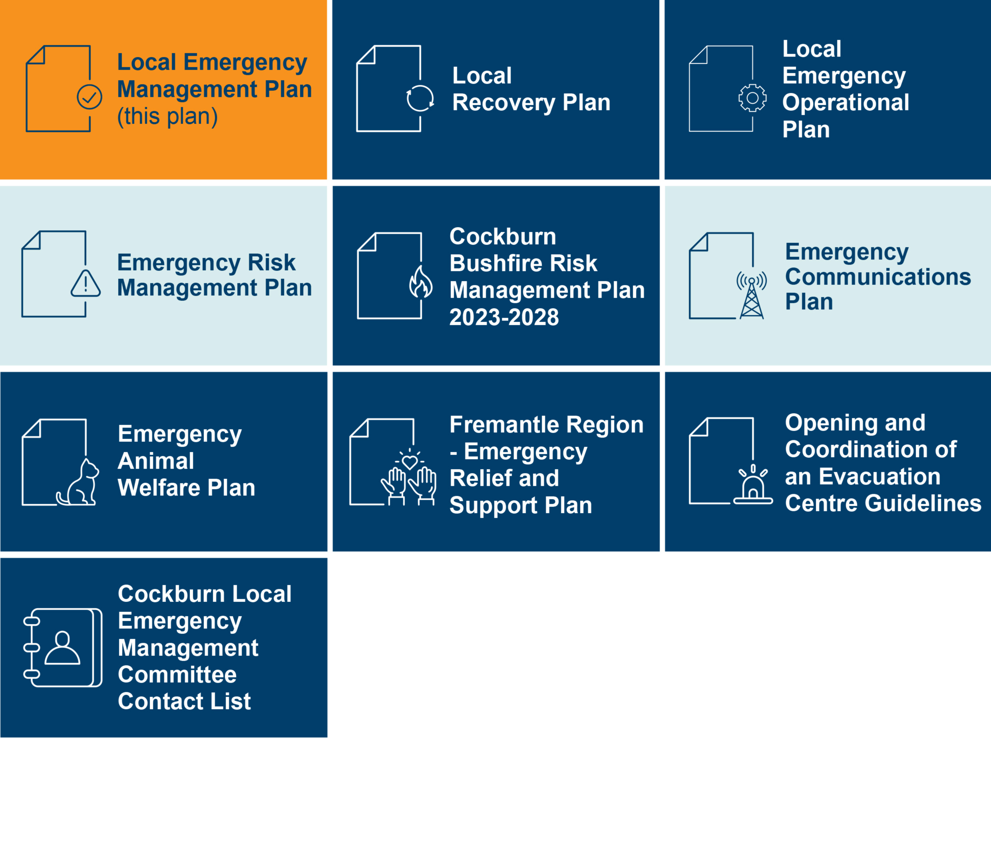

2.2 Agreements, Understandings and Commitments
Emergency management works best through collaboration and shared efforts to build community resilience and reduce risks. As such, the City of Cockburn is a partner in the Memorandum of Cooperation - Provision of Emergency Support 2025 – 2030 with Perth local governments in the South Metropolitan area. Parties to the agreement include the following Local Governments:
- City of Armadale  - City of Cockburn  - City of Fremantle  - City of Kwinana  - City of Mandurah | - City of Melville  - Shire of Murray  - City of Rockingham  - Shire of Serpentine Jarrahdale  - Shire of Waroona
The Memorandum of Understanding formalises cooperative arrangements between local governments for the sharing of emergency management information and knowledge, as well as the provision of support for disaster recovery activities.
The City is also in two agreements for the provision of staff to support the City of Cockburn’s emergency management responsibilities. This includes:
- A Memorandum of Understanding for the Provision of a Community Emergency Services Manager with the Department of Fire and Emergency Services for the delivery of fire and emergency services to the City, primarily through the management of the City’s Volunteer Bush Fire Brigades.
- a Memorandum of Understanding for the Provision of a Bushfire Risk Mitigation Coordinator with the Department of Fire and Emergency Services and the City of Mandurah for three years to work with stakeholders and plan, complete and evaluate bushfire risk mitigation activities within both local government areas.
The City also has operational arrangements with DFES to support fire response, including:
- maintenance and use of a Bulk Water Tanker (12.2) at Jandakot Volunteer Bush Fire Brigade, and
- mobilisation of South Coogee Volunteer Bush Fire Brigade within the Gazetted Fire District.

2.3 Roles and Responsibilities

A Hazard Management Agency is ‘to be a public authority or other person who or which, because of that agency’s functions under any written law or specialised knowledge, expertise and resources, is responsible for emergency management, or the prescribed emergency management aspect, in the area prescribed of the hazard for which it is prescribed.’ [s.4 Emergency Management Act]
The Hazard Management Agencies are prescribed in the Emergency Management Regulations 2006.
Their function is to:
- Undertake responsibilities where prescribed for these aspects [Emergency Management Regulations]
- Appoint Hazard Management Officers [s.55 Emergency Management Act]
- Declare / revoke emergency situation [s.50 & 53 Emergency Management Act]
- Coordinate the development of the State Hazard Plan for that hazard [State Emergency Management Policy s.1.5]

- Ensure effective transition to recovery by local government
A Controlling Agency is an agency nominated to control the response activities to a specified type of emergency.

The function of a Controlling Agency is to;
- undertake all responsibilities as prescribed in Agency specific legislation for Prevention and Preparedness.
- control all aspects of the response to an incident.
- During Recovery the Controlling Agency will ensure effective transition to recovery.

A Combat Agency as prescribed under subsection (1) of the Emergency Management Act 2005 is to be a public authority or other person who or which, because of the agency’s functions under any written law or specialised knowledge, expertise and resources, is responsible for performing an emergency management activity prescribed by the regulations in relation to that agency.


A Support organisation is public authority or other person who or which, because of the agency’s functions under any written law or specialised knowledge, expertise and resources is responsible for providing support functions in relation to that agency.

Figure 2: Western Australia recognised hazards and assigned Hazard Management Agencies (HMA) - Emergency Management Regulations 2006
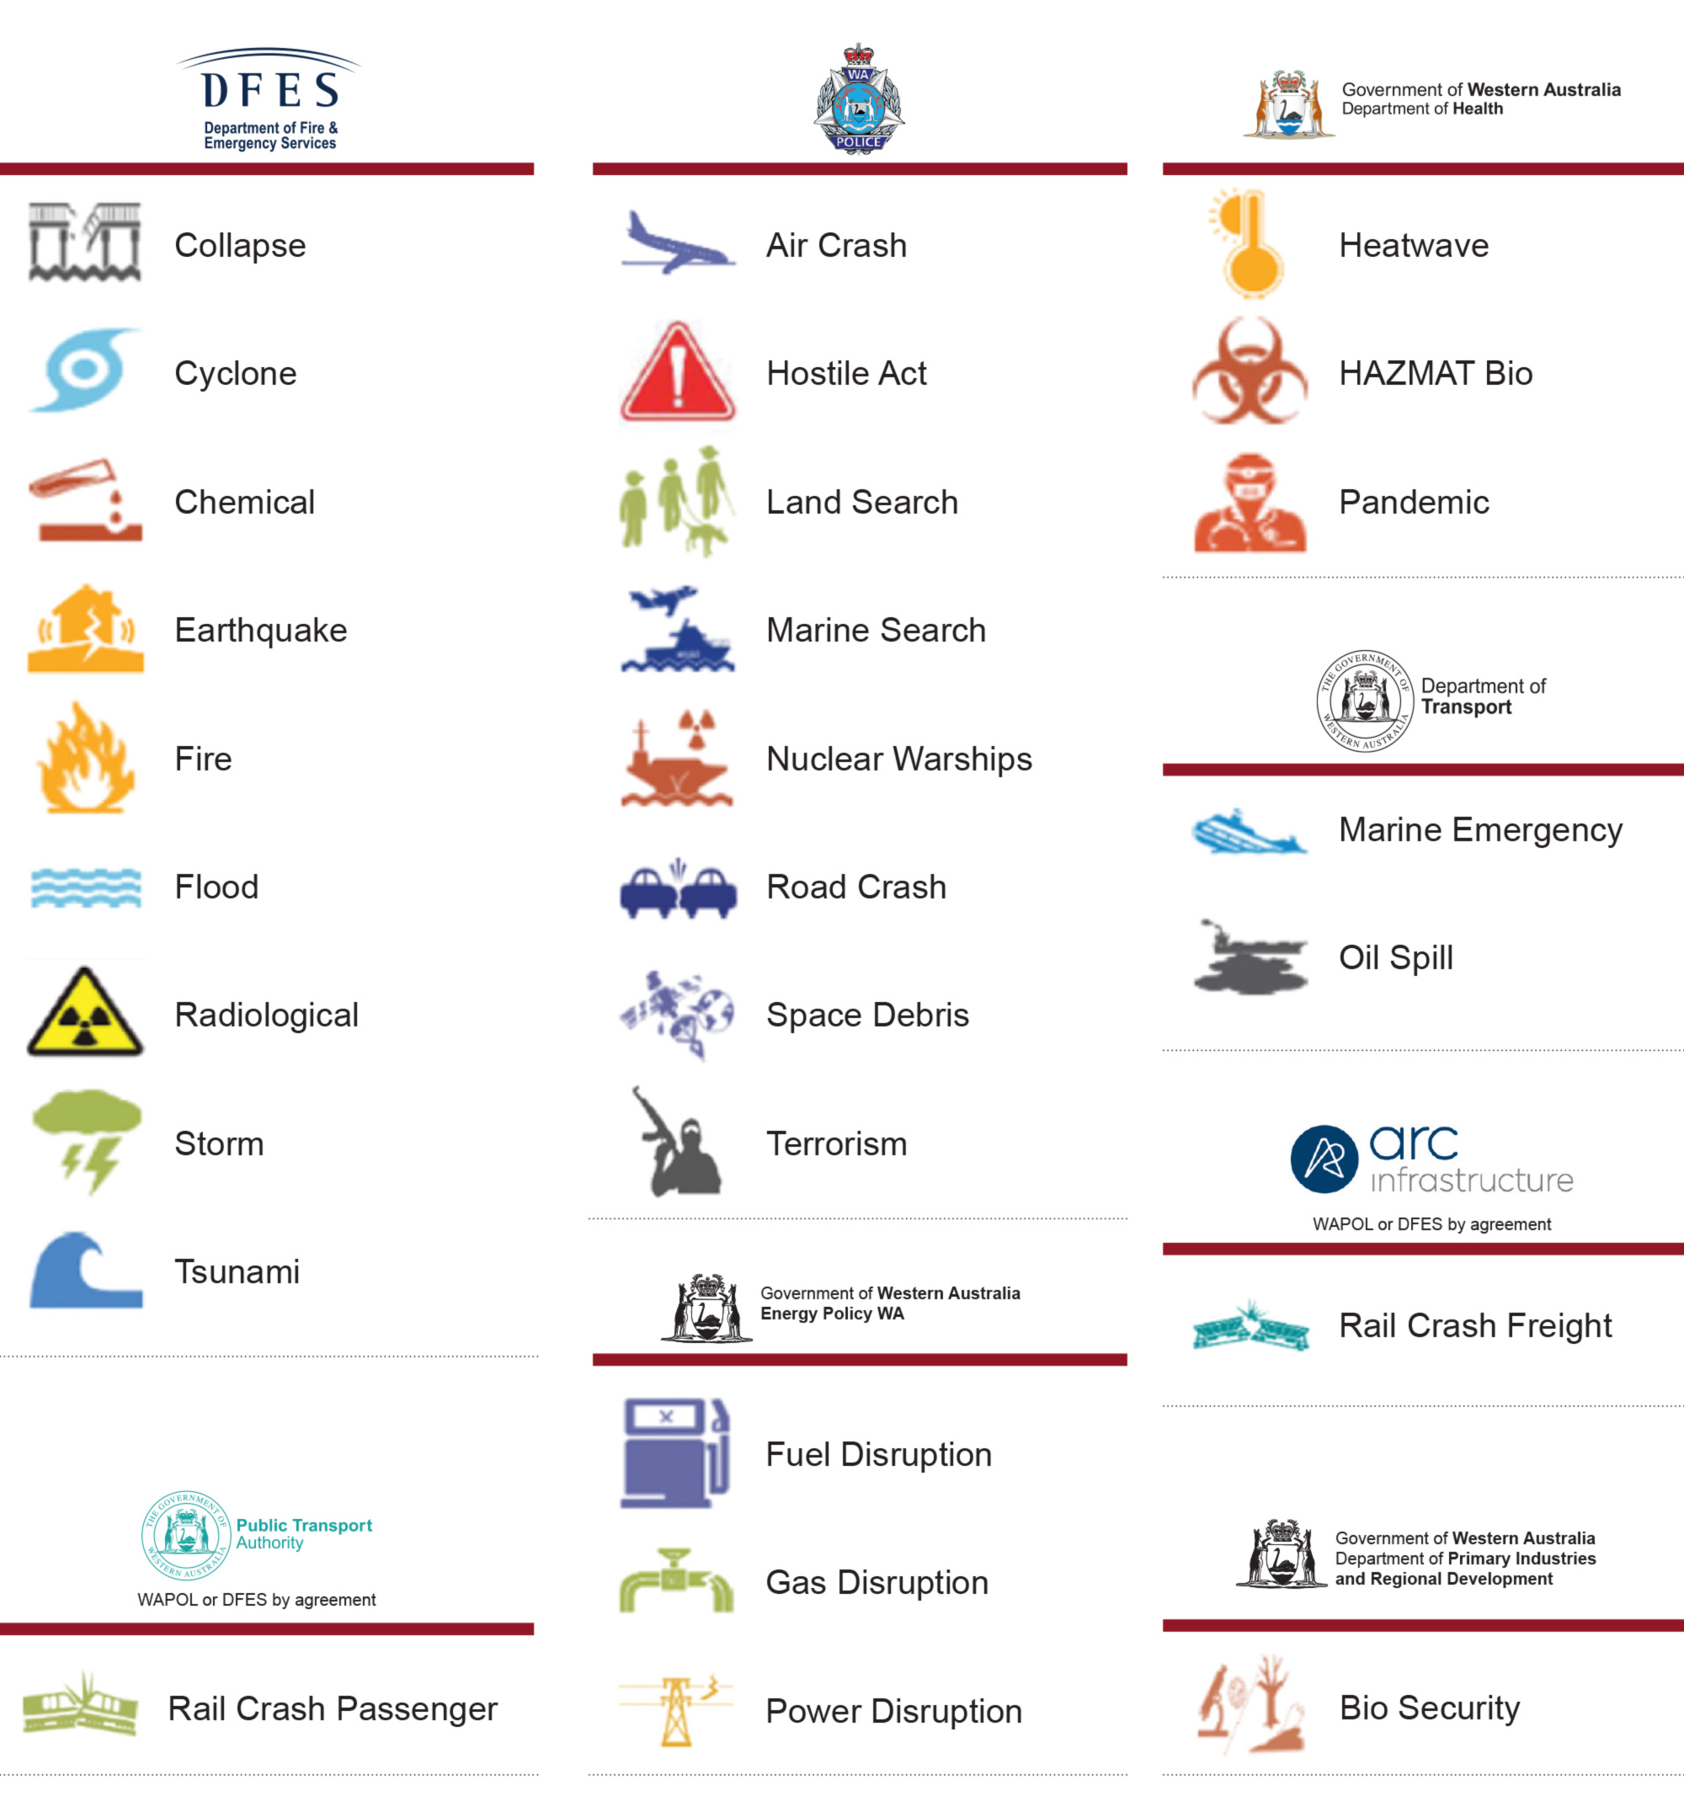

Figure 3: Summarises the role of Local Government prevention, preparedness, response and recovery, which is outlined in more detail in the Emergency Management Act 2005, the State Emergency Management Framework, and the Local Government Emergency Management Knowledge Hub.
Prevention and Preparedness | Response | Recovery
- Local Emergency Management Arrangements  - Emergency risk management  - Bushfire risk mitigation and compliance  - Local Emergency Management Committee  - Community education  - Exercising, training, and capability  - Animal welfare  - People at higher risk  - Person-centred emergency preparedness  - Collaboration and partnerships | - Combat Agency (Fire)  - Communications  - Evacuation and relief services  - Donations and volunteers  - Incident support | - Coordination  - Communications  - Recovery planning  - Recovery finance and funding

2.4 Cockburn Local Emergency Management Committee
The City of Cockburn has established the Cockburn Local Emergency Management Committee under section 38(1) of the Emergency Management Act 2005 to oversee, plan and test the Local Emergency Management Arrangements per the Terms of Reference (see Appendix Two).
The Cockburn Local Emergency Management Committee includes representatives from agencies, organisations and community groups relevant to the identified risks and emergency management arrangements for the locality of the City of Cockburn.
For more information, refer to the Cockburn Local Emergency Management Committee Terms of Reference in Appendix Two of this plan.

2.5 Community Education and Emergency Planning
Having a plan for yourself, family, animals and/or colleagues or customers of what to do in an emergency is important to keep everyone safe and allow emergency services to do what they need to do to reduce safety hazards.
Figure 4: Person-centred emergency preparedness capability wheel showing the eight areas to think about your personal strengths and support needs. (from Collaborating 4 Inclusion).
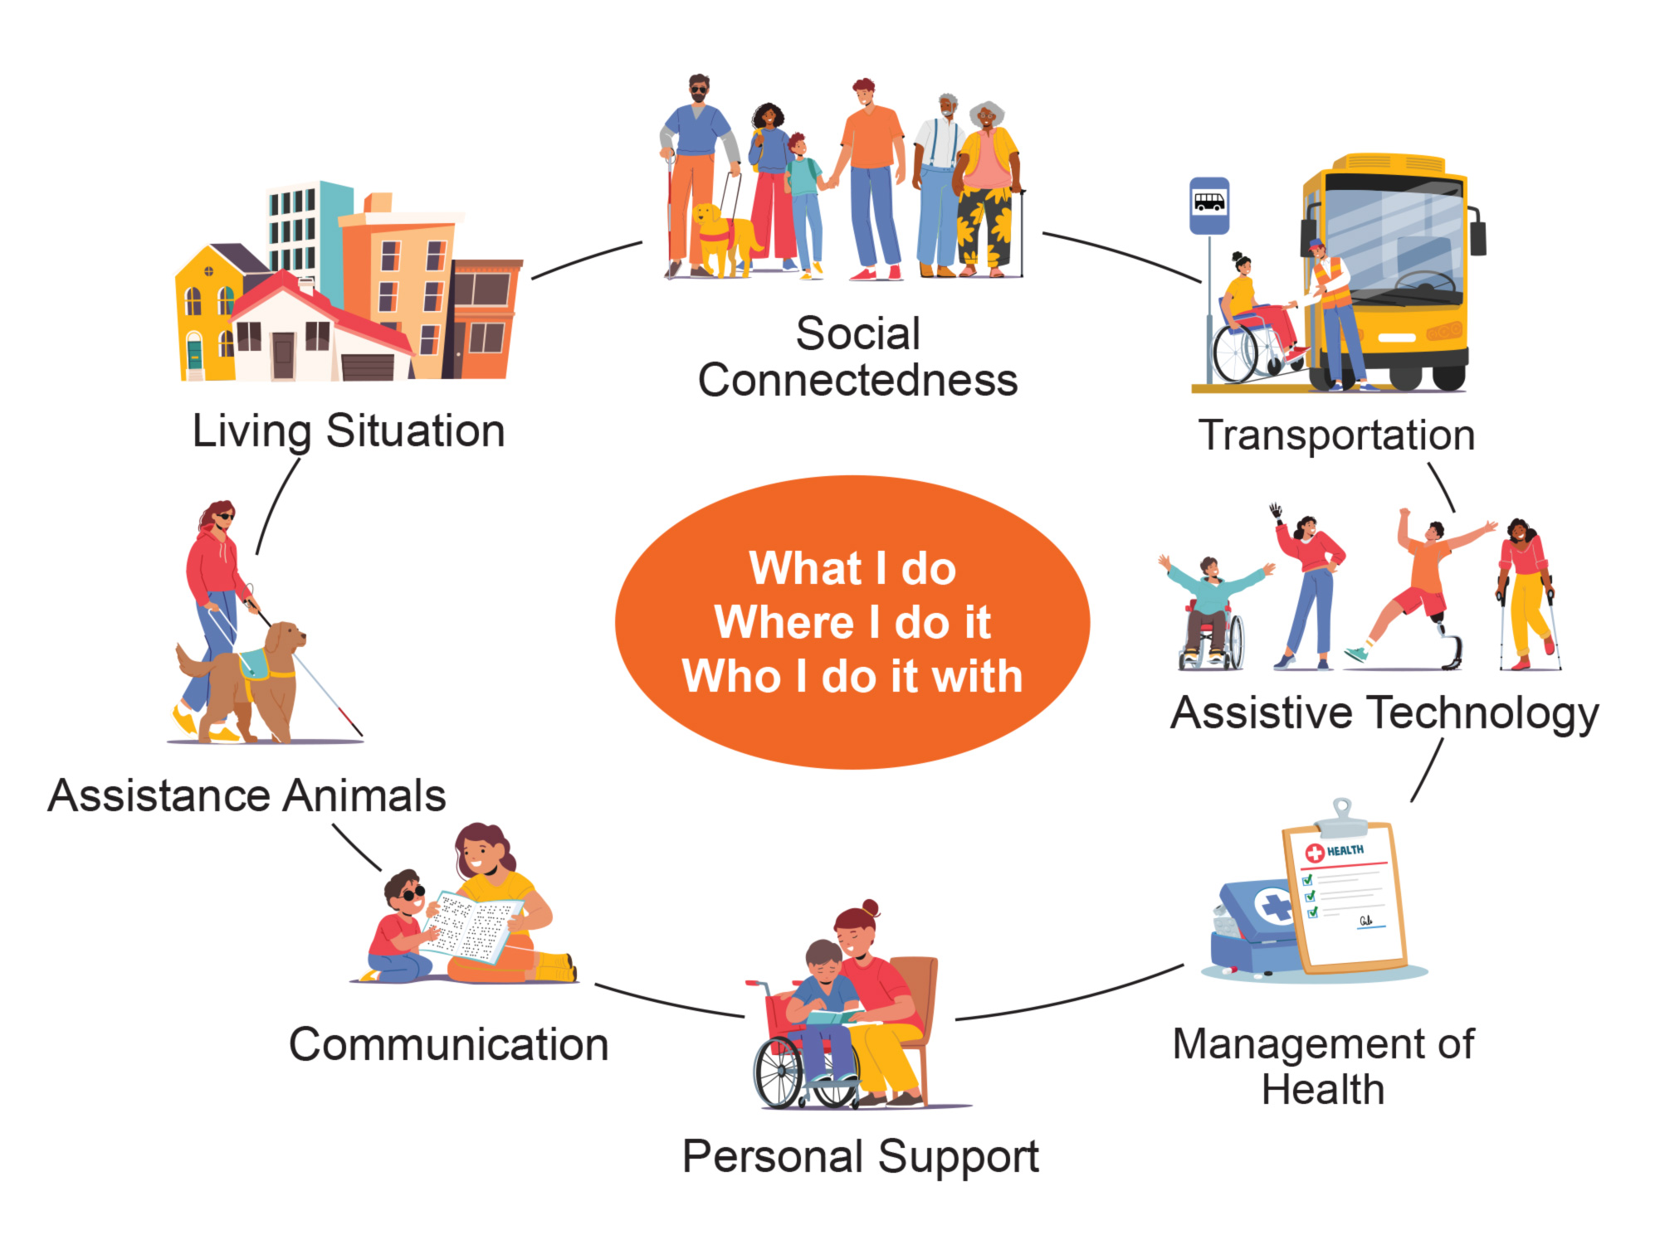
Note: Information in this section can be used as advice for planners, developers and facility managers, particularly for the application of State Planning Policy 3.7 (SPP 3.7).
Emergency planning for hazards likely to have a rapid impact to people, such as heatwaves, bushfires and storms, must extend beyond a home's boundaries or a facility’s emergency assembly point. Vulnerable land uses are facilities where people need specific care or may be unable to respond independently, such as schools, aged care facilities, retirement villages, hospitals, prisons, residential care, and childcare centres.
These facilities should plan to shelter-in-place where possible to reduce exposure of people at higher risk to danger. Sheltering in place is a good alternative to leaving whereby you may be exposed to danger or harm from the hazard, such as heat, harmful chemicals, fire or unsanitary water.
Planning for evacuation should include decision triggers to evacuate early, such as when Advice is issued via Emergency WA website or app. Evacuation beyond the emergency assembly point should be to a like-for-like facility, a safe distance away from the hazards of the emergency, particularly for vulnerable land uses. This ensures that appropriate equipment, supervision, and safety from the emergency/hazards can be maintained.
For example, a childcare centre should prearrange to evacuate to another childcare facility a practicable distance away to maintain appropriate facilities, staff qualifications, and security.
- School --> school
- Aged care --> aged care
- Retirement village --> retirement village
- Hospital --> hospital
Facilities owned by the City of Cockburn, private entities or otherwise should not be nominated as a place of evacuation without prior written approval from the facility owner/manager. This ensures there is a plan for arrival and accessing the facility with agreement by both parties. Nominated evacuation centres by the City of Cockburn and the Department of Communities in this plan or during an emergency are usually not suitable for large groups/organisations of people (such as schools, aged care or retirement villages) seeking to evacuate.

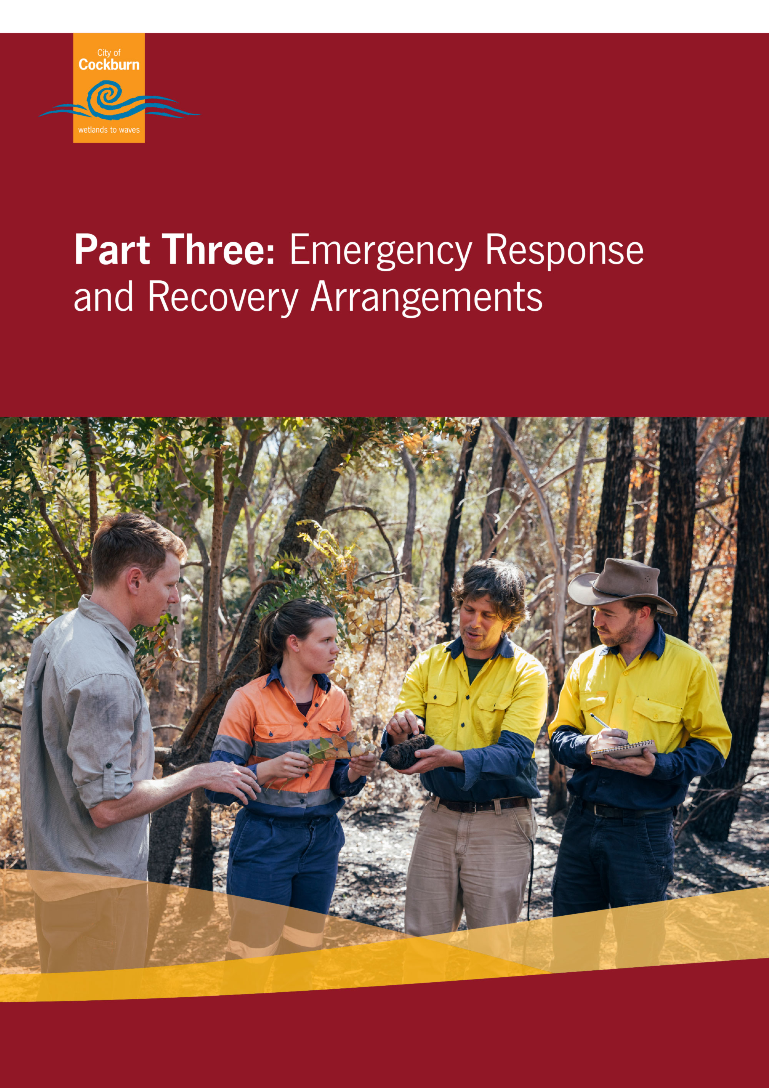

Part Three: Emergency Response and Recovery Arrangements

3.1 Areas of Operation
During an emergency where there are active operations to address a hazard, areas on public and/or private property may be demarcated from the general public. These areas may require training, qualifications, and personal protective equipment/clothing (PPE/C) in order to enter.
In most circumstances, it would only be appropriate for emergency services to enter what can be referred to as the ‘hot zone’ where active emergency response is occurring. There may also be a warm zone, where there is area demarcated from the general public and incident management teams are coordinating and City of Cockburn staff with the relevant training and PPE/C may attend to provide support.
Figure 5: Areas of operations demonstrating appropriate access, and training and PPE/C for emergency operational areas.
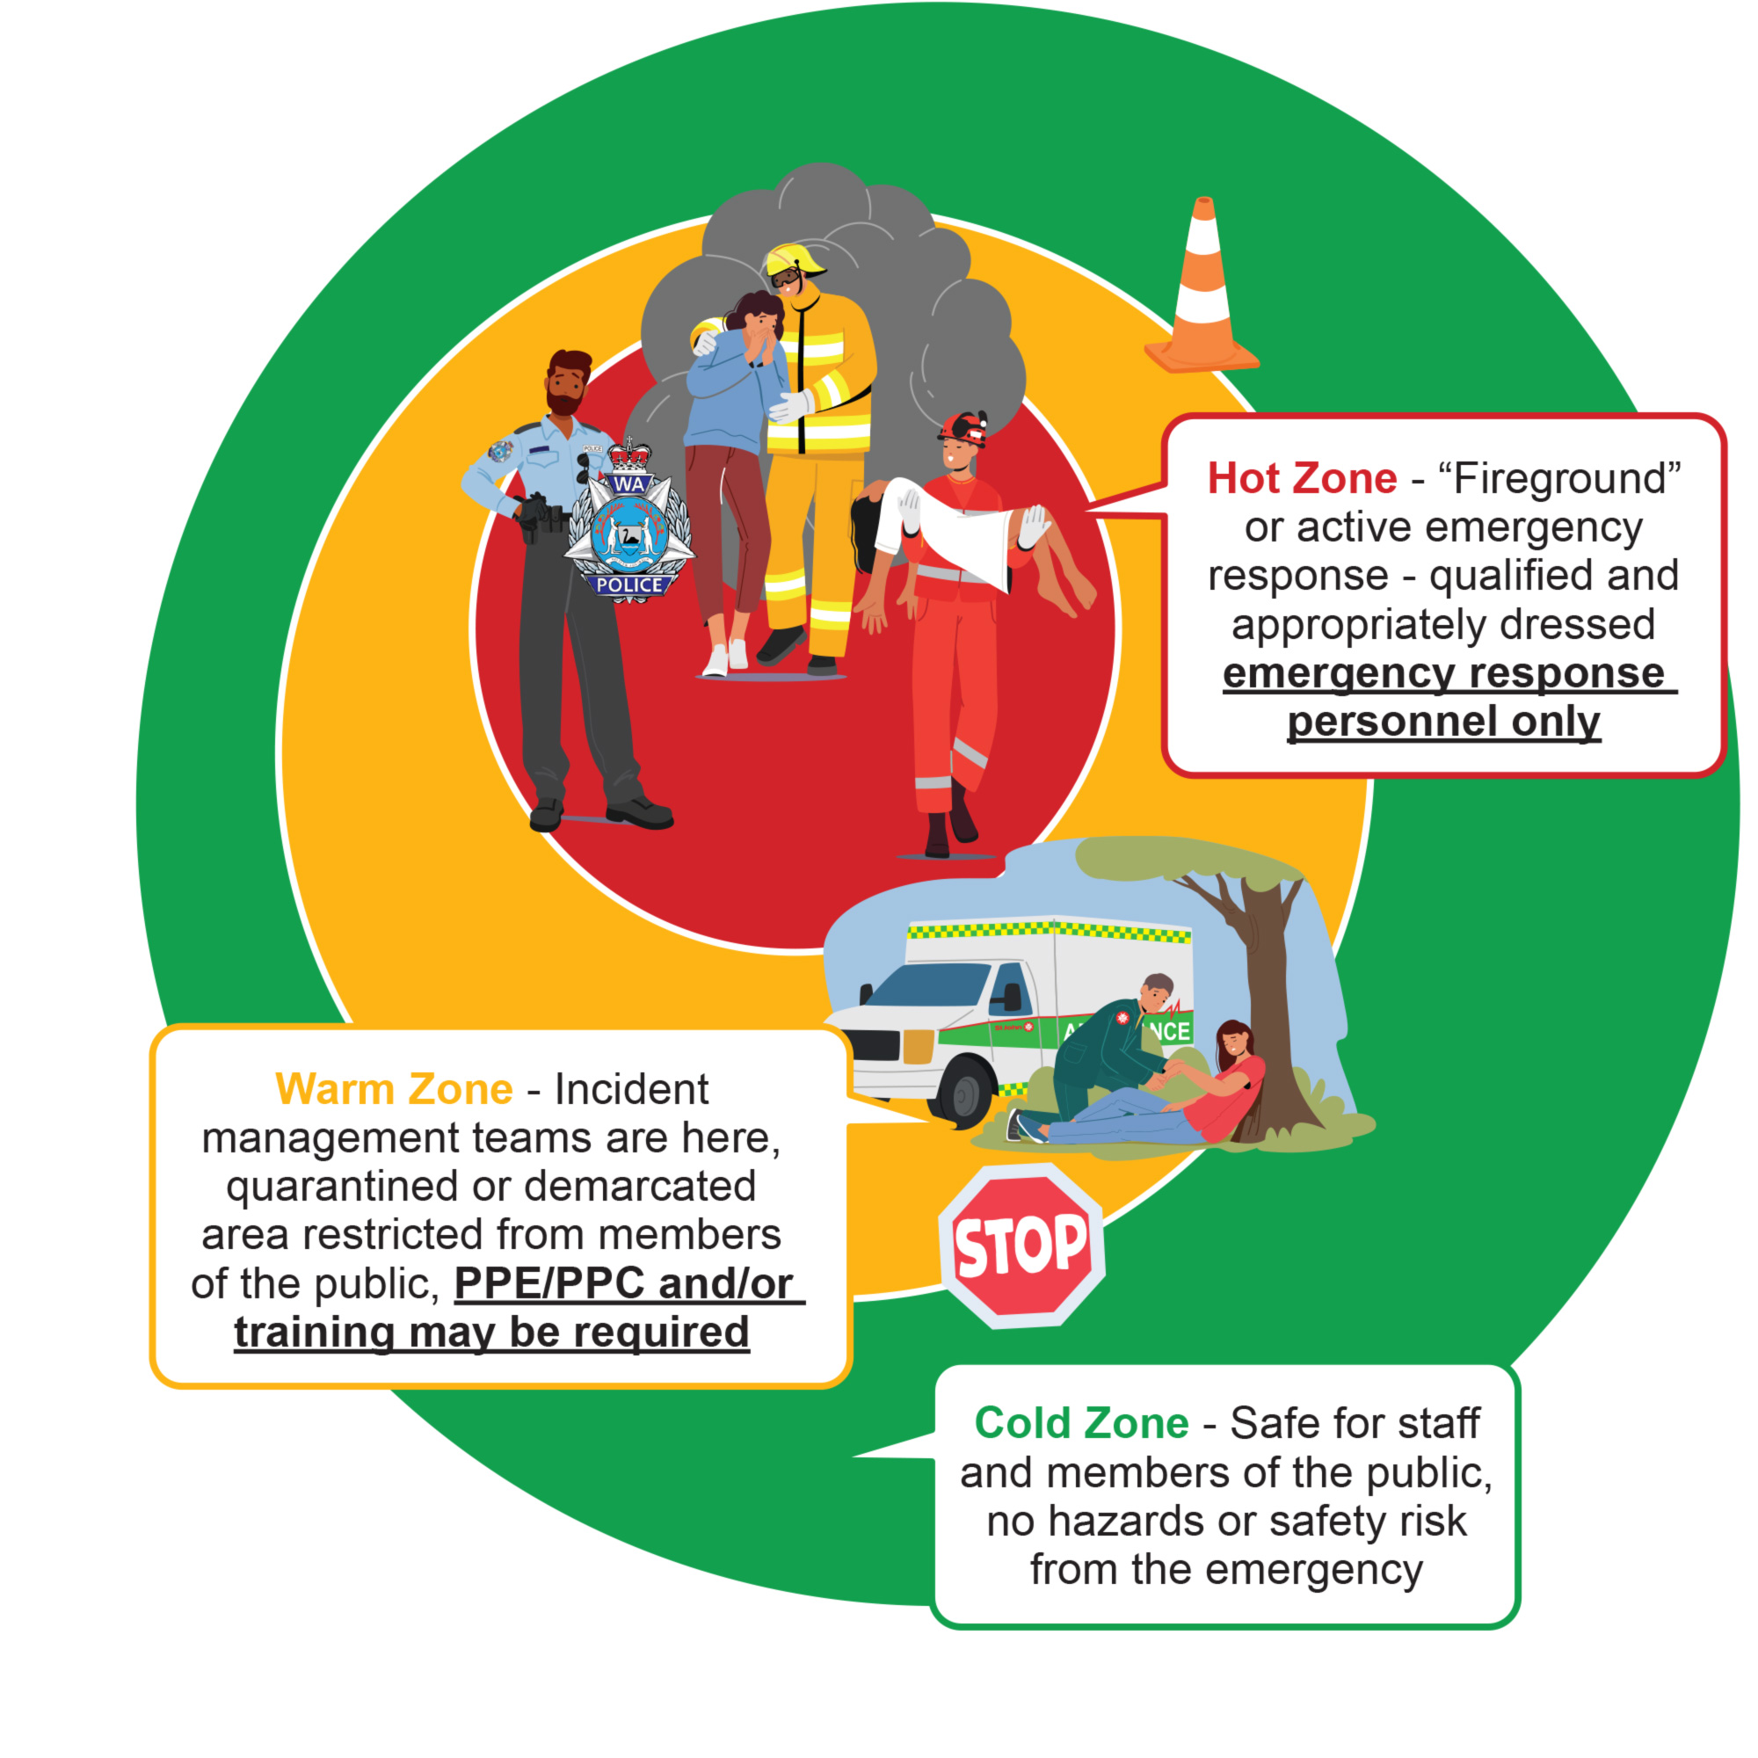

3.2 Local Recovery Planning
In accordance with the Emergency Management Act 2005, recovery management is the coordinated process of supporting “emergency affected communities in the reconstruction and restoration of physical infrastructure, the environment and community, psychosocial and economic wellbeing” (section 3).
Under section 36(b) of the Emergency Management Act 2005, it is a function of local government to manage recovery following an emergency affecting the community in its district.
An effective and successful recovery management should follow the National Principles for Disaster Recovery:
- Understanding the context
- Recognising complexity
- Using community-led approaches
- Ensuring coordination of all activities
- Employing effective communication, and
- Acknowledgment and building capacity.
The Cockburn Local Recovery Plan provides detailed arrangements and information for recovery activities and outlines how to do operational recovery.
For more information, refer to the Local Recovery Plan.

3.3 Animals and the Natural Environment
Animals and nature play a significant role in both the lives and livelihoods of all people in the community. We know that impacts on animals (whether domesticated, livestock or wildlife) and the natural environment can have a significant effect on the recovery of people and society.
Nature-based emergency preparedness and recovery activities ensure that people do not grow to fear nature, particularly regarding natural hazards, and emphasis is given to connecting and engaging with nature.
Pets and livestock (collectively referred to as animals) are ultimately the responsibility of the owners. The City has arrangements for assisting with animals evacuated or impacted due to an emergency.
For more information, refer to the Local Recovery Plan and the Emergency Animal Welfare Plan.

3.4 Communications
During times of an emergency, one of the most critical components of managing an incident is getting information to the public in a timely and efficient manner.
Communities threatened or impacted by emergencies have an urgent and vital need for information and direction. Such communities require adequate, timely information and instructions to be aware of the emergency and to take appropriate actions to safeguard life and property. The provision of this information during response is the responsibility of the Controlling Agency. The City of Cockburn is responsible to support emergency response communications and lead emergency recovery communications to ensure the community is informed and the City’s activities align to the below principles.
Guiding principles for emergency communications:
- Timeliness – regularly updating stakeholders on the situation
- Cooperation – being responsive and considerate to enquiries, deadlines and the other needs of stakeholders
- Sensitivity – prioritising stakeholders, guarding sensitive information as needed
- Transparency – remaining honest and open about the situation and the response progress
- Simplicity – ensuring communication is easily understood and consistent
- Accuracy – Sharing only confirmed facts, never making assumptions or giving false information; and
- Accountability – accepting responsibility if appropriate and reasonable
For more information, refer to the Emergency Communications Plan.
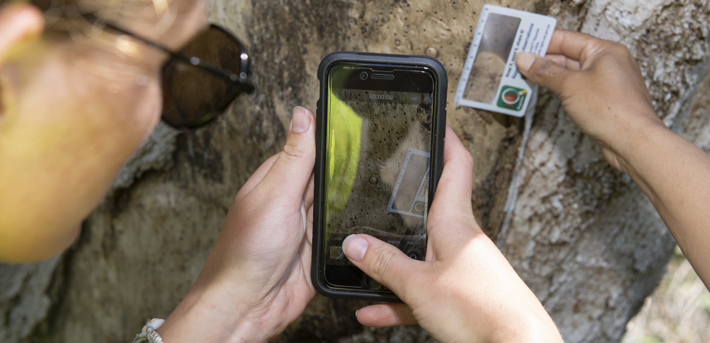

3.5 Evacuation and Places of Shelter
Comprehensive emergency management planning should involve planning for community evacuations. Although the actual act of evacuating a community is the responsibility of the Hazard Management Agency or Controlling Agency (where authorised by the Hazard Management Agency), the City of Cockburn, with the assistance of the Cockburn Local Emergency Management Committee, is responsible for pre-emergency evacuation planning.
Referencing relevant evacuation planning from adjoining local areas may assist where the impact of a hazard may not be confined to the local government boundaries and may offer the most suitable evacuation options for some emergencies.
Evacuation planning includes all five stages of an evacuation decision, warning, withdrawal, shelter and return. Not all phases are applicable to all emergencies.
Decision – is getting people out the best option?
Warning – telling people of the need to go.
Withdrawal – self-evacuation, recommend evacuation or direct to evacuate using emergency powers.
Shelter – where can people go to receive support?
Return – allocation of people back and supporting their return.
Animals, excluding support animals, are not permitted in evacuation centres for safety and health reasons. For arrangements regarding animals during evacuation, please refer to the State Support Plan – Animal Welfare in Emergencies and the local Emergency Animal Welfare Plan.
For more information, refer to Fremantle Region – Emergency Relief and Support Plan.
For more information on local evacuation planning, including who in the City is trained, and how to set up and manage an evacuation centre, refer to the Opening and Coordination of an Evacuation Centre Guidelines.

3.6 Local Resources for Response and Recovery
Cockburn is a vibrant and diverse community with lots of services on offer to the community, and there are many community organisations engaged with the community and government organisations.
Community organisations and leaders may play a vital role in emergency preparedness and recovery. As such, the City maintains a Resource Register as part of the Local Emergency Management Arrangements to keep a record of local organisations and groups that could participate in support services, recovery leadership or assisting in recovery activities. The Resource Register also list all the local facilities that could be used in an emergency.
For more information, refer to the Resource Register.
For more information on organisations to assist with animals (pets and wildlife), refer to the Emergency Animal Welfare Plan.
An Evacuation Centre may be required to be opened by the City of Cockburn at the request of the Incident Controller or the Department of Communities. Any facility owned or managed by the City of Cockburn may be utilised as an evacuation centre as determined by the Incident Controller in consultation with the local government (likely the Local Recovery Coordinator). The following facilities have been pre-determined as most suitable for use a local or district evacuation centre:
- Frankland Park Sporting and Community Facility
- Success Regional Sports and Community Facility
- Treeby Community and Sports Centre
- Wally Hagen Basketball Stadium
Any City facility may be used as an evacuation centre on the basis of suitability for use, proximity to the hazard and capacity for the City of Cockburn to support. Community members shouldn’t rely on these pre-determined facilities to be the facility opened during an emergency.
Further information on evacuation centres and provision of support services is in the Fremantle Region – Emergency Relief and Support Plan.

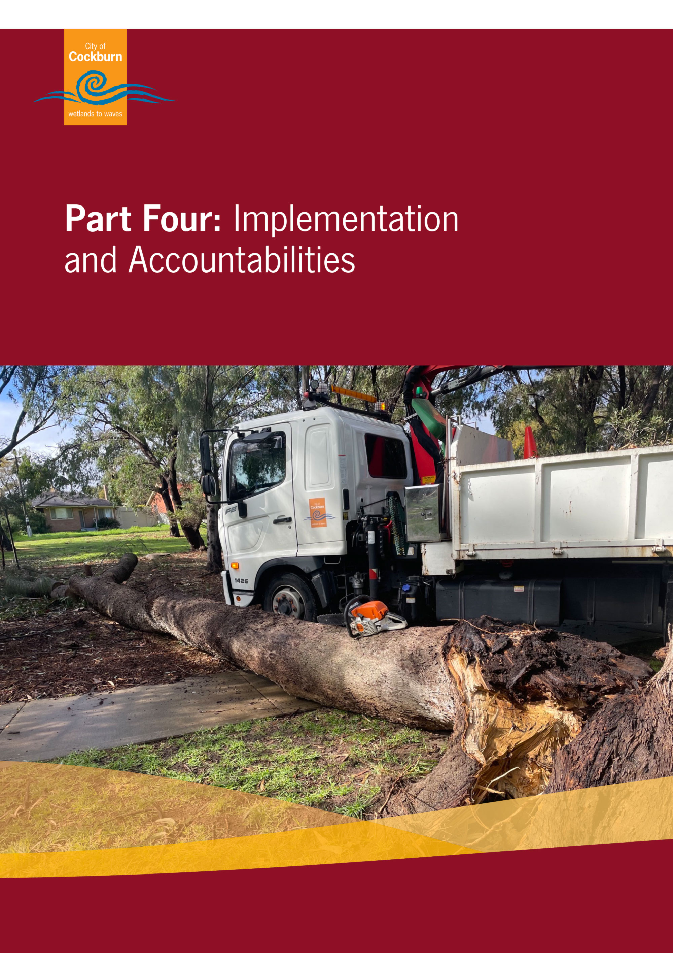

Part Four: Implementation and Accountabilities
A shared responsibility for resilience is a central principle of emergency management in Western Australia, defined with the WA State Emergency Management Framework. Supporting a shared responsibility for resilience is part of a broader systemic approach to emergency management and disaster risk reduction. While emergency management agencies have clear responsibilities in the WA State Emergency Management Framework, our collective safety and preparedness are improved through community-led and strengths-based approaches to community disaster resilience.
As part of our responsibilities and maturity in emergency management, it is important for the City of Cockburn and the Cockburn Local Emergency Management Committee to periodically assess our progress in emergency management.

4.1 Maturity Assessment
Various assessment tools exist that the City of Cockburn can utilise to assess community disaster resilience and preparedness, and also the City’s maturity in planning and supporting the community to be prepared for emergencies. These include:
- United Nations Disaster Risk Reduction: Disaster Resilience Scorecard for Cities
- Collaboration4Inclusion: Disability Inclusive Emergency Management (DIEM) Organisational Emergency Preparedness Profile
- [Coming soon] WA Local Government Association (WALGA) and State Emergency Management Committee (SEMC) Local Emergency Management Arrangements Maturity Framework or equivalent
The City may also undertake further community disaster resilience processes and evaluations in line with the WA Community Disaster Resilience Strategy, as it did in 2025 in partnership with the Department of Fire and Emergency Services.

4.2 Reporting and Review
Updates on the implementation of this Plan should be reported annually to the Cockburn Local Emergency Management Committee and Council, or otherwise provided through the review and preparation of Local Emergency Management Arrangements.
A review of this Plan should be undertaken every five years through the Cockburn Local Emergency Management Committee and City of Cockburn Council. Major amendments or additions between these scheduled reviews may be required based on incident debriefs, exercises or otherwise.
Documents within the Local Emergency Management Arrangements should be reviewed appropriately:
- After an event or incident that requires the activation of an Incident Support Group or significant recovery coordination
- After training or drills that exercise the arrangements
- Every five (5) years
- Any other time the City of Cockburn considers appropriate; or
- A unanimous decision by the Cockburn Local Emergency Management Committee.
The review may entail only minor administrative amendments which are to be noted or adopted by the Cockburn Local Emergency Management Committee accordingly, or a more significant change to document structure which requires tabling at City of Cockburn Council, District Emergency Management Committee and State Emergency Management Committee.

4.3 Exercising
Testing and exercising are essential to ensure that the Local Emergency Management Arrangements are workable and effective for the Cockburn Local Emergency Management Committee. The testing and exercising of arrangements are an important role of the Committee and ensures that individuals and organisations remain appropriately aware of what is required of them during an emergency response situation.
The exercising of a Hazard Management Agency's response to an incident is the responsibility of the Hazard Management Agency; however, it could be incorporated into a Cockburn Local Emergency Management Committee exercise.
Exercising the Local Emergency Management Arrangements will allow the Cockburn Local Emergency Management Committee and City of Cockburn staff to:
- Test the effectiveness of the Local Emergency Management Arrangements
- Bring together members of Cockburn Local Emergency Management Committee/City of Cockburn staff and give them knowledge of, and confidence in, their roles and responsibilities
- Help educate the community about local arrangements and programs
- Allow participating agencies an opportunity to test their operational procedures and skills in simulated emergency conditions, and
- Test the ability of separate agencies to work together on common tasks, and to assess the effectiveness of coordination between them.
Exercising should occur at least once annually for staff and the Cockburn Local Emergency Management Committee to test local emergency management arrangements, including procedures and knowledge.

4.4 Lessons Management
Lessons management should be guided by the State Emergency Management Committee’s advice and guides. In the absence of official guidance, refer to the Australia Disaster Resilience Handbook on Lessons Management.
Some important aspects of lessons management to note include:
Debrief as soon as practicable after an event to learn and improve through discovery
Capture specific observations and avoid being general
Regularly track and report the implementation of lessons
See the City of Cockburn Emergency Debrief Template (DOC Set ID: 12470898) to be completed after an emergency.



Appendix One – Glossary of Terms
Terminology used throughout this document shall have the meaning as prescribed in either section 3 of the Emergency Management Act 2005 or as defined in the State Emergency Management Glossary or the WA Emergency Risk Management procedure, or where appropriate in the Local Government Act 1995.
For ease of use, terms have also been provided below.
AIIMS or Australasian Interservice Incident Management System | A nationally adopted structure to formalise a coordinated approach to emergency incident management.
all hazards approach | the ‘all hazards’ approach assumes the functions and activities applicable to one hazard are often applicable to a range of hazards. The all hazards approach increases efficiency by recognising and integrating common emergency management elements across all hazard types. It does not, however, prevent the development of specific plans and arrangements for hazards that require a specialised approach.
capability | collective ability to undertake prevention, preparedness, response and recovery activities to reduce the impact of emergencies and to create a better prepared, more resilient and safer state
Combat Agency | a Combat Agency prescribed under section 6(1) of the Emergency Management Act 2005 is to be a public authority or other person who or which, because of the agency’s functions under any written law or specialised knowledge, expertise and resources, is responsible for performing an emergency management activity prescribed by the regulations in relation to that agency
Controlling Agency | an agency nominated to control the response activities to a specified type of emergency. The responsibility for being a Controlling Agency stems from either: • legislation other than the Emergency Management Act 2005; or • by agreement between the relevant Hazard Management Agency and one or more agencies
desk top exercise | an umbrella term for some types of indoor discussion exercise. They may feature a model of the area on which a prepared scenario is played out, or simply using a projected map, not in real time. The model or map is used to illustrate the deployment of resources, but no resources are actually deployed. Additionally, responses may be prepared in syndicate, in plenary, or under the guidance of a facilitator who maintains the pace and asks questions. A cost-effective and highly-efficient exercise method that should be conducted as a prelude to a field exercise as part of a graduated series. See also exercise.
discussion exercise | a discussion exercise is an indoor exercise employing a carefully prepared scenario to test and practice various aspects of emergency management planning, procedures or training synonym: tabletop exercise, model exercise or syndicate exercise see also exercise
emergency | the occurrence or imminent occurrence of a hazard which is of such a nature or magnitude that it requires a significant and coordinated response
emergency relief and support | the provision of immediate and ongoing social services to alleviate, as far as practicable, the effects on individuals impacted by an emergency. Communities has the primary responsibility for coordinating the provision of ERS services across six functional domains: • emergency accommodation • emergency food • emergency clothing and personal requisites • personal support services • registration and reunification • financial assistance
evacuation | the planned relocation of persons from dangerous or potentially dangerous areas to safer areas and eventual return
evacuation centre | a centre that provides individuals impacted by an emergency with basic human needs which may include accommodation; food; personal support; clothing and personal requisites; registration and reunification; and financial assistance
exercise | simulation of emergency management events, through discussion or actual deployment of personnel, in order to: • train personnel; • review/test the planning process or other procedures; • identify needs and/or weaknesses; • demonstrate capabilities; and • practice people in working together see also discussion exercise, field exercise, table top exercise and tactical exercise without troops
field exercise | an exercise activity in which emergency management organisations and agencies take action in a simulated situation, with deployment of personnel and other resources to achieve maximum realism. It is conducted actually on the ground, in real time but under controlled conditions, as though it were a real emergency
hazard | an event, situation or condition that is capable of causing or resulting in loss of life, prejudice to the safety, or harm to the health of persons or animals; or destruction of, or damage to property or any part of the environment and is defined in the Emergency Management Act 2005 or prescribed in the Emergency Management Regulations 2006
HMA or Hazard Management Agency | a public authority, or other person, prescribed by the Emergency Management Regulations 2006 to be a Hazard Management Agency for emergency management, or an aspect of emergency management, of a hazard
Impact Statement | An Impact Statement is used to collect information about all known and emerging impacts from a level 2 or level 3 incident. Where required an Impact Statement must be completed prior to the transfer of responsibility for management of recovery to the affected local government(s). The Controlling Agency is to convene a meeting with the affected local government(s) and the State Recovery Coordinator to review and sign the Impact Statement.  The information collected in an Impact Statement provides a point-in-time, concise summary of –  - known and emerging impacts,  - management actions currently in place,  - responsible agencies,  - future management actions required, and  - changes to responsibility for impact management
incident | the occurrence or imminent occurrence of a hazard
incident control centre | the location where the Incident Controller and, where established, members of the incident management team provide overall direction of response activities in an emergency situation synonym: emergency operations centre
Incident Controller | the person designated person designated by the relevant Controlling Agency, to be responsible for the overall management and control of an incident within an incident area and the tasking of agencies in accordance with the needs of the situation [note: agencies may use different terminology, however, the function remains the same]
incident management | the process of controlling the incident and coordinating resources
IMT or incident management team | a group of incident management personnel comprising the Incident Controller, and the personnel they appoints to be responsible for the functions of operations, planning and logistics. The team headed by the Incident Controller which is responsible for the overall control of the incident
ISG or Incident Support Group | a group of agency/organisation liaison officers convened by the Incident Controller to provide agency specific expert advice and support in relation to operational response to the emergency
LEC or Local Emergency Coordinator | the person appointed by the State Emergency Coordinator to provide advice and support to their Local Emergency Management Committee in the development and maintenance of emergency management arrangements, assist hazard management agencies in the provision of a coordinated response during an emergency in the district to carry out other emergency management functions under the direction of the State Emergency Coordinator
mitigation | measures taken in advance of a disaster aimed at decreasing or eliminating its impact on society and environment
multi-agency response | an incident of high fire incidence over short periods of time in any administrative unit, usually overtaxing the normal initial attack capability of the unit
OASG or Operational Area Support Group | a group of agency/organisation liaison officers convened and Operational Area Manager to provide agency specific expert advice and support in relation to strategic management of the emergency
PPRR | an abbreviation for prevention, preparedness, response and recovery
recovery hub | any centre established within or near the disaster area to meet the immediate needs of emergency affected persons which will be the focal point for the delivery of emergency relief and support services to the community but does not provide accommodation
resilience | the ability of a system, community or society, exposed to hazards to resist, absorb, accommodate to and recover from the effects of a hazard in a timely and efficient manner, including through the preservation and restoration of its essential basic structure and functions. This is determined by the degree to which the community has the necessary resources and is capable or organising itself both prior to and during times of need
risk | a concept used to describe the likelihood of harmful consequences arising from the interaction of hazards, communities and the environment:  - the chance of something happening that will have an impact upon objectives. It is measured in terms of consequence and likelihood;  - a measure of harm, taking into account the consequences of an event and its likelihood. For example, it may be expressed as the likelihood of death to an exposed individual over a given period; and  - • expected losses (of lives, persons injured, property damaged, and economic activity disrupted) due to a particular hazard for a given area and reference period. Based on mathematical calculations, risk is the product of hazard and vulnerability
shelter in place | the advice to community to remain in their location, this may be an open space, building, indoors or other suitable place of shelter, usually with additional advice from emergency services as to how to take actions to reduce their exposure to the hazard
situation report (SITREP) | a brief report that is published and updated periodically during an emergency which outlines the details of the emergency, the needs generated, and the responses undertaken as they become known
table top exercise | an umbrella term for some types of indoor discussion exercise. They may feature a model of the area on which a prepared scenario is played out, or simply using a projected map, not in real time. The model or map is used to illustrate the deployment of resources, but, no resources are actually deployed. Additionally, responses may be prepared in syndicate, in plenary, or under the guidance of a facilitator who maintains the pace and asks probing questions. A cost effective, and highly efficient, exercise method that should be conducted as a prelude to a field exercise as part of a graduated series

Appendix Two – Cockburn Local Emergency Management Committee Terms of Reference
1. Name
Cockburn Local Emergency Management Committee (or simply Cockburn LEMC)
2. Authority
The Cockburn Local Emergency Management Committee is established under section 38 of the Emergency Management Act 2005 in accordance with the State Emergency Management Framework.
The Cockburn Local Emergency Management Committee is not an operational committee nor a committee of the Council but rather the organisation established by the local government to assist in the preparation of Local Emergency Management Arrangements for its district.
The Cockburn Local Emergency Management Committee does not have the authority or power to commit the Council or the City of Cockburn or any association, organisation, group or individual to expenditure without the City’s endorsement.
3. Aim
The aim of the Cockburn Local Emergency Management Committee is to collaborate with local support organisations, hazard management agencies, and key local stakeholders representatives, to collectively build a resilient community that is prepared to respond and recover from an emergency.
4. Objectives
The City of Cockburn has established a Local Emergency Management Committee, hereafter referred to as the Cockburn Local Emergency Management Committee, under section 38(1) of the Emergency Management Act 2005 to oversee, plan and test the local emergency management arrangements. The Cockburn Local Emergency Management Committee includes representatives from agencies, organisations and community groups that are relevant to the identified risks and emergency management arrangements for the community and achieve the objectives of the group. The objectives are to:
- Develop Local Emergency Management Arrangements that are practical to all stakeholders and service agencies
- Ensure that Local Emergency Management Arrangements are contemporary and relevant to the community and addresses all possible risks and scenarios
- Participate in inter-local government relations to further emergency management cooperation within the emergency management district
- Build resilience and engage with the community through safety and awareness campaigns, and by disseminating information through social media, media outlets, and public events
- Participate in interagency training exercises that improve the capabilities and knowledge of the Cockburn Local Emergency Management Committee, local stakeholders, and hazard management agencies
- Exercise the Local Emergency Management Arrangements to test their effectiveness in practical applications, and actively strive for continuous improvement
- Share meeting minutes, committee member experiences and proposed actions with local government elected members, State agencies and the local community; and
- Strategise ways to mitigate potential emergencies and to improve recovery arrangements.
5. Duties and Responsibilities
- Advise and assist the City of Cockburn in ensuring that Local Emergency Management Arrangements are established and maintained for its district.
- Liaise with public authorities and other persons in the development, review and testing of local emergency management arrangements.
- Carry out other emergency management activities as directed by the State Emergency Management Committee or prescribed by the regulations.
- Perform at least one emergency training exercise a year to assist improve the capabilities of their community to prepare for, respond to and recover from emergencies.
- Prepare and submit an annual report on activities undertaken by the Cockburn Local Emergency Management Committee during the financial year to the District Emergency Management Committee for the district.
6. Meeting Management
6.1 Chairperson
The Chairperson should be an elected member of the City of Cockburn Council, typically the Mayor. Council is to appoint the Chairperson and an elected member as the Chairperson's proxy to represent Council.
6.2 Deputy Chair
The Cockburn Local Emergency Coordinator should be appointed as Deputy Chair and take on the role of Chairperson in the absence of the Chairperson. The Deputy Chair provides support and advice to the Cockburn Local Emergency Management Committee Chair and Executive Officer as required.
6.3 Executive Officer
The Cockburn Local Emergency Management Committee Executive Officer is the City of Cockburn Fire and Emergency Management Manager. The Executive Officer is responsible for coordinating the development and submissions of documents in accordance with legislative and policy requirements including the:
- Annual report
- Annual Business Plan
- Local Emergency Management Arrangements, including maintaining the contact register.
- ensuring the provision of professional and timely secretariat support including:
  - development and distribution of the meeting agenda, minutes, and action lists
  - maintaining a register of correspondence
  - maintenance of the Cockburn Local Emergency Management Committee membership contact list
- facilitating the provision of relevant emergency management advice to the Chair and Cockburn Local Emergency Management Committee as required
- participating as a member of Cockburn Local Emergency Management Committee sub-committees and working groups as required
- facilitating two-way communication between the Cockburn Local Emergency Management Committee and the Executive Officer of the relevant District Emergency Management Committee to undertake day-to-day emergency management business as required from both a local and district level
6.4 Minute Taker
The Minute Taker is to provide administrative support to the Cockburn Local Emergency Management Committee Chair and Executive Officer as required, including the preparation of minutes. The Minute Taker is to be the City of Cockburn Fire and Emergency Management Officer.
6.5 Cockburn Local Emergency Management Committee Members
Cockburn Local Emergency Management Committee members can provide support to the Committee by:
- attending and actively participating in meetings
- advising the Executive Officer of non-attendance and arranging for a proxy
- contributing to the agenda and reviewing all meeting papers prior to the meeting
- completing meeting actions as required
- bringing copies of relevant documents
- reading and being familiar with the Terms of Reference
- representing their organisation by providing input/advice into the meeting and sharing outcomes of the meeting with their organisation
- participating in emergency management activities
6.6 Quorum
A quorum for the Committee will be at least 40% of its voting membership.
6.7 Minutes and Agendas
The Executive Officer is responsible for preparing agendas of all business transacted at each meeting.
A draft agenda will be emailed to members three (3) weeks prior to the meeting. Members have two weeks to include agenda items and/or comments. The final agenda will be issued to members at least one week prior to the scheduled meeting.
Copies of the meeting minutes will be made available to the City of Cockburn Council by way of information at least one month after the committee meeting. Meeting minutes will be forwarded to Committee members two (2) weeks post the meeting.
6.8 Schedule
Meetings will be held typically quarterly and scheduled by the Executive Officer.
Additional meetings will be convened if and as required at the discretion of the Chairperson.
6.9 Membership notes:
- Special guests may be invited to attend committee meetings as determined by the Cockburn Local Emergency Management Committee Executive Officer, in consultation with the Cockburn Local Emergency Management Committee Chair.
- Each voting member should nominate a proxy to the Executive Officer within their agency or organisation to attend if the appointed member is absent.
- Non-attendance at meetings of voting members without a justifiable apology, or that have not been represented by their proxy will be asked to provide an explanation to the Chairperson. Repeated non-attendance may result in the Chairperson notifying the District Emergency Management Committee.
- Members representing agencies and organisations that can no longer participate in the committee should advise the Executive Officer of their resignation and nominate an alternative representative for membership.
- Committee membership will be reviewed at each meeting by the Cockburn Local Emergency Management Committee Executive Officer to ensure that it is representative of the community and the potential risks and scenarios.
- New members may join the Cockburn Local Emergency Management Committee via resolution of the committee.
7. Membership
7.1 Agency Members (Voting):
- Australian Red Cross
- Dept of Fire and Emergency Services
  - District Emergency Management Advisor
  - District Officer, South Coastal
  - District Officer, State Emergency Services
- Dept of Communities
- Dept Primary Industries and Regional Development
- St John Ambulance
- WA Police, Officer in Charge
  - Cockburn
  - Murdoch
  - Fremantle
- At least community representatives, not otherwise representing an emergency management agency
7.2 Local Government Members (Voting):
- Chairperson (Elected Member)
- Chief Bush Fire Control Officer
- Fire and Emergency Management Manager (Executive Officer)
- Fire and Emergency Management Officer
- Environmental Health Coordinator
- Minute Taker (non-voting, if not a position above)
- Local Recovery Coordinator (if not a position above)
7.3 Invited Guests (Non-voting) may include:
- Adventure World
- Australian Marine Complex
- Cockburn Marine Rescue
- Cockburn Surf Life Saving Club
- Dept of Biodiversity, Conservation and Attractions
- Dept of Education
- Fiona Stanley Hospital
- Jandakot Airport
- Jandakot Volunteer Bush Fire Brigade
- Main Roads
- Murdoch University
- South Coogee Volunteer Bush Fire Brigade
- Water Corporation
- Western Power
8. Role and Responsibilities
The Cockburn Local Emergency Management Committee plays a vital role in assisting our communities become more prepared for major emergencies by;
- Developing, enhancing and testing preparedness planning from a multi-agency perspective having local knowledge of hazards, demographic and geographic issues; they provide advice to Hazard Management Agencies to develop effective localised hazard plans
- providing a multi-agency forum to analyse and treat local risk, and
- providing a forum for multi-agency stakeholders to share issues and learnings to ensure continuous improvement.
9. Decision-Making
The LEMC is to make decisions, such as the adoption of Local Emergency Management Arrangements, by consensus. A motion is carried if a majority of the Committee members (voting), either present at the meeting or via email, vote in favour of the motion.
10. Plan of Activities
Activities the Cockburn Local Emergency Management Committee should undertake annually includes the following;
- Training and upskilling of members including presentations, such as
- agency roles
- hazard management
- risk management or
- emerging hazards or risks.
- Local Emergency Management Arrangement Document updates and endorsement
- Exercise (Desktop or Field)
  - hazard focused
  - scenario based
- Risk assessment
- Local Emergency Management Arrangements familiarisation, including a dive into one section or plan within the Local Emergency Management Arrangements for the purpose of preparation and review.


City of Cockburn
Whadjuk Boodjar
9 Coleville Crescent, Spearwood WA 6163
PO Box 1215, Bibra Lake DC WA 6965
Telephone: 08 9411 3444
Email: customer@cockburn.wa.gov.au
City of Cockburn website: www.cockburn.wa.gov.au

It was gazetted on 27 November 2009 that the responsibilities of local government under Part 3 of the Emergency Management Act 2005 for the locality of Rottnest Island Reserve rests with the Rottnest Island Authority. Therefore, Rottnest Island is not considered in this plan or the Cockburn Local Emergency Management Arrangements.
(ages 0 to 24), ABS data 2021
NDIS Data as of 4 September 2025
ABS Data 2021
ABS Data 2021. See more information, https://www.cockburn.wa.gov.au/Community/Cultural-Diversity/Cultural-Diversity-of-Cockburn

