Tender Title: |  | RFT 27/2025 - Facilities Online Booking Platform
Request ID: |  | 70196
Tender Description: |  | The City of Cockburn (The Principal) is seeking quotations for the provision of an online, cloud-based, managed facilities bookings platform, to facilitate the booking, allocation management and maximised utility of the City’s public facilities for internal and public customers.  The proposed Contract shall be in force for a period of five (5) years from the date of contract award, with a Principal instigated option to extend up to two (2) years and a further twelve (12) months; thereafter, up to a maximum contract period of eight (8) years.
Advert Approval: |  | Decision to Advertise: Director Corporate and System Services  Decision Date: Tuesday, 15 July 2025
Closing Date and Time: |  | 2:00PM (AWST) Tuesday, 5 August 2025
Opening Date and Time: |  | 2:00PM (AWST) Tuesday, 5 August 2025
 | Tenderer’s Name:
1 | ATTEKUS PTY LTD
2 | INTEGRATED MONITORING SYSTEMS PTY LTD
3 | Jonas Leisure
4 | SpacetoCo (SpacetoCo Pty. Ltd.)

Advertisement
Method 1: City of Cockburn Website | Method 2: City of Cockburn Public Library Notice Boards
Method 3:  The Western Australian, Saturday,  19 July 2025 | Tender Awarded by:
Copy of Statewide Notice:  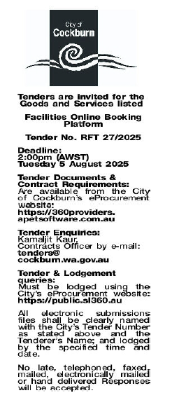 | A/ CEO – Carissa Bywater  Thursday, 4 September 2025
 | Date of Council Meeting:
 | NA
Name of Successful Tenderer(s): | SpacetoCo (SpacetoCo Pty. Ltd.)
Amount of Successful Tender(s): (ex GST) | $434,000.00

