Tender Title: |  | RFT22/2025 – Planting and Revegetation Maintenance - City of Cockburn Reserves and Roe 8 Corridor
Request ID: |  | 63572
Tender Description: |  | The City of Cockburn is seeking the services of a suitably qualified and experienced contractor(s) to undertake a range of revegetation related services within the natural areas to ensure our conservation areas are revegetated and maintained to the standards expected by the community, the City (The Principal) is seeking a suitably qualified and experienced contractor(s) to undertake a range of revegetation related services within these natural areas.  For Zones A and B the Proposed Contract shall be in force for a period of three (3) years from the Contract Commencement Date, with Principal instigated options to extend the period for a subsequent one (1) year period and up to an additional twelve (12) months, thereafter, up to a maximum contract period of five (5) years.  For Zone C the Proposed Contract shall be in force for a period of two and a half (2.5) years from the Contract Commencement Date, with Principal instigated options to extend the period for a subsequent one (1) year period and up to an additional twelve (12) months, thereafter, up to a maximum contract period of four and a half (4.5) years.
Advert Approval: |  | Decision to Advertise: Director Infrastructure Services  Decision Date: Monday, 23 June 2025
Closing Date and Time: |  | 2:00PM (AWST) Thursday, 10 July 2025
Opening Date and Time: |  | 2:00PM (AWST) Thursday, 10 July 2025
 | Tenderer’s Name:
1 | Balcatta Reuse Shop t/a Workpower Inc
2 | Green Skills Inc
3 | Landcare Weed Control t/a John Derrick Lodge
4 | Landscape Australia Construction t/a Pinoche Holdings Pty Ltd
5 | Natural Area Consulting Management Services t/a Natural Area Holdings Pty Ltd

Advertisement
Method 1: City of Cockburn Website | Method 2: City of Cockburn Public Libraries Notice Boards
Method 3:  The Western Australian, Wednesday,  25 June 2025, Page 47 | Tender Awarded by:
Copy of Statewide Notice:  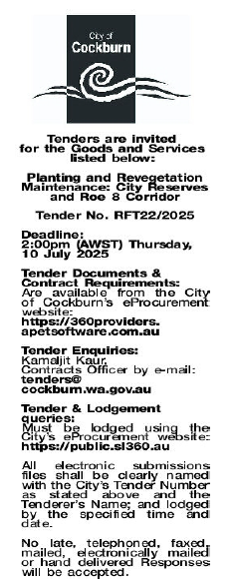 | OCM  Tuesday, 2 September 2025
 | Date of Council Meeting:
Tuesday, 2 September 2025
Minutes: 0151
Item No: 14.3.2
Name of Successful Tenderer(s): | Zone A: Workpower Inc  Zone B: Natural Area Holdings Pty Ltd  Zone C: Workpower Inc
Amount of Successful Tender(s): (ex GST) | Zone A: $338,532 (Ex GST)  Zone B: $416,714 (Ex GST)  Zone C: $313,903 (Ex GST)

