Tender Title: |  | EDUCTING CLEANING SERVICES (Gully and Access Pits)
Request ID: |  | 71427
Tender Description: |  | The City is seeking a service provider to undertake the educting and cleaning of gully pits, access pits, and gross pollutant traps, as well as to assist with the road  sweeping program. The scope of required services encompasses both scheduled and unscheduled  activities, including inspection, programming, comprehensive reporting (including defect reporting), as well as the educting and cleaning of gully pits, access pits,  associated pipework, and gross pollutant traps.  Repair works are excluded from this contract.
Advert Approval: |  | Decision to Advertise: Director Infrastructure Services  Decision Date: Wednesday, 12 November 2025
Closing Date and Time: |  | 2:00PM (AWST) Thursday, 27 November 2025
Opening Date and Time: |  | 2:00PM (AWST) Thursday, 27 November 2025
 | Tenderer’s Name:
1 | Aaro Group t/a Aaro Group Pty Ltd
2 | Drainflow Services (Maintenance Division)
3 | Precision Pipe Technologies
4
5
6
7
8
9
10

Advertisement
Method 1: City of Cockburn website | Method 2: City of Cockburn Libraries Public Noticeboards
Method 3:  The Western Australian, Wednesday, 12 November 2025 | Tender Awarded by:
Copy of Statewide Notice:  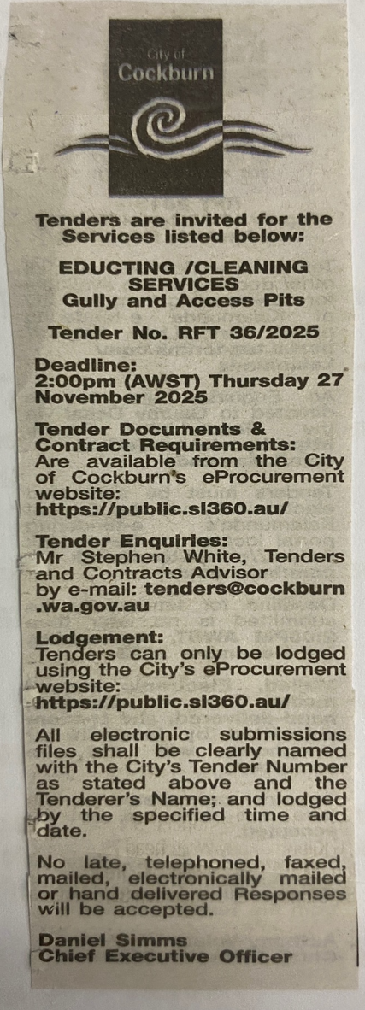 | OCM  Choose an item.  Tuesday, 10 February 2026
 | Date of Council Meeting:
Date: 10 February 2026
Minutes: 2026/Minutes No.0009
Item No. 14.3.3
Name of Successful Tenderer(s): | DFS Industrial and Environmental  Services Pty Ltd T/as Drainflow Services
Amount of Successful Tender(s): (ex GST) | $3,728,720

