Tender Title: |  | RFT 21/2023  Events Production & Staging Equipment Hire Services
Request ID:
Tender Description: |  | The City of Cockburn (the Principal) is seeking a suitably qualified and experienced contractor for the supply and operation of events equipment and the provision of associated services.
Advert Approval: |  | Decision to Advertise: Chief of Community Services  Decision Date: Thursday, 7 September 2023
Closing Date and Time: |  | 2:00PM (AWST) Thursday, 28 September 2023
Opening Date and Time: |  | 2:00PM (AWST) Thursday, 28 September 2023
 | Tenderer’s Name:
1 | Mega Vision Australia Pty Ltd t/a Mega Vision Sound & Lighting
2
3
4
5
6
7
8
9
10

Advertisement
Method 1: City of Cockburn | Method 2: Yammer
Method 3:  The Western Australian,  Wednesday, 13th September 2023 | Tender Awarded by:
Copy of Statewide Notice:  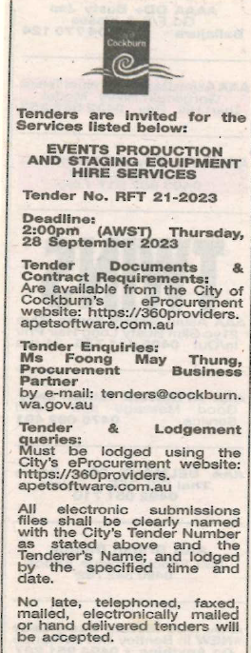 | Chief of Community Services  Thursday, 14 December 2023
 | Date of Council Meeting:
 | Not applicable
Name of Successful Tenderer(s): | Mega Vision Australia Pty Ltd t/a Mega Vision Sound & Lighting
Amount of Successful Tender(s): (ex GST) | $524,970 Ex GST

