Tender Title: |  | RFT11/2020  Project Management Services – Beale Park Redevelopment, Spearwood WA
Request ID: |  | 35994
Tender Description: |  | Provide a full suite of Project Management Services for the design and construction of the Beale Park Redevelopment project in Spearwood.
Advert Approval: |  | Decision to Advertise: Director of Govenernance & Community Services  Decision Date: Wednesday, 13 May 2020
Closing Date and Time: |  | 2:00pm (AWST) Thursday, 28 May 2020
Opening Date and Time: |  | 2:00pm (AWST) Thursday, 28 May 2020
 | Tenderer’s Name:
1 | CBRE (GCS) PTY LTD
2 | CBRE (GCS) PTY LTD
3 | CUSHMAN & WAKEFIELD PTY LTD
4 | NS PROJECTS PTY LTD
5 | BRETT DAVID INVESTMENTS PTY LTD
6 | ARGENTA GROUP (WA) PTY LTD
7 | MOTUS TRUST & PECUDA SHIRLEY FAMILY TRUST
8 | APP CORPORATION PTY LTD
9 | DCWC SERVICES PTY LTD
10 | JDN CONSULTING & ENGINEERING SOLUTIONS PTY LTD
11 | JOHNSTAFF PROJECTS (WA) PTY LTD
12 | RPS AAP CONSULTING PTY LTD
13 | SAVILLS PROJECTS MANAGEMENT PTY LTD
14 | TURNER & TOWNSEND THINC PTY LTD
15 | DAVINA HOLDINGS PTY LTD
16 | INSIGHT PROJECT SERVICES PTY LTD
17 | GHD PTY LTD

Advertisement
Method 1: City of Cockburn | Method 2: NA
Method 3:  The West Australian | Tender Awarded by:
Copy of Statewide Notice:  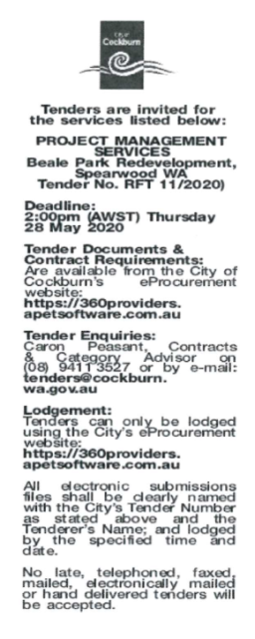 | Director of Finance & Corporate Services  Choose an item.  Friday, 17 July 2020
 | Date of Council Meeting:
Click here to enter a date. or
Not applicable
Item No:
Name of Successful Tenderer(s): | Savills Project Management Pty Ltd
Amount of Successful Tender(s): (ex GST) | $169,985.00

