Tender Title: |  | FIRE PROTECTION SYSTEMS & EQUIPMENT  Audit, Inspection, Testing & Preventative Maintenance  Five (5) Year Contract
Request ID: |  | 55152
Tender Description: |  | The City of Cockburn is seeking a suitably qualified and experienced Contractor for the inspection, testing, preventative maintenance, repair and replacement of fire  detection, suppression and evacuation systems and equipment in accordance with relevant Australian Standards, including Cockburn Aquatic and Recreation Centre (Cockburn ARC) at Cockburn Central, Port Coogee Marina and the City’s operations vehicle fleet.
Advert Approval: |  | Decision to Advertise: Chief Operations Officer  Decision Date: Friday, 3 January 2025
Closing Date and Time: |  | 2:00PM (AWST) Tuesday, 11 February 2025
Opening Date and Time: |  | 2:00PM (AWST) Tuesday, 11 February 2025
 | Tenderer’s Name:
1 | Banhams (Banhams WA Pty Ltd)
2 | Fire Shield (Fire Shield Services Pty Ltd)
3 | HECS (Jaypoint Nominees Pty Ltd)
4 | Keyoak (Keyoak Pty Ltd)
5 | Property Fire Maintenance (People and Property Enterprises Pty Ltd)
6 | Workpower (Workpower Inc)
7 | Wormald (Wormald Australasia Pty Ltd)
8
9
10

Advertisement
Method 1: City of Cockburn website | Method 2: City of Cockburn Public Libraries Notice Boards
Method 3:  The Western Australian, Saturday, 11 January 2025. | Tender Awarded by:
Copy of Statewide Notice:  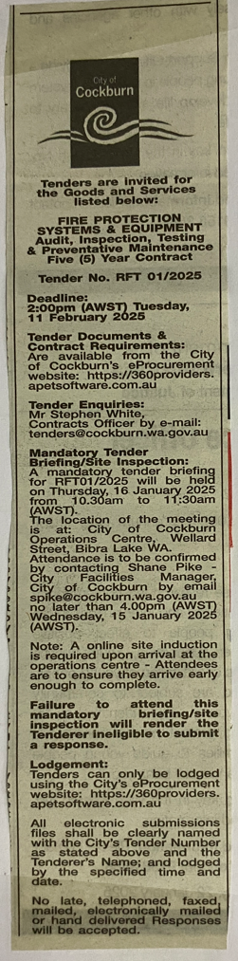 | OCM  Choose an item.  Tuesday, 8 July 2025
 | Date of Council Meeting:
Tuesday, 8 July 2025
Minutes: 0133
Item No: Item 14.3.1
Name of Successful Tenderer(s): | Property Fire Maintenance (PFM)
Amount of Successful Tender(s): (ex GST) | $1,053,863 (Ex GST)

