21 August 2019

Improved safety reason for temporary closure and major upgrade of Solomon Road

Achieving improved road safety for residents of the growing suburbs of Treeby and Jandakot will result in the temporary closure of a section of Solomon Road for about 15 weeks from late 2019 to early 2020.
The road upgrade must be completed by Stockland as part of development conditions for the Calleya estate in Treeby.
When works are complete in early March, about 800m of Solomon Road will be transformed into a safer 70kph zone with street lighting and a central median, replacing the rural-standard two-lane section between Dollier and Jandakot roads.
City of Cockburn Engineering & Works Director Charles Sullivan, said while the closure was inconvenient it was a safer option for motorists and construction staff than reducing the road to a single lane for a disruptive six-month construction period.
“Ongoing discussions with Georgiou Group made it clear that this is the safest option,” Mr Sullivan said.
“Reconstruction of this section of Solomon Road needs to be done over several stages due to the large difference in level between the existing and finished road section.
“The depth of cut will be up to 1.5m below the existing road level which is a significant construction challenge.
“There will be about 3,000 cubic metres of cut to fill onsite and about 8,000 cubic metres of material removed offsite and it’s these major earthmoving activities that we want to keep separate from motorists in the area.
“The roadworks, which will begin in late November, will also deliver a higher standard of safety for pedestrians and cyclists using Solomon Road.”

Mr Sullivan said the closure period was chosen as current improvements to Clementine Boulevard and Jandakot Road will be finished by late November, and roadworks on Armadale Road west of Tapper Road (part of the Armadale Road upgrade) won’t begin until February/March 2020.
“Traffic management continues to be a priority for our residents, and the City of Cockburn is committed to helping you move around more easily by providing safe, efficient, connected and sustainable solutions to congestion,” Mr Sullivan said.
Two diversions will be in place during the project:
- From Solomon Road along Cutler Road and Prinsep Road to Berrigan Drive, and
- Jandakot Road along Warton Road to Armadale Road.
Peppworth Place will remain accessible throughout the works. Treeby residents will be able to access Clementine Boulevard onto Jandakot Road, and from Ghostgum Avenue onto Armadale Road.

Local residents are encouraged to attend an information session about the temporary road closure 6.30-7.30pm, Tuesday, 10 September. It will be held at Cockburn ARC (function room), 31 Veterans Parade, Cockburn Central.
Chaired by Jandakot MLA Yaz Mubarakai, the information session will be attended by representatives of the Georgiou Group, Stockland and the City of Cockburn.

Register by 6 September by signing in at comment.cockburn.wa.gov.au/SolomonRd, call 08 9411 3444 or email customer@cockburn.wa.gov.au
ENDS

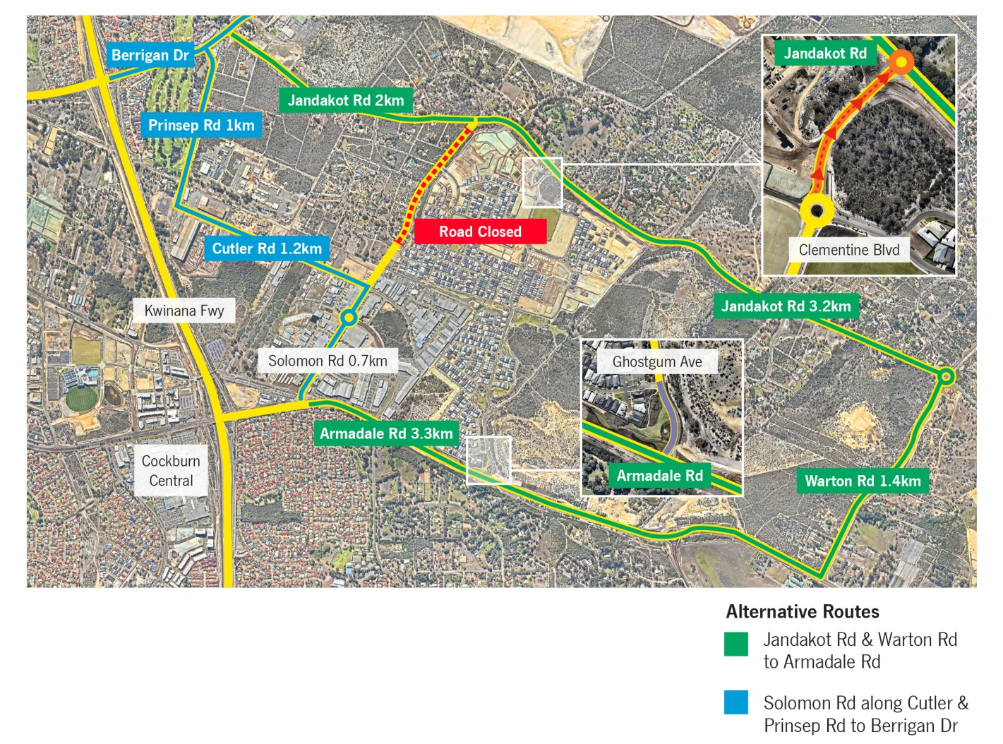

For more information contact:
Media and Communications Officer
City of Cockburn
T: 08 9411 3551
E: media@cockburn.wa.gov.au

