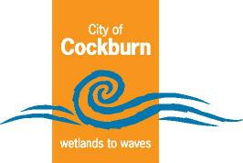
City of Cockburn

Strategic Community Plan
2025–2035

Cockburn, the best place to be
City of Cockburn website: www.cockburn.wa.gov.au
June 2025

Acknowledgement of Country
Cockburn Nyungar moort Beeliar boodja-k kaadadjiny. Koora, yeyi, benang baalap nidja boodja-k kaaradjiny.
Ngalak kaditj boodjar kep wer kaadidjiny kalyakool yoodaniny, wer koora wer yeyi ngalak Birdiya koota-djinanginy.
The City of Cockburn acknowledges the Nyungar people of Beeliar Boodjar. Long ago, now and in the future they care for Country.
We acknowledge a continuing connection to Land, Waters and Culture and pay our respects to Elders, past and present.
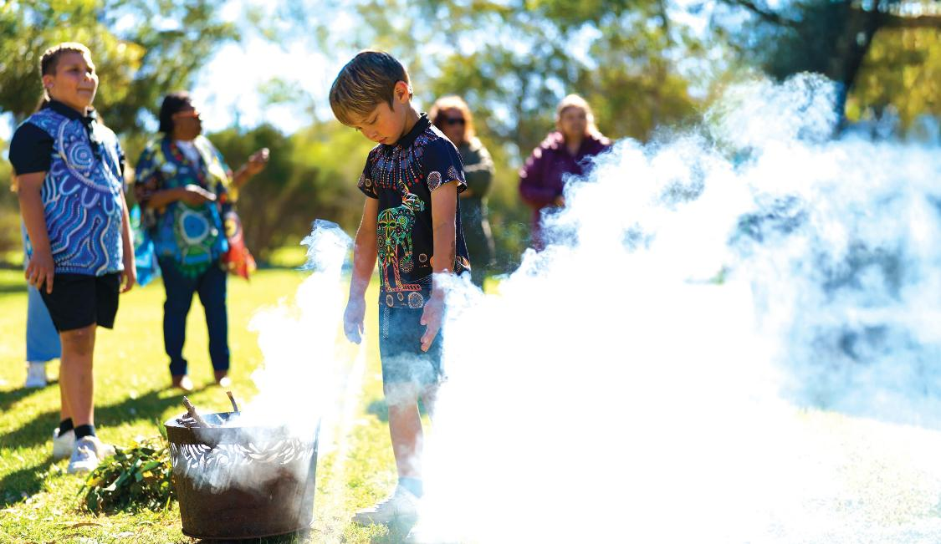
Photo: Smoking ceremony at Bibra Lake
Cover photo: Coogee Live at Coogee.

Contents
Message from the Mayor 4
Message from the CEO 5
What is a Strategic Community Plan? 6
How to read the Strategic Community Plan 13
Our strategic framework 15
Our strategy on a page 17
Our city 18
About our city 20
Where we live 27
Developing this plan 31
Community input 32
Our vision 35
Strategic Outcomes 36
1. Our Economy 36
2. Our Environment 37
3. Our Community 38
4. Our Places 40
5. Our Governance 41
Aligning with the UN Sustainable Development Goals 43
Implementing our plan 46
Tracking our success 47
Contact Us 50
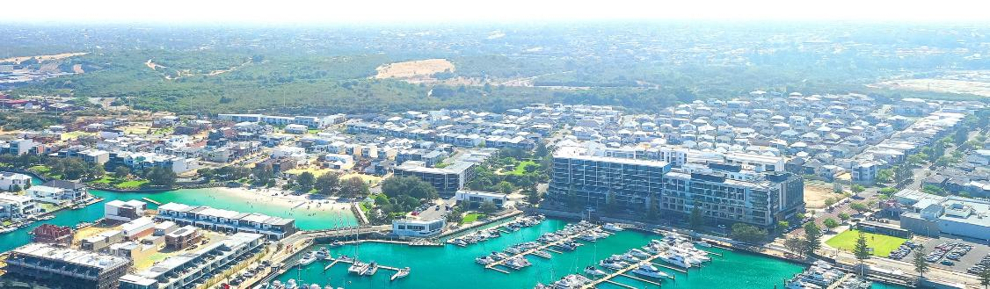
Photo: Port Coogee Marina, North Coogee.

Message from the Mayor
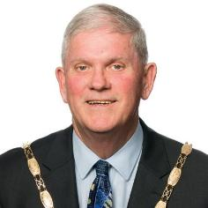
As Mayor of the City of Cockburn, I am proud to present our Strategic Community Plan 2025–2035 – a bold and community-driven vision for the future of our city. This plan builds upon the strong foundations of our previous Strategic Community Plan 2020–2030, reflecting both our achievements and the evolving aspirations of our community.
This plan is more than a document – it’s a commitment to the people of Cockburn. It represents thousands of conversations, ideas, and shared aspirations from our residents, community groups, businesses and stakeholders. Together, we have co-created a road map for the next decade, one that celebrates what makes Cockburn special while planning for a thriving, inclusive and sustainable future.
Cockburn is growing rapidly, and with that growth come both opportunity and responsibility. We must balance new development with the preservation of our natural environment. We must foster a strong local economy that supports jobs and innovation. We must invest in accessible services and infrastructure that meet the evolving needs of our diverse population.
The Strategic Community Plan reflects these ambitions through five key outcomes – Our Economy, Our Environment, Our Community, Our Places, and Our Governance. These outcomes are interconnected, and they guide how we prioritise projects, allocate resources and measure success.
I’m particularly proud of the way this Plan was shaped with the community. From pop-up engagements and surveys to cultural projects like the community quilt, we’ve listened closely to ensure every voice matters. This spirit of collaboration will remain central to our journey ahead.
As we look to the next ten years, I invite all Cockburn residents to stay involved. Whether it’s sharing feedback, joining community initiatives or simply being an active neighbour, together we will continue to shape a Cockburn that is vibrant, connected and full of opportunity.
This is our city. This is our future. Let’s keep making Cockburn the best place to be.
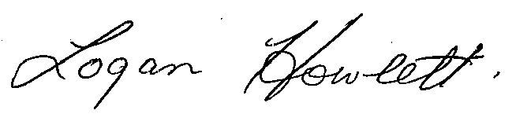
His Worship the Mayor
Logan K. Howlett, JP

Message from the CEO
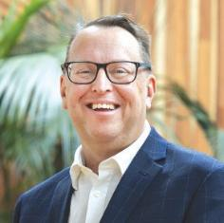
It is with great enthusiasm that I present the City of Cockburn’s Strategic Community Plan 2025–2035: a ten-year vision built on the values, priorities and aspirations of our community.
The Strategic Community Plan is the City’s highest-level planning document and serves as the foundation for all our work over the next decade. It outlines what we aim to achieve and, most importantly, why. Guided by your input, this Plan ensures that everything we do – from major infrastructure projects to the everyday services that support our neighbourhoods – is driven by what matters most to the people of Cockburn.
The five outcome areas mentioned by the Mayor help shape our policies, guide our investments and inform our operational decisions. The Corporate Business Plan details the projects we will undertake to deliver on this plan.
Crucially, our ability to succeed depends on staying connected with our community. Through initiatives like the biennial Liveability Study, we’re not only measuring our performance, we’re listening. These insights allow us to make evidence-based decisions and remain agile in a rapidly changing world.
The path ahead will bring both challenges and opportunities – from climate change and population growth to digital transformation, the economic climate and evolving community expectations. However, together we are well-placed to respond with confidence.

Daniel Simms
Chief Executive Officer

What is a Strategic Community Plan?

Shaping our future: Introduction to the Strategic Community Plan 2025–2035
Welcome to the City of Cockburn's Strategic Community Plan (SCP) for 2025-2035 – our shared vision and long-term road map for the future.
The City is one of Western Australia's most dynamic and fastest-growing local governments and strategically planning for the future is not just important, it's essential. Cockburn is a unique place, blessed with natural beauty from wetlands to waves, a diverse and engaged community and a growing economy. This plan outlines how we intend to embrace these strengths while addressing the challenges and embracing the opportunities that lie ahead. Our goal is to ensure Cockburn continues to evolve as the best place to be – a thriving, inclusive, sustainable and connected City where everyone can live, work and play. It reflects our aspirations and guides how we plan, prioritise and deliver services, projects and initiatives.
This isn't just a plan; it's our plan, developed with extensive input from you – our residents, businesses, community groups and stakeholders. Your aspirations, priorities and vision for Cockburn are at the heart of this document. 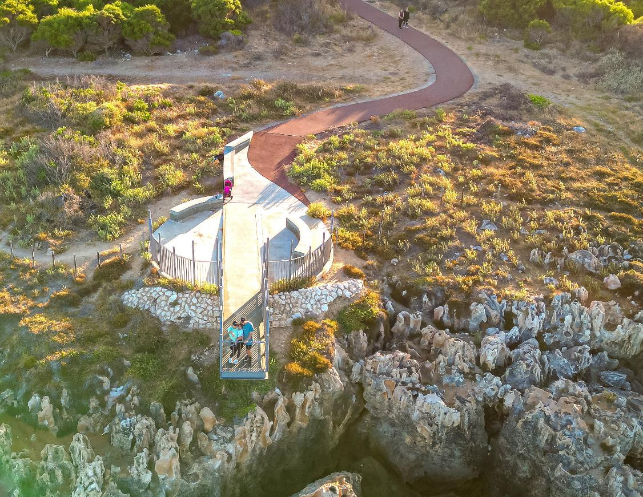
Photo: Henderson Cliffs, Henderson.

Our commitment
We are dedicated to making Cockburn “the best place to be,” where everyone feels welcome, connected and supported. This plan is built on community feedback, ensuring that your priorities are at the heart of the City’s decision-making process. Together, we aim to create a thriving, sustainable and inclusive future.

What is a Strategic Community Plan
Think of the Strategic Community Plan (SCP) as our community's collective compass. It's the City of Cockburn's principal guiding document, shaping our decisions now while setting our strategic direction well into the future. Here’s what makes it essential:
Defines our long-term vision:
It captures what we, as a community, want Cockburn to look and feel like in the future.
Reflects community aspirations:
It's based on what you told us matters most – your priorities for our economy, environment, community, infrastructure and governance.
Guides council decisions:
It guides Council's focus, helping us make informed decisions about services, projects, budgets and resource allocation.
Sets strategic priorities:
It identifies the key outcome areas where the City will concentrate its efforts to achieve our shared vision.
Provides a framework for action:
It ensures the City's operational plans and day-to-day activities are aligned with the long-term goals of our community.
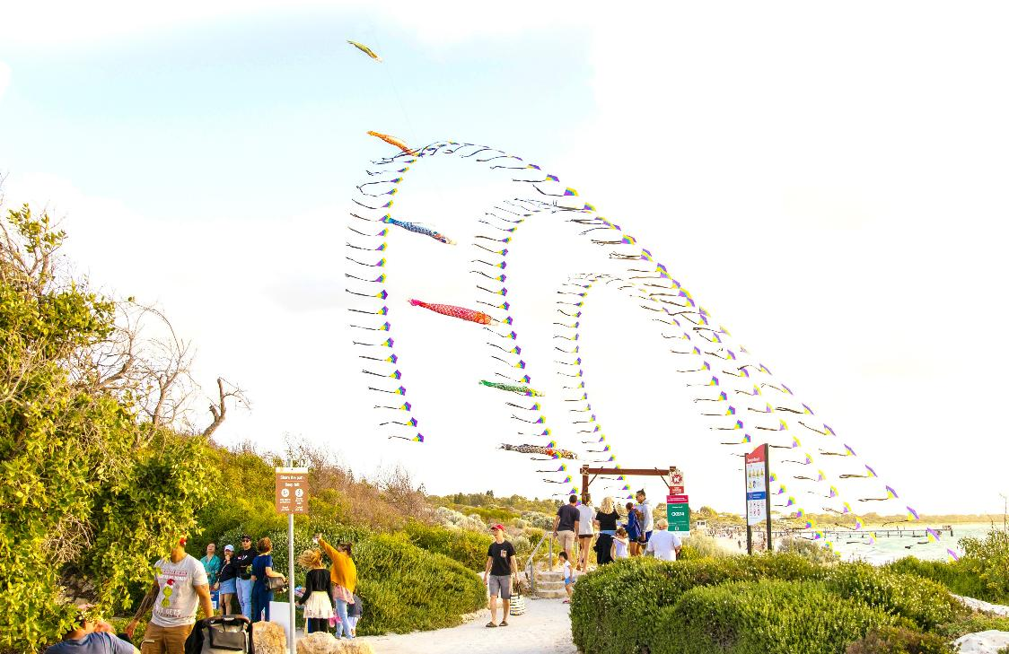
Photo: Christmas on the Coast event, Coogee Beach.

How to use this plan
The Strategic Community Plan is for everyone in the City of Cockburn, including residents, ratepayers, businesses, Elected Members and the City’s workforce. Here’s how you can use it:

Community members
- Understand how your feedback has shaped the vision and priorities of the plan.
- Explore the initiatives and projects that contribute to the future of your community.
- Discover opportunities to support and participate in achieving the goals outlined in the plan.
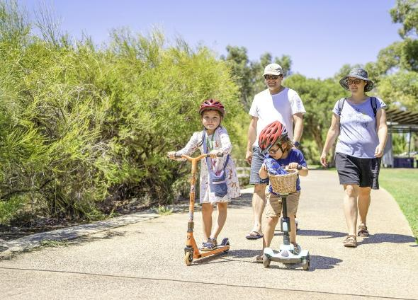
Photo: Family at Bibra Lake Reserve, Bibra Lake.

Elected Members
- Use the plan to guide decision-making and ensure alignment with the community’s vision.
- Evaluate proposals and policies to confirm they contribute to the strategic outcomes.
- Monitor the City’s performance and hold it accountable for achieving the stated goals.
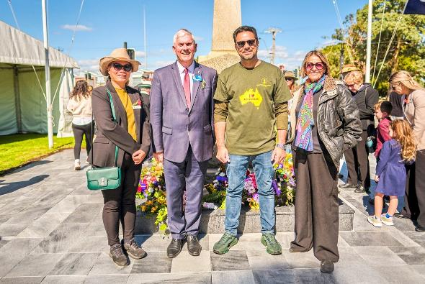
Photo: (from Left to Right) Cr Carol Zhang; Mayor Logan Howlett; Mirza Yasser Ahmad, Secretary External Affairs, Ahmadiyya Muslim Association; and Cr Phoebe Corke at War Memorial on the grounds of Memorial Hall, Hamilton Hill.

City workforce
- Plan and deliver services, projects and initiatives that align with the SCP’s strategic priorities.
- Assess new proposals to ensure they support the vision and outcomes of the plan.
- Balance competing priorities by focusing on initiatives that provide the greatest value to the community.

Photo: Rick Wheeler, Ranger Team Leader at Coogee Beach, Coogee.

Inside the Strategic Community Plan
This plan outlines the direction for the City of Cockburn from 2025 to 2035, providing a road map for sustainable growth and community wellbeing. Here’s what it includes:
Vision:
The guiding principles that shape our community’s future.
Strategic focus areas:
Key priorities such as environmental stewardship, economic growth, social inclusion and governance excellence.
Community aspirations:
Insights from consultation and engagement with residents and stakeholders.
Implementation framework:
How the SCP drives the City’s Corporate Business Plan and annual budgets.
Monitoring and reporting:
How we will measure success and keep the community informed of progress.

Working together
This Strategic Community Plan maps our journey, but its success relies on partnership. Bringing the vision outlined in these pages to fruition requires ongoing collaboration between the City and everyone who calls Cockburn home or contributes to its life. Your continued engagement and active participation are essential as we translate these shared goals into tangible outcomes for our community. We value this partnership and look forward to building Cockburn's next chapter alongside you.

Photo: Adventure World, Bibra Lake

How to read the Strategic Community Plan
To help you navigate this plan and understand how our aspirations translate into focus areas, we've structured it logically. It flows from our overarching Vision down to specific Objectives under key community Outcomes. Here's how it works:

The structure: from vision to action

Our vision
This is the highest-level statement, capturing the ultimate aspiration for Cockburn. Cockburn, the best place to be.

Strategic outcomes
Beneath the vision sit five broad strategic outcomes. These represent the key areas where our community desires positive results over the next decade. They describe the desired future state for Cockburn across different facets of community life.
These outcomes were developed based on community feedback and reflect what matters most to you. They are:
Outcome 1. Our Economy:
Attracting investment, supporting business and visitor growth and boosting local jobs through vibrant hubs.
Outcome 2. Our Environment:
Valuing natural assets, building climate resilience and using resources sustainably.
Outcome 3. Our Community:
A diverse, active, and connected community that feels safe and has access to local services.
Outcome 4. Our Places:
Enhancing distinctive, liveable areas with well-connected, safe transport options.
Outcome 5. Our Governance:
Transparent leadership that listens, communicates openly and plans for a sustainable future.

Strategic objectives
Under each strategic outcome, you will find several strategic objectives. These are the more specific goals and areas of focus the City will concentrate on to achieve the broader outcome.
These objectives guide the City's planning and resource allocation.

Connecting the dots... Strategic Community Plan, Corporate Business Plan and Annual Report
Our Strategic Community Plan sets out the long-term vision and priorities for our community. The Corporate Business Plan details how we’ll bring that vision to life through specific projects, programs and the services we deliver. The Annual Report tracks our progress each year, showing how we’re delivering on what you told us matters most.
Together, these documents link strategy, action and accountability – keeping us aligned with our community’s aspirations.
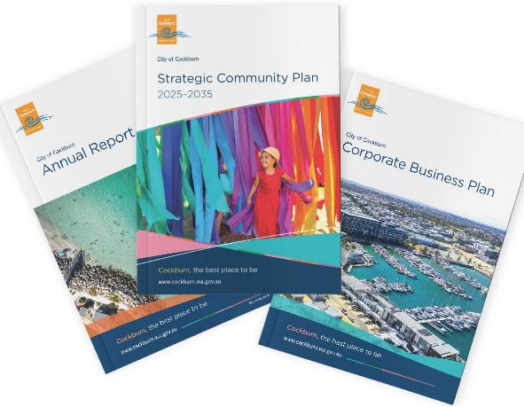

Our strategic framework
Our Local Government operates within an Integrated Planning and Reporting Framework (IPRF). This framework, mandated by the Western Australian Government, ensures a structured and transparent approach to planning and decision-making.
The IPRF connects the long-term vision of our Strategic Community Plan with our current plans and strategies. It guides how we identify community needs, set strategic objectives, allocate resources and ultimately measure our success in achieving those goals. Through the IPRF, we strive to deliver effective services, manage finances responsibly and remain accountable to the community we serve.
The following diagram illustrates the City’s Integrated Planning and Reporting Framework and shows the City’s strategies and plans within the framework.
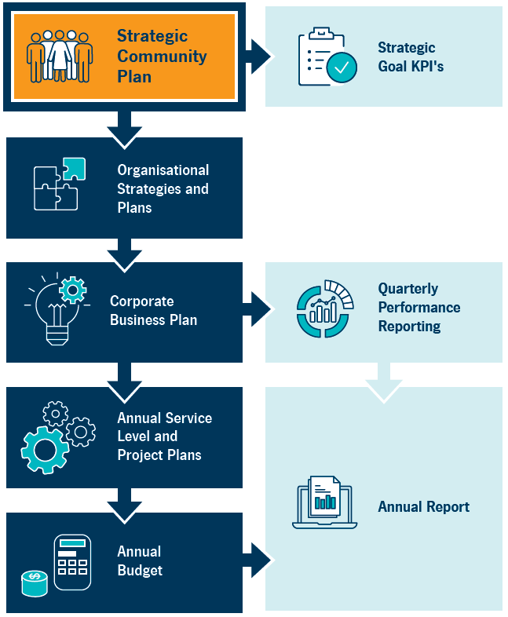
Transcriber’s Note: The diagram above is a flow chart with eight labelled boxes linked by arrows. At each step, arrows point forward to one or more boxes. The flow chart is presented below as lists in which the possible next steps are listed beneath each box label.
- Strategic Community Plan
  - forward to Strategic Goal KPIs
  - forward to Organisational Strategies and Plans
- Organisational Strategies and Plans
  - forward to Corporate Business Plan
- Corporate Business Plan
  - forward to Quarterly Performance Reporting
  - forward to Annual Service Level and Project Plans
- Quarterly Performance Reporting
  - forward to Annual Report
- Annual Service Level and Project Plans
  - forward to Annual Budget
- Annual Budget
  - forward to Annual Report

Our strategy on a page
This section presents the vision for Cockburn, highlighting our driving purpose. It also outlines our strategic objectives and outcomes as detailed in our Strategic Community Plan.
Vision: Cockburn, the best place to be
Purpose: Support our communities to thrive by providing inclusive and sustainable services which reflect their aspirations
Our outcomes and our objectives:
- Our Economy
  - Empower and support local businesses
  - Facilitate economic growth and employment opportunities
  - Attract investment to the city by promoting innovation and economic opportunity
  - Facilitate vibrant, connected commercial hubs and visitor experiences
- Our Environment
  - Protect and enhance our natural areas and streetscapes
  - Facilitate sustainable waste management and resource conservation
  - Enhance climate resilience and champion environmental initiatives to mitigate impacts
- Our Community
  - Strengthen and facilitate a safe and secure Cockburn
  - Promote and support active, healthy lifestyles through recreation and wellness
  - Celebrate and recognise Aboriginal and Torres Strait Islander and diverse cultures
  - Foster connected, accessible communities and services
- Our Places
  - Plan for growth and sustainable development
  - Strengthen unique, liveable and adaptive places
  - Enhance connectivity and mobility through integrated transport networks
- Our Governance
  - Facilitate transparent and accountable governance for today and tomorrow
  - Strengthen engagement, communication and enhance customer experience
  - Champion strategic partnerships and stakeholder collaboration
  - Strive for financial sustainability and operational excellence

Our city
Cockburn: Our Home, Our Story
Welcome to the City of Cockburn – a place we’re proud to call home. From our sunlit beaches to our vibrant parks, from the bustling local businesses to the friendly faces of our neighbours, Cockburn is more than a city – it’s our community.
Picture yourself starting the day with a walk along Coogee Beach, where the waves meet golden sands. Or maybe it’s a family picnic at Bibra Lake, surrounded by the sounds of nature. With hundreds of parks and reserves and kilometres of stunning coastline, Cockburn is a haven for outdoor lovers. These are the spaces where we connect, where our kids laugh in local playgrounds, and where we take a moment to appreciate the beauty of our surroundings.
Cockburn isn’t just where we live; it’s where we grow. Our city has seen incredible progress, with a population of more than 135,000 today and expected to grow to nearly 190,000 by 2045. Together, we’ve built a diverse and welcoming community, with people from all walks of life coming together to make Cockburn what it is: a place of opportunity and belonging.
Our local economy is thriving, contributing billions of dollars to the Australian economy every year. With thousands of local businesses, many of them small enterprises, Cockburn is a place where ambition turns into action. Whether you’re running your own business or supporting local shops, our community is built on shared success.
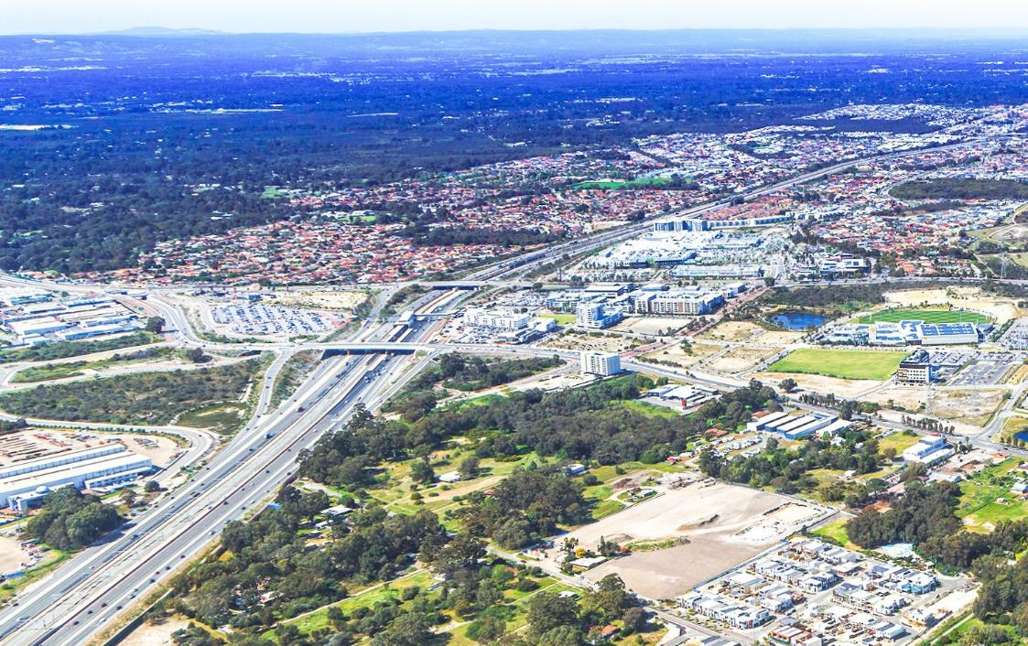
Photo: Cockburn Central.
What truly defines Cockburn is its vibrant community spirit and fantastic lifestyle amenities. With numerous active local clubs, bustling community centres hosting diverse programs, and state-of-the-art recreational facilities like the Cockburn ARC, there's always something happening. We pride ourselves on fostering connections through popular local events and providing outstanding parks and accessible beaches where families and friends gather, making Cockburn a lively and engaging place to call home.
As we look to the future, our city is ready to grow with us. With plans for new housing, better roads and evolving services, Cockburn is set to remain a place where everyone – families, young people and seniors – can thrive. We’re building a city that works for all of us, one step at a time.
Cockburn is more than just a place on a map; it’s the heart of everything we do. It’s the sporting fields where we cheer for our teams, the libraries where we learn and share stories, and the arts and cultural spaces where our creativity shines.
This is our Cockburn – our home, our story, and the best place to be. Together, we’re writing the next chapter. From its historical beginnings to its bright future, it invites you to be part of its journey.

About our city
Value added, GSP, GDP:
- Value added by Cockburn to the Australian economy: $12.7 billion
- Gross State Product (GSP) in Western Australia: $436.85 billion
- Gross Domestic Product (GDP) in Australia: $2.67 trillion
(Source: REMPLAN 2024)
Cockburn contributes 4.5% of the total value added by the Greater Perth region and represents 2.9% of Western Australia's $437 billion value added, demonstrating its role as a key driver of economic growth and improved living standards for Western Australians.
Businesses operating in:
- City of Cockburn: 9,919
- Western Australia: 246,661
- Australia: 2,662,998
(Source: Australian Bureau of Statistics 2024)
Cockburn's business ecosystem comprises approximately 9,919 businesses, the majority of which are small-scale enterprises. This accounts for roughly 4% of the total businesses operating in Western Australia.
Jobs located in:
- Cockburn: 51,957
- Western Australia: 1,308,799
- Australia: 13,262,616
(Source: Australian Bureau of Statistics 2024)
Cockburn accounts for 4% of Western Australia's total jobs, making it a significant contributor to the state's economy and providing employment opportunities for both local residents and commuters.
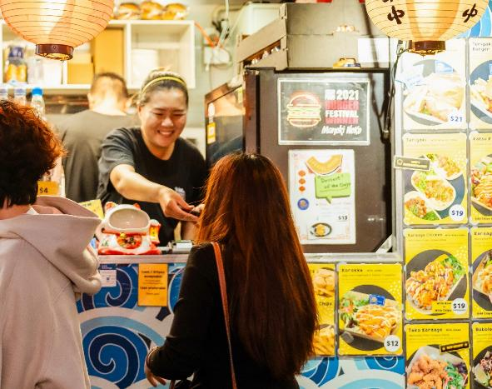
Photo: Mosaic Multicultural Festival at Cockburn Central.
Tree canopy cover in the City of Cockburn: 18% (Source: City of Cockburn Statistics 2025)
Cockburn maintains a significant tree canopy cover of 18 per cent, contributing to the overall health and biodiversity of the area.
Number of parks and reserves: 396 (Source: City of Cockburn Statistics 2025)
Total hectares of parks and reserves: 1,572.5ha (Source: City of Cockburn Statistics 2025)
Hectares of bush reserves: 1,074.6ha (Source: City of Cockburn Statistics 2025)
With a total of 396 parks and reserves, encompassing 1,572.45 hectares, Cockburn offers ample green spaces for its residents. Of these, 1,074.61 hectares are designated as bush reserves, preserving the City’s natural environment.
Number of sporting reserves/fields: 30 (Source: City of Cockburn Statistics 2025)
Number of sporting clubs in Cockburn: ~120 (Source: City of Cockburn Statistics 2025)
With 30 sporting reserves/fields and an estimated 120 sporting clubs, Cockburn offers a variety of opportunities for residents to participate in physical activities.
Number of playgrounds: 215 (Source: City of Cockburn Statistics 2025)
Number of arts and cultural facilities: 2 (Source: City of Cockburn Statistics 2025)
Number of libraries: 3 (Source: City of Cockburn Statistics 2025)
Median age:
- Cockburn: 37
- Western Australia: 38
- Australia: 38
(Source: REMPLAN 2024)
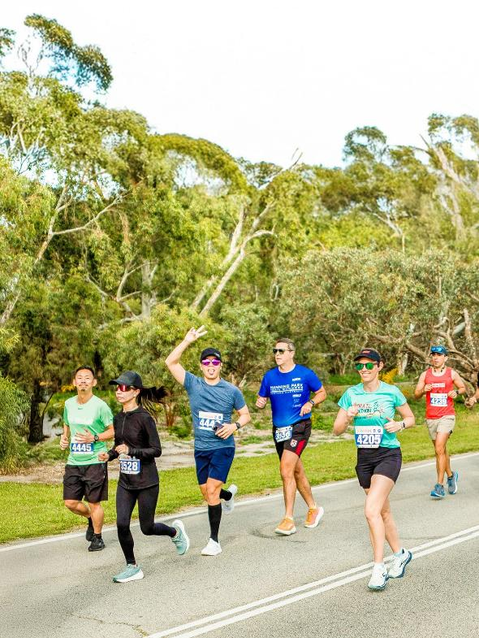
Photo: Bibra Lake Fun Run at Bibra Lake.
Proportion of population born in:
Australia:
- Cockburn: 61.7%
- Western Australia: 65%
- Australia: 66%
United Kingdom:
- Cockburn: 8%
- Western Australia: 8.9%
- Australia: 4.4%
New Zealand:
- Cockburn: 2.7%
- Western Australia: 2.8%
- Australia: 2.1%
Philippines:
- Cockburn: 2.4%
- Western Australia: 1.4%
- Australia: 1.2%
India:
- Cockburn: 1.9%
- Western Australia: 2.3%
- Australia: 2.6%
South Africa:
- Cockburn: 1.7%
- Western Australia: 1.7%
- Australia: 0.7%
Italy:
- Cockburn: 1.4%
- Western Australia: 0.7%
- Australia: 0.6%
(Source: REMPLAN 2024)
While the majority of residents were born in Australia (61.7 per cent), Cockburn boasts a diverse population with significant representation from the United Kingdom (8 per cent), New Zealand (2.7 per cent), and a growing Asian community (including the Philippines and India).
Population growth:
Age Groups | 2025 Population | 2045 Population
Preschool (0-4 years) | 8,443 (6.2%) | 9,969 (5.3%)
School-age (5-14 years) | 17,155 (12.6%) | 20,492 (10.8%)
Youth (15-24 years) | 16,362 (12%) | 22,147 (11.7%)
Young Workers (25-34 years) | 20,235 (14.8%) | 25,887 (13.6%)
Workers (35-49 years) | 30,981 (22.7%) | 39,593 (20.9%)
Older Workers (50-64 years) | 24,029 (17.6%) | 35,614 (18.8%)
Retired (65-79 years) | 14,631 (10.7%) | 25,158 (13.3%)
Elderly (80+) | 4,552 (3.3%) | 10,823 (5.7%)
Total | 136,388 | 189,683
Estimated population in 2025: 136,388 (Source: REMPLAN 2024)
Projected population by 2045: 189,683 (Source: REMPLAN 2024)
Cockburn's population is projected to experience a shift in age demographics. While the working-age population (25-64 years) is expected to grow, the proportion of older residents (65+) is also projected to increase. This indicates a growing demand for age-appropriate services and infrastructure.
Estimated dwellings in 2025: 51,085 (Source: REMPLAN 2024)
Projected dwellings by 2045: 73,860 (Source: REMPLAN 2024)
Cockburn is experiencing significant growth, with the population projected to increase by nearly 40% from 136,388 in 2025 to 189,683 in 2045. This growth is reflected in the housing market, with the number of dwellings expected to rise from 51,085 to 73,860 over the same period.
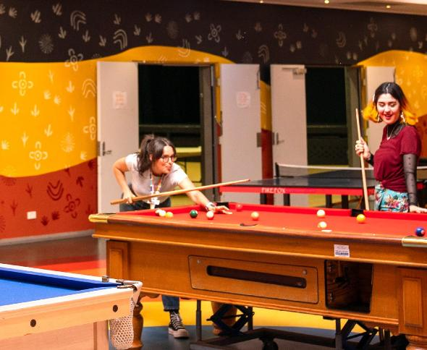
Photo: Kerri Mulford, Youth Development Officer, and Leila Diaz, Youth Advisory Collective member, at Youth Centre in Success.
Population density: 811 people per square kilometre (Source: REMPLAN 2024)
Total kilometres of City-managed roads: 894km (Source: City of Cockburn Statistics 2025)
Total kilometres of City-managed footpaths: 893km (Source: City of Cockburn Statistics 2025)
Cockburn's land area of 168.1 square kilometres is home to a population density of 811 people per square kilometre, indicating a relatively high concentration of residents. The city maintains a vast network of roads (894 kilometres) and footpaths (893 kilometres), ensuring connectivity and accessibility.
Land area: 168.1km² (Source: City of Cockburn Statistics 2025)
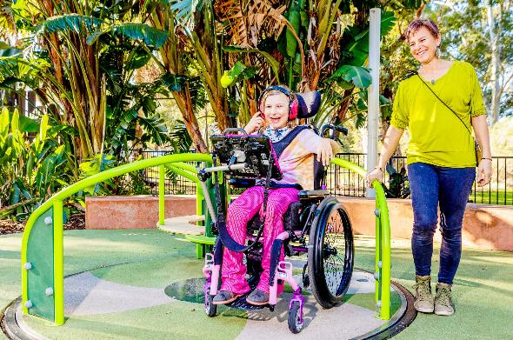
Photo: All-abilities play environment at Bibra Lake adventure playground.
Number of people reached through our social media posts: 3.5 million (Source: City of Cockburn Statistics 2025)
City of Cockburn website views: 2.1 million (Source: City of Cockburn Statistics 2025)
Cockburn has a strong online presence, with the official City of Cockburn website attracting 2.1 million views. The City’s social media posts reach an impressive 3.5 million people, while the Comment on Cockburn website receives 72,876 visits.
Visits to the Comment on Cockburn website: 72,876 (Source: City of Cockburn Statistics 2025)
Customer requests raised: 67,371 (Source: City of Cockburn Statistics 2025)
Calls received by the Contact Centre: 82,872 (Source: City of Cockburn Statistics 2025)
Cockburn's commitment to its residents is evident in its service delivery. The Contact Centre handles 82,872 calls annually, with 67,371 customer requests raised annually.

Where we live
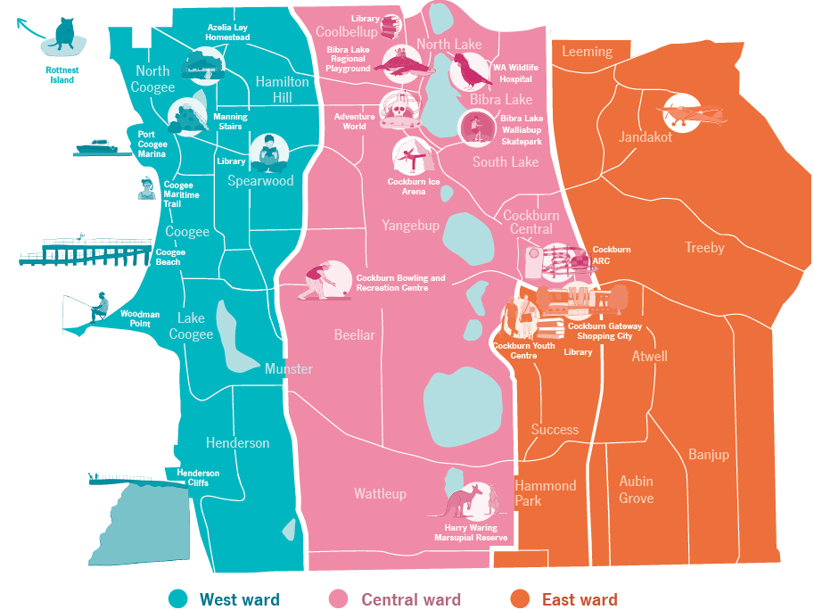
Transcriber’s Note: The map above is of the City of Cockburn, divided into three colour-coded wards. Please contact City of Cockburn for more information or clarification.
West Ward is highlighted in blue on the map. It includes the suburbs of North Coogee, Coogee, Lake Coogee, Henderson, Munster, Spearwood, and Hamilton Hill, as well as Rottnest Island off the coast of Western Australia. Landmarks in West Ward include Azelia Ley Homestead, Manning Stairs, Port Coogee Marina, Coogee Maritime Trail, Coogee Beach, Woodman Point, and Henderson Cliffs.
Central Ward is highlighted in pink on the map. It includes the suburbs of Coolbellup, North Lake, Bibra Lake, South Lake, Yangebup, Hamilton Hill, Spearwood, Beeliar, Munster, Wattleup, and Cockburn Central. Landmarks in Central Ward include Bibra Lake Regional Playground, Adventure World, WA Wildlife Hospital, Bibra Lake Walliabup Skatepark, Cockburn Ice Arena, Cockburn Bowling and Recreation Centre, Cockburn ARC, and Harry Waring Marsupial Reserve.
East Ward is highlighted in orange on the map. It includes the suburbs of Jandakot, Leeming, Treeby, Atwell, Success, Hammond Park, Aubin Grove, and Banjup. Landmarks in East Ward include Jandakot Airport, Cockburn Youth Centre, and Cockburn Gateway Shopping City.

Photo: Omeo Shipwreck, North Coogee.

Our Cockburn Council and Elected Members

Mayor
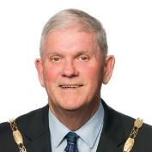 Logan K. Howlett, JP, His Worship the Mayor

West Ward
 Kevin Allen, Councillor, West Ward
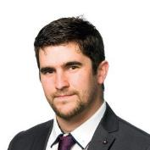 Michael Separovich, Councillor, West Ward
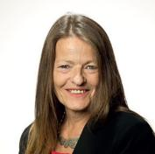 Phoebe Corke, Councillor, West Ward

Central Ward
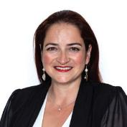 Chontelle Stone, Deputy Mayor and Councillor, Central Ward
 Tom Widenbar, Councillor, Central Ward
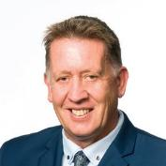 Philip Eva, JP, Councillor, Central Ward

East Ward
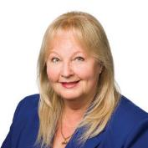 Carol Reeve-Fowkes, Councillor, East Ward
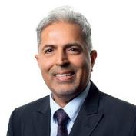 Tarun Dewan, Councillor, East Ward
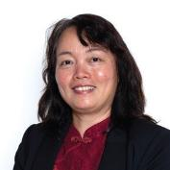 Carol Zhang, Councillor, East Ward
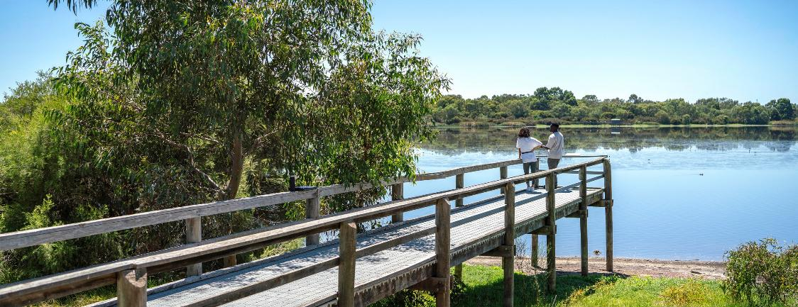
Photo: Bibra Lake Reserve, Bibra Lake.

Developing this plan
This SCP is a 10-year strategy that reflects the community’s aspirations, outlines our future priorities and defines the actions needed to achieve them.
This Plan:
- provides a clear understanding of community priorities, aspirations and needs
- shapes the development of local government and regional plans
- informs future resourcing and investment decisions
- ensures compliance with legislative requirements
- defines how success will be measured over time
In addition to formal feedback, the City undertook extensive community consultation through the Shaping Cockburn’s Future! project, focused on co-designing the Strategic Community Plan.
Engagement for this Plan built on the insights from the 2024 Liveability Study, which received over 1,800 responses. A gap analysis helped identify under-represented voices, directly informing the next phase of community engagement held across February and March 2025.
Priorities are expected to evolve over time. The SCP undergoes a desktop review every two years and a full community review every four years, ensuring the Plan stays responsive to changing local and global conditions – social, environmental, technological and economic.
This engagement approach – focused on meeting the community where they are – demonstrated the City’s strong commitment to collaboration, inclusiveness and fairness in shaping Cockburn’s future.
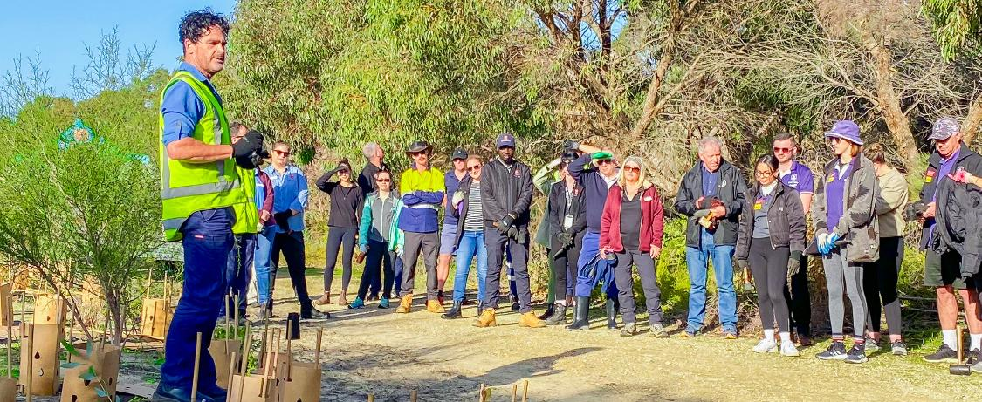
Photo: Adam Harris, Environmental Officer Natural Resource, leading staff planting day.

Community input
Throughout the Shaping Cockburn’s Future! project, the City undertook a comprehensive communication and engagement campaign to raise awareness and encourage community input into the Strategic Community Plan. Our goal was to connect with as many residents as possible and ensure a wide range of voices were heard across suburbs, age groups and backgrounds.
Consultation methods included:
- online surveys and hard-copy forms
- email and phone conversations
- in-person conversations at community pop-ups across Cockburn
- participation in reference groups such as the Aboriginal, Youth, Children’s, Age Friendly, Disability and Multicultural groups
- interactive sessions at libraries and the Seniors and Youth Centres
- workshops with the combined Residents Group Network attendance at Coogee Live and other local events
One stand-out initiative was the community quilt, where residents created individual fabric squares to represent their hopes for Cockburn’s future. These squares will be sewn together by the Seniors and Youth Centres, becoming a visual symbol of shared aspirations.
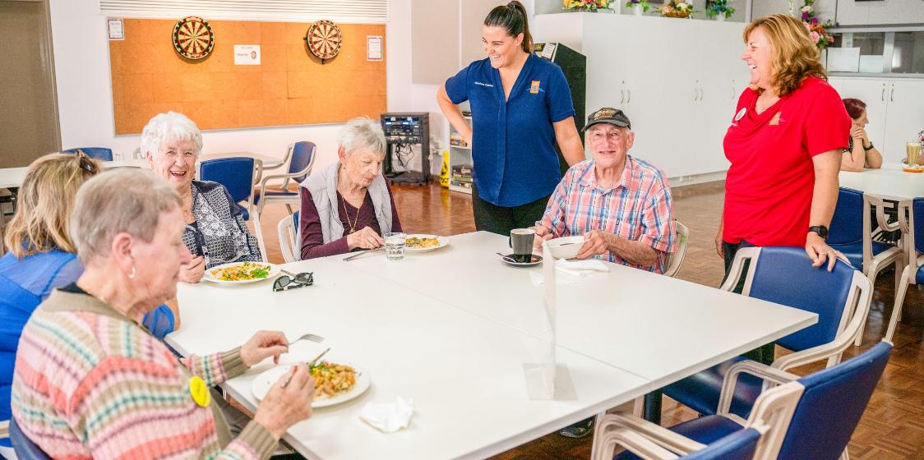
Photo: Seniors Centre Programs Booking Officer Kayla Maloney, Seniors Centre Coordinator Julie McDonald, and wonderful seniors enjoying their time at the Seniors Centre in Spearwood.
Other multichannel approaches included:
- 12,500 postcards delivered to homes in Banjup, Treeby, Cockburn Central, and North Lake
- Two targeted social media ads reaching a combined 10,495 accounts
- Branded staff email signatures linking to the engagement page
- A social media video post highlighting City services, organically reaching 2,855 accounts
- E-newsletter distributed to over 10,500 subscribers on Comment on Cockburn
- A dedicated project page on the Comment on Cockburn website
- 34 signs installed in key parks and open spaces across Cockburn
- An Instagram story promoting our pop-up stand at Cockburn Gateway Shopping City, reaching 775 accounts
- Feature advertisement in the February 2025 edition of Cockburn Soundings
During the engagement period, the community responded with interest and enthusiasm.

How you connected with us
- Over 1,800 responses to the 2024 Liveability Study
- 1,500 visits to the Comment on Cockburn project page
- Over 120 people provided formal feedback online
- Over 500 in-person conversations at events and pop-ups
Comment on Cockburn: comment.cockburn.wa.gov.au
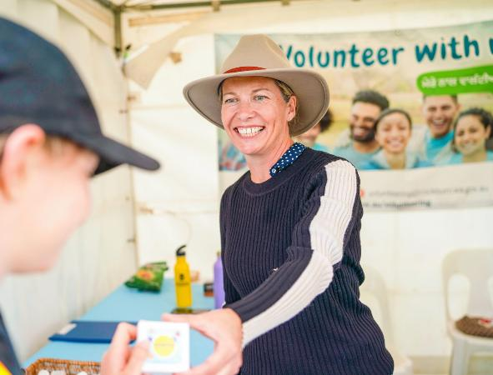
Photo: Tracey Armstrong, Community Development Officer at City of Cockburn

Our vision
Cockburn, the best place to be.
The City of Cockburn’s Strategic Community Plan 2025–2035 continues to champion a bold and forward-looking vision: Cockburn, the best place to be. This vision captures our collective aspiration to nurture a future where our city flourishes – economically, environmentally, socially and culturally. It reflects our commitment to building a place people are proud to live in, work in and visit.
This involves strengthening a resilient local economy that supports local enterprise and generates employment opportunities close to home. It includes caring for our natural environment; celebrating our beautiful coastline, bushland, and green spaces; and making sustainable choices that protect our future. It means cultivating a community that is inclusive, supportive, and connected, where everyone can access essential services, feel safe, and know they belong. It also encompasses designing distinctive and liveable neighbourhoods that residents are proud to call home, filled with vibrant destinations and efficient transport options that keep people connected.
Underpinning all of this is strong, transparent governance that puts our community first, listens to your voices and plans responsibly for the decades ahead. Our Strategic Community Plan is the road map to realising this vision and ensuring that Cockburn truly is the best place to be.
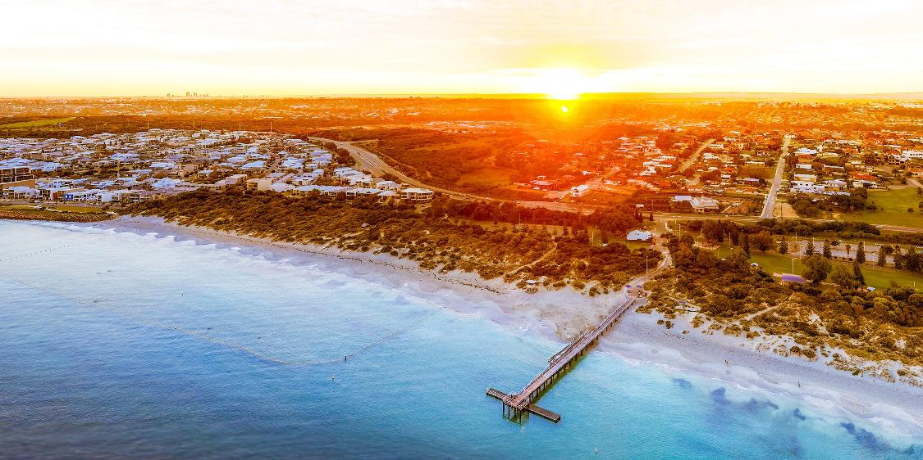
Photo: Coogee Jetty, Coogee Beach.
Together, let’s make Cockburn the best place to be.
This Strategic Community Plan is our shared commitment to making Cockburn an exceptional place to live, work, play and grow.

Strategic Outcomes

Our Economy
Our City attracts investment supporting commercial and business growth.
Our distinctive hubs facilitate and attract local business and visitor growth, providing employment and community access to services.

Objectives
- Empower and support local businesses.
- Facilitate economic growth and employment opportunities.
- Attract investment to the city by promoting innovation and economic opportunity.
- Facilitate vibrant, connected commercial hubs and visitor experiences.

Services
- Business and Economic Development

Community feedback
“Businesses which are local. Not having to go to big shopping centres. More corner stores or pop-up markets.”
“Support for small business is crucial; local businesses create local jobs.”
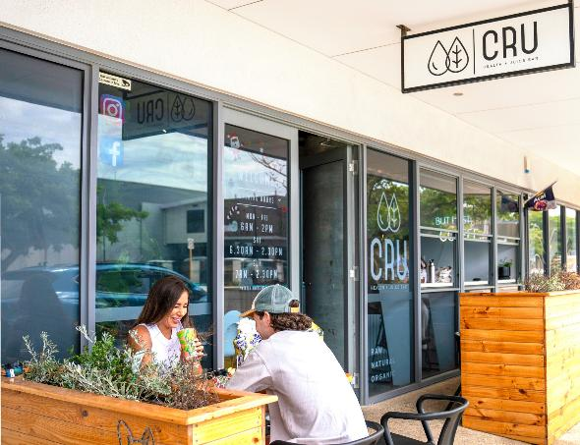
Photo: CRU Health + Juice Bar, North Coogee.

Our Environment
Our natural environment is valued and resilient to a changing climate. Our community enjoys our open spaces, bushland and coast and takes pride and ownership in their streetscapes.
We use our resources with a focus on conservation and mitigate the impacts of climate change.

Objectives
- Protect and enhance our natural areas and streetscapes.
- Facilitate sustainable waste management and resource conservation.
- Enhance climate resilience and champion environmental initiatives to mitigate impacts.

Services
- Parks, Environment and Streetscapes
- Sustainability
- Waste Services

Community feedback
“I love that my home sits at the crossroads of urban energy and natural beauty, offering the best of both worlds.”
"I like the access to quality green spaces and parks; it feels like a family-friendly area."
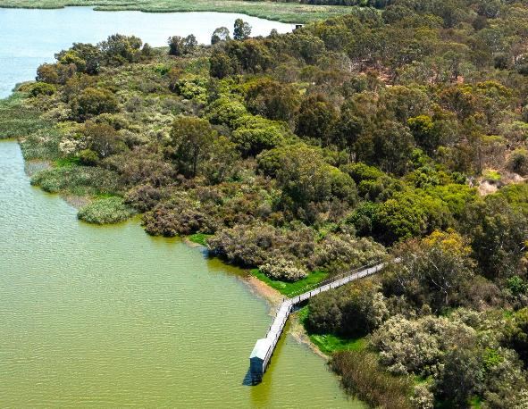
Photo: Bibra Lake Boardwalk and Bird Hide, Bibra Lake.

Our Community
Our diverse and valued community is engaged and involved in activities and events with access to services in local distinctive places.
Our community feels safe, secure and connected and is active and healthy.

Objectives
- Strengthen and facilitate a safe and secure Cockburn.
- Promote and support active, healthy lifestyles through recreation and wellness.
- Celebrate and recognise Aboriginal and Torres Strait Islander and diverse cultures.
- Foster connected, accessible communities and services.

Services
- Community Services
- Community Safety Services
- Events and Cultural Services
- Library Services
- Public Health Services
- Recreation and Place Services

Community feedback
"The people in my neighbourhood are friendly and connected, happy to say hello when out walking and have a chat. We know a lot of people in the area which makes it feel safe and welcoming."
"My neighbours are great. I like how much care the City puts into its parks. All the sustainability grants and local business grants are great."
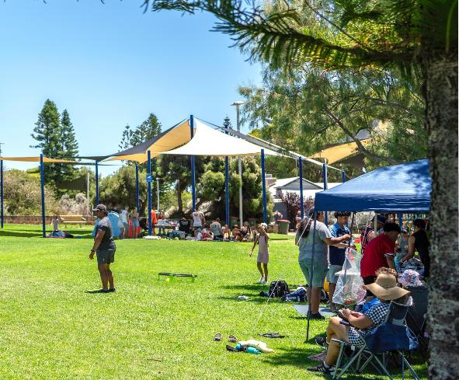
Photo: Coogee Beach Reserve, Coogee.

Our Places
The City prioritises our resources and is dedicated to enhancing our distinctive and liveable areas to address the needs of our community.
Our neighbourhoods and locations are linked through safe transportation choices, including roads, cycleways and pathways.

Objectives
- Plan for growth and sustainable development.
- Strengthen unique, liveable and adaptive places.
- Enhance connectivity and mobility through integrated transport networks.

Services
- Assets and Projects
- Development Services
- Planning Services

Community feedback
"Cockburn is where my family have lived for almost 100 years. We have watched it grow from a quiet town to the strong family orientated city, with very good facilities."
"It’s a great location, easy to get to places, and the council provides fantastic support to its residents."
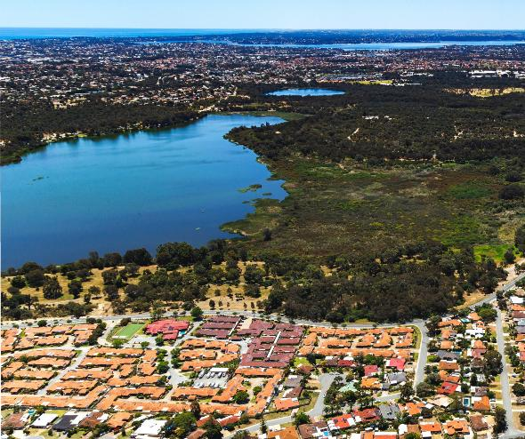
Photo: Bibra Lake Reserve, Bibra Lake.

Our Governance
Our City is governed through transparent and accountable leadership with a focus on open communication, listening and engaging with our community, with an eye on the future.

Objectives
- Facilitate transparent and accountable governance for today and tomorrow.
- Strengthen engagement and communication and enhance customer experience.
- Champion strategic partnerships and stakeholder collaboration.
- Strive for financial sustainability and operational excellence.

Services
- Communications and Engagement
- Financial Services
- Fleet Services
- Governance and Legal Services
- Information and Technology
- People and Organisational Performance

Community feedback
"I always have had great experiences with the Council, which encourages us to reach out again when required."
"I've found staff members to be extremely helpful on the phone and the council to be impressively prompt in responding to reports such as a broken public water bubbler, etc."
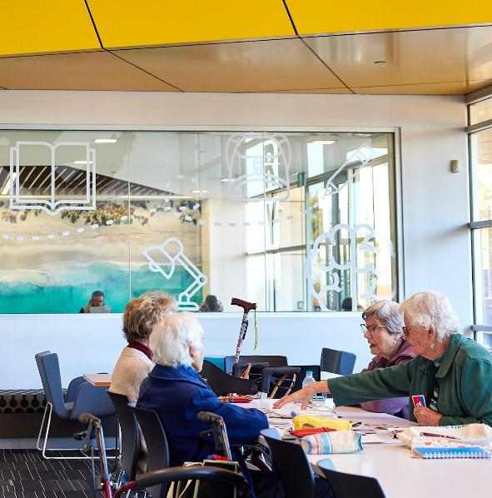
Photo: Success Library, Success.

Aligning with the UN Sustainable Development Goals

The United Nations Sustainable Development Goals (SDGs) are a set of 17 global goals designed to address the world’s most pressing social, environmental and economic challenges by 2030. These goals provide a shared framework for building stronger, fairer and more sustainable communities.
While the SDGs are international in scope, local governments play a vital role in achieving them. Many of the services, programs and infrastructure delivered by the City of Cockburn directly support these goals – from protecting our environment and fostering community wellbeing to driving economic growth and ensuring transparent, inclusive governance.
As we plan for Cockburn’s future through our Strategic Community Plan 2025–2035, we are aligning our outcomes and objectives with relevant SDGs to demonstrate how our local actions contribute to global progress. This alignment reinforces our commitment to sustainability, equity and long-term resilience not just for Cockburn but as part of a shared global vision.

Our Economy
Attracting investment, supporting business and visitor growth and boosting local jobs through vibrant hubs.
- Goal 1 - No poverty: By encouraging economic participation, we help reduce financial hardship in our community.
- Goal 8 - Decent work and economic growth: Supporting local businesses and job creation leads to a thriving and resilient economy.
- Goal 9 - Industry, innovation, and infrastructure: Investing in smart infrastructure and innovation ensures long-term economic sustainability.
- Goal 17 - Partnerships: Working together with industry, government, and community groups strengthens our economic foundations.

Our Environment
Valuing natural assets, building climate resilience and using resources sustainably.
- Goal 6 - Clean water and sanitation: We ensure access to clean water through careful management and conservation of local water systems.
- Goal 7 - Affordable and clean energy: Promoting renewable energy supports a cleaner, more sustainable future.
- Goal 11 - Sustainable cities and communities: We plan responsibly for growth that respects our environment.
- Goal 12 - Responsible consumption and production: Reducing waste and using resources wisely is a shared responsibility.
- Goal 13 - Climate action: We're taking steps to prepare for and reduce the impacts of climate change locally.
- Goal 14 - Life below water: Protecting our waterways and oceans supports marine biodiversity and healthy aquatic ecosystems.
- Goal 15 - Life on land: We preserve natural habitats and promote biodiversity across our landscapes.

Our Community
A diverse, active, and connected community that feels safe and has access to local services.
- Goal 2 - Zero hunger: While we don’t deliver food services directly, we support local organisations and initiatives that help improve food security and access to nutritious food.
- Goal 3 - Good health and well-being: Access to healthcare, recreation and wellbeing services is a key priority.
- Goal 4 - Quality education: Lifelong learning opportunities help our community grow and thrive.
- Goal 5 - Gender equality: We foster equality by ensuring everyone has access to the same opportunities.
- Goal 10 - Reduced inequalities: We work to remove barriers and support those who face disadvantage.
- Goal 11 - Sustainable cities and communities: We design safe, liveable spaces for people of all ages and backgrounds.

Our Places
Enhancing distinctive, liveable areas with well-connected, safe transport options.
- Goal 6 - Clean water and sanitation: Good infrastructure supports reliable water and sanitation systems.
- Goal 7 - Affordable and clean energy: Our developments aim to support low-emissions and energy-efficient solutions.
- Goal 8 - Decent work and economic growth: Local projects and infrastructure investment stimulate employment.
- Goal 9 - Industry, innovation, and infrastructure: Smart infrastructure ensures our places grow sustainably.
- Goal 11 - Sustainable cities and communities: We create places that are accessible, inclusive, and environmentally responsible.

Our Governance
Transparent leadership that listens, communicates openly and plans for a sustainable future.
- Goal 3 - Good health and well-being: We consider health in our planning and service delivery.
- Goal 5 - Gender equality: Our policies and practices promote equity across our organisation and community.
- Goal 8 - Decent work and economic growth: We provide fair, meaningful employment and support local business.
- Goal 10 - Reduced inequalities: Inclusion and accessibility are at the heart of our decision-making.
- Goal 13 - Climate action: We take responsibility for reducing our environmental impact.
- Goal 16 - Peace, justice and strong institutions: We govern with integrity, transparency, and accountability.
- Goal 17 - Partnerships for the goals: Access to healthcare, recreation, and wellbeing services is a key priority.

Implementing our plan
Delivering on the community’s aspirations requires more than just planning; it requires consistent action, transparent reporting and strong partnerships.
The Strategic Community Plan 2025–2035 provides the long-term vision and priorities for the City of Cockburn. To bring this vision to life, it will be supported by a suite of integrated planning and reporting documents, including the Corporate Business Plan, Long-Term Financial Plan and the Workforce Plan.

Putting strategy into action
Our Corporate Business Plan outlines the specific projects, services and initiatives the City will undertake over a four-year period to progress the objectives of this Strategic Community Plan. This plan is reviewed annually to ensure we remain responsive to changing community needs, emerging trends and available resources.

How we’ll track progress
To make sure we’re staying on track and delivering what matters most to our community, we’ll keep you updated and involved every step of the way.
We’ll regularly monitor how we’re progressing with the goals in this Plan – and we’ll share this information with you in clear, accessible ways. This means:
- Annual updates in the City’s Annual Report, outlining what’s been achieved and what’s next
- Regular updates via the City’s website, social media and Cockburn Soundings
- Ongoing listening through community surveys and other feedback opportunities
- Yearly reviews of the Corporate Business Plan to keep our actions aligned with community needs

Keeping the plan relevant
The Strategic Community Plan is a living document. To remain relevant, it will undergo a desktop review every two years and a comprehensive review every four years, including broad community consultation. This ensures that as Cockburn grows and changes, so too do our direction and our response to the challenges and opportunities ahead.
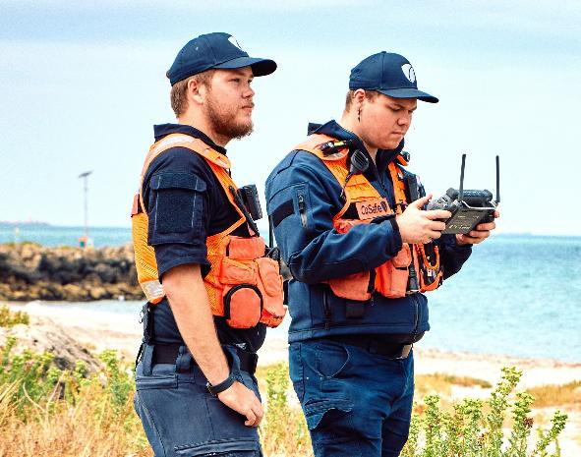
Photo: CoSafe surveying the C.Y. O'Connor Beach with a drone.

Tracking our success
Delivering on the vision outlined in the Strategic Community Plan (SCP) requires a commitment to continuous improvement, accountability and meaningful community engagement. The City of Cockburn recognises the importance of tracking progress, ensuring we are meeting the needs of our residents, and being responsive to changing priorities. To this end, we conduct a biennial survey through our comprehensive Liveability Study, enabling us to assess how well we are delivering on the plan’s outcomes and make adjustments where necessary.

The pulse check: the Liveability Study
The Liveability Study plays a vital role in helping us track community outcomes and ensures that our actions align with the real experiences and needs of our residents. Conducted every two years, the study collects data from local residents about their neighbourhoods, focusing on what they value, how they experience their local environment, and where improvements can be made.
In partnership with Place Score, the study provides us with:
- Community values - Insights into what is most important to our residents in their ideal neighbourhoods.
- Place experience - Ratings of the current quality of those neighbourhoods and the lived experience of residents.
- Strengths and priorities - Identification of attributes that are highly valued but underperforming, guiding us to areas that need focused attention.
- Community ideas - A wealth of innovative ideas from residents on how to improve their local neighbourhoods, which help shape our future priorities.
Key features of the Liveability Study:
- Community engagement: We ensure a representative sample of the community, considering factors such as demographic diversity and spatial distribution across the Local Government Area (LGA).
- Benchmarking performance: Cockburn's performance is benchmarked with other local government areas to identify opportunities for improvement.
- Liveability metrics: Data is collected and made available on the Liveability Platform, which allows the City of Cockburn to track progress over time and view the alignment with the SCP.
- Practical solutions: The feedback captured in the study is used to inform decisions and refine strategies to improve liveability outcomes across the City.

A broader commitment to community engagement
The Liveability Study is just one of many ways the City of Cockburn engages with the community. We are committed to continuous feedback through customer service interactions, targeted workshops, online consultations, and outreach to key groups. This holistic approach ensures we maintain an ongoing dialogue with residents, listen to their concerns, and respond proactively to their needs.

Why it matters
By conducting the Liveability Study and engaging with the community, we can:
- Ensure transparency in our reporting and decision-making processes.
- Make informed investments that are in line with the community’s highest priorities.
- Track our progress towards achieving the outcomes of the SCP and refine our strategies as needed.
- Foster long-term community wellbeing, ensuring our initiatives are creating lasting value.
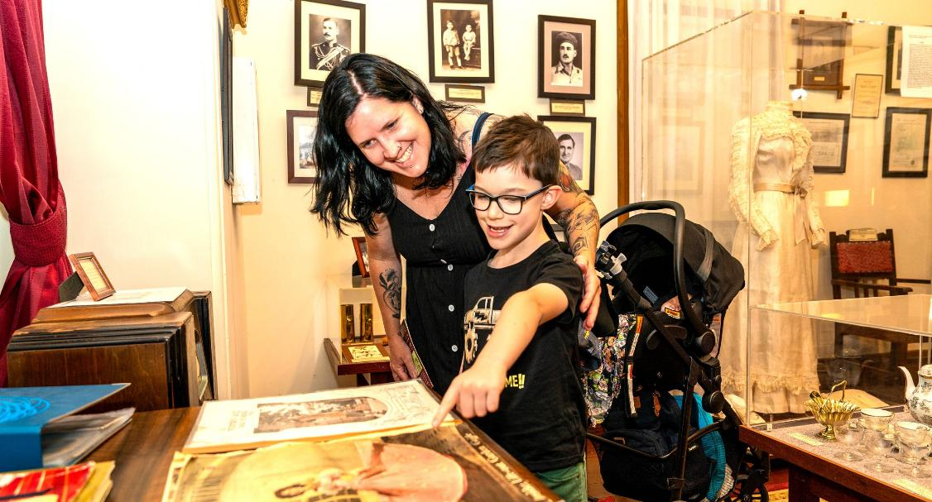
Photo: Azelia Ley Homestead Museum located in Manning Park, Hamilton Hill.
This pulse check, alongside our continuous engagement efforts, enables the City of Cockburn to deliver on the promises of the Strategic Community Plan and ensure that we are always working towards a thriving, sustainable and connected community.
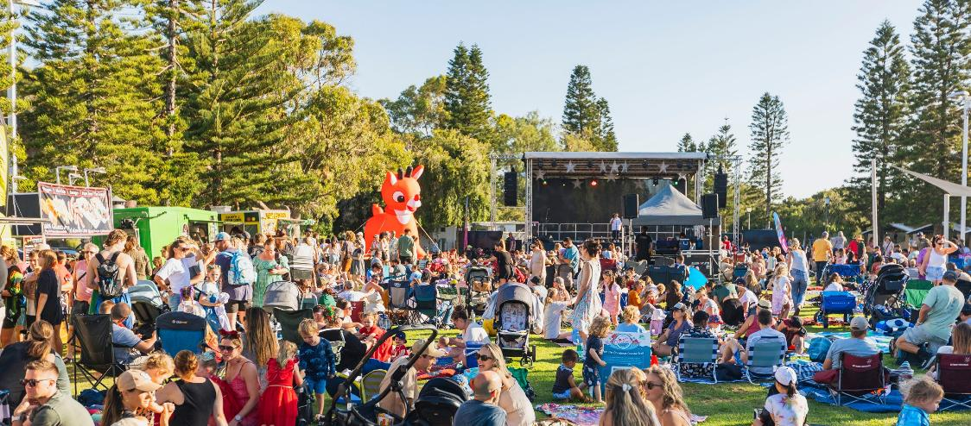
Photo: Christmas event at Coogee Beach Reserve

Contact Us
City of Cockburn, Whadjuk Country
9 Coleville Crescent, Spearwood WA 6163
PO Box 1215, Bibra Lake DC WA 6965
Phone: 08 9411 3444 | Email: customer@cockburn.wa.gov.au
Cockburn, the best place to be
Cockburn website: www.cockburn.wa.gov.au

