Tender Title: |  | RFT 10/2020  Provision of Consultancy Services - Port Coogee Marina Expansion Design
Request ID: |  | 35990
Tender Description: |  | The City of Cockburn is seeking an experienced engineering consultancy firm to prepare designs and specifications for the Stage 3 expansion of the Port Coogee Marina.
Advert Approval: |  | Decision to Advertise: Director of Engineering & Works  Decision Date: Wednesday, 6 May 2020
Closing Date and Time: |  | 2:00pm (AWST) Tuesday, 16 June 2020
Opening Date and Time: |  | 2:00pm (AWST) Tuesday, 16 June 2020
 | Tenderer’s Name:
1 | M P Rogers & Associates(C) (T/as M.P. ROGERS & ASSOCIATES PTY LTD)
2 | WGAWA PTY LTD (Wallbridge Gilbert Aztec (WA)) (T/as WGAWA PTY LTD)
3 | The Trustee for JMF UNIT TRUST (T/as The Trustee for JMF UNIT TRUST)
4 | International Marina Consultants PTY LTD (T/as International Marina Consultants PTY LTD)
5
6
7
8
9
10

Advertisement
Method 1: City of Cockburn | Method 2: NA
Method 3:  The Western Australian, Wednesday,  6th May 2020 | Tender Awarded by:
Copy of Statewide Notice:  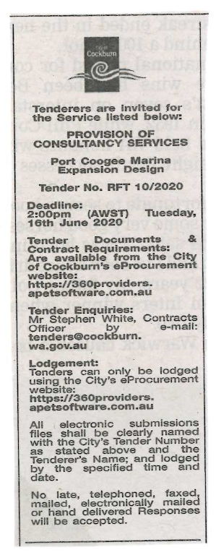 | Director of Engineering & Works  Choose an item.  Thursday, 16 July 2020
 | Date of Council Meeting:
Click here to enter a date. or
Not applicable
Item No:
Name of Successful Tenderer(s): | WGAWA PTY LTD (Wallbridge Gilbert Aztec (WA) (T/as WGAWA PTY LTD)
Amount of Successful Tender(s): (ex GST) | $164,639.00

