City of Cockburn
Engineering Directorate
Vehicle Crossover Specification and Forms

Index
Contents
PROPERTY OWNER INFORMATION 3
OBJECTIVE 3
DEFINITIONS 3
STATUTORY REQUIREMENTS 3
APPLICATION FOR CROSSOVER 3
TECHNICAL SPECIFICATION FOR VEHICLE CROSSOVER CONSTRUCTION 4
1. GENERAL 4
2. CONSTRUCTION 5
2.1 General Information 5
2.2 Concrete Crossovers 6
2.3 Brick paved Crossovers 7
2.4 Asphalt Crossovers 7
2.5 Council Contribution 8
2.6 Location 8
2.7 Protection of Existing Services and the Public 9
2.8 Reinstatement 9
2.9 Maintenance 10
2.10 Policy- Second Crossovers 10
2.11 Width Requirements 10
2.12 Alternative Materials – Residential Properties 10
Quotations 11
Appendix - .C. 1 Kerb Explanation Sheet - Drawing 12
Vehicle Crossover Drawing - Concrete 13
Vehicle Crossover Drawing – Brick Paving 14
Vehicle Crossover Drawing - Asphalt 15
Vehicle Crossover Drawing – Point of Truncation (Corner Properties) 16
Vehicle Crossover Drawing – Corner Property and Bulb 17
Vehicle Crossover Drawing – Levels and Gradients 18
3. APPLICATION FORM 19
Crossover Construction 19
Crossover Contribution Application Form - Appendix - .B. 21

PROPERTY OWNER INFORMATION

OBJECTIVE

To ensure a uniform approach to the construction of vehicle crossovers within the City of Cockburn.

DEFINITIONS

Crossover: A crossover is the extension of a driveway from the edge of the property boundary to the edge of the road.

Verge: The portion of land between the road kerb line and the property boundary.

Property Owner: Refers to the owner or authorised occupier of a property that the crossover serves and includes a builder, agent or contractor authorised by the owner of the property to construct or modify a crossover.

Contractor: Refers to the person / agent or company undertaking the construction works.

Subsidy: The contribution that the City will make towards the cost of an approved crossover.

STATUTORY REQUIREMENTS

Under the provisions of Schedule 9.1, clause 7 of the Local Government Act 1995 and the Local Government (Uniform Local Provisions) Regulations 1996, landowners must make application to the City of Cockburn for approval to construct a crossover.

Crossovers must be constructed to the satisfaction of the City of Cockburn.

APPLICATION FOR CROSSOVER

The owner of a property, or their agent, wishing to construct a vehicle crossover must make written application to the City – Applications forms can be found on the City of Cockburn webpage or at the City of Cockburn Administration Building.

Crossovers
Chief Executive Office
City of Cockburn
PO Box 1215
Bibra Lake DC WA 6065

Enquiries: Applications for Crossovers enquiries/approvals
9411 3444 Email: customer@cockburn.wa.gov.au
Website: www.cockburn.wa.gov.au

TECHNICAL SPECIFICATION FOR VEHICLE CROSSOVER CONSTRUCTION

GENERAL

  - This specification can be read in conjunction with:
- The Australian Planning Commission R-Codes, State Planning Policy for Residential Designs.
- The City of Cockburn’s Verge Development Guide
- The City of Cockburn’s Standard Specifications and Cost of Crossovers, Position statement - PSEW12
- The City of Cockburn’s Subdivision Construction Standards - PSEW11
- Vehicle Access Policy - LPP 5.6
- The City of Cockburn’s Standard Details Roadworks, Road Pavement and Kerb Details

  - This specification is made pursuant to the provisions of Schedule 9.1, clause 7 of the Local Government Act 1995 as may be amended.

  - The construction of vehicle crossovers on verges shall be constructed to the levels within the limits shown on the “Standard Detail” drawings 2478B 03, sheets 01 – 06, attached.

  - All levels for the gradient, surface finish, jointing or any other item shall be as directed by the City’s Engineering Service Unit.

  - All material used in the construction of vehicle crossovers shall be in accordance with the standard specification of the Council. Any materials used which are considered inferior to those specified or as directed by the Council shall be liable to rejection and replacement without any payment or compensation being made by the City of Cockburn to the Contractor for the supply, delivery, laying, placing, finishing, removal or disposal of anything so rejected.

  - Protection of works and the public shall be provided by the Contractor, who shall supply and keep supplied as directed, all the necessary signs, barricades, road warning lamps, temporary bridges or any other item as may be directed by the Council to provide for the safety of the public and to protect the work from damage for a minimum period of two (2) days following completion of works. Failure to do so shall render the Contractor liable under Schedule 9.1 clause 7 of the Local Government Act 1995 as amended. All such protective equipment shall comply with the relevant SAA Code. All/any protective warning signs used shall be in accordance with AS 1742 Part 3.

  - During the course of works any damage caused to any Council facilities, public utility services, private property, and/or to the vehicle crossover itself, by the Contractor or by others because of inadequate protection by the Contractor shall be the sole responsibility of the Contractor who shall be held responsible for the repair, replacement, legal claims, liability or any other thing which may arise as a result of the damage caused. Where a footpath requires reinstatement due to crossover construction the Contractor will notify the City within 24 hours of construction.

CONSTRUCTION

General Information

    - Levels:
The crossover is to be constructed to the levels as set out in the City’s specification sheet (See Appendix C.1 & drawing 2478B03, sheet 06.).

    - Alignment:
The alignment of the crossover must be in accordance with the details on the attached drawings (See Standard Detail Drawings 2478B03, sheets 01 to 05).

    - Siting of Residential and Commercial Crossovers:
A driveway and crossover must not be closer than 6 metres to an intersection. Under AS 2890.1, a 6 metre separation distance is defined with reference to the corner truncation or the point at which the carriageway begins to deviate (refer to Standard Detail Drawings – 2478B03, sheets 04 & 05).
Other restrictions on driveway and crossover locations are shown by a heavy line marked on “Typical Case 4 and 5 drawing” for lots sited adjacent to a “T” junction. Where the standard prescribed above is impracticable to apply, the applicant must justify any variation in writing. City officers will determine variation requests on their merits, having regard for safety and convenience requirements.

    - Kerbing:
Where fully mountable kerbing is cast, the crossover is to be constructed without removing the kerb. Where the carriageway is kerbed in barrier or semi-mountable kerbing, the kerb must be cut by means of a concrete saw and removed for the width of the crossover, plus any tapers.

    - Footpath:
The crossover is to be constructed without removing the footpath, footpaths are to remain as part of the connective network providing pedestrians and bicycle users safe passage. Should an existing footpath be present at the site of a proposed crossover the path should be assessed to ensure it complies with Australia Standards (AS 1428.1), is constructed to the appropriate standard to support vehicular traffic, and is in good repair. Should the existing footpath not conform to the required standards it shall be required to be rebuilt at a cost to the property owner as part of the crossover works.

The existing concrete footpath can be left in place, if it is 100mm thick, in good repair and; when located against the kerb, has fully mountable kerbing. Where a concrete footpath exists, the footpath is to be cut by means of a concrete saw at the nearest joint in the footpath from the proposed side of the crossover. There is to be expansion joint material placed in between the new crossover and the footpath. The crossover is to be constructed to match the levels of the footpath leaving no gaps or tripping hazards. Please see attached drawings 2478B03 sheets 2-4 for the requirement of expansion joints.

    - General:
Upon completion of the crossover, the verge shall be leveled and left in a clean safe and tidy condition, so as not to create and hazard to others using this verge area.

    - Side Boundary:
If the crossover is not constructed by the City, it is the owner’s responsibility to ensure that the crossover is located correctly within the verge. NO part of the crossover shall extend over the side boundary lines of neighboring property, and shall be installed within the nominal length of the kerb line of that property, except where an alternative is authorised by the Council’s Engineering Director. The nominal length of the kerb line is defined in this instance as the distance between the extended side boundaries at the kerb line (see drawings enclosed). For crossovers constructed in a cul-de-sac bulb or in acute angle roadways, the location shall be determined as shown in the “Typical Case 3” drawings attached.

    - No Internal Driveway:
If no internal driveway has been constructed, the crossover can be constructed first, but the property owner must complete an indemnity form to protect the City against any damage, and clearly mark the location of the crossover on-site.

Concrete Crossovers

    - The concrete crossover shall be constructed in accordance with the profiles, dimensions and depths shown on drawing No. 2478B03- Sheet 01, Vehicle Crossing – Concrete. Requiring a minimum crossover width of 3m and a maximum width of 6m at the property boundary line.

    - The excavation shall be made to provide a firm, sound base free from depressions or soft spots or any deleterious materials.

    - All concrete used in the works shall develop a minimum compressive strength of 20 Mpa at 28 days and shall give the specified strength with maximum slump of 50 mm with the addition of a high early strength additive.

    - The thickness of concrete shall be a minimum of 100 mm for residential crossovers and a minimum of either 150 mm or 200 mm for commercial and industrial crossovers respectively, as directed by the Council’s Engineering Director. Commercial and Industrial crossovers shall have SL63 or equivalent reinforcement mesh included at all times.

    - The base shall be thoroughly moistened prior to placing of the concrete. Concrete shall be evenly placed to the depth specified and spaded, especially at the edges, to give maximum density.
    - The finish shall be obtained by screeding to correct levels and wood floating and brooming to provide a non-slip dense surface, free from any defect

    - Joints shall be made in the form of plain dummy construction joints and finished with an approved jointing tool, as follows:

In line and parallel to:
- The property line junction;
- The edge of the footpath construction: and
- The kerb line face.

    - An expansion-jointing strip shall be placed between the internal driveway and the new vehicle crossover, plus between the new vehicle crossover and any fully mountable kerb and any footpath.

    - The return of kerbing shall normally be 150 mm wide or match existing and returned longitudinally to the kerb on a 1m radius from the main kerb line at each side of the crossover location. It shall be constructed so as to be monolithic with the crossover proper, with the kerbing to be vertical on the outside face and gently humored into the crossover for pedestrian, pram or wheelchair traffic access.

    - The crossover junction with the kerb face line shall not be below the channel invert and shall be finished with an approved bull nose section. The concrete at the kerb line shall be thickened to 150 mm for a width of 150 mm from the kerb face for residential crossovers and 225 mm thickness for commercial and industrial crossovers.

Brick paved Crossovers

    - The crossover shall be constructed in accordance with the profiles, dimensions and depths shown on Drawing No. 2478B03, sheet 03 – Vehicle Crossing -Brick Paving. Requiring a minimum crossover width of 3m and a maximum width of 6m at the property boundary line.

    - The excavation shall be made to provide a firm sound base, free from depressions or soft spots or any deleterious materials.

    - The paving bricks are to be of a trafficable type, with a minimum of 80mm thickness and laid in either a 45° or 90° herringbone pattern, unless otherwise requested in writing to the City.

    - The paving bricks are to be laid on a minimum compacted thickness of 150 mm of crushed limestone.

    - The edges of the crossover are to be retained as shown in detail B of the drawing.

    - The bricks shall be laid on a bed of 30 mm well graded clean siliceous sand and compacted and joint filled to the brick manufacturer’s specification.

    - Where the existing kerb has been removed, a “Rollover Kerb or Mountable Kerb” must be constructed (see detail A-A), and any brick paving levels are to meet at the top of this kerb (see Drawing No. 2478B03, sheet 03 – Vehicle Crossing - Brick Paving.

    - Unless specifically detailed in this specification, all practices and materials to be used as specified in the brick manufacturer’s recommendation.

Asphalt Crossovers

    - Asphalt crossovers are gradually being phased out in the built up areas of the City of Cockburn in preference of either concrete or brick paving. This is due to rising maintenance costs and the rising cost of the asphalt (uneconomical).

    - The City will only consider an asphalt crossover in the rural areas if required. This is due to there being no kerb or proper drainage system available at those locations.

    - If you live in the built-up area and desired an asphalt crossover, you will need to apply to the City (in writing) explaining why it is required to be constructed in asphalt.

    - The subgrade replacement material shall consist of suitable material free from boulders, clods, stumps, roots, sticks or any other deleterious materials. This material shall be non-cohesive granular material complying with the particle size distribution and linear shrinkage requirements in accordance with the above mentioned specifications for select fill. Material with particle size up to 100 mm may be allowed. The fill material shall have a minimum soaked CBR value of 10% @ 95% MMDD to a min depth of 300mm below bottom of box levels.

    - The limestone sub-base material shall consist of uniformly graded, durable pebble in soil mortar free from aggregate > 75 mm and clods, stumps and other deleterious materials. The minimum CBR requirement is 30 % at 94 % MMDD and 100 % OMC. The sub-base layer should be compacted to 94 % of MMDD and be dried back to 85 % of OMC.

    - The road base material should comprise of clean, hard, durable fragments of crushed rock and shall not include materials which break up when alternately wetted and dried. The material shall consist of a uniformly blended mixture of coarse and fine aggregate and have a soaked California Bearing Ratio (CBR) of > 80 % at 96 % Maximum Modified Dry Density (MMDD) and 100 % Optimum Moisture Content (OMC). The base course layer should be compacted to 98 % of MMDD and be dried back to 60 % of OMC.

    - Asphalt (Dense Graded Asphalt) shall be compacted to achieve the following average in situ air voids:-
Asphalt mix type Average in situ air voids

Council Contribution

    - The construction of the first crossover to any residence may be partly subsidised by the City, provided that the crossover is constructed in accordance with this specifications.

    - The crossover can be constructed either by the City, by a private contractor or the property owner, to the City’s specifications.

    - Where the crossover is not constructed to the City’s specification and is considered unsatisfactory by the City’s Inspector, no contribution will be paid and the City may request the crossover be rebuilt to the correct specifications.

    - Where the crossover is not constructed to the City’s specification but is considered satisfactory by the City’s Inspector, a contribution may be granted.

    - Where the crossover is constructed to the City’s specification and is approved by the City’s Inspector, the City may grant the contribution, as long as a copy of all receipts are supplied with the application form.

    - Contributions will only be granted on receipt of the completed application form, in accordance with the attached details (See “Appendix A” – How to Apply for the City Contribution and “Appendix B” Council Contribution Application Form).

Location

    - Crossovers shall be constructed at right angles to the road alignment.

    - Crossovers shall be located a minimum of 1.0m from side boundary unless otherwise approved, refer to drawings DWG2478.

    - A crossover located in proximity to a mature street tree must first been assessed and approved by the City of Cockburn’s Parks Department prior to construction.

    - Crossovers in cul-de-sac shall be located as shown on drawing DWG2478.

    - Crossover shall be located a minimum of 1 metre from a pram ramps, utilities, light pole, structures, side entry pits and other service access points and drainage structures unless otherwise approved.

    - Where there is difficulty in positioning the crossover or a potential that traffic safety may be compromised, advice shall be sought from the City of Cockburn Authorized Representative, prior to constructing the crossover.

Protection of Existing Services and the Public

    - Existing services within the vicinity of the proposed crossover shall be protected at all times. The Authorised Representative may be contacted to provide advice in relation to the protection of existing services.

    - Conflicting Public Utility Services shall be adjusted or relocated at the applicant’s expense, subject to the approval of the relevant utility.

    - The City’s existing drainage structures (pits and manholes) conflicting with the location of the proposed crossover are to be adjusted by the City, and costs borne by the applicant. Relocation however, will be undertaken only where it can be demonstrated that this is the only option available.

    - Removal, adjustment or reinstatement of reticulation is the responsibility of the applicant.

    - Street trees shall not be removed without specific approval from the Authorized Representative. Removal however, will be undertaken only where it can be demonstrated that this is the only option available. All costs associated with tree removal shall be borne by the applicant.

    - The applicant shall be responsible for the protection of the public at all times. Signage, lighting, barricades or any other protection measure deemed necessary, shall be provided by the applicant to ensure protection of the public during construction.

    - Safe access for pedestrians on the verge shall be maintained at all times.

Reinstatement

    - Reinstatement works shall be completed to the satisfaction of the Authorized Representative. All reinstatement works shall be carried out such that the verge is left in a condition equal to or better than the original verge condition.

    - Remnants or debris from crossover works shall be disposed of by the applicant. The site shall be left in a clean and tidy condition.

    - Responsibility for any damage to City facilities, private property and the consequent repair, replacement, legal claims and liability resulting from crossover works shall be as follows:-
      - The City constructed crossover : The City’s contractor shall be responsible
      - Privately constructed crossover: The Applicant shall be responsible.

    - Any verge reshaping necessary to make the new crossover safe is the applicant’s responsibility.

    - Any damage incurred must be repaired using materials that match the existing facilities or properties.

Maintenance

    - Maintenance and repairs of the City’s or privately constructed crossover is the responsibility of the applicant.

    - If a crossover is to be constructed nearer than 1 metre to an existing street tree, the property owner shall be responsible for the installation of an approved root barrier material. The barrier shall be installed directly adjacent to crossover and run along its entire length. Any future damages caused by the street tree will be at the cost of the property owner. All due care should be undertaken to avoid damaging street trees.

Policy- Second Crossovers

    - Individual lots are limited to one (1) crossover for every 30 metres of lot frontage.

    - The total accumulated width when constructing a second crossover shall be no wider than one third of the property frontage, or a maximum aggregate width of 9 metres, whichever is less.

Width Requirements

    - Residential Crossovers:
- From 3 metres to 6 metres for residential properties, not including the wings.
- A minimum of 3 metres to a maximum 6 metres at the property boundary line.
- A minimum of 5 metres to a maximum of 8 metres at the road edge. Unless otherwise approved by the Engineering Service Unit.

    - Commercial and Industrial Crossovers:
- From 3 metres to 9 metres for Commercial and Industrial developments, not including the wings.
- A minimum of 3 metres to a maximum 9 metres at the property boundary line.
- A minimum of 5 metres to a maximum of 11 metres at the road edge. Unless otherwise approved by the Engineering Service Unit.
- Refer to City’s Policy APD57

Alternative Materials – Residential Properties

    - The City supports the use of permeable and porous materials, subject to the approval from the City prior to construction. The materials must be trafficable and maintained by the property owner accessing the crossover.

    - The crossover must not be a safety or tripping hazard to both road users, bike riders and pedestrians.

Quotations

Crossovers

You can have contractors supply you with a quotation – there are several listed in the local newspapers, websites or the yellow pages telephone directory.

It is advisable that you always obtain at least three (3) quotations for this type of work, to ensure you are getting best value for your dollar.

The City does not undertake the quotation or construction of crossovers.
All correspondence in relation to crossovers is to be addressed as follows:
CROSSOVERS
Chief Executive Officer
City of Cockburn
PO Box 1215
BIBRA LAKE DC WA 6065

City of Cockburn Engineering Services

Appendix - .C. 1 Kerb Explanation Sheet - Drawing

Example of a “Mountable Kerb”

Example of a
“Semi Mountable Kerb”

Example of a “Barrier Kerb”
The style may vary slightly

The style may vary slightly
Approx
25mm face
The style may vary slightly
Approx
50mm face

This kerb may be left in and the new crossover but into the back edge of this kerb, as this kerb allows for easy access for vehicles.

This kerb must be removed when constructing a new crossover and replaced with either a “Mountable kerb or a concrete apron of at least 25m back from the kerb.

This kerb must be removed when constructing a new crossover and replaced with either a “Mountable kerb or a concrete apron of at least 2m back from the kerb

IMPORTANT NOTE:
If constructing a “Brick Paved” crossover, under NO circumstances must the brick paving run directly into the road edge. There MUST be at least a “Mountable Kerb” installed or a 2m wide concrete apron abutting the back of the kerb.

Note: The City of Cockburn’s Roadworks, Road Pavement and Kerb Standard Details for more information.

Vehicle Crossover Drawing - Concrete

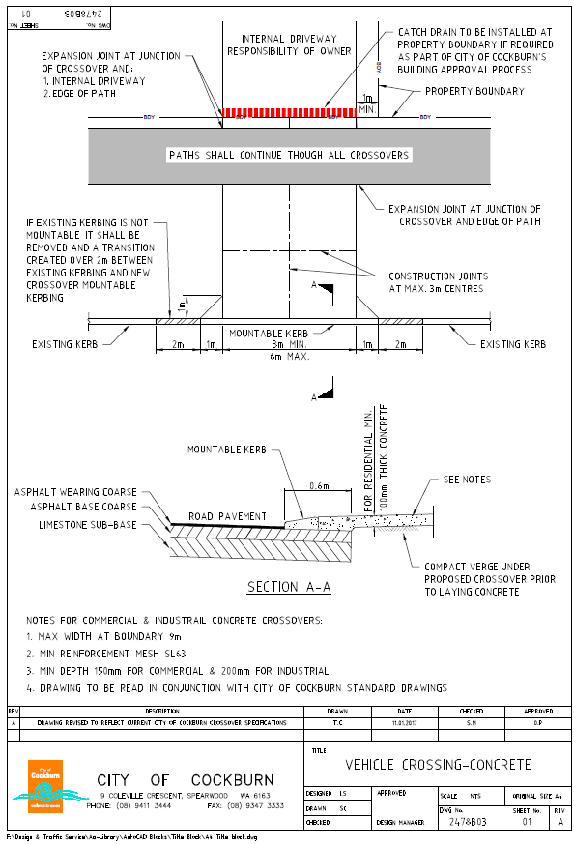

Vehicle Crossover Drawing – Brick Paving

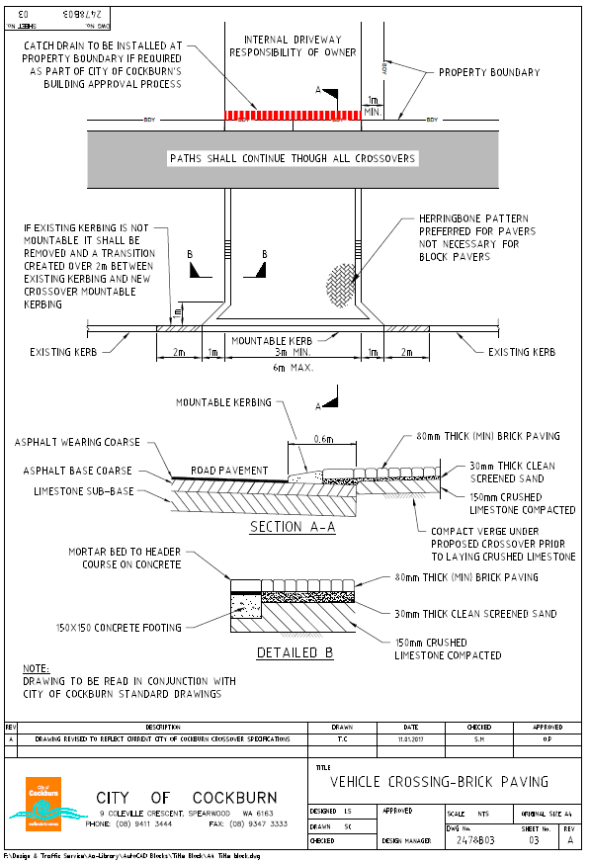

Vehicle Crossover Drawing - Asphalt

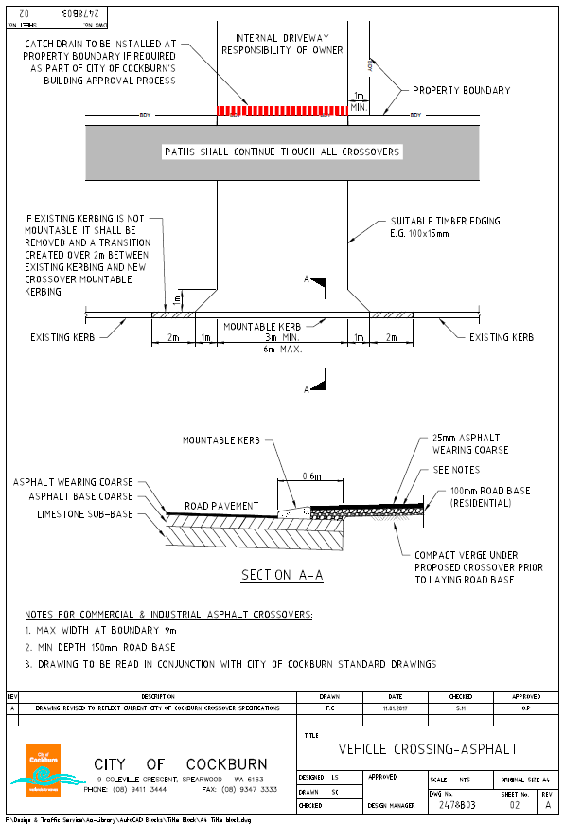

Vehicle Crossover Drawing – Point of Truncation (Corner Properties)

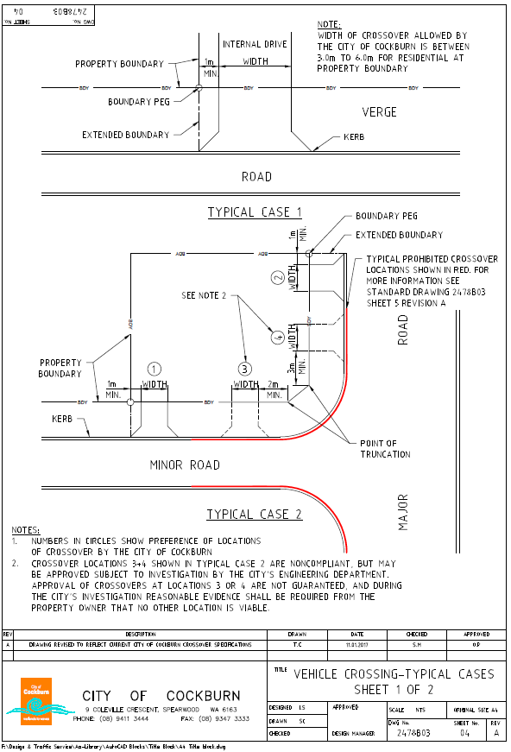

Vehicle Crossover Drawing – Corner Property and Bulb

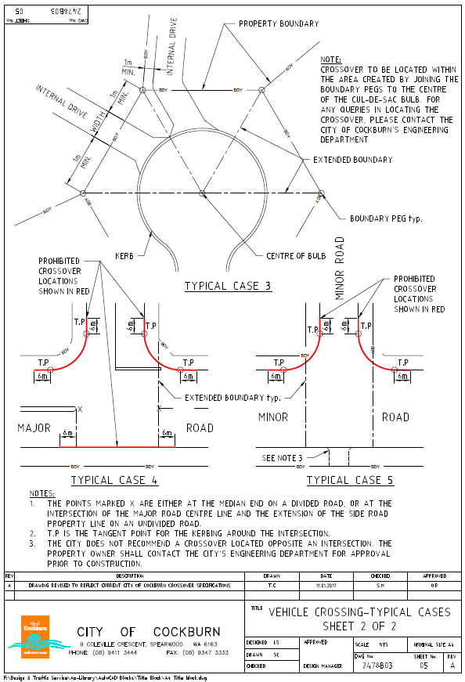

Vehicle Crossover Drawing – Levels and Gradients

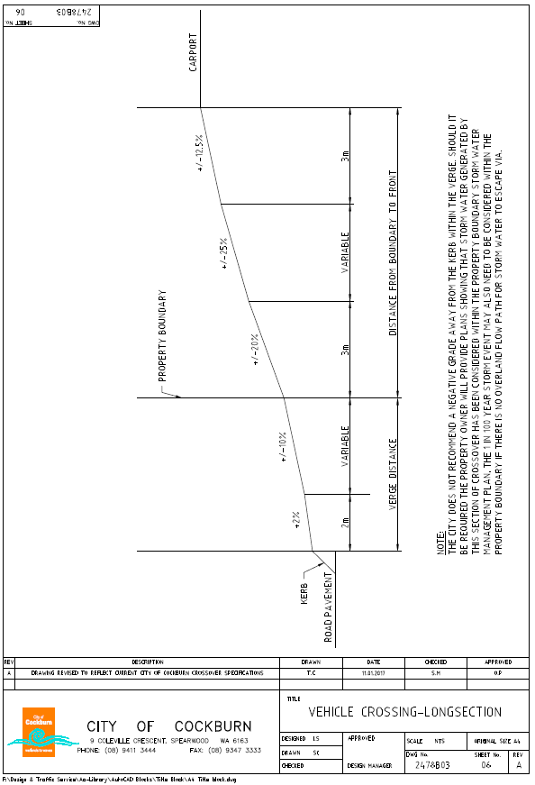

APPLICATION FORM

Crossover Construction

Please complete this application form in conjunction with the City of Cockburn’s Vehicle Crossover Specifications and submit via one of the following methods:

- City of Cockburn 2. Email: customer@cockburn.wa.gov.au
PO Box 1215
Bibra Lake DC WA 6965

PROPERTY DETAILS
Applicant Name:
House No: | Street:
Suburb: |  |  |  | Post Code:
Home Phone No: |  |  | Mobile:
Email:
Date: |  | Signature:

This property has a mature street tree on the verge – Parks Departments.

APPLICATION DETAILS

Please complete a sketch of the verge and location of the crossover on the next page, a copy of your site plan is required for this application.

CITY OF COCKBURN
ENGINEERING SERVICES

Crossover Contribution Application Form - Appendix - .B.

Sender:
Email Address:
Current Postal Address:
Contact Number:
Chief Executive Officer
City of Cockburn
P O Box 1215 DC
BIBRA LAKE WA 6965

ATTENTION: ENGINEERING DEPARTMENT
To Whom it may concern
I wish to advise you of the completion of the crossover at : |  |  |  |  |  |  |  | Lot: | _______ |  | No. | _______
Street: | ______________________________________ |  |  |  |  |  |  | Suburb: |  | ___________________
which was constructed in Liquid Limestone / Concrete / Brick Paving / Other - ……………………….
 |  |  | (Circle whichever is applicable) |  |  |  |  |  |  | (Fill in material used)
is now ready for inspection.
I hereby request the City’s Contribution for the above crossover.
EFT BANK DETAILS
Financial Institution:
Branch:
BSB No: |  | (6 digits)
Account No: |  | (max 9 digits)
Account Name
Yours faithfully

SIGNATURE OF OWNER DATE

Please Note: Processing time for refunds is up to 8 weeks.
Only the property owner will receive a Council Contribution.

If bank details are not provided the form will be returned to you, delaying payment of the contribution.
LIMESTONE DOCKETS MUST BE ENCLOSED FOR BRICK PAVED CROSSOVERS

