Managing your financial concerns after COVID-19
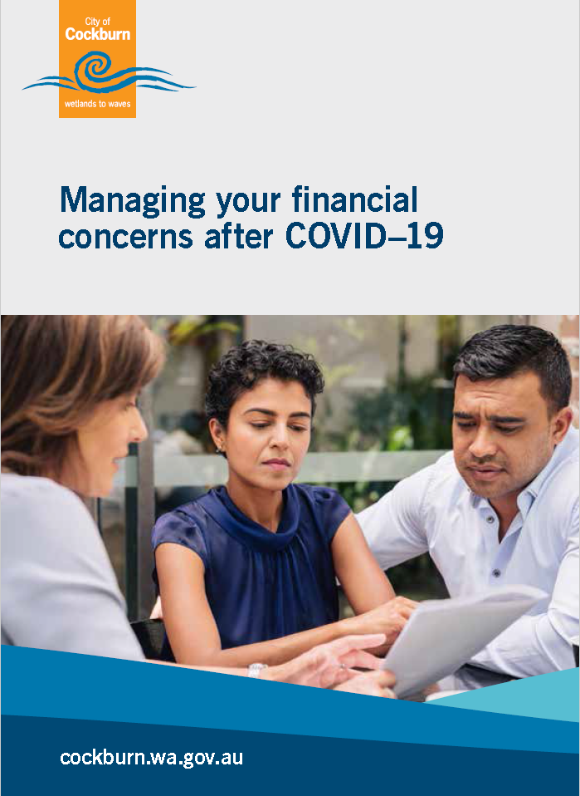
City of Cockburn: cockburn.wa.gov.au

Acknowledgement of Country
The Mayor, Councillors and staff of the City of Cockburn acknowledge the Whadjuk Nyungar people of Beeliar boodja as the traditional custodians of this land. We pay our respect to the Elders, past, present and emerging.

Post Covid-19 Assistance

Loans
According to the Australian Banking Association (ABA), as of 4 June, one in 14 mortgages had been deferred:
- Number of mortgages deferred: 485,063
- Number of business loans deferred: 216,372
- Total number Covid loan deferrals: 779,458
- Value on mortgages deferred: $175 and a half billion dollars
- Total value all loans deferred $236 billion dollars of deferred loans.
If you were experiencing financial difficulty due to COVID-19, you may have put your home loan repayments on hold for up to six months. During this time, interest continued to be charged on your loan. This interest needs to be repaid and will increase your mortgage payments depending on the size, interest rate and length of assistance. The reason for this is because you’ll be paying off a higher balance in the same period of time.
Please access independent information and advice before deciding which option is best for your situation.
If you are already at the minimum repayment amount, all funds in your redraw and offset accounts have been exhausted and you are still unable to service the loan, you could look into the following options. Remember the Lender will need to assess the suitability of the chosen option based on individual circumstances at the time.

Extend the life of the loan
As an example, if you have a 25 year loan you could discuss the option of extending it to 30 years. This could keep payment amounts close to the ‘pre-mortgage holiday’ period.
Applications will be treated as new applications including credit check and financial capacity at the time of application for finance. The enquiry will be listed on your credit file.

Interest Capitalisation
This will prevent your payments from increasing after the assistance ends. The additional outstanding interest can be added at the end of the loan period as it is added to the principle.
Placing the arrears on the end of the loan often requires proof of being able to maintain the repayments on the loan prior to bank assistance. Some lenders may request up to six months of continuous payments with all amount paid in full before the option of capitalisation can be approved.

Change your repayments to interest only
You may wish to consider applying to switch from principal and interest repayments to interest-only repayments. This will increase the amount of interest over the life of the loan as the principal is not being addressed for the agreed period. It will reduce your repayment amount if you are still having financial difficulty.

Stay with your lender and restructure your loan
Other options could include staying with a principal and interest loan, but restructuring it, such as moving from a variable to a fixed rate, or switching to a split variable/fixed arrangement. Some banks are changing or waiving their fees for loan restructuring, however, you should check what fees and charges may apply to loan changes. It could also be a good time to negotiate a reduction in your interest rates.

Refinance and consolidate any other debts
Consider how much equity you have in your property. If you have enough equity you may be able to consolidate your other debts. This will again increase the length of the loan but can be considered if other debts can’t be met in addition to the mortgage repayments. Be sure to consider all associated fees and application costs as well as the timing and impact these changes could have on your wider financial situation.

Insurance – Check your superannuation and ask your lender
You may have insurance that covers you for illness or loss of employment. If you do and you’re eligible to receive payments under that insurance, you could consider using that money to make your loan repayments. Contact your bank and superannuation company and ask the question, “Do I have any insurance attached to my product?”

Fee Waiver
Contact your lender and ask for any monthly account keeping or yearly fees to be waived.

Credit Cards
Note: Interest is calculated daily on the outstanding balance, so it’s always best to pay as much as you can to reduce this balance.
If you can’t meet your minimum monthly repayments and are experiencing financial hardship post Covid-19, request the card be cancelled, it could provide longer term options. Once the card is cancelled some lenders will consider a request to hold interest and fees allowing their customers to make agreed payments off the balance. Ensure the arrangement is sustainable as missed payments can result in the agreement being terminated with fees and charges again applied to the balance.
Note: if you are unable to pay your minimum monthly payment by the due date, you may not be able to continue to use your card. An inability to maintain minimum payment requirements will be recorded on your credit file as banks are required to continue to report to the relevant credit bureaus affecting your credit file.

Selling Your House
For most people, owning a house is a life-long goal, and selling your home may seem to be a disaster. One of the purposes of this information brochure is to help you find advice and assistance which can help you to keep your home. However, if circumstances such as long-term unemployment, or ill-health make it clear that you can’t keep making mortgage payments, a time may come when you need to make a rational and thorough assessment of your position to see if there is a way forward other than selling your home. This should include a skilfully conducted review of your financial position to see what options are open to you. Some points to consider are:
- If a thorough analysis of your financial position and prospects show that you can’t keep paying the mortgage, then it is better to sell your house sooner rather than later. If you have equity in the house – that is, the house is worth more than the mortgage secured on it, selling the house sooner will mean you may have some money left after the sale to help you re-establish yourself. If you have negative equity – that is, your house is worth less than the amount owed on your mortgage – selling sooner minimizes the debt left after the sale.
- Do not get money out of your superannuation fund unless you have thorough advice on this from a qualified person such as a financial counsellor. Money you have in a regulated superannuation fund is protected from your creditors, even if you eventually become bankrupt.
- If you have negative equity in your property, you must get the bank’s written permission to sell before you put your house on the market. Getting the bank’s written permission, and selling the house yourself, is much better than handing back the keys and walking away. If you do this you have no control over the sale, and if your house is left empty, it may be vandalized.
- Plan your finances so that you can move gracefully into a rented house. Having a secure roof over your head is most important for you and your family’s welfare. It may be more difficult to get a rental property if you are bankrupt.

Bankruptcy
Bankruptcy may seem attractive if you have very large debts, however you should not become bankrupt unless you have had advice from a qualified person, such as a financial counsellor. Bankruptcy does relieve you of debt owing on a mortgage, however large the amount, but it does have a life-long effect on your financial reputation. It limits your capacity to get credit, travel overseas, or work in some occupations.

Resources
The Credit Consumer Legal Service WA (CCLSWA) has auto letter generators, fact sheets, and step by step guides on many financial issues. They have information on repossession, credit files, how to manage missed payments and many helpful tools. They can be contacted on (08) 9221 7066 or visit their resources page CCLSWA Resources: https://cclswa.org.au/cclswa-online-resources/
Money Smart is also an excellent site which includes loan calculators. Visit Moneysmart: moneysmart.gov.au

How to proceed if my lender or financial institution won’t assist or I am unhappy with my outcome
- Contact the lender about the outcome and state you wish to make a complaint and they will supply you with the information on how to proceed
- Write a letter/email of complaint to the lender outlining the reasons the outcome is not agreeable. Be sure to state it is a complaint; include your full name, contact details and date. Outline your experience before the complaint was lodged and the issue you want to raise including any emails, letters and phone contact details. Clearly state what you want the bank to do to resolve the situation.
Internal Dispute Resolution (IDR) – If you are not satisfied with the complaints system and outcome you can take your complaint to an external agent.

Most lenders and financial institutions require a membership with the Australian Financial Complaints Authority (AFCA) – an external agent.
They are a not-for-profit scheme that assists individuals and small businesses with disputes. It’s important you have tried to resolve the matter with your financial institution before lodging a complaint with AFCA. They will hear complaints about;
- Credit, finance and loans
- Insurance companies
- Banking deposits and payments
- Investments and financial advice
- Superannuation.
They are free to access and can be contacted on 1800 931 678 to make a complaint via phone or ask for a form. You can also complain via their website or get more information on AFCA: www.afca.org.au/
External Dispute Resolution (EDR) AFCA

“Debt” Flowchart
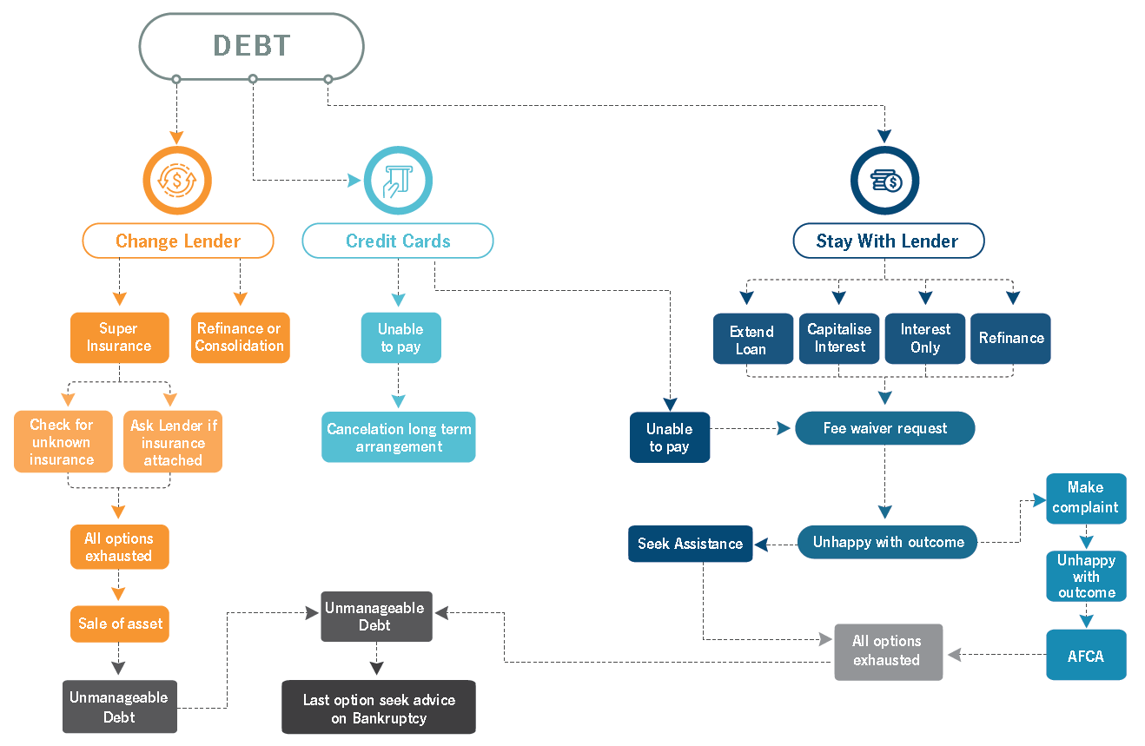
The diagram above is a flow chart outlining possible options if you are in debt.
Debt is at the top of the chart. From there, there are three starting points: Change Lender, Credit Cards, and Stay With Lender. At each step, arrows point forward to one or more options. The flow chart is presented below as a series of ordered lists.

Change Lender
- Change Lender
  - forward to Super Insurance
  - forward to Refinance or Consolidation
- Super Insurance
  - forward to Check for unknown insurance
  - forward to Ask Lender if insurance attached
- Check for unknown insurance / Ask Lender if insurance attached
  - forward to All options exhausted
- All options exhausted
  - forward to Sale of asset
- Sale of asset
  - forward to Unmanageable Debt
- Unmanageable Debt
  - forward to Last option seek advice on Bankruptcy

Credit Cards
- Credit Cards
  - forward to Unable to pay
- Unable to pay
  - forward to Cancelation long term arrangement
  - forward to Stay With Lender: Fee waiver request

Stay With Lender
- Stay with Lender
  - forward to Extend Loan
  - forward to Capitalise Interest
  - forward to Interest Only
  - forward to Refinance
- Extend Loan / Capitalise Interest / Interest Only / Refinance
  - forward to Fee waiver request
- Fee waiver request
  - forward to Unhappy with outcome
- Unhappy with outcome
  - forward to Seek Assistance
  - forward to Make complaint
- Seek Assistance
  - forward to All options exhausted
- Make complaint
  - forward to Unhappy with outcome
- Unhappy with outcome
  - forward to AFCA
- AFCA
  - forward to All options exhausted
- All options exhausted
  - forward to Unmanageable Debt
- Unmanageable Debt
  - forward to Last option seek advice on Bankruptcy

Disclaimer
The purpose of this brochure is to suggest options available to you if you have difficulty meeting your financial commitments. This document is not intended to give legal advice, but to provide general information, and suggestions of how you can obtain information for your own particular purposes. Before you take any steps to change your financial position, you should get advice from a suitably qualified professional person such as a financial counsellor, Legal Aid or the Consumer Credit Legal Service.
We encourage individuals get qualified independent advice.
Legal information can be accessed from the Legal Aid information line on 1300 650 579.

Contact Us
9 Coleville Crescent, Spearwood WA 6163
PO Box 1215, Bibra Lake DC WA 6965
Telephone: 08 9411 3444
Email: customer@cockburn.wa.gov.au
City of Cockburn website: cockburn.wa.gov.au
This information is available in alternative formats upon request.
Paper from responsible sources.

