Tender Title: |  | RFT 09/2025 – Minor Pool Chemicals
Request ID: |  | 55522
Tender Description: |  | The City of Cockburn (The Principal) is seeking a suitably qualified and experienced contractor for Minor Pool chemicals that are the subject of this RFT09/2025.  All services shall be executed to the satisfaction of a Council Representative/s in strict accordance with the contract, this specification, contracted schedule of rates and with any working instructions provided by the Council Representative/s as the service proceeds.  The objective of this specification is to ensure Cockburn ARC is provided with all chemicals required to maintain the water bodies within its facility to acceptable standards under the ‘Code of Practice for the for the Design, Construction, Operation, Management & Maintenance of Aquatic Facilities (2024)’.
Advert Approval: |  | Decision to Advertise: Director Community and Place  Decision Date: Friday, 21 March 2025
Closing Date and Time: |  | 2:00PM (AWST) Thursday, 10 April 2025
Opening Date and Time: |  | 2:15PM (AWST) Thursday, 10 April 2025
 | Tenderer’s Name:
1 | Environex International Pty Ltd

Advertisement
Method 1: City of Cockburn | Method 2: Yammer
Method 3:  The Western Australian,  Wednesday, 26 February 2025 | Tender Awarded by:
Copy of Statewide Notice:  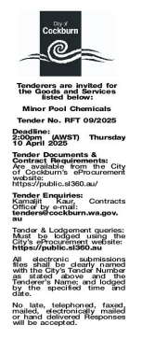 | Non-Award
 | Date of Council Meeting:
 | Not applicable
Name of Successful Tenderer(s): | Not Applicable
Amount of Successful Tender(s): (ex GST) | Not Applicable

