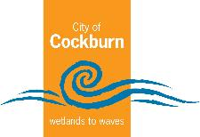

City of Cockburn
Annual Report 2020–2021
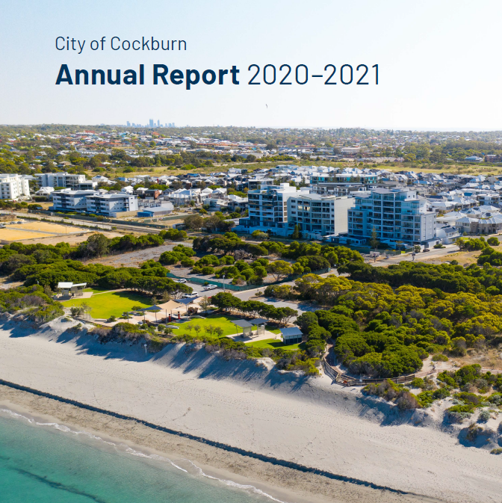
Cockburn, the best place to be
City of Cockburn website: www.cockburn.wa.gov.au
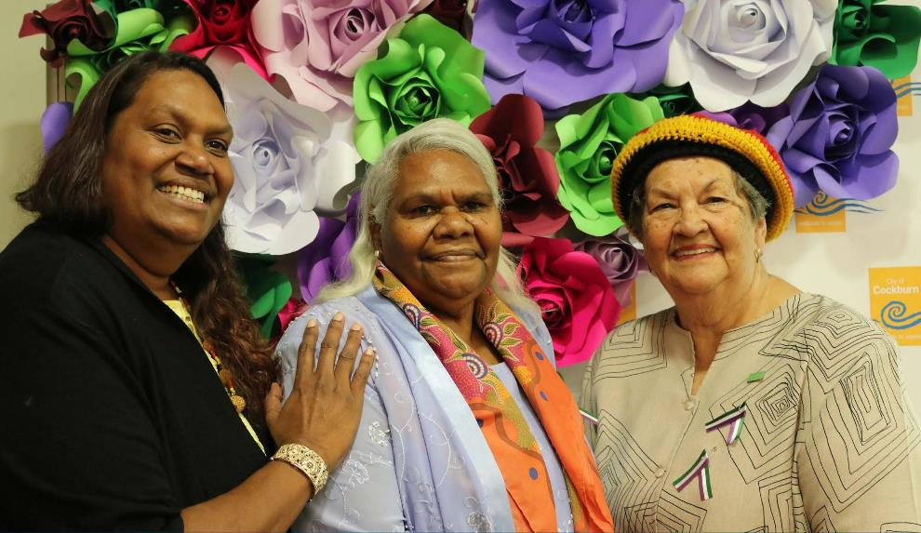
Photo: Marissa Verma - Bindi Bindi Dreaming, Janetia Knapp, Nyungar Elder Marie Taylor at International Women’s Day - March 2021
Front Cover: Cockburn Coastline, Coogee - December 2020

Acknowledgement of Country
The Mayor, Councillors and staff of the City of Cockburn acknowledge the Whadjuk Nyungar people of Beeliar boodja as the traditional custodians of this land. We pay our respect to the Elders, past, present and emerging.

Contents
City of Cockburn Annual Report 2020–2021 1
Acknowledgement of Country 2
Contents 3
Elected Members and Executive Team 2020-2021 4
Meeting Attendance and Background: Elected Members 2020-2021 7
Mayor’s Report 13
Chief Executive Officer’s Report 16
Emerging Issues 19
A Snapshot of our City 21
The Year Ahead 2021-2022 24
Corporate Strategic Planning 26
Governance Report 30
Recordkeeping Compliance Report 34
Building and Statutory Planning Approvals Report 36
Research and Community Engagement 38
State of Sustainability Report 42
Disability Access and Inclusion Report 46
Awards and Achievements 52
Organisational Structure 55
Remuneration of Senior Employees 61
Corporate Business Plan 2020-2021 KPI Progress Report 63
Corporate Business Plan Progress 2020-2021 65
Spend on Asset Development and Operational Activities 2020-2021 84
Complaints of Minor Breaches 86
Financial Report 128
Contact 129

Elected Members and Executive Team 2020-2021

Elected Members
Logan K. Howlett, JP, His Worship the Mayor
Lara Kirkwood, Deputy Mayor and Councillor, East Ward
Lee-Anne Smith, OAM, Councillor, East Ward
Chamonix Terblanche, Councillor, East Ward
Kevin Allen, Councillor, West Ward
Michael Separovich, Councillor, West Ward
Phoebe Corke, Councillor, West Ward
Philip Eva JP, Councillor, Central Ward
Chontelle Stone, Councillor, Central Ward
Tom Widenbar, Councillor, Central Ward

Executive Team
Tony Brun, Chief Executive Officer from February 2021
Daniel Arndt, Chief Built and Natural Environment/Acting CEO
Charles Sullivan, Director Engineering and Works until November 2020
Anton Lees, Chief Operations Officer from November 2020
Don Green, Executive Governance and Strategy
Stuart Downing, Chief Financial Officer
Gail Bowman, Executive Manager Strategy and Civic Support/ Chief Community Services

Vision
Cockburn, the best place to be

Purpose
Support our communities to thrive by providing inclusive and sustainable services which reflect their aspirations.

Meeting Attendance and Background: Elected Members 2020-2021
Elected Members | Ordinary Council Meeting  (11) | Special Council Meetings  (6) | Delegated Authorities and Policies Committee  (4) | Audit and Strategic Finance Committee  (4) | Events Committee  (1) | Grants and Donations Committee  (3)
Mayor Logan Howlett  Age group: 64+, Gender: Male, Linguistic background: English, Country of birth: Australia, Identify as Aboriginal or Torres Strait Islander (Yes or No): No | 11 | 6 | 4 | 4 | 1 | 3
Deputy Mayor  Cr Lara Kirkwood  Age group: 35-44, Gender: Female, Linguistic background: English, Country of birth: South Africa, Identify as Aboriginal or Torres Strait Islander (Yes or No): No | 11 | 6 | Non Member | Non Member | 1 | Non Member
Cr Lee-Anne Smith  Information not provided | 7 | 1 | Non Member | Non Member | Non Member | 1
Cr Kevin Allen  Age group: 64+, Gender: Male, Linguistic background: English, Country of birth: Australia, Identify as Aboriginal or Torres Strait Islander (Yes or No): No | 10 | 5 | Non Member | 4 | Observer | Non Member
Cr Philip Eva  Age group: 55-64, Gender: Male, Linguistic background: English, Country of birth: United Kingdom, Identify as Aboriginal or Torres Strait Islander (Yes or No): No | 11 | 6 | Non Member | Non Member | Observer | 3
Cr Chamonix Terblanche  Age group: 35-44, Gender: Female, Linguistic background: Afrikaans, Country of birth: South Africa, Identify as Aboriginal or Torres Strait Islander (Yes or No): No | 7 | 3 | 2 | 1 | Observer | 1
Cr Chontelle Stone  Age group: 35-44, Gender: Female, Linguistic background: English, Country of birth: Australia, Identify as Aboriginal or Torres Strait Islander (Yes or No): Yes | 11 | 3 | 3 | 3 | Observer | Non Member
Cr Michael Separovich  Age group: 25-35, Gender: Male, Linguistic background: English, Country of birth: Australia, Identify as Aboriginal or Torres Strait Islander (Yes or No): No | 11 | 6 | 4 | 4 | Non Member | Non Member
Cr Phoebe Corke  Age group: 55-64, Gender: Female, Linguistic background: English, Country of birth: England, Identify as Aboriginal or Torres Strait Islander (Yes or No): No | 11 | 6 | 4 | 3 | 1 | 3
Cr Tom Widenbar  Age group: 25-35, Gender: Male, Linguistic background: English, Country of birth: Australia, Identify as Aboriginal or Torres Strait Islander (Yes or No): No | 10 | 5 | 3 | 3 | 1 | 2

Mayor’s Report
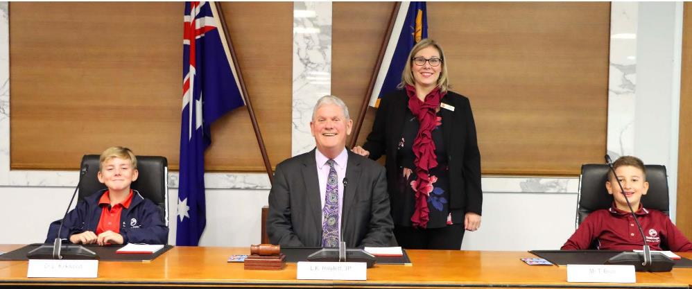
Photo: Mayor Howlett, Deputy Mayor Lara Kirkwood with South Coogee Primary School Students at City of Cockburn School Tour - June 2021
I am delighted to present my 13th annual report to the Cockburn community. As I write, Western Australia remains one of the safest places in the world to be during the COVID-19 pandemic. Once again, during lockdown, City employees did a fantastic job adapting services, providing support to the vulnerable in our community, and enabling the technology for over 90 per cent of employees to work safely from home. As a result, we were able to deliver the majority of our services and continue with planned projects.
In September 2020, Cockburn became the first Council in Western Australia to set a zero-waste target following the adoption of a Climate Change Strategy 2020-2030. The strategy is committed to continuing the City’s 20-year role as a climate resilience and sustainability leader. The City will work with the Cockburn community and the State Government to achieve net zero community emissions by 2050, aligning with the WA government’s proposed emissions reduction target.
I was delighted to host the City’s first United Nations International Day of Peace event on 21 September. Six Ginkgo biloba saplings, raised from a seed harvested from a Ginkgo biloba that survived the WW2 bombing of Hiroshima on 6 August 1945 were planted.
Cockburn’s unique youth ANZAC parade, founded by RSL City of Cockburn sub-branch patron Arthur J Stanton OAM, celebrated its 20th anniversary this year. It remains the only enduring ANZAC youth parade and service of its kind in Australia.
Happily, the Coogee Live festival went ahead just before lockdown. This was the fourth year of this two-day celebration of all that is great about Cockburn. We were blessed with good weather, and the event was a roaring success, with thousands turning out to enjoy the activities, food, and entertainment.
In June, Council adopted a balanced budget, with a small overall surplus and a surplus on the operating account, which are primary indicators of financial health and performance. The budget incorporates a small rate rise of 1.5 per cent in keeping with the City’s continued financial strategy to ensure our rates are low, including in comparison to neighbouring councils.
Our community continues to tell us, through independent research the City commissions, that we are doing a good job. When benchmarked against other WA local governments, the City leads the way in several areas, including health and community services, Cockburn ARC, sustainable practices, kerbside bin collections, and economic development.
Our community rated us as an organisation with a performance index score of 68 and an 89 per cent positive rating, which shows Cockburn as the leader among similar Councils and 13 points above the WA average. However, we are always looking for continuous improvement. The research highlights what community priorities the City should focus on. These include safety and security, traffic management, and streetscapes, particularly in the older suburbs. We will continue to work on these.
At Cockburn, we are a community focused organisation. Last year, the City gave $1.46m back to the community in grants and donations for the community groups, environmental, sporting, and cultural projects.
Supporting our local business community continues to be a big part of our focus. Prior to and throughout the COVID-19 pandemic, we have supported businesses with a range of activities to develop their skills. This year we also started providing small business financial counselling, which has been well received.
The City also sponsored two Cockburn businesses to participate in Curtin University’s five-day Ignition program. The program helps businesses trial and prepare fresh ideas for the commercial environment.
And finally, I would like to acknowledge the many volunteers out there in our community who give up so much time to help make Cockburn the great place that it is.
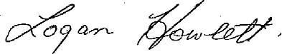
His Worship the Mayor
Logan K. Howlett. JP
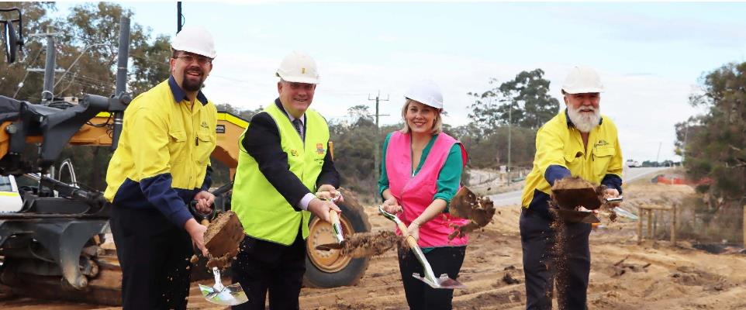
Photo: (from Left to Right) General Manager Tracc Civil Pty Ltd Frank Janssen, Mayor Howlett, Deputy Mayor Lara Kirkwood, Operations Manager Tracc Civil Pty Ltd Craig Risbey at Jandakot Road Stage 2 sod-turning - May 2021

Chief Executive Officer’s Report
This is my first annual report as CEO, having started at the City in February 2021. This also happened to be the first day of lockdown for the year in WA. I was immediately impressed how the staff transitioned into closing necessary facilities and services, communicating this to the community, with 90 per cent of staff equipped to work from home and continue local government business.
The first thing I noticed is that Cockburn is a community focused, fiscally responsible, and passionate organisation. My strategy is to build on those strengths by creating a modern organisation that is best equipped to deliver on the Strategic Community Plan 2020-2030. The plan was developed with the community and adopted by Council, with a vision to make Cockburn the best place to be.
Cockburn is also a powerhouse growth zone, with high-value investment opportunities in the commercial and industrial sectors generating sustainable prosperity. World-class opportunities exist at the Australian Marine Complex in Henderson, the Western Trade Coast and Latitude 32, Bibra Lake commercial zone, Jandakot City, and Cockburn Central, fast becoming the south metro area’s leading regional centre.
Looking inwards, I undertook a restructure of the business to ensure we are in the best shape to deliver the outcomes that we have promised to the community. Council adopted my proposal to move from a five-division structure to seven divisions. The two new divisions are Corporate Affairs, and People, Experience, and Transformation.
Corporate Affairs encompasses Advocacy and Engagement and Business and Economic Development, both significant new areas of focus for the City, and Customer Experience and Communications and Marketing.
People, Experience, and Transformation is a new standalone division because our people are critical to delivering our projects and services. We need to ensure that we have the right culture and a diverse and flexible workplace to attract the best people. We also need to create a safe workplace where employees come to work and know that they will go home at the end of the day.
We also undertook a small review of the Strategic Community Plan to consolidate the number of objectives to ensure the plan is achievable while still delivering on our community aspirations.
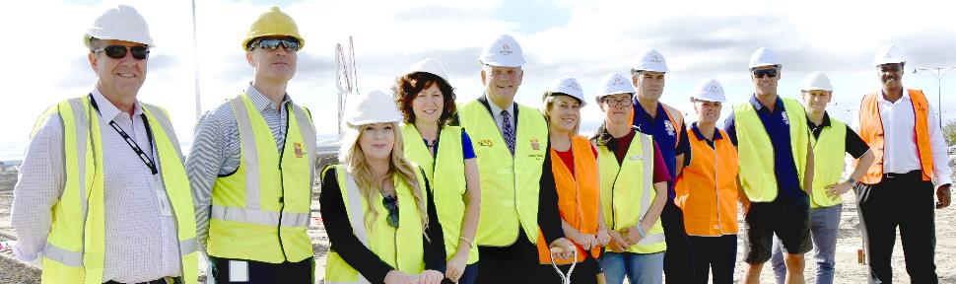
Photo: (from Left to Right) City of Cockburn CEO Tony Brun, Acting Chief Operations Officer Anton Lees, Head of Community Development Karoline Jamieson, Acting Chief of Community Services Gail Bowman, Mayor Howlett, Deputy Mayor Lara Kirkwood, Treeby Community Association President Lani Slaughter, Fremantle Roosters Rugby League Club (FRRLC) President Steve Revere, FRRLC Vice President Wendy Mann, FRRLC Director Ryan Foster, City of Cockburn Leisure and Planning Projects Officer Rohan Blee, McCorkell Constructions Managing Director Mark Nyaanga at sod turning Treeby Community Sports Centre - April 2021
In April 2020, the City was made aware of a Department of Local Government Inquiry into the City. We received no detail as to why this was initiated, but the City cooperated fully with the inquiry. The final report was tabled in Parliament on 12 May 2021. After reviewing the report and liaising with the Department, Council committed to undertake a full independent governance review, which, as I write, has commenced. I will report on the outcomes of this review in the annual report next financial year.
The City’s population forecast is 119,149 and is forecast to grow to 165,989 by 2041 (Source: REMPLAN). As our population continues to grow, we must manage to expand our infrastructure and manage our assets.
However, with finite resources, low interest rates, and an expectation of prudent rate rises, we must ensure we deliver our services sustainably. To that end, we commenced a review of all expenditures across the City with the aim of reducing recurrent and capital works expenditure without overly impacting service delivery.
This review has resulted in the deferral of some projects and a review of the scope of other projects. We have also started reviewing how we undertake procurement to ensure that we are getting the best value for money.
During the year, we finalised designs for the Port Coogee Marina expansion and continued redevelopment of the Cockburn Wetlands Precinct at Bibra Lake. We started building Frankland Park Recreation Centre and ovals and began stage two of Jandakot Road. We continued to refine the design and seek additional funding for the Aboriginal Cultural and Visitors Centre.
It has been a pleasure getting to know the Elected Members, staff, and the diverse community members I have met to date. I will continue to get out and further meet and listen to our community.
Tony Brun
Chief Executive Officer

Emerging Issues

COVID-19 Pandemic

The world is experiencing unprecedented challenges due to the COVID-19 pandemic. The emergent social and economic crisis continues to demand new and evolving responses from Local Government. The City will continue to support the community while focusing on areas such as public health and wellbeing, support for vulnerable people, financial relief, and supporting local businesses and the economy.

Economic Challenges
While Australia’s unemployment rate as at March 2021 was 5.6 per cent, WA’s rate is the lowest in the Country at 4.8 per cent. Significant challenges remain as the COVID-19 pandemic continues to require lockdowns and restrictions, impeding economic recovery and increasing the need for the City to support local businesses and industry to provide local employment opportunities.

Environmental Challenges
Climate change impacts have been identified as a key factor for future planning. The City will need to be prepared for a possible rise in sea level, an increase in erosion impacts on vulnerable coastal areas, an increase in temperatures and a drying climate. The reduction of the City’s tree canopy, decrease in groundwater availability and bushfire mitigation are also key environmental challenges for the future.

Community, Lifestyle and Security Challenges
Services to enhance safety and security, and services to support our ageing, culturally diverse and growing community, continue to be important priorities into the future. Community safety and crime prevention issues are complex in nature and require all levels of government and the community to work together to achieve significant change over the life of this plan. An increase in mental health and social issues will require the City to continue to increase provision or facilitation of responsive local social support and mental health services for the community.

City Growth and Moving Around Challenges
Traffic congestion will continue to be a priority area due to population growth. It is anticipated that improvements in car driving behaviour, public transport, and transport networks will reduce traffic congestion. The City will need to identify strategic partnerships and work collaboratively with the State and Federal Governments to address this issue.

Listening and Leading Challenges
Financial sustainability challenges will continue, including pressure for rate capping, increasing ratepayer expectations and demand to decrease ‘red tape’. Over the next 10 years it is anticipated that society will go through a significant digital transformation journey that will enable new innovative products and services, drive efficiency and allow better decision making. Legacy systems are also an emerging issue that are creating challenges for large organisations to be agile and quickly adapt to change. Cybersecurity continues to be a global and local risk that will need to be managed into the future.

A Snapshot of our City
Based on Australian Bureau of Statistics 2016 Census data.
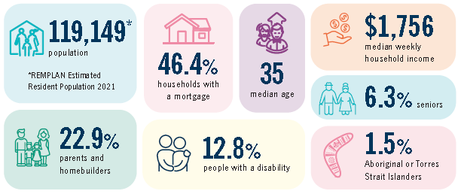
- 119,149 – population (REMPLAN Estimated Resident Population 2021)
- 46.4% – households with a mortgage
- 35 – median age
- $1,756 – median weekly household income
- 6.3% – seniors
- 22.9% – parents and homebuilders
- 12.8% – people with a disability
- 1.5% – Aboriginal or Torres Strait Islanders

Cultural Diversity in Cockburn

Diversity statistics in Cockburn from the 2016 Census
Australian Census 2016 results show that the City of Cockburn is becoming more culturally diverse. Overall, 34.1 per cent of the population was born overseas.

The most common ancestries
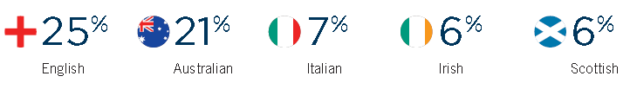
- 25% – English
- 21% – Australian
- 7% – Italian
- 6% – Irish
- 6% – Scottish

The most common countries of birth
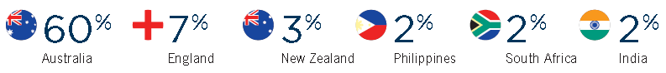
- 60% – Australia
- 7% – England
- 3% – New Zealand
- 2% – Philippines
- 2% – South Africa
- 2% – India

The common languages other than English spoken at home
In 2016, 21.4 per cent of residents spoke a language other than English at home, again above the average for WA (19 per cent).
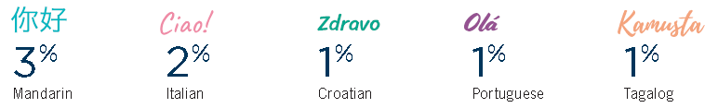
- 3% – Mandarin
- 2% – Italian
- 1% – Croatian
- 1% – Portuguese
- 1% – Tagalog

The Year Ahead 2021-2022
Below are examples of major projects and services as detailed in the Corporate Business Plan 2020-2024.

City Growth and Moving Around
Major Expenditure | $million
Roads projects including Hammond Road duplication (Branch Circus to Bartram Road), Rowley Road and Lyon Road, Rockingham Road rehabilitation, Spearwood Avenue and Hamilton Road upgrades | 13.8

Community, Lifestyle and Security
Major Expenditure | $million
Parks and environment construction program including playground renewals, natural area improvements and shade sails | 4.8
Goodchild Park changerooms upgrade | 0.85
Frankland Park Sport and Community Facility construction – total budget $6.7m | 1.77
Treeby Community and Sports Centre construction – total budget $6.7m | 2.92
Community grants and donations | 1.46
Free community events | 0.9
CCTV expansion | 0.5

Local Economy
Major Expenditure | $million
Support buying local through policy and buy local campaign | negligible
Deliver grants to support economic development | 0.08

Listening and Leading
Major Expenditure | $million
Develop advocacy plans as per the Council-adopted Advocacy and Engagement Framework | negligible
Review the Community Engagement Policy and Framework | 0.02

Environmental Responsibility
Major Expenditure | $million
Tree planting | 0.7
Review the City’s Bushfire Risk Management Plan 2015-2020 | negligible

Corporate Strategic Planning

Strategic Community Plan
The City’s Strategic Community Plan 2020-2030 sets the strategic direction for the organisation. A minor review of the plan was undertaken this financial year. The review consolidated the strategic objectives to better reflect the priorities of the community and to align accountabilities within the organisation for reporting purposes.
The 33 strategic objectives that were adopted by Council during the major review in July 2020 have been consolidated to 15, without losing the original intent under the five existing outcome areas. The consolidated objectives were advertised for a public comment period.

Corporate Business Plan
The Corporate Business Plan 2020-2021 to 20232024 concurrently underwent a minor review to reflect changes to the Strategic Community Plan 2020-2030. The Corporate Business Plan hinges on the acceptance of priorities, outcomes and strategic objectives included in the Strategic Community Plan.

Summary
The City has reviewed and updated its Corporate Strategic Planning process (below) to align with the Integrated Planning and Reporting Framework Guidelines developed by the Department of Local Government, Sport and Cultural Industries (DLGSCI).
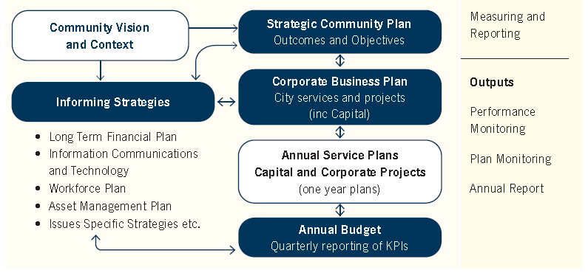
The diagram above is a flowchart showing the Corporate Strategic Planning process. The chart is multidirectional, with boxes linked by arrows. At each step, arrows point forward or back to one more boxes. The flowchart is presented below as a list:
- Community Vision and Context
  - forward to Strategic Community Plan – Outcomes and Objectives
  - forward to Informing Strategies, i.e.
    - Long Term Financial Plan
    - Information Communications and Technology
    - Workforce Plan
    - Asset Management Plan
    - Issues Specific Strategies etc.
- Strategic Community Plan – Outcomes and Objectives
  - forward to Corporate Business Plan – City services and projects (including Capital)
  - forward to Informing Strategies
- Corporate Business Plan – City services and projects (including Capital)
  - forward to Annual Service Plans, Capital and Corporate Projects (one year plans)
  - back to Strategic Community Plan – Outcomes and Objectives
  - back to Informing Strategies
- Informing Strategies
  - back to Strategic Community Plan – Outcomes and Objectives
  - forward to Annual Budget – Quarterly Reporting of KPIs
- Annual Service Plans, Capital and Corporate Projects (one year plans)
  - forward to Annual Budget – Quarterly Reporting of KPIs
  - back to Corporate Business Plan – City services and projects (including Capital)
- Annual Budget – Quarterly Reporting of KPIs
  - back to Annual Service Plans, Capital and Corporate Projects (one year plans)
  - back to Informing Strategies
To the right of the flowchart is a section labelled Measuring and Reporting, which lists the following Outputs:
- Performance Monitoring
- Plan Monitoring
- Annual Report
The Strategic Community Plan has five key community outcomes:
- Local Economy
- Environmental Responsibility
- Community, Lifestyle and Security
- City Growth and Moving Around
- Listening and Leading.

Measurement
The City measures its success each year by reporting on the progress of the projects in the Corporate Business Plan (see page 64). Other measures that demonstrate the City’s progress towards the achievement of the objectives outlined in the Strategic Community Plan include:
- Community Scorecard results
- Customer satisfaction survey results
- Awards
- Community engagement outcomes
- State of Sustainability Report
- Internal Audit Report.

Governance Report

Compliance
The DLGSCI requires all local governments to complete a Compliance Audit Return 2020 (CAR 2020).
The City utilised the services of Macri Partners to subject the CAR 2020 to an external audit before submitting the CAR 2020 to Council. Based on the audit methodology employed, Macri Partners confirmed that the City’s responses to the questions in the audited sections of the CAR 2020 are correct, with conformity of 99 per cent for the year.
The City utilises an online compliance management system for statutory forms such as financial disclosures, gifts, travel contributions and delegated authorities.

Legislative Review
On 3 February 2021 the Western Australian government concluded a review of the Local Government Act 1995 which resulted in the Local Government Legislation Amendment Act 2019 (LG Amendment Act). This review resulted in a new code of conduct for employees and one for elected members. These are now available on the City’s website.

Freedom of Information
The Freedom of Information (FOI) Act 1992 gives members of the public the right to access documents held by local governments, subject to limitations. The City prepared, as required by section 96 of the FOI Act, an up-to-date information statement and made it available to the public. The City had 27 FOI requests in the 2020-21 financial year.

Public Interest Disclosure
The Public Interest Disclosure (PID) Act 2003 promotes accountability within state and local government agencies and organisations by facilitating the disclosure of public interest information involving misconduct, offences and misuse of public resources or risks to public health or safety. The Act aims to protect informers who make public interest disclosures. In in the 2020-21 financial year, the City has had no disclosures under the PID Act.

Audits – External and Internal

External
The Western Australian Office of the Auditor General is responsible for auditing the local government sector and conducted audits on local government in the following areas:
- Local Government Building Approvals
- Fraud Prevention in Local Government
- Waste Management – Service Delivery
- Regulation of Consumer Food Safety Laws by Local Governments
- Information Systems Audit Report 2020 – Local Government Entities
- Audit Results Report – Annual 2019-20 Financial Audit of Local Government Entities.
In demonstrating continual improvement of its operations and services the City has adopted the recommendation from the audit findings.

Internal
The City engaged an enterprise security and solution service provider to undertake an audit to determine what type of personal and sensitive information is held by the City and what the privacy considerations for the held data are.
They conducted the audit, in accordance with AS ISO 31000:208 Risk Management Guidelines and the audit report was submitted to Council. An outcome of this audit was that the City has now drafted a Privacy Management Policy and Framework which has been endorsed by Council.

Competition Principles Agreement
In 2007, all Australian governments recommitted to the Competition Principles Agreement (CPA), (11 April 1995). The CPA is an inter-governmental agreement between the Commonwealth and state/territory governments that sets out how governments will apply National Competition Policy Principles to public sector organisations within their jurisdiction. The National Competition Policy itself concluded in 2005-06 and has been succeeded by Australia’s National Reform Agenda which is an addition to, and continuation of, the National Competition Policy reforms.
The Competition Principles Agreement (as amended 13 April 2007) sets out nominated principles from the agreement that now apply to local government. The provisions of clause 5 within the CPA require local government to report annually on the implementation, application and effects of Competition Policy. Competition Policy does not require contracting out or competitive tendering. It does not preclude local government from continuing to subsidise its significant business activities from general revenue, nor does it require privatisation of government functions. It does require local governments to identify their significant business activities and apply competitive disciplines to those businesses which compete with the private sector.
A number of the City’s services are exempt from the Competition Policy, as it applies only to business activities that generate income in excess of $200,000 from fee revenue that is directly generated from external users and an operating expenditure greater than $2m. Activities undertaken by the City which have previously been considered for market testing, owing to the competitive nature of the service include:

- Domestic waste collection
- Waste disposal business
- Cockburn ARC (aquatic and leisure centre).
The City has resolved to retain the in-house provision of Cockburn ARC, domestic waste collection and waste disposal business.

Risk Management
In in the 2020-21 financial year, the City undertook a request for tender for an Enterprise Risk Management Solution – Supply, Implementation (including Project Management, Scoping and commissioning), Training and Support. A successful service provider was identified and subsequently the City awarded Risk Management and Safety Systems Pty Ltd (RMSS) a three-year contract, with an option to extend for another two years. RMSS will provide the City with a cloud based on-line risk register as part of the City’s enterprise risk management system.

Business Continuity
Since the declaration of the state of emergency in WA on 15 March 2020, as a result of the COVID-19 pandemic, the City has been working under the guidelines issued by the WA Health Department while updating its Infectious Disease Pandemic Business Continuity Plan. This plan has enabled the City to identify and manage resources to continue its critical operations and delivery of essential services to the community.

Recordkeeping Compliance Report

Evaluation of Recordkeeping Systems
Work was undertaken with the organisation’s Information Services Business Unit to review its recordkeeping practices through the Knowledge Management project. This resulted in several changes to processes to improve recordkeeping and reduce the amount of information being stored outside of the recordkeeping system.
The City’s Records Management Policy was reviewed, updated, and adopted by Council in December 2020. The policy is reviewed every two years with the next review due in December 2022.

Recordkeeping Training Program
All new staff are required to undertake an online Records Awareness Training (RAT) course. The interactive course outlines the recordkeeping roles and responsibilities of all employees at the City of Cockburn. Participants must undertake and pass a short assessment at the completion of the course. Employees must then repeat the course every two years.
An online course outlining the specific recordkeeping responsibilities of Managers and Supervisors has also been implemented.
Regular training for new and existing staff is also held on the use of the organisation’s electronic document and records management system, called ECM.

Evaluation of the Recordkeeping Training Program
All participants who attend ECM training are asked to complete a training feedback form. The feedback forms are regularly reviewed and suggestions for improvements are incorporated into the training program.
The ECM training program was reviewed and amended in September 2020. All training is now undertaken in the new ECM CiAnywhere interface.

Recordkeeping Induction Program
New staff must complete the RAT and where relevant ECM training as part of their induction.
New Managers/Supervisors are also required to complete the online Recordkeeping Training for Managers and Supervisors.
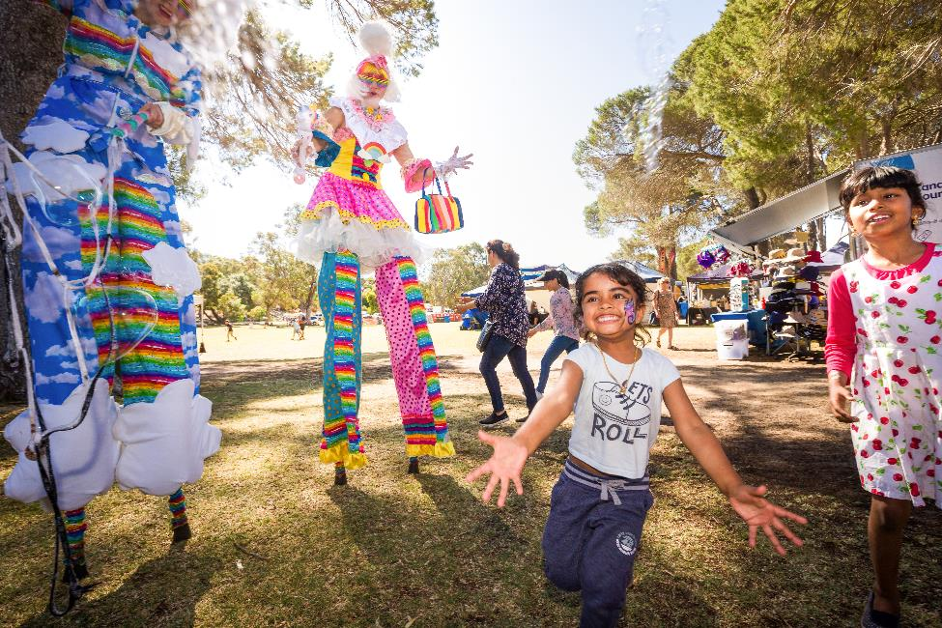
Image: Cockburn Rotary Spring Fair - October 2020

Building and Statutory Planning Approvals Report

Building
- 3,444 building permits issued
- Total value of building works $616.2 million
- Average time of 14 working days to issue all building permits
- The average issuance time for a building permit in 2020-21 was:
  - Certified – 8 working days
  - Uncertified – 20 working days.
Building approvals for the previous four years are as follows:
Year Ending | Number of Permits | $million Value | $million Fee | Residential | Commercial | Industrial | Other
30 June 2018 | 2,489 | 422 | 0.82 | 941 | 79 | 36 | 1,438
30 June 2019 | 2,230 | 506 | 0.848 | 988 | 27 | 46 | 1,433
30 June 2020 | 2,247 | 349 | 0.712 | 1,076 | 80 | 14 | 1,169
30 June 2021 | 3,444 | 616 | 1.24 | 1,993 | 121 | 9 | 1,321

Statutory Planning
- Statutory Planning received 1,515 development applications, a 29 per cent increase from the previous year
- 828 development applications were required to be determined within 60 days. The City determined 76.93 per cent of those applications within 60 days
- 265 development applications were required to be determined within 90 days. The City determined 74.34 per cent of those applications within 90 days
- 2,196 new lots were approved (green title, survey strata and built strata), an increase of 51 per cent from the previous year
- The estimated construction value of all development applications received over the year increased by 53 per cent over the previous year to $266 million

Research and Community Engagement

Community Scorecard Results 2021
The City annually measures residents’ perceptions of the services, infrastructure and facilities in Cockburn to gauge satisfaction levels with services in Cockburn and services provided by the City. This year’s independent survey was undertaken by Catalyse using a representative sample of residents.
This survey also highlights community priority areas for the City to focus on. In the last year these were safety and security, traffic management and streetscapes, particularly in older suburbs. The City is leading the industry in 11 industry areas including economic development and job creation, recognition and respect for Aboriginal people, culture and heritage, health and community services and efforts to promote and adopt sustainable services.

Results from the Community Scorecard 2021
Overall performance | Performance Index Score*
The City as a governing organisation | 68
Customer service | 67
Enjoy living in the City of Cockburn | 78
Sport and recreation facilities | 72
Maintenance of local roads | 62
Preservation and promotion of local history and heritage | 64
Management of the environment | 66
Safety and security | 56
Mobile security patrols | 61
Promotion and adoption of sustainable practices | 64
Community buildings, halls and toilets | 67
Streetscapes residential areas | 52
Footpath and cycleways | 58
Access to public transport | 67
Traffic management | 54
Feel included and connected to the community | 63
Cockburn ARC | 84
*The Performance Index Score is not a percentage score. It is calculated by taking into account the entire scale from strongly disagree to strongly agree.
Percentage of population who agree | Agreement Index Score*
The City has developed and communicated a clear vision | 49
The City has a good understanding of the community’s needs | 38
*The Agreement Index Score is explained as a score out of 100 using the formula (average score – 1) ÷ 4 x 100.

Customer Satisfaction Results
The City undertakes independent customer satisfaction surveys across a number of service units each year. The percentage of satisfied customers reported is the number of customers who scored the service seven or more out of 10.
Service | % Satisfied customers
Sports Field Hire & Booking Services | 100
Front Counter | 98
Seniors Services | 97.6
Youth Centre | 96.2
Library - Overall visit experience | 95.7
Library - Satisfaction with Customer Service | 94.6
Henderson Waste Recovery Park Commercial | 94.1
Henderson Waste Recovery Park Domestic | 92.2
Building Services | 91.9
Contact Centre | 89.3
Facility Booking & Management Services | 88.4
Swimming Pool Inspection Service | 87.6
Sports Fields and management of them | 78.2
Statutory Planning Services | 78
Roads Services (construction and maintenance) | 77.5
Environmental Health Services (customer requests) | 76.6
Ranger Services (customer requests) | 75.9
Parks Services (customer requests) | 71.9

Community Engagement Report
The City undertakes community engagement throughout the year to seek feedback on various initiatives and to inform the community of its priorities.
The City’s focus is to inform, consult and provide opportunities for active participation in City projects and activities. The City uses a variety of methods to seek feedback including listening posts, workshops, surveys, meetings, one-on-one conversations and more.
These projects are communicated using a number of mediums. Some examples include direct mail, newspaper advertisements, e-newsletters, social media and signage.
Over the past 12 months, the City has attracted community input via its Comment on Cockburn community engagement website which had:
- 58,100 site visits
- 8,683 registered site users
- 1,000 new user registrations
- 2,500 project participants

State of Sustainability Report
The City of Cockburn’s 11th annual State of Sustainability Report is a snapshot of the City’s collective efforts in working towards a sustainable future.
The City had 76 indicators for sustainability across the organisation along with a number of high-level targets across five key sustainability areas including water conservation, waste minimisation, energy and emissions reduction, biodiversity and liveability. One hundred per cent of the key performance indicators were in progress or achieved during 2020-21 reflecting the City’s ongoing commitment to pursuing sustainability excellence.
Below is a snapshot of the City’s sustainability highlights for 2020-21.

Sustainability Highlights
- Achieved platinum Waterwise Council status
- Adopted the following strategies and plans:
  - Climate Change Strategy 2020-2030
  - Waste Strategy 2020-2030
  - Integrated Transport Strategy 2020-2030
  - Coogee Beach Foreshore Management Plan 2020-2070
  - Community Development Strategy 2021-2025
- Established new corporate targets for 100 per cent renewable energy and net zero emissions by 2030
- Maintained a Zero Emissions Fleet via the carbon offset program
- Rehabilitated 4.8 hectares of bushland with 76,000 seedlings
- Commenced a green hydrogen feasibility study and electric waste truck trial
- Integrated Environmentally Sustainable Design (ESD) into five facilities
- Established a partnership with Climate Active to empower schools, business and households to reduce their carbon footprint
- Gazetted and implemented an important amendment to the local planning scheme and Local Planning Policy 1.2 known as ‘Better Neighbourhoods’
- Installed an additional 12 artificial reef structures at the Coogee Maritime Trail
- Received a $37,000 Urban Canopy Grant for areas in Beeliar and Bibra Lake
- Successfully trialled a commercial food waste service, which is now in operation
- Continued local business support including masterclasses, briefings, enewsletters, events, workshops, and the #ShopLocalCockburn campaign
- Developed Cockburn Restart Hub to assist businesses with COVID-19 recovery

KPIs (Key Performance Indicators)

Governance
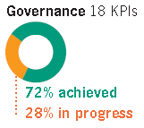
18 KPIs
- 72% achieved
- 28% in progress
Governance is the cornerstone of the City’s approach to sustainability. It enables the City to listen to and guide its residents and ratepayers to build a sustainable future.

Society
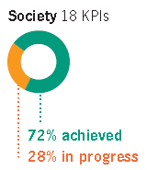
18 KPIs
- 72% achieved
- 28% in progress
Society is at the heart of sustainability in Cockburn. Our people, from our residents, ratepayers, volunteers and businesses, to schools, visitors and employees, are the driving force behind the way we develop, now and into the future.

Environment
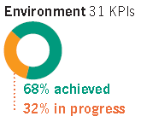
31 KPIs
- 68% achieved
- 32% in progress

The environment is the foundation for sustainability in the City of Cockburn. Our natural areas and resources must be sustainably managed now and in the future.

Economy
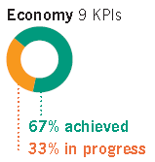
9 KPIs
- 67% achieved
- 33% in progress
A viable economy underpins the sustainable development of the City and must be resilient in the face of uncertainty and risk. The City’s economy is directly integrated with its society and environment.

Disability Access and Inclusion Report
The City’s Disability Access and Inclusion Plan (DAIP) provides a framework for translating the principles and objectives of the Disability Services Act 2003 into achievable initiatives. Below are the outcomes.

Outcome 1: People with disability can access City of Cockburn services and events
- With COVID-19 shutdowns impacting events, an accessible ‘Wide Angle Film Festival’ was offered free of charge to the community online
- The City hosted a Social Inclusion Forum with the theme ‘Leave no one behind’, to celebrate International Day of People with Disability
- The City held a free Beach Access Day to showcase the City’s beach access equipment and facilities along the Cockburn coastline on International Day of People with Disability
- Other City of Cockburn events and workshops provided inclusive and accessible provisions, including:
  - Christmas on the Green included theatrical Auslan Interpreting for the deaf and hard of hearing community to participate in Christmas celebrations
  - Australia Day Coogee Beach Festival: Accessible matting provided and free hire of portable hearing devices
  - Teddy Bears Picnic: Accessible matting provided at Manning Park
  - Coogee Live Event: Audio description and video captioning for a performance by the East Hamilton Hill Primary School where they told dreamtime stories in Nyungar and English. An accessible tactile tour was run by Disability in the Arts, Disadvantage in the Arts, Australia. Free hire of beach wheelchairs, beach walker, portable hearing devices and accessible matting were also provided
  - Author presentation at Success Library by Craig Silvey on his book Honeybee was Auslan interpreted. The story is about a transgender teenager, mental health issues, unconventional friendships and resilience
  - Mini Beasts Workshop: A hands-on interactive workshop with two Auslan interpreters
  - The annual family dance provides entertainment including performances by DAPAK (dancers with disability).

Outcome 2: People with disability have equal opportunity to access the buildings and other facilities at the City of Cockburn
- An access audit was conducted in 2020 at Cockburn ARC (Aquatic and Recreation Centre) in response to both staff and community feedback. A priority list of improvements was identified
- Accessible pathway improvements were provided at Bibra Lake shopping complex in response to a local resident’s request. The shopping area is now wheelchair and pram accessible
- Hearing Australia provided information sessions and testing of the City’s portable and integrated hearing loops systems across the organisation
- Construction of a new accessible ramp is planned to be ready by summer 2021-2022, to enable people with disability easier access to Coogee Beach
- The City introduced procurement guidelines to assist staff involved in new building constructions and renovation projects. The guidelines require project staff to engage and include the services of an access consultant for the project
- Port Coogee Accessible Fishing Jetty, Chelydra Point Reserve, North Coogee: Accessible parking was increased to two ACROD bays. This improvement combined with the ramp on the fishing jetty increases access to this area
- Accessible bench seats with backs and armrests have been installed at Bibra Lake Reserve
- An accessible BBQ has been installed at Bloodwood Park, South Lake
- Upgrades to the existing facility at the Wetlands Precinct on Hope Road in Bibra Lake includes additional parking, improved traffic and public access to the site. Interconnected landscaped walkways and outdoor classrooms are included
- Playground renewal and installation of lighting at Duggan Park, Hammond Park includes an accessible basket swing
- An accessible shelter with picnic setting including wheelchair access on one end has been installed at Hopbush Park, South Lake
- At Lakeridge Reserve, Cockburn Central an accessible table setting, and an accessible parent/ child swing has been installed
- Manning Park, Spearwood has had new accessible BBQs, drinking fountains and furniture
- Perena Rocchi Park, Yangebup upgrades included an accessible carousel
- Radonich Park, Beeliar upgrades included a shelter with an accessible picnic setting with wheelchair access
- At Ramsay Park, Bibra Lake an accessible BBQ has been installed.

Outcome 3: People with disability receive information that is readily accessible from the City of Cockburn
- An Access and Inclusion e-newsletter has been established
- The City continues to make its information as accessible as possible. This includes providing accessible templates for staff, a corporate style guide that has 12pt minimum font size and clear colour contrast guidelines, producing large corporate documents in accessible word and PDF formats for the website, WCAG2.1 accreditation for the website, ensuring that all videos have transcripts and subtitles
- An accessible venues document was created for staff to assist with local community and business enquiries regarding accessible venues and availability in the City of Cockburn
- Accessible hire forms have been created for free hire of the City’s beach wheelchairs and walker. Businesses such as Rocky Bay, Therapy Focus, Senses Australia, Perth Dive School, Alpha Carers and the Education Department of WA have utilised this service over the past 12 months in Cockburn.

Outcome 4: People with disability receive the same level of quality service as other people in the community from staff at the City of Cockburn
- Disability Awareness training is offered face to face annually to all new staff. The City has created an online refresher disability awareness course for staff. This caters to a larger number of City staff who work shifts.

Outcome 5: People with disability have equal opportunity to lodge complaints to the City of Cockburn
- Community feedback is encouraged and advertised on the City’s website and an article was published in the City’s Disability Access and Inclusion eNewsletter
- The City’s fulltime Disability Access and Inclusion Officer provides ongoing support to staff and community members
- A Clinical Governance Framework for Cockburn Care was introduced in 2020. Cockburn Care has been supporting older residents and people with a disability to live independently in their own home for as long as possible. The Clinical Framework underpins the program and incorporates the City’s Abuse and Neglect Policy and Procedures, the Challenging Behaviours Policy (including Minimal Restriction principle), and Staff Code of Behaviour among other City policies and procedures.

Outcome 6: People with disability have equal opportunity to participate in public consultation conducted by the City of Cockburn
- The City’s Disability Reference Group (DRG) provided feedback on a range of projects and strategies:
  - The New Council Administrative and Chambers Building Concept Design
  - Climate Change Strategy
  - Community Development and Volunteer Strategy
  - Draft designs for the Omeo Park Rest room and shade area in North Coogee.
- The City participated in the co-design and creation of the digital marketing campaign with the National Disability Service to raise awareness of the misuse of ACROD bay parking across the state
- A workshop was held in March 2021 for the members of the DRG to develop and create disability access and inclusion goals and priorities for the year ahead
- The City continued to facilitate monthly DRG meetings via online platforms during the COVID-19 shutdown period enabling the DRG to remain connected and to discuss emerging issues due to the pandemic. Since the shut down this new meeting format is preferred and remains in place
- Grant applications and grant terms and conditions are now hyperlinked to the City’s DAIP. Upon signing the ‘Conditions of Funding’ successful applicants, agree to complete an accessible events checklist
- A grant for Rocky Bay was approved to establish a demonstration space for assistive and adaptive equipment in an accessible community kitchen in the City. The fit out will be suitable for teaching kitchen skills for increased independence
- Council supported a grant to Coogee Beach Surf Lifesaving Club to support the marketing and accessibility of the Starfish Nippers program which is designed for children with disability and run in conjunction with the regular Sunday Nippers Program
- Community consultation was held with the local community living along the Cockburn coast which resulted in a request for the future DAIP to include improvements to accessibility in this area.

Outcome 7: People with disability have the same opportunities as other people to obtain and maintain employment with the City of Cockburn
- The City has a memorandum of understanding in place with BizLink until 2023, which commits to the City continuing to support the employment development of people with disability
- The Cockburn Youth Centre Employ Me program is a free service helping young people, including young people with disability, with all things career and work related. Young people aged 14-24 can book in and get assistance with writing resumes and cover letters, applying for jobs, building interview skills and general career advice. Participants have the choice of having sessions in person at Cockburn Youth Centre, over the phone or online with the Youth Development Officer.

Awards and Achievements
Award or Agency | Place and Category
Parks & Leisure Australia (WA) | High Commendation, Playspace Award 2020 under $0.5m for Perena Rocchi Reserve and Pump Track, Yangebup
Australian Institute of Landscape Architects | Winner, National Landscape Architecture Award 2020 for Barrow Park Play Space, North Coogee
Cities for Climate Protection Climate Awards 2020 | Highly Commended. Renewable Energy Achievement Award. Leading the Way in WA.
Department of Planning, Lands & Heritage | Commendation, Contribution by a Public or Private Organisation for the City of Cockburn history website
Environmental Health Association | Fellowship awarded to Nick Jones, Manager Environmental Health
Master Builders-Bankwest Excellence in Construction Awards | Winner, Best Public Use Building $5m-$10m for Lakeland Hockey and Sporting Facility
AUSTSWIM | Mel Holst, National Teacher of Infant and Preschool Aquatics 2020
Public Health Advocacy Institute of Western Australia Local Government Policy Awards | Inaugural Outstanding Service Award – Joan de Castro, Children’s Development Officer
Public Health Advocacy Institute of Western Australia Local Government Policy Awards | City of Cockburn named overall winner in the policy category
Public Health Advocacy Institute of Western Australia Local Government Policy Awards | Commended in the Aboriginal Child Health category
Public Health Advocacy Institute of Western Australia Local Government Policy Awards | Commended in the Environments Promoting Physical Activity category
Public Health Advocacy Institute of Western Australia Local Government Policy Awards | Winner, Smoke Free Environment category
Public Health Advocacy Institute of Western Australia Local Government Policy Awards | Winner, Shade in Public Places category
Royal Life Saving WA | Winner, Gold Star Bravery Award, 2020. Cockburn ARC staff, Adam Anistino, Tamila Andreeva, Rhiannon Keel, Jennifer Littlejohn
Royal Life Saving WA | Winner, Bravery Commendation Cockburn ARC aquatic staff, Tayliah Zimmer and Sarahjayne Whiteley
Water Corporation | Platinum Waterwise Council of the Year (joint award)

Photo: Vic Andrich, President of Environmental Health Australia giving Nick Jones the Fellowship award
Photo: Joan de Castro with Inaugural Outstanding Service Award

Organisational Structure
Council adopted a new seven division structure during the financial year. The structure has been created to deliver on the Strategic Community Plan objectives more effectively.
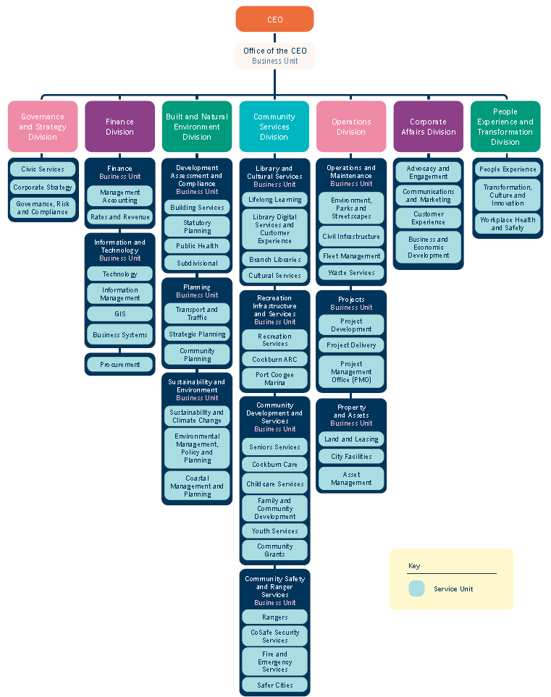
The diagram above is a hierarchical chart depicting the organisational structure of the City of Cockburn. This chart is described below as a series of bulleted lists.

CEO and Seven Divisions
- CEO
  - Office of the CEO – Business Unit
    - Governance and Strategy Division
    - Finance Division
    - Built and Natural Environment Division
    - Community Services Division
    - Operations Division
    - Corporate Affairs Division
    - People Experience and Transformation Division
Under each of these divisions are a number of Service Units, some of which are categorised into different Business Units.

Governance and Strategy Division
- Civic Services
- Corporate Strategy
- Governance, Risk and Compliance

Finance Division
- Finance Business Unit
  - Management Accounting
  - Rates and Revenue
- Information and Technology Business Unit
  - Technology
  - Information Management
  - GIS
  - Business Systems
    - Procurement

Built and Natural Environment Division
- Development Assessment and Compliance Business Unit
  - Building Services
  - Statutory Planning
  - Public Health
  - Subdivisional
- Planning Business Unit
  - Transport and Traffic
  - Strategic Planning
  - Community Planning
- Sustainability and Environment Business Unit
  - Sustainability and Climate Change
  - Environmental Management, Policy and Planning
  - Coastal Management and Planning

Community Services Division
- Library and Cultural Services Business Unit
  - Lifelong Learning
  - Library Digital Services and Customer Experience
  - Branch Libraries
  - Cultural Services
- Recreation Infrastructure and Services Business Unit
  - Recreation Services
  - Cockburn ARC
  - Port Coogee Marina
- Community Development and Services Business Unit
  - Seniors Services
  - Cockburn Care
  - Childcare Services
  - Family and Community Development
  - Youth Services
  - Community Grants
- Community Safety and Ranger Services Business Unit
  - Rangers
  - CoSafe Security Services
  - Fire and Emergency Services
  - Safer Cities

Operations Division
- Operations and Maintenance Business Unit
  - Environment, Parks and Streetscapes
  - Civil Infrastructure
  - Fleet Management
  - Waste Services
- Projects Business Unit
  - Project Development
  - Project Delivery
  - Project Management Office (PMO)
- Property and Assets Business Unit
  - Land and Leasing
  - City Facilities
  - Asset Management

Corporate Affairs Division
- Advocacy and Engagement
- Communications and Marketing
- Customer Experience
- Business and Economic Development

People Experience and Transformation Division
- People Experience
- Transformation, Culture and Innovation
- Workplace Health and Safety

Remuneration of Senior Employees

Annual Salary of Senior Employees
Annual Salary Range ($) | Number of Employees
130,000 – 139,999 | 13
140,000 – 149,999 | 8
150,000 – 159,999 | 3
160,000 – 169,999 | 2
170,000 – 179,999 | 2
180,000 – 189,999 | 4
190,000 – 199,999 | 3
200,000 – 209,999 | 4
210,000 – 219,999 | 1
220,000 – 229,999 | 2
230,000 – 239,999 | 0
240,000 – 249,999 | 1
250,000 – 259,999 | 0
260,000 – 269,999 | 1
270,000 – 279,999 | 0
280,000 – 289,999 | 1
290,000 – 299,999 | 0
300,000 – 309,999 | 0
310,000 – 319,999 | 1
320,000 – 329,999 | 1
330,000 – 339,999 | 0
370,000 – 379,999 | 0
- The CEO’s salary is a combination of the Acting CEO (seven months) and the current CEO (five months)
- All payments which form salary and wages have been included, plus superannuation and company matching super contributions
- If an employee received an allowance for a vehicle this is included above, however if an employee was provided with a vehicle there is no allowance payable and therefore nothing has been included.
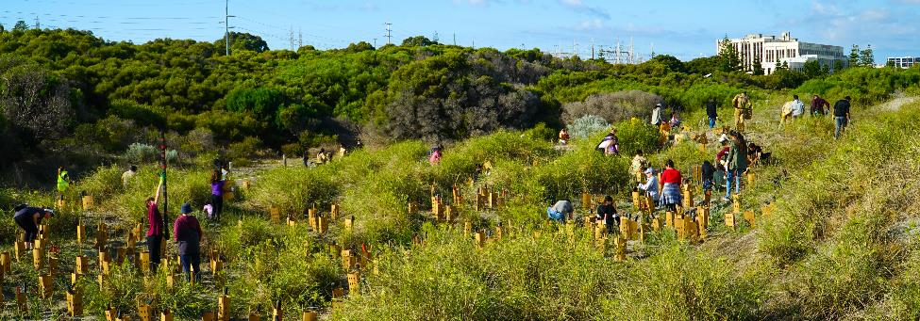
Photo: C.Y. O’Connor Beach planting - June 2021

Corporate Business Plan 2020-2021 KPI Progress Report

Highlights from the Year
Below are some highlights from this financial year. A full report of the progress of all 2021-2022 actions in the Corporate Business Plan follows on page 66.

Local Economy
A sustainable and diverse local economy that attracts increased investment and provides local employment.
- First City Economic Development Grants program awarded 20 businesses $85,000
- Ran #ShopLocalCockburn campaign to encourage residents to shop local and amended procurement policy to ensure the City shops locally where possible.

Environmental Responsibility
A leader in environmental management that enhances and sustainably manages our local natural areas and resources.
- Review of the Waste Strategic Plan completed
- Climate Change Strategy 2020-2030 adopted by Council.

Community, Lifestyle and Security
A vibrant, healthy, safe, inclusive and connected community.
- Gave $1.46m back to the community in grants and donations
- Re-launched a new, more effective and affordable CoSafe service
- New Community Development and Volunteering strategies adopted by Council.

City Growth and Moving Around
A growing City that is easy to move around and provides great places to live.
- The Transport Strategy, incorporating the Road Safety Strategy, Parking Plan and TravelSmart Plan was adopted by Council
- Verde Drive extension was completed
- Yarra Vista Park upgrades were completed.

Listening and Leading
A community focused, sustainable, accountable and progressive organisation.
- Asset Management Plan for Marine and Coastal Assets was completed
- Requirements gathered for a single view of the customer and customer relationship management tool was completed.

Corporate Business Plan Progress 2020-2021
Only projects for the 2020-21 financial year are shown under each strategy area.

Outcome 1: Local Economy
A sustainable and diverse local economy that attracts increased investment and provides local employment.

Business as usual
Facilitate a sustainable and diverse local economy that attracts increased investment and provides local employment. Businesses are engaged and informed about City services and processes, business skills and capacity development, and regional and local opportunities.

Key Projects

Strategy: Plan for and facilitate opportunities for local business (including home business and sole traders), local activity centres and industry to thrive
Project | Status
Develop the Economic Development Framework and Action Plan | In progress
Work with business and the community to expand the use of smart technology to improve resource efficiency and affordability | In progress
Review and update the Local Commercial and Activity Centres Strategy 2011 | In progress

Strategy: Build local business capacity through partnerships, networks, programs and skill development
Project | Status
Support buying locally through our policies and practices | Completed
Deliver grants to support Economic Development Policy and Guidelines | Completed
Embed economic development principles into the Grants & Donations program to support business development | Not started

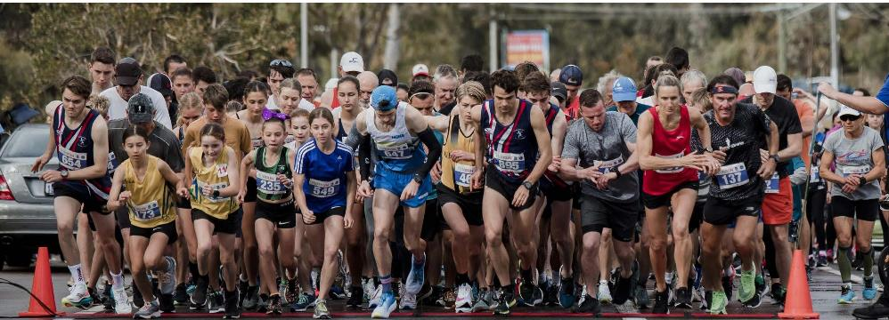
Photo: Bibra Lake Fun Run - September 2020

Strategy: Advocate for and attract investment, economic growth, and local employment
Project | Status
Strategic research and partnerships focused on new investments | In progress
Progress planning and advocacy to support the development of Latitude 32 and the Australian Marine Complex | In progress
Provision of New Economic Development Service area to support the Economic Development Framework | In progress
Prepare an infrastructure and funding advocacy plan that underpins economic and growth strategic priorities for Cockburn | In progress
Work with the community, South West Group, innovators and industry to explore development of clusters, innovation and co-working hubs across Cockburn | In progress
Leverage of national defence programs to position Cockburn as the destination of choice for investment | In progress

Strategy: Facilitate and advocate for the provision of a full range of education and training opportunities
Project | Status
Promote programs to build innovation skills and pathways to accelerate innovation activity | In progress

Strategy: Ensure the City is ‘easy to do business with’ through improved business focused processes
Project | Status
Review community events approvals process and other process reviews | In progress
Implement Small Business Friendly Approvals Project | In progress

Strategy: Waste Strategy
Project | Status
Develop a new commercial food waste collection service | Completed

Strategy: Community, Sport and Recreation Facilities Plan
Project | Status
Develop the City’s new Visitor Information Service as part of the Aboriginal Cultural and Visitors Centre | In progress

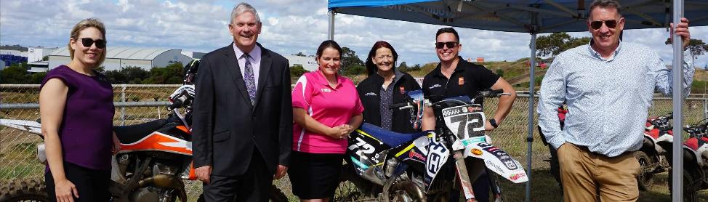
Photo: (from Left to Right) Deputy Mayor Councillor Lara Kirkwood, Mayor Howlett, Councillor Chontelle Stone, Councillor Phoebe Corke, Councillor Tom Widenbar, Councillor Philip Eva at XLR8 Youth Motocross Program Launch - November 2020

Outcome 2: Environmental Responsibility
A leader in environmental management that enhances and sustainably manages our local natural areas and resources.

Business as usual
Manage and recover waste. Manage public open space. Assess landscape and environmental areas development approvals. Maintain Platinum Waterwise Council status. Protect strategically identified remnant bushland, wetlands, coastal, environment and ecological corridors. Provide environmental education and administer grants that enhance and protect the environment. Develop and implement the Climate Change Strategy.

Key Projects

Strategy: Sustainably manage our environment by protecting and enhancing our unique natural areas, coast, bushland, wetlands and native wildlife
Project | Status
Construct Wetlands Education Centre/WA Wildlife | In progress
Review and continue to implement the Natural Areas Management Strategy 2012-2022 | In progress
Review the City’s Bushfire Risk Management Plan 2015-2020 | In progress
Implement and review the Urban Forest Plan 2018-2028 | In progress
Develop and Implement Citywide entry statement program | In progress

Strategy: Improve our urban forest and streetscapes across the City
Project | Status
Implement and review the Cash in Lieu Plan 2017-2020 for public open space | In progress

Strategy: Provide accessible high-quality open spaces and parks for community benefit
Project | Status
Develop Aubin Grove youth facilities | In progress
Implement and review the Public Open Space Strategy 2014-2024 | In progress

Strategy: Minimise the City’s waste to landfill through reducing, reusing, re-purposing, re-gifting and recycling of waste
Project | Status
Henderson Waste Recovery Park leachate evaporation project (ongoing) | In progress
Review and implement the Waste Strategic Plan 2020-2030 | Completed
Deliver general waste to the East Rockingham Energy from Waste Facility 2022 | In progress
Construct a new Community Drop-off Facility, relocated entry and leasable land for complimentary waste contractors at Henderson Waste Recovery Park | In progress

Strategy: Sustainably manage water, energy and other resources and promote the use of environmentally responsible technologies
Project | Status
Plan and implement initiatives to reduce building and facility and plant non-renewable energy consumption and Green House Gas Emissions | In progress
Research and develop a position on alternative fuelled waste trucks | In progress
Implement the Water Efficiency Action Plan 2018–2028 | In progress
Undertake a feasibility study for the use of hydrogen powered waste trucks | In progress
Invest in Henderson Waste Recovery Park onsite renewable energy generation | In progress

Strategy: Address climate change through planning, adaptation, mitigation, infrastructure and ecological management
Project | Status
Review and implement the City’s Coastal Management and Adaptation Plan | In progress
Develop a Climate Change Strategy 2020-2030 | Completed
Implement the Climate Change Strategy | In progress

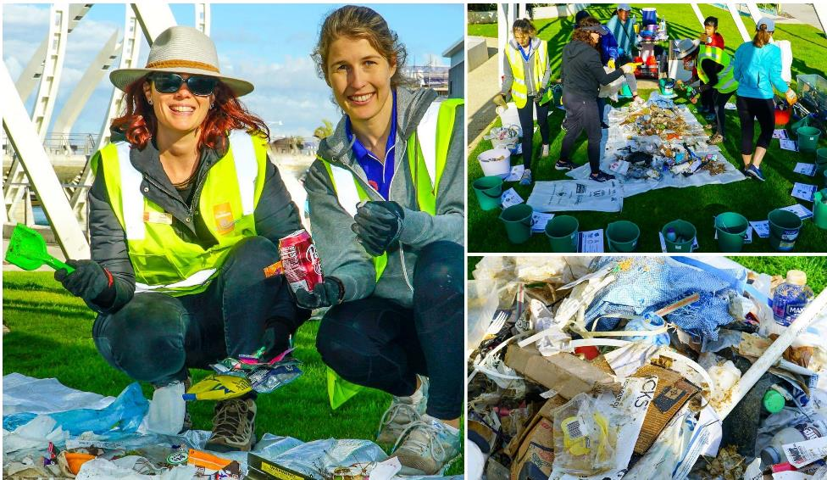
Photo: Victoria Hartill, Clare Courtauld at Coogee Beach for World Ocean Day - June 2021

Outcome 3: Community, Lifestyle and Security
A vibrant, healthy, safe, inclusive and connected community.

Business as usual
Provide community safety and development initiatives, free community events, ranger services, recreation and community development and services. Administer grants and donations through the Cockburn Community Fund to support the community. Provide a range of community services including libraries, a volunteer resource centre, childcare services, youth services, family and children’s services, seniors’ services and public health services.

Key Projects

Strategy: Provide a diverse range of accessible, inclusive and targeted community services, recreation programs, events and cultural activities that enrich our community
Project | Status
Review and implement the Age Friendly Strategy 2016-2021 | Completed
Review and implement the Children and Families Strategy 2016-2021 | Completed
Review and implement the Disability Access and Inclusion Plan 2017-2022 | Completed
Review and implement the Youth Services Strategy 2017-2022 | Completed
Review and implement the Cultural Strategy (Art, Culture, Heritage and Events) 2016-2020 | Completed
Review and Implement the Libraries Strategic Plan 2020-2025 | Completed
Incorporate the Cultural Diversity Strategy into the Community Development Strategy | Not started
Map the application and approval process for external and internal run events and implement recommended process improvements | In progress
Undertake a feasibility study for arts and cultural spaces in Cockburn and implement approved recommendations | Not started

Strategy: Foster local community identity and connection through social inclusion, community development, and volunteering opportunities
Project | Status
Review and implement the Community Development Strategy 2016-2020 | Completed
Develop a Volunteering Strategy | Completed

Strategy: Facilitate and support health and wellbeing outcomes for our community
Project | Status
Develop a Public Health Plan | In progress

Strategy: Provide community, sport, recreational, and cultural facilities and infrastructure to meet community needs
Project | Status
Review and implement the Community, Sport and Recreation Facilities Plan 2018-2033 | In progress
Treeby Community and Sports Centre design and construction | In progress
Malabar Park construction | In progress
Beale Park design and construction | In progress
Cockburn Coast Oval construction | In progress
Expansion of Port Coogee Marina | In progress
Frankland Park construction | In progress
Wally Hagan Recreation Centre development | In progress
Cockburn ARC – health and fitness expansion | In progress
Complete a peer review of the draft design of the Coogee Golf Course | Completed
Santich Park upgrade – Stage 1 | In progress

Strategy: Facilitate and advocate for increased community safety
Project | Status
Review and Implement the City’s Community Safety and CCTV Strategy 2017-2022 | In progress
Finalise the development of a Smart City facility security and access control system and commence roll-out of preselected locations | In progress

Strategy: Recognise and celebrate the significance of cultural, social and built heritage including Aboriginal and Torres Strait Islanders and multicultural groups
Project | Status
Review and implement the Reconciliation Action Plan 2018-2021 | In progress
Review Azelia Ley Homestead Museum management model and tenure | In progress
Design and construct the Aboriginal Cultural and Visitors Centre | In progress

Outcome 4: City Growth and Moving Around
A growing City that is easy to move around and provides great places to live.

Business as usual
Provide guidance for the growth of the City. Ensure that buildings and structures are safe and comply with all relevant building legislation, codes, standards and regulations. Design roads, drains, paths, cycle ways and associated infrastructure. Construct and maintain roads, drainage, paths and associated infrastructure. Manage the City’s property interests and land portfolio.

Key Projects

Strategy: Plan to provide residents with great places to live, activated social connections and high-quality open spaces
Project | Status
Review and implement the Land Management Strategy | Not started
Prepare the new Local Planning Strategy and Scheme for the District | In progress
Australian Building Cladding Audit – complete the audit and follow up work related to flammable cladding | In progress

Strategy: Sustainably revitalise urban areas to deliver high levels of amenity and to cater for population growth
Project | Status
Implement the Phoenix Central; Hamilton Hill, Coolbellup, The Lakes Revitalisation Strategies | In progress

Strategy: Review the City’s approach to future revitalisation strategies
Project | Status
To be informed by the review of the City’s Local Planning strategy | Not started

Strategy: Plan and facilitate diverse and affordable housing choices for residents and vulnerable communities
Project | Status
Implement and Review the Housing Affordability and Diversity Strategy | In progress

Strategy: South Fremantle Power Station
Project | Status
Progress planning and advocacy for redevelopment of the South Fremantle Power Station site and the associated electrical sub-station | In progress

Strategy: Develop Cockburn Central as our City centre and strengthen local area localities through planning and activation
Project | Status
Prepare an intervention framework to promote growth, good design, and viable outcomes in our activity centres. (part of the Local Commercial and Activity Centres Strategy review) | In progress
Design of the New Council and Administration Centre - Cockburn Central | In progress

Strategy: Advocate and plan for reduced traffic congestion
Project | Status
Advocate for the analysis and planning to support the delivery of the Fremantle to Cockburn Transit Link | In progress
Develop public events, information campaigns and education resources about traffic congestion, road safety and alternative transport mode choices to reduce the dependency on trips by private car | In progress

Strategy: Plan, develop and advocate for safe, sustainable, integrated local transport networks, public transport and regional transport networks
Project | Status
Implement Road Projects Plan 2019-2033 | In progress
Advocate for improvements to public transport | In progress
Review and implement the Integrated Transport Strategy, incorporating the Road Safety Strategy, Parking Plan and Travel Smart Plan | In progress

Strategy: Continue to complete the coverage of accessible cycleways, footpaths, parking and end of trip facilities, and trail networks across the City
Project | Status
Construct new and refurbished footpaths | Completed
Complete Bicycle Network Infrastructure 2017-2026 | Completed
Review and integrate the Footpath Plan | In progress
Review and implement the Trails Master Plan | In progress

Strategy: Coastal corridor and east-west public transport options
Project | Status
Progress concept development and advocacy for coastal corridor and east-west public transport options | In progress

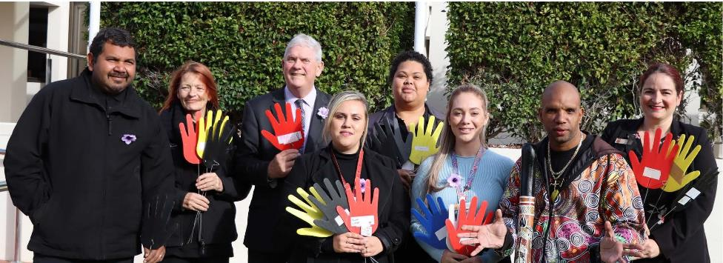
Photo: (from Left to Right) Mitchell Garlett, Councillor Phoebe Corke, Mayor Howlett, Shelley Farmer, Roshann Kaputin, Kathleen Miller, Tim Kelly, Councillor Chontelle Stone at Reconciliation Week, Flag Raising - May 2021

Outcome 5: Listening and Leading
A community focused, sustainable, accountable and progressive organisation.

Business as usual
Provides strategic direction for the City, and administrative and governance support to the organisation to ensure compliance with legislative requirements and corporate guidelines and meets statutory obligations in accordance with the Local Government Act 1995. Engage with State and Federal Government agencies to secure funding and support. Manage the City’s assets through Asset Management Plans. Provide best practice project management services to deliver the City’s capital works projects, programs and strategies. Provide excellent customer service and community engagement.

Key Projects

Strategy: Ensure good governance through transparent and accountable planning, processes, reporting, policy and decision making
Project | Status
Implement Knowledge Management Project – corporate records management | Completed
Develop, implement, and maintain a four-year corporate planning cycle and new strategy software system | In progress
Consolidate the existing strategies and strategic documents into a cohesive framework of strategies and list of operational documents linked to the strategic outcomes and objectives | Completed
Review and continual management of the Enterprise Risk Management Framework | In progress
Organisational Risk Management Maturity Review | In progress
Review, assess and apply new or amended legislative requirements from the LG Act Review | In progress

Strategy: Actively advocate and seek regional collaboration focused on growing the wellbeing and self-sufficiency of the community to better meet its social, environmental and economic needs
Project | Status
Apply for areas to be included in funding for underground power | In progress
Participate in the Westport Local Government Reference Group as per the Terms of Reference | In progress

Strategy: Listen to, communicate, consult and engage with our residents, businesses and community in a timely, open and collaborative
Project | Status
Review the Community Engagement Policy and Framework | In progress

Strategy: Deliver value for money through sustainable financial management, planning and asset management
Project | Status
Review and implement the Asset Management Strategy 2017 and ensure consistent organisational asset management principles are in place | In progress
Create and review an Asset Management Plan for marine and coastal assets | Completed
Create and review the Asset Management Plan for Cockburn ARC | In progress
Operations Centre Upgrade Stage 2 | In progress
Office of the Auditor General performance audits – participation and review better practice recommendations | In progress
Refine the long-term financial planning methods to better integrate with the City’s Strategic Community Plan objectives | In progress
Implement COVID-19 financial measures including zero % rate, fee and charges increase for 2021. The impact has then been extrapolated across the 10 years of the Long-Term Financial Plan | In progress

Strategy: Provide high quality accessible customer service and experiences for all our community
Project | Status
Undertake requirements for gathering a single view of the customer/ CRM and implement a solution | Completed

Strategy: Workplace diversity
Project | Status
Focus on providing a workplace that supports diversity | In progress

Strategy: Attract, engage, develop, support and retain our employees to provide exceptional services for the community
Project | Status
Review and Implement the Workforce Plan 2017-2022 | In progress

Strategy: Build an organisational culture that encourages innovation in both digital and non-digital mediums, and utilisation of technology to increase efficiency and effectiveness
Project | Status
Implement and review the Sustainability Strategy 2017-2022 | In progress
Review and Implement the Information Services Strategy 2016-2020 | Completed
Review and update the existing customer request system to meet current business processes | Not started
Develop and implement two Smart Cities Projects in partnership with the South West Group (Smart Street lighting and LoRaWAN network) | In progress
Develop an Innovation Framework and culture | In progress
Review and Implement the Digital Strategy 2019-2024 | In progress

Spend on Asset Development and Operational Activities 2020-2021
Asset Development | $Million
Landfill site | $0.31
Plant – new and replacement | $3.77
Parks and environment | $4.20
Roads, footpath and drainage | $11.51
Developer contributed infrastructure | $11.42
Buildings | $14.22
Marina and coastal | $0.29
Total | $45.72

Operational Activities | $Million
Plant maintenance | $3.16
Facilities maintenance | $7.20
Marina and coastal | $1.14
Waste disposal | $9.97
Roads, footpaths and drainage maintenance | $7.64
Parks and environment maintenance | $17.36
Waste collection | $5.82
Total | $52.29

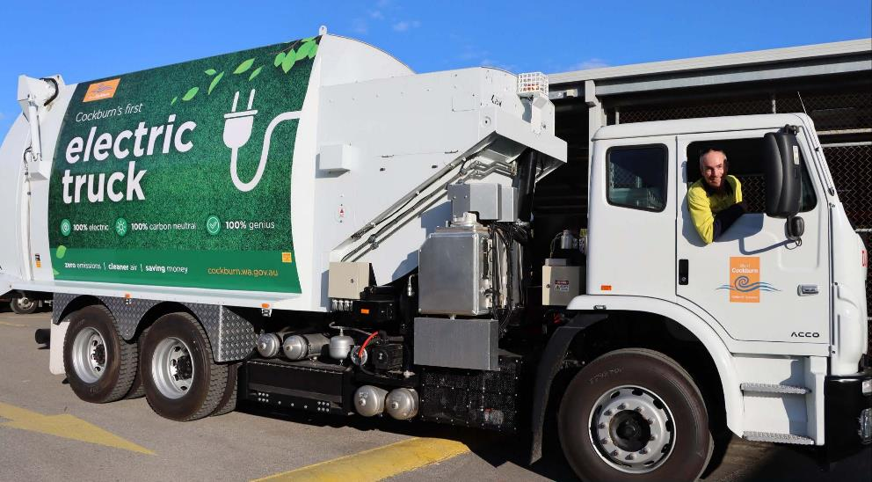
Photo: Electric Waste Truck - June 2021

Complaints of Minor Breaches
The Local Government Act 1995 (Section 5.121) requires a Register of Complaints against Elected Members to be maintained. For 2020-21, 16 official complaints were received and a censure imposed by the Standards Panel. The details must be entered into the complaints register and published on the City’s website.

Complaint 1
Date of hearing: 1 February 2021 (SP 2020-033)
Name of Councillor: Michael Separovich
Name of person who made the complaint: Don Green, Executive Governance & Strategy

Description of minor breach determined by standards panel
Councillor Michael Separovich committed one breach of Regulation 10(1)(b) of the Local Government (Rules of Conduct) Regulations 2007 (WA) when he attempted to influence, by means of a threat, the conduct of a person who is a local government employee in their capacity as a local government employee.

Details of action taken under section 5.110(6)
- Councillor Michael Separovich, a councillor for the City of Cockburn, publicly apologise, as specified in paragraph 2, or failing compliance with paragraph 2, then paragraph 3:

Public Apology
- At the ordinary council meeting first occurring after the expiration of 28 days from the date of service of this Order on him, Councillor Michael Separovich (“Cr Separovich”)
  - attend the relevant ordinary council meeting;
  - ask the presiding person for his or her permission to address the meeting to make a public apology to the public;
  - make the apology immediately after Public Question Time or during the Announcements part of the meeting, or at any other time when the meeting is open to the public, as the presiding person thinks fit; and
  - address the Council and public as follows, without saying any introductory words before the address, and without making any comments or statement after the address: ‘I advise this meeting that:
    - A complaint was made to the Local Government Standards Panel, in which it was alleged that I contravened the Local Government (Rules of Conduct) Regulations 2007 (WA) when I sent an email and used a threatening tone towards a senior member of Council staff.
    - ii. The Panel found that by behaving in this manner I committed one breach of Regulation 10(1)(b) of the said Regulations as I attempted to influence, by means of a threat, the conduct of a person who is a local government employee in their capacity as a local government employee.
    - I accept that I should not have acted in such a manner and I now apologise to Mr Daniel Arndt for having done so.”
- If Cr Separovich fails to, or is unable to, comply with the requirements of paragraph 2 in the required timeframe then, within the next 28 days following the ordinary council meeting referred to in paragraph 2:
  - Cr Separovich shall cause the following notice of public apology to be published in noless than 10 point print, as a one-column or two-column display advertisement in the first 10 pages of the ‘Cockburn ‘Gazette’ newspaper; and
  - The Chief Executive Officer of the City of Cockburn shall arrange for the following notice of public apology to be published:
    - on the Facebook page of the City of Cockburn in no less than 10 point font size; and
    - in an appropriate place on the website of the City of Cockburn in no less than 10 point font size; and
    - in the next occurring issue of any City of Cockburn public newsletter (if any) (whether in electronic or print copy) in no less than 10point font size.

Public Apology by Councillor Michael Separovich
A complaint was made to the Local Government Standards Panel, in which it was alleged that I contravened the Local Government (Rules of Conduct) Regulations 2007 (WA) when I sent an email and used a threatening tone to a senior member of Council staff. The Panel found that by behaving in this manner I committed one breach of Regulation 10(1)(b) of the said Regulations as I attempted to influence, by means of a threat, the conduct of a person who is a local government employee in the person’s capacity as a local government employee. I accept that I should not have acted in such a manner and I now apologise to Mr Daniel Arndt for having done so.

Complaint 2
Date of hearing: 1 February 2021 (SP 2020-039)
Name of Councillor: Michael Separovich
Name of person who made the complaint: Don Green, Executive Governance & Strategy

Description of minor breach determined by standards panel
Councillor Michael Separovich committed one breach under the Local Government Act 1995 (WA) (“the Act”) and regulation 17(1)(b) of the Local Government (Rules of Conduct).

Details of action taken under section 5.110(6)
Councillor Michael Separovich, a member of the City of Cockburn, within four(4) months of the date of this Order, shall undertake: (1) the training course for Elected Members ‘Serving on Council’ provided by WA Local Government Association (WALGA) for a period of fifteen(15) hours; or (2) a training course with substantially similar learning outcomes provided by an alternative Version: 12, Version Date: 27/07/2021 Document Set ID: 8253716 registered organisation for a similar duration, but at least twelve (12) hour.

Complaint 3*
Date of hearing: 9 February 2021 (SP 2020-108)
Name of Councillor: Michael Separovich
Name of person who made the complaint: Don Green, Executive Governance & Strategy, on behalf of a third party

Description of minor breach determined by standards panel
Councillor Michael Separovich committed one breach under the Local Government Act 1995 (WA) (“the Act”) and regulation 7(1)9b) of the Local Government (Rules of Conduct) Regulations 2007 (“the Regulations”) when he made deliberately antagonistic and offensive remarks on social media regarding the fatal shootings at a Black Lives Matter protest in the United States of America.

Details of action taken under section 5.110(6)
Councillor Michael Separovich,
- a councillor for the City of Cockburn, be publicly censured, as specified in paragraph 3.
- a councillor for the City of Cockburn, make the monetary payment set out in paragraph

Public Censure
- Within the period of 29 days to 43 days from the day following the date of service of this Order on Councillor Separovich, the Chief Executive Officer of the City of Cockburn shall arrange for the following Notice of Public Censure to be published, in no less than 10 point print or font:
  - on the Facebook Page of the City of Cockburn;
  - on an appropriate page of the website of the City of Cockburn; and
  - be published in every City of Cockburn public or community newsletter (whether in electronic or print copy) (if any).

Notice of Public Censure
The Local Government Standards Panel has found that Councillor Michael Separovich, a Councillor of the City of Cockburn, breached regulation 7(1)(b) of the Local Government (Rules of Conduct) Regulations 2007 (WA) when he made a Facebook Post that was deliberately antagonistic and offensive on social media in relation to the Black Lives Matter protests in the United States of America. Councillor Separovich’s conduct was improper, in breach of the City’s Code of Conduct and deserving of a penalty. The Panel censures Councilor Separovich for the breach of regulation 7(1)(b) of the Local Government (Rules of Conduct) Regulations 2007 (WA).

Local Government Standards Panel

Monetary Sanction
- Within two (2) months of being advised of the sum total of the remuneration and allowances payable by the City in relation to the Complaint, Cr Separovich shall pay to the City that amount in full.
*Upon review by the State Administrative Tribunal this decision was set aside on 29 September 2021 and no sanction was imposed.

Complaint 4*
Date of hearing: 9 February 2021 (SP 2020-102)
Name of Councillor: Michael Separovich
Name of person who made the complaint: Don Green, Executive Governance & Strategy, on behalf of a third party

Description of minor breach determined by standards panel
Councillor Michael Separovich committed one breach under the Local Government Act 1995 (WA) (“the Act”) and regulation 7(1)9b) of the Local Government (Rules of Conduct) Regulations 2007 (“the Regulations”) when he made comments that were deliberately antagonistic and offensive remarks on social media regarding the fatal shootings at a Black Lives Matter protest in the United States of America.

Details of action taken under section 5.110(6)
- Councillor Michael Separovich, a councillor for the City of Cockburn publicly apologise, as specified in paragraph 3, or failing to comply with paragraph 3, then paragraph 4 shall apply.
- Councillor Michael Separovich, a councillor for the City of Cockburn, make the monetary payment set out in paragraph 5.

Public Apology
- On the ordinary council meeting first occurring after the expiration of 28 days from the date of service of this Order on him, Councillor Separovich shall:
  - attend the relevant ordinary council meeting;
  - ask the presiding person for his or her permission to address the meeting to make a public apology to the public;
  - make the apology immediately after Public Question Time or during the Announcements part of the meeting, or at any other time when the meeting is open to the public, as the presiding person thinks fit; and
  - address the Council and public as follows, without saying any introductory words before the address, and without making any comments or statement after the address:
‘I advise this meeting that:
    - A complaint was made to the Local Government Standards Panel, in which it was alleged that I contravened the Local Government (Rules of Conduct) Regulations 2007 (WA) when I made an offensive and derogatory Facebook Post.
    - The Panel found that I breached regulation 7(1)(b) of the said Regulations as my conduct was in breach of the City’s Code of Conduct and deserving of a penalty.
    - I accept that I should not have engaged in the relevant conduct.
    - I now apologise to my fellow Councillors and the public.’
- If Councillor Separovich fails to, or is unable to, comply with the requirements of paragraph 3 THEN, within the next 28 days following the ordinary council meeting referred to in paragraph 3, the Chief Executive Officer shall arrange for the following notice of public apology to be published in no less than 10 point print or font:
  - on the Facebook Page of the City of Cockburn;
  - on an appropriate page of the website of the City of Cockburn; and
  - be published in every City of Cockburn public or community newsletter (whether in electronic or print copy) (if any):
A complaint was made to the Local Government Standards Panel, in which it was alleged that I contravened the Local Government (Rules of Conduct) Regulations 2007 (WA) when I made an offensive and derogatory Facebook Post. The Panel found that I breached regulation 7(1)(b) of the said Regulations as my conduct was in breach of the City’s Code of Conduct and deserving of a penalty. I accept that I should not have engaged in the relevant conduct. I now apologise to my fellow Councillors and the public.

Monetary Sanction
- Within two(2) months of being advised of the sum total of the remuneration and allowances payable by the City in relation to the Complaint, Cr Separovich shall pay to the City that amount in full.
*Upon review by the State Administrative Tribunal this decision was set aside on 29 September 2021 and no sanction was imposed.

Complaint 5
Date of hearing: 1 February 2021 (SP 2020-042)
Name of Councillor: Michael Separovich
Name of person who made the complaint: Don Green, Executive Governance & Strategy

Description of minor breach determined by standards panel
Councillor Michael Separovich committed one breach of Regulation 7(1)(b) of the Local Government (Rules of Conduct) Regulations 2007 (WA), as his conduct was wrongful, inappropriate and deserving of a penalty and, further, his actions were likely to cause detriment to the parties involved.

Details of action taken under section 5.110(6)
- Councillor Michael Separovich, a councillor for the City of Cockburn, publicly apologise, as specified in paragraph 2, or failing compliance with paragraph 2, then paragraph 3:

Public Apology
- At the ordinary council meeting first occurring after the expiration of 28 days from the date of service of this Order on him, Councillor Michael Separovich (“Cr Separovich”)
  - attend the relevant ordinary council meeting;
  - ask the presiding person for his or her permission to address the meeting to make a public apology to the public;
  - make the apology immediately after Public Question Time or during the Announcements part of the meeting, or at any other time when the meeting is open to the public, as the presiding person thinks fit; and
  - address the Council and public as follows, without saying any introductory words before the address, and without making any comments or statement after the address.
‘I advise this meeting that::
    - A complaint was made to the Local Government Standards Panel, in which it was alleged that I contravened the Local Government (Rules of Conduct) Regulations 2007 (WA) when I wrote an email to elected members that discredited staff members of the City and implied that they had not distributed an agenda for the Special Council Meeting planned for March 2020 in a timely manner.
    - The Panel found that by behaving in this manner I committed one breach of Regulation 10(1)(b) of the said Regulations as my conduct was wrongful, inappropriate and deserving of a penalty and, further, my actions were likely to cause detriment to the parties involved.
    - I accept that I should not have acted in such a manner and I now apologise to staff of the City concerned for having done so.”
- If Cr Separovich fails to, or is unable to, comply with the requirements of paragraph 2 in the required timeframe then, within the next 28 days following the ordinary council meeting referred to in paragraph 2:
  - Cr Separovich shall cause the following notice of public apology to be published in no less than 10 point print, as a one-column or two-column display advertisement in the first 10 pages of the ‘Cockburn ‘Gazette’ newspaper; and
  - The Chief Executive Officer of the City of Cockburn shall arrange for the following notice of public apology to be published:
    - on the Facebook page of the City of Cockburn in no less than 10 point font size; and ii. in an appropriate place on the website of the City of Cockburn in no less than 10 point font size; and iii. in the next occurring issue of any City of Cockburn public newsletter (if any) (whether in electronic or print copy) in no less than 10 point font size than 10 point font size; and
    - in an appropriate place on the website of the City of Cockburn in no less than 10 point font size; and iii. in the next occurring issue of any City of Cockburn public newsletter (if any) (whether in electronic or print copy) in no less than 10 point font size.

Public Apology by Councillor Michael Separovich
A complaint was made to the Local Government Standards Panel, in which it was alleged that I contravened the Local Government (Rules of Conduct) Regulations 2007 (WA) when I wrote an email to elected members that discredited staff members of the City and implied that they had not distributed an agenda for the Special Council Meeting planned for March 2020 in a timely manner. The Panel found that by behaving in this manner I committed one breach of Regulation 71)(b) of the said Regulations as my conduct was wrongful, inappropriate and deserving of a penalty and, further, my actions were likely to cause detriment to the parties involved.
I accept that I should not have acted in such a manner and I now apologise to staff of the City of Cockburn, for having done so.

Complaint 6*
Date of hearing: 25 March 2021 (SP 2020-057)
Name of Councillor: Michael Separovich
Name of person who made the complaint: Don Green, Executive Governance & Strategy, on behalf of a third party

Description of minor breach determined by standards panel
Councillor Michael Separovich, a councillor for the City of Cockburn, where it was alleged that he contravened the Local Government (Rules of Conduct) Regulations 2007 (WA) when he published a series of derogatory and disrespectful posts on Facebook that were highly inflammatory and provocative.
The Panel found that by behaving in this manner he committed one breach of Regulation 7(1) (b) of the said Regulations as his conduct was in breach of the City’s Code of Conduct and was wrongful, inappropriate and deserving of a penalty. Furthermore, his actions were likely to cause detriment to the parties involved.

Details of action taken under section 5.110(6)
- Councillor Michael Separovich, a councillor for the City of Cockburn, publicly apologise, as specified in paragraph 5, or failing compliance with paragraph 5, then paragraph 6.
- If Cr Separovich is ordered to make the same public apology (as specified in paragraph 5 or 6) by the Panel in relation to other Minor Breach matters for the same conduct, then the Public Apology is only to be made once (in all forms as specified in paragraph 5 or 6).
- Councillor Michael Separovich, a councillor for the City of Cockburn, be censured, as specified in paragraph 7.
- If the same Notice of Public Censure (as specified in paragraph 7) is ordered to be published by the Panel in relation to other Minor Breach matters for the same conduct, then the Notice of Public Censure is only to be published once in each publication and on each forum.

Public Apology
- At the ordinary council meeting first occurring after the expiration of 28 days from the date of service of this Order on him, Councillor Michael Separovich (“Cr Separovich”) shall:
  - attend the relevant ordinary council meeting;
  - ask the presiding member for his or her permission to address the meeting to make a public apology to the public;
  - make the apology immediately after Public Question Time or during the Announcements part of the meeting, or at any other time when the meeting is open to the public, as the presiding person thinks fit; and
  - address the Council and public as follows, without saying any introductory words before the address, and without making any comments or statement after the address:
‘I advise this meeting that:
    - A complaint was made to the Local Government Standards Panel, in which it was alleged that I contravened the Local Government (Rules of Conduct) Regulations 2007 (WA) when I published a series of derogatory and disrespectful posts on Facebook that were highly inflammatory and provocative.
    - The Panel found that by behaving in this manner I committed one breach of Regulation 7(1)(b) of the said Regulations as my conduct was in breach of the City’s Code of Conduct and was wrongful, inappropriate and deserving of a penalty. Furthermore, my actions were likely to cause detriment to the parties involved.
    - I accept that I should not have acted in such a manner and I now apologise to the City, the Council and the community, for having done so.
- If Cr Separovich fails to, or is unable to, comply with the requirements of paragraph 5 in the required timeframe then, within the next 28 days following the ordinary council meeting referred to in paragraph 2:
  - Cr Separovich shall cause the following notice of public apology to be published in the first 10 pages of the ‘Cockburn Gazette’ newspaper; and
  - the Chief Executive Officer of the City of Cockburn shall arrange for the following notice of public apology to be published:
    - on the Facebook page of the City of Cockburn; and
    - in an appropriate place on the website of the City of Cockburn; and
    - in the next occurring issues of all City of Cockburn community and public newsletters (if any) (whether in electronic or print copy).

Public Censure
- Within the period of 29 days to 43 days from the day following the date of service of this Order on Councillor Separovich, the Chief Executive Officer of the City of Cockburn shall arrange for the following Notice of Public Censure to be published:
  - In The West Australian newspaper
  - In Cockburn Gazette
  - Public Notices on the website of City of Cockburn
  - In every City of Cockburn community and public newspaper (if any) (whether in electronic or print copy); and
  - On the Facebook page of the City of Cockburn

Notice of Public Censure
The Local Government Standards Panel has found that Councillor Michael Separovich, a Councillor for the City of Cockburn breached regulation 7(1) (b) of the Local Government (Rules of Conduct) Regulations 2007 (WA) when he published a series of derogatory and disrespectful posts on Facebook that were highly inflammatory and provocative. Councillor Separovich’s conduct was wrongful and inappropriate and deserving of a penalty and, further, his comments were likely to cause detriment to the City, the Council and community. The Panel censures Councillor Separovich for the breach of regulation 7(1)(b) of the Local Government (Rules of Conduct) Regulations 2007 (WA).

Local Government Standards Panel
*Upon review by the State Administrative Tribunal this decision was set aside on 29 September 2021 and no sanction was imposed.

Complaint 7*
Date of hearing: 25 March 2021 (SP 2020-055)
Name of Councillor: Michael Separovich
Name of person who made the complaint: Don Green, Executive Governance & Strategy, on behalf of a third party

Description of minor breach determined by standards panel
Councillor Michael Separovich, a councillor for the City of Cockburn, where it was alleged that he contravened the Local Government (Rules of Conduct) Regulations 2007 (WA) when he published a series of derogatory and disrespectful posts on Facebook that were highly inflammatory and provocative.
The Panel found that by behaving in this manner he committed one breach of Regulation 7(1) (b) of the said Regulations as his conduct was in breach of the City’s Code of Conduct and was wrongful, inappropriate and deserving of a penalty. Furthermore his actions were likely to cause detriment to the parties involved.

Details of action taken under section 5.110(6)
- Councillor Michael Separovich, a councillor for the City of Cockburn, publicly apologise, as specified in paragraph 5, or failing compliance with paragraph 5, then paragraph 6.
- If Cr Separovich is ordered to make the same public apology (as specified in paragraph 5 or 6) by the Panel in relation to other Minor Breach matters for the same conduct, then the Public Apology is only to be made once (in all forms as specified in paragraph 5 or 6).
- Councillor Michael Separovich, a councillor for the City of Cockburn, be censured, as specified in paragraph 7.
- If the same Notice of Public Censure (as specified in paragraph 7) is ordered to be published by the Panel in relation to other Minor Breach matters for the same conduct, then the Notice of Public Censure is only to be published once in each publication and on each forum.

Public Apology
- At the ordinary council meeting first occurring after the expiration of 28 days from the date of service of this Order on him, Councillor Michael Separovich (“Cr Separovich”) shall:
  - attend the relevant ordinary council meeting;
  - ask the presiding member for his or her permission to address the meeting to make a public apology to the public;
  - make the apology immediately after Public Question Time or during the Announcements part of the meeting, or at any other time when the meeting is open to the public, as the presiding person thinks fit; and
  - address the Council and public as follows, without saying any introductory words before the address, and without making any comments or statement after the address:
‘I advise this meeting that:
    - A complaint was made to the Local Government Standards Panel, in which it was alleged that I contravened the Local Government (Rules of Conduct) Regulations 2007 (WA) when I published a series of derogatory and disrespectful posts on Facebook that were highly inflammatory and provocative.
    - The Panel found that by behaving in this manner I committed one breach of Regulation 7(1)(b) of the said Regulations as my conduct was in breach of the City’s Code of Conduct and was wrongful, inappropriate and deserving of a penalty. Furthermore, my actions were likely to cause detriment to the parties involved.
    - I accept that I should not have acted in such a manner and I now apologise to the City, the Council and the community, for having done so.
- If Cr Separovich fails to, or is unable to, comply with the requirements of paragraph 5 in the required timeframe then, within the next 28 days following the ordinary council meeting referred to in paragraph 2:
  - Cr Separovich shall cause the following notice of public apology to be published in the first 10 pages of the ‘Cockburn Gazette’ newspaper; and
  - the Chief Executive Officer of the City of Cockburn shall arrange for the following notice of public apology to be published:
    - on the Facebook page of the City of Cockburn; and
    - in an appropriate place on the website of the City of Cockburn; and
    - in the next occurring issues of all City of Cockburn community and public newsletters (if any) (whether in electronic or print copy).

Public Censure
- Within the period of 29 days to 43 days from the day following the date of service of this Order on Councillor Separovich, the Chief Executive Officer of the City of Cockburn shall arrange for the following Notice of Public Censure to be published:
  - In The West Australian newspaper
  - In Cockburn Gazette
  - Public Notices on the website of City of Cockburn
  - In every City of Cockburn community and public newspaper (if any) (whether in electronic or print copy); and
  - On the Facebook page of the City of Cockburn

Notice of Public Censure
The Local Government Standards Panel has found that Councillor Michael Separovich, a Councillor for the City of Cockburn breached regulation 7(1) (b) of the Local Government (Rules of Conduct) Regulations 2007 (WA) when he published a series of derogatory and disrespectful posts on Facebook that were highly inflammatory and provocative. Councillor Separovich’s conduct was wrongful and inappropriate and deserving of a penalty and, further, his comments were likely to cause detriment to the City, the Council and community.
The Panel censures Councillor Separovich for the breach of regulation 7(1)(b) of the Local Government (Rules of Conduct) Regulations 2007 (WA).

Local Government Standards Panel
*Upon review by the State Administrative Tribunal this decision was set aside on 29 September 2021 and no sanction was imposed.

Complaint 8*
Date of hearing: 25 March 2021 (SP 2020-043)
Name of Councillor: Michael Separovich
Name of person who made the complaint: Don Green, Executive Governance & Strategy, on behalf of a third party

Description of minor breach determined by standards panel
Councillor Michael Separovich, a councillor for the City of Cockburn, where it was alleged that he contravened the Local Government (Rules of Conduct) Regulations 2007 (WA) when he published a series of derogatory and disrespectful posts on Facebook that were highly inflammatory and provocative. The Panel found that by behaving in this manner he committed one breach of Regulation 7(1)(b) of the said Regulations as his conduct was in breach of the City’s Code of Conduct and was wrongful, inappropriate and deserving of a penalty. Further more his actions were likely to cause detriment to the parties involved.

Details of action taken under section 5.110(6)
- Councillor Michael Separovich, a councillor for the City of Cockburn, publicly apologise, as specified in paragraph 5 below, or failing compliance with paragraph 5, then paragraph 6.
- If Cr Separovich is ordered to make the same public apology (as specified in paragraph 5 or 6) by the Panel in relation to other Minor Breach matters for the same conduct, then the Public Apology is only to be made once (in all forms as specified in paragraph 5 or 6).
- Councillor Michael Separovich, a councillor for the City of Cockburn, be censured, as specified in paragraph 7.
- If the same Notice of Public Censure (as specified in paragraph 7) is ordered to be published by the Panel in relation to other Minor Breach matters for the same conduct, then the Notice of Public Censure is only to be published once in each publication and on each forum.

Public Apology
- At the ordinary council meeting first occurring after the expiration of 28 days from the date of service of this Order on him, Councillor Michael Separovich (“Cr Separovich”) shall:
  - attend the relevant ordinary council meeting;
  - ask the presiding member for his or her permission to address the meeting to make a public apology to the public;
  - make the apology immediately after Public Question Time or during the Announcements part of the meeting, or at any other time when the meeting is open to the public, as the presiding person thinks fit; and
  - address the Council and public as follows, without saying any introductory words before the address, and without making any comments or statement after the address:
‘I advise this meeting that:
    - A complaint was made to the Local Government Standards Panel, in which it was alleged that I contravened the Local Government (Rules of Conduct) Regulations 2007 (WA) when I published a series of derogatory and disrespectful posts on Facebook that were highly inflammatory and provocative.
    - The Panel found that by behaving in this manner I committed one breach of Regulation 7(1)(b) of the said Regulations as my conduct was in breach of the City’s Code of Conduct and was wrongful, inappropriate and deserving of a penalty. Furthermore, my actions were likely to cause detriment to the parties involved.
    - I accept that I should not have acted in such a manner and I now apologise to the City, the ouncil and the community, for having done so.
- If Cr Separovich fails to, or is unable to, comply with the requirements of paragraph 5 above in the required timeframe then, within the next 28 days following the ordinary council meeting referred to in paragraph 2 above:
  - Cr Separovich shall cause the following notice of public apology to be published in the first 10 pages of the ‘Cockburn Gazette’ newspaper; and
  - the Chief Executive Officer of the City of Cockburn shall arrange for the following notice of public apology to be published:
    - on the Facebook page of the City of Cockburn; and
    - in an appropriate place on the website of the City of Cockburn; and
    - in the next occurring issues of all City of Cockburn community and public newsletters (if any) (whether in electronic or print copy).

Public Censure
- Within the period of 29 days to 43 days from the day following the date of service of this Order on Councillor Separovich, the Chief Executive Officer of the City of Cockburn shall arrange for the following Notice of Public Censure to be published:
  - In the West Australian newspaper
  - In Cockburn Gazette
  - Public Notices on the website of City of Cockburn
  - In every City of Cockburn community and public newspaper (if any) (whether in electronic or print copy); and
  - On the Facebook page of the City of Cockburn

Notice of Public Censure
The Local Government Standards Panel has found that Councillor Michael Separovich, a Councillor for the City of Cockburn breached regulation 7(1)(b) of the Local Government (Rules of Conduct) Regulations 2007 (WA) when he published a series of derogatory and disrespectful posts on Facebook that were highly inflammatory and provocative.
Councillor Separovich’s conduct was wrongful and inappropriate and deserving of a penalty and, further, his comments were likely to cause detriment to the City, the Council and community.
The Panel censures Councillor Separovich for the breach of regulation 7(1)(b) of the Local Government (Rules of Conduct) Regulations 2007 (WA).

Local Government Standards Panel
*Upon review by the State Administrative Tribunal this decision was set aside on 29 September 2021 and no sanction was imposed.

Complaint 9*
Date of hearing: 25 March 2021 (SP 2020-051)
Name of Councillor: Michael Separovich
Name of person who made the complaint: Don Green, Executive Governance & Strategy, on behalf of a third party

Description of minor breach determined by standards panel
Councillor Michael Separovich, a councillor for the City of Cockburn, where it was alleged that he contravened the Local Government (Rules of Conduct) Regulations 2007 (WA) when he published a series of derogatory and disrespectful posts on Facebook that were highly inflammatory and provocative. The Panel found that by behaving in this manner he committed one breach of Regulation 7(1)(b) of the said Regulations as his conduct was in breach of the City’s Code of Conduct and was wrongful, inappropriate and deserving of a penalty. Furthermore his actions were likely to cause detriment to the parties involved.

Details of action taken under section 5.110(6)
- Councillor Michael Separovich, a councillor for the City of Cockburn, publicly apologise, as specified in paragraph 5, or failing compliance with paragraph 5, then paragraph 6.
- If Cr Separovich is ordered to make the same public apology (as specified in paragraph 5 or 6) by the Panel in relation to other Minor Breach matters for the same conduct, then the Public Apology is only to be made once (in all forms as specified in paragraph 5 or 6).
- Councillor Michael Separovich, a councillor for the City of Cockburn, be censured, as specified in paragraph 7.
- If the same Notice of Public Censure (as specified in paragraph 7) is ordered to be published by the Panel in relation to other Minor Breach matters for the same conduct, then the Notice of Public Censure is only to be published once in each publication and on each forum.

Public Apology
- At the ordinary council meeting first occurring after the expiration of 28 days from the date of service of this Order on him, Councillor Michael Separovich (“Cr Separovich”) shall:
  - attend the relevant ordinary council meeting;
  - ask the presiding member for his or her permission to address the meeting to make a public apology to the public;
  - make the apology immediately after Public Question Time or during the Announcements part of the meeting, or at any other time when the meeting is open to the public, as the presiding person thinks fit; and
  - address the Council and public as follows, without saying any introductory words before the address, and without making any comments or statement after the address:
‘I advise this meeting that:
    - A complaint was made to the Local Government Standards Panel, in which it was alleged that I contravened the Local Government (Rules of Conduct) Regulations 2007 (WA) when I published a series of derogatory and disrespectful posts on Facebook that were highly inflammatory and provocative.
    - The Panel found that by behaving in this manner I committed one breach of Regulation 7(1)(b) of the said Regulations as my conduct was in breach of the City’s Code of Conduct and was wrongful, inappropriate and deserving of a penalty. Furthermore, my actions were likely to cause detriment to the parties involved.
    - I accept that I should not have acted in such a manner and I now apologise to the City, the Council and the community, for having done so.
- If Cr Separovich fails to, or is unable to, comply with the requirements of paragraph 5 in the required timeframe then, within the next 28 days following the ordinary council meeting referred to in paragraph 5:
  - Cr Separovich shall cause the following notice of public apology to be published in the first 10 pages of the ‘Cockburn Gazette’ newspaper; and b. the Chief Executive Officer of the City of Cockburn shall arrange for the following notice of public apology to be published: i. on the Facebook page of the City of Cockburn; and ii. in an appropriate place on the website of the City of Cockburn; and iii. in the next occurring issues of all City of Cockburn community and public newsletters (if any) (whether in electronic or print copy).

Public Censure
- Within the period of 29 days to 43 days from the day following the date of service of this Order on Councillor Separovich, the Chief Executive Officer of the City of Cockburn shall arrange for the following Notice of Public Censure to be published:
  - In The West Australian newspaper
  - In Cockburn Gazette
  - Public Notices on the website of City of Cockburn
  - In every City of Cockburn community and public newspaper (if any) (whether in electronic or print copy); and
  - On the Facebook page of the City of Cockburn

Notice of Public Censure
The Local Government Standards Panel has found that Councillor Michael Separovich, a Councillor for the City of Cockburn breached regulation 7(1) (b) of the Local Government (Rules of Conduct) Regulations 2007 (WA) when he published a series of derogatory and disrespectful posts on Facebook that were highly inflammatory and provocative. Councillor Separovich’s conduct was wrongful and inappropriate and deserving of a penalty and, further, his comments were likely to cause detriment to the City, the Council and community. The Panel censures Councillor Separovich for the breach of regulation 7(1)(b) of the Local Government (Rules of Conduct) Regulations 2007 (WA).

Local Government Standards Panel
*Upon review by the State Administrative Tribunal this decision was set aside on 29 September 2021 and no sanction was imposed.

Complaint 10*
Date of hearing: 25 March 2021 (SP 2020-047)
Name of Councillor: Michael Separovich
Name of person who made the complaint: Don Green, Executive Governance & Strategy, on behalf of a third party

Description of minor breach determined by standards panel
Councillor Michael Separovich, a councillor for the City of Cockburn, where it was alleged that he contravened the Local Government (Rules of Conduct) Regulations 2007 (WA) when he published a series of derogatory and disrespectful posts on Facebook that were highly inflammatory and provocative.
The Panel found that by behaving in this manner he committed one breach of Regulation 7(1) (b) of the said Regulations as his conduct was in breach of the City’s Code of Conduct and was wrongful, inappropriate and deserving of a penalty. Furthermore his actions were likely to cause detriment to the parties involved.

Details of action taken under section 5.110(6)
- Councillor Michael Separovich, a councillor for the City of Cockburn, publicly apologise, as specified in paragraph 5, or failing compliance with paragraph 5, then paragraph 6.
- If Cr Separovich is ordered to make the same public apology (as specified in paragraph 5 or 6) by the Panel in relation to other Minor Breach matters for the same conduct, then the Public Apology is only to be made once (in all forms as specified in paragraph 5 or 6).
- Councillor Michael Separovich, a councillor for the City of Cockburn, be censured, as specified in paragraph 7.
- If the same Notice of Public Censure (as specified in paragraph 7) is ordered to be published by the Panel in relation to other Minor Breach matters for the same conduct, then the Notice of Public Censure is only to be published once in each publication and on each forum.

Public Apology
- At the ordinary council meeting first occurring after the expiration of 28 days from the date of service of this Order on him, Councillor Michael Separovich (“Cr Separovich”) shall:
  - attend the relevant ordinary council meeting;
  - ask the presiding member for his or her permission to address the meeting to make a public apology to the public;
  - make the apology immediately after Public Question Time or during the Announcements part of the meeting, or at any other time when the meeting is open to the public, as the presiding person thinks fit; and d. address the Council and public as follows, without saying any introductory words before the address, and without making any comments or statement after the address:
‘I advise this meeting that:
    - A complaint was made to the Local Government Standards Panel, in which it was alleged that I contravened the Local Government (Rules of Conduct)
    - Regulations 2007 (WA) when I published a series of derogatory and disrespectful posts on Facebook that were highly inflammatory and provocative.
    - The Panel found that by behaving in this manner I committed one breach of Regulation 7(1)(b) of the said Regulations as my conduct was in breach of the City’s Code of Conduct and was wrongful, inappropriate and deserving of a penalty. Furthermore, my actions were likely to cause detriment to the parties involved.
    - I accept that I should not have acted in such a manner and I now apologise to the City, the Council and the community, for having done so.
- If Cr Separovich fails to, or is unable to, comply with the requirements of paragraph 5 in the required timeframe then, within the next 28 days following the ordinary council meeting referred to in paragraph 2:
  - Cr Separovich shall cause the following notice of public apology to be published in the first 10 pages of the ‘Cockburn Gazette’ newspaper; and b. the Chief Executive Officer of the City of Cockburn shall arrange for the following notice of public apology to be published:
    - on the Facebook page of the City of Cockburn; and
    - in an appropriate place on the website of the City of Cockburn; and
    - in the next occurring issues of all City of Cockburn community and public newsletters (if any) (whether in electronic or print copy).

Public Censure
- Within the period of 29 days to 43 days from the day following the date of service of this Order on Councillor Separovich, the Chief Executive Officer of the City of Cockburn shall arrange for the following Notice of Public Censure to be published:
  - In The West Australian newspaper
  - In Cockburn Gazette
  - Public Notices on the website of City of Cockburn
  - In every City of Cockburn community and public newspaper (if any) (whether in electronic or print copy); and
  - On the Facebook page of the City of Cockburn

Notice of Public Censure
The Local Government Standards Panel has found that Councillor Michael Separovich, a Councillor for the City of Cockburn breached regulation 7(1) (b) of the Local Government (Rules of Conduct) Regulations 2007 (WA) when he published a series of derogatory and disrespectful posts on Facebook that were highly inflammatory and provocative. Councillor Separovich’s conduct was wrongful and inappropriate and deserving of a penalty and, further, his comments were likely to cause detriment to the City, the Council and community. The Panel censures Councillor Separovich for the breach of regulation 7(1)(b) of the Local Government (Rules of Conduct) Regulations 2007 (WA).

Local Government Standards Panel
*Upon review by the State Administrative Tribunal this decision was set aside on 29 September 2021 and no sanction was imposed.

Complaint 11 *
Date of hearing: 25 March 2021 (SP 2020-046)
Name of Councillor: Michael Separovich
Name of person who made the complaint: Don Green, Executive Governance & Strategy, on behalf of a third party

Description of minor breach determined by standards panel
Councillor Michael Separovich, a councillor for the City of Cockburn, where it was alleged that he contravened the Local Government (Rules of Conduct) Regulations 2007 (WA) when he published a series of derogatory and disrespectful posts on Facebook that were highly inflammatory and provocative.
The Panel found that by behaving in this manner he committed one breach of Regulation 7(1) (b) of the said Regulations as his conduct was in breach of the City’s Code of Conduct and was wrongful, inappropriate and deserving of a penalty. Furthermore his actions were likely to cause detriment to the parties involved.

Details of action taken under section 5.110(6)
- Councillor Michael Separovich, a councillor for the City of Cockburn, publicly apologise, as specified in paragraph 6, or failing compliance with paragraph 6, then paragraph 7.
- If Cr Separovich is ordered to make the same public apology (as specified in paragraph 6 or 7) by the Panel in relation to other Minor Breach matters for the same conduct, then the Public Apology is only to be made once (in all forms as specified in paragraph 6 or 7).
- Councillor Michael Separovich, a councillor for the City of Cockburn, be censured, as specified in paragraph 8.
- If the same Notice of Public Censure (as specified in paragraph 8 next page) is ordered to be published by the Panel in relation to other Minor Breach matters for the same conduct, then the Notice of Public Censure is only to be published once in each publication and on each forum.
- Councillor Michael Separovich, a councillor for the City of Cockburn, make the monetary payment set out in paragraph 9.

Public Apology
- At the ordinary council meeting first occurring after the expiration of 28 days from the date of service of this Order on him, Councillor Michael Separovich (“Cr Separovich”) shall:
  - attend the relevant ordinary council meeting;
  - ask the presiding member for his or her permission to address the meeting to make a public apology to the public;
  - make the apology immediately after Public Question Time or during the Announcements part of the meeting, or at any other time when the meeting is open to the public, as the presiding person thinks fit; and
  - address the Council and public as follows, without saying any introductory words before the address, and without making any comments or statement after the address:
‘I advise this meeting that:
    - A complaint was made to the Local Government Standards Panel, in which it was alleged that I contravened the Local Government (Rules of Conduct) Regulations 2007 (WA) when I published a series of derogatory and disrespectful posts on Facebook that were highly inflammatory and provocative.
    - The Panel found that by behaving in this manner I committed one breach of Regulation 7(1)(b) of the said Regulations as my conduct was in breach of the City’s Code of Conduct and was wrongful, inappropriate and deserving of a penalty. Furthermore, my actions were likely to cause detriment to the parties involved.
    - I accept that I should not have acted in such a manner and I now apologise to the City, the Council and the community, for having done so.
- If Cr Separovich fails to, or is unable to, comply with the requirements of paragraph 6 in the required timeframe then, within the next 28 days following the ordinary council meeting referred to in paragraph 6:
  - Cr Separovich shall cause the following notice of public apology to be published in the first 10 pages of the ‘Cockburn Gazette’ newspaper; and
  - the Chief Executive Officer of the City of Cockburn shall arrange for the following notice of public apology to be published:
    - on the Facebook page of the City of Cockburn; and
    - in an appropriate place on the website of the City of Cockburn; and
    - in the next occurring issues of all City of Cockburn community and public newsletters (if any) (whether in electronic or print copy).

Public Censure
- Within the period of 29 days to 43 days from the day following the date of service of this Order on Councillor Separovich, the Chief Executive Officer of the City of Cockburn shall arrange for the following Notice of Public Censure to be published:
  - In The West Australian newspaper
  - In Cockburn Gazette
  - Public Notices on the website of City of Cockburn
  - In every City of Cockburn community and public newspaper (if any) (whether in electronic or print copy); and
  - On the Facebook page of the City of Cockburn

Notice of Public Censure
The Local Government Standards Panel has found that Councillor Michael Separovich, a Councillor for the City of Cockburn breached regulation 7(1) (b) of the Local Government (Rules of Conduct) Regulations 2007 (WA) when he published a series of derogatory and disrespectful posts on Facebook that were highly inflammatory and provocative. Councillor Separovich’s conduct was wrongful and inappropriate and deserving of a penalty and, further, his comments were likely to cause detriment to the City, the Council and community.
The Panel censures Councillor Separovich for the breach of regulation 7(1)(b) of the Local Government (Rules of Conduct) Regulations 2007 (WA).

Local Government Standards Panel

Monetary Sanction
- Within two (2) months of being advised of the sum total of the remuneration and allowances payable by the City in relation to the Complaint, Cr Separovich shall pay to the City that amount in full.
*Upon review by the State Administrative Tribunal this decision was set aside on 29 September 2021 and no sanction was imposed.

Complaint 12*
Date of hearing: 25 March 2021 (SP 2020-044)
Name of Councillor: Michael Separovich
Name of person who made the complaint: Don Green, Executive Governance & Strategy, on behalf of a third party

Description of minor breach determined by standards panel
Councillor Michael Separovich, a councillor for the City of Cockburn, where it was alleged that he contravened the Local Government (Rules of Conduct) Regulations 2007 (WA) when he published a series of derogatory and disrespectful posts on Facebook that were highly inflammatory and provocative.
The Panel found that by behaving in this manner he committed one breach of Regulation 7(1) (b) of the said Regulations as his conduct was in breach of the City’s Code of Conduct and was wrongful, inappropriate and deserving of a penalty. Furthermore his actions were likely to cause detriment to the parties involved.

Details of action taken under section 5.110(6)
- Councillor Michael Separovich, a councillor for the City of Cockburn, publicly apologise, as specified in paragraph 5 below, or failing compliance with paragraph 5, then paragraph 6 below.
- If Cr Separovich is ordered to make the same public apology (as specified in paragraph 5 or 6) by the Panel in relation to other Minor Breach matters for the same conduct, then the Public Apology is only to be made once (in all forms as specified in paragraph 5 or 6).
- Councillor Michael Separovich, a councillor for the City of Cockburn, be censured, as specified in paragraph 7.
- If the same Notice of Public Censure (as specified in paragraph 7) is ordered to be published by the Panel in relation to other Minor Breach matters for the same conduct, then the Notice of Public Censure is only to be published once in each publication and on each forum.

Public Apology
- At the ordinary council meeting first occurring after the expiration of 28 days from the date of service of this Order on him, Councillor Michael Separovich (“Cr Separovich”) shall:
  - attend the relevant ordinary council meeting;
  - ask the presiding member for his or her permission to address the meeting to make a public apology to the public;
  - make the apology immediately after Public Question Time or during the Announcements part of the meeting, or at any other time when the meeting is open to the public, as the presiding person thinks fit; and
  - address the Council and public as follows, without saying any introductory words before the address, and without making any comments or statement after the address:
‘I advise this meeting that:
    - A complaint was made to the Local Government Standards Panel, in which it was alleged that I contravened the Local Government (Rules of Conduct) Regulations 2007 (WA) when I published a series of derogatory and disrespectful posts on Facebook that were highly inflammatory and provocative.
    - The Panel found that by behaving in this manner I committed one breach of Regulation 7(1)(b) of the said Regulations as my conduct was in breach of the City’s Code of Conduct and was wrongful, inappropriate and deserving of a penalty. Furthermore, my actions were likely to cause detriment to the parties involved.
    - I accept that I should not have acted in such a manner and I now apologise to the City, the Council and the community, for having done so.
- If Cr Separovich fails to, or is unable to, comply with the requirements of paragraph 5 in the required timeframe then, within the next 28 days following the ordinary council meeting referred to in paragraph 2:
  - Cr Separovich shall cause the following notice of public apology to be published in the first 10 pages of the ‘Cockburn Gazette’ newspaper; and
  - the Chief Executive Officer of the City of Cockburn shall arrange for the following notice of public apology to be published:
    - on the Facebook page of the City of Cockburn; and
    - in an appropriate place on the website of the City of Cockburn; and
    - in the next occurring issues of all City of Cockburn community and public newsletters (if any) (whether in electronic or print copy).

Public Censure
- Within the period of 29 days to 43 days from the day following the date of service of this Order on Councillor Separovich, the Chief Executive Officer of the City of Cockburn shall arrange for the following Notice of Public Censure to be published:
  - In The West Australian newspaper
  - In Cockburn Gazette
  - Public Notices on the website of City of Cockburn
  - In every City of Cockburn community and public newspaper (if any) (whether in electronic or print copy); and
  - On the Facebook page of the City of Cockburn

Notice of Public Censure
The Local Government Standards Panel has found that Councillor Michael Separovich, a Councillor for the City of Cockburn breached regulation 7(1)(b) of the Local Government (Rules of Conduct) Regulations 2007 (WA) when he published a series of derogatory and disrespectful posts on Facebook that were highly inflammatory and provocative.
Councillor Separovich’s conduct was wrongful and inappropriate and deserving of a penalty and, further, his comments were likely to cause detriment to the City, the Council and community. The Panel censures Councillor Separovich for the breach of regulation 7(1)(b) of the Local Government (Rules of Conduct) Regulations 2007 (WA).

Local Government Standards Panel
*Upon review by the State Administrative Tribunal this decision was set aside on 29 September 2021 and no sanction was imposed.

Complaint 13*
Date of hearing: 25 March 2021 (SP 2020-045)
Name of Councillor: Michael Separovich
Name of person who made the complaint: Don Green, Executive Governance & Strategy, on behalf of a third party

Description of minor breach determined by standards panel
Councillor Michael Separovich, a councillor for the City of Cockburn, where it was alleged that he contravened the Local Government (Rules of Conduct) Regulations 2007 (WA) when he published a series of derogatory and disrespectful posts on Facebook that were highly inflammatory and provocative.
The Panel found that by behaving in this manner he committed one breach of Regulation 7(1)(b) of the said Regulations as his conduct was in breach of the City’s Code of Conduct and was wrongful, inappropriate and deserving of a penalty. Furthermore his actions were likely to cause detriment to the parties involved.

Details of action taken under section 5.110(6)
- Councillor Michael Separovich, a councillor for the City of Cockburn, publicly apologise, as specified in paragraph 5, or failing compliance with paragraph 5, then paragraph 6.
- If Cr Separovich is ordered to make the same public apology (as specified in paragraph 5 or 6) by the Panel in relation to other Minor Breach matters for the same conduct, then the Public Apology is only to be made once (in all forms as specified in paragraph 5 or 6).
- Councillor Michael Separovich, a councillor for the City of Cockburn, be censured, as specified in paragraph 7.
- If the same Notice of Public Censure (as specified in paragraph 7) is ordered to be published by the Panel in relation to other Minor Breach matters for the same conduct, then the Notice of Public Censure is only to be published once in each publication and on each forum. Public Apology
- At the ordinary council meeting first occurring after the expiration of 28 days from the date of service of this Order on him, Councillor Michael Separovich (“Cr Separovich”) shall:
  - attend the relevant ordinary council meeting;
  - ask the presiding member for his or her permission to address the meeting to make a public apology to the public;
  - make the apology immediately after Public Question Time or during the Announcements part of the meeting, or at any other time person thinks fit; and
  - address the Council and public as follows, without saying any introductory words before the address, and without making any comments or statement after the address: when the meeting is open to the public, as the presiding
‘I advise this meeting that:
    - A complaint was made to the Local Government Standards Panel, in which it was alleged that I contravened the Local Government (Rules of Conduct) Regulations 2007 (WA) when I published a series of derogatory and disrespectful posts on Facebook that were highly inflammatory and provocative.
    - The Panel found that by behaving in this manner I committed one breach of Regulation 7(1)(b) of the said Regulations as my conduct was in breach of the City’s Code of Conduct and was wrongful, inappropriate and deserving of a penalty. Furthermore, my actions were likely to cause detriment to the parties involved.
    - I accept that I should not have acted in such a manner and I now apologise to the City, the Council and the community, for having done so.
- If Cr Separovich fails to, or is unable to, comply with the requirements of paragraph 5 in the required timeframe then, within the next 28 days following the ordinary council meeting referred to in paragraph 2:
  - Cr Separovich shall cause the following notice of public apology to be published in the first 10 pages of the ‘Cockburn Gazette’ newspaper; and
  - the Chief Executive Officer of the City of Cockburn shall arrange for the following notice of public apology to be published:
    - on the Facebook page of the City of Cockburn; and
    - in an appropriate place on the website of the City of Cockburn; and
    - in the next occurring issues of all City of Cockburn community and public newsletters (if any) (whether in electronic or print copy).

Public Censure
- Within the period of 29 days to 43 days from the day following the date of service of this Order on Councillor Separovich, the Chief Executive Officer of the City of Cockburn shall arrange for the following Notice of Public Censure to be published:
- In The West Australian newspaper
- In Cockburn Gazette
- Public Notices on the website of City of Cockburn
- In every City of Cockburn community and public newspaper (if any) (whether in electronic or print copy); and
- On the Facebook page of the City of Cockburn

Notice of Public Censure
The Local Government Standards Panel has found that Councillor Michael Separovich, a Councillor for the City of Cockburn breached regulation 7(1)(b) of the Local Government (Rules of Conduct) Regulations 2007 (WA) when he published a series of derogatory and disrespectful posts on Facebook that were highly inflammatory and provocative.
Councillor Separovich’s conduct was wrongful and inappropriate and deserving of a penalty and, further, his comments were likely to cause detriment to the City, the Council and community. The Panel censures Councillor Separovich for the breach of regulation 7(1)(b) of the Local Government (Rules of Conduct) Regulations 2007 (WA).

Local Government Standards Panel
*Upon review by the State Administrative Tribunal this decision was set aside on 29 September 2021 and no sanction was imposed.

Complaint 14
Date of hearing: 25 March 2021 (SP 2020-052)
Name of Councillor: Michael Separovich
Name of person who made the complaint: Don Green, Executive Governance & Strategy

Description of minor breach determined by standards panel
Councillor Michael Separovich, a councillor for the City of Cockburn, committed two minor breaches under the Local Government Act 1995 (WA) (“the Act”) and regulations 6(2)(a) and 7(1)(b) of the Local Government (Rules of Conduct) Regulations 2007 (WA) (“the Regulations”) when he disclosed information relating to a confidential minor breach complaint (“Minor Breaches”).

Details of action taken under section 5.110(6)
The Local Government Standards Panel Orders that: Within four (4) months of the date of this Order, Councillor Michael Separovich, a member of the City of Cockburn, shall undertake:
- the training course for Elected Members ‘Serving on Council’ provided by the WA Local Government Association (WALGA) for a period of fifteen (15) hours; or
- a training course with substantially similar learning outcomes provided by an alternative registered training organisation for similar duration, but at least twelve (12) hours.

Complaint 15*
Date of hearing: 25 March 2021 (SP 2020-053)
Name of Councillor: Michael Separovich
Name of person who made the complaint: Don Green, Executive Governance & Strategy

Description of minor breach determined by standards panel
Councillor Michael Separovich, a councillor for the City of Cockburn, where it was alleged that he contravened the Local Government (Rules of Conduct) Regulations 2007 (WA) when he published a series of derogatory and disrespectful posts on Facebook that were highly inflammatory and provocative. The Panel found. that by behaving in this manner he committed one breach of Regulation 7(1)(b) of the said Regulations as his conduct was in breach of the City’s Code of Conduct and was wrongful, inappropriate and deserving of a penalty. Further more his actions were likely to cause detriment to the parties involved.

Details of action taken under section 5.110(6)
- Councillor Michael Separovich, a councillor for the City of Cockburn, publicly apologise, as specified in paragraph 6 below, or failing compliance with paragraph 6, then paragraph 7.
- If Cr Separovich is ordered to make the same public apology (as specified in paragraph 6 or 7 below) by the Panel in relation to other Minor Breach matters for the same conduct, then the Public Apology is only to be made once (in all forms as specified in paragraph 6 or 7).
- Councillor Michael Separovich, a councillor for the City of Cockburn, be censured, as specified in paragraph 8.
- If the same Notice of Public Censure (as specified in paragraph 8) is ordered to be published by the Panel in relation to other Minor Breach matters for the same conduct, then the Notice of Public Censure is only to be published once in each publication and on each forum.
- Councillor Michael Separovich, a councillor for the City of Cockburn, make the monetary payment set out in paragraph 9.

Public Apology
- At the ordinary council meeting first occurring after the expiration of 28 days from the date of service of this Order on him, Councillor Michael Separovich (“Cr Separovich”) shall:
  - attend the relevant ordinary council meeting;
  - ask the presiding member for his or her permission to address the meeting to make a public apology to the public;
  - make the apology immediately after Public Question Time or during the Announcements part of the meeting, or at any other time when the meeting is open to the public, as the presiding person thinks fit; and
  - address the Council and public as follows, without saying any introductory words before the address, and without making any comments or statement after the address: ‘I advise this meeting that:
    - A complaint was made to the Local Government Standards Panel, in which it was alleged that I contravened the Local Government (Rules of Conduct) Regulations 2007 (WA) when I published a series of derogatory and disrespectful posts on Facebook that were highly inflammatory and provocative.
    - The Panel found that by behaving in this manner I committed one breach of Regulation 7(1)(b) of the said Regulations as my conduct was in breach of the City’s Code of Conduct and was wrongful, inappropriate and deserving of a penalty. Furthermore, my actions were likely to cause detriment to the parties involved.
    - I accept that I should not have acted in such a manner and I now apologise to the City, the Council and the community, for having done so.
- If Cr Separovich fails to, or is unable to, comply with the requirements of paragraph 6 above in the required timeframe then, within the next 28 days following the ordinary council meeting referred to in paragraph 6 above:
  - Cr Separovich shall cause the following notice of public apology to be published in the first 10 pages of the ‘Cockburn Gazette’ newspaper; and
  - the Chief Executive Officer of the City of Cockburn shall arrange for the following notice of public apology to be published:
    - on the Facebook page of the City of Cockburn; and
    - in an appropriate place on the website of the City of Cockburn; and iv. in the next occurring issues of all City of Cockburn community and public newsletters (if any) (whether in electronic or print copy).

Public Censure
- Within the period of 29 days to 43 days from the day following the date of service of this Order on Councillor Separovich, the Chief Executive Officer of the City of Cockburn shall arrange for the following Notice of Public Censure to be published: a. In The West Australian newspaper b. In Cockburn Gazette c. Public Notices on the website of City of Cockburn d. In every City of Cockburn community and public newspaper (if any) (whether in electronic or print copy); and e. On the Facebook page of the City of Cockburn

Notice of Public Censure
The Local Government Standards Panel has found that Councillor Michael Separovich, a Councillor for the City of Cockburn breached regulation 7(1) (b) of the Local Government (Rules of Conduct) Regulations 2007 (WA) when he published a series of derogatory and disrespectful posts on Facebook that were highly inflammatory and provocative. Councillor Separovich’s conduct was wrongful and inappropriate and deserving of a penalty and, further, his comments were likely to cause detriment to the City, the Council and community. The Panel censures Councillor Separovich for the breach of regulation 7(1)(b) of the Local Government (Rules of Conduct) Regulations 2007 (WA).

Local Government Standards Panel

Monetary Sanction
- Within two (2) months of being advised of the sum total of the remuneration and allowances payable by the City in relation to the Complaint, Cr Separovich shall pay to the City that amount in full.
*Upon review by the State Administrative Tribunal this decision was set aside on 29 September 2021 and no sanction was imposed.

Complaint 16
Date of hearing: 15 January 2021 (SP 2020-103)
Name of Councillor: Michael Separovich
Name of person who made the complaint: Don Green, Executive Governance & Strategy, on behalf of a third party

Description of minor breach determined by standards panel
Councillor Michael Separovich (Councillor) for the City of Cockburn (“the City”), committed one minor breach under the Local Government Act 1995 (WA) (“the Act”) and regulation 7 of the Local Government (Rules of Conduct) Regulations 2007 (WA) (“the regulations”) when he made comments that were deliberately antagonistic and offensive on social media in respect to the Black Lives Matter protests in the United States of America (“the Minor Breach”).

Details of action taken under section 5.110(6)
The Local Government Standards Panel orders pursuant to section 5.110(6)(b)(iii), section 5.110(6)(b) (iv) and section 5.110(6)(c) of the Act that, in relation to the Minor Breach of regulation 7 or the regulations, Cr Separovich:
- undertake training as set out in paragraph 3; and
- make the monetary payment set out in paragraph 4.

Training
- Within 4 months of the date of this Order, Councillor Michael Separovich, a Councillor for the City of Cockburn, shall undertake:
  - the training course for Elected Members ‘Effective Community Leadership’ provided by WA Local Government Association (WALGA) for a period of no less than 7.5 hours, attending either in person or via e-learning; or
  - a training course with substantially similar learning outcomes provided by an alternative registered training organisation for a period of not less than 7.5 hours.

Monetary Sanction
- Within two (2) months of being advised of the sum total of the remuneration and allowances payable by the City in relation to the Complaint, Cr Separovich shall pay to the City that amount in full.

Financial Report
To view the City of Cockburn’s Annual Financial Report 2020-2021 on the City’s website visit the link below and scroll down.
City of Cockburn: Corporate Strategic Planning: https://www.cockburn.wa.gov.au/Strategies-and-Plans
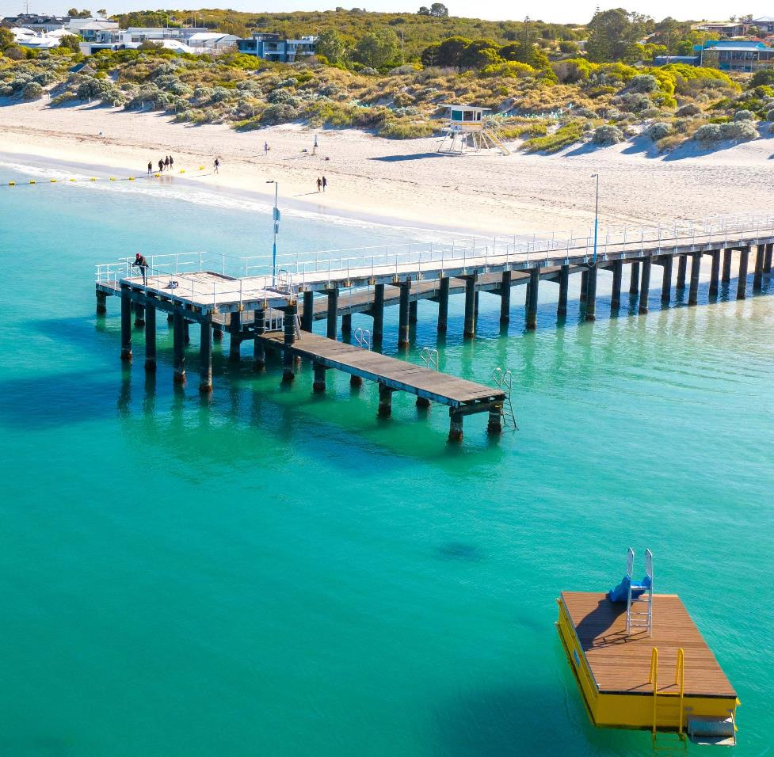
Coogee Jetty - December 2020

Contact
9 Coleville Crescent, Spearwood WA 6163
PO Box 1215, Bibra Lake DC WA 6965
Telephone: 08 9411 3444
Email: customer@cockburn.wa.gov.au
City of Cockburn website: www.cockburn.wa.gov.au

City of Cockburn Facebook: www.facebook.com/CityofCockburn
City of Cockburn Twitter: www.twitter.com/CityofCockburn
City of Cockburn Instagram: www.instagram.com/cityofcockburn
City of Cockburn YouTube: www.youtube.com/CityofCockburn
This information is available in alternative formats upon request.
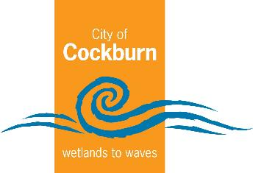
Cockburn, the best place to be

