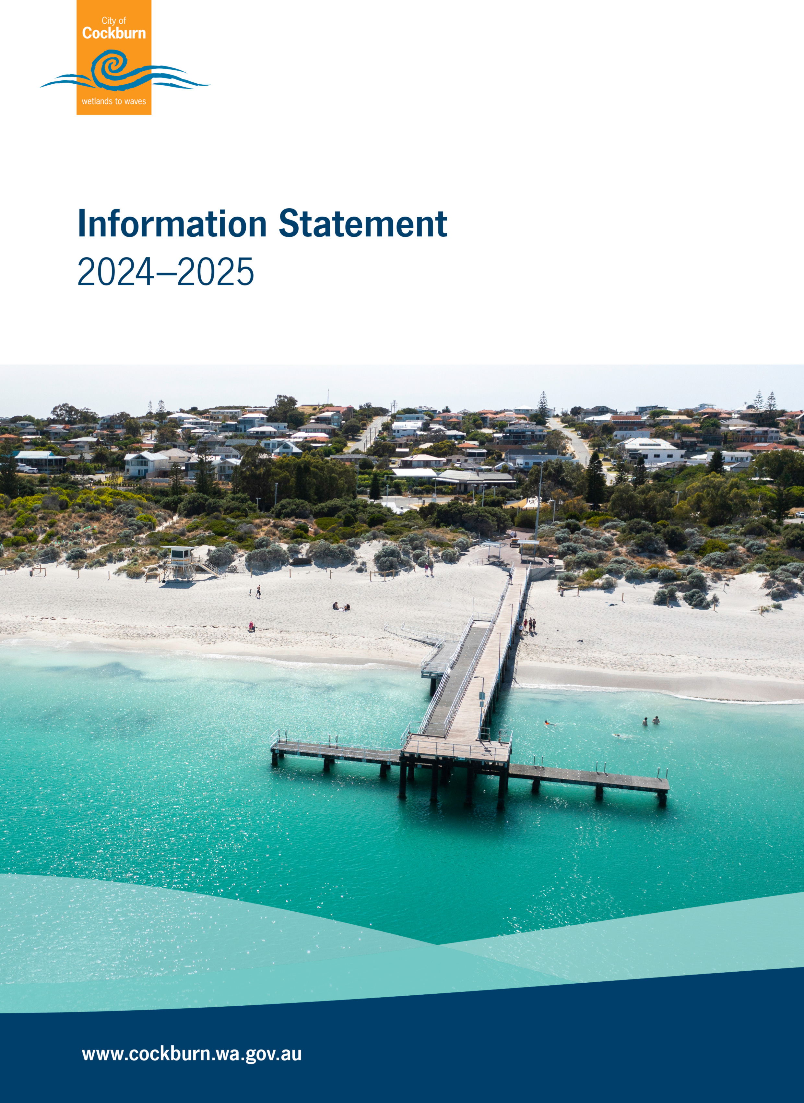

Table of Contents
1. Preface 1
2. Legislation Administered 2
2.1 Legislation 2
2.2 City of Cockburn Local Laws 5
3. Structure of the City 7
3.1 Council Structure 7
3.2 Organisational Structure 8
4. Functions of the City 10
4.1 The Council 10
4.2 The Mayor 10
4.3 Role of the Councillors 11
4.4 The Chief Executive Officer 11
4.5 The Local Government Act 1995 11
4.6 Standing Orders 12
4.7 Policies of the Council 12
4.8 Delegated Authority 12
4.9 Council Local Laws 12
5. Public Participation 13
5.1 Community Consultation 13
5.2 Elected Members 13
5.2.1 How to contact Elected Members 13
5.2.2 Council Elections 13
5.3 Written Request 14
5.4 Ordinary Meeting of the Council 14
5.4.1 Petitions 14
5.4.2 Public Question Time 15
5.5 Reference Groups to the Council 15
6. Documents Held by the City of Cockburn 16
6.1 Documents available without submission of a Freedom of Information Request 16
6.2 Other Documents Held by the City 16
6.3 Charges for Planning Services 17
6.4 Charges for Public Health Services 19
7. Operation of the FOI Act at the City of Cockburn 21
7.1 Initial Enquiries 21
7.2 Request for Information under the Freedom of Information Act 1992 21
7.3 Forms of Access and Amendment to Personal Information 24
7.4 Fees and Charges 26
7.5 Organisation Decision Makers Regarding Access for Amendment 27
Appendix 1: 28

Preface
The Freedom of Information Act 1992 (the FOI Act), which came into effect in 1993, created a general right of access to documents held by State and local government.
The objects and intent of the FOI Act are to:
- Enable the public to participate more effectively in governing the State.
- Make the persons and bodies that are responsible for State and local government more accountable to the public.
To meet these objectives the FOI Act requires local government agencies to publish an information statement that is to be updated annually. The City of Cockburn’s (the City’s) Information Statement serves as that information statement.
The City’s Information Statement includes information on:
- The structure and functions of the City
- Decision-making functions
- Community participation in the formulation of the City’s policy and performance of the City’ s functions
- Description of the kinds of documents generated and held by the City and which documents may be viewed, purchased, or obtained free of charge
- How to access documents and personal information held by the City
- How to amend personal information in documents held by the City.
Copies of this document can be obtained by accessing the City’s website or by visiting the City of Cockburn Administration Centre.
City of Cockburn
9 Coleville Crescent
Spearwood WA 6163
Telephone: (08) 9411 3444
Fax: (08) 9411 3333
Email: foi@cockburn.wa.gov.au
Website: City of Cockburn: www.cockburn.wa.gov.au

Bernadette Pinto
Governance Officer/FOI Coordinator

Legislation Administered

2.1 Legislation
The following is a list of legislation passed by the Federal and State Parliaments for which the City of Cockburn is responsible.
- Building Act 2011
  - An Act to administer building works both public and private throughout the State of WA.
- Bush Fires Act 1954 and Subsidiary Legislation
  - An Act to make better provision for diminishing the dangers resulting from bush fires and the prevention, control, and extinguishment of bush fires.
- Cat Act 2011
  - An Act to provide for the control and management of cats, and promote and encourage the responsible ownership of cats, and for related matters.
- Caravan Parks and Camping Grounds Act 1995 and Subsidiary Legislation
  - An Act to provide for the regulation of caravanning and camping, to control and license caravan parks and camping grounds, to provide for standards in respect of caravans, to amend certain Acts and for related purposes.
- Cemeteries Act 1986
  - An Act to provide for the declaration and management of cemeteries, the establishment, constitution and functions of cemetery boards, the licensing of funeral directors, and the regulation of burials.
- Control of Vehicles (Off-road Areas) Act 1978
  - An Act to prohibit the use of vehicles in certain places, to make provision as to the use of vehicles otherwise than on a road, to provide for areas where the use of off-road vehicles shall be permitted, for the registration of off-road vehicles, and for related purposes.
- Dog Act 1976 and Subsidiary Legislation
  - An Act to amend and consolidate the law relating to the control and registration of dogs, the ownership and keeping of dogs and the obligations and rights of persons in relation thereto, and for incidental and other purposes.
- Food Act 2008 and Subsidiary Legislation
  - An Act providing for the safety and suitability of food for human consumption, and for related purposes.
- Environmental Protection Act 1986
  - An Act to provide for the prevention, control, and abatement of environmental pollution and for the conservation, preservation, enhancement, and management of the environment. The City’s Environmental Health Officers are authorised persons under the Act for the emission of noise and unauthorised discharges from premises.
- Health (Miscellaneous Provisions) Act 1911 and Associated Regulations
  - An Act to consolidate and amend the Law relating to Public Health, the introduction of which will occur in a staged manner.
- Heritage Act 2018
  - An Act requiring all local authorities to compile and regularly review an inventory of local places which are significant or may become significant heritage properties.
- Justices of the Peace 2004
  - An Act to consolidate and amend the Laws relating to Justices of the Peace and their Powers and Authorities.
- Liquor Control Act 1988 and Subsidiary Legislation
  - An Act administered in part by Local Government to regulate the sale, supply, and consumption of liquor, use of premises on which liquor is sold and the services and facilities provided in conjunction with or ancillary to the sale of liquor.

- Litter Act 1979 and Subsidiary Legislation
  - An Act to make provision for the abatement of litter and to establish, incorporate and confer powers upon the Keep Australia Beautiful Council (WA).
- Local Government Act 1995 and Subsidiary Legislation
  - To provide the good rule and government, convenience, comfort, and safety of persons in Municipal districts, with it being Council's responsibility to administer it within the City of Cockburn.
- Public Health Act 2016 and Subsidiary Legislation
  - An Act to consolidate and amend the Law relating to Public Health, the introduction of which is occur in a staged manner.
- Public Works Act 1902
  - An Act to consolidate and amend the laws relating to public works.
- Rates and Charges (Rebates and Deferments) Act 1992
  - An Act to permit administrative authorities to allow rebates on or the deferral of payment of certain amounts payable by way of rates or charges by pensioners and other eligible persons.
- Community Titles Act 2018
  - An Act to facilitate the subdivision of land into cubic spaces and the disposition of titles thereto and to provide for incidental and connected purposes.
- Planning and Development Act 2005
  - This Act provides for the planning and development of land for urban, suburban, and rural purposes. The general objective of this Act is to improve and develop land to the best possible advantage and to balance the use of all land resources.
- Planning and Development (Local Planning Schemes) Regulations 2015
  - The regulations provide arrangements for local planning strategies, schemes and amendments and provide a Model Scheme Text and a set of provisions that form part of every local planning scheme in the State.
- City of Cockburn Town Planning Scheme No. 3
  - This is the Town Planning Scheme which controls the development and use of land in the district.
- Valuation of Land Act 1978
  - An Act to provide for the valuation of land and for other purposes.
- Land Administration Act 1997
  - An Act which provides for the disposition and management of State land.
- Work Health and Safety Act 2020
An Act --
  - to make provision about, and in connection with –
  - the health and safety of workers; and
  - health and safety at workplaces; and
  - risks to health and safety arising from work;
and
  - to make consequential and related amendments to, and repeals of, various written laws; and
  - for related purposes

2.2 City of Cockburn Local Laws
The following are the Local Laws administered by the City of Cockburn:
- City of Cockburn Consolidated (Local Government Act) Local Laws 2000
These are the City’s consolidated local laws enabling the control and regulation of Animals in Public Places, Beaches and Reserves, Dangerous and Offensive Things, Hawkers, Stallholders and Street Traders, Council Property, Signs, Hoardings and Billpostings, Streets and Public Places, Security and Law and Order.
- City of Cockburn Health Local Law 2000
To enable Council to provide for the regulation, control, and management of day to day health matters and to establish various health standards and requirements for the district.
- City of Cockburn Parking and Parking Facilities Local Law 2007
Enables Council to regulate the parking of vehicles within the parking regions and provide for the management and operation of parking facilities occupied by the local government.
- City of Cockburn Jetties, Waterways and Marina Local Law 2012
Enables Council to provide a mechanism for the regulation and control of activities within the Port Coogee Marina waterways and associated infrastructure.
- City of Cockburn Fencing Local Law 2012
Enables Council to regulate, control and manage fences within the district.
- City of Cockburn Standing Orders Local Law 2016
Details the conduct of Council Business proceedings and establishes the procedures to be followed at Council meetings to ensure that they are conducted in an orderly manner.
- City of Cockburn Bush Fire Brigade Local Law 2025
Enables the Council to establish and maintain normal activities of the Bush Fire Brigades.
- City of Cockburn Waste Local Law 2020
Enables the Council to establish and maintain local laws for waste avoidance, resource recovery, and provide for waste services.

Structure of the City

3.1 Council Structure
The Council of the City of Cockburn consists of ten (10) Elected Members including the Mayor. The Mayor is elected by the community, with the Deputy Mayor elected by the Councillors. The Deputy Mayor is elected by Council at its first meeting following the Local Government Elections every two years. The Mayor and Councillors serve a term of four (4) years, with elections held in October every two years.
Elected Members’ details and the Ward represented by each comprise the following:
- Mayor
  - Logan K Howlett JP
- East Ward
  - Cr Carol Zhang
  - Cr Carol Reeve-Fowkes
  - Cr Tarun Dewan
- West Ward
  - Deputy Mayor Phoebe Corke
  - Cr Kevin Allen
  - Cr Hilda Srhoy
- Central Ward
  - Cr Philip Eva JP
  - Cr Tom Widenbar
  - Cr Chontelle Stone

3.2 Organisational Structure
The CEO is responsible for managing the day to day operations of the City, who, along with the Executive Leadership Team and staff, act on the Council’s decisions by developing and putting into practice Council policies and resolutions. The City has seven Divisions led by Division Chiefs and Executives who report directly to the Chief Executive Officer, as the senior officer within the organisation. The seven are:
- Governance and Strategy
- Built and Natural Environment
- Finance
- Operations
- Community Services
- Corporate Affairs
- People Experience and Transformation
Under the Divisions there are 13 Business Units, each of which has a Head to manage the day-to-day running of the operational areas.

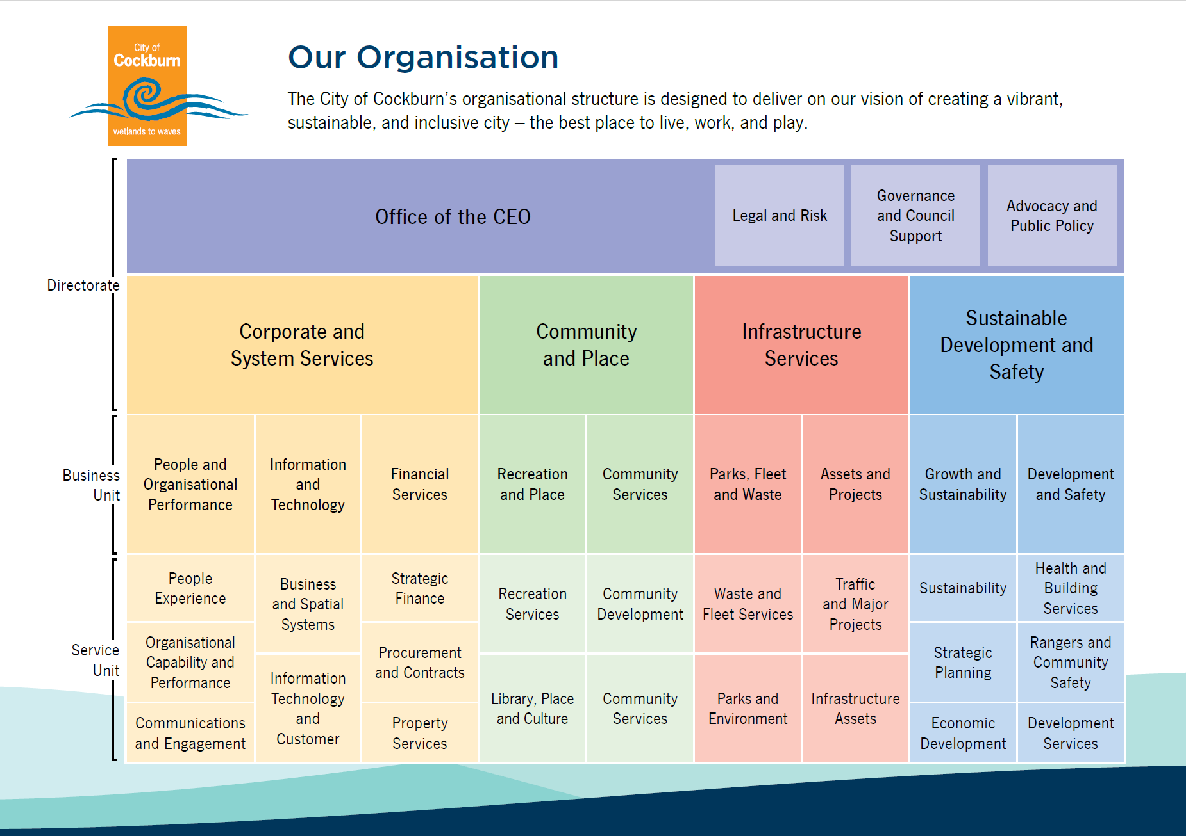

Functions of the City

4.1 The Council
The Council is made up of members of the local community who are elected to office for a term of four years by residents and ratepayers of the City.
The Council comprises ten Elected Members who serve in three Wards - East, West and Central and the Mayor. As a group they are the decision-making body. (A map showing the Ward boundaries is attached at Appendix 1).
The Council Meeting receives reports for consideration from Divisional officers. These reports contain recommendations which Council adopt, reject, amend, or defer pending receipt of further information.
The Council Meeting is attended by the Elected Members, Chief Executive Officer, four Chiefs, three Executives, Council Minute Officer, Governance Officer, Manager, Legal and Compliance, City Media Officer and any other officers as determined necessary. This meeting is held on the second Tuesday of each month in the Council Chambers commencing 7pm, with members of the public welcome to attend.

4.2 The Mayor
The Mayor is the City's Civic Leader and presides at all Council Meetings.
The role of the Mayor is to:
- preside at meetings in accordance with the Local Government Act;
- provide leadership and guidance to the community in the district;
- carry out civic and ceremonial duties on behalf of the Council;
- speak on behalf of the Council;
- perform such other functions as are given to the Mayor by the Local Government Act or any other written law; and
- liaise with the Chief Executive Officer on the affairs of the Council and the performance of its functions.
The role of the Deputy Mayor is to perform the functions of the Mayor when authorised to do so in the Mayor’s absence.

4.3 Role of the Councillors
Councillors do not have any authority to act or make decisions as individuals and they are members of a corporate body working together for the community. Decisions must therefore be the consensus decisions of Council.
Nevertheless, Councillors play a key role in the policy-making of a Council and thus have responsibility, in many ways, for:
- representing the interest of electors, ratepayers, and residents of the district;
- providing leadership and guidance to the community in the district;
- facilitating communication between the community and the Council;
- participating in the Council's decision-making processes at Council and Committee Meetings; and
- performing such other functions as are given to a Councillor by the Local Government Act or any other written law.
A Councillor’s task in fulfilling these responsibilities vary from abstract discussions of Council's aims and objectives to the real functions of replying to requests, passing-on electors' points of view for action and preparing notes on matters to bring before Council. Involvement in local government requires an active community role.

4.4 The Chief Executive Officer
The day to day management of the City rests with the Chief Executive Officer. Under their leadership, staff act on Council decisions by developing and putting into practice the Council policies and resolutions.

4.5 The Local Government Act 1995
The Local Government Act 1995 describes the functions of local governments and provides a framework for the administration and financial management of local governments. The Act also provides for community participation in the decisions and affairs of local governments as well as setting out measures which make local governments more accountable to their communities.

4.6 Standing Orders
The Local Law relating to the Conduct of Proceedings of the Business of the Council, known as the Standing Orders, govern the proceedings of Council and Committee Meetings. In governing the proceedings of a meeting, the local law specifically details issues such as the order of business at Council meetings, conduct of meetings with regard to determinations by the Presiding Member, rules of debate, voting and amendments and various miscellaneous matters.

4.7 Policies of the Council
To provide guidance for the Officers of the City, Council adopts policies which are included in the Policy Manual and provide the basis for decision-making-.
The Policy Manual includes Council policies on Assets and Maintenance, Business, Economy and Technology, Community Support and Development, Corporate Planning, Budgeting and Procurement, Elected Members, Environment and Sustainability, Events, Arts, Culture and Heritage, Fire and Emergency Management, Governance, Libraries, Planning (Land Administration), Planning (Town Planning and Development), Public Health and Security, Sport and Recreation, Street Trees and Verges, Subdivision Development, Transport, Traffic and Parking.

4.8 Delegated Authority
The Chief Executive Officer and some Senior Officers and other Officers have delegated authority from the Council to make decisions where the head of power in the relevant Acts allows. These delegations are listed in the Council Register of Delegated Authority and are reviewed annually by the Council.

4.9 Council Local Laws
The local laws adopted by the Council ensure that facilities in the City of Cockburn are maintained for all residents of the City to utilise and that all local laws are administered consistently.

Public Participation
Opportunities for public participation include:

5.1 Community Consultation
The Council seeks the views of the community in a number of projects in which it is involved. Community involvement can range from surveys seeking the opinions of residents in relation to traffic treatments, to parks design in conjunction with community artists. In providing for public participation in planning, the City’s Town Planning Scheme No. 3 specifies certain types of development applications be advertised for public comment. The City may also facilitate various forums and meetings to engage with the community on planning proposals. The Council also has a statutory obligation to advertise and invite public submissions relating to proposals to adopt or modify the City's Local Laws, Local Planning Strategy, Local Planning Scheme and Local Planning Policies.

5.2 Elected Members

5.2.1 How to contact Elected Members
Members of the public can contact their Elected Members to discuss any issue relevant to the Council. Should issues be operational in nature, members of the public should contact the City directly to seek assistance.
Contact telephone numbers for Elected Members are listed in the various publications produced by Council such as the Annual Report and Cockburn Soundings or by accessing the City of Cockburn website.
Residents wishing to write to an Elected Member should send their correspondence to their individual email addresses which can be found on the City’s website or to:
City of Cockburn
PO Box 1215
Bibra Lake DC WA 6965
Or via email to electedmembers@cockburn.wa.gov.au

5.2.2 Council Elections
Council elections are held every two years on the third Saturday in October. Members are elected to positions for a four-year term.
The Mayor is elected by the community for a four-year term. The Deputy Mayor is elected by the members of Council every two years but also serves a term of four years as a Councillor.
Although voting in local government elections is not compulsory, ratepayers and residents are strongly encouraged to exercise their democratic right and directly participate in the electoral process.

5.3 Written Request
Residents can write to Council on any Council policy, activity or service that takes place within the community.

5.4 Ordinary Meeting of the Council
The public can attend any Ordinary Council, Special Council Meeting and Audit Risk and Compliance Committee Meeting but is not allowed to take part in the debate.
Members of the public have opportunities to put forward their views on particular issues before Council.

5.4.1 Petitions
Petitions inform the Council, in a public way, of the views of a section of the community and serve as a means of placing community concerns before Council.
Electors of the City of Cockburn, from different properties, may petition the City to take some form of action over a particular issue. For example, petitions may request the Council to change an existing policy, local law, or recent decision, or for the Council to take action for a certain purpose or for the benefit of particular persons. The subject of a petition however must be a matter on which the Council has the power to act.
When a Petition is received by an Elected Member, it will be referred to the Chief Executive Officer for appropriate action. Every Petition presented will be referred to an officer who is responsible for investigating the matter. This officer will inform the Petition initiator of the action proposed in dealing with the Petition. This may involve having to prepare a detailed report for a future meeting of the Council for its consideration.

5.4.2 Public Question Time
The Local Government Act 1995 provides that question time be allocated at all Ordinary and Special Meetings of Council and the Audit Risk and Compliance Committee Meeting.
Electors and members of the public have the opportunity to participate in Council Meetings by asking question(s) during Public Question Time. If a question cannot be answered effectively at the meeting, a reply will be forwarded by the Administration in writing.
The following rules apply to the public address session:
  - Questions provided in writing by the deadline (5pm the previous day of the Council meeting) on issues on the Agenda before Council will be called for first.
  - Questions raised at the meeting on any matter relating to the City which is not on the Agenda will then be called.
  - Questions received in writing by the deadline (5pm the previous day of the Council meeting) on non-agenda items.
  - Questions raised at the meeting on non-agenda items.
  - Each person is restricted to three (3) minutes to ask their question(s).
  - Any person addressing Council must resume their seat when called upon to do so by the Presiding Member. Speakers will be called upon to resume their seat if they resort to personal denigration of an Elected Member, City Officer, or another Member of the Public.

5.5 Reference Groups to the Council
A Reference Group may be appointed to facilitate the provision of informed and considered views on issues for inclusion in Council deliberation.

Documents Held by the City of Cockburn

6.1 Documents available without submission of a Freedom of Information Request
The following documents are examples of those available for public inspection at the Administration Building free of charge. Members of the public may purchase copies of documents and the charges are shown as follows:
Documents | Price
Building Plans | For viewing by owner or with owners’ permission only
Determinations made under the City of Cockburn Town Planning Scheme | For viewing by owner or with owners’ permission only
Scheme maps | Fees and Charges Schedule

Council Agendas/Minutes are available to the public on the City’s website Agendas and Minutes - City of Cockburn at the following times:
Council Agenda | 4pm on the Friday prior to Council meeting of each month excluding the month of January (no Council meetings)
Council Minutes (previous month) | Ten (10) working days from the date of Council Meeting

6.2 Other Documents Held by the City
The City of Cockburn holds several different types of documents for which a Freedom of Information request for information should be submitted. These include letters and general correspondence, internal reports, external consultant reports to other agencies, plans, memorandums, and drawings. Bulletins, circulars, magazines, and periodical publications are not generally held on record by City, unless such information is included on, or accompanied by, a letterhead of the relevant organisation.
Information is held on the City's central records system which is a type of multi-numbered classification system grouped into functional areas. Employee information is held either in the central records system or personal files held by the People, Culture and Safety Division, which is not usually available for inspection by the public.

6.3 Charges for Planning Services
In addition to the above the City also undertakes several planning services for a fee. These are as follows:
Development:
Refer to Fees and Charges Schedule for determination of development application (other than for an extractive industry).
Advertising of Development Applications
0-10 Letters | No charge
11-50 Letters | $100
51-100 Letter | $200
101-150 Letters | $300
151 + Letters | $400

Subdivision Clearances:
Not more than 5 lots | $73 per lot
More than 5 lots but not more than 195 lots | $73 per lot for the first 5 lots then $35 per lot thereafter
More than 195 lots | $7,393

Built strata:
Not more than 5 lots | $65.00 per lot + a base rate of $656
More than 5 lots but not more than 100 lots | $43.50 per lot for Lot no.6 to100 + base rate of $981
More than 100 lots | $5113.50

Local development plans:
Local Development Plan | $1560
Modification to local Development Plan | $780

Miscellaneous:
Zoning Statements/Zoning Certificates | $73
Reply to a property settlement questionnaire | $73
Issue of written planning advice (Also applies to research and written information not associated with a current development, subdivision, or rezoning application). | $73
Section 40 Liquor Licensing Certificates | $200

Scheme Amendments/Structure Plans:
These fees are calculated according to estimated salary costs, direct costs, specialist report costs and documentation costs. This is as per the Planning and Development Regulations 2015. Anyone wishing to lodge either a scheme amendment or structure plan should firstly contact the Planning Department to obtain a fee quotation. Fees need to be paid prior to the formal assessment of a proposal beginning.
Reports & Maps:
Scheme Text | $60.00
Other (per page) | $0.40
Map Colour A3 | $15.00
Map Colour A2 | $20.00
Map Colour A1 | $40.00
Map Colour A0 | $80.00

Note: While this list describes application fees, please be aware you may be subject to Development Contributions if your proposal is approved. For more information visit: Development contribution: https://www.cockburn.wa.gov.au/Building-and-Development/Developer-Contributions or contact 9411 3444.

6.4 Charges for Public Health Services
Food premises in the City of Cockburn are subject to routine assessments to determine if the premises and practices comply with the relevant requirements of the Food Act 2008, the Food Regulations 2009, and Australia New Zealand Food Standards Code (Australia Only).
All prospective food premises purchasers are strongly recommended to review these documents so that they are aware of their legal obligations.
The Fee required for a settlement enquiry is currently $95.00 if no inspection is required or $190.00 if an inspection is requested. A report outlining the condition of the premises in relation to the Food Act and Food Standards Code will be provided.
Environmental Health Historical File Search
Property owners and prospective purchasers of properties can have an Environmental Health Historical File Search undertaken to find out what activities have been undertaken on their properties. This is particularly relevant for Contaminated Sites investigations. A search of City records may reveal specific information relating to wastewater systems, complaints and sometimes, general land use activities. The fee for such an enquiry is $190.00 (for up to 2 hours research) and if it is extensive, additional charges of $95.00 per hour may be incurred as part of the process.

7. Operation of the FOI Act at the City of Cockburn

7.1 Initial Enquiries
Initial enquiries regarding the release of information should be made to the FOI Coordinator (Governance Officer) either in person at the Administration Building or by telephone 9411 3444.
Further information can be obtained from the Information Commissioner’s Office and the Freedom of Information Act, available on the State Law Publisher’s website (www.legislation.wa.gov.au).

7.2 Request for Information under the Freedom of Information Act 1992
Requests for information may be considered in accordance with the FOI Act.
All applications must:
- Be in writing.
- Give enough information so that the documents are readily identified.
- Provide an Australian address to which information may be sent.
- Be lodged at the City with the application fee payable.
There is no application fee or charges associated with FOI applications for personal information about the applicant, and amendment of personal records. Written requests for non-personal information should be forwarded with the application fee of $30.00 to:
By Post
FOI Coordinator
City of Cockburn
PO Box 1215
Bibra Lake DC WA 6965

In Person
FOI Coordinator
City of Cockburn
9 Coleville Crescent
Spearwood WA 6163

Or online at Freedom of Information - City of Cockburn
Telephone: (08) 9411 3444
Facsimile: 08) 9411 3333
Email: foi@cockburn.wa.gov.au

Applicants will receive a response from the City as soon as possible within the statutory forty-five (45) days of the City receiving the request with the application fee.
Access Arrangements
Access to documents may be granted by way of inspection, a copy of a document, an audio recording, and a manuscript of a recording or by email.
Refusal of access
Some documents are exempt. Schedule 1 of the FOI Act is designed to protect essential public and private interests. However, exemptions may not be claimed unless there are good reasons to deny access to requested information. Exempt information may be personal or commercial information.
Notice of Decision
As soon as possible, but in any case, within forty-five (45) calendar days, the applicant will be provided with a Notice of Decision, which will include details such as:
- The date which the decision was made.
- The name and the designation of the officer who made the decision.
- If any documents are exempt documents, the reasons for classifying them as exempt or the fact that access is given to an edited document.
- Information on the Right of Review and the procedures to be followed to exercise those rights.
Internal Review Rights
Should an applicant not be satisfied with an access decision, they have the right to apply for an Internal Review.
An application for internal review must be lodged within thirty (30) calendar days after being given this written Notice of Decision, and must:
- Be in writing.
- Give particulars of the decision to be reviewed.
- Provide an Australian address to which notices can be sent.
There is no lodgement fee for an application for Internal Review and there are no charges for dealing with an Internal Review request.
If an application for Internal Review is received, it will not be dealt with by the person who made the initial decision, or by any person who is subordinate to the original decision-maker. The outcome of an application for Internal Review may result in a confirmation, variation, or reversal of the initial decision under review. Applicants are advised of the outcome within fifteen (15) calendar days from the date of receiving the Internal Review request.
The address for lodgement of an Internal Review is:
FOI Coordinator
City of Cockburn
9 Coleville Crescent
Spearwood WA 6163

Mail to:
FOI Coordinator
City of Cockburn
PO Box 1215
Bibra Lake DC WA 6965
Facsimile: 08 9411 3333
E-mail: foi@cockburn.wa.gov.au

External Review Rights
Should an applicant not be satisfied with the decision of the Internal Review, they then have the right to lodge a complaint with the Office of the Information Commissioner seeking an External Review of that decision. The applicant is required to lodge their complaint with the Office of the Information Commissioner within sixty (60) calendar days of receiving the Notice of Decision.
A complaint to the Information Commissioner must –
- Be in Writing.
- Give particulars of the decision to which the complaint relates.
- Have attached a copy of the Internal Review Decision or initial decision if Internal Review was not available.
- Give an address in Australia to which notices can be sent.
There is no charge for lodging a complaint with the Office of the Information Commissioner.
The office and postal address of the Information Commissioner is:
Office of the Information Commissioner
Albert Facey House
469 Wellington Street
Perth WA 6000
Telephone: 6551 7888
E-mail: info@foi.wa.gov.au
Website: www.oic.wa.gov.au

Should the applicant have any further queries or require any further information about their rights at this stage, the applicant is to contact the Office of the Information Commissioner.

7.3 Forms of Access and Amendment to Personal Information
Access to personal information pertaining only to them is available to the public free of charge.
If a person finds that information contained in a document is inaccurate, incomplete, out of date or misleading, then the person can apply to the City to amend the information.
Amendment can be made free of charge in writing and forwarding it to the City of Cockburn.
A person can request access to documents by way of inspection, a copy of a document, an audio recording, a manuscript of a recording or a written document in the case of a document from which words can be reproduced in written form.
Where the City is unable to grant access in the form requested, access may be given in a different form.

7.4 Fees and Charges
Charges in addition to the application fee for access to documents are made in accordance with the Freedom of Information Act 1992. If it is anticipated the access cost will exceed $30.00, the applicant has a right to request an estimate of the likely charges for the application. Furthermore, it is the City’s responsibility to notify the applicant of any estimate exceeding this figure and the basis upon which it has been calculated, with Council to inquire as to whether the applicant wishes to proceed with the application.
The current fees and charges as applied by the City of Cockburn are as follows:
Description | Amount
Application (for applications for personal information of the applicant) | No fee
Application (for applications for non-personal information) | $30.00
Charge for time dealing with application (per hour or pro-rata for a part of an hour) | $30.00
Charge for access time supervised by staff (per hour, or pro-rata for a part of an hour) | $30.00
Charges for photocopying:
• per hour, or pro-rata for a part of an hour of staff time  • per copy | $30.00  $0.20¢
• Charge for time taken by staff transcribing information from a tape or other device (per hour, or pro-rata for a part of an hour) | $30.00
• Charge for duplicating a tape, film, or computer information | Actual Cost
• Charge for delivery, packaging, and postage | Actual Cost
• Advance deposit which may be required by agency under Section 18(1) of the Act, as a percentage of the estimated charges will be payable in excess of the application fee. | 25%
• Further advance deposit which may be required by an agency under Section 18(4) of the Act, expressed as a percentage of the estimated charges will be payable in excess of the application fee. | 75%
• Internal Review & External Review | No fee

7.5 Organisation Decision Makers Regarding Access for Amendment
The FOI Coordinator advises on what information may be released and what information is exempt under the FOI Act.
Decisions relating to the review of a request for information are made by the Chief Executive Officer.

Appendix 1:
The map below shows the division of the West Ward (Purple), Central Ward (Yellow) and East Ward (Green). Please contact City of Cockburn for more information or clarification.



