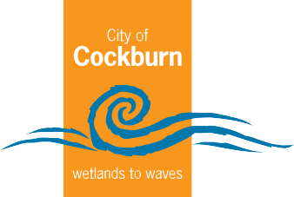
City of Cockburn | Public Health Service

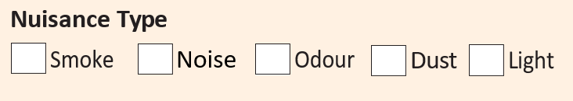
Public Health Record of Events
REMEMBER! Complaints are often best resolved by speaking to your neighbours. Together we can make the City of Cockburn the best place to be.

Date | Time |  | Weather | What Happened | Nuisance Rating | Your Actions
Date | Start | Finish


Noise Rating
N5 Extremely loud jumbo jet
N4 Noise equivalent to rock band
N3 Noise equivalent to power tools

N1 Low-level noise conversation
Smoke Rating
No visible
smoke
Visible
Smoke
Thick
black smoke
These nuisance ratings can be used to complete the Records of Events.
Filling out this form correctly with information relating to your concern, will assist the City’s Environmental Health Officer in investigating this matter.
Previous case law suggests that in order to prove a “nuisance”, accurate and verifiable evidence is required should legal action be taken.








Useful Agencies
Dust Rating
D5 Visible dust crossing site boundary
D4
D3 Dust on site
D2
D1 No dust
Odour Rating
Odour
Strong
Odour
Law Society of WA 9324 8600
Murdoch Police 9313 9000
Cockburn Police 9418 9777
COSAFE 1300 267 233
Fremantle Police 9430 1000
Citizens Advice Bureau 9221 5711
Things to consider for weather conditions:
•
•
•
- Clear / Cloudy
Real Estate Institute WA 9380 8222
Tenants Advisory Board 6148 3636
Department of Health 9222 2000
Water Corporation 13 13 95

I declare this document is true and correct to the best of my knowledge and belief, and I made this statement knowing that if it is tendered in evidence I will be willfully guilty of a crime if I have included anything in this document that I know to be false or I do not believe to be true.

