Tender Title: |  | RFT 20/2025 – Electrical Services – City Wide Maintenance, Repairs, Replacement, Testing and Design
Request ID: |  | 70243
Tender Description: |  | The City of Cockburn (the principal) is seeking WA licensed, experienced and reliable Electrical Contractor(s) to provide City Wide Maintenance, Repairs, Replacement, Testing and Design at the Principal’s buildings and properties, parks and reserves throughout the City of Cockburn. This includes various administration buildings, Cockburn ARC, the Port Coogee Marina, community centres, sports clubrooms, libraries, residential housing, toilet blocks, irrigation cabinets, lighting, barbeques etc.  Tenderers were invited to apply for one, multiple or all of the following services:  1.Facilities Citywide - excluding Cockburn ARC (Schedule A).  2.Parks (Schedule B).  3.Cockburn ARC (Schedule C).
Advert Approval: |  | Decision to Advertise: Director Infrastructure Services  Decision Date: Saturday, 9 August 2025
Closing Date and Time: |  | 2:00PM (AWST) Tuesday, 2 September 2025
Opening Date and Time: |  | 2:00PM (AWST) Tuesday, 2 September 2025
 | Tenderer’s Name:
1 | Gilmour & Jooste Electrical Pty Ltd
2 | Nilsen WA Pty Ltd
3 | North Lake Electrical Pty Ltd
4 | Paramount Power
5 | Pearmans Electrical Services
6 | Surun Services Pty Ltd

Advertisement
Method 1: City of Cockburn Website | Method 2: City of Cockburn Public Libraries Notice Boards
Method 3:  The Western Australian, Saturday 9 August 2025 | Tender Awarded by:
Copy of Statewide Notice:  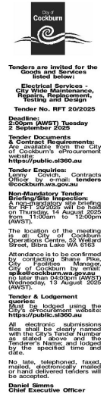 | OCM  Tuesday, 11 November 2025
 | Date of Council Meeting:
Tuesday, 11 November 2025
Minutes: 0209
Item No: 14.3.1
Name of Successful Tenderer(s): | North Lake Electrical Pty Ltd
Amount of Successful Tender(s): (ex GST) | Schedule A - $2,824,020.00  Schedule B - $549,742.70  Schedule C - $783,852.00

