Tender Title: |  | CONSULTANCY SERVICES Detailed Design & Documentation – Hammond Road Upgrade (Russell Road to Frankland Road)
Request ID: |  | 70193
Tender Description: |  | The intent of this tender is to select a suitably qualified and experienced Consultant to undertake geometric design and design works for the road infrastructure upgrade of Hammond Road.
Advert Approval: |  | Decision to Advertise: Director Infrastructure Services  Decision Date: Friday, 11 July 2025
Closing Date and Time: |  | 2:00PM (AWST) Thursday, 14 August 2025
Opening Date and Time: |  | 2:00PM (AWST) Thursday, 14 August 2025
 | Tenderer’s Name:
1 | AARVEE Engineering Consultants Pty Ltd
2 | Design and Analysis Pty Ltd
3 | GHD Pty Ltd
4 | Ground Civil
5 | JJ Ryan Consulting Pty Ltd
6 | Porter Consulting Engineers
7 | Progressive Pty Ltd
8 | SMEC Australia Pty Ltd
9 | Stantec Australia Pty Ltd
10 | Talis Consultants
11 | WGA WA Pty Ltd
12 | WML Consultants

Advertisement
Method 1: City of Cockburn website | Method 2: City of Cockburn Libraries Public Noticeboards
Method 3:  The Western Australian, Wednesday, 16th July 2025 | Tender Awarded by:
Copy of Statewide Notice:  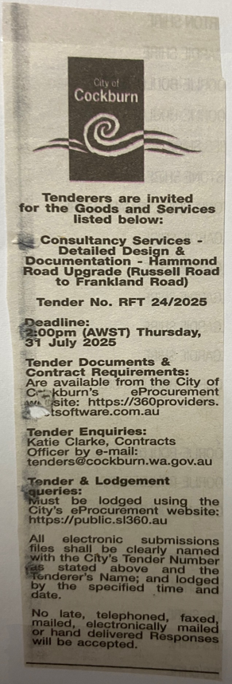 | Director Infrastructure Services  Choose an item.  Monday, 1 September 2025
 | Date of Council Meeting:
Date: N/A
Minutes: N/A
Item No. N/A
Name of Successful Tenderer(s): | WGA WA Pty Ltd
Amount of Successful Tender(s): (ex GST) | $314,875.00

