Tender Title: |  | RFT10/2021  Weed Spraying Services
Request ID: |  | 38363
Tender Description: |  | Weed Spraying Services (including kerb lines, footpaths, drainage sumps etc.) at locations throughout the Principals municipal area.
Advert Approval: |  | Decision to Advertise: Chief Operations Officer  Decision Date: Monday, 17 May 2021
Closing Date and Time: |  | Thursday, 10 June 2021
Opening Date and Time: |  | Thursday, 10 June 2021
 | Tenderer’s Name:
1 | Adelby Pty Ltd t/a Adelby Pty Ltd (Office)
2 | DOWNER EDI WORKS PTY LTD t/a DM Roads (Downer Roads – Bituminous Products and Services)
3 | ENVIRONMENTAL INDUSTRIES PTY LTD t/a Environmental Industries Pty Ltd (Maintenance)
4 | GAS ASSETS PTY LTD t/a Gecko Contracting Turf & Landscape Maintenance (Gecko Contracting Turf & Landscape Maintenance)
5 | SANPOINT PTY LTD t/a LD TOTAL (N/A)
6 | The Trustee for G & S BLAZESKI FAMILY TRUST t/a The Trustee for G & S BLAZESKI FAMILY TRUST trading as tiger pest and weed control
7 | The Trustee for SPRAYKING WA UNIT TRUST t/a Sprayking WA
8 | The Trustee for SUPA GROUP DISCRETIONARY TRUST t/a Supa Pest and Weed Control (Harry Prince)
9 | THE TRUSTEE FOR TURFMASTER UNIT TRUST t/a Turfmaster Facility Management
10

Advertisement
Method 1: City of Cockburn | Method 2: Yammer
Method 3:  The Western Australian  Wednesday, 19th of May | Tender Awarded by:
Copy of Statewide Notice:  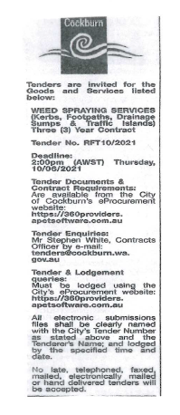 | Chief Operations Officer  Thursday, 5 August 2021
 | Date of Council Meeting:
 | Not applicable
Name of Successful Tenderer(s): | The Trustee for Sprayking WA Unit trust t/a Sprayking WA
Amount of Successful Tender(s): (ex GST) | $288,434

