Tender Title: |  | RFT05/2025 – Commercial Waste Front Lift Services
Request ID: |  | 55303
Tender Description: |  | The City of Cockburn (the Principal) requires contractors to provide the Principal with commercial front lift services. The contractor must service 18 x 3m3 bins from Council owned and operated sites within the City of Cockburn.  There is also a requirement to service 2 x 9m3 skip bins and a 30m3 hook lift bin from the City’s Operation Centre as detailed in Part 3 – Scope of Services of this Request for Tender (RFT) document.  The objectives of this RFT are to:  • Receive fee proposal from experienced contractors to provide commercial front lift services;  • Ensure the services expected meet the expectation of the Principal.
Advert Approval: |  | Decision to Advertise: Director Infrastructure Services  Decision Date: Monday, 10 February 2025
Closing Date and Time: |  | 2:00PM (AWST) Tuesday, 4 March 2025
Opening Date and Time: |  | 2:00PM (AWST) Wednesday, 12 February 2025
 | Tenderer’s Name:
1 | CLEANAWAY OPERATIONS PTY LTD
2 | KELAIR HOLDINGS PTY LTD t/a Instant Waste Management
3 | VEOLIA RECYCLING & RECOVERY PTY LTD
4

Advertisement
Method 1: City of Cockburn website | Method 2: City of Cockburn Libraries Public Noticeboards
Method 3:  The Western Australian, Wednesday,  12 February 2025, Page 42 | Tender Awarded by:
Copy of Statewide Notice:  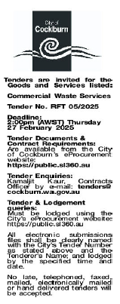 | Anton Lees, Director Infrastructure Services  Carissa Bywater, Director Corporate and System Services  Wednesday, 12 February 2025
 | Date of Council Meeting:
 | N/A

Name of Successful Tenderer(s): | VEOLIA RECYCLING & RECOVERY PTY LTD
Amount of Successful Tender(s): (ex GST) | $558,704.00 Ex GST

