Tender Title: |  | RFT 15-2020  Provision of Concreting Services - Footpaths, Shared Use Paths Etc. (In-Situ Construction)
Request ID: |  | 36416
Tender Description: |  | Concreting contractor to provide the Principal in-situ concreting requirements. The services include but are not limited to footpath, shared use paths, driveways/crossovers, and concrete pads/footings throughout the City of Cockburn.
Advert Approval: |  | Decision to Advertise: Director of Engineering & Works  Decision Date: Friday, 7 August 2020
Closing Date and Time: |  | 2:00pm (AWST) Thursday, 27 August 2020
Opening Date and Time: |  | 2:00pm (AWST) Thursday, 27 August 2020
 | Tenderer’s Name:
1 | AXIIS CONTRACTING PTY LTD t/a Axiis Contracting (Axiss Contracting)
2 | DOWSING GROUP PTY LTD
3 | FIRST CLASS CONCRETING PTY LTD t/a First Class Constructions (WA) (Projects)
4 | THE TRUSTEE FOR FOURIE FAMILY TRUST t/a Sable Contractors
5
6
7
8
9
10

Advertisement
Method 1 : City of Cockburn | Method 2 : NA
Method 3 :  The West Australian | Tender Awarded by:
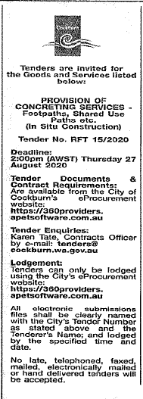  Copy of Statewide Notice: | OCM  Choose an item.  Thursday, 12 November 2020
 | Date of Council Meeting:
Thursday, 12 November 2020
Minutes: 0232
Item No: 16.2
Name of Successful Tenderer(s): | Dowsing Group Pty Ltd
Amount of Successful Tender(s): (ex GST) | $2,398,769

