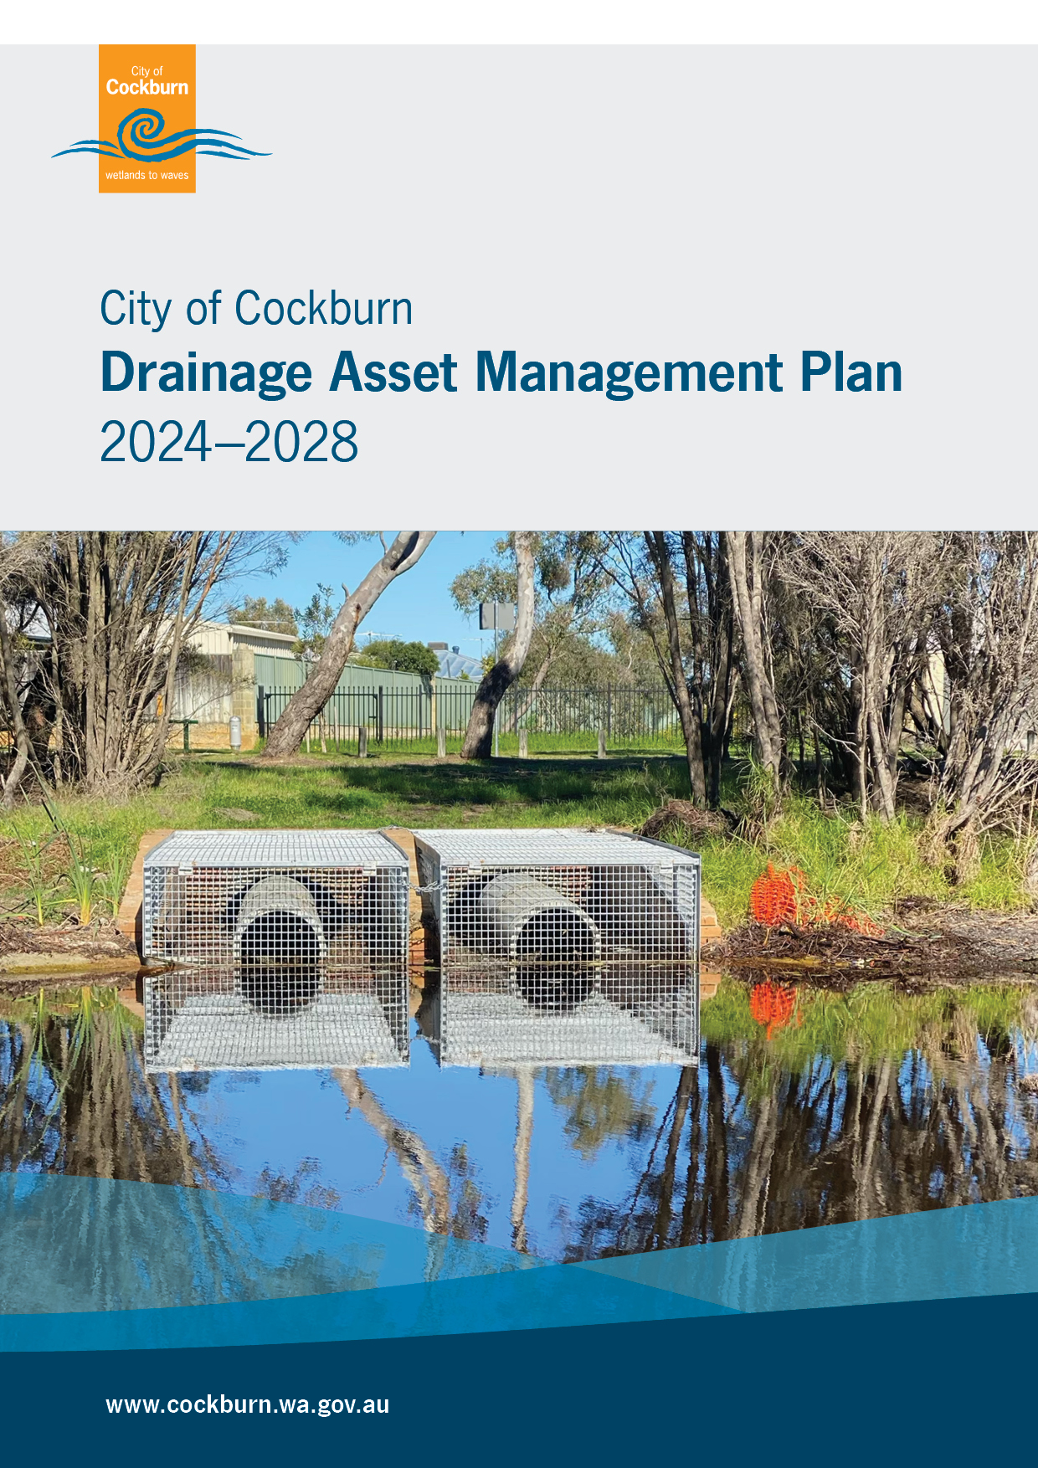
Cover page photo is taken at Atwell Reserve of the open drain outlet

Asset Management Plan
Document ID: 12330905
Date | Revision Details | Author | Reviewed | Approved
Sept 2021 | Final Version 2020 - 2024 | Property & Asset Services | Manager Engineering Services | Executive Committee / Council
April 2026 | Final Version 2024 - 2028 | Asset Services | Service Manager Infrastructure Assets | Executive Leadership Team / Elected Members

Acknowledgement of country
The City of Cockburn acknowledges the Nyungar people of Beeliar Boodjar. Long ago, now and in the future they care for Country.
We acknowledge a continuing connection to Land, Waters and Culture and pay our respects to Elders, past and present.
Contents
Acknowledgement of country 2
1 Executive summary 7
1.1 Purpose of the plan 7
1.2 Asset description 7
1.3 Levels of service 7
1.4 Future demand 8
1.5 Lifecycle management plan 8
1.6 Risk management 10
1.7 Financial summary 10
1.8 Assumptions and improvement planning 11
2 Introduction 12
2.1 Background 12
2.2 Stakeholders 12
2.3 Principles, goals and objectives of asset management 13
2.4 Plan framework 14
3 Levels of service 17
3.1 Customer research and expectations 17
3.2 Strategic and corporate goals 17
3.3 Legislative requirements 19
3.4 Customer values 19
3.5 Customer levels of service 20
3.6 Technical levels of service 22
4 Future demand 25
4.1 Demand drivers 25
4.2 Demand forecasts 25
4.3 Impacts and Demand Management Plan 25
4.4 Asset programs to meet demand 27
4.5 Climate change adaptation 27
5 Lifecycle management plan 29
5.1 Background data 30
5.2 Operations and maintenance plan 36
5.3 Renewal plan 38
5.4 Acquisition plan 40
5.5 Disposal plan 42
5.6 Summary of lifecycle costs and planned budget 42
6 Risk management planning 44
6.1 Critical assets 44
6.2 Risk assessment 45
6.3 Infrastructure resilience approach 47
6.4 Service and risk trade-offs 47
7 Financial summary 49
7.1 Financial statements and projections 49
7.2 Valuation forecasts 52
8 Assumptions and improvement planning 54
8.1 Data and information sources 54
8.2 Key assumptions 54
8.3 Forecast reliability and confidence 55
8.4 Improvement plan 56
8.5 Monitoring and review procedures 58
8.6 Performance measures 58
9 References 59
10 Appendices 60
10.1 Appendix A Acquisition forecast 60
10.2 Appendix B Operation forecast 61
10.3 Appendix C Maintenance forecast 63
10.4 Appendix D Renewal forecast summary 65
10.5 Appendix E Disposal summary 66
10.6 Appendix F Budget summary by lifecycle activity 67
10.7 Appendix G Legislative requirements 68

List of tables
Table 2.1: Key Stakeholders in the AMP 13
Table 3.1: Customer Satisfaction Survey Levels 17
Table 3.2: Goals and how these are addressed in this Plan 19
Table 3.3: Customer Values 20
Table 3.4: Customer Level of Service Measures 22
Table 3.5: Technical Levels of Service 24
Table 4.1: Demand Management Plan 26
Table 4.2: Managing the Impact of Climate Change on Assets and Services 27
Table 4.3: Building Climate Change Resilience into New and Existing Assets 28
Table 5.1: Assets covered by this Plan 32
Table 5.2: Known Service Performance Deficiencies 34
Table 5.3: Condition Grading System 34
Table 5.4: Assumed Age / Condition of Assets 35
Table 5.5: Maintenance and Operating Budget Trends 36
Table 5.6: Asset Hierarchy for Underground Pipes 37
Table 5.7: Useful Lives of Assets 38
Table 5.8: Renewal Priority Ranking Criteria 39
Table 5.9: Acquired Assets Priority Ranking Criteria 40
Table 6.1: Critical Assets 45
Table 6.2: Risks and Treatment Plans 47
Table 7.1: Asset Ratios 50
Table 7.2: Forecast Costs (Outlays) for the Long-Term Financial Plan 52
Table 8.1: Data Confidence Grading System 55
Table 8.2: Data Confidence Assessment for Data used in AMP 56
Table 8.3: Improvement Plan 57
Table 10.1: Acquisition Forecast Summary 61
Table 10.2: Operation Forecast Summary 63
Table 10.3: Maintenance Forecast Summary 65
Table 10.4: Renewal Forecast Summary 66
Table 10.5: Budget Summary by Lifecycle Activity 67

List of figures
Figure 1.1: Forecast Lifecycle Costs and Planned Budgets 9
Figure 2.1: Strategic Asset Management Planning Framework (SAMPF) 15
Figure 2.2: City Corporate Planning Framework 16
Figure 5.1: Asset Lifecycle Activities 30
Figure 5.2: Asset Age Profile 33
Figure 5.3: Condition Profile 35
Figure 5.4: Operations and Maintenance Summary 37
Figure 5.5: Forecast Renewal Costs 40
Figure 5.6: Acquisition (Constructed) Summary 41
Figure 5.7: Acquisition Summary 42
Figure 5.8: Lifecycle Costs and Planned Budget Summary 43
Figure 6.1: Risk Management Process – Abridged 45
Figure 7.1: Valuation Terminology 52
Figure 10.1: Customer Enquiries/Requests Related to Flooding over Previous Ten Years 62
Figure 10.2: Customer Enquiries/Requests Related to Drainage Structures over Previous Ten Years 64

Executive summary
The City of Cockburn’s community relies on a diverse portfolio of infrastructure assets, including roads, buildings, bridges, parks and footpaths. The stormwater drainage assets covered by this Asset Management Plan are valued at approximately $458 million.
This Asset Management Plan (AMP) provides a strategic framework for managing our community’s drainage infrastructure assets, ensuring they remain safe, reliable and capable of meeting current and future demands.

Purpose of the plan
The AMP aims to:
- Provide a systematic approach to asset management.
- Address critical risks associated with aging infrastructure and limited funding.
- Ensure infrastructure supports the community's social, economic, and environmental goals.
This AMP details information about the City’s stormwater drainage network, as well as defining the Level of Service (LOS) and outlining the funding required to maintain this LOS over a 10 year planning period.
This highlights any funding gaps between the planned and forecast expenditure, which assists in optimising expenditure on managing assets through the Long-Term Financial Plan.

Asset description
The stormwater drainage network comprises:
- 562km of pipes
- 24,115 pits
- 562 On Site Detention Storages (OSDS)
- 225 infiltration chambers
- 10 storage tanks
- 22km fencing
The above infrastructure assets have a replacement cost estimated at $457,836,195.

Levels of service
Levels of Service are typically split into ‘Customer’ and ‘Technical’ and each have their own metrics, which the City is able to measure its performance against.
The City’s overall customer LOS objective is to maintain 70 per cent community satisfaction with stormwater drainage assets. When compared against the most relevant scoring (‘evidence of City management’) from the September 2024 Place Score community survey, the City scored the equivalent of 65 per cent, which indicates that the City is not currently achieving this target.
The allocation in the planned budget is currently insufficient to meet community expectations.
The main service consequences of an insufficient planned budget are:
- Increased risk of flooding
- Increased risk of structural failure, which can create a sinkhole in the case of underground assets, posing a significant risk to the community and other nearby infrastructure/property
- Increased discharge of pollution into waterways – environmental management has been identified as a cause for concern by the community.

Future demand
The factors influencing future demand and the impacts they have on service delivery are created by:
- Population growth leading to increased new subdivision developments, which increase impervious areas and hence increase stormwater runoff
- Increased traffic and growth in industrial areas potentially increasing runoff pollution load
- Climate change increasing severity of storm events.
Strategies to manage these demands are discussed in Section 4.

Lifecycle management plan
How we plan to manage and operate the assets at the agreed levels of service throughout their lifecycle is contingent on the 10-year Long-Term Financial Plan (LTFP). It is important to be aware of the ‘Whole of Life’ lifecycle costs associated with assets (i.e. cost of construction, operation and maintenance costs, renewal and upgrade costs and disposal costs at end of life).

What does it cost?
The lifecycle costs necessary to provide the services covered by this AMP include operations, maintenance, renewal and upgrade costs of existing assets, as well as the acquisition or construction of new assets to meet demand. Disposal of assets is also considered when it is no longer cost effective to continue to maintain/operate an asset.
When lifecycle costs are prepared for a minimum 10-year planning period, they can be used to inform the 10-year LTFP. The first 10-year lifecycle forecast is estimated to cost $45,981,792 or $4,598,179 on average per year.
Depreciation is excluded from these cost estimates.

What we will do
The funding made available in the first 10-years’ of the LTFP is $44,131,352 or $4,413,135 on average per year which is approximately 96 per cent of the cost to undertake the lifecycle activities.
The reality is, only what is funded in the LTFP can be provided. Informed decision making depends on the AMP emphasising the consequences of planned budgets on the LOS provided and communicating the residual risks to decision makers. It is important to ensure the organisation is delivering the services in a financially sustainable manner.
The current 10-year LTFP may struggle to keep up with demand, however more information is needed to give a more accurate projection. The projection in Figure 1.1 is based on available information:
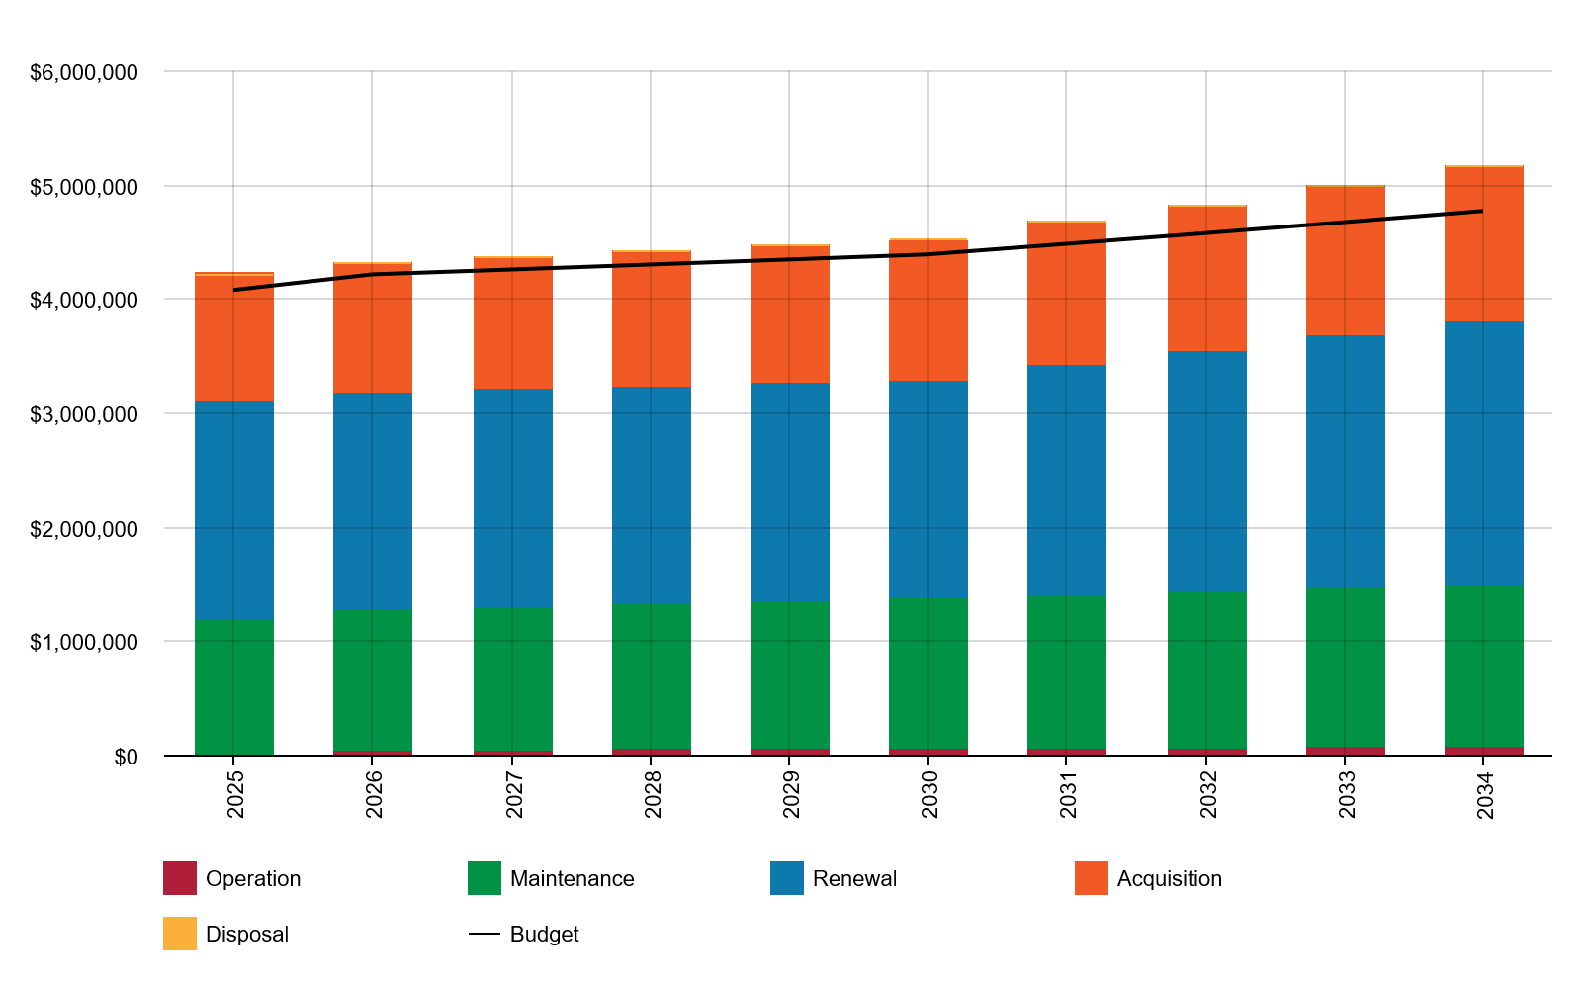
Figure 1.1: Forecast Lifecycle Costs and Planned Budgets
We plan to provide stormwater drainage services as per the following:
- Clear sand and debris out of underground drainage assets within the 10-year planning period
- Repair/maintain damaged infrastructure to prolong life, where there is opportunity to do so
- Replace significantly damaged pipes, upgrade sumps and install new underground stormwater infiltration tanks within the 10-year planning period.

What we cannot do
We currently do not allocate enough budget to sustain services at the proposed level of service in the longer term (i.e. 10 years and beyond). We also cannot collect condition data for our entire drainage network, as the cost of doing this would dramatically increase our operating costs, reducing available funding for drainage infrastructure renewals and upgrades.

Risk management
The current planned budget is insufficient to manage risks in a manner acceptable to the Community. In particular, if left as-is, climate change is a Very High risk and stormwater drainage management is a High risk.
The main risk consequences are:
- Increased risk of flooding
- Increased risk of structural failure, which can create a sinkhole in the case of underground assets, posing a significant risk to the community and other nearby infrastructure/property
- Increased discharge of pollution into ecosystems.
Strategies and actions to manage these risks are discussed in Section 6.

Financial summary
Providing financially sustainable and affordable services from infrastructure requires the careful management of service levels, costs and risks.
The 10-year LTFP is $4,413,135 on average per year, which is insufficient to maintain current service levels into the future. This indicates that 96 per cent of the forecast costs needed to provide the services documented in this AMP are accommodated in the LTFP.
Asset values are forecast to increase as additional assets are added.

Assumptions and improvement planning
Key assumptions made in this AMP are:
- Renewal forecasts have been made by professional judgement based on limited data
- Population and asset growth projections are assumed to be accurate
- Unit rates are representative of asset replacement costs
- Useful lives are an accurate representation of the behaviour of assets in the field and the City’s practices in renewing/replacing assets at their end of useful life
- Operations and maintenance growth projections are assumed to be accurate.
An alternative method was used to forecast the renewal lifecycle costs for this AMP, due to the absence of condition data for the City’s stormwater drainage assets.
This AMP is based on a ‘reliable’ level of confidence information.
The next steps resulting from this AMP to improve asset management practices are:
- Establish an ongoing maintenance contract to facilitate inspections/repairs of drainage assets
- Capacity assessment of drainage assets – stormwater modelling
- Revise definition of operation and maintenance to align with best practice, for more accurate cost projections
- Adding missing stormwater drainage assets to the asset register.

Introduction

Background
This AMP communicates the actions and necessary funds required to sustainably deliver services through the management of assets, compliance with regulatory requirements, and required funding to provide the appropriate levels of service over the long term planning period.
The AMP is to be read in conjunction with the City’s Asset Management Policy and Asset Management Strategy, along with the following strategic documents:
- Strategic Community Plan 2025 – 2035
- Corporate Business Plan 2024/25 – 2027/28
- Annual Business Plan(s)
- Long Term Financial Management Plan 2024/25 – 2033/34
- Drainage Management Strategy 2018-2028 (DMS)
- Drainage Catchment Strategy 2017 (DCS)
- Engineering, Construction and Drainage Standards Policy
- Local Planning Strategy.
The infrastructure assets covered by this AMP include stormwater pipes, pits, onsite stormwater disposal systems (OSDS), water harvesting devices (WHD) and sump fencing. For a detailed summary of the assets covered in this AMP refer to Table 5.1 in Section 5.
These assets are used to provide drainage of stormwater runoff from primarily roads and have a total replacement value of approximately $458 million.

Stakeholders
Key stakeholders in the preparation and implementation of this AMP are shown in Table 2.1.
Key Stakeholder | Role in Asset Management Plan
Elected Members | Represent needs of community/shareholders  Allocate resources to meet planning objectives in providing services while managing risks  Ensure service is sustainable.
Chief Executive Officer (CEO) | Organisational direction and leadership
Executive Leadership Team (ELT) | Executive management endorsement, sign off and executive ownership
Group Manager Assets and Projects | Review and strategic management sign off
Service Manager Infrastructure Assets | Review and line management sign off
Infrastructure Asset Services | Asset Management Plan development, review, continuous improvement and implementation of the AMP maintenance actions
Community, Residents, Tourists & Business | Provide feedback to the City and Councillors on how the City is going in maintaining the agreed levels of service.
Public Transport Authority & Transperth | Work in conjunction with the City ensuring the City’s network meets requirements
Insurers | Assist to manage financial risk of the City
State Emergency Services | Attendance to call-outs and security
Table 2.1: Key Stakeholders in the AMP

Principles, goals and objectives of asset management
The principles of asset management as per the International Standards for asset management are:
- Value: asset management focuses on the value assets provide to the organisation over time
- Alignment: asset management aligns financial, technical and operational decisions with the organisational objectives, promoting vertical and horizontal coordination
- Leadership: leadership and sustained commitment at all levels are crucial for successful asset management.
Our goal for managing infrastructure assets is to deliver the defined level of service (as amended from time to time) in the most cost effective manner for present and future consumers.
The key objectives of infrastructure asset management as defined by the International Infrastructure Management Manual are:
- Defining levels of service and monitoring performance
- Managing the impact of growth through demand management and infrastructure investment
- Taking a lifecycle approach to developing cost-effective management strategies for the long-term that meet the defined level of service
- Identifying, assessing and appropriately controlling risks
- Linking to a Long-Term Financial Plan which accommodates the required expenditure and how it will be funded.

Plan framework
The 2024 - 2028 Drainage AMP has been developed in accordance with the International Infrastructure Management Manual (IIMM) and complies with Department of Local Government & Communities Asset Management Framework.
As part of the City’s Strategic Asset Management Planning Framework (SAMPF), the Drainage AMP will be developed every 4 years and be subject to a 2-year desktop review. This AMP review will focus on core elements required by the LTFP, for example asset valuations, growth projections, financial analysis including operating, sustainability ratios and 10-year renewals. This will ensure that future revisions of the LTFP will be derived from a structured AMP development cycle that has received Executive and or Council approval, increasing confidence and integration of asset management data and methodologies into the City’s long term financial planning and adopted service levels.
Figure 2.1 provides a visual representation and timeline of the SAMPF.
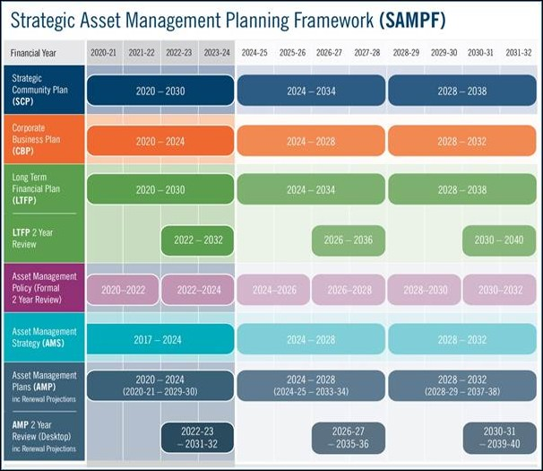
Figure 2.1: Strategic Asset Management Planning Framework (SAMPF)
- Level of Service and Enterprise Risk Management – outlines the level of service provided by council and identifies risks to the city | - Financial Analysis – what funds are required to provide the required services
- Future Growth and Demand how this will impact on future service delivery and how this is to be met | - Asset management practices – current systems and practices in place
- Lifecycle Management – how the city will manage its existing and future assets to provide the required services | - Improvement and monitoring – how the plan will be monitored and improved to ensure it is meeting Council’s objectives.

Corporate planning framework
The formalisation and alignment of the City’s SAMPF within the Corporate Planning Framework reflects the City’s increasing maturity and recognises the importance of Asset Management in supporting the City in delivering long term financial sustainability of services and capital asset renewal.
With the continued implementation of the SAMPF, the City will commence measuring service levels for planned and reactive maintenance to determine operational performance and asset utilisation.
The City strives to improve its strategic and operational asset management practices and to continue its journey towards advanced asset management. The Department of Local Government, Sport and Cultural Industries (DLGSC) has developed the Western Australia Local Government Integrated Planning and Reporting Framework. Accordingly, the future direction and need for advanced level practices are continually assessed.
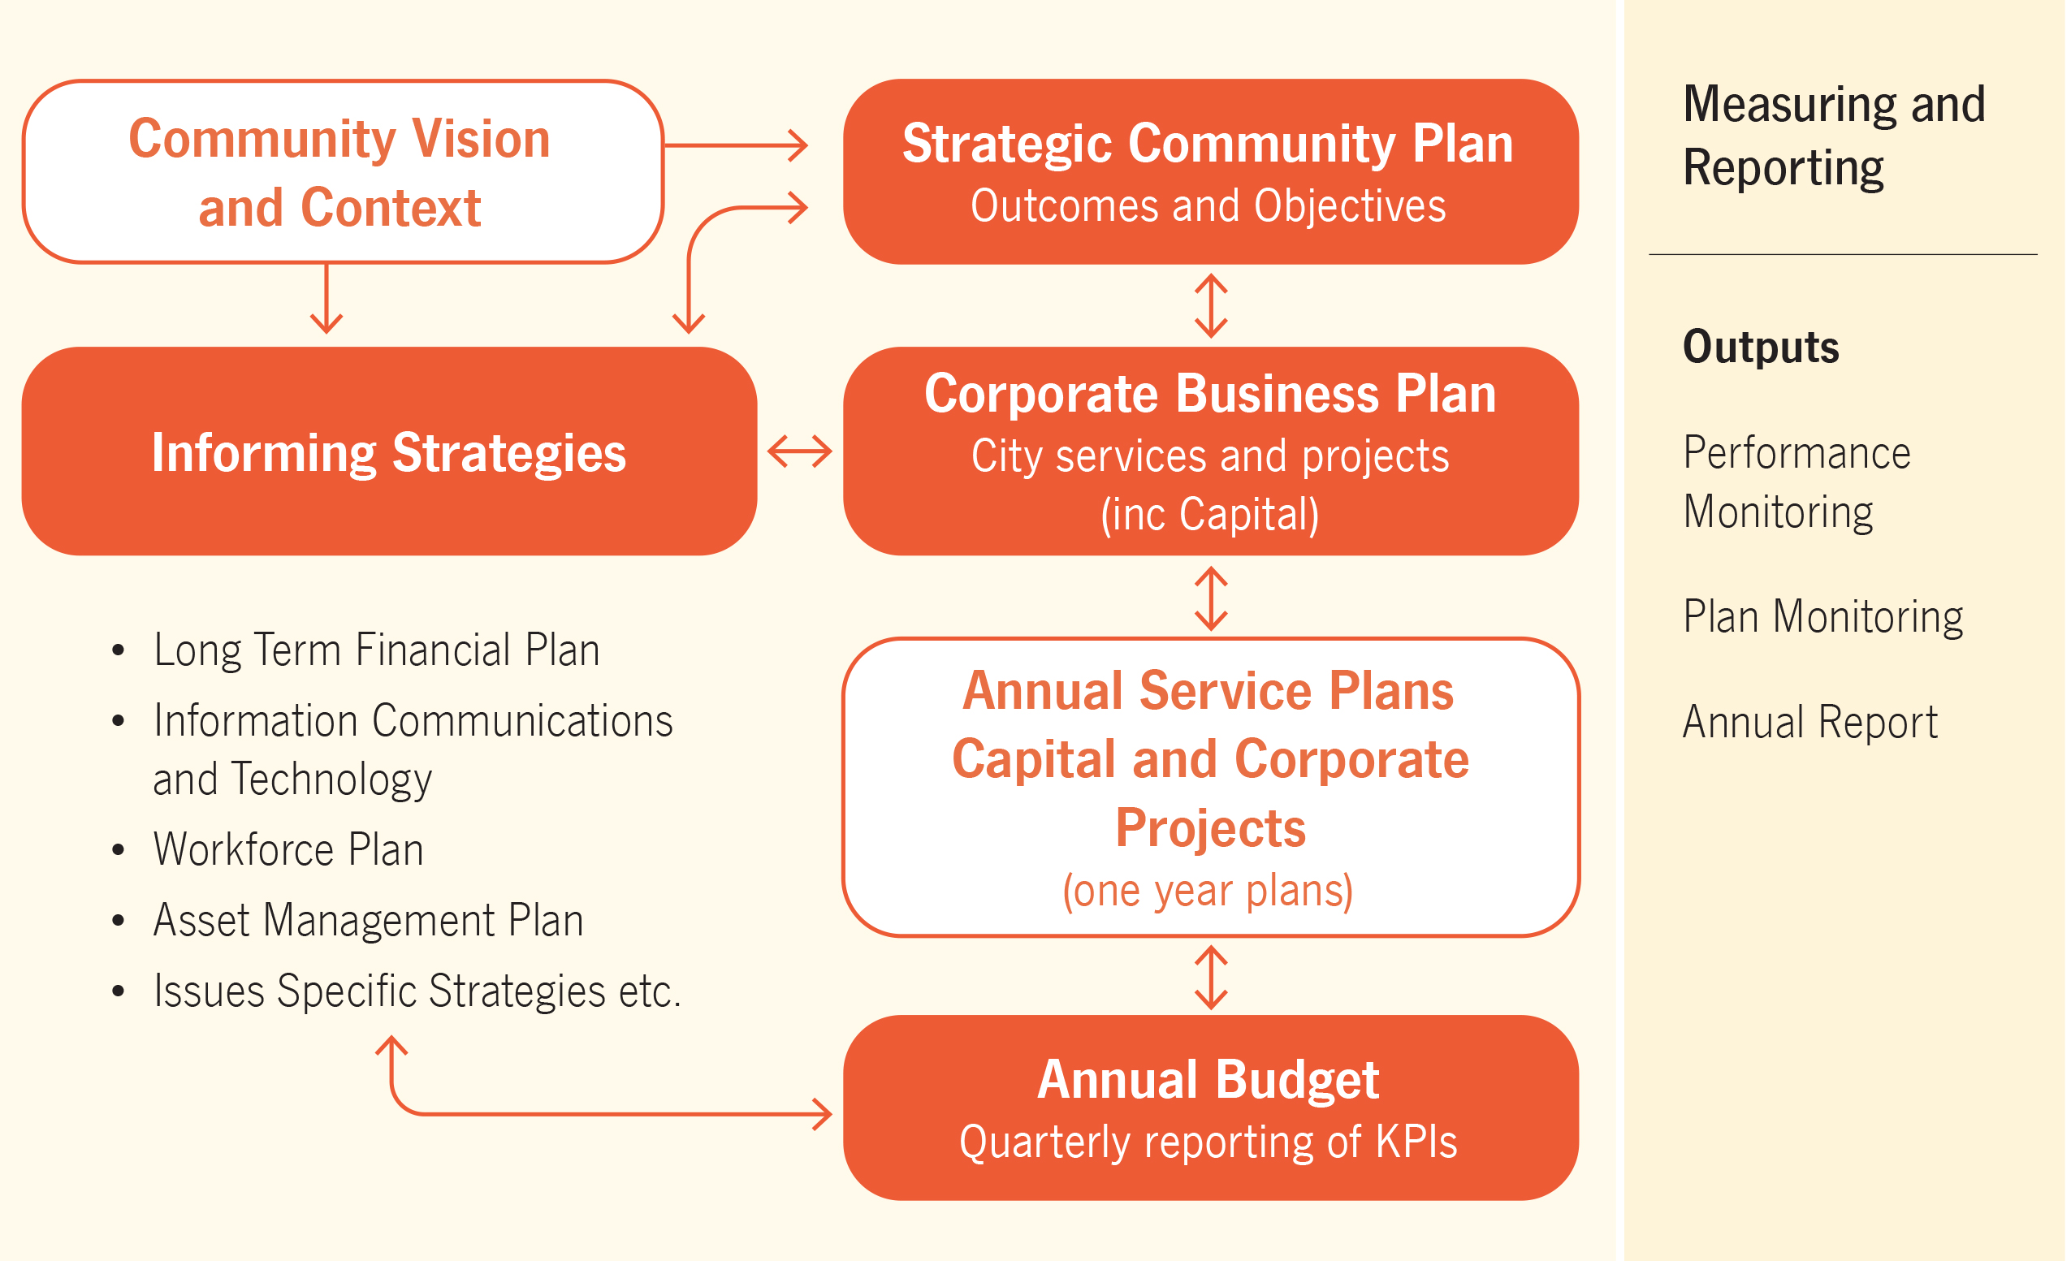
Figure 2.2: City Corporate Planning Framework

Levels of service
Levels of service define the standards and performance targets that infrastructure assets are expected to meet to ensure they provide reliable, safe, and efficient services to the community.

Customer research and expectations
The City carries out the Place Score Liveability Survey bi-annually to gather and evaluate customer feedback across a range of services that the City provides. This allowed the City to measure its performance against community expectations.
The first and most recent Place Score Liveability Survey was undertaken in September 2024. In total, 1811 residents participated in the survey. The most relevant place score metric is ‘Evidence of City management’, with a Place Experience (PX) score of 6.5/10 as part of the most recent survey.
Table 3.1 summarises the results from our Customer Satisfaction Survey.
Performance Measure | Performance Score (PX)
Performance Measure | Good  PX ≥ 7 | Average  6 ≤ PX < 7 | Poor  PX < 6
Sustainable urban design |  |  | 5.7
Protection of the natural environment |  | 6.9
Ease of Driving and Parking | 7.5
Evidence of City management (signage, street sweeping etc) |  | 6.5
Evidence of recent public investment |  | 6.0
Table 3.1: Customer Satisfaction Survey Levels

Strategic and corporate goals
This AMP is prepared under the direction of the City’s vision, mission, goals and objectives.
Our vision is:
Cockburn, the best place to be.
Our mission is:
Support our communities to thrive by providing inclusive and sustainable services which reflect their aspirations.
Strategic goals have been set by the City and are found in the City’s Strategic Community Plan. The relevant goals and objectives and how these are addressed in this AMP are summarised in Table 3.2.
Strategic Outcome | Strategic Objective | Deliverable | Measure
Our Economy  Attracting investment, supporting business and visitor growth and boosting local jobs through vibrant hubs. | 1A. Empower and support local businesses | Streamlined process for negotiating stormwater drainage levels of service vs cost with businesses | Customer survey results
Our Environment  Valuing natural assets, building climate resilience and using resources sustainably. | 2A. Protect and enhance our natural areas and streetscapes. | Meet environmental requirements for stormwater flows and pollutant loads. | Customer survey results
 | 2A. Protect and enhance our natural areas and streetscapes. | Build and maintain Water Sensitive Urban Design stormwater drainage assets where required | Water quality results
 | 2A. Protect and enhance our natural areas and streetscapes. |  | Extent of implementation of Water Sensitive Urban Design mentioned in DMS
 | 2C. Enhance climate resilience and champion environmental initiatives to mitigate impacts. | Manage flooding risk | Customer survey results
Our Places  Enhancing distinctive, liveable areas with well-connected, safe transport options. | 4A. Plan for growth and sustainable development. | Delivery of upgrades in response to most up to date City Drainage Strategy. | Number of flooding complaints
 | 4C. Enhance connectivity and mobility through integrated transport networks. |  | Number of flooding complaints
Our Governance  Transparent leadership that listens, communicates openly and plans for a sustainable future. | 5D. Strive for financial sustainability and operational excellence. | Ensure adequate funding to meet agreed service levels, optimise lifecycle cost | Asset Renewal Funding Ratio
 | 5B. Strengthen engagement and communication and enhance customer experience. | Negotiate stormwater drainage levels of service vs cost with the community and businesses | Customer survey results and feedback  Business surveys
Table 3.2: Goals and how these are addressed in this Plan

Legislative requirements
There are many legislative requirements relating to the management of assets. Legislative requirements that impact the delivery of the drainage service are outlined in Appendix G.

Customer values
Service levels are defined in three ways, customer values, customer levels of service and technical levels of service.
Customer Values indicate:
- What aspects of the service is important to the customer
- Whether they see value in what is currently provided
- The likely trend over time based on the current budget provision.
Customer Values | Customer Satisfaction Measure | Customer Feedback | Expected Trend Based on Planned Budget
Stormwater drainage is safe | Strategic Community Plan or customer requests | Some broken sump fences and grated pit lids reported | Maintain
Can reasonably drive on the road during a storm | Strategic Community Plan or customer requests | Some flooding reported during major downpours | Increasing flooding
Customer’s property is protected from flood damage | Strategic Community Plan or customer requests | Property damage from flooding is very rare | Maintain but climate change a long term threat
Can use a park after a major storm | Strategic Community Plan or customer requests | Flooded parks are a nuisance | Increasing flooding in parks
Protection of the natural environment | Strategic Community Plan or customer requests | Natural environment currently appears OK | At risk of degrading but also due to other factors
Table 3.3: Customer Values

Customer levels of service
The Customer Levels of Service are considered in terms of:
Condition How good is the service … what is the condition or quality of the service?
Function Is it suitable for its intended purpose …. Is it the right service?
Capacity/Use Is the service over or under used … do we need more or less of these assets?
In Table 3.5 under each of the service measures types (Condition, Function, Capacity/Use) there is a summary of the performance measure being used, the current performance, and the expected performance based on the current budget allocation.
These are measures of fact related to the service delivery outcome (e.g. number of occasions when service is not available or proportion of replacement value by condition) to provide a balance in comparison to the customer perception that may be more subjective.
Type of Measure | Level of Service | Performance Measure | Current Performance | Expected Trend Based on Planned Budget
Overall | Community satisfaction of 70% or greater with the City’s drainage network. | Community feedback | Score of 6.5/10 for ‘Evidence of City management’ in recent community survey. | Continued underperformance
Condition | Maintain at least 80% of the City’s drainage in Condition 3 or better | Indicative condition assessment scores (based on age and expected remaining useful life) | Percentage of drainage infrastructure in condition 3 or better is 99%, however it is majority aged based estimates, not actual | An increasing portion of our stormwater drainage network will reach end of useful life prior to Capital intervention based upon the increasing gap between planned budget and forecast expenditure, particularly between 2031 and 2035.
Condition | Confidence levels |  | Medium | Medium
Function | Action customer requests relating to drainage structures  (aim to acknowledge within 5 working days in line with the City’s Customer Service Charter) | Number of drainage structure service requests received | 201 requests relating to drainage structures in 2023/24 – six of the complaints in 2023/24 were of sinkholes | Number of customer requests expected to increase based on past 10 year trend (see Appendix C)
Function | Community satisfaction of 70% or greater with the City’s environmental protection measures. | Community feedback | Score of 6.9/10 for ‘Protection of the natural environment’ | Score of 7/10 should be achievable but needs further investigation
Function | Pollution reduction targets met as per the DMS | Adherence to Engineering, Construction and Drainage Standards Policy | Some natural assets under stress | No significant change
Function | Confidence levels |  | High | High
Capacity | Action customer requests relating to flooding  (aim to acknowledge within 5 working days in line with the City’s Customer Service Charter) | Number of flooding complaints received | 66 flooding complaints in 2023/24 | Number of customer requests expected to increase slightly overall, with climate fluctuations, based on past 10 year trend (see Appendix B)
Capacity | Confidence levels |  | High | Medium
Table 3.4: Customer Level of Service Measures

Technical levels of service
Technical Levels of Service – To deliver on the customer values, and impact they have on Customer Levels of Service, are operational or technical measures of performance. These technical measures relate to the lifecycle activities (see Section 5) and allocation of resources to best achieve the desired customer outcomes and demonstrate effective performance.
Service and asset managers plan, implement and control technical service levels to influence the service outcomes.
Table 3.6 shows the lifecycle activities related to the current 10 year planned budget, and the forecast costs recommended in this AMP.
Lifecycle Activity | Purpose of Activity | Activity Measure | Current Performance* | Recommended Performance **
Acquisition | Provide new drainage as required | Identify new drainage required | In alignment with expected population and infrastructure requirements defined in Planning WA’s ‘Perth and Peel @ 3.5 million’ framework | In alignment with expected population and infrastructure requirements defined in Planning WA’s ‘Perth and Peel @ 3.5 million’ framework
Acquisition | Upgrade existing drainage as required | Identify drainage upgrades required | As outlined in the City’s Forward Capital Works Plan. | As outlined in the City’s Forward Capital Works Plan.
Acquisition |  | Budget | $781,979 average per annum | $1,170,214 average per annum
Operations | Keep drains clear of debris | Frequency of educting pits | Every 2.5 years | Annually
Operations | Keep drains clear of debris | Frequency of clearing sumps and swales | Annually | Maintain
Operations | Keep drains clear of debris | Frequency of cleaning bubble up pits | Every 3 years | Maintain
Operations | Keep drains clear of debris | Frequency of pipe jetting and flushing | 5% of pipes annually | Implement risk managed Maintenance Management System and specify/monitor/adjust/report blockage risk levels
Operations |  | Budget | $1,304,031 per year on average | Increase
Maintenance | Keep drainage safe | Maintenance issues identified by community actioned within 20 working days | Current maintenance budget and resourcing is sufficient to enable action on localised defects within 20 business days. | Action defects within 15 working days.
Maintenance |  | Budget | Captured under Operations budget | Captured under Operations budget
Renewal | Keep drainage in satisfactory and safe condition | Proportion of drainage assets in “poor” or “very poor” condition | <1% - however majority of condition is estimated from age, not actual condition | Maintain
Renewal | Allocate sufficient medium and long term renewal funding | Asset renewal funding ratio | 97% | 100%
Renewal |  | Budget | $1,926,416 per year on average | $2,015,829 per year on average
Disposal | Dispose of drainage assets that are no longer required | Drainage disposed of when opportunities identified | Nil allocated due to nil disposal opportunities identified | Continue reviewing opportunities to dispose of assets. This should be driven by updated Drainage Strategies.
Disposal |  | Budget | $0 per year | $0 per year
Table 3.5: Technical Levels of Service
Note: * Current activities related to planned budget.
**Expected performance related to forecast lifecycle costs.
It is important to monitor the service levels regularly as circumstances can and do change. Current performance is based on existing resource provision and work efficiencies. It is acknowledged that circumstances such as technology and customer priorities will change over time.

Future demand
Future demand refers to the effects on infrastructure assets services driven by factors such as population movement, economic development, technological advancements, and changing environmental or community expectations.

Demand drivers
A demand driver refers to the factors or trends that influence the need for infrastructure services and capacity. Some examples of factors influencing future demand include (but are not limited to):
- Population growth
- Changing demographics
- Industry development/changes in technology
- Legislation changes
- Climate change.
Demand drivers help predict future infrastructure needs and guide planning and investment decisions.

Demand forecasts
The current position and projections for demand drivers that may impact future service delivery and use of assets have been identified and documented in Table 4.1.

Impacts and Demand Management Plan
The impact of demand drivers that may affect future service delivery and use of assets are shown in Table 4.1.
The impact on service delivery will be managed through a combination of managing and upgrading existing assets and the provision of new assets to meet demand. Demand management practices can include non-asset solutions, insuring against risks and managing failures.
Opportunities identified to manage demand are shown in Table 4.1. Further opportunities will be developed in future revisions of this AMP.
Demand driver | Current position | Projection | Impact on services | Demand Management Plan
Population | 133,869 as at 2025 | 177,920 by 2046 | Increased population demand for new developments creating additional impervious areas, leading to higher runoff. This will require additional drainage assets, resulting in additional maintenance and renewal costs. | Ensure maintenance and renewal budgets keep up with increase in asset stock.
Demo-graphics and infill | 16,883 people 67 or older as at 2025 | 31,329 people 67 or older by 2046 | Existing dwellings potentially redeveloped at a higher density, creating additional impervious areas, leading to higher runoff. This will require additional drainage assets, resulting in additional maintenance and renewal costs. | Ensure stormwater retained onsite – development controls. Also ensure verge policy adhered to.
Industry | Existing industrial areas are expanding and reaching full potential | Extensive new industrial and commercial areas focused around Jandakot Airport and Latitude 32 Industrial area | Requirement for freight routes and upgrading of existing roads. Increase in impervious areas resulting in increased requirement for effective drainage and stormwater management infrastructure. | Ensure adequate developer contributions for necessary stormwater drainage upgrades. City funded road upgrades should include adequate stormwater drainage design.
Climate Change | Severe storm events more frequent than approx. 30-50 years ago | Storm events will continue to become more severe | More frequent flooding impacting on road users and properties | Update Drainage Catchment Study at regular intervals to make use of latest climate models
Table 4.1: Demand Management Plan

Asset programs to meet demand
The new assets required to meet demand may be acquired, donated or constructed. Additional assets are discussed in Section 5.4.
Acquiring new assets will commit the City to ongoing operations, maintenance and renewal costs, and depreciation expenses for the period that the service provided from the assets is required. These future costs and expenses are identified and considered in developing the long-term financial plan.

Climate change adaptation
The impacts of climate change will have a significant impact on the assets we manage and the services they provide. In the context of the Asset Management Planning process climate change can be considered as both a future demand and a risk that needs to be managed.
How climate change impacts on assets will vary depending on the location and the type of services provided, as will the way in which we respond and manage those impacts.
As a minimum we consider how to manage our existing assets given potential climate change impacts for our region.
Risk and opportunities identified to date are shown in Table 4.2.
Climate change risk | Projection | Impact on services | Climate Change Management Plan
More extreme flooding/storm events during winter months | Increase in the frequency and severity of flooding and storm events | Existing stormwater drainage may struggle to keep up with increasing stormwater runoff flow rates | Regular (e.g. 5 yearly) stormwater modelling at the road segment and drainage asset level, making use of latest climate models, should be considered
Table 4.2: Managing the Impact of Climate Change on Assets and Services

Additionally, the way in which we construct new and upgrade existing assets should recognise that there is opportunity to build in resilience to climate change impacts. Building resilience can have the following benefits:
- Assets can better withstand the impacts of climate change
- Services can be sustained
- Assets that can endure may potentially lower the lifecycle cost and reduce their carbon footprint.
Table 4.3 summarises opportunities to build climate change resilience into new and existing assets.
Asset Description | Climate change risk | Resilience Plan for New Assets | Resilience Plan for Existing Assets
Pits and Pipes | Blockages have a more severe and less predictable flooding impact than previously | Novel designs that are less susceptible to blocking, e.g. poly pipes, streamlined pits, systems to mitigate root intrusion | Maintenance management system that takes into account leaf load and sediment load  Debris baskets installed in problematic areas  Verge management (see Roads AMP)
Open Infiltration and Conveyance Systems | Debris build up has a more severe and less predictable flooding impact than previously | Upstream capture of debris where possible | Debris clearing, controlled vegetation clearing/spraying, maintenance management system
Table 4.3: Building Climate Change Resilience into New and Existing Assets
The impact of climate change on new and existing assets is evolving and new opportunities will be developed in future revisions of this AMP.

Lifecycle management plan
The lifecycle management plan details how the City plans to manage and operate the assets at the agreed levels of service (Refer to Section 3) throughout their entire lifecycle, from acquisition or creation to disposal. The goal is to maximise the value of the assets while minimising costs and risks, ensuring they continue to meet performance requirements over time.
From a financial perspective, infrastructure activities tend to be classified as being either Operating or Capital. The lifecycle activities used in the asset management and financial planning and reporting process cover:
Capital Expenditure:
- Acquisition – the activities to provide a higher level of service (e.g., widening a road, sealing an unsealed road, replacing a pipeline with a larger size) or a new service that did not exist previously (e.g. a new library).
- Renewal – the activities that replace or restore assets to the standard it had originally provided (e.g., road resurfacing and pavement reconstruction, pipeline replacement and building component replacement).
- Disposal – the decommissioning, removing, or repurposing of assets that are no longer cost-effective, safe, or necessary (e.g. shutting down an old water treatment plant, demolishing unsafe buildings, dismantling old bridges, etc.).
Operating Expenditure:
- Operations - the routine activities that keep services accessible and effective, balancing efficiency with user expectations (e.g. cleansing, mowing grass, energy, inspections, etc.)
- Maintenance – the preventative and corrective actions to sustain asset functionality and minimise unexpected failures. Maintenance activities enable an asset to continue providing service for its useful life (e.g., structural repairs, grated lid replacement, table drain grading).
A pictorial representation of the asset lifecycle activities is shown below in Figure 5.1.
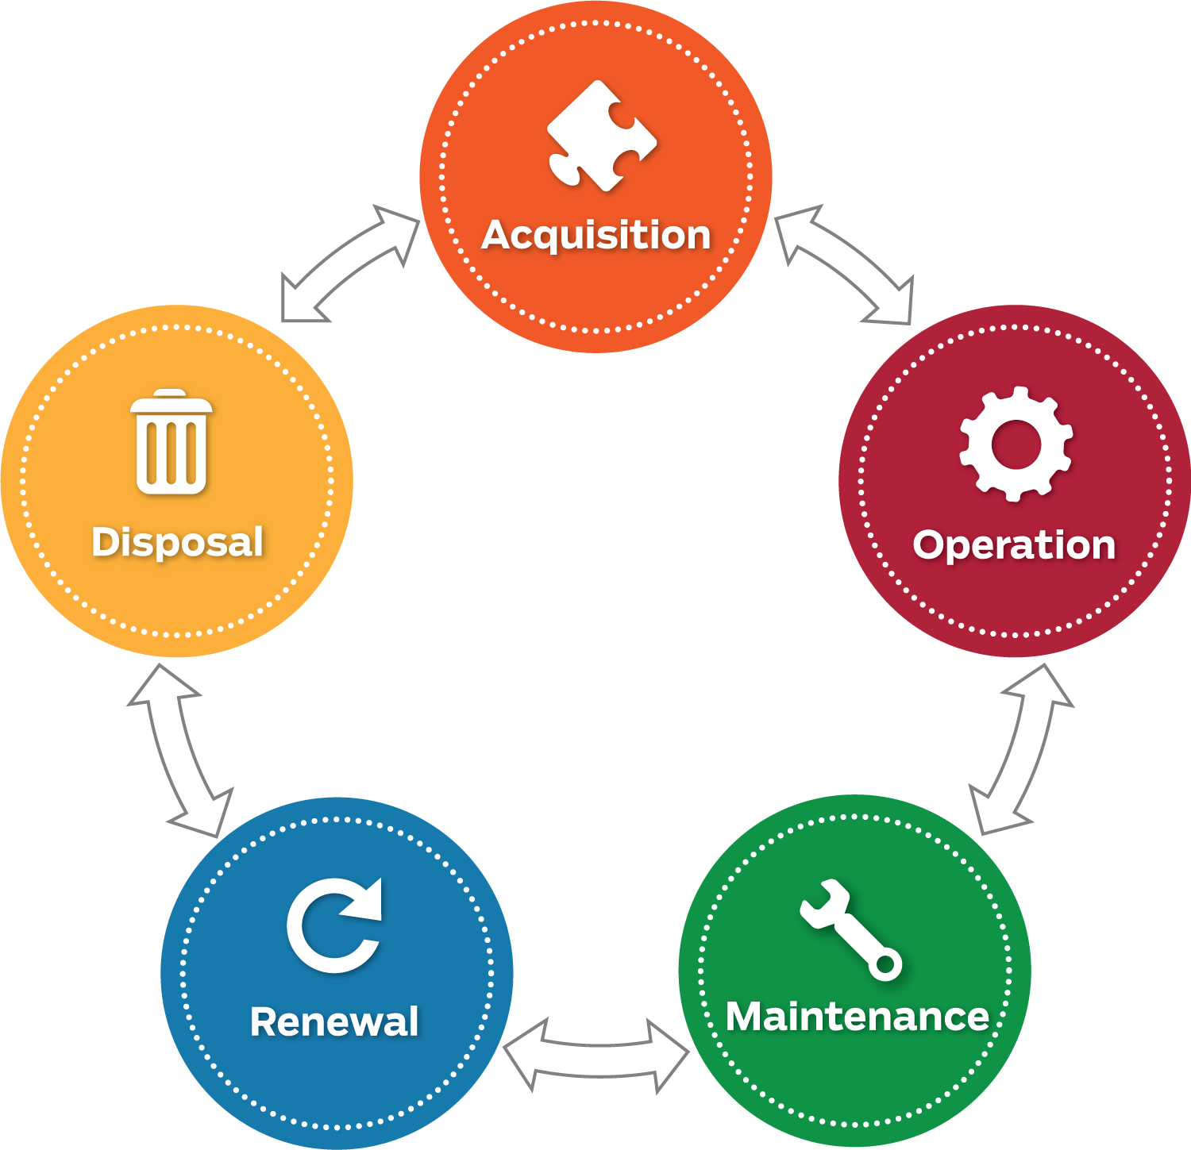
Figure 5.1: Asset Lifecycle Activities

Background data

Physical parameters
The assets covered by this AMP are shown in Table 5.1.
Asset Classification | Asset Type | Quantity | Unit | Replacement Value ($)
Pipes | Dia. <300 | 65289 | m | 49,037,388
Pipes | Dia. 300 - 550 | 449574 | m | 251,028,361
Pipes | Dia. 600 - 1200 | 40704 | m | 42,422,594
Pipes | Dia. - 1350 - 2050 | 5990 | m | 10,568,400
Pipes | Total | 561557 | m | 353,056,743
Pits | Bubble up Pit | 408 | No. | 2,743,935
Pits | Chute | 0 | No. | 0
Pits | Combined catch pit and side entry pit | 105 | No. | 432,776
Pits | Double Grated Pit | 36 | No. | 195,386
Pits | Double Gully Pit | 3 | No. | 12,371
Pits | Double Grated Side Entry Pit | 58 | No. | 379,609
Pits | Double side entry Pit | 88 | No. | 471,704
Pits | End wall/Head wall | 683 | No. | 1,963,659
Pits | Gatic Cover Pit | 44 | No. | 179,063
Pits | Grated Gully Pit | 3850 | No. | 15,016,456
Pits | Grated Pit | 423 | No. | 1,650,214
Pits | Gross pollutant trap | 164 | No. | 6,072,737
Pits | Grated side entry pit | 563 | No. | 2,536,325
Pits | Grated Soak Well | 35 | No. | 114,634
Pits | Gully Pit | 229 | No. | 944,350
Pits | Junction Pit | 6890 | No. | 24,741,694
Pits | Junction with Chamber | 14 | No. | 50,040
Pits | Junction Pit with Drop | 1 | No. | 3,574
Pits | Side Entry Pit | 9187 | No. | 36,290,492
Pits | Side Entry / Gully Pit | 957 | No. | 3,946,080
Pits | Soak Well | 371 | No. | 1,215,121
Pits | Soakwall combined side entry pit | 6 | No. | 19,652
Pits | Total | 24115 | No. | 98,979,873
OSDS (Area) | Basin | 118 | No.
OSDS (Area) | Detention Basin | 17 | No.
OSDS (Area) | Drain Gully | 2 | No.
OSDS (Area) | Lake | 15 | No.
OSDS (Area) | Linear Swale | 7 | No.
OSDS (Area) | Open Drain | 56 | No.
OSDS (Area) | Retention Basin | 25 | No.
OSDS (Area) | Spillway | 6 | No.
OSDS (Area) | Sump | 216 | No.
OSDS (Area) | Swale | 98 | No.
OSDS (Area) | Wetland | 1 | No.
OSDS (Area) | Total | 561 | No. | 0
WHD | Infiltration Chamber | 225 | No. | 1,583,032
WHD | Storage Tank | 10 | No. | 70,357
WHD | Total | 235 | No. | 1,653,389
Fences | Bollards | 1871 | m | 214,066
Fences | Colorbond | 2268 | m | 200,129
Fences | Chain Wire / Mesh | 10035 | m | 722,467
Fences | Railings | 2272 | m | 791,513
Fences | Wall (Brick / Concrete / Stone) | 4214 | m | 2,218,015
Fences | Total | 20660 | m | 4,146,189
Total |  |  |  | 457,836,195
Table 5.1: Assets covered by this Plan
The City’s stormwater drainage consists of multiple asset types and each have different management considerations. The OSDS assets do not have an assigned value as they are deemed to not depreciate; they are excavated or natural assets.
The age profile of the assets included in this AMP are shown in Figure 5.2.

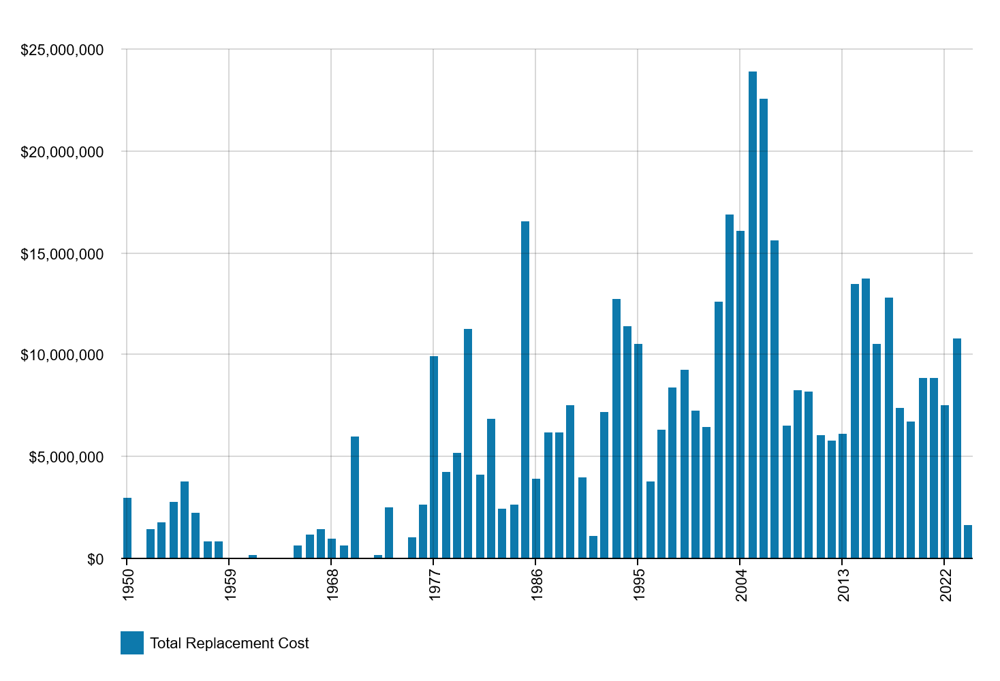
Figure 5.2: Asset Age Profile
The assets built between 1950-1959 should be prioritised for inspections/renewals and this has been included in the Improvement Plan.
Amounts are shown in real values (i.e., current values, net of inflation).

Asset capacity and performance
The City of Cockburn commissioned Cardno Consulting in 2017 to undertake a Drainage Catchment Study (DCS) to identify system deficiencies and provide a prioritised list of upgrade projects that could be undertaken to improve the aesthetics, performance and efficiency of stormwater disposal. A revision of the DMS is in progress (by UrbAqua).
Locations where deficiencies have been identified are in Table 5.2.
Location | Service Deficiency
DCS report – recommendations | Prioritised recommendations are detailed on pages 16 to 35 of the DCS report. The order of cost totalling $5,608,200 based on 2017 costings.
South Lake | Require a Gross Pollutant Trap (GPT) as untreated/ unmanaged water going into lake systems are having an environmental impact on the service
Broadwater Gardens Reserve
Spearwood Penn
Lake Drive
Table 5.2: Known Service Performance Deficiencies
The DCS has been used to develop a 10-year program to upgrade the capacity of underperforming sumps, with further investigation and detailed analysis by the City. Many sumps have already been upgraded.

Asset condition
The DMS stipulates use of CCTV to condition rate the pits and pipes. Resourcing this significant ongoing work appears to be an outstanding issue, with some approaches suggested in the DMS. A risk managed approach will be required, i.e. an approach that balances risk level against cost of inspection. Refer Section 6.
Condition is measured using a 1 – 5 grading system as detailed in Table 5.3. It is important that a consistent approach is used in reporting asset performance enabling effective decision support. A finer grading system may be used at a more specific level, however, for reporting in the AMP results are translated to a 1 – 5 grading scale for ease of communication.
Condition Grading | Description of Condition
1 | Very Good: free of defects, only planned and/or routine maintenance required
2 | Good: minor maintenance required plus planned maintenance
3 | Fair: defects requiring regular and/or significant maintenance to reinstate service
4 | Poor: significant defects, renewal/rehabilitation required
5 | Very Poor: physically unsound and/or beyond rehabilitation, immediate action required. Asset is at end of useful life.
Table 5.3: Condition Grading System
Drainage assets in the asset register have an assumed condition rating based on the construction date and useful life as detailed in Table 5.4. Some fences have been audited and condition assessed in August 2019 providing a true condition of these assets.
Condition | Assumed Age (years)
1 | 1 to 20
2 | 21 to 40
3 | 41 to 60
4 | 61 to 80
5 | 81 to 100
Useful Life | 100
Table 5.4: Assumed Age / Condition of Assets
The condition profile is shown in Figure 5.3:
- Fences around the sumps are 97% in excellent to moderate condition (1 to 3) and the only fencing in very poor condition has a total CRC of $13,653
- The pipes and pits are very young, with 93% still assumed to be in condition 1 and 2.
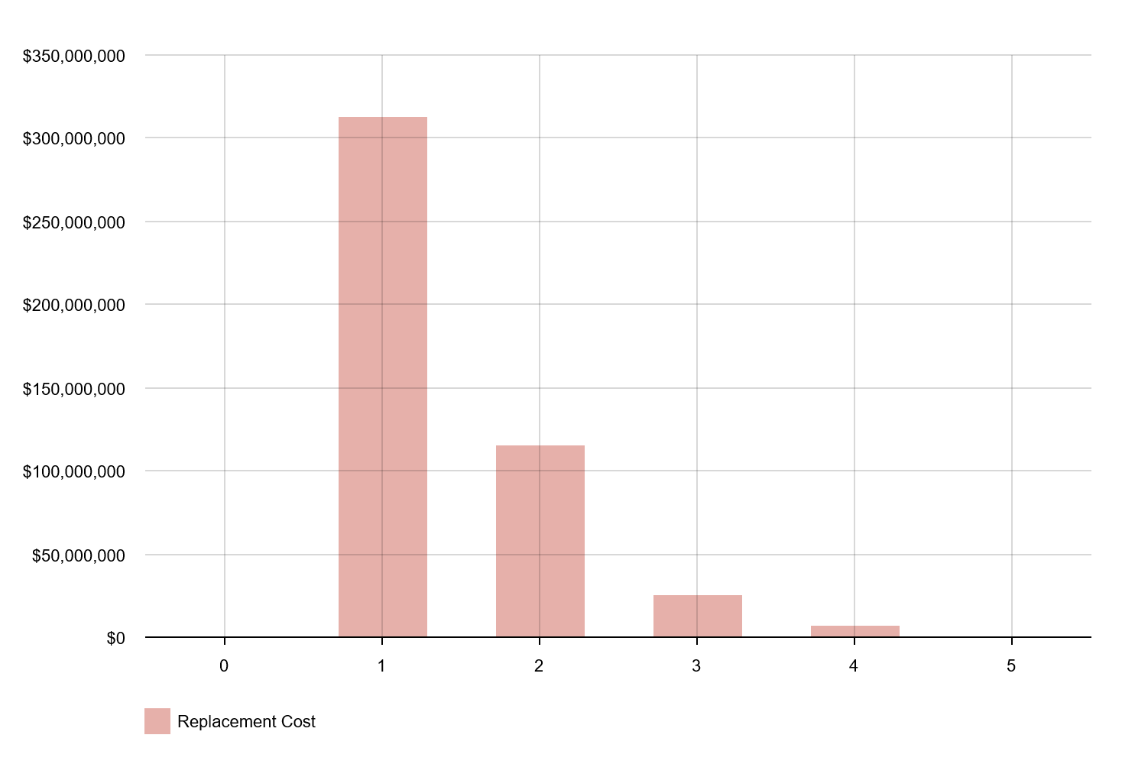
Figure 5.3: Condition Profile

Operations and maintenance plan
For the purpose of modelling within this AMP, the following definitions apply:
Reactive maintenance is unplanned maintenance work carried out in response to service requests and management/supervisory directions.
Planned maintenance is work that is identified and managed through a maintenance schedule. Examples include cleaning, inspection, assessing the condition against failure/breakdown and reporting the works to develop a maintenance history and improve service delivery performance.
Operating expenditure is continuously required expenditure e.g. power, fuel, staff, security patrols, plant equipment, on-costs and overheads.
The trend in maintenance and operating budgets are shown in Table 5.5.
Financial Year | Total Maintenance Expenditure ($) | Total Operating Expenditure ($)
2017/18 | 933,056 | 59,992
2018/19 | 1,155,025 | 15,440
2019/20 | 1,103,426 | 5,606
2020/21 | 1,112,478 | 12,269
2021/22 | 1,101,777 | 62,727
2022/23 | 1,148,878 | 61,661
2023/24 | 1,182,571 | 81,536
Table 5.5: Maintenance and Operating Budget Trends
These previous Operating and Maintenance budget levels are considered to have been adequate to meet service levels. Assessment and priority of reactive maintenance is undertaken by staff using experience and judgement.

Asset hierarchy
An asset hierarchy provides a framework for structuring data in an information system to assist in collection of data, reporting information and making decisions. The hierarchy includes the asset class and component used for asset planning and financial reporting and service level hierarchy used for service planning and delivery.
Currently, the below hierarchy is defined for underground stormwater pipes:
Group | Diameter Min (mm) | Diameter Max (mm)
A | 0 | 225
B | 300 | 550
C | 600 | 1200
D | 1350 | 2050
Table 5.6: Asset Hierarchy for Underground Pipes
It is in the Improvement Plan to incorporate serviced catchment size, the hierarchy of the road that the pipe is under (if any) and other factors.

Summary of forecast operations and maintenance costs
Forecast operations and maintenance costs are expected to vary in relation to the total value of the asset stock. If additional assets are acquired, the future operations and maintenance costs are forecast to increase. If assets are disposed of the forecast operation and maintenance costs are expected to decrease. Figure 5.4 shows the forecast operations and maintenance costs relative to the proposed operations and maintenance planned budget.
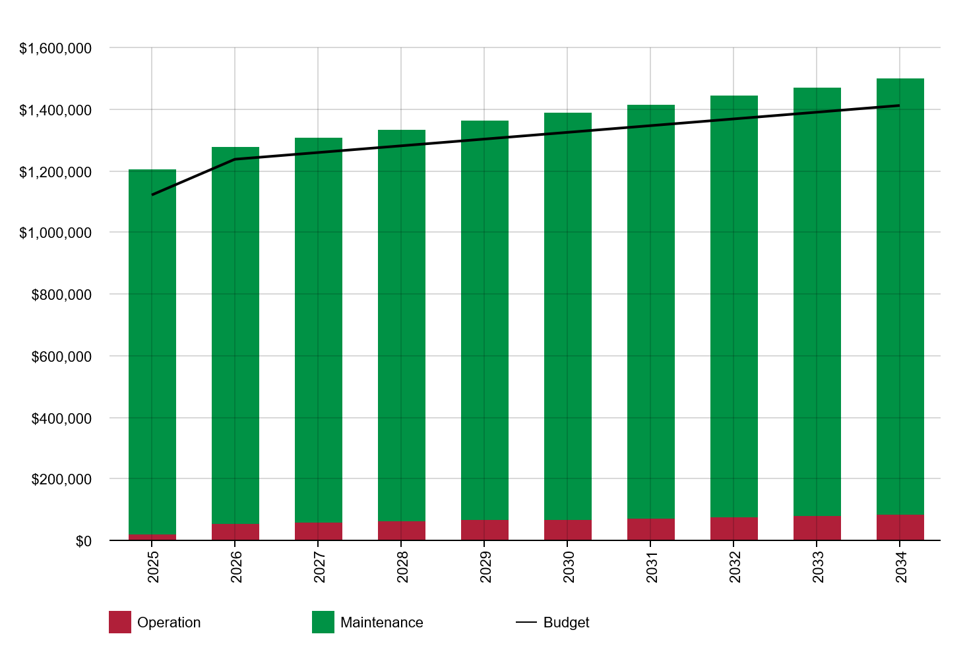
Figure 5.4: Operations and Maintenance Summary
Future maintenance and operating expenditure are forecast to grow in line with the value of the asset stock. With the City’s continued asset growth, maintenance and operating expenditure needs to be budgeted to ensure new drainage is maintained to the service levels identified in section 3. According to this analysis this may not be the case going forward. This is further discussed in Section 7.2 of the Financial Analysis.
Please note the apparently low spend on operations reflects the current definition of Operations and Maintenance; it is in the improvement plan to review this definition in line with best practice.

Renewal plan
Renewal is major capital work which does not significantly alter the original service provided by the asset, but restores, rehabilitates, replaces or renews an existing asset to its original service potential. Work over and above restoring an asset to original service potential is considered to be an acquisition resulting in additional future operations and maintenance costs.
Assets requiring renewal are identified from one of two approaches in the Lifecycle Model.
- The first method uses Asset Register data to project the renewal costs (replacement cost) and renewal timing (acquisition year plus updated useful life to determine the renewal year), or
- The second method uses an alternative approach to estimate the timing and cost of forecast renewal work (i.e. condition modelling system, staff judgement, average network renewals, or other).
The Useful Life used for this plan has been based on the City of Cockburn’s depreciation policy as represented in Table 5.7. The useful life of assets is to be reassessed in the future – for underground assets in particular - using deterioration modelling to better predict the useful life of the drainage assets. This will require data on the actual condition of the assets.
Asset Classification | Useful Life (years)
Pits and Pipes | 50
Fences – Steel Rail, Plastic Bollards, | 15
Chain Wire, Colorbond, Steel Bollards, | 20
Cyclone, Ringlock, Timber Bollards, | 25
Stone, Removable Bollards, | 40
Brick, Concrete, Limestone, Granite Bollards | 50
Table 5.7: Useful Lives of Assets
The estimates for renewals in this AMP were based on the alternative method.

Renewal ranking criteria
Asset renewal is typically undertaken to either:
- Ensure the reliability of the existing infrastructure to deliver the service it was constructed to facilitate (e.g. replacing or relining a concrete pipe that keeps blocking due to sand ingress through cracks), or
- To ensure the infrastructure is of sufficient quality to meet the service requirements (e.g. replace fencing around a sump that has holes, ensuring public safety).
Renewals are prioritised by identifying assets or asset groups that:
- Have a high consequence of failure
- Have high use and subsequent impact on users would be significant
- Have higher than expected operational or maintenance costs
- Have potential to reduce life cycle costs by replacement with a modern equivalent asset that would provide the equivalent service.
The ranking criteria used to determine priority of identified renewal proposals is detailed in Table 5.8.
Criteria | Weighting (%)
Age | 50
Ongoing maintenance / capacity issues | 50
Table 5.8: Renewal Priority Ranking Criteria

Summary of future renewal costs
Assets identified for the renewal plan have been aligned to the DMS report, as discussed in Section 3, and are estimated to be a proportion of the recommended upgrades based on capacity deficiency. As such the projected renewals past 2026/27 are estimated by extrapolating from the DMS. As the DMS is outdated (2018) and under review, engineering judgement has also been applied.
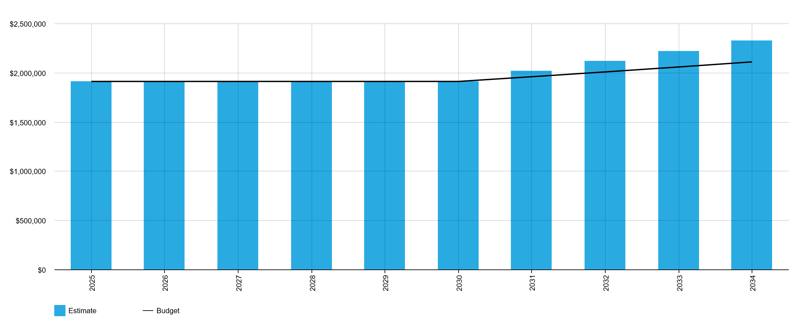
Figure 5.5: Forecast Renewal Costs

Acquisition plan
Acquisition reflects new assets that did not previously exist or works which will upgrade or improve an existing asset beyond its original service level. They may result from growth, demand, social or environmental needs. Assets may also be donated to the City by developers or third parties.

Selection criteria
Proposed acquisition of new assets, and upgrade of existing assets, are identified from various sources such as community requests, proposals identified by strategic plans or partnerships with others. Potential upgrade and new works should be reviewed to verify that they are essential to meet strategic needs of the community. Proposed upgrade and new work analysis should also include the development of a preliminary renewal estimate to ensure that the services are sustainable over the longer term. Verified proposals can then be ranked by priority and available funds and scheduled in future works programmes. The priority ranking criteria is detailed in Table 5.9.
Criteria | Weighting (%)
New asset requirement identified in strategic documentation (e.g. Strategic Community Plan, Corporate Business Plan, Drainage Management Strategy) | 50
Strong community demand (e.g. community group, petition, etc). | 25
Supported by empirical data such as population growth data, approved developments, gap in agreed level of service, etc. | 25
Total | 100
Table 5.9: Acquired Assets Priority Ranking Criteria

Summary of future asset acquisition costs
Forecast acquisition asset costs are summarised in Figure 5.6 and shown relative to the proposed acquisition budget. The forecast acquisition capital works program is shown in Appendix A.
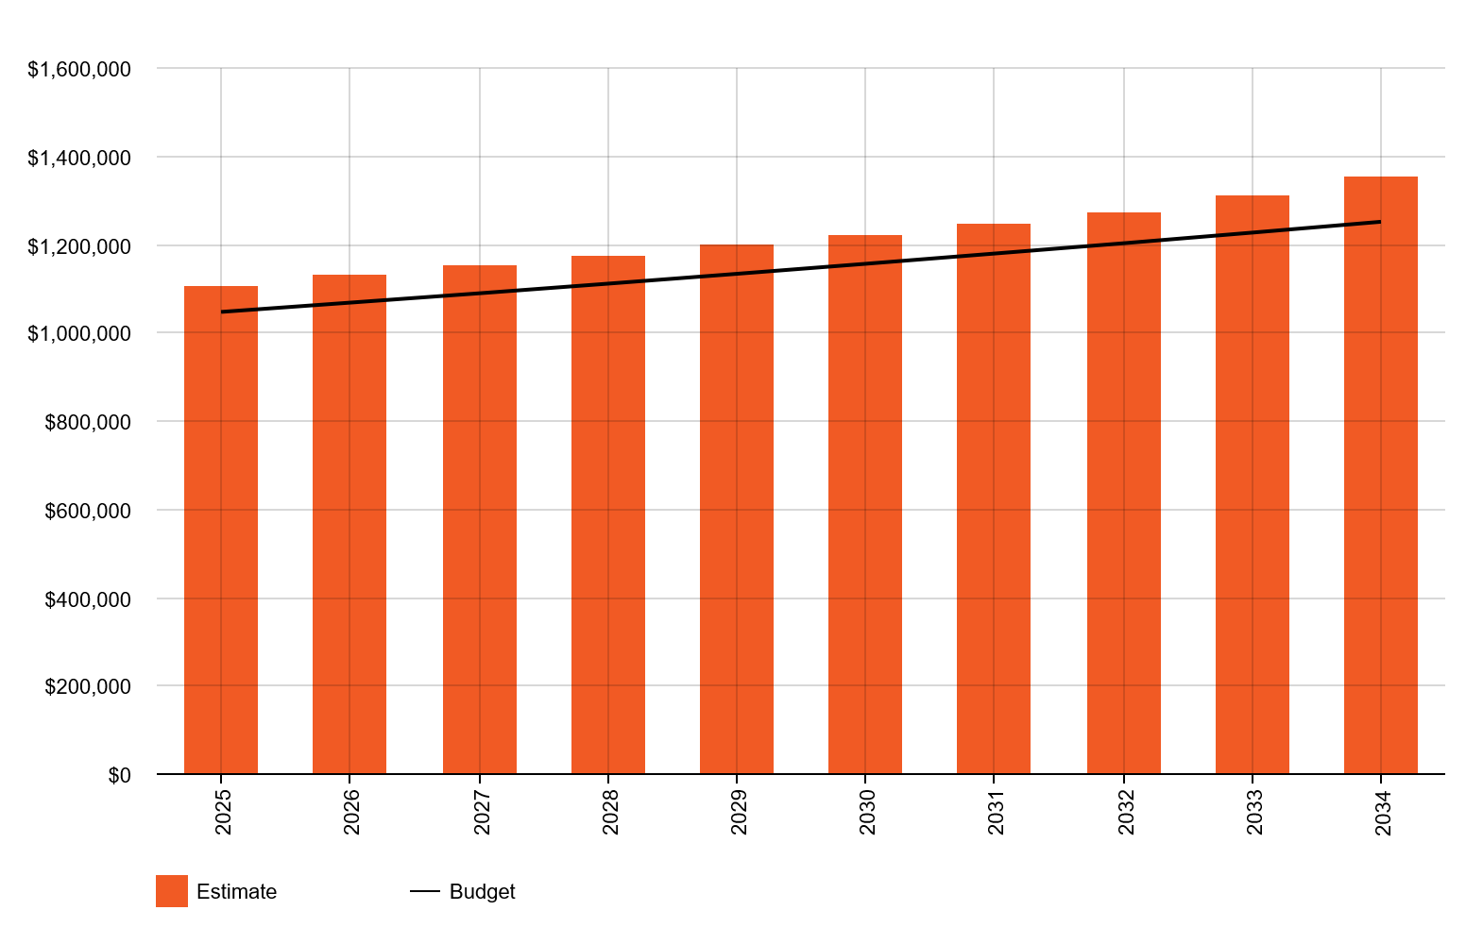
Figure 5.6: Acquisition (Constructed) Summary
Amounts are shown in real values (i.e., current values, net of inflation).
When the City of Cockburn commits to new assets, we must be prepared to fund future operations, maintenance and renewal costs. We must also account for future depreciation when reviewing long term sustainability. When reviewing the long-term impacts of asset acquisition, it is useful to consider the cumulative value of the acquired assets being taken on by the Entity. The cumulative value of all acquisition work, including assets that are constructed and contributed shown in Figure 5.7.
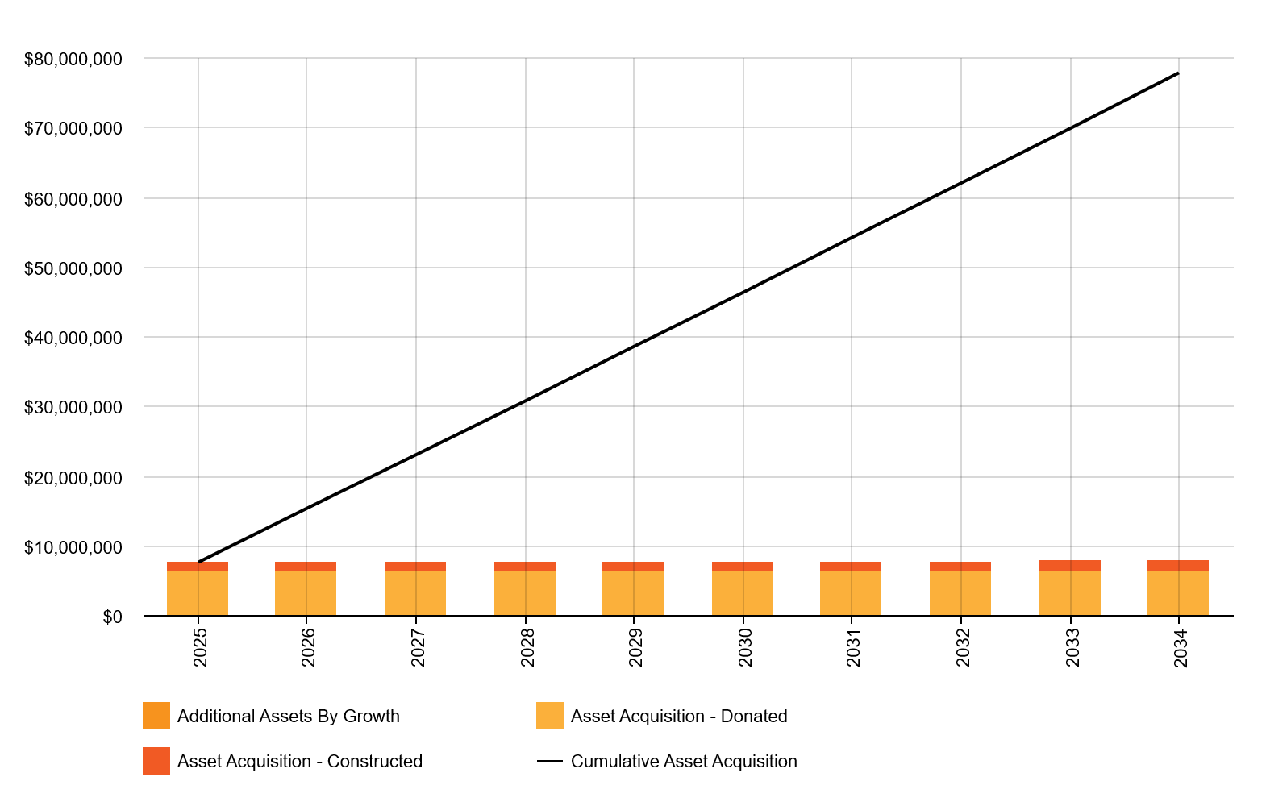
Figure 5.7: Acquisition Summary
Amounts are shown in real values (i.e., current values, net of inflation).
Expenditure on new assets and services in the capital works program will be accommodated in the long-term financial plan, but only to the extent that there is available funding.
With the review of the DMS underway, identification of stormwater drainage projects – including new and upgrade – has largely been reactive. Reviewing the previous five years of stormwater drainage projects has highlighted that planning and budgeting for required acquisitions has been challenging. As such, in the absence of a revised DMS, future budgets and expenditures have been forecast based on previous budgets.

Disposal plan
No asset disposals have been identified.

Summary of lifecycle costs and planned budget
The financial projections from this asset plan are shown in Figure 5.8. These projections include forecast costs for acquisition, operation, maintenance, renewal, and disposal. These forecast costs are shown relative to the proposed budget.
The bars in the graphs represent the forecast costs needed to minimise the life cycle costs associated with the service provision. The proposed budget line indicates the estimate of available funding. The gap between the forecast work and the proposed budget is the basis of the discussion on achieving balance between costs, levels of service and risk to achieve the best value outcome.
Figure 5.8: Lifecycle Costs and Planned Budget Summary
Amounts are in today’s dollars, i.e. excluding inflation.
Forecasts were projected based on the previous five years of budgets and expenditures. It is consistent with the anecdotal message from the operations team that the budget is under stress, as well as reliance on customer complaints for identifying capital works projects.

Risk management planning
The purpose of infrastructure risk management is to document the findings and recommendations resulting from the periodic identification, assessment and treatment of risks associated with providing services from infrastructure, using the fundamentals of International Standard ISO 31000:2018 Risk management – Principles and guidelines.
Risk Management is defined in ISO 31000:2018 as: ‘coordinated activities to direct and control with regard to risk’.
An assessment of risks associated with service delivery will identify risks that will result in loss or reduction in service, personal injury, environmental impacts, a ‘financial shock’, reputational impacts, or other consequences. The risk assessment process identifies credible risks, the likelihood of the risk event occurring, and the consequences should the event occur. The risk assessment should also include the development of a risk rating, evaluation of the risks and development of a risk treatment plan for those risks that are deemed to be non-acceptable.

Critical assets
Critical assets are defined as those which have a high consequence of failure causing significant loss or reduction of service. Critical assets have been identified and along with their typical failure mode, and the impact on service delivery, are summarised in Table 6.1. Failure modes may include physical failure, collapse or essential service interruption.
Critical Asset(s) | Failure Mode | Impact
Assets servicing large catchment areas | Extensive flooding | Property damage and traffic hazards
Assets under distributor roads | Structural failure creating a sinkhole | Severe traffic hazard, insurance claims, death
Assets discharging directly into sensitive ecosystems | Excessive pollution | Algae blooms, native flora/fauna death, pests, media coverage and reputational damage
Major pipes (>900mm diameter) | Structural failure or blockage | Prevention of stormwater discharge at downstream end of network, resulting in flooding of upstream portions of network.
Table 6.1: Critical Assets
By identifying critical assets and failure modes an organisation can ensure that investigative activities, condition inspection programs, maintenance and capital expenditure plans are targeted at critical assets.

Risk assessment
The risk management process used is shown in Figure 6.1 below.
It is an analysis and problem-solving technique designed to provide a logical process for the selection of treatment plans and management actions to protect the community against unacceptable risks.
The process is based on the fundamentals of International Standard ISO 31000:2018.
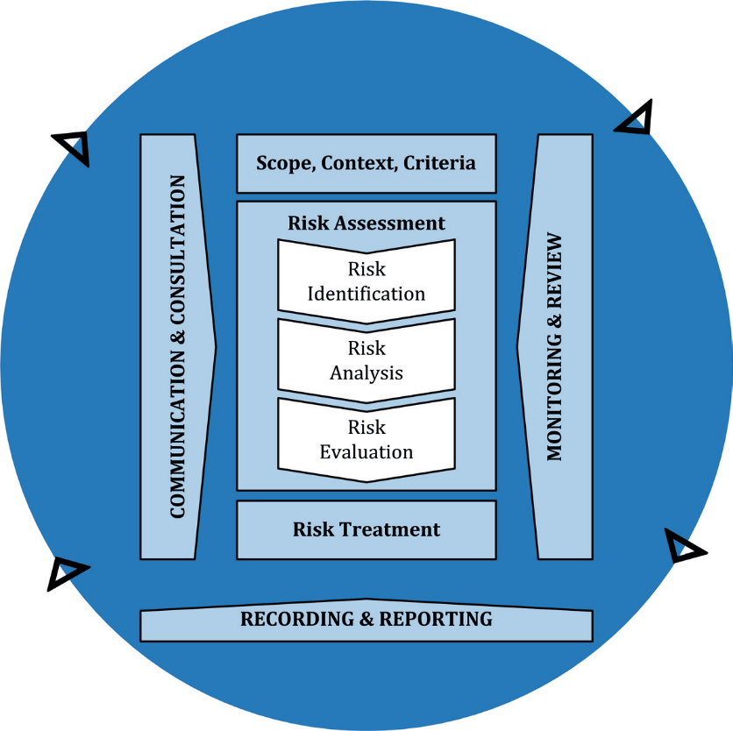
Figure 6.1: Risk Management Process – Abridged
Source: ISO 31000:2018, Figure 1, p9
The risk assessment process identifies credible risks, the likelihood of the risk event occurring, the consequences should the event occur, development of a risk rating, evaluation of the risk and development of a risk treatment plan for non-acceptable risks.
An assessment of risks associated with service delivery will identify risks that will result in loss or reduction in service, personal injury, environmental impacts, a ‘financial shock’, reputational impacts, or other consequences.
Critical risks are those assessed with ‘Very High’ (requiring immediate corrective action) and ‘High’ (requiring corrective action) risk ratings identified in the Infrastructure Risk Management Plan. The residual risk and treatment costs of implementing the selected treatment plan is shown in Table 6.2. It is essential that these critical risks and costs are reported to management and the Council.
Service or Asset  at Risk | What can Happen | Risk Rating (VH, H) | Risk Treatment Plan | Residual Risk * | Treatment Costs
All | Community infrastructure damage from climate change impacts | VH | Implement recommendations of DMS (pending review) | M | $1m-$10m
All | Failure to align the drainage design program with the Drainage Management Action Plan | H | Ensure DMS review is expedited – identify and resolve blockages | M | $10,000-$20,000  (note DMS review already procured)
All |  | H | Implement recommendations of DMS | M | $1m-$10m
All |  | H | Ongoing stormwater flow monitoring using monitoring devices (e.g. Internet of Things sensors) and supporting systems to identify drainage asset deficiencies | M | $100,000 per annum
All | Failure to effectively plan for capital works projects | H | Ensure sufficient project planning resources are available (e.g. stormwater drainage designers) | M | $150,000 per annum
All | Failure to effectively plan for capital works projects | H | Drainage condition inspections | M | $500,000 per annum
Table 6.2: Risks and Treatment Plans
Note * The residual risk is the risk remaining after the selected risk treatment plan is implemented.

Infrastructure resilience approach
The resilience of our critical infrastructure is vital to the ongoing provision of services to customers. To adapt to changing conditions we need to understand our capacity to ‘withstand a given level of stress or demand’, and to respond to possible disruptions to ensure continuity of service.
Resilience recovery planning, financial capacity, climate change risk assessment and crisis leadership.
We do not currently measure our resilience in service delivery, though it is considered in the project scoping phase. This will be included in future iterations of the AMP.

Service and risk trade-offs
The decisions made in adopting this AMP are based on the objective to achieve the optimum benefits from the available resources.

What we cannot do
There are some operations and maintenance activities and capital projects that are unable to be undertaken within the next 10 years. These include:
- Condition inspection of all underground drainage assets
- Upgrade of all existing drainage assets that require it.

Service trade-off
If there is forecast work (operations, maintenance, renewal, acquisition or disposal) that cannot be undertaken due to available resources, then this will result in service consequences for users. These service consequences include:
- Critical drainage assets are not adequately maintained or renewed, resulting in a greater percentage of the drainage network being in poor condition (i.e. Condition 4 or 5)
- An increasing number of drainage assets become unfit for purpose, leading to an increase in flooding, unexpected failures and other hazards
- Critical new drainage construction projects cannot occur to improve drainage and alleviate locations of flooding
- Environmental impacts on ecosystems from poor management of stormwater runoff.

Risk trade-off
The operations and maintenance activities and capital projects that cannot be undertaken may sustain or create risk consequences. These risk consequences include:
- Sudden formation of sinkholes render roads unsafe, likely increasing instances of accidents that result in injury or death
- Increased insurance claims and litigation from property damage due to flooding
- Increased community complaints
- Loss of biodiversity eroding trust and reputation.
These actions and expenditures are considered and included in the forecast costs, and where developed, the Risk Management Plan.

Financial summary
This section contains the financial and valuation forecasts resulting from the information presented in the previous sections of this plan. Forecasts will be improved as the discussion on sustainable levels of service, risk and cost matures in line with the financial strategy.

Financial statements and projections

Asset valuations
The City’s drainage assets were last valued in August 2024. Assets are valued at ‘greenfield replacement cost’, based on a ‘cost to construct’ approach. The valuation considered inputs such as:
- Drainage assets
- Unit rates
- Condition data
- Residual value (after depreciation was considered)

Sustainability of service delivery
There are three key indicators of sustainable service delivery that are considered in the AMP for this service area. The three indicators are the:
- Asset Consumption Ratio (Fair Value/Current Replacement Cost);
- Asset Sustainability Ratio (planned renewal budget for next year / annual depreciation expense); and
- Asset Renewal Funding Ratio (planned renewal budget for the next 10 years / forecast renewal outlays for the next 10 years)
The targets for these ratios are set by the Department of Local Government, Sport and Cultural Industries (DLGSCI) through the Integrated Planning and Reporting Framework (IPRF). The calculation methodology and targets for these ratios are outlined in Table 7.1.
Asset class | Consumption ratio | Sustainability ratio | Renewal funding ratio
Description | How much has the City used of its assets? | Is the City replacing assets as they wear out? | Is the City setting aside sufficient future funding for asset renewals?
Calculation | Depreciated replacement cost /  current replacement cost | Capital renewal (one year) /  annual depreciation (one year) | Planned capital renewal (10 years) /  required capital renewal (10 years)
Target | 50-75% standard  60-75% ideal | 90-110% standard | 75-95% standard  95-105% ideal
What it means | Lower than standard = assets are deteriorated and will result in a poor level of service  Higher than ideal = assets are being replaced too early resulting in poor value for money* | Lower than standard = the City is under investing in asset renewal/replacement resulting in a poor level of service  Higher than standard = the City is over investing in asset renewal/replacement resulting in poor value for money* | Lower than standard = the City is allocating too little funding to long term asset renewal/replacement which will result in a lower level of service in future  Higher than ideal = the City is allocating too much funding to long term asset renewal/replacement which will result in poor value for money in future
Table 7.1: Asset Ratios
* Higher than standard can also mean the asset base is relatively young

Asset Consumption Ratio
Asset Consumption Ratio 81 per cent
This ratio shows the written down value of depreciable assets in relation to their ‘as new’ value in current prices. A ratio of less than 50 per cent indicates a rapid deterioration of the asset base, whilst a ratio greater than 75 per cent may indicate an over investment in the asset base. In the case of stormwater drainage, it simply indicates the asset stock is young in relation to its useful life.

Asset Sustainability Ratio
Asset Sustainability Ratio 111 per cent
The target ratio should be between 90-110 per cent. A lower value indicates that at some time in the future, more renewal funding will be required. A higher value may indicate ‘above average’ renewal spending over the lifecycle of the asset base, which may simply correspond with peaks in new assets being added, depending on the useful lives of the assets.

Asset Renewal Funding Ratio
Asset Renewal Funding Ratio 97 per cent
The Asset Renewal Funding Ratio illustrates that over the next 10 years we expect to have 97 per cent of the funds required for the optimal renewal of assets. However, care needs to be taken – the projected renewals are based on limited data and so are subject to change.
The forecast renewals along with the planned renewal budget, and the cumulative shortfall where one exists, is illustrated in Appendix D.

Forecast costs (outlays) for the long-term financial plan
shows the forecast costs (outlays) required for consideration in the 10 year long-term financial plan.
Providing services in a financially sustainable manner requires a balance between the forecast outlays required to deliver the agreed service levels with the planned budget allocations in the long-term financial plan.
A gap between the forecast outlays and the amounts allocated in the financial plan would indicate further work is required on reviewing service levels in the AMP and/or financial projections in the LTFP.
We will manage any ‘gap’ by communicating the service performance, cost, and risk implications in consultation with the community and key stakeholders.

Year | Acquisition ($) | Operation ($) | Maintenance ($) | Renewal ($) | Disposal ($)
24/25 | 1,105,453 | 23,411 | 1,179,453 | 1,913,371 | 0
25/26 | 1,127,562 | 56,029 | 1,221,092 | 1,913,371 | 0
26/27 | 1,150,113 | 59,517 | 1,244,761 | 1,913,371 | 0
27/28 | 1,173,115 | 63,006 | 1,268,429 | 1,913,371 | 0
28/29 | 1,196,577 | 66,494 | 1,292,098 | 1,913,371 | 0
29/30 | 1,220,509 | 69,983 | 1,315,767 | 1,913,371 | 0
30/31 | 1,244,919 | 73,471 | 1,339,435 | 2,015,829 | 0
31/32 | 1,269,818 | 76,960 | 1,363,104 | 2,118,287 | 0
32/33 | 1,308,557 | 80,448 | 1,386,772 | 2,220,745 | 0
33/34 | 1,352,273 | 83,937 | 1,410,441 | 2,323,203 | 0
Table 7.2: Forecast Costs (Outlays) for the Long-Term Financial Plan

Valuation forecasts
The best available estimate of the value of assets included in this AMP are shown in Figure 7.1.

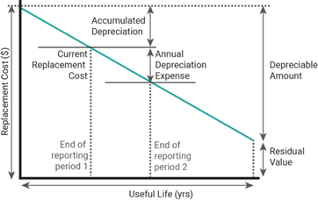
Figure 7.1: Valuation Terminology

The assets are valued at depreciated replacement cost:
- Replacement Cost (Gross) $457,836,195
- Depreciable Amount $457,836,195
- Current Replacement Cost $373,121,102
- Annual Depreciation Expense $4,690,149
Asset values are forecast to increase as additional assets are added.
Acquiring new assets will add to existing operations, maintenance, future renewal, and depreciation expenses.
Projected renewals are indicative only due to a lack of condition information. A risk managed approach will need to be taken with managing renewals, with improvements to the process to be investigated. Similarly, a risk managed approach should be taken with stormwater drainage infrastructure upgrades and additions.

Assumptions and improvement planning

Data and information sources

Accounting and financial data sources
This AMP utilises accounting and financial data sourced from Technology One CiAnywhere 2024A Release (775).

Asset management data sources
This AMP also utilises asset management data sourced from Technology One CiAnywhere 2024A Release (775).

Key assumptions
In compiling this AMP, it was necessary to make some assumptions. This section details the key assumptions made in the development of this AMP and should provide readers with an understanding of the level of confidence in the data behind the forecasts.
Key assumptions made in this AMP are:
- Renewal forecasts have been made by professional judgement.
- Population and asset growth projections are assumed to be accurate.
- The data supplied was as accurate as possible at the time of compilation of this asset management plan.
- The breakdown of the actual reactive, planned and operational expenditure is assumed to be accurate.
Assets requiring renewal are identified from either the asset register or an alternative method.
- The timing of capital renewals based on the asset register is applied by adding the useful life to the year of acquisition or year of last renewal,
- Alternatively, an estimate of renewal lifecycle costs is projected from external condition modelling systems and may be supplemented with, or based on, expert knowledge. When doing so, the forecast remaining useful life in the asset register should be adjusted where necessary.
The Asset Register Method was used to forecast the renewal lifecycle costs for this AMP initially, however that identified no renewals other than sump fencing. Therefore, professional judgement was used, considering identification of renewals will be by a risk managed approach. This second revision used the Alternative Method.

Forecast reliability and confidence
The forecast demands, costs, planned budgets, and valuation projections in this AMP are based on the best available data. For effective asset management and financial planning and reporting, it is critical that the information is reliable and up to date. Data confidence is classified on an A to E level scale in accordance with the guidance provided in the International Infrastructure Management Manual.
Confidence Grade | Description
A. Very High | Data based on sound records, procedures, investigations and analysis, documented properly and agreed as the best method of assessment. Dataset is complete and estimated to be accurate ± 2%
B. High | Data based on sound records, procedures, investigations and analysis, documented properly but has minor shortcomings, for example some of the data is old, some documentation is missing and/or reliance is placed on unconfirmed reports or some extrapolation. Dataset is complete and estimated to be accurate ± 10%
C. Medium | Data based on sound records, procedures, investigations and analysis which is incomplete or unsupported, or extrapolated from a limited sample for which grade A or B data are available. Dataset is substantially complete but up to 50% is extrapolated data and accuracy estimated ± 25%
D. Low | Data is based on unconfirmed verbal reports and/or cursory inspections and analysis. Dataset may not be fully complete, and most data is estimated or extrapolated. Accuracy ± 40%
E. Very Low | None or very little data held.
Table 8.1: Data Confidence Grading System
The estimated confidence level for and reliability of data used in this AMP is shown in Table 8.2.

Data | Confidence Assessment | Comment
Demand drivers | B | Professional judgement, corporate knowledge and id projections.
Growth projections | B | Id projections
Acquisition forecast | B | Professional judgement, corporate knowledge and Local Government projections.
Operation forecast | B | City records of past expenditure and professional judgement
Maintenance forecast | B | City records of past expenditure, feedback from C&M and professional judgement
Renewal forecast  - Asset values | A | Latest asset valuation data.
- Asset useful lives | C | Useful lives are based on industry practice and condition ratings. However, there is not a high level of confidence with the ‘Year Acquired’ information for some older assets.
- Condition modelling | D | Ad-hoc, reactive CCTV inspections with primary purpose to investigate customer complaints
Disposal forecast | B | No planned drainage disposals at this moment in time, although this may change within the planning period and, if so, must be reflected in the AMP.
Table 8.2: Data Confidence Assessment for Data used in AMP
The confidence level for and reliability of data used in this AMP is estimated to be C - Medium.

Improvement plan
It is important that we recognise gaps in the planning process that require improvement to ensure effective asset management and informed decision making. The improvement plan generated from this AMP is shown in Table 8.3.
Section | Project | Responsibility | Task
3.2 | Monitoring performance measures against levels of service targets | Asset Services | Drainage Management Strategy review meetings, update AMP with broad findings
5.2, 5.3 | Condition and performance assessment of drainage assets (catchments, sumps) | Asset Services  Design Services | External contractor to audit  Link to performance deficiency  Consider remaining life  Consider risk consequence, e.g. concrete pipe under distributor road pavement  Consider getting contractor to repair as well
5.2 | Maintenance Expenditure Trends | Asset Services  Finance Services | Improve allocation of budget to better represent maintenance types  Review definition of operations and maintenance, adjust systems accordingly
5.2 | Asset hierarchy | Asset Services | Consider overlying assets (e.g. road pavement)  Update Criticality or other appropriate field in GIS and T1
6 | Proactive risk assessment that incorporates tree root intrusion | Asset Services | Identify data we have on trees  Identify pipes that have trees on or near them
5 | Useful Lives | Asset Services | Revise and ensure consistency with adopted useful lives
5 | Continuing capture of stormwater drainage not currently in asset register | Asset Services | Utilise as-con and design drawings where available  Scan paper drawings  Capture pits and sumps from GIS and Google Street View
5.1 | Documenting 3D as construction drawings for sump earthworks | Planning Services  Design Services | Ensure drainage sumps are installed according to design  Ensure subdivisional Ascon drawings are handed over to the City
5.1 | Digitising the missing drainage catchments | Asset Services  Design Services | Analysing the existing drainage catchment layer in GIS and adding/ updating the drainage
6 | Annual review and update of risk register | Asset Services  Design Services | Workshop review and update of all relevant risks in risk register
Table 8.3: Improvement Plan

Monitoring and review procedures
This AMP will be reviewed during the annual budget planning process and revised to show any material changes in service levels, risks, forecast costs and proposed budgets as a result of budget decisions.
This AMP will be reviewed and updated annually to ensure it represents the current service level, asset values, forecast operations, maintenance, renewals, acquisition and asset disposal costs and planned budgets. These forecast costs and proposed budget are incorporated into the Long-Term Financial Plan or will be incorporated into the Long-Term Financial Plan once completed.
The AMP has a maximum life of 4 years and is next due for complete revision in 2028.

Performance measures
The effectiveness of this AMP can be measured in the following ways:
- The degree to which the required forecast costs identified in this AMP are incorporated into the long-term financial plan,
- The degree to which the 1 to 5-year detailed works programs, budgets, business plans and corporate structures consider the ‘global’ works program trends provided by the AMP,
- The degree to which the existing and projected service levels and service consequences, risks and residual risks are incorporated into the Strategic Planning documents and associated plans,
- The Asset Renewal Funding Ratio achieving the Organisational target (this target is often 90-110 per cent).

References
- City of Cockburn – Asset Management Strategy 2017 – 2024
- City of Cockburn – Strategic Community Plan 2025 – 2035
- City of Cockburn – Long Term Financial Plan 2024-2025 to 2033-2034
- City of Cockburn – Management Budget 2024 - 2025
- City of Cockburn – Enterprise Risk Management
- City of Cockburn – Drainage Management Strategy 2018 – 2028
- City of Cockburn – Drainage Catchments Study by Cardno – 2017
- City of Cockburn – Engineering, Construction and Drainage Standards Policy
- City of Cockburn – Place Score – Liveability Survey 2024
- City of Cockburn - Population forecast - https://forecast.id.com.au/cockburn/
- IPWEA, ‘International Infrastructure Management Manual’, Institute of Public Works Engineering Australasia, Sydney, https://www.ipwea.org/resourcesnew/bookshop/iimm
- DVC, 2006, ‘Asset Investment Guidelines’, ‘Glossary’, Department for Victorian Communities, Local Government Victoria, Melbourne, http://www.dvc.vic.gov.au/web20/dvclgv.nsf/allDocs/RWP1C79EC4A7225CD2FCA257170003259F6?OpenDocument
- Government of Western Australia, Department of The Premier and Cabinet - Western Australian Legislation - Acts in force
- IPWEA, ‘NAMS+ - A Toolkit for Asset Management Planning’, Institute of Public Works Engineering Australasia, Sydney, https://www.ipwea.org/resourcesnew/namsplus
- IPWEA, 2024 ‘International Infrastructure Financial Management Manual’, Institute of Public Works Engineering Australasia, Sydney, https://www.ipwea.org/resourcesnew/bookshop/iifmm
- IPWEA, 2018, Practice Note 12.1, ‘Climate Change Impacts on the Useful Life of Assets’, Institute of Public Works Engineering Australasia, Sydney, https://www.ipwea.org/resourcesnew/bookshop/pn12-1
- IPWEA, 2012, Practice Note 6 Long-Term Financial Planning, Institute of Public Works Engineering Australasia, Sydney, https://www.ipwea.org/publications/ipweabookshop/practicenotes/pn6
- IPWEA, 2014, Practice Note 8 – Levels of Service & Community Engagement, Institute of Public Works Engineering Australasia, Sydney, https://www.ipwea.org/publications/ipweabookshop/practicenotes/pn8
- ISO, 2024, ISO 55000:2024 Asset Management – Vocabulary, overview, and principles
- ISO, 2018, ISO 31000:2018 Risk management – Guidelines
- The Local Government and Municipal Knowledge Base - LGAM Knowledge Base
- Local Government of Western Australia – Asset Management Framework and Guidelines
- Main Roads Western Australia - Welcome - Main Roads Western Australia

Appendices

Appendix A Acquisition forecast
The new drainage assets and existing drainage assets that require upgrades to meet urban expansion/growth will be funded through a combination of municipal funding and Developer Contribution Plans.

Acquisition forecast assumptions and source
The forecast for donated assets likely to be received from developers over the next five years has been calculated by averaging out the previous five years total donated assets received through subdivisions. This equates to approx. 7km of new stormwater pipes, 373 new pits and other infrastructure totalling about $7m per year.

Acquisition (constructed) project summary
At present, the City does not have adequate drainage Capital project planning in place for future City-led New/Upgrade projects. These projects should be informed by the City’s 2017 Drainage Catchment Study or an updated equivalent study. At minimum, the Civil Infrastructure team should provide advice regarding locations that would provide the most strategic benefit for Capital works intervention in terms of Whole of Life Costs. It is clear there is more work to be done to identify and cost stormwater drainage acquisition projects, particularly when comparing with budgets and expenditures over the past five years (see Section A.3 below).

Acquisition forecast summary
These were calculated by linearly projecting the previous five years of budgets and expenditures.
Year | Constructed ($) | Donated ($) | Growth ($)
24/25 | 1,105,453 | 6,573,278 | 0
25/26 | 1,127,562 | 6,573,278 | 0
26/27 | 1,150,113 | 6,573,278 | 0
27/28 | 1,173,115 | 6,573,278 | 0
28/29 | 1,196,577 | 6,573,278 | 0
29/30 | 1,220,509 | 6,573,278 | 0
30/31 | 1,244,919 | 6,573,278 | 0
31/32 | 1,269,818 | 6,573,278 | 0
32/33 | 1,308,557 | 6,573,278 | 0
33/34 | 1,352,273 | 6,573,278 | 0
Table 10.1: Acquisition Forecast Summary

Appendix B Operation forecast

Operation forecast assumptions and source
Strictly speaking, operations is expenditure done on an asset that does not depend on its condition. In the case of stormwater drainage, this would include cleaning and vegetation management. However, to date this has not been the practice. Currently this is the cost of ‘supporting’ aspects like power, fuel, staff, security patrols, plant equipment, on-costs and overheads. It is in the improvement plan to review this definition and allocation of funds.
The planned annual operating expenditure was linearly extrapolated from the previous five years of expenditure.
Flooding complaints appear to be increasing slightly, putting extra burden on Operating and Maintenance budgets:

Figure 10.1: Customer Enquiries/Requests Related to Flooding over Previous Ten Years
The majority of the Operating and Maintenance budget is classed as Operating, however this has been used heavily for maintenance as well. This is why both the maintenance and operating budgets have been combined in Figure 5.2.1. The planned Operating and Maintenance budget is assumed to match the planned Operating and Maintenance expenditure.

Operation Forecast Summary
Table 10.2 provides a summary of Forecast Operations expenditure over the planning period.

Year | Operation Forecast ($) | Additional Operation Forecast ($) | Total Operation Forecast ($)
24/25 | 23,411 | Included in forecast | 23,411
25/26 | 56,029 | Included in forecast | 56,029
26/27 | 59,517 | Included in forecast | 59,517
27/28 | 63,006 | Included in forecast | 63,006
28/29 | 66,494 | Included in forecast | 66,494
29/30 | 69,983 | Included in forecast | 69,983
30/31 | 73,471 | Included in forecast | 73,471
31/32 | 76,960 | Included in forecast | 76,960
32/33 | 80,448 | Included in forecast | 80,448
33/34 | 83,937 | Included in forecast | 83,937
Table 10.2: Operation Forecast Summary

Appendix C Maintenance forecast

Maintenance forecast assumptions and source
The 2023/24 adopted maintenance budget for addressing operational drainage issues was approximately $370,000, however it was overspent based on an a higher-than expected number of customer queries (refer Appendix B). Maintenance covers cleaning, inspection and repairs.
Similar to operating expenditure, maintenance expenditure forecasts were linearly extrapolated from past expenditure.
Drainage structure complaints have been steadily increasing:

Figure 10.2: Customer Enquiries/Requests Related to Drainage Structures over Previous Ten Years
Of these, in 2023/24:
- Six were of sinkholes, possibly indicating structural failure of below ground infrastructure
- 76 were of damaged lids
- 20 were of damaged fences
- 5 were of requests for new stormwater drainage infrastructure due to localised flooding (i.e. requested acquisition)
- 4 were concerns about newly installed stormwater drainage infrastructure
- 61 were of debris causing blockages
The strong upwards trend (with a spike during the COVID-19 pandemic) suggests more frequent/extensive proactive inspections are required.
In addition, the lakes were reported to be silting up, making it progressively more expensive to keep the stormwater outlets clear and flowing.

Maintenance forecast summary
Table 10.3 provides a summary of forecast maintenance expenditure over the planning period.
Year | Maintenance Forecast ($) | Additional Maintenance Forecast ($) | Total Maintenance Forecast ($)
24/25 | 1,199,550 | Included in forecast | 1,199,550
25/26 | 1,246,941 | Included in forecast | 1,246,941
26/27 | 1,295,953 | Included in forecast | 1,295,953
27/28 | 1,346,636 | Included in forecast | 1,346,636
28/29 | 1,399,043 | Included in forecast | 1,399,043
29/30 | 1,453,228 | Included in forecast | 1,453,228
30/31 | 1,509,249 | Included in forecast | 1,509,249
31/32 | 1,567,162 | Included in forecast | 1,567,162
32/33 | 1,627,028 | Included in forecast | 1,627,028
33/34 | 1,688,908 | Included in forecast | 1,688,908
Table 10.3: Maintenance Forecast Summary

Appendix D Renewal forecast summary

Renewal forecast assumptions and source
Method 1 was used to predict renewals initially. Due to the estimated age of the infrastructure and the assumption of fixed useful lives, only fence renewals were predicted. As underground drainage renewals are typically higher priority, this has made forecasting actual expenditure challenging. Therefore, the forecast renewals were taken to be a fixed proportion of the new and upgrade program from the DMS.

Renewal project summary
Project | Expenditure for Financial Year Ending ($m)
Project | 25 | 26 | 27 | 28 | 29 | 30 | 31 | 32 | 33 | 34
Drainage Renewal Program | 1.7 | 1.9 | 1.9 | 1.9 | 1.9 | 2.0 | 2.0 | 2.1 | 2.1 | 2.0

Renewal forecast summary
Table 10.4 provides a summary of Forecast Renewal expenditure over the planning period.
Year | Renewal Forecast ($) | Renewal Budget ($)
24/25 | 1,913,371 | 1,913,371
25/26 | 1,913,371 | 1,913,371
26/27 | 1,913,371 | 1,913,371
27/28 | 1,913,371 | 1,913,371
28/29 | 1,913,371 | 1,913,371
29/30 | 1,913,371 | 1,913,371
30/31 | 2,015,829 | 1,961,205
31/32 | 2,118,287 | 2,010,235
32/33 | 2,220,745 | 2,060,491
33/34 | 2,323,203 | 2,112,003
Table 10.4: Renewal Forecast Summary

Renewal plan
Refer to Section 10.4.2.

Appendix E Disposal summary

Disposal forecast assumptions and source
As of June 2025, it is assumed there are no drainage asset disposal projects required over the planning period. However, this AMP should be updated with any disposal projects identified during the planning period, as well as the life cycle cost summary.

Disposal project summary
Any disposal projects identified during the planning period should be listed here in future AMP updates.

Disposal forecast summary
No asset disposals are planned.

Appendix F Budget summary by lifecycle activity
The budget summary shown in Table 10.5 is based on the renewal budget from the LTFP and the projected O&M budget, as discussed in Appendix B and C.
Year | Acquisition ($) | Operation ($) | Maintenance ($) | Renewal ($) | Disposal ($) | Total ($)
24/25 | 1,047,230 | 703,678 | 417,500 | 1,913,371 | 0 | 4,081,779
25/26 | 1,068,175 | 777,310 | 459,779 | 1,913,371 | 0 | 4,218,634
26/27 | 1,089,538 | 729,138 | 529,766 | 1,913,371 | 0 | 4,261,813
27/28 | 1,111,329 | 680,966 | 599,752 | 1,913,371 | 0 | 4,305,419
28/29 | 1,133,555 | 632,794 | 669,739 | 1,913,371 | 0 | 4,349,460
29/30 | 1,156,227 | 584,622 | 739,726 | 1,913,371 | 0 | 4,393,946
30/31 | 1,179,351 | 536,450 | 809,713 | 1,961,205 | 0 | 4,486,720
31/32 | 1,202,938 | 488,278 | 879,700 | 2,010,235 | 0 | 4,581,152
32/33 | 1,226,997 | 440,106 | 949,687 | 2,060,491 | 0 | 4,677,281
33/34 | 1,251,537 | 391,934 | 1,019,674 | 2,112,003 | 0 | 4,775,148
Table 10.5: Budget Summary by Lifecycle Activity

Appendix G Legislative requirements
Legislation | Requirement
Local Government Act 1995 | Provides for a system of Local Government by describing the functions of and providing a framework for the administration and financial management of Local Governments.
Main Roads Act 1930 | Consolidates and amends the law relating to and making provision for the construction, maintenance and supervision of highways, main and secondary roads, and other roads and the control of access to roads.
Main Roads WA – Code of Practice for traffic management for works on roads (April 2011) | To promote safe and consistent traffic management practice at work sites on roads in accordance with state legislation and national standards. Requires general compliance with the Australian Standard 1742.3-2009 and associated field guides, provides details of additional requirements necessary to meet WA requirements. Also outlines the competency requirements for personnel responsible for managing traffic on work sites.
Planning and Development Act 2005 | Provides for a system land use planning and development in the State and for related purposes.
Transport Co-ordination Act 1966 | Provides for the co-ordination, planning and advancement of all forms of transport in WA, to provide for the review, control and licensing of transport services and for incidental and other purposes.
Environmental Protection Act 1986 | Provides for an Environmental Protection Authority, for the protection, control and abatement of pollution and environmental harm, for the conservation, preservation, protection, enhancement and management of the environment and for matters incidental to or connected to the foregoing.
Environment Protection and Biodiversity Conservation Act 1999 | Provides a legal framework to protect and manage nationally and internationally important flora, fauna, ecological communities and heritage places, defined in the Act as matters of national environmental significance.
Contaminated Sites Act 2003 | Provides for the identification, recording, management and remediation of contaminated sites, to consequentially amend certain other Acts and for related purposes.
Conservation and Land Management Act 1984 | Makes better provision for the use, protection and management of certain public lands and waters and the flora and fauna thereof, establishes authorities to be responsible therefore, and for incidental or connected purposes.
Soil and Land Conservation Act 1945 | Relates to the conservation of soil and land resources, and to the mitigation of the effects of erosion, salinity and flooding.
Rail Safety Act 2010 | Requires Local Governments to develop an Interface Agreement with the rail manager/operator for every rail/road crossing in their area of responsibility by 1 February 2014
Fire and Emergency Services Authority of WA Act 1998 | Establishes an Authority with functions relating to the provision and management of emergency services, and for related purposes.
Aboriginal Heritage Act 1972 | Provision for the preservation on behalf of the community of places and objects customarily used by or traditional to the original inhabitants of Australia or their descendants
Native Title Act 1993 and amendments 1998 | Provides for the recognition and protection of native title and to establish ways in which future dealings affecting native title may proceed.
Occupational Safety and Health Act 1984 (WA) | Provides for the promotion, coordination, administration and enforcement of Safety and Health in WA. Places emphasis on the prevention of accidents and injury
Disability Services Act 1993 | An Act for the establishment of the Disability Services Commission and the Ministerial Advisory Council on Disability, for the furtherance of principles applicable to people with disabilities, for the funding and provision of services to such people that meet certain objectives, for the resolution of complaints by such people, and for related purposes.
Code of Practice Working Hours 2006 | Provides guidance for employers and workers on the management of Safety and Health hazards and risks commonly associated with working hour arrangements.
Australian Standards | Standards are published documents setting out specifications and procedures designed to ensure products, services and systems are safe, reliable and consistently perform the way they were intended to. They establish a common language which defines quality and safety criteria.
Western Australian Planning Commission Act 1985 | An Act to establish a body with responsibility for urban, rural and regional land use planning and land development and related matters in the State, and for connected purposes.
Local Government Guidelines for Subdivisional Development, 2011 | To provide greater clarity and certainty of subdivisional engineering requirements, the Department of Planning has partnered with the Institute of Public Works Engineering Australia (WA Division) (IPWEA) to produce Edition No. 2.1 of the Local Government Guidelines for Subdivisional Development, 2011. These 2011 Guidelines are intended to underlie, and support subdivision conditions applied by the Western Australian Planning Commission pursuant to the Planning and Development Act 2005. The Guidelines encompass current legislation and best practice minimum engineering standards.

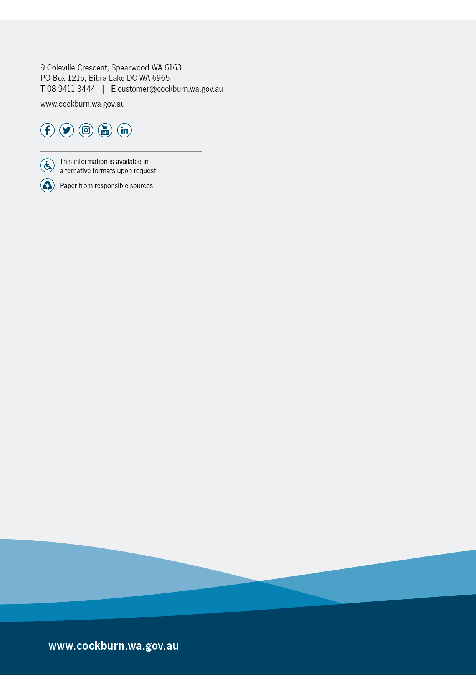

ISO 55000:2024 Asset Management – Vocabulary, overview, and principles
IPWEA International Infrastructure Management Manual (IIMM), Sec 1.2.1
IPWEA, 2015, IIMM, p 2|28.
IPWEA Practice Note 12.1 Climate Change Impacts on the Useful Life of Infrastructure
IPWEA, 2015, IIMM, Sec 2.5.4, p 2|80.
IPWEA, 2015, IIMM, Sec 3.4.4, p 3|91.
Based on IPWEA, 2015, IIMM, Sec 3.4.5, p 3|97.
ISO 31000:2009, p 2
Enterprise Risk Management
Enterprise Risk Management
AIFMM, 2015, Version 1.0, Financial Sustainability Indicator 3, Sec 2.6, p 9.
Also reported as Written Down Value, Carrying Amount or Net Book Value in some jurisdictions.
IPWEA, 2015, IIMM, Table 2.4.6, p 2|71.

