EXTRACTIVE INDUSTRIES
Planning Information Sheet

WHAT IS AN EXTRACTIVE INDUSTRY?

Industry – Extractive means an industry which involves the extraction, quarrying or removal of sand, gravel, clay, hard rock, stone or similar material from the land and includes the treatment and storage of those materials, or the manufacture of products from those materials on, or adjacent to, the land from which the materials are extracted, but does not include industry – mining.

DO THEY ALL REQUIRE PLANNING APPROVAL?

All proposals for Industry – Extractive require planning approval from the City of Cockburn. Industry - Extractive can only be considered for approval within the ‘Industry’ and ‘Rural’ zones under the City of Cockburn Town Planning Scheme No. 3 (TPS 3). For more information about what forms, fees and information is required please download the Planning Application Checklist.

Development Standards | Information Required
The following development standards shall apply to all proposals for Industry – Extractive uses:  - A setback of not less than 40 metres wide to a road reserve or other public reserve and not less than 20 metres wide to all other boundaries to the lot is to be provided unless determined otherwise by the local government.  - The setback shall comprise the existing vegetation which shall remain undisturbed except for:  - access ways for entering and leaving the extractive industry site;  - firebreaks as may be required under the Bush Fires Act;  - re-vegetation to reinstate or supplement the existing vegetation to provide an effective visual screen from adjoining and nearby public and private owned land; and  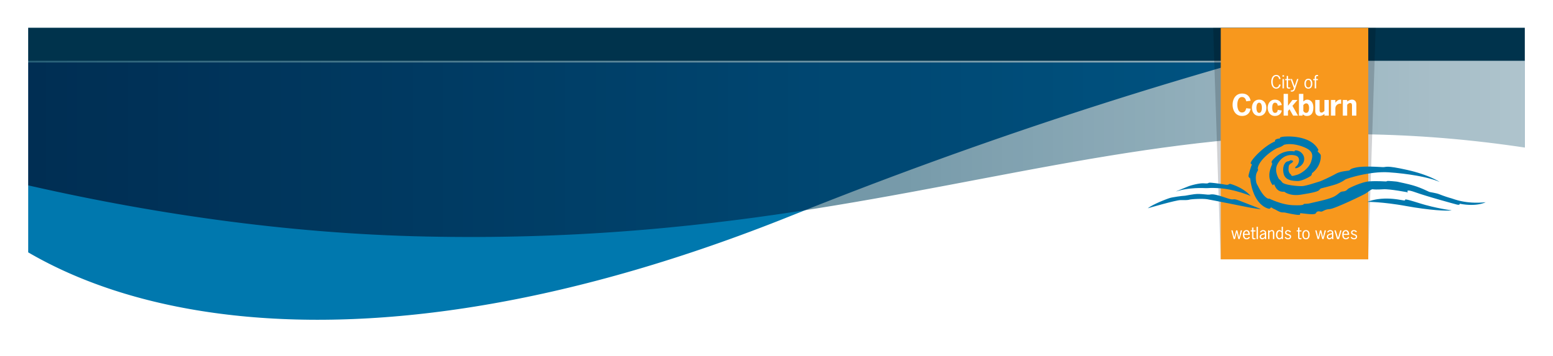  - public and private utility infrastructure.  Rehabilitation:  - Permanent rehabilitation of the site is to occur progressively at a similar rate as the extraction or at a time agreed between the quarry operator and the local government;  - Soil profiles are to be reconstructed to facilitate rehabilitation of the site;  - Revegetation is to be based on the planting of native flora typical of the locality with the species and plant density to be determined by the local government having regard to the rehabilitation plan submitted under clause5.12.1(a)(vi);  - The rehabilitation and stabilising of completed excavation are to be progressively implemented in accordance with the approved rehabilitation plan and shall be managed, maintained and monitored by the landowner for a minimum of 2 years to the local government's satisfaction;  - Annual Rehabilitation Reports are to be completed outlining the progressive implementation of rehabilitation and stabilising of completed excavation to the local government’s satisfaction; and  - Statement of Planning Policy No. 2.4 shall be used in considering any application for planning approval for an Industry - Extractive. | - A report detailing the existing physical environment including geology, soil profiles, surface and ground water hydrology, identified sites of historic / heritage or cultural significance, current land use, zoning, surrounding land use and potential external impacts;  - A Flora and Fauna report for the site prepared by a qualified botanist to the specifications and satisfaction of local government, and is to include, but not limited to, consideration of any declared rare flora or priority species and declared sites of environmental and biological significance;  - A vehicle access plan detailing site ingress / egress, road haulage routes, frequency of vehicle movements and proposals for any vehicle maintenance and fuel storage facilities;  - A plan showing excavation stages, existing and final site levels together with cross-sections;  - A Management Plan detailing the measures to be taken to control dust, noise, erosion, soil and groundwater pollution, fire and weeds, including demonstrated compliance with any relevant standard and the protection of any features of the land to be retained or preserved;  - A Rehabilitation Plan and implementation programme to either restore the land as close as possible to its condition prior to the extraction of materials or to provide for a future use appropriate to, and consistent with the zoning of the land; and  - Details of the proposed times of operation.

