Tender Title: |  | Verge Mowing Services - City Wide
Request ID: |  | 79330
Tender Description: |  | The City is seeking a suitably qualified and experienced Contractor to conduct Verge Mowing Services along Priority One, Priority Two, and Rural and Industrial Roadsides.
Advert Approval: |  | Decision to Advertise: Director Infrastructure Services  Decision Date: Tuesday, 19 May 2026
Closing Date and Time: |  | 2:00PM (AWST) Thursday, 28 May 2026
Opening Date and Time: |  | 2:00PM (AWST) Thursday, 28 May 2026
 | Tenderer’s Name:
1 | GREEN BY NATURE LANDSCAPE SERVICES (WA, SA, TAS, ACT, NT) PTY LTD t/a Green By Nature (West Australia)
2 | GECKO CONTRACTING TURF AND LANDSCAPE MAINTENANCE t/a Gecko Contracting Turf & Landscape Maintenance
3 | Landscape Australia Construction

Advertisement
Method 1: City of Cockburn website | Method 2: City of Cockburn Libraries Public Noticeboards
Method 3:  The Western Australian, Wednesday, 13 May 2026 | Tender Awarded by:
Copy of Statewide Notice:  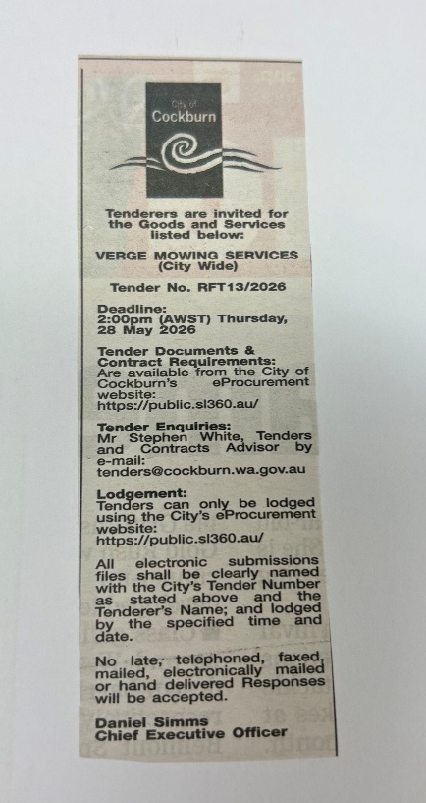 | OCM  Tuesday, 14 July 2026
 | Date of Council Meeting:
Date: 14 July 2026
Minutes: 2026/MINUTE NO 0098
Item No. 14.3.1
Name of Successful Tenderer(s): | Category A - Priority One - Landscape Australia Constructions  Category B – Priority Two - Green By Nature (West Australia)  Category C – Rural and Industrial Roadsides - Landscape Australia Constructions
Amount of Successful Tender(s): (ex GST) | Category A - Priority One - Landscape Australia Constructions: $231,840 (Ex GST)  Category B – Priority Two - Green By Nature (West Australia): $576,051.70 (Ex GST)  Category C – Rural and Industrial Roadsides - Landscape Australia Constructions: $494,250.00 (Ex GST)

