Tender Title: |  | RFT 15/2026 - Provision of Road Planing (Cold) Services
Request ID: |  | 79420
Tender Description: |  | The City of Cockburn is seeking the services of a suitably qualified and experienced Road Planing Contractor for the City’s (cold) road planing requirements at locations throughout the City of Cockburn area.  The scope of works also include road profiling, stabilisation levelling, temporary ramp installation, surface repairs, handwork around road infrastructure and services and sweeping.
Advert Approval: |  | Decision to Advertise: Director Infrastructure Services  Decision Date: Thursday, 18 June 2026
Closing Date and Time: |  | 2:00PM (AWST) Wednesday, 15 July 2026
Opening Date and Time: |  | 2:00PM (AWST) Wednesday, 15 July 2026
 | Tenderer’s Name:
1 | West Coast Profilers Pty Ltd t/a West Coast Profilers
2 | Dowsing Group
3 | Fulton Hogan Industries Pty Ltd t/a Fulton Hogan (Hazelmere)
4 | SGA Roads Pty Ltd t/a SGA Group (WA)

Advertisement
Method 1: City of Cockburn website | Method 2: City of Cockburn Libraries  Public Noticeboards
Method 3: The Western Australian, Saturday  20 June 2026, Page 162 | Tender Awarded by:
Copy of Statewide Notice:  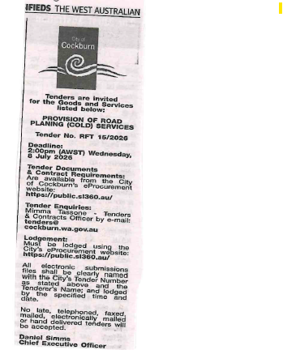 | OCM  Tuesday, 25 August 2026
 | Date of Council Meeting:
Tuesday, 11 August 2026
Minutes: 2026/MINUTE NO 0028
Item No: 14.3.1
Name of Successful Tenderer(s): | West Coast Profilers Pty Ltd t/a West Coast Profilers
Amount of Successful Tender(s): | $3,515,563.00 (Ex GST)

