Tender Title: |  | CONSTRUCTION SERVICES - BLACKSPOT INTERSECTION UPGRADE - PROJECT SITE 1 (Carrington Street & Forrest Road) Hamilton Hill WA
Request ID: |  | 70231
Tender Description: |  | The City seeks the services of a suitably qualified, registered and experienced Construction Contractor to undertake civil works and traffic signal upgrade. The Site  location is the Intersection of Carrington Street and Forrest Road in Hamilton Hill, Western Australia.
Advert Approval: |  | Decision to Advertise: Director Infrastructure Services  Decision Date: Tuesday, 5 August 2025
Closing Date and Time: |  | 2:00PM (AWST) Saturday, 9 August 2025
Opening Date and Time: |  | 2:00PM (AWST) Saturday, 9 August 2025
 | Tenderer’s Name:
1 | Civcon Civil & Project Management t/a Civcon Civil and Project Management
2 | Tracc Civil Pty Ltd (Office)
3 | WCP Civil Pty Ltd
4 | Dowsing Group
5 | Roadline Civil Contractors t/a Roadline Civil
6
7
8
9
10

Advertisement
Method 1: City of Cockburn website | Method 2: City of Cockburn Libraries Public Noticeboards
Method 3:  The Western Australian, Saturday, 9 August 2025 | Tender Awarded by:
Copy of Statewide Notice:  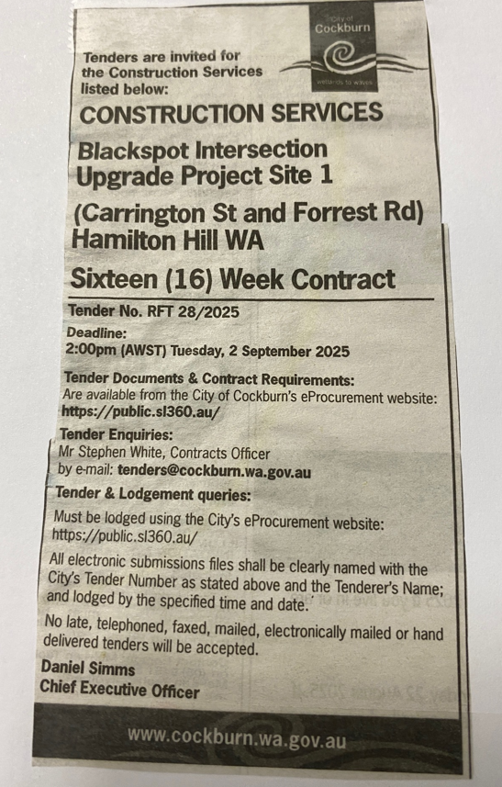 | OCM  Choose an item.  Tuesday, 9 December 2025
 | Date of Council Meeting:
Date: 09 December 2025
Minutes: (2025/MINUTE NO 0223)
Item No. 14.3.3
Name of Successful Tenderer(s): | WCP Civil Pty Ltd
Amount of Successful Tender(s): (ex GST) | $1,169,467

