Tender Title: |  | RFT 20-2020  Architectural Services - Beale Park Redevelopment
Request ID: |  | 36668
Tender Description: |  | For the design, documentation and lead (principle) consultant role for the design and construction of the Beale Park Redevelopment project in Spearwood.
Advert Approval: |  | Decision to Advertise: Director of Govenernance & Community Services  Decision Date: Wednesday, 26 August 2020
Closing Date and Time: |  | 2:00pm (AWST) Tuesday, 15 September 2020
Opening Date and Time: |  | 2:00pm (AWST) Tuesday, 15 September 2020
 | Tenderer’s Name:
1 | HODGE COLLARD PRESTON UNIT TRIST t/a Hodge Collard Preston Architects (Nicholas Preston)
2 | HENNING JACOBUS LIEBENBERG
3 | Mode Design Corp . Pty Ltd t/a MODE
4 | (A)POD PTY LTD t/a (A)POD Pty Ltd T/A Donovan Payne Architects
5 | The Trustee for THE BDG Trust t/a Bollig Design Group (Bollig Design Group)
6 | GRESLEY ABAS PTY LTD
7 | Lyons Architects Holdings Pty Ltd t/a Lyons Architects
8
9
10

Advertisement
Method 1 : City of Cockburn | Method 2 : NA
Method 3 :  The West Australian | Tender Awarded by:
Copy of Statewide Notice:  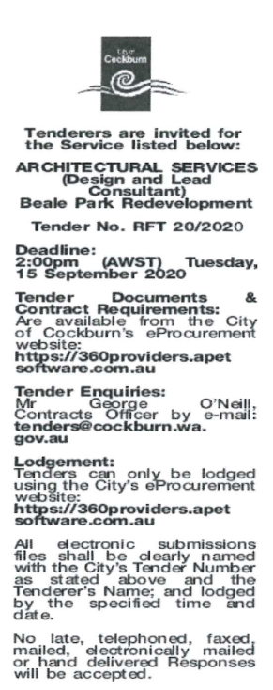 | Director of Govenernance & Community Services  Choose an item.  Thursday, 22 October 2020
 | Date of Council Meeting:
Click here to enter a date. or
Choose an item.
Item No:
Name of Successful Tenderer(s): | Bollig Design Group
Amount of Successful Tender(s): (ex GST) | $163,000

