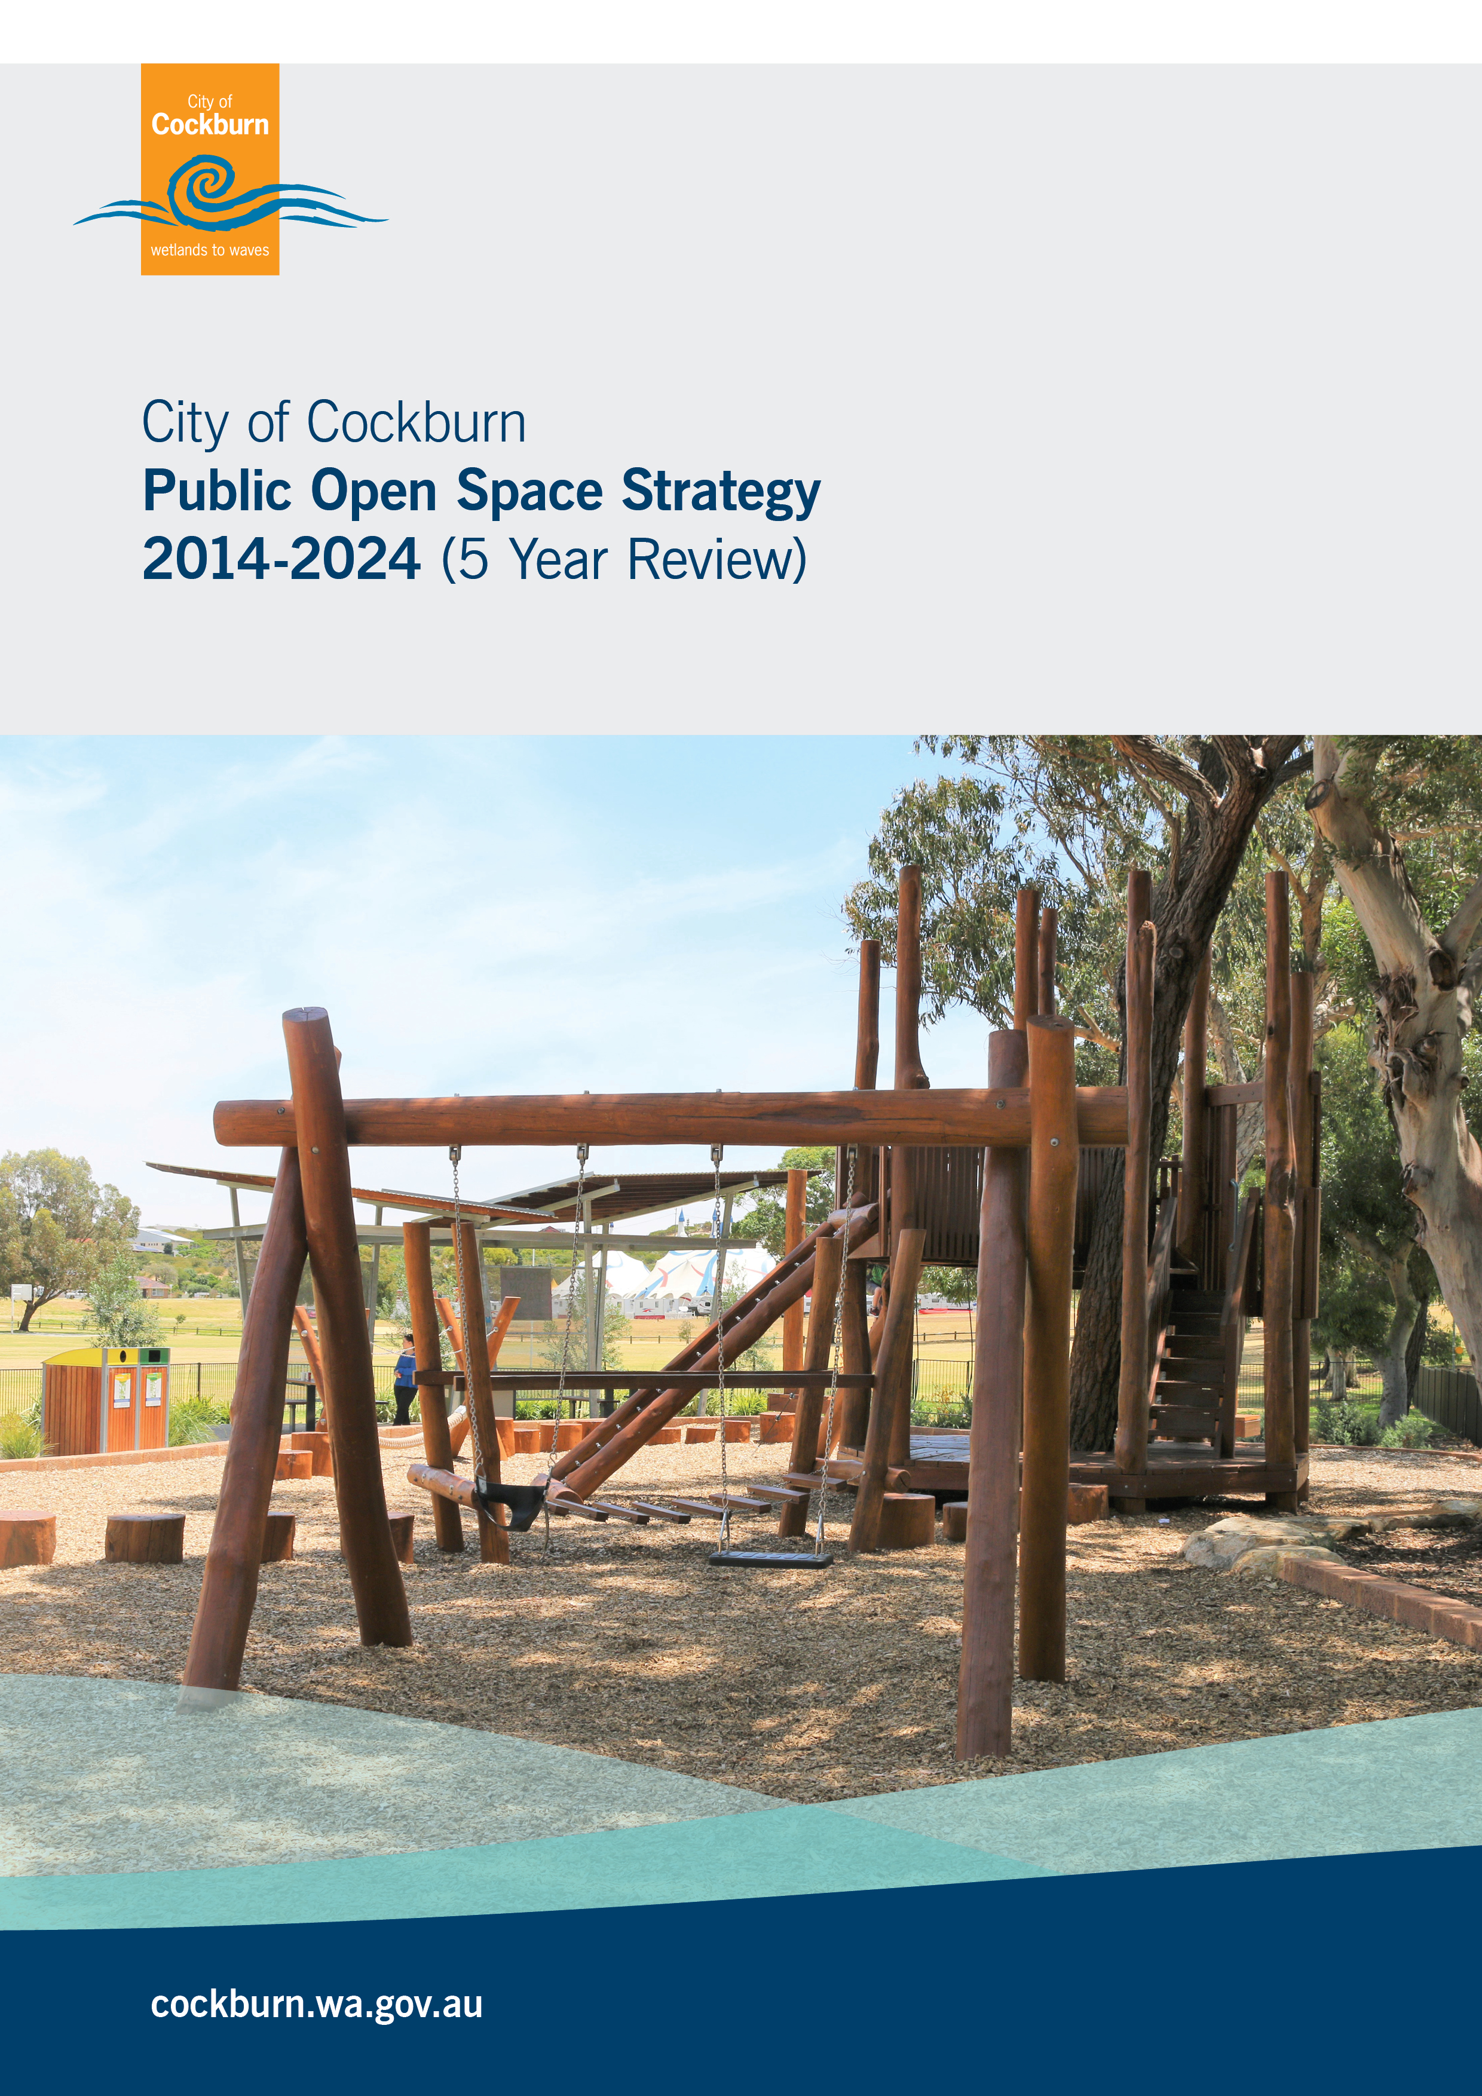

Document Information
Document Information:
Document Title: | Public Open Space Strategy
Prepared by: | Anton Lees, City of Cockburn
ECM – Doc Set ID | 8330032
Document status: | Draft | Version: | 1.1
Front Cover | Dixon Park Playground

Document Control
Version History:
Version: | Description: | Issue Date: | Authorised by:
1.0 | Draft | 01.08.2014 | Manager, Parks and Environment
1.0 | Endorsed by Council | 09.10.2014 | Council
1.1 | 5 Year Review | 1.03.2019 | Manager, Parks and Environment
1.2 | Endorsed by Executive | 11.06.2019 | Manager, Parks and Environment
1.3 | Public Release |  | Manager, Parks and Environment

Table of Content
Document Information 2
Document Control 2
Executive Summary 5
1 Introduction 7
2 Vision 8
3 Links to the Strategic Community Plan 2016 – 2026 9
4 Themes 10
4.1 Classification 10
4.1.1 Functional 11
4.1.2 Catchment Hierarchy 12
4.1.3 Neighbourhood Open Spaces 15
4.1.4 Local Open Space 16
4.2 Value 18
4.2.1 Health & Liveability 18
4.2.2 Multi-use of Public Open Space 20
4.2.3 Lighting 21
4.2.4 Toilets 22
4.3 Participation 23
4.3.1 Lifestyle Changes 23
4.3.2 Dog Exercise Parks 23
4.3.3 Community Gardens 23
4.3.4 Skate Parks 24
4.3.5 Pump Tracks 24
4.3.6 Multipurpose Courts 24
4.3.7 Memorial Plaques 24
4.3.8 Playground Fencing 25
4.4 Connectivity 26
4.4.1 Streetscape Strategic Approach 26
4.4.2 Streetscape Development 26
4.4.3 Entry Statement 26
4.4.4 Major Road Streetscapes 27
4.4.5 Minor Road Streetscapes 27
4.4.6 Road Reserve Management 27
4.4.7 Streetscapes as Ecological Linkages 27
4.4.8 Streetscape Zones 28
4.4.9 Street Trees 29
4.4.10 Arboricultural Inspections 30
4.4.11 Clearance from Power Lines 30
4.4.12 Street Tree Database 31
4.4.13 Street Tree Master Plan 31
4.4.14 Urban Forest Plan 32
4.5 Responsible Management 33
4.5.1 Managing Existing POS 33
4.5.2 Managing New POS 33
4.5.3 Challenges in Managing POS 34
4.5.4 POS Rationalisation 34
4.5.5 Process Improvement 34
4.5.6 Smart Technology 34
4.5.7 Safety and Risk Management 35
4.5.8 Asset Management 35
4.5.9 Level of Service 35
4.5.10 Improvement Plan 35
5 Community Scorecard 36
6 Resourcing the Plan 37
7 Measuring Achievement 38
8 Action Pan 39
8.1.1 Theme 1: Classification 39
8.1.2 Theme 2: Value 40
8.1.3 Theme 3: Participation 41
8.1.4 Theme 4: Connectivity 43
8.1.5 Theme 5: Responsible Management 44
10 Annexes POS Classification Levels of Service 47
11 Annexes Streetscape Level of Service Per Annum 48
12 Annexes POS Inventory 2019 & Development Schedule 49
13 Annexes Future Public Opens Space 60

Executive Summary
Public Open Space (POS) is the most visible asset the City is responsible for providing, managing and maintaining, and provides a key opportunity for communicating the City’s vision and values. POS provides a number of different services, including opportunities for social and recreational pursuits, community development, improved amenity, green spaces and ecological functions.
The City has over 800ha of POS distributed over 320 parks and reserves along with 38,500 street trees and several high profile streetscapes requiring a strategic framework to manage. This strategy sets out the strategic foundations for local, neighbourhood and district parks, regional and coastal reserves, street trees, roadside verges, streetscape environments and ecological corridors. The strategy guides development and sound management principles to ensure the assets are sustained now and into the future. The strategy resides within the City’s broader framework of corporate strategic planning, ensuring alignment with the organisation’s vision and values, and is cognisant of state and local planning frameworks and regulations.
This five year revision of the strategy has provided the opportunity to synthesize the content and report on the actions completed to date. Sixty two actions were identified at the commencement of the strategy of which thirty three are being implemented on an annual basis. Of the remaining twenty nine, sixteen actions have been completed at the 5 year anniversary. Two new actions have been included to the program one which responds to the community survey on entry statements and the second one relating to the digital space around the use of smart technology to improve the management of POS and park infrastructure.
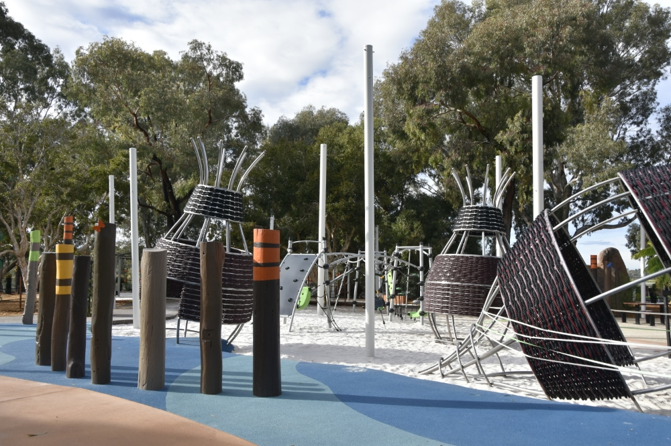
Figure 1: Bibra Lake Adventure Playground

Introduction
The Public Open Space Strategy will provide direction to guide the future provision, enhancement and management of open space in the City of Cockburn (the City). The strategy will assist the City in its future allocation of resources, decision making and adequately respond to the trends and issues associated with public open space.
This strategy also incorporates streetscapes, roads and street trees in order to reflect the connectivity and importance of these areas as they overlap with POS. With an ever changing environment, road reservations have the potential to form part of a linear POS framework which could accommodate recreational pursuits, link adjacent POS areas, create ecological corridors linking remnant vegetation and enhance pedestrian and cycle links to smaller POS areas increasing their value.
POS in this strategy is subject to many forms of tenure and management, with maintenance, management and ownership being both shared and dispersed between the City and the State’s various authorities. POS is extensively used by the local community and visitors for recreation and leisure functions, social gatherings, events and tourism. POS is important for biodiversity, mitigation of the urban heat island effect, public health and has heritage value.
The Public Open Space Strategy has been structured around five key themes.
- Classification – Establishes dual classification system identifying the primary function and open space hierarchy to inform the community of the provision of POS, including how the City will manage and invest in infrastructure to ensure sustainability for future generations.
- Value – Define the character and diversity of our parks and community hubs ensuring they are safe and functional spaces which enable sporting and social recreational pursuits and provide relaxation nodes for the community.
- Participation – Create a strong alliance with the community, state and local governments, education and health departments and private sector to achieve shared use and common goals and ensure that parks are accessible to people of all abilities in the community.
- Connectivity – Establish streetscape environments that connect to POS by creating shady streets with good tree canopy cover to encourage walking and to provide links for wildlife to move across the City.
- Responsible Management – Invest in maintenance to provide substantial benefits to the community along with sustainable development combined with strong asset management principles to ensure spaces are enjoyable and sustainable. Addressing community needs and emerging trends will require a well-articulated and responsive management regime.

Vision
The principle vision of the Public Open Space Strategy is to:
“Create a sustainable hierarchy of accessible and resource efficient quality open spaces and streetscape environments that enhance the recreational, environmental, social and health needs of current and future generations”
A Public Open Space Strategy is vital for maintaining the high quality of our public domain and for achieving the City’s vision:
“Council’s vision is to build on the solid foundations that our history has provided to ensure that the Cockburn of the future will be the most attractive place to live, work, visit and invest in, within the Perth Metropolitan area”
This POS Strategy will provide the City with a foundation which will provide attractive, functional and sustainable public spaces and streetscape environments. Good quality open space and connected streetscapes will ensure a sustainable lifestyle for the community and environmental asset which when well managed will improve as it matures over time.

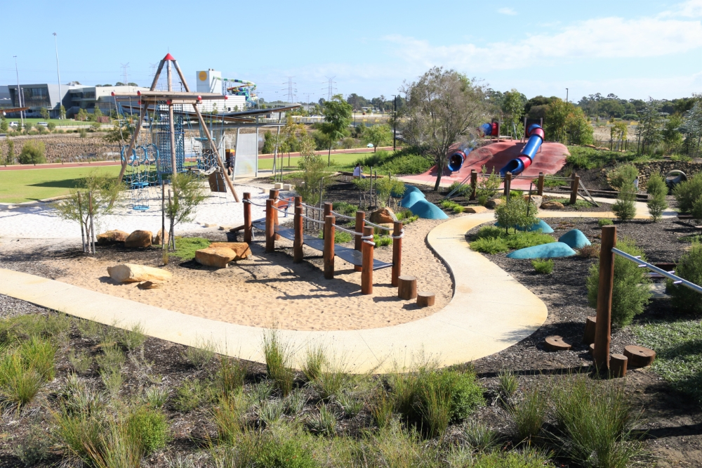
Figure 2: Yandi Park

Links to the Strategic Community Plan 2016 – 2026

Themes

4.1 Classification
The classification framework for the City’s public open space will follow the framework constructed by the Department of Local Government, Sport and Cultural Industries. The framework was developed through extensive consultation with the Department of Planning, Lands and Heritage, Local Governments (including Cockburn), Parks and Leisure WA and professional industry groups. The framework will enable universally recognised terms to be applied to each POS during planning and management applications. The strategy adopts two class denominations;
- Function (primary use and activities) has three primary types of open space:
  - Recreation Spaces
  - Sport Spaces
  - Nature Spaces

- Catchment Hierarchy (size and distance to open space) has four categories:
  - District Open Spaces
  - Regional Open Space
  - Neighbourhood Open Space
  - Local Open Space
The framework has been applied to open spaces managed by the City to inform future development and management applications. A detailed breakdown of the two class denominations and hierarchy categories enables an understanding of the criteria to be applied to each POS and the expected level of embellishment.
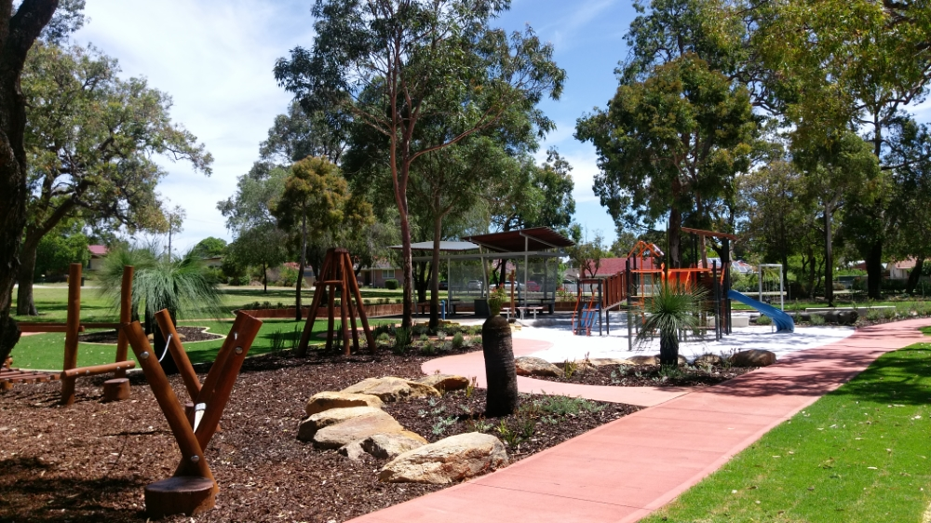
Figure 3: Jarvis Park

4.1.1 Functional

Recreation Spaces
Recreation spaces provide an environment for informal play and physical activity, relaxation and social interaction. Recreation spaces enhance physical and mental health through activity and are accessed by the community for play, socialising, intrinsic rewards and stimulation. Recreation spaces are framed through open parklands with a scattering of garden beds, providing corridor links, community gardens and also providing community facilities or forming parts of a civic square.

Sporting Spaces
Sporting spaces provide a setting for formal structured sporting activities such as team competitions, physical skill development and training. Sporting spaces are designed to accommodate playing surfaces, and other infrastructure for sporting pursuits. Sporting players and spectators attend these locations for the express purpose of organised sport, training or viewing the activities on display. These spaces are easily accessed and used by the broader community for other informal recreational activities.
Sporting spaces should be flexible in their design to accommodate a range of sports or sized competitions in line with the community needs. Sporting spaces are ideally coupled with nature and / or recreational functions to create valued community assets which become a destination for a variety of people.

Nature Spaces
Nature spaces provide an atmosphere where people can enjoy the natural environment and care for the local biodiversity. Nature spaces provide the opportunity for minor recreational activities including walking, cycling, and general play and exploring the natural elements. Nature spaces include bushlands, coastal environments, wetlands and natural features in the landscape. These spaces are managed to ensure recreational access whilst protecting local ecological and biodiversity values.

Embellishment Levels
The embellishment of POS is typically facilitated initially by a developer through the subdivision process then improved in accordance with changing community needs and/or where a revitalisation strategy is being implemented. Developers are required to develop the POS to a minimum standard which may include earthworks, irrigation, grassing, pathways which form part of a cycleway / pedestrian network and maintenance for two summers. However a majority of POS coming through the subdivision process is embellished to a higher level, in order to create a space that meets the needs of the future community. Embellishment will align with the criteria identified below. Improving the POS amenity post subdivision is via this strategy, revitalisation strategies, customer requests and other informing documents.

Catchment Hierarchy

Regional Open Space
Regional Open Space (ROS) is created outside the structure planning process by the WA Planning Commission in consultation with Local Government. These spaces serve the greater Perth, exclusive of Local Government boundaries. Local Government may accept responsibility for the management and maintenance of the ROS or other open space catchment hierarchies such as a district open space which may be located within a regional open space, but this must be in accordance with the State Government Management Plans for the ROS, and their consent.
Regional Open Space may accommodate important recreation and sport spaces as well as significant conservation and / or natural features including but not limited to organised sports, children’s play, picnicking, bush walking and protection of natural features. The size of the ROS should be designed to cater for both adult and junior sporting competition and the appropriate supporting amenity.

. Regional Open Spaces Criteria:
- Significant biodiversity & environmental values
- Provide for organised sporting activities
- Attracts visitors from outside the LGA
- Size is variable and can exceed 20ha
- Accessed by vehicle or public transport
- Parking provision is essential
- Well connected to major road networks
- House community events

Development Status
Regional Open Spaces are typically developed in accordance with a master plan with community consultation. Currently the City has Five (5) regional open spaces: Manning Park, Bibra Lake, Market Garden Swamp (North and South), C Y O’Connor Beach and Coogee Beach. Management plans have been developed for all these ROS ensure the diversity of the site is sustained and development addressed systematically. ROS is developed to an advanced level based on the high attendance and participation from the community resulting in a higher operating expenditure value per year.

Level of Embellishment
- Playground Equipment & Shade Structure
- Exercise equipment
- Skate Parks
- Car park
- Public toilets
- Lighting & CCTV
- Shelters / Gazebos
- Advanced landscaping
- Multipurpose Courts
- Drinking Fountains
- Irrigation
- Signs ( informative / interpretive/ entrance)
- Footpaths
- Be accessible and Inclusive
- Conservation areas
- Sporting Infrastructure (half-court Basketball, set football / soccer goals, etc.)

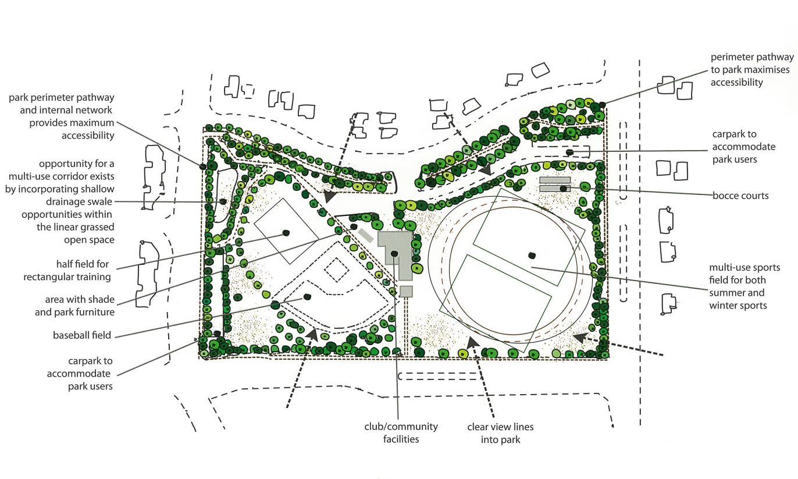
Figure 4: Example of District Open Space. Source: Department of Sports and Recreation (DSR)

District Open Space
District open space is a term used to describe areas that generally serve the whole municipality or reasonably several suburbs within the City. The expectation is that residents are prepared to drive to these places for structured sporting competitions. These locations may have significance for the municipality as a whole or a substantial part of it due to size, function or diversity. Municipal level public open spaces may be significant for their conservation or cultural values.

District Open Spaces Criteria:
- Generally within 2km or a 5 minute drive
- Typical size >5ha
- Centrally located
- Accommodate required sporting dimensions for a variety of codes
- Be collocated with schools
- Services by public transport
- Accessible by car, cycling or walking
- Good accessible footpath connectivity with local community
- Good passive surveillance

Development Status
District open spaces are master planned though the strategic planning stage and are fully developed to enable immediate use by the local and wider community. Where additional features are required after this process, community and club consultation will be completed and subject to funding availability.

Level of Embellishment
- Clubrooms including public toilets & parking bays
- Playground equipment & shade structure
- Signs ( informative / interpretive/ entrance)
- Picnic Setting / Shelters / Gazebos
- Skate Parks
- Advanced landscaping
- Perimeter fencing
- Drinking Fountains
- Irrigation
- Footpaths
- Lighting
- Sporting Infrastructure (½ Court Basketball, set football / soccer goals, etc.)
- Be accessible

Neighbourhood Open Spaces
Neighbourhood open spaces serve as places of leisure and social interaction for the community, offering a variety of recreational activities and facilities. These open spaces frame community facilities and can function as community spaces, such as town squares. Neighbourhood open spaces also enable the community to connect to the environment and provide habitat for fauna in dense urban residential areas.

Neighbourhood Open Spaces Criteria
- Within 800m or a 10 minute walk of the surrounding community
- Central with the surrounding neighbourhood
- Accessibility friendly
- Good pedestrian and cycling connections
- Typical size 1ha-5ha
- Support good passive surveillance
- Create a sense of place

Development Status
The development of neighbourhood open spaces will range from primary to advanced levels of embellishment. Basic aspects ensure the park is functional and provides a range of recreational infrastructure for the community. Advanced development includes additional elements that support an increase in social interaction and recreational pursuits based on a park’s location within a suburb. A change in status will require consultation with the community and be subject to capital and operational funding availability.

Primary Level Embellishment
- Irrigated grass
- Playground equipment & shade sails
- Picnic settings / Shelters / Gazebo’s
- Major landscaping
- Perimeter fencing
- Footpaths
- Bins, including dog poo stations
- Signs
- Sporting Infrastructure (½ Court Basketball, set football / soccer goals, etc.)
- Be accessible

Advanced level of Embellishment
- Exercise Equipment
- Skate Parks
- Drinking Fountain
- BBQs
- Lighting
- Public Toilets (feasibility study per site to be completed)
- Major landscaping
- Designated Dog Exercise Areas
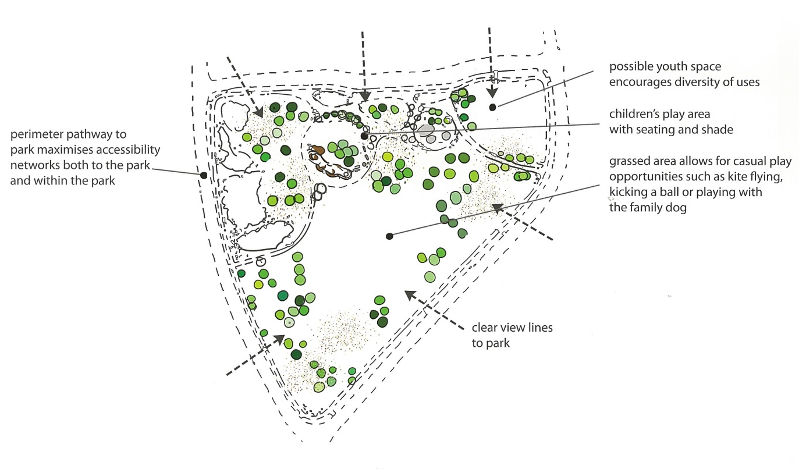
Figure. 5: Example of Neighbourhood Open Space. Source: (DSR)

Local Open Space
Local open space describes small local parks that are predominantly provided for the needs of the immediate residential population. They are predominately for casual and informal recreation by the community and easily accessed by bicycle or foot. Local open spaces include places for play, informal recreation and sport, at a relatively low level of complexity. The provision of parking is generally not required however in new subdivisions, parking embayment to the perimeter of a park are being negotiated with developers in order to reduce the amount of landscape to irrigate and to mitigate the lack of parking current being experienced by the TPS.

Local Open Spaces Criteria:
- Generally within 400m walking distance of homes in the local area
- Accessibility friendly, no major road impediments
- Good pedestrian and cycling connections
- Typical size 0.4ha – 1 ha
- Support good passive surveillance
- Build a sense of place
- Assist to the preservation of local biodiversity

Development Status
The development of local open spaces ranges from primary to advanced embellishment. Primary aspects will ensure parks are functional and provide basic infrastructure for the community. Advanced development include additional elements that have been determined essential, due to an under provision of public open space in a suburb or as a result of urban infill in the surrounding precinct. A change in status will require consultation with the community and be subject to capital and operational funding availability.

Primary Level Embellishment
- Unirrigated grass
- Minor landscaping
- Local biodiversity
- Seating
- Park name sign

Advanced Level of Embellishment
- Irrigated grass
- Playground equipment
- Major landscaping
- Footpaths
- Bins
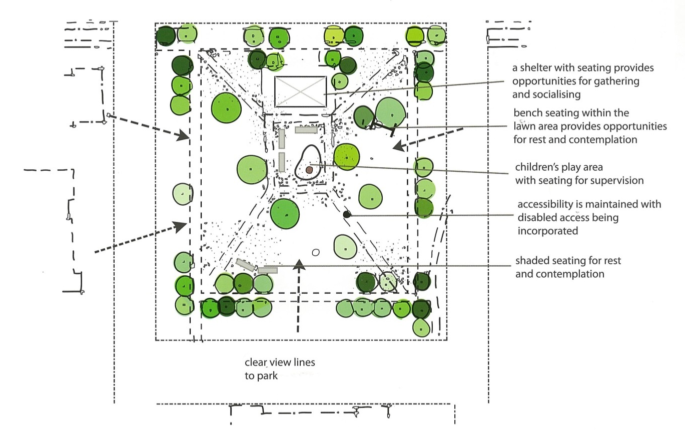

Figure: 6 Example of local open space. Source: (DSR)

Value
POS provides a combination of social, economic and environmental value to the community. A principal role of POS is to support health, recreation and leisure functions including active pursuits such as organised sports, exercise, children’s play and social activities, as well as encompassing passive uses such as quiet reflection in an attractive setting.
Environmental protection is an essential role of public open space, through habitat and biodiversity conservation along with air and water quality management. It also provides a strong connection to nature for people living in highly urbanised environments. Natural areas are highly valued for their natural beauty, contribution to neighborhood character and community identity, cultural heritage value, tourism potential and the emotional connection people may attach to them.

Health & Liveability
The environment is a major influence on health and recent research has shown that we cannot continue to deal with illness only after it appears, or encourage individuals to change their attitudes and lifestyles, when the environments in which they live and work gives them little choice or support. Recent studies show that the leading causes of illness are no longer infectious diseases, but chronic ones such as cardiovascular disease, obesity, cancer, mental health disorders, neurological and sensory disorders and chronic respiratory conditions, as well as injuries. The City is actively working to improve POS not only in the suburbs, but in industrial and other commercial areas, to assist the working community in maintaining and improving their health.
State and local planning has recently been focusing on a holistic approach to public health by considering the overall impact that four environmental factors have on promoting and protecting the health and wellbeing of our communities. These include:
  - Built / Physical
Appropriate allocation, design and maintenance of public open spaces with associated built and natural infrastructure can promote healthy physical activity. Built infrastructure can also create opportunities for informal meeting places and provide a mechanism for connecting community members.
  - Social Environment
A well designed and maintained hierarchy of POS can create opportunities for community participation, leading to enhanced mental and physical well-being, including sporting clubs, walking groups, dog walkers and friends groups. Social engagement ensures connected communities and enables people to become involved in the programs offered by the City’s Community Development and Services Unit.
  - Economic Environment
Community participation in activities that open space networks provide and promote will stimulate the building of a robust local economy. Community interaction through varying age ranges, gender and cultural diversity have the capacity to develop stronger communities, leading to investment in community infrastructure.
  - Natural Environment
The presence, availability and ease of access to the natural environment provide the community with a healthier and more sustainable future, including improved water quality, and protection of indigenous vegetation. POS provides for important ecological aspects such flora and fauna along with vegetation which assists in combating greenhouse gas emissions. Vegetation in POS also provides habitat for wildlife, including corridor links to and along waterways and assists in the maintenance of water quality in urban waterways. The City’s Natural Areas Management Strategy addresses these areas.

  - Urban Liveability
Well-designed and maintained areas of open space add to the liveability of our urban areas. They provide a ‘green break’ between houses, buildings, and roads. Parks also bring aesthetic value to an area, particularly highly developed areas, providing visual relief from a harsh built environment.
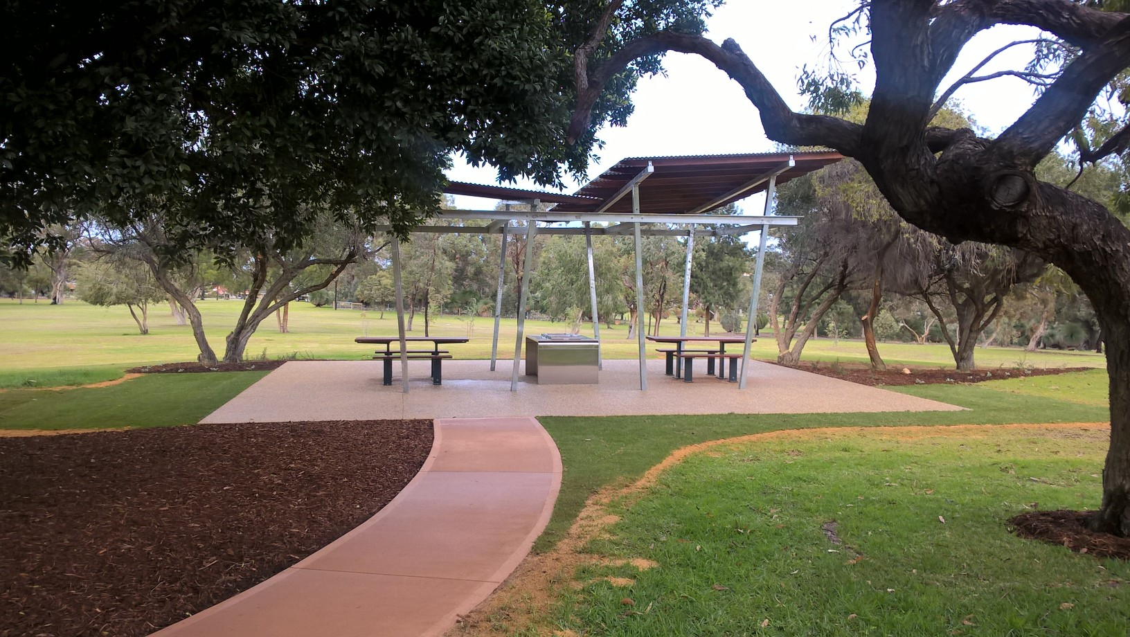
Figure 7: MacFaull Park

Multi-use of Public Open Space
The multi-use POS aims to accommodate a wider variety of roles and manage competing uses. The City is actively pursuing the following outcomes in its larger parks to maximise their potential and value:
- reintroducing native vegetation into parkland to enhance its ecological role and to enrich and add interest to the park,
- managing the demand for BMX sports by creating carefully managed pump tracks and trails in natural areas and
- provide play and picnic facilities in the perimeter areas of sports ovals, places that might otherwise suffer from being underused and underappreciated.
POS often serve more than one purpose, yet have traditionally been allocated to a single or dominant use, for example football and/or cricket ovals, playgrounds or drainage. In most cases, single use POS does not ensure the most efficient use of land resources and opportunities.
The conservation of natural areas raises the issue of the tension between conserving the natural environment and promoting recreation in public open space. While there is an increasing concern for the environment from individuals or groups seeking to protect and conserve natural areas, there is an increasing number seeking to utilise or develop natural areas for a range of activities. Whilst the City seeks to establish a balance between conservation and recreation, it is acknowledged that in some instances these different objectives cannot be reconciled. For example, the management of small bushland sites, which are generally not sustainable and require extensive resources if they are to be maintained. This issue again highlights the need for appropriate classification and management of spaces.
There are also competing uses among recreational and sporting activities that can be difficult to resolve. For example, a number of different sports codes or clubs wanting to use the same reserve, resulting in overuse, impacts on ground condition and amenity or exclusion of some groups. There may also be competing uses relating to different functions of a space that may not complement each other, such as quiet reflection, dog exercise and organised sport.
These issues must be addressed on a number of levels, firstly through ensuring the adequate provision of public open space — both in total area and in different types of opportunities to meet a range of diverse community needs (an understanding of community need and the space needed to meet these needs is also required). Secondly this issue can be addressed through the design of the POS, through a planned approach to play space zones and location and siting of facilities. Uses can change over time as a result of emerging community needs, trends, issues and demographics and the need to design spaces for flexibility and variety of use is important (multi-use spaces). There also needs to be due consideration and understanding of the key needs of a range of users. For example, the dimensions of playing fields for different sports are relatively fixed to meet training and match play requirements. The issue of competing uses must also be addressed through ongoing innovative management of public open spaces.

Lighting
Lighting helps make public open spaces more enjoyable and functional for the community to utilise during late evening or early morning. Lighting is provided to high use activity nodes and connecting pathways to create a safer environment. Lighting can create an atmosphere which can increase the feel of the City’s POS and assist with mitigating inappropriate behavior.
An Open Space Lighting Guideline has been prepared to ensure the community can receive the benefits associated with lighting in a formulated approach. The guideline outlines the purpose, definitions, responsibilities, process for lighting requests, types of lighting and controls.

Toilets
The demand for toilet facilities located within public open spaces has been increasing over a period of time in order to meet the community needs. The installation of key park infrastructure, i.e. destination playgrounds, skate parks, pump tracks, multi-purpose facilities, etc. has seen greater attendances at these open spaces and for longer periods. Although a number of open spaces have adjacent commercial properties with toilets facilities, the restrictive nature and impediment of walking a short distance to these sites continues to be raised as a negative perspective by the community. As our community service programs increase along with attendance rates, toilet facilities become paramount at these key destination locations.

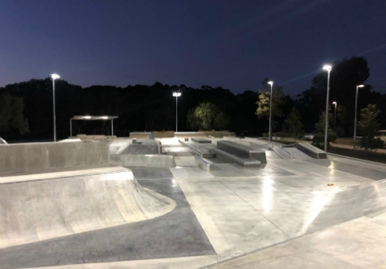
Figure 8: Bibra Lake Skate Park

Participation

Lifestyle Changes
Although lifestyle is an individual choice, it is evident that certain lifestyle trends are evolving in Australian society that influences public open space provision. These include:
- Changes in recreational pursuits particularly with an emphasis on sporting and recreational opportunities, with a need for open space areas to accommodate changing interests and popular pursuits. The popularity of the typical Australian ‘outdoor lifestyle’ remains evident. Additionally, there is increasing competition for sport and recreation time from personal computers, entertainment systems and private recreation facilities.

- Workforce changes — longer working hours for many resulting in less recreational time, yet also more flexible and casual hours resulting in different sectors of the community recreating at different times. Economic prosperity also provides many with increased disposable income to spend on recreational pursuits.

- The trend to construct larger dwellings on smaller residential lots makes POS increasingly more important in the modern community. Local, neighbourhood and district POS becomes the de facto front and back yard for many children, to support their play space needs.

Dog Exercise Parks
There is an increasing demand for dog exercise parks located within the City’s POS network. Dog exercise parks require a relatively large land area to enable dogs to run unleashed, provided they are under the control of the owner, and include dedicated areas for structured activities. The location of dog exercise parks requires extensive community consultation to ensure full acceptance by the community and that the City is cognisant of its ongoing management.

Community Gardens
Community gardens provide an environment for people to produce food and actively build the health and wellbeing of the community through shared activities.
The City is supportive of the establishment of these gardens; however the onus on creation and ongoing management must be through an incorporated body. A policy on the establishment of a community gardens has been developed and a supplementary set of guidelines have been provided for ease of reference.
A feasibility study into the appointment of a Community Garden Officer to facilitate community gardens is required in order to respond to the repeated requests and continuing requests by the community for the City to take a more active role in their establishment.

Skate Parks
The City currently has four skate parks distributed across the City and located on POS conducive to the classification framework. The demand for skate parks is on the increase across the City by individuals and community groups.
Although skate parks create an environment conducive to strong links with the community, they need to be carefully balanced with the long term values and function of the particular POS. The City’s Youth Services Strategy and Team address the provision of skate parks throughout the City in consultation with the Parks & Environment Business Unit.

Pump Tracks
Pump tracks are circuits framed by rolling banks, sharp turns and a variety of features which are designed to be ridden by people on bicycles. The circuits are extremely tight with body movements creating the momentum to complete the track without pedaling. The City has delivered 5 pump tracks at various POS locations and with a low investment cost additional sites will be considered.

Multipurpose Courts
The City’s community services division has identified a growth in the need for multipurpose courts within POS. These half size courts facilitate basketball, netball, handball, mini tennis and other recreational activities on a hard surface. Although the provision of these courts is relatively low across the City’s existing POS network, a framework for development is required. This strategy has determined their preferred location within the POS classification hierarchy to ensure they can be readily accessed by the local and wider community.

Memorial Plaques
The City receives requests for the installation of plaques attached to park infrastructure or as standalone structures within the POS. The plaques are primarily a dedication to eminent men or women who have contributed to the City through business, sporting or community work. In addition to plaques, memorial gardens are being created to develop areas of reflection or dedication to an individual or institution. The locations of these sites are predominately focused on areas where high patronage prevails, enabling good accessibility and the provision of functional park infrastructure. A policy and guidelines has been developed to guide the future placement of memorial gardens and plaques

Playground Fencing
The City receives requests from the community for playgrounds to be fully fenced in close proximity to the road network. In addition, fencing is also sought by parents with children who have a disability so they can create a safer and more comfortable play environment. To ensure the City can meet the expectations of these community interests a playground fencing policy will be developed.

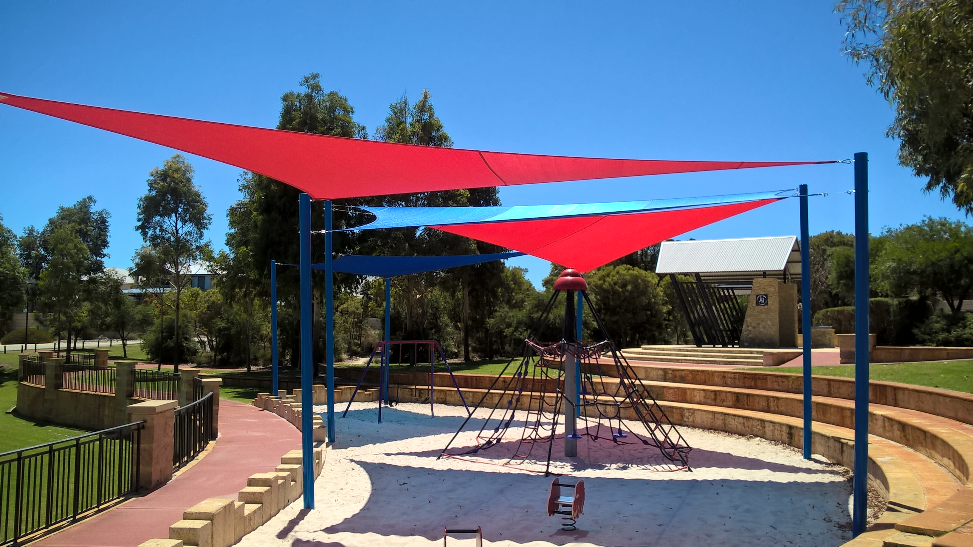
Figure 9: Peregrine Park

Connectivity
Establishing connectivity through POS and streetscape provision is a key objective in increasing community movement and link ecological corridors. POS provides the destination point between journeys to community hubs, educational pursuits or the business sector. Strong tree-lined streets ensure the trip is safe and enjoyable without being impacted by the elements.

Streetscape Strategic Approach
Streetscapes within the City frame the road network to create aesthetically pleasing and inviting streets. Landscaping major road corridors can increase people’s daily travel experience and reduce the speed of traffic. The diversity of landscape for these road corridors is contingent on the road hierarchy and how it changes from urban to rural to industrial. Streetscapes also provide ecological corridors which encourage the movement of native fauna from one natural area to another or POS.

Streetscape Development
Landscaping streetscapes is an established practice on street verges and median strips. This program increases the number of street trees and compensates for the loss of trees and vegetation due to urban development. Landscape development is framed on ecological corridors, themed precinct approaches and major roads following upgrades.
Subdivision plans include landscape plans for the placement of trees and vegetation within streetscapes and areas of public open space. These plans are subject to the planning approval process ensuring the appropriate street tree species are selected.

Entry Statement
Landscaped entry statements are an essential component for visitors and to the surrounding community of their arrival into the City. An entry statement is typically bold in character with bespoke designs to illicit a reaction by the passing motorist and passengers. These entry statements have a surrounding landscape to soften the adjacent hard pavement and promote the City’s values. A program of entry statements at key entry locations across the City is to be prepared and implemented.
Private entry statements are installed either within the road reservation or POS by developers to advertise their residential estates. These entry statements are not permanent structures and are generally removed at the completion of the development or when they reach the end of their useful life.

Major Road Streetscapes
The City of Cockburn has a number of major roads with significant environmental and cultural diversity characteristics that have or will influence the landscape design. The following list of major roads has themes that address these criteria.

- Armadale Road
- Beeliar Drive
- Cockburn Road
- Hammond Road
- North lake Road
- Phoenix Road
- Rockingham Road
- Russell Road
- Spearwood Avenue
- Warton Road

Minor Road Streetscapes
The City has a large volume of landscaped streets in the form of roundabouts, median islands, car parks and entry statements. These landscaped environments create a feature of the road environment and reduce the heat island effect created by surrounding hard surfaces. Landscape to these streetscapes is predominately minor to ensure standard vision clearance standards are achieved and meet current levels of service. Although these sites are restricted in landscape they provide distinct characteristics that define suburbs and entry points into the City. Car parks provide the destination and drop off point for residents at community facilities and are landscaped to achieve a large canopy cover over the parking surface.

Road Reserve Management
Management of road reserves involves maintaining the vegetation contained within the verges and median islands of the City’s road reserves. Primarily the service includes the mowing of verges, selective weed control through herbicide applications, and responding to customer requests. The level of service for streetscapes has been aligned to industry standards and the inherent knowledge of vegetation growth rates in specific locations. These levels of service ensure the minimum frequencies are achieved with limited scope to add services due to changing environmental conditions. Funding for streetscapes has typically been driven by financial limitations without consideration of aesthetic aspects. The levels of service for roads maintenance is outlined in Annex 11.3

Streetscapes as Ecological Linkages
The Natural Areas Management Strategy 2012-2022 provides the framework for ecological linkages through the City. These linkages are contiguous natural areas or revegetated areas that directly connect larger areas of natural bushland to allow movement of organisms. The linkages identified are as follows:
- North /south road linkages
- East/west road linkages
- Rail linkages
- Western power transmission line linkages
- BP refinery oil pipe line linkages
- Private rural lot linkages
- Residential linkages
The development of streetscapes will help facilitate ecological corridors and create opportunities for fauna movement through diversity of plant species.

Streetscape Zones
Streetscapes can be divided into five different zones:
Coastal Zones
These are zones nearest the coast which will experience the direct force of the salt laden prevailing winds, with quick draining sandy soils.
Significant Verges, Median & Roundabouts
These zones include verges, medians or roundabouts that the City identifies as significant and therefore have a particular character predetermined for the streetscaping to create this street hierarchy. These include roads such as major entrances to suburbs, significant roundabouts, median or landmarks locations, verges near schools, shops and community centers.
The City will use the Liveable Neighbourhood principle of a 400m walkable radius to determine high use community areas which present an opportunity for large shade tree planting along major pedestrian routes. All of these areas will have a prescribed master plan of the tree species to be planted to ensure a controlled theme is created for each suburb.
Ecological Corridors and Wetlands
The identified ecological corridors and wetlands within the City and a further 50m offset to these areas will use endemic and native species of trees for all future plantings. This will reinforce the biodiversity and connectivity of these areas which provide a food and habitat source for the fauna within the City of Cockburn. Planting of endemic and native species will also ensure that self-seeding from the street trees in the surrounding area will contribute to the increase of an appropriate plant species.

Industrial and commercial
The zones are often identified by larger setbacks and car parks directly adjacent to the front lot boundary. This space allows the planting of larger street trees which will provide a greater shade to help combat the extreme heat sinks often associated with these areas.
Residential
The remaining streetscapes throughout the City which do not fall into any of the above zones will use a methodology and criteria to inform which tree from the street tree master plan will be the most appropriate for that specific area. The aim of this zone is to create a consistent avenue planting with the similar species to both sides of the road.

Street Trees
The City is a constructed cultural and urban landscape consisting of streets, buildings (residential, industrial and commercial), natural areas and POS. Trees play an important role in enriching the cultural experience of a location, therefore the aesthetic characteristics of the trees need to be an important selection consideration.
The selection of species may be made to reinforce climatic, historical, cultural or natural associations that satisfy local requirements. Very large trees in confined spaces often result in unacceptably high management costs. Conversely small growing trees in broad spaces rarely contribute positively to visual quality or canopy coverage. Trees selected will be in scale with other components of the streetscape and subject to service alignment and surrounding infrastructure and the largest growing species will be selected.
One of the key street tree selection objectives is to ensure the selection of the ‘right tree for the right location’. This means ensuring that the selection of the species is appropriate to local environmental conditions and the constraints of the planting location. The species selection aims to ensure that the tree makes a positive contribution to environmental, amenity, aesthetic and heritage values of the area and any negative impacts are minimised. Street tree selection will be in accordance with the Street Tree Master Plan (4.4.13)
In order to ensure the health and longevity of street trees, aesthetic and design considerations will be accommodated only where optimum conditions for plant growth are available. The proven performance of the species in particular environmental conditions and functional requirements will be the prime considerations for street tree selection.

Arboricultural Inspections
The management of street trees is currently managed through City officers with the engagement of a consulting arborist as required. The incorporation of a consulting arborist in the management program achieves a degree of independence in the decision making process. The assistance of a consultant is generally required when the request could be controversial, subject to the political process or escalate to involve the media in an attempt to garner community support for the removal of a tree or trees. In addition the consulting arborist can provide Quantified Tree Risk Assessments and reports to determine the potential risk of a tree.

Clearance from Power Lines
The Western Australian Office of Energy Safety sets out the regulations for the clearance of vegetation from power lines. The regulations list each power line classification and the clearance zones required to mitigate disruption to the network. In addition the regulations outline that management of naturally occurring vegetation is performed by the service provider whilst planted street trees are the responsibility of the local Council. Compliance with regulations is facilitated by contracts issued by service providers that manage the entire tree works process.
Management of the clearance of vegetation from power lines will be facilitated through the street tree database. The database generates reports that list all trees under power lines orientated to each suburb, previous pruning history and a monetary value for the works. All street trees under power lines will be pruned on an annual basis, subject to growth habits and additional requirements by the regulators.
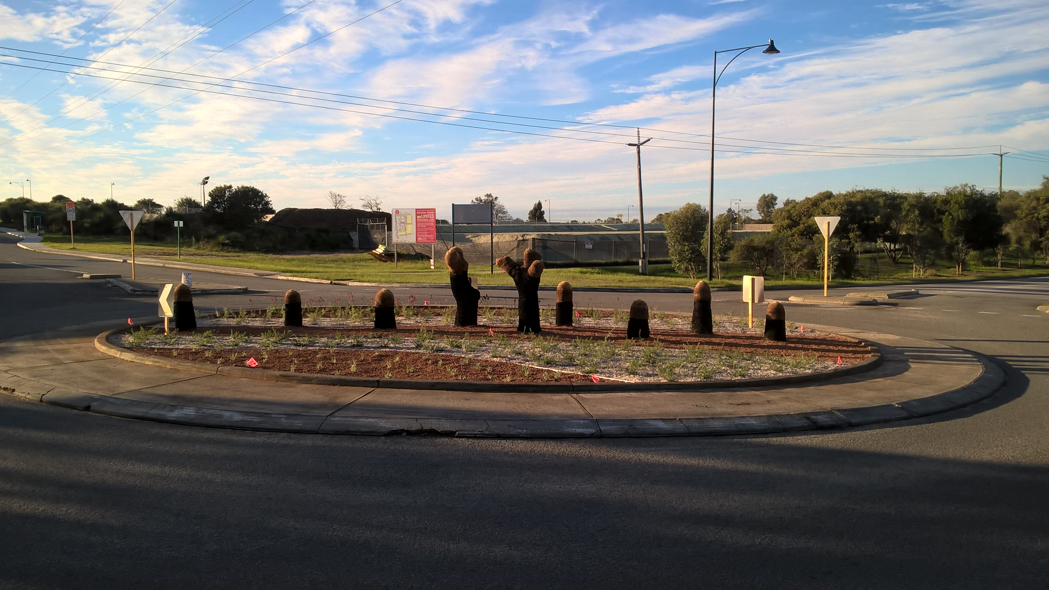
Figure 10: Roundabout Cordelia / Coolbellup

Street Tree Database
To enable informed decisions on street tree selection and ongoing management a street tree database has been developed. The database has been collated by an Arboricultural firm to ensure accuracy of data. The information gathered identified the following key criteria:
- Location (Address, Suburb, Ward)
- Inspection date
- Tree species
- Under power lines
- Height
- Canopy
- Trunk diameter
- Age
- Health structure
- Photograph
- Value
- Any works required
A series of reports have been developed to provide key information on total number of trees, trees per suburb, trees requiring clearance from power lines, dominant tree species per suburb and citywide. Street tree management is further informed by the significant tree listing contained within the Local Government Inventory and Heritage List. Information sourced through this document ensures trees of significance are managed with a greater oversight so they can be sustained for future generations.

Street Tree Master Plan
A street tree master plan has been developed from the City’s database of street trees. The Street Tree Master Plan identifies the street trees to be planted in each street throughout the City.
The selection of street trees will be determined by the database with consideration of the Urban Forest documentation and the objectives outlined above. The aim of the Master Plan is to provide a species criteria and guide which will ensure that all future plantings within the City of Cockburn are in keeping with the vision and mitigate random plantings.
It is acknowledged that there are already existing themes and multiple random plantings within many streets of the City. Where this occurs, the most common and suitable species present which fit a selection criteria will be continued for future plantings on that street. Where new developments are created, a greater control of street tree selection will be implemented to achieve the City’s vision.
In addition the plan will focus on the use of Australian natives where feasible subject to existing road network constraints. Tree selection will also be cognisant of solar panels on adjacent residential homes in high density settings to ensure the penetration of sunlight during winter periods. The street tree master plan will be implemented through annual funding allocations.

Urban Forest Plan
The purpose of the Urban Forest Plan is to set out a clear vision for the future management and expansion of Cockburn’s urban forest. The plan provides a snapshot of the current state of our urban forest and maps a pathway to increasing canopy cover whilst protecting against future vulnerabilities. It builds upon existing policies and is strategically aligned to a suite of existing plans and strategies to support the delivery of its vision and targets.
The plan acknowledges complementary actions already set in place by existing policy mechanisms and identifies gaps which are addressed in the four year action plan. It provides a valuable tool to encourage collaboration across business units, specifically the Roads, Waste and Planning teams to achieve a fully integrated vision for the City.

Figure 11: Waverley Streetscape

Responsible Management
POS can no longer be viewed in isolation, as more importance is being placed on the better integration of strategies and programs, partnerships and effective community involvement. There is an increased understanding of the vital role of green infrastructure in providing environmental services such as urban cooling and habitat for wildlife. This has now become a key part of urban planning and should be considered a fundamental factor in all built development.
A comprehensive open space strategy spanning the planning, design, management and maintenance of open spaces is an essential tool for delivering this multi-functional network of spaces as well as the broader objectives of health, social inclusion and community cohesion – in short, the creation of excellent places.

Managing Existing POS
The City currently manages its POS network through a workforce committed to ensuring high presentation and a safe and functional environment for the community’s use. The workforce is continually reviewed in accordance with the Workforce Plan. Not all works can be achieved through the internal workforce and as such the City engages contractors to supplement this void. The City primarily engages the services of playground specialists, irrigation specialists, turf consultants, Arboriculturalist, etc.

Managing New POS
The City can expect to receive 110ha of POS from future development areas with the majority of these areas requiring embellishment to meet the community needs. New subdivisions require the provision of 10% POS under the state planning framework, which will provide for a range of open spaces that are user friendly, safe and conveniently located. There is a need to ensure that all future POS provision is cognisant of existing POS to ensure a balanced approach is applied to avoid smaller pocket parks being delivered. An assessment should be facilitated by officers during the structure planning phase in order to respond to current day POS classifications for that suburb. Development and embellishment of the POS should align to this strategy. It is vital that the City proactively manages developer POS proposals and contributions accordingly.
The City has a ‘POS Development Guide’ which provides guidance to developers on the typical embellishment levels of POS within the City. The guide provides a framework for approvals and ensures the City receives asset details which are easily uploaded into databases for reporting through the Parks and Environment Asset Management Plan.

Challenges in Managing POS
Some of the key challenges for the City in relation to planning, management and operation of POS in the coming decade include:
- Ensuring that the quality of POS is maintained and further enhanced to ensure that it meets the community’s changing needs into the future
- Urban water sensitive design
- Striking an appropriate balance between protecting the City’s environmental values as well as providing appropriate community facilities and infrastructure
- Climate change adaptation in order to find alternative water supplies to POS
- Coping with increased infill development where reliance on POS will be highly important to resident’s wellbeing
- Meeting the recreational and POS need of an ageing population
- Providing infrastructure that adequately caters for multi-use activities
- Implementing sustainable management and operational practices

POS Rationalisation
Decisions need to be made where tiny or small allotments in isolation are surplus to requirements and may not make any meaningful contribution to the overall POS hierarchy into the future. Detailed investigations are required to determine whether these areas may be valuable assets in the future when the pressure of urban development increases. In some cases it may be reasonable to dispose of a number of small areas of undeveloped POS and purchase a larger allotment that better caters for the recreational needs of a suburb or larger area of the City. An integrated approach with the City’s Strategic Planning Division will be required to further this.

Process Improvement
Process improvement is a systematic approach to ensure an organisation enhances its principal procedures to achieve more efficient results. It is imperative that a continual process is engendered to identify, analyse and improve business process to meet organisational goals and objectives.

Smart Technology
Smart technology is revolutionising the capacity to manage POS through new devices and mechanisms whilst enhance existing corporate software applications. Smart technology comes in many various formats and it is incumbent on management to investigate these new horizons in order to maximise the benefits to management practices and processes, operations programs and how the community can access or be involved in cutting edge technology.

Safety and Risk Management
All reasonable and practical efforts are taken to minimise risks to visitors and users of areas of POS, however there is always an element of risk in outdoor recreation activities. Visitor and user safety are integral components of works programs and capital developments within POS. Recreation facilities and amenities for visitors will be developed and maintained in accordance with relevant Australian Design Standards.

Asset Management
The Parks and Environment Asset Management Plan 2018 outlines the management of assets in compliance with regulatory requirements and highlight the funding necessary to deliver the required levels of service. The asset management plan requires continual updating to include new POS, changes in POS classification and changes to service levels through legislative changes to infrastructure management.

Level of Service
To ensure POS is maintained to a level which is proportionate to community needs, industry standards and financial limitations, a service level matrix has been developed. The matrix outlines the open space classification and service frequency for each of the key maintenance activities required. These levels of service ensure a consistent presentation to the open space depending on its classification. Parks are maintained to ensure they are continually used, reach their anticipated lifespans and compensation claims to the City are reduced. Appendix 3 POS Classification Level of Service per annum sets out the service level for key infrastructure, turf and landscaped areas.

Improvement Plan
Development of public open space requires assessment of existing infrastructure and development plans, impacts from population growth, demographic changes, revitalisation strategies, emerging issues and distribution of open space across the City and each suburb. The development of the POS Strategy has enabled the formulation of a 10 year improvement plan to ensure commensurate investment each year. The plan outlines the function and classification of each open space, key assets and current development level as identified for each catchment hierarchy. The improvement plan outlines the current recreational components of each POS and lists their future development status. Development options are listed to ensure alignment with key aspects of the development status for each classification. The plan is included in Annex 11.4

Community Scorecard
As this is a 5 year review of the Strategy, community consultation was not undertaken. The original strategy has been available on the City’s website since 2014 and there has been minimal enquiries relating to its content.
The 2019 Community Scorecard which evaluates the community’s priorities and performance against key indicators provides a snapshot on playgrounds, parks and streetscape management. As shown in figure 12, the City has a 93% positive rating score for its playgrounds and parks and continues to deliver consistent appearance and management approach. The City is also the leader in this area of management when benchmarked against other similar size councils.
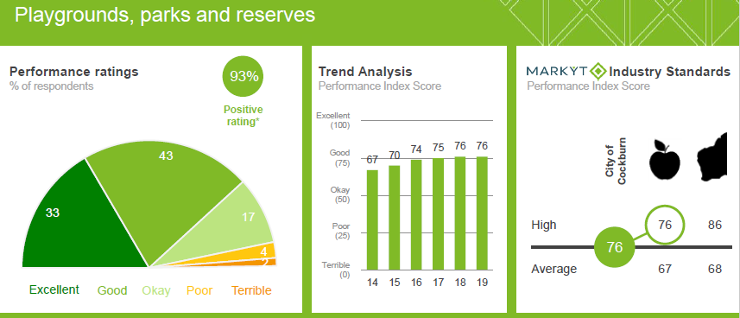
Figure 12: Playground and park evaluation 2019 Community Scorecard, Catalyse Pty Ltd
The City’s scorecard for streetscapes, Figure 13, demonstrates a positive rating of 84% and a consistent performance index. However the community continue to raise this as an area requiring ongoing investment in resources and funding in order to meet the value they place on this public realm environment.
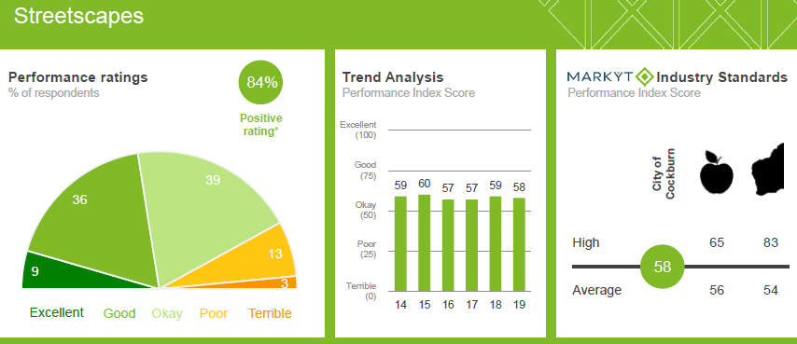
Figure 13: Streetscape evaluation 2019 Community Scorecard, Catalyse Pty Ltd.

Resourcing the Plan
Operating Expenditure
Operation expenditure has been framed on the continual revision of programs and levels of services identified for the classification of open space road reservation as outlined. The operating budgets are increased annually in accordance with Council adopted budget parameters. With the increased growth of open space and the transition to the engagement of external service providers, the capacity to deliver all the services expected by the community is being challenged.
Capital & Renewal Expenditure
The Long Term Financial Plan 2016/17-2025/26 provides the framework for the delivery of the open space development schedule as outlined in annexes 12. Additionally this document is the source of the renewal programs which have been formulated through the Parks & Environment Asset Management Plan. Addition capital funds are sourced through Public Open Space Cash-in-Lieu Contributions scheme which sets out a coordinated approach to the expenditure of funds received through Cash-In-Lieu of public open space in accordance with Planning and Development Act 2005. The expenditure of these funds can only be allocated within the POS reserve location and invested in specific infrastructure that will predominately ensure the functionality and usability of the park is increased for the betterment of the community
Work Force Plan
The workforce provides the mechanism for new staff in accordance with the growing business needs and the changing services being delivered by the City. The current work force plan identifies the following FTE staff over the next 5 years in order to deliver the key objectives of this plan and other master plans stemming from this document. However due to the increase in outsourcing entire estate maintenance Park contract managers will need to be explored in future iterations of the plan
- Urban Forest Officer (x1)
- Operations Project Officer (x1)
- Foreshore Maintenance Team (x2)
- Verge Compliance Officer (x2)
- Landscape Architect (x1)
Action Plan
Delivering the key actions of the strategy will be through annual requests for funding in combination with internal resources.

Measuring Achievement
To achieve the vision of the Public Open Space Strategy a range of actions have been prepared which bring together physical planning and policy directions. The actions build on the current projects and programs delivered by the City and direct future priorities in public open space planning and management. Within each objective there are measurable actions and tools to measure performance.
Toolkit
- Advocacy – marketing, discussions, promotions
- Activation – improved utilisation of existing space
- Asset management – whole of life costing
- Alliances – forming partnerships and working together.
Indicative costs for the proposed actions have been prepared:
Scale | Indicative Cost
Low | < $10,000
Medium | $10,000-100,000
High | $100,000-250,000
Funded | Resourced from operational budgets
The timing of actions is based on priority and achievability.
Priority | Timeframe
Short | With 2 years
Medium | Within 5 years
Long | Beyond 5 years
Ongoing | Continual Implementation
Completed | Action Completed

Five Year Review
Sixty two actions were identified at the commencement of the strategy of which thirty three are being implemented an on annual basis. Of the remaining twenty nine, sixteen actions have been completed at the 5 year anniversary. Two new actions have been included to the program one which responds to the community survey on entry statements and the second one relating to the digital space around the use of smart technology to improve the management of POS and park infrastructure.

Action Pan

Theme 1: Classification
Action |  | Toolkit | Measure | Cost | Priority / Status
Strategy 1.1: Establish the hierarchy of POS and Streetscapes to inform the City’s community of its function and recreational composition.
1.1.1 | Ensure current POS and streetscapes are identified in accordance with the defined hierarchy. | Advocacy | POS and Streetscapes identified | Funded | Ongoing
1.1.2 | Develop guidelines that enable new POS and streetscapes are classified upon acceptance. | Advocacy | Guidelines developed | Funded | Completed
1.1.3 | Ensure existing POS which provides significant tourist and event opportunities is protected and enhanced. | Advocacy | Prominent locations identified | Funded | Ongoing
Strategy 1.2: Foster and promote the POS and Streetscape hierarchy.
1.2.1 | Develop strategic promotional material which informs the community of POS and streetscapes. | Advocacy | Promotional material developed | High | Completed
1.2.2 | Foster ownership of POS to community groups to increase its value. | Advocacy | Develop framework | High | Long
Strategy 1.3: Develop open space that has the capacity to support a diverse range of complementary uses that contribute to the City of Cockburn economy.
1.3.1 | Develop management plans for regionally significant POS which supports diversity and encourages tourism. | Activation | Develop management plan for Manning Park | High | Completed
1.3.2 | Ensure service levels reflect the need for spaces to accommodate markets, festivals and events. | Asset Management | Implement level of Service | Funded | Ongoing
1.3.3 | Develop strategic alliances with government agencies, education establishments and private providers to develop facilities to increase sport, recreation and cultural opportunities. | Alliances | Integrated team | Funded | Ongoing

Theme 2: Value
Action |  | Toolkit | Measure | Cost | Priority / Status
Strategy 2.1: Provide POS that stimulate opportunities for the vibrant, diverse and creative settings which have a strong sense of place and strengthen community identity.
2.1.1 | Develop character and identity themes and styles through community involvement, creativity and artistic expression to inform POS planning and development. | Activation | Character and identity themes are completed and integrated. | High | Long
2.1.2 | Complete a framework that encourages and promotes integration of art and creative expression in public places and spaces. | Activation | Arts Policy integrated with POS design principles | Medium | Long
2.1.3 | Recognise the community value of trees and landscaping through the preparation of a POS and Street Tree Master Plan. | Activation | Master plans developed | High | Completed
2.1.4 | Develop policies and guidelines for playground designs, which incorporate and stimulate community participation. | Activation | Policy & guidelines developed | Medium | Medium
2.1.5 | Develop lighting guidelines that enable vibrant night settings that harmonise the community. | Activation | Guidelines developed | Funded | Completed
2.1.6 | Develop guidelines with Rangers S/U which identifies POS that facilitates dog activation | Activation | Guidelines developed | High | short
Strategy 2.2: Work collaboratively with the community for the protection and enhancement of our cultural heritage in open space.
2.2.1 | Strengthen linkages and interpretation of cultural heritage in open space. | Activation | Develop guidelines | Funded | Ongoing
2.2.2 | Work collaboratively with traditional owners to strengthen connections through projects and programs. | Advocacy | Develop framework for collaboration | Low | Ongoing
2.2.3 | Foster the provision of plaques and memorial gardens to retain links with cultural heritage through guidelines. | Activation | Develop guidelines | Medium | Completed
Strategy 2.3: Strengthen the concept of community hubs and pursue opportunities to provide open space in key locations.
2.3.1 | Identify and audit existing community hubs to inform further planning and activation of public open space. | Advocacy | Community hubs identified | Low | Ongoing
2.3.2 | Activate community hubs by improving visual and physical integration with parks and civic spaces through communication and negotiation with property owners and community groups. | Advocacy | Activation plans developed and implemented | High | Long

Theme 3: Participation
Action |  | Toolkit | Measure | Cost | Priority / Status
Strategy 3.1: Provide spaces and infrastructure to support and encourage active and creative pursuits by the community.
3.1.1 | Reviews annual surveys to inform future planning and management. | Advocacy | Annual user surveys | Medium | Ongoing
3.1.2 | Prepare guidelines to support the establishment of community gardens. | Advocacy | Guidelines developed | Funded | Completed
3.1.3 | Prepare a business plan for a Community Garden Officer to facilitate the development of community gardens in POS and engender community participation. | Advocacy | Plan completed and presented to Council | Low | Medium
3.1.4 | Annually update the POS development guideline to ensure sound planning, development and maintenance. | Advocacy | Guidelines developed | Funded | Completed
3.1.5 | Work in partnership with the City’s Health Department to plan for outdoor recreation opportunities to improve the health and wellbeing of the community. | Advocacy | Integrated team | Medium | Ongoing
3.1.6 | Develop guidelines that facilitate the delivery of storm water to POS which mitigates the loss of recreational activities. | Advocacy | Guidelines developed | Medium | Medium
3.1.7 | Develop a plan for the distribution for outdoor exercise equipment to support community health. | Advocacy | Plan developed | Medium | Completed
3.1.8 | Develop a playground shade sail strategy which outlines key functions and supports active use by the community. | Advocacy | Implementation | Funded | Completed
3.1.9 | Ensure that parks are accessible to people of all abilities, through compliance with the City’s Disability, Access and Inclusion Plan (DAIP).Develop a prioritised roll out of access upgrades directed by catchment sizes | Alliances | Compliance with DAIP | Low | Ongoing
3.1.10 | Provide workers with opportunities for leisure and recreation in the City’s commercial and industrial areas through the provision and upgrade POS. | Activation | Audit of facilities | Medium | High
3.1.11 | Identify the most appropriate parks for the installation of infrastructure and signage to support group fitness sessions and personal trainers. | Activation | Parks identified | Low | Medium
Strategy 3.2: Ongoing provision of quality active sports ovals to encourage improved physical wellbeing of the community.
3.2.1 | Prepare design guidelines that promote the utilisation of existing sports grounds for recreation space for the local communities outside of sports usage times (e.g. shade, seating and paths). | Advocacy | Guidelines developed | Medium | Long
3.2.2 | Undertake a Sport Oval Carry Capacity study to determine the maximum patronage limitation of the active sporting area to ensure that functionality is maintained. | Advocacy | Annual audits completed | Medium | Ongoing
3.2.3 | Develop a policy for the management of active sports ovals to ensure quality, bookings and usages are delineated to meet community expectations. | Advocacy | Guidelines developed | Medium | Short
3.2.4 | Align the POS Strategy with the Sport & Recreational Strategic plan to ensure the management and provision of active sports ovals is facilitated to meet the demands of future the communities. | Advocacy | Integrated team | Funded | Completed

Theme 4: Connectivity
Action |  | Toolkit | Measure | Cost | Priority / Status
Strategy 4.1: Create well-connected public open space through the provision of linked trails, street trees and footpaths, ecological corridors with community hubs and POS.
4.1.1 | Strengthen pedestrian links between parks, activity centers and community hubs to improve transport. | Activation | Linkages improved | Funded | Completed
4.1.2 | Ensure recreational path planning provides for walking, cycling, skate boarding, etc. | Activation | Paths and trails provide a diverse range of users | Low | Ongoing
4.1.3 | Identify park locations with opportunities for public transport, cycle links & integrate into transport planning. | Activation | Identify POS | Low | Medium
4.1.4 | Use endemic native vegetation, where practical, along trails, streetscapes, community hubs, streetscapes, parks & reserves to provide and enhance ecological linkages. | Activation | Majority of landscaping utilises endemic vegetation | Low | Completed
4.1.5 | Identify major entry statements across the City with opportunities to landscape and locate bespoke signage | Activation | Develop major entry landscape designs & delivery plan | Low | Short
Strategy 4.2: Ensure linkages and access to sensitive areas is appropriately planned.
4.2.1 | Incorporate regionally significant POS in the Trails Master Plan, Bicycle Network & Footpath Plan Strategies | Advocacy | Update plans | Funded | Completed
4.2.2 | Ensure coastal foreshore planning guides beach access locations, infrastructure level, coastal defence, financial sustainability and mitigate environmental impact. | Advocacy | Develop policies | Low | Medium
4.2.3 | Ensure linkages and access to sensitive areas is planned and appropriate to minimise environmental impacts. | Activation | Appropriate design | Medium | Ongoing
4.2.4 | Develop a policy for ecological corridors outlining revegetation and embellishment standard expected of developers when rehabilitating these sites | Advocacy | Develop policy | Low | Medium
Strategy 4.3: Further develop the balance between old and new suburban open space planning to encourage the protection of distinct communities.
4.3.1 | Locate, where appropriate, larger parks and sports grounds to contribute to and enhance the benefits of old and new suburbs. | Advocacy | Integrated team | Funded | Ongoing
4.3.2 | Identify opportunities to utilise amenity reserves, parks, streetscapes, trails and paths to develop ecological corridors. | Advocacy | Ecological corridors identified | Funded | Completed

Theme 5: Responsible Management
Action |  | Toolkit | Measure | Cost | Priority
Strategy 5.1: Proactively plan and deliver open space that encourages sound investment and meets community needs.
5.1.1 | Review Levels of Service to ensure maintenance is responsive to community values and changing needs | Asset Management | Desired levels of service implemented & reviewed | Low | Ongoing
5.1.2 | Integrate ‘whole of life’ costs into open space planning, landscape development and infrastructure selection. | Asset Management | Whole of life costs integrated into planning | Low | Ongoing
5.1.3 | Develop landscape guidelines to consider low maintenance designs that minimise ongoing costs but achieve acceptable aesthetic outcomes. | Asset Management | Guidelines developed | Funded | Completed
5.1.4 | Incorporate into the City’s Long Term Financial Plan allocation of funding for the planning, management and maintenance of public open space and streetscapes to ensure viable and sustainable assets capable of delivering the desired levels service and incorporate into the Long Term Financial Plan. | Asset Management | Plan developed and implemented | Funded | Ongoing
5.1.5 | Undertake annual benchmarking audits which compare the City to other local government authorities. | Asset Management | Annual Audits completed | Low | Ongoing
Strategy 5.2. Support innovative and sustainably designed public open space and streetscape that minimise maintenance and whole of life costs.
5.2.1 | Review design standards to identify more cost effective outcomes over the whole of the asset life. | Asset Management | Design standards reviewed, improve subdivision specifications and Town Planning Scheme provisions to better serve street tree and verge management | Low | Short
5.2.2 | Prepare guidelines for donated assets to achieve desired standards while minimising operational and whole of life costs within the planning scheme. | Asset Management | Guideline developed | Low | Short
5.2.3 | Apply resource efficient and effective strategies in development (e.g. hydrozoning, native planting, etc) to minimise natural resource use. | Asset Management | Ongoing program implemented | Funded | Ongoing
5.2.4 | Review and implement the Water Action Plan to include initiatives which promote sustainable design. | Asset Management | Ongoing program implemented | Funded | Ongoing
5.2.5 | Investigate and trial smart technology products in order to improve the management practices and process of POS | Activation | Investigate and trial one smart technology product or software program annually | Funded | Ongoing
Strategy 5.3: Ensure that the open space network provides for the changing and increasing needs of the community.
5.3.1 | Develop a process to maintain, develop and refine spatial information systems that contributes timely and valuable data to inform POS planning and asset management and maintenance of streetscapes and the urban forest. | Asset Management | Process developed and implemented | Funded | Ongoing
5.3.2 | Prepare a guideline for community input to consider the change in open space function in relation to urban infill strategies. | Advocacy | Guideline developed | Low | Short
5.3.3 | Monitor POS to identify low use parks and develop enhancement strategies. | Asset Management | Monitor | Funded | Ongoing
5.3.4 | Ensure development in the open space network is consistent with universal access and safety guidelines. | Asset Management | Designs comply with standards | Funded | Ongoing
5.3.5 | Actively seek to reduce POS space lost to secondary uses, especially in foreshore areas (e.g. car parking, commuter paths, storage spaces). | Asset Management & Activation | Increased usable space | Funded | Ongoing
Strategy 5.4: Encourage and promote community involvement in management of public open space.
5.4.1 | Develop guidelines and protocols that promote and enable volunteer involvement in management and operation of POS. | Alliances | Guidelines developed | Low | Long
5.4.2 | Continue to engage with communities on detailed planning, management and delivery in accordance with the City’s Community Engagement Policy. | Advocacy | Engagement in accordance with policy | Low | Ongoing
5.4.3 | Prepare a suite of information tools (e.g. print, web, social media & radio) to promote access and provide information. | Advocacy | Information tools developed | Medium | Medium
Strategy 5.5: Utilise Council’s open space to assist in the mitigation and adaptation to climate change.
5.5.1 | Incorporate into the Sustainability Action Plan actions that enable Council to consider the design of open space areas help to mitigate and adapt to the effects of climate change. | Advocacy | Annual updates | Funded | Ongoing
5.5.2 | Recognise the value of open space and trees in supporting local biodiversity, enhancing amenity and user comfort to assist climate change adaptation and mitigation. | Advocacy | Local biodiversity supported | Funded | Ongoing

10 Annexes POS Classification Levels of Service
Open Space Classification | Public Open Space Levels of Service per Annum
Open Space Classification | Turf Mowing | Turf Renovation & Fertilising | Landscape Maintenance | Play Equipment Inspection | Shade Sail Removal & Installation | Irrigation Inspection | Park Amenities Inspection & Maintenance | Skate Park Maintenance | Dog Exercise Area  Maintenance | BBQ Clean | Public Toilet Cleaning
District Open Space | 52 | 4 | 26 | 1 Major  2 Minor | 2 | 52 | 1 | 12 | N/A | 26 | 52
Regional Open Space | 52 | 1 | 26 | 1 Major  2 Minor | 2 | 26 – 40 | 1 | 12 | 26 | 365 | 365
Neighbourhood Open Space – Advanced Embellishment | 26 | 2 | 26 | 1 Major  2 Minor | 2 | 26 | 1 | 12 | 26 | 12 | 52
Neighbourhood Open Space – Primary Embellishment | 26 | 1 | 26 | 1 Major  2 Minor | 2 | 26 | 1 | N/A | N/A | N/A | N/A
Local Open Space – Advanced Embellishment | 26 | 1 | 26 | 1 Major  2 Minor | N/A | 26 | 1 | N/A | N/A | N/A | N/A
Local Open Space – Primary Embellishment | 17 | N/A | 17 | N/A | N/A | N/A | N/A | N/A | N/A | N/A | N/A

11 Annexes Streetscape Level of Service Per Annum
Streetscape | Streetscape Levels of Service per Annum
Streetscape | Turf Mowing | Landscape Maintenance | Irrigation Inspection | Tree Management
High Profile Streetscapes | 26 | 26 | 26 | In accordance with street tree database / customer request
Medium Profile Streetscape | 12 | 12 | 26 | In accordance with street tree database / customer request
Priority 1 Roads | Min 4 / Max 6 | N/A | N/A | In accordance with street tree database / customer request
Priority 2 Roads | Min 2 / Max 4 | N/A | N/A | In accordance with street tree database / customer request
Rural Roads | 2 | N/A | N/A | In accordance with street tree database / customer request
Industrial Roads | 2 | N/A | N/A | In accordance with street tree database / customer request
Unkempt Verge (Only upon request by the adjacent property owner) | Up to 4 times when grass height exceeds 150mm | N/A | N/A | N/A
Pruning of Trees - Powerlines | N/A | N/A | N/A | Annually
Pruning of Trees – Residential | N/A | N/A | N/A | In accordance with street tree database / customer request
Public Access Ways | N/A | Weed control, litter & shrub pruning | N/A | N/A
Roundabouts | N/A | 12 | N/A | In accordance with street tree database / customer request
Entry Statements | 26 | 26 | 26 | In accordance with street tree database / customer request

12 Annexes POS Inventory 2019 & Development Schedule

13 Annexes Future Public Opens Space


City of Cockburn
9 Coleville Crescent, Spearwood WA 6193
PO Box 1215, Bibra Lake DC Western Australia 6965
T: 08 9XXX XXXX F: 08 9411 3333
E: name@cockburn.wa.gov.au
cockburn.gov.wa.au

