18 July 2018
Cockburn and Split celebrate 20 years as Sister Cities
The month of July marks the 20th anniversary of the City of Cockburn’s sister city relationship with the Croatian city of Split.
The successful relationship will be marked by an art exhibition and performance of a play at Hamilton Hill’s Memorial Hall on 25 July from 7pm.
The exhibition will feature images of Split by well-known Croatian photographer Boris Kragic and a collection of oils of local market gardens called the Spearwood Project by celebrated local artist Larry Mitchell. It will be open for viewing 10am-3pm on Thursday and Friday, 26-27 July.
For one show only, actors Jasynda Radanovic and Firdaws Adelpour will perform The Doll by famous Croatian playwright Miro Gavran, directed by Romana Petrusic.
The Doll, a tongue-in-cheek look at romantic male/female relationships, premiered in New York in 2012 and has since been performed in Australia, Croatia, Cuba, the Czech Republic, Denmark, India, the Netherlands, Slovakia, Slovenia and the USA.
The play is presented by Croatia House and the Consulate General of the Republic of Croatia. It will be performed at 7pm. Tickets costing $30 and a synopsis are available here: https://bit.ly/2mmlaKu
Mayor Logan Howlett said the Sister City relationship with Split recognises the many settlers who came to Cockburn from the former Yugoslavia at the end of the Second World War and the local Croatian community that continues to contribute to the City's economic and cultural life.

“Croatian pioneers cultivated the growth of Cockburn and our cities share a rich market gardening history,” Mayor Howlett said.
“Split is the second-largest urban centre in Croatia and dates to the 6th Century BC. In 2007, Cockburn celebrated the friendship with the installation of a public art piece by Dawn and Phil Gamblen called ‘Cultivate’ on Friendship Way, near the Spearwood Avenue and Beeliar Drive roundabout.
“The installation is marked by the traditional Croatian greeting, Dobro Dosli, which means good day.
“Three crowned leopards on brick and limestone columns overlooking the roundabout represent both the coat of arms of Ancient Roman Emperor Diocletion who founded Split and the centre piece of the modern Croatian Flag.”

Caption: A photograph of the Old Town of Split by Boris Kragic blends with an oil painting of a Spearwood market garden by local artist Larry Mitchell.
–––––––––
ENDS
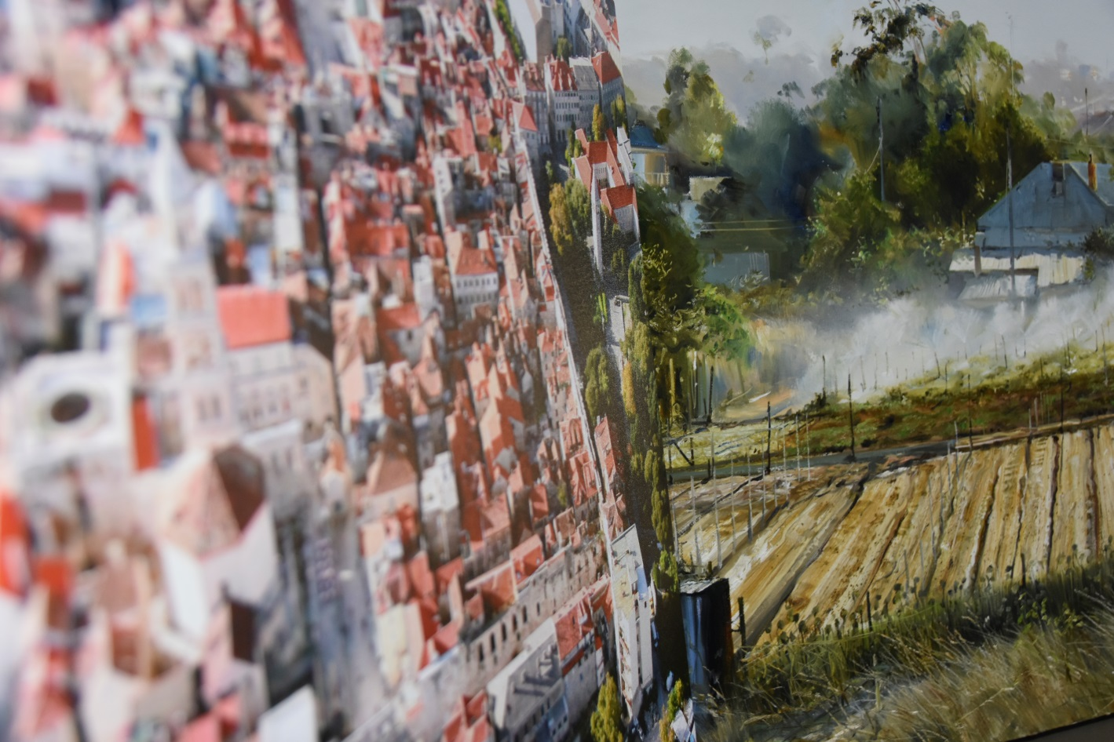

For more information contact:
Media and Communications Officer
City of Cockburn
T: 08 9411 3551
E: media@cockburn.wa.gov.au

