Tender Title: |  | RFT04/2025 – Static Guard Security Services – Cockburn ARC
Request ID: |  | 55302
Tender Description: |  | The City of Cockburn (the Principal) is seeking a suitably licensed and experienced Contractor for the provision of Static Security Services, outside of standard business hours, for the Cockburn Aquatic & Recreation Centre (Cockburn ARC).
Advert Approval: |  | Decision to Advertise: Director Community and Place  Decision Date: Friday, 31 January 2025
Closing Date and Time: |  | 2:00PM (AWST) Thursday, 27 February 2025
Opening Date and Time: |  | 2:00PM (AWST) Thursday, 27 February 2025
 | Tenderer’s Name:
1 | Hi-Lite Security
2 | MBN Facilities Management Services
3 | Vibrant MCS
4 | Millenium Security
5 | MSS Security
6 | Nightguard Security Services
7 | Paramount Security
8 | Resolute Security Services
9 | Site Protection Security
10 | Southern Cross Group

Advertisement
Method 1: City of Cockburn website | Method 2: City of Cockburn Libraries Public Noticeboards
Method 3:  The Western Australian, Wednesday 5 February 2025 | Tender Awarded by:
Copy of Statewide Notice:  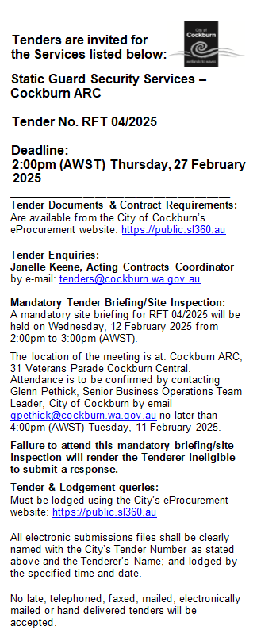 | Kylie Johnson, Director Community and Place  Carissa Bywater, Director Corporate and System Services  Wednesday, 5 February 2025
 | Date of Council Meeting:
 | N/A

Name of Successful Tenderer(s): | Vibrant MCS Pty Ltd t/as Vibrant  Services
Amount of Successful Tender(s): (ex GST) | $506,477.00 Ex GST

