10 July 2023

**WA heavyweight legend to hold free boxing sessions at Cockburn Youth Centre**

**Main points:**

* Retired heavyweight legend Hayden ‘H Bomb’ Wright will lead a boxing program at Cockburn Youth Centre
* Free program aimed at youth aged 10-17
* Basic boxing skills will be teamed with tips for leading a healthy active lifestyle.

Retired Yangebup heavyweight pro boxing legend Hayden ‘H Bomb’ Wright will head up a new free boxing program at Cockburn Youth Centre.

The weekly program is for youth aged 10 to 17 with fun, active drills that teach the basics of boxing as a combat sport and martial art.

But coach and mentor Hayden said some of the most important aspects of the program would be passing on the sport’s complimentary but all-important lessons for leading a healthy, active lifestyle and building confidence, self-respect and discipline, while making new friends and connecting with the community.

Known as the ‘H Bomb’ during his professional boxing career, Hayden has developed into a powerful and respected youth mentor, with four years’ experience running his own free boxing programs for local youth from his home-based Yangebup Boxing Club.

Hayden began his heavyweight boxing career in 2015 with a total knock-out win at Metro City, Northbridge against Chris Vollmer. He retired in February this year with a title belt, after a total knock out of opponent Sasha Bobojcov at the Gold Coast Croatian Sports Centre in Carrara.

He has three titles to his name – WA, South Queensland and Australian Journeyman – but says the biggest lessons boxing taught him were to keep going especially when things get hard, to stay focused on maintaining physical and mental health, to value friends and family, and get involved with your community by helping it out.

Hayden, a disability support worker and father of three children under five, bucks the ‘hard man’ persona common in boxing, and has a natural desire to share his skills with the community, especially kids struggling to fit in.

“Growing up is tough, often kids feel like outsiders. Boxing is a way to feel part of a team even though it’s an individual sport,” Hayden said.

“It’s an outlet for physical energy for everyone, and staying active is often the key to good mental health and getting to know and be proud of yourself. Plus you make great friends in the community along the way.

“That’s why I started the free weekly session at my boxing club, to help out the local kids that didn’t really have a lot to do to keep busy in their spare time.

“I am excited to be able to offer a similar model once a week at the City of Cockburn’s youth centre in Term 3, where I can hopefully share my skills with some new kids who are up for a bit of a challenge.”

The sessions will begin on Thursday 20 July 5-6pm with a free feed after. The centre is at 25 Wentworth Parade in Success.

Find out more about the boxing program and lots of other youth centre activities for Term 3 on the City’s [website](https://www.cockburn.wa.gov.au/Community-and-Business/Youth-and-Young-Adults-10-24-years/Term-Program).

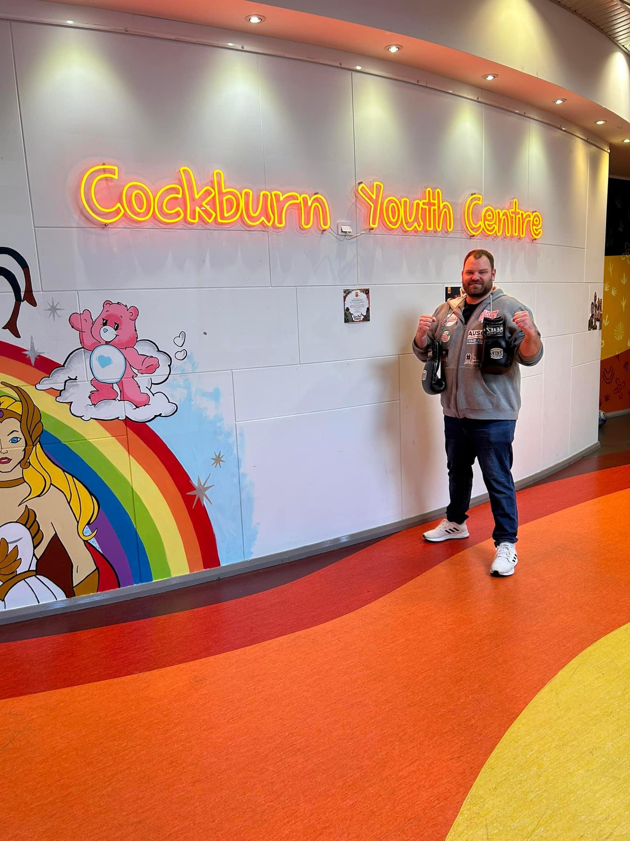

ENDS

For more information contact:  
Media and Communications Officer  
City of Cockburn  
T: 08 9411 3551  
E: media@cockburn.wa.gov.au