

Background and guidelines for regular hire groups

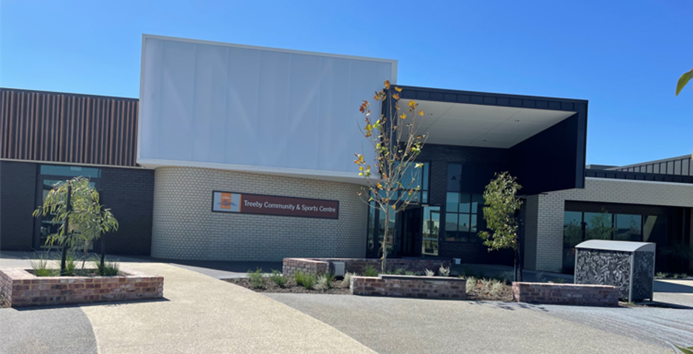

Expression of Interest –

Community Centre Regular Hirer

Treeby Community & Sports Centre

# Background

The new suburb of Treeby is part of the City of Cockburn and is located in the southern suburbs of the Perth Metropolitan area, approximately 20 kilometers from Perth CBD. Just north east of the Kwinana Freeway and Armadale Road exit, Treeby is forecast to be home to approximately 7,500 new residents by 2036.

The new $6.7 million Treeby Community and Sports Centre is located on the corner of Torwood Avenue and Clementine Boulevard in Treeby (Figure 1 below). It is situated in the main town centre next to Treeby Primary School which opened this year.

The Centre is owned and managed by the City of Cockburn. The new facility will be a flexible space that will serve a variety of different purposes and will help increase participation in sport, recreation and physical activity by the local community.

The new Centre can accommodate a variety of regular hirers allowing for a wide range of programs to be available to the local community. The community will also have the ability to hire the Centre for once off events such as birthday parties and family gatherings.

The City is seeking expressions of interest from enthusiastic groups/individuals who like to become a regular hier at Treeby Community and Sport Centre.Hirers can be a not for profit group or a registered business.

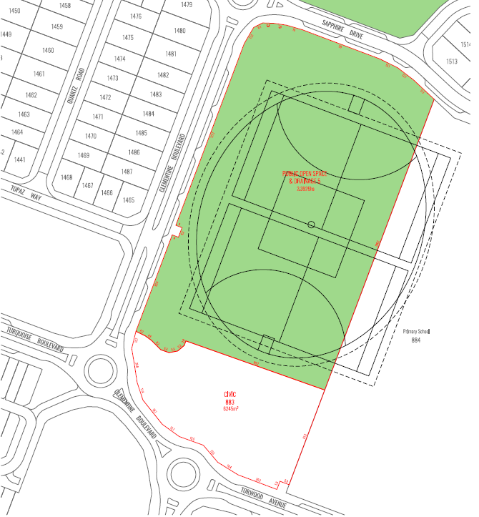

**Treeby Primary School**

**Treeby Community & Sporting Facility**

*Figure 1: Site Layout*

Facilities Available

The following details will help determine if the new community and sporting facility in Treeby is a suitable venue for your group.

Please ensure you have an understanding of the facilty prior to submitting an expression of interest.

## Community Facility

The new facility has the following rooms available to hire:

1. **Function Room - 146m2** 
   * 1. Adult Banquet Tables & Chairs
     2. Audio Visual Equipment
     3. Commercial Kitchen
2. **Community Room – 122m2**
   * 1. Adult Tables & Chairs
     2. Children Tables & Chairs
     3. Audio Visual Equipment
     4. Kitchen
     5. Private Toilets
     6. Enclosed Outdoor area with Shelter.
3. **Activity Room – 64m2**
   * 1. Kitchenette
     2. Adult Tables, Chairs and Stools
     3. Audio Visual Equipment
4. **Meeting Room 24m2 – Small Room**
   * 1. Boardroom Table and Chairs
     2. Hot Water Urn

All rooms have reverse cycle airconditioning and entry doors have a swipe card access system. There is also ample on site and street parking bays plus there is CCTV.

Mulitple storage areas are located within the facility for regular hirers to have access to. If you require storage please indicate this on your application form.

There maybe limited availability to book some rooms on weekends due to the high volume of patrons on site involved with sporting commitments taking place on the adjacent Treeby Park

## Management Arrangements

Prospective applicants will be able to hire their preferred room on an hourly basis over the course of a 12 month period (January to December) via the City’s Community Centre Regular Hirer Application Process (includes Conditions of Hire) and Council adopted Fees and Charges.

The current fees and charges for each room are listed below:

|  |  |  |
| --- | --- | --- |
| **Room** | **Not For Profit Rate** | **Commercial Rate** |
| Function Room | $22.00 | $36.00 |
| Community Room  Activity Room | $19.00 | $30.00 |
| Meeting Room | $17.00 | $27.00 |

Only regular hirers that have a current Certificate of Incorporation will receive the not for profit rate.

Monthly storage fees for all regular hirers range from $8.50 to $21.00. Please note on your application form whether you require storage.

Public Liability Insurance

It is a requirement of all regular bookings that hirers must have a current Certificate of Currency. Applicants must provide their current Certificate of Currency as part of the application process.

## Sports Oval

A large sports oval is located adjacent to the Centre. Fremantle Rugby League Club will hire the space on a regular basis for training and games. As part of the Club’s hire agreement they will have sole access to some sections of the Centre plus use of shared areas. The Club will predominately be on site from 4pm Monday to Friday and weekends.

Treeby Primary School will also have access to the Oval during school hours.

# Expression of Interest

To determine the most suitable regular hirers for the Centre, potential groups will be required to submit an EOI. This process will require applicants to provide past (if applicable), present and future information in regards to paying facility hire fees, proposed growth/sunstainability measures, plans to engage the community and surrounding suburbs of Treeby, and testimonials.

A selection panel will assess all applications based on the following factors to determine the most suitable mix of groups for the facility:

* Community needs
* Opportunities they will provide to the local community
* Long term sustainability.
* Ability to pay facility hire fees

Applications should be highly motivated in assisting the City’s vision to ensure that Cockburn will be the most attractive place to live, work, visit and invest in, within the Perth metropolitan area.

Following the Expression of Interest all applicants will be notified of the outcome by email.

The City will work closely with the successful applicants to assist with their establishment at the site. It is expected that successful applicants will be fully operational at site by the first week of Term 1 2023.

All Expression of Interests must be submitted by 4.00pm Friday 20 May 2022. The City of Cockburn also extends an invitation to interested applicants to attend a non-mandatory faciility inspection at 5pm on Tuesday 10 May. Please contact the City to register your interest to attend the inspection.

If you have any queries regarding please don’t hesitate to contact our Recreation Team on 9411 3444 or [communityvenues@cockburn.wa.gov.au](mailto:communityvenues@cockburn.wa.gov.au).



**City of Cockburn**

9 Coleville Crescent, Spearwood WA 6193

PO Box 1215, Bibra Lake DC Western Australia 6965

T: 08 9411 3444

E: [communityvenues@cockburn.wa.gov.au](mailto:communityvenues@cockburn.wa.gov.au)

cockburn.gov.wa.au