Policy Type

Local Planning Policy

Policy Purpose

The Phoenix Revitalisation Strategy identified a vision for the Phoenix Activity Centre to evolve into a town centre, and the Phoenix Activity Centre Structure Plan provides further guidance for development.

These Design Guidelines set out development control policy measures to achieve the key objectives of the Revitalisation Strategy and the Activity Centre Structure Plan.

The purpose of this Policy is to set out design guidelines for the Phoenix Activity Centre, which is divided into three precincts as follows:
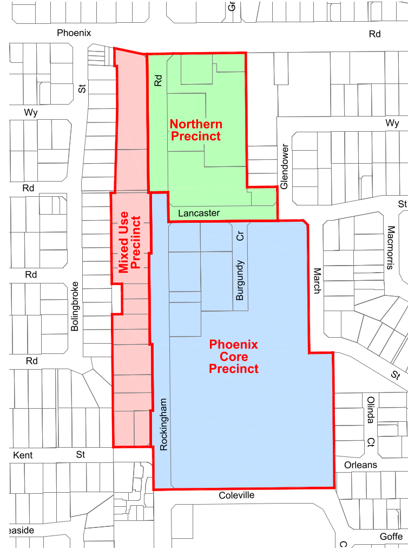
- Phoenix Core Precinct
- Mixed Use Precinct
- Northern Precinct

This Policy should be read in conjunction with the Phoenix Activity Centre Structure Plan.

Policy Statement

Definitions:

Active Frontage means street frontages where there is an active visual engagement between people in the street and those on the ground floors of buildings.

Articulation means the breaking up of a building façade into individual elements to provide a modulated effect aimed at enhancing individual building identity, variety and interest through the use of such elements as window projections, balconies, awnings, minor recesses and/or projections of walls or parts of walls.

Built Form means the configuration of the aggregate form of all buildings, structures, etc., which make up the physical environment of a locality.

Bulk means the size, or mass, of a building within its built form context.

Character means the essential combination of the public and private domains. Every property, public place or piece of infrastructure and the way it is used by the public, makes a contribution, whether large or small. It is the cumulative impact of all these contributions that establishes neighbourhood character.

Context means the specific character, quality, physical, historic and social context of a building’s setting and may, according to circumstances, be a group of buildings, a part of a street, whole street, part of a town or the whole town.

Legibility means a street and movement system designed to provide a clear sense of direction and connection, giving definite signals regarding the spatial layout and geography of an area.

Public Realm means areas of a town which belong to the community as a whole. This refers to spaces that are physically accessible to the public, and those aspects of other spaces that are visible from physically accessible spaces. It incorporates features such as streets, parks, squares, community buildings and the street facades of other buildings.

Scale means the size of a building and its relationship with its surrounding buildings or landscape.

- General policy objectives

1. To create a high quality and safe pedestrian environment along Rockingham Road in the Phoenix Activity Centre.

2. To create a new sense of place with high-quality and dynamic building and landscape design and landmark development sites.

3. To create an activity centre with a readily identifiable character.

4. To facilitate safe and convenient pedestrian and cyclist movement within the Activity Centre, resolving vehicle and pedestrian/cyclist conflict points.
5. To create an Activity Centre that is highly legible.

6. To create attractive, active frontages that provide visual interest and contribute to pedestrian and cyclist safety and comfort.

7. To ensure that signage is not visually obtrusive, does not result in excessive visual clutter; and does not hinder passive surveillance.

8. To ensure that signage is compatible with the scale, design and visual character of the building and activity centre.

9. To provide adequate opportunities for commercial advertising to support and encourage business activity.

10. To encourage an increase in pedestrian and cycling trips by maximising the convenience, safety and appeal of these modes of travel.

11. To create safe, functional and attractive car parking areas that allow for landscaping and facilitate safe and convenient pedestrian and cyclist movement.

12. To encourage landmark development features which are integrated with buildings, and which improve legibility within the activity centre.

13. To utilise artworks to create community identify; improve inactive frontages; improve legibility; and provide functional infrastructure for pedestrians and cyclists.

14. To promote the integration of wayfinding with urban design, landscaping, architectural design and public art.

15. To encourage mixed use development and a diversity of land uses.

- General Provisions

1. Signage

- Development should include clearly identifiable entry point(s) for customers/pedestrians in the building design, rather than relying on signage.

- Signage is to be an integrated part of the building/site, and should be compatible with the scale, design and visual character of the building/site, and should not result in visual clutter.

- Signage should:

  - Be contained within the lot boundary;
  - Be easy to read with a clear message;
  - Advertise only goods and services that relate to the business on which the sign is located.

- Signage is not to cover a large portion of retail/commercial windows or prevent passive surveillance.

- Signage, and associated structure, should not be used in isolation to signify entry points to development.

2. Lighting

(a) Development should make provision for the location of external lighting, to include the lighting of commercial building facades for public safety purposes and to add variety, interest and character to the development at night.

(b) Lighting should be even and consistent to avoid shadows and glare and should be provided to increase safety and security along important pedestrian pathways.

- Services

- Bin and service enclosures are to be screened and located away from visually prominent parts of the site. Wherever possible services should be designed to visually integrate into buildings, rather than be a separate element.

- Development should be consistent with the City’s Local Planning Policy 1.14 – Waste Management.

4. Landscaping

- Development proposals should include landscaping plans that provide detail of plant species and maintenance.

- Water-sensitive design planting principles are encouraged.

- Opportunities should be taken to include simple pedestrian amenities such as seats and shade/shelter.

- Phoenix Core Precinct

1. Movement

(a) Development Applications are to be accompanied by a Pedestrian and Cyclist Movement Plan demonstrating how pedestrian and cyclist connectivity can be accommodated safely and conveniently, addressing the following:

(i) Demonstrate improvements to legibility, permeability and pedestrian safety along and connecting with Rockingham Road.

(ii) Inclusion of separate pedestrian path(s) on the vehicle access ramp from Rockingham Road to secure safe pedestrian movement, where the ramp is retained as part of a redevelopment proposal, or a proposal for expansion of the floorspace.

(iii) Demonstrate how car parking areas include safe and convenient pedestrian routes to key destinations, both from car parking bays, bus stops, and from the wider pedestrian network. This may require a decrease in the number of parking spaces to allow for improved accessibility and/or improved landscaping.

(iv) Provision of high quality, safe, secure and accessible end-of-trip facilities for cyclists.

(b) All development applications for the Phoenix Shopping Centre site that propose expansion of floorspace, or extensions or modifications to car parking areas or vehicle access ramps, must address the following matters:

(i) Demonstrate improvements to the servicing area on Rockingham Road.
(ii) Minimising the width and impact of vehicle crossovers on the pedestrian environment if possible, given that they serve to disconnect the pedestrian environment, reduce pedestrian comfort and increase potential conflict between vehicles and cyclists and pedestrians.
(iii) Improving the inactive frontage.
(iv) Improving the interface with the bus stop.

(c) Improve pedestrian connectivity through the Phoenix Shopping Centre site, and to the main entries of the shopping centre.

(d) Demonstrate improvements to the servicing area on March Street which reduce negative impacts on residential amenity.

2. Built Form

(a) Proposed buildings or extensions/major modifications to buildings are to address street frontages (and internal roads) and maximise opportunities for passive surveillance of streets, car parking areas, and areas used by pedestrians and cyclists.

(b) Proposed buildings or extensions/major modifications to buildings are to be appropriately detailed at ground level so that they create an attractive, safe and interesting environment for occupants and pedestrians alike.

(c) Ground floor non-residential frontages fronting Rockingham Road or primary pedestrian linkages are to be designed as shop fronts with no less than 70% glazing. Buildings fronting other public areas shall be glazed for a minimum of 50%. Glazing percentages are to apply from between 0.9m and 2.1m above footpath/street level.

(d) Where an active frontage cannot be achieved, for example servicing/loading areas, it should be demonstrated how the frontage has been designed to contribute to a high quality, safe and attractive street environment by:

(i) Minimising the length and height of blank walls, and
(ii) Articulating blank walls through the creative application of complementary materials, avoiding large continuous masses of the same finish; and/or the provision of appropriately integrated structural features, lighting, street furniture, artworks, or display windows where possible.

(e) Vehicle ingress and egress, loading facilities and building services should be designed so that they do not detract from a high quality, safe and attractive public realm.

(f) Wherever possible development should use built form to signify entry points rather than relying on signage elements (including ‘signage’ structures) to serve as a landmark to the shopping centre, and/or to signify the location of entrances to the shopping centre.

(g) Wherever possible the opportunity to “sleeve” large scale retail and/or to introduce outwards-facing uses to avoid blank walls is strongly encouraged. Buildings at ground level should contain activities that positively contribute (either passively or actively) to the public domain.

(h) Ensure where appropriate that development complements and corresponds to neighbouring or abutting built form through consideration of form, detail and application of materials.

3. Visual Impact

(a) The visual impact of development must be demonstrated from the perspective of the surrounding Residential area to the east of the activity centre.

(b) Buildings and structures should present well from all angles as some may be visible from a considerable distance.

(c) Development should demonstrate that consideration has been given to the vista and pedestrian connectivity from Orleans Street, including ensuring the following is achieved:

(i) The establishment of safe and attractive pedestrian connectivity;
(ii) ensuring development is not obtrusive when viewed from Orleans Street

4. Landscaping

(a) Development proposals should include the retention of existing landscaping on March Street to provide a buffer with the residential development on the eastern side of the road.

- Mixed Use Precinct

1. Objectives

(a) To create a vibrant mixed use environment that facilitates a diversity of uses.

(b) Promote a diversity of housing types within the activity centre structure plan area.

(c) To encourage rationalisation of signage to reduce visual clutter and enhance the streetscape.

(d) To encourage mixed use development whereby non-residential uses can be accommodated at the ground floor.

(e) To ensure residential amenity and security is protected in mixed use environments.

(f) To protect the residential amenity of dwellings on adjacent ‘Residential’ zoned land.

(g) To ensure high-quality, built form in the ‘Mixed Use’ zone that provides interest to the street, and promotes passive surveillance.

(h) To ensure new development in the ‘Mixed Use’ zone achieves visual cohesiveness.

(i) To ensure buildings are robust and adaptable to allow for future use changes so that the mixed use area can evolve over time to meet the needs of businesses and the community.

(j) To ensure that buildings give additional prominence to street corners by using landmark features which will create visual interest in the streetscape and assist with legibility.
(k) To ensure buildings contribute positively to the public realm by creating visual interest, facilitating passive surveillance of streets and spaces used by the public, and contributing to pedestrian comfort.

(l) To ensure safe vehicle access and egress to Rockingham Road, and improve pedestrian safety and comfort by:

- Rationalising vehicle crossovers to Rockingham Road generally where possible.

(m) To improve the pedestrian amenity of Rockingham Road through the introduction of a landscaping strip.

2. Built Form

(a) Development should incorporate non-residential ground floor uses that promote activity and informal surveillance of the street and have facades that add interest and vitality to the public realm.

(b) New building(s) setback and height shall be in accordance with the R60 density code.

(c) Where commercial uses are not considered viable in the short term, ground floor tenancies/dwellings are encouraged to be designed to be adaptable for future commercial uses, including incorporating a recommended minimum ground floor tenancy/dwelling height of 3.9 metres above the finished ground floor level.

(d) To ensure that building facades are architecturally interesting the upper levels of buildings should be articulated to break-up long sections of plain facades. This should include at least three of the following features:

(i) Major openings;
(ii) Different colours, materials or textures;
(iii) Indentations and extrusions which break the building into individual elements;
(iv) Protruding balconies;
(v) Awnings over windows.

(e) All building levels should be clearly defined through the use of colours, materials and detailing.

(f) The upper level(s) of buildings should be designed to promote informal surveillance of the street through the use of balconies and/or large windows.

(g) Upper floor windows of buildings, which face a public street or communal access way, should be largely unobscured to promote passive surveillance.
(h) Ground floor non-residential frontages fronting Rockingham Road or primary pedestrian linkages are to be designed as shop fronts with no less than 70% glazing. Buildings fronting other public areas shall be glazed for a minimum of 50%. Glazing percentages are to apply from between 0.9m and 2.1m above footpath/street level.

(i) Commercial buildings should address the street in a traditional manner with windows facing the street and clearly defined entry points that are visible from the street. To achieve this entry points should generally include at least two of the following features:

(i) Appropriately scaled signage above the entry door;
(ii) Recessed entry points;
(iii) Highlighting the entry point through the use of different materials.

(j) Buildings should be designed so that services do not project above the specified maximum height of the building and should be screened from view. To ensure adaptability of buildings this should include consideration of larger servicing unit requirements for other uses (such as restaurants) so that these can be accommodated should the building undergo a future change of use.

(k) To articulate street corners, provide visual interest and assist with legibility, new buildings located on corner sites should include:

(i) Architectural roof features that protrude above the normal roof line;
(ii) Increased parapet heights with additional detail, colour and textures; and/or
(iii) Increased height and bulk at the street corner.

(l) New buildings with parapets should include indentations; additional modulation, and/or variation in parapet heights and designs so-as-to provide additional interest to the street.

(m) In mixed use developments commercial uses should be separated from residential uses by being located on separate floors of a building to ensure the amenity and security of residents and commercial tenants.

(n) Development applications are to be accompanied by design and documentation of ‘back-of-house’ services, including ducting and vents. To ensure the robustness and adaptability of buildings this should consider a general and basic overview of potential ‘back-of-house’ services for food businesses (such as ducting and vents allowing for the mechanical ventilation of kitchen areas, and ‘grease traps’).

(o) In order to frame the street and encourage passive surveillance, buildings adjacent to Rockingham Road are encouraged to be a minimum of two storeys in height, with single storey commercial buildings to be assessed on their merits against the objectives of the policy.

(p) Garages facing Rockingham Road will not be supported.

3. Parking and Movement

(a) At-grade car parking areas should be landscaped with suitable trees at the rate of one tree per 6 bays. The chosen trees should provide shade, improve amenity and assist in visual screening from above. The car park should also be appropriately lit.

(b) Any new multi-storey car parks should incorporate interactive street frontages, such as shops or other uses that promote activity, where possible. These can be ’sleeved’ along the street frontages of the car park structure.

(c) Where car parking levels (including undercroft levels) are visible from a street or public space, high quality architectural detailing shall be incorporated into the façade of all floors.

(d) Access to development sites should include only one crossover and be located to minimise impact to street tree(s).

(e) Wherever possible the finished level of buildings/tenancies should match that of the adjacent footpath so that continuous access is provided from the pedestrian footpath into each commercial tenancy and a consistent streetscape is achieved on Rockingham Road.

(f) Services should be located away from the street and clear efforts made to minimise impacts to neighbouring development.

(g) Safe and comfortable pedestrian access shall be provided from the parking area to the entry point of the proposed development and to all street frontages.

4. Change of use proposals for dwellings

(a) Where the existing dwelling or building is the subject of a change of use proposal (to be accommodated within an existing dwelling/building), the following provisions will apply:

(i) Only one vehicle crossover is to be utilised, with any existing additional crossovers to be removed unless safe access and egress cannot be accommodated otherwise.
(ii) Existing large crossovers are to be reduced in size.
(iii) Car parking areas are to be designed so that vehicles can exit onto Rockingham Road in forward gear.
(iv) Upgrades to the façade of the building shall be undertaken consistent with Built Form provisions.
5. Landscaping

- A comprehensive landscaping plan is required for the front setback area and verge, demonstrating an appropriate and attractive mix of hard paving and in-ground planting, provided that the plantings maintain openness to the building to ensure a visible and safe entrance, and create no potential entrapment areas.

- Northern Precinct

1. Objectives

(a) To ensure buildings contribute positively to the public realm by creating visual interest, facilitating passive surveillance of streets and spaces used by the public, and contributing to pedestrian comfort.

(b) To facilitate safe, comfortable pedestrian and cyclist movement, particularly in a north south direction through the activity centre.

(c) To improve legibility for pedestrians throughout the precinct.

(d) To ensure safe and legible vehicle access and egress throughout the precinct, particularly onto Rockingham and Phoenix Road.

2. Built Form

(a) New buildings or proposed modifications to existing buildings should include clearly identifiable pedestrian entry point(s).

3. Parking and Movement

(a) Development must demonstrate how safe and convenient pedestrian movement from the street footpaths and car parking areas to building entry points are facilitated.

Strategic Link: | Town Planning Scheme No. 3
Category | Planning - Town Planning & Development
Lead Business Unit: | Development Assessment and Compliance
Public Consultation:  (Yes or No) | Yes
Adoption Date:  (Governance Purpose Only) | 9/12/2025
Next Review Due:  (Governance Purpose Only) | 12/2027
ECM Doc Set ID:  (Governance Purpose Only) | 6583632

