Tender Title: |  | RFT 07/2023  Marina and Coastal Annual Inspections & Maintenance Works
Request ID: |  | 47075
Tender Description: |  | The City of Cockburn (the Principal) is seeking a suitable qualified and experienced contractor to conduct marine & coastal maintenance and annual inspections of Cockburn’s marine assets and infrastructure across Cockburn’s coast and Port Coogee Waterways.
Advert Approval: |  | Decision to Advertise: Chief Operations Officer  Decision Date: Wednesday, 17 May 2023
Closing Date and Time: |  | 2:00PM (AWST) Thursday, 22 June 2023
Opening Date and Time: |  | 2:00PM (AWST) Thursday, 22 June 2023
 | Tenderer’s Name:
1 | Franmarine Underwater Services (HQ)
2 | Indianic Group Pty Ltd
3 | Shore Water Marine Pty Ltd
4
5
6
7
8
9
10

Advertisement
Method 1: City of Cockburn | Method 2: Yammer
Method 3:  The Western Australian,  Wednesday, 24th May 2023 | Tender Awarded by:
Copy of Statewide Notice:  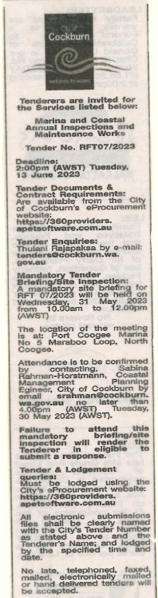 | A/ Chief of Built and Natural Environment  Thursday, 17 August 2023
 | Date of Council Meeting:
 | Not applicable
Name of Successful Tenderer(s): | Shorewater Marine Pty Ltd
Amount of Successful Tender(s): (ex GST) | $271,009

