Tender Title: |  | ARBORICULTURAL SERVICES (CITY WIDE)
Request ID: |  | 71429
Tender Description: |  | The City is seeking suitably qualified and experienced Contractor/s to conduct arboricultural works within parks, streetscapes and bushland reserves. The tender is  divided into the three (3) separate zones.
Advert Approval: |  | Decision to Advertise: Director Infrastructure Services  Decision Date: Friday, 7 November 2025
Closing Date and Time: |  | 2:00PM (AWST) Tuesday, 16 December 2025
Opening Date and Time: |  | 2:00PM (AWST) Tuesday, 16 December 2025
 | Tenderer’s Name:
1 | The Trustee for Chalmers Family Trust t/a Chalmers Tree Services Pty Ltd (Chalmers Tree Services)
2 | Tree Care WA
3 | Beaver Tree Services t/a Beaver Tree Services Aust Pty Ltd
4 | ARBFIRM Pty Ltd
5 | ARBOR West Pty Ltd
6
7
8
9
10

Advertisement
Method 1: City of Cockburn website | Method 2: City of Cockburn Libraries Public Noticeboards
Method 3:  The Western Australian, Saturday, 15 November 2025 | Tender Awarded by:
Copy of Statewide Notice:  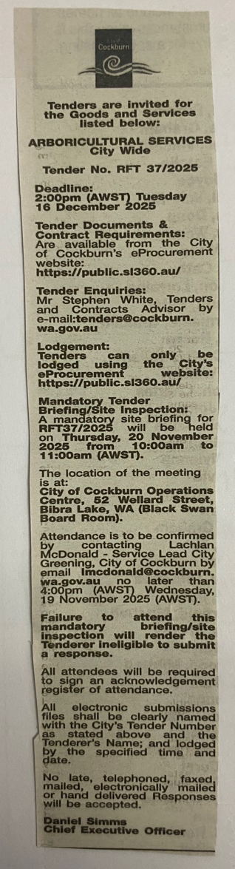 | OCM  Choose an item.  Tuesday, 10 February 2026
 | Date of Council Meeting:
Date: 10 February 2026
Minutes: 2026/MINUTE NO 0015
Item No. 19.1
Name of Successful Tenderer(s): | Zone A (West): Tree Care WA Zone B (East): Beaver Tree Services Zone C (Bushland City Wide): Tree Care WA
Amount of Successful Tender(s): (ex GST) | Zone A (West): Tree Care WA: $2,889,274.00 Zone B (East): Beaver Tree Services $2,472,169.00 Zone C (Bushland City Wide): Tree Care WA $488,557.00

