Tender Title: |  | CONSTRUCTION SERVICES - BLACKSPOT INTERSECTION UPGRADE - PROJECT SITE 2 (Rockingham Road & Spearwood Ave) Spearwood WA
Request ID: |  | 70245
Tender Description: |  | The City is seeking the services of a suitably qualified, registered and experienced Construction Contractor to undertake civil works and traffic signal upgrade at the  Intersection of Rockingham Road and Spearwood Avenue in Spearwood, Western Australia. The intersection of Spearwood Avenue and Rockingham Road is an existing  four-way signalised intersection. Main Roads Western Australia (MRWA) has identified the current signal operations are not compliant with the current standards for disabled access including those requiring mobility devices (wheelchairs, walker/rollator and mobility scooters) as well as vision impaired and other pedestrians who may have restricted mobility.
Advert Approval: |  | Decision to Advertise: Director Infrastructure Services  Decision Date: Tuesday, 5 August 2025
Closing Date and Time: |  | 2:00PM (AWST) Thursday, 4 September 2025
Opening Date and Time: |  | 2:00PM (AWST) Thursday, 4 September 2025
 | Tenderer’s Name:
1 | Tracc Civil Pty Ltd (Office)
2 | Civcon Civil & Project Management t/a Civcon Civil and Project Management
3 | Dowsing Group
4 | Fulton Hogan Industries Pty Ltd t/a Fulton Hogan (Hazelmere)
5 | Garli Pty Ltd (Rivervale)
6
7
8
9
10

Advertisement
Method 1: City of Cockburn website | Method 2: City of Cockburn Libraries Public Noticeboards
Method 3:  The Western Australian, Saturday, 9 August 2025 | Tender Awarded by:
Copy of Statewide Notice:  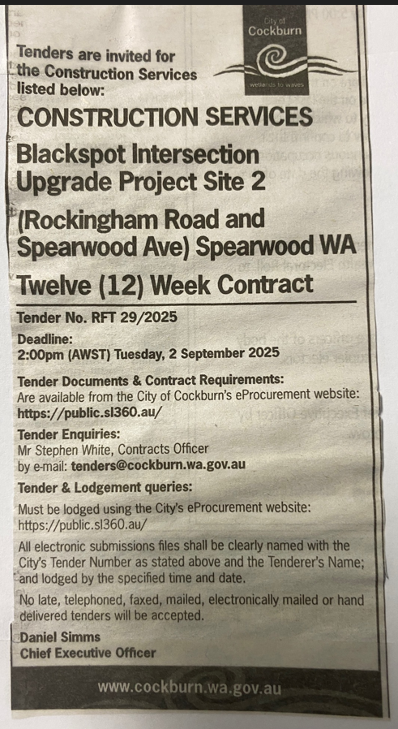 | OCM  Choose an item.  Tuesday, 9 December 2025
 | Date of Council Meeting:
Date: 09 December 2025
Minutes: (2025/MINUTE NO 0224)
Item No. 14.3.2
Name of Successful Tenderer(s): | Civcon Civil & Project Management
Amount of Successful Tender(s): (ex GST) | $960,095

