Tender Title: |  | VERGE MOWING SERVICES  Arterial Road Reserves P2 – Streetscapes
Request ID: |  | 63512
Tender Description: |  | The intent of this Tender is to select a suitably qualified and experienced Contractor to conduct scheduled mowing of its nominated road reserves and the removal and disposal of litter.
Advert Approval: |  | Decision to Advertise: Director Infrastructure Services  Decision Date: Monday, 19 May 2025
Closing Date and Time: |  | 2:00PM (AWST) Thursday, 12 June 2025
Opening Date and Time: |  | 2:00PM (AWST) Thursday, 12 June 2025
 | Tenderer’s Name:
1 | Adelby Pty Ltd
2 | Gecko Contracting Turf & Landscape (GAS Assets Pty Ltd)
3
4
5
6
7
8
9
10

Advertisement
Method 1: City of Cockburn website | Method 2: City of Cockburn Libraries Public Noticeboards
Method 3:  The Western Australian, Saturday, 24 May 2025 | Tender Awarded by:
Copy of Statewide Notice:  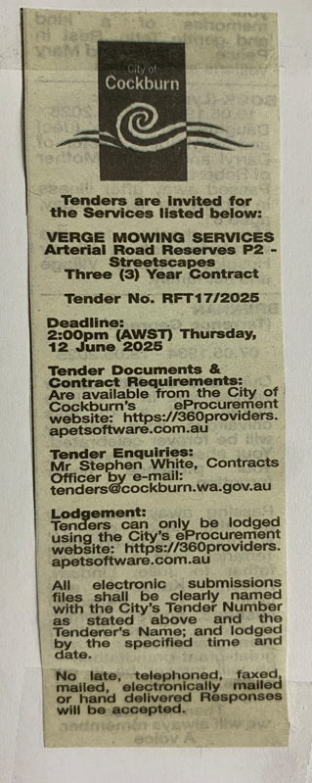 | Director Infrastructure Services  Choose an item.  Thursday, 3 July 2025
 | Date of Council Meeting:
Date:
Minutes:
Item No.
Name of Successful Tenderer(s): | GAS Assets Pty Ltd t/as Gecko Contracting Turf & Landscape Maintenance
Amount of Successful Tender(s): (ex GST) | $368,178.16 (Ex GST)

