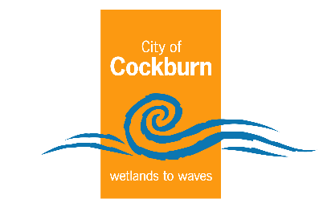

9 August 2022
City of Cockburn and Curtin strengthen partnership
The enduring partnership between the City of Cockburn and Curtin University has been formalised in a Memorandum of Understanding (MoU) designed to help the local community prosper.
The City and University already have long-standing partnerships at the Cockburn Health and Community Facility, Success and Cockburn ARC, where students combine work and practical placements with study in various health-related fields.
The proposal was endorsed by Cockburn Council on 9 June, and City and University representatives gathered for its official signing on 9 August.
Benefits of the MOU for the City have been immediate, with the launch of a new round of the Curtin Ignition program- an intensive course for aspiring entrepreneurs, academics and corporate innovators. Work is also underway with the Curtin University Social Media Research Lab (The Agency), focusing on research to support the development of a visitor/destination strategy for the City.
City of Cockburn Mayor Logan Howlett said the formal partnership reflected both parties’ common goal of positive community impact through leadership and innovation.
“Cockburn is involved in many aspects of our community’s lives, from urban planning to coastal erosion, waste reduction to arts and culture. Providing opportunities to work with Curtin on both research projects and other initiatives that could contribute to improvements in these areas, will be a win-win for both organisations, and ultimately the people of Cockburn,” Mayor Howlett said.
Curtin University Vice-Chancellor Professor Harlene Hayne said the collaboration will provide opportunities for both the Curtin and Cockburn communities.
“Curtin is delighted to be working hand in hand with the City of Cockburn on projects involving sustainability, urban planning, health and sport and recreation, We also appreciate the work-integrated learning and volunteer opportunities it provides our students and staff,” Professor Hayne said.
The City and University are establishing a steering committee that will meet biannually to agree on the opportunities to focus on and how progress on collaborative activities will be evaluated.
Ends
City of Cockburn Media contact:
Tel: (08) 9411 3551 Email: media@cockburn.wa.gov.au

Curtin University Media contact:
Vanessa Beasley
Tel: (08) 9266 1811 Mobile: 0466 853 121 Email: vanessa.beasley@curtin.edu.au

