Tender Title: |  | RFT 21/2025 – Tree Watering Services
Request ID: |  | 63577
Tender Description: |  | The City of Cockburn (the principal) requires the services of a suitably qualified and experienced Contractor to conduct truck and mobile tank watering of the following (but is not limited to):  - Trees  - Roll On Turf  - Shrubs  The proposed Contract shall be in place for a period of three (3) years from the date of award; with Principal instigated options to extend the period for a subsequent one (1) year period and up to an additional twelve (12) months after that, to a maximum of five (5) years.
Advert Approval: |  | Decision to Advertise: Director Infrastructure Services  Decision Date: Friday, 20 June 2025
Closing Date and Time: |  | 2:00PM (AWST) Wednesday, 16 July 2025
Opening Date and Time: |  | 2:00PM (AWST) Wednesday, 16 July 2025
 | Tenderer’s Name:
1 | Baroness Holdings Pty Ltd t/a Tree Planting and Watering

Advertisement
Method 1: City of Cockburn | Method 2: City of Cockburn Public Libraries Notice Boards
Method 3:  The Western Australian, Wednesday 25 June 2025 | Tender Awarded by:
Copy of Statewide Notice:  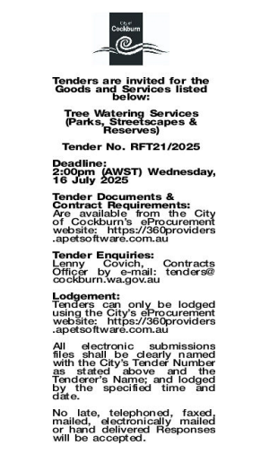 | OCM  Tuesday 2 September 2025
 | Date of Council Meeting:
Tuesday 2 September 2025
Minutes: 0150
Item No: 14.3.1

Name of Successful Tenderer(s): | Baroness Holdings t/a Tree Planting and Watering
Amount of Successful Tender(s): (ex GST) | $2,001,852.00

