Tender Title: |  | CLEANING OF PUBLIC BARBEQUES (COMMERCIAL)  Five (5) Year Contract
Request ID: |  | 55459
Tender Description: |  | The City of Cockburn seeks a suitably qualified and experienced Contractor to complete commercial cleaning of the Principals public barbeques located throughout the municipals area.
Advert Approval: |  | Decision to Advertise: Director Infrastructure Services  Decision Date: Thursday, 20 March 2025
Closing Date and Time: |  | 2:00PM (AWST) Thursday, 10 April 2025
Opening Date and Time: |  | 2:00PM (AWST) Thursday, 10 April 2025
 | Tenderer’s Name:
1 | A1 Hi-Pressure Cleaning (Lesania Pty Ltd)
2 | Ascend Cleaning And Waste Pty Ltd
3 | Brightmark Group Pty Ltd
4 | Intelife (Intelife Group Limited)
5 | Premier Services Australia Pty Ltd
6 | Stadiacorp Pty Ltd (WA)
7 | Swanty Oz Pty Ltd
8 | Extreme Clean Australia (The Trustee for ECA Unit Trust)
9 | Uniting Global Pty Ltd
10 | Vibrant Cleaning Group (Vibrant Services Pty Ltd)
11 | Your Local Maintenance Team Pty Ltd (Your Local Maintenance Team Pty Ltd)

Advertisement
Method 1: City of Cockburn website | Method 2: City of Cockburn Libraries Public Noticeboards
Method 3:  The Western Australian, Saturday, 22 March 2025 | Tender Awarded by:
Copy of Statewide Notice:  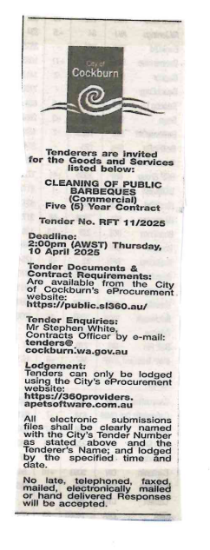 | Director Infrastructure Services  Choose an item.  Wednesday, 18 June 2025
 | Date of Council Meeting:
Date:
Minutes:
Item No.
Name of Successful Tenderer(s): | Intelife (Intelife Group Limited)
Amount of Successful Tender(s): (ex GST) | $351,528 (Ex GST)

