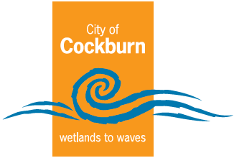
City of Cockburn

Annual Report
2023-2024
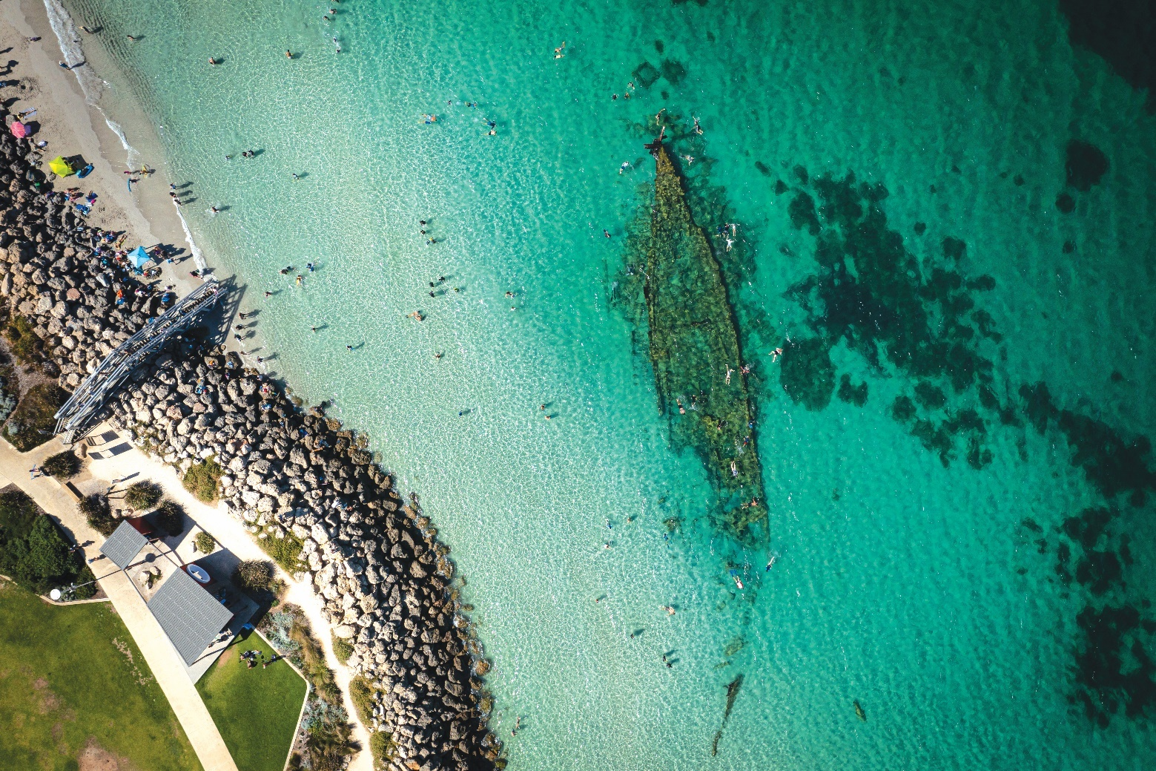
Cockburn, the best place to be
www.cockburn.wa.gov.au
November 2024

Acknowledgement of Country
The Mayor, Councillors and staff of the City of Cockburn acknowledge the Whadjuk Nyungar people of Beeliar boodja as the traditional custodians of this land. We pay our respect to the Elders, past and present.
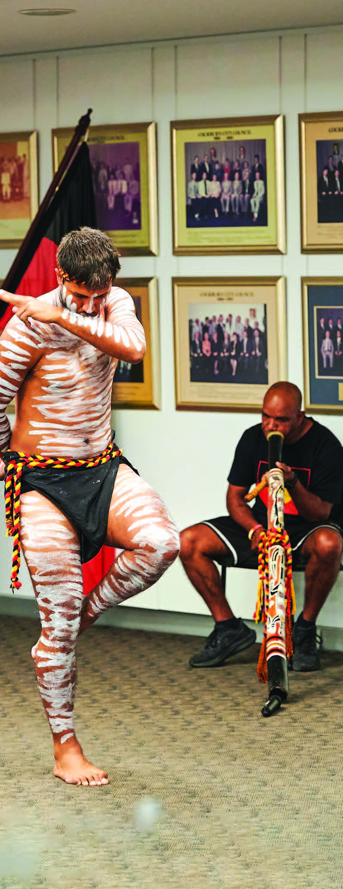
Photo: City of Split Welcome Function - October 2023. Didgeridoo player Tim Kelly and his son Troy Kelly, dancing.
Front cover photo: Omeo Shipwreck, Coogee.

Contents
Acknowledgement of Country 2
Message from the Mayor 5
Message from the CEO 6
What is an Annual Report 8
How to Read an Annual Report 10
Our Strategic Framework 11
Our Strategy on a Page 14
About our City 15
Our Council and Elected Members 25
Our Organisation 44
Directorates and Office of the CEO 48
Our People 65
Delivering Our Outcomes 72
Community Satisfaction 74
Local Economy Outcomes 76
Environmental Responsibility Outcomes 88
Community, Lifestyle and Security Outcomes 101
City Growth and Moving Around Outcomes 124
Listening and Leading Outcome 135
Awards and Achievements 151
Capital Grants, Subsidies and Contributions 156
Building and Development Applications 157
Our Capital Investment 160
Our Assets 162
Our Budget 164
Risk Management 168
Governance Report 170
Disability Access and Inclusion Plan (DAIP) 171
Recordkeeping 176
Community Engagement 177
Climate Change and Sustainability Snapshot 179
The Year Ahead 187
Plan for the Future 195
Annual Financial Report 200
Contact Us 201

Message from the Mayor
As I reflect on my sixteenth year as Mayor and the many things Council has achieved, I am proud to report that the City continued to deliver exceptional community services in a tight economic climate while keeping its rates some of the lowest in Perth. This requires meticulous planning and careful prioritisation in a climate of high inflation and significant cost increases.
After much work and significant community engagement, the Community Infrastructure Plan 2024-2041 was endorsed for public comment in June 2024 and will be taken to Council for adoption in FY2024-25. This plan prioritises 26 future major community infrastructure proposals over the short to long-term.
Construction started for three major projects: Cockburn ARC and Fremantle Football Club expansion and Stratton Street, Hamilton Hill drainage upgrades. Malabar BMX redevelopment progressed well and will become a new community hub and home for the Cockburn BMX Club and Friends of the Community.
We are committed to keeping our community safe and achieved several important milestones. Council adopted the Cockburn Bushfire Risk Management Plan 2023-2028. We also undertook an extensive review of the CoSafe operating model which will enhance the quality of staffing, training and overall service delivery while ensuring cost-effectiveness. The City’s popular CCTV Home Rebate Program assisted with 200 CCTV installations.
Key challenges the City continues to face are coastal pressures, including increased coastal erosion, reduced annual rainfall, increased temperatures and spread of the Polyphagous Shot Hole Borer further threatening our tree canopy. The City’s first Sustainability and Environment Reference Group was established, with representatives from the community and industry to provide advice to Council on strategic matters relating to the environment and sustainability.
Progress continued towards removal of the Roe 8 and 9 highway reservations, with the formal town planning processes initiated and advertised by the State Government. This is a critical first step which reinforces the continuing rehabilitation works in the corridor.
The City continued to offer its Financial Counselling Services, assisting a total of 176 families, individuals, and small businesses and securing debt waivers totalling $153,290.
As always, I would like to thank the wonderful volunteers who dedicate thousands of hours in our community to help make Cockburn the best place to be.
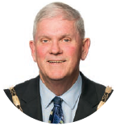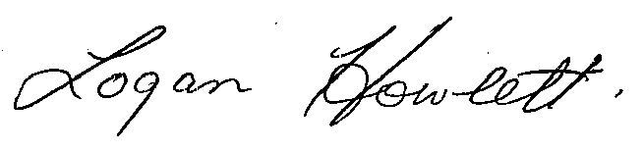
His Worship the Mayor
Logan K. Howlett, JP

Message from the CEO
Joining the City as your Chief Executive Officer in October 2023, I am both honoured and thrilled to present this report that reflects the hard work and dedication of our entire community. This past year has been one of significant milestones, strategic advancements and positive change. It stands as a testament to our commitment to transparency, community engagement, and sustainable development.
One of the key focuses since my arrival has been the enhancement of our internal processes and workforce capabilities. We launched an in-depth organisational review using the Australian Business Excellence Framework (ABEF), resulting in a three-year improvement plan. This plan aligns our budget with our service delivery priorities, strengthens our project management governance, and places renewed emphasis on work, health and safety.
Our workforce is truly the backbone of the City, and this year we’ve implemented several initiatives aimed at supporting, developing and recognising our people. A major highlight has been the introduction of our Safety Leadership Program, which has already led to an increase in employee engagement in safety protocols. We've also revamped our onboarding process to ensure that 94 per cent of new staff feel that safety is a known priority. This is part of our broader “Everybody be safe Everyday” campaign, which aims to embed a culture of safety and accountability across the organisation.
We are fully committed to continually enhancing our customer service. In line with this, we have procured a new customer experience software platform designed to enhance the overall experience for our residents and streamline interactions. This new system will allow us to be more efficient, transparent and responsive, ensuring that we meet the needs of our growing community.
From a strategic planning perspective, this year saw the significant advancement of our Local Planning Strategy, awaiting State Government approval. This milestone is crucial as we plan for Cockburn's sustainable growth, ensuring that we continue to build a city that is resilient, vibrant and inclusive. We’ve also strengthened our economic development initiatives, particularly focusing on international collaborations with Indonesia and Singapore, to leverage opportunities in shipbuilding, the blue economy and the AUKUS partnership.
Despite challenges such as rising costs, climate change pressures and coastal erosion, we have remained focused on delivering for our community. Initiatives like our Sustainability and Environment Reference Group and the revitalised Financial Planning Framework demonstrate our ongoing commitment to both environmental stewardship and financial responsibility.
I am deeply grateful to our dedicated staff, elected members, and volunteers who have contributed to our achievements over the past year. Their passion, hard work and resilience are what truly make Cockburn the best place to live, work and thrive.
I look forward to another successful year as we build on this momentum.
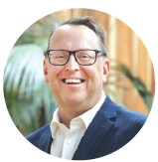
Daniel Simms
Chief Executive Officer

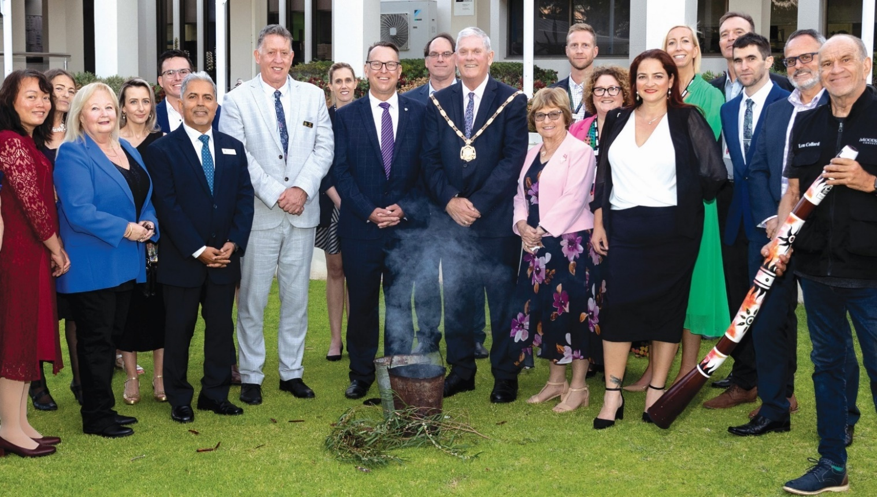
Photo: Swearing In Ceremony - October 2023. (Left to Right) Cr Carol Zhang; Cr Phoebe Corke; Cr Carol Reeve-Fowkes; Jessica Widenbar; Cr Tom Widenbar; Cr Tarun Dewan; Cr Philip Eva JP; Chantelle Hanrahan, Acting Executive People Experience and Transformation; Daniel Simms, Chief Executive Officer; Daniel Arndt, Chief of Built and Natural Environment; Mayor Logan Howlett and wife Pat; Andrew Tomlinson, Head of Community Infrastructure and Safety; Emma Milne, Executive Governance and Strategy; Deputy Mayor Cr Chontelle Stone; Victoria Green, Executive Corporate Affairs; Anton Lees, Chief of Operations; Cr Michael Separovich; Nelson Mauricio, Acting Chief Financial Officer; and Nyungar Elder Professor Len Collard.

What is an Annual Report
Welcome to the City of Cockburn Annual Report 2023-24.
We are pleased to present the City of Cockburn’s Annual Report for 2023-24. This comprehensive document provides a snapshot of our organisation’s performance against key performance indicators set by Council, our achievements, challenges and financial results.
The Annual Report is a cornerstone of our commitment to transparency, accountability and community engagement. It reflects our dedication to delivering exceptional services, fostering a vibrant community and achieving measurable success.

Key features of our Annual Report
- Aligned Vision: Our report aligns with the City’s strategic vision, ensuring that our actions contribute to a thriving community.
- Community-Driven Focus: We are committed to serving the needs of our community, and our annual report highlights our efforts to engage residents and businesses in decision-making processes. Our community-driven approach is evident in the projects we deliver and the services we provide.
- Financial Responsibility: We are dedicated to responsible financial management, and our report provides a detailed overview of our financial performance.
- Measurable Success: We track and report on our performance against key indicators, demonstrating our commitment to accountability and results.

What you’ll find in this report
The Annual Report is divided into several key sections:
- Leadership Insights: Our Mayor and CEO provide their perspectives on the year’s accomplishments and challenges
- Our City in Focus: Learn about Cockburn, our Council and the services we offer
- Progress Towards Strategic Community Plan Outcomes: An evaluation of our progress toward the goals and objectives outlined in our Corporate Business Plan, highlighting our successes, recognitions and challenges, categorised by the Strategic Community Plan outcomes
- Governance, Legal and Community Inclusion: Information on governance practices, legal compliance, and development activity, and an update on our Disability Access and Inclusion Plan
- Financial Performance: A detailed analysis of our financial position and performance
- Looking Ahead: Discover our plans for the future and how we're working to address emerging challenges and opportunities.

Connecting the dots…
The Annual Report, Corporate Business Plan and Strategic Community Plan
The Annual Report serves as a valuable tool for understanding how our activities contribute to the broader goals outlined in our Strategic Community Plan. While the Annual Report looks back on the past year, the Corporate Business Plan provides a forward-looking perspective, outlining our plans for the future. Together, these documents provide a comprehensive picture of our organisation’s performance and direction.
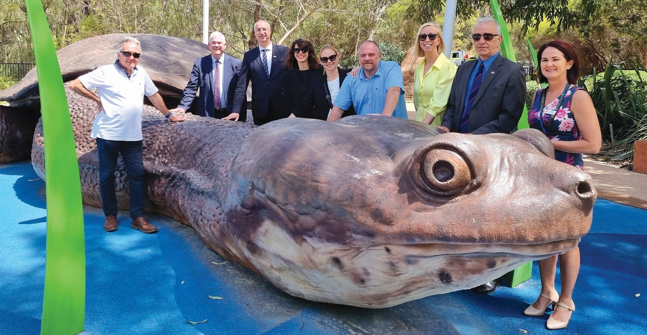Photo: Croatian Delegation visit to Cockburn at Bibra Lake Regional Playground - October 2023. (Left to Right) Cr Kevin Allen; Mayor Logan Howlett; Ivica Puljak, Mayor of Split; Antonija Eremut Erceg, Head of Department for City Development; Petricija Kuzmanić; Antonio Kuzmanić Deputy Mayor of Split; Victoria Green, Executive Corporate Affairs; Željko Domazet, President of the City Council (City of Split); and Julie Reidy, Environment, Parks and Streetscapes Manager.

How to Read an Annual Report
We’ve designed the Annual Report to be clear and accessible. The first few pages provide a high-level overview of our strategic direction, setting the tone for all future corporate strategy documents.
Following this, the Annual Report dives into the details of our organisation and then outlines our achievements, challenges and financial and Corporate Business Plan performance over the past year. These projects and activities are presented in a user-friendly table format.

Understanding the Corporate Business Plan Project/activity table
Transcriber’s Note: The following explanation refers to the tables in the “Corporate Business Plan Progress 2023-24” sections. It includes a screenshot showing an example of the Project/activity table as it appears in the original Annual Report 2023-2024. The Project/activity table has been modified for greater accessibility in this eText version of the Annual Report. Please contact City of Cockburn for more information or clarification.
- Project/activity at a glance: The first column includes a Project/activity title, a unique identifier, and the project’s overall completion status.
- Quarterly Milestones: Moving across the table, you’ll find quarterly milestones for the past financial year. These boxes are colour-coded in the Annual Report to visually represent progress throughout the year, with the legend provided at the bottom of the page.
- Notes: The final section provides a written update of the key performance indicator for the financial year, explaining the reasons behind the project’s or activity’s overall completion status.

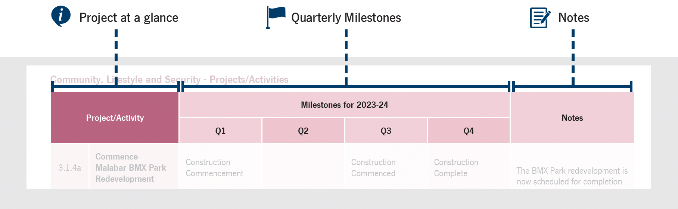
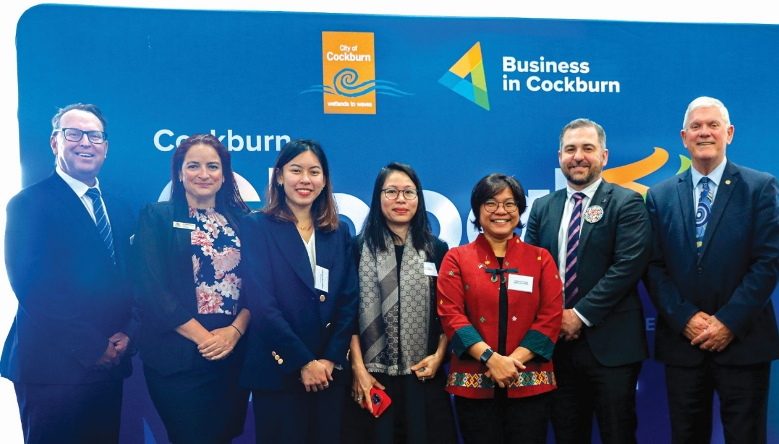
Photo: Cockburn Global conference - October 2023. (Left to Right) Daniel Simms, City of Cockburn CEO; Deputy Mayor Cr Chontelle Stone; Rochelle Yap, First Secretary (Political) Singapore High Commission in Canberra; Mrs Thanh Ha Nguyen, Consulate General of Viet Nam in Western Australia and The Northern Territory; Ibu Listiana Operananta, Consulate General of the Republic Indonesia in Perth; David Scaife, Cockburn MLA; and Mayor Logan Howlett.

Our Strategic Framework
Our Local Government operates within an Integrated Planning and Reporting Framework (IPRF). This framework, mandated by the Western Australian Government, ensures a structured and transparent approach to planning and decision-making.
The IPRF connects the long-term vision of our Strategic Community Plan with our current plans and strategies. It guides how we identify community needs, set strategic objectives, allocate resources, and ultimately measure our success in achieving those goals. Through the IPRF, we strive to deliver effective services, manage finances responsibly, and remain accountable to the community we serve.
The following diagram illustrates the City’s Integrated Planning and Reporting Framework and shows the City’s strategies and plans within the framework.
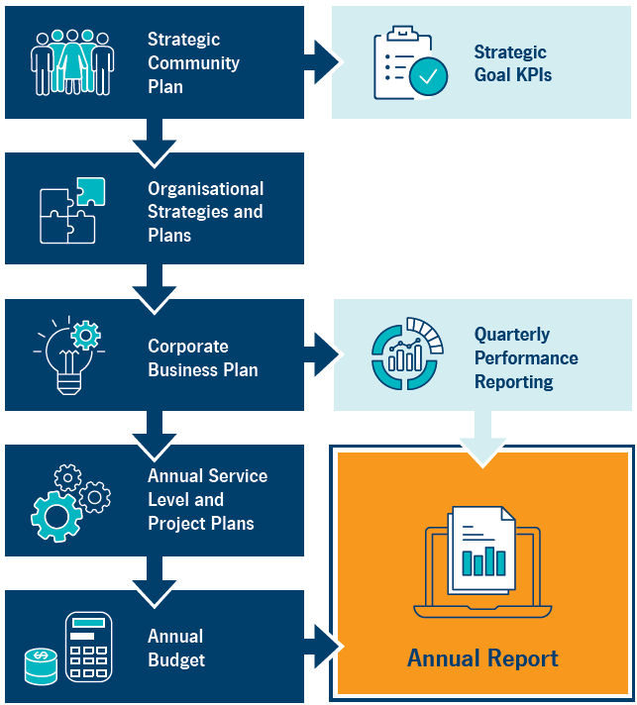
Transcriber’s Note: The diagram above is a flowchart that shows the connections between the City’s strategies and plans. At each step, arrows point forward to one or more boxes. The flowchart is presented below as a series of ordered lists. Please contact City of Cockburn for more information or clarification.
- Strategic Community Plan
  - forward to Strategic Goal KPIs
  - forward to Organisational Strategies and Plans
- Organisational Strategies and Plans
  - forward to Corporate Business Plan
- Corporate Business Plan
  - forward to Quarterly Performance Reporting
  - forward to Annual Service Level and Project Plans
- Quarterly Performance Reporting
  - forward to Annual Report
- Annual Service Level and Project Plans
  - forward to Annual Budget
- Annual Budget
  - forward to Annual Report

Our Strategy on a Page
This page presents the vision for Cockburn, highlighting our driving purpose. It also outlines our strategic objectives and outcomes as detailed in our Strategic Community Plan.
Vision: Cockburn, the best place to be
Purpose: Support our communities to thrive by providing inclusive and sustainable services which reflect their aspirations
Our Outcomes:
1. Local Economy | 2. Environmental Responsibility | 3. Community, Lifestyle and Security | 4. City Growth and Moving Around | 5. Listening and Leading
Our Strategic Outcomes: | Our Strategic Outcomes: | Our Strategic Outcomes: | Our Strategic Outcomes: | Our Strategic Outcomes:
1A. Increased investment, economic growth and local employment | 2A. Protection and enhancement of our natural areas | 3A. Accessible and inclusive community, recreation and cultural services and facilities that enrich our community | 4A. An attractive, socially connected and diverse built environment | 5A. Best practice governance, partnerships and value for money
1B. Thriving local commercial centres, local businesses and tourism industry | 2B. Sustainable resource management including waste, water and energy | 3B. A safe and healthy community that is socially connected | 4B. Cockburn Central as the capital of the South Metro Region | 5B. High-quality and effective community engagement and customer service experiences
1C. A city that is ‘easy to do business with’ | 2C. Address Climate Change | 3C. Aboriginal and Torres Strait Islander cultures and heritage are recognised and celebrated | 4C. An integrated, accessible and improved transport network | 5C. Employer of choice focusing on equity, innovation and technology

About our City

Local Economy 
Jobs located in:
- Cockburn: 51,957
- Western Australia: 1,308,799
- Australia: 13,262,616
(Source: Australian Bureau of Statistics 2024)
Cockburn accounts for 4 per cent of Western Australia’s total jobs, making it a significant contributor to the state’s economy and providing employment opportunities for both local residents and commuters.
Businesses operating in:
- Cockburn: 9,528
- Western Australia: 246,661
- Australia: 2,589,873
(Source: Australian Bureau of Statistics 2024)
Cockburn’s business ecosystem is comprised of approximately 9,528 businesses, the majority of which are small-scale enterprises. This accounts for roughly 4 per cent of the total businesses operating in Western Australia.
Home ownership rate in:
- Cockburn: 72.5%
- Western Australia: 69.2%
- Australia: 66%
(Source: City of Cockburn, 2021 Census, Australian Bureau of Statistics)
Cockburn boasts a significantly higher homeownership rate than the national average, with 72.5 per cent of households owning their homes compared to 66 per cent. This trend is further reflected in the housing stock, with a greater prevalence of freestanding homes and a lower proportion of apartments in Cockburn than across Australia.
Households renting in:
- Cockburn: 25.4%
- Western Australia: 27.3%
- Australia: 30.6%
(Source: City of Cockburn, 2021 Census, Australian Bureau of Statistics)
Weekly median household income in:
- Cockburn: $1,988
- Western Australia: $1,815
- Australia: $1,746
(Source: City of Cockburn, 2021 Census, Australian Bureau of Statistics)
Value Added, GSP, GDP:
- Value added by Cockburn to the Australian economy: $12.42 billion
- Gross State Product (GSP) in Western Australia: $426.9 billion
- Gross Domestic Product (GDP) in Australia: $2,571 billion
(Source: REMPLAN 2024)
Cockburn contributes 4.5 per cent of the total value added by the Greater Perth region and represents 2.9 per cent of Western Australia’s $427 billion GSP, demonstrating its role as a key driver of economic growth and improved living standards for Western Australians.
Cockburn development:
- Number of development applications received: 910
- Total value of development approvals: $312 million
(Source: City of Cockburn Statistics 2024)

Environmental Responsibility 
Seedlings planted in winter revegetation works: 56,000
Tree canopy cover in the City of Cockburn: 18%
The City actively participates in environmental conservation through initiatives like winter revegetation, planting 56,000 seedlings.
Cockburn also maintains a significant tree canopy cover of 18 per cent, contributing to the overall health and biodiversity of the area.
Number of parks and reserves: 396
Biodegradable dog bags dispensed annually: 2,304,000
Average annual carbon emissions generated by City operations (tonnes of carbon dioxide equivalent): 29,000 tCO2-e
Annual average solar energy generated from City facilities (megawatts): 1,150MW
The City generates an average of 29,000 tonnes of carbon dioxide equivalent annually from its operations. To offset this, Cockburn utilises solar energy, producing an average of 1,150 megawatts annually from its facilities.
City-managed coastline: 15km
Total hectares of parks and reserves: 1572.5ha
Hectares of bush reserves: 1074.6ha
With a total of 396 parks and reserves, encompassing 1,572.45 hectares, Cockburn offers ample green spaces for its residents. Of these, 1,074.61 hectares are designated as bush reserves, preserving the City’s natural environment.
(Source: City of Cockburn Statistics 2024)

Community Lifestyle and Security 
Number of sporting reserves/fields: 30
Number of sporting clubs in Cockburn: ~120
(Source: City of Cockburn Statistics 2024)
With 30 sporting reserves/fields and an estimated 120 sporting clubs, Cockburn offers a variety of opportunities for residents to participate in physical activities.
Number of playgrounds: 215
Number of arts and cultural facilities: 2
Number of libraries: 3
(Source: City of Cockburn Statistics 2024)
Median age:
- Cockburn: 37
- Western Australia: 38
- Australia: 38
(Source: REMPLAN 2024)
Couple families with children:
- Cockburn: 47%
- Western Australia: 44.6%
- Australia: 43.7%
(Source: City of Cockburn, 2021 Census, Australian Bureau of Statistics)
Cockburn is a popular choice for families. Nearly half of all residents (47 per cent) belong to couple families with children. With 215 playgrounds scattered throughout the City, there’s always a fun spot for kids to explore.
 Aboriginal and Torres Strait Islander people population:
- Cockburn: 1.9%
- Western Australia: 3.3%
- Australia: 3.2%
(Source: REMPLAN 2024)
Although Cockburn has a smaller percentage of Aboriginal and Torres Strait Islanders compared to the national average (1.9 per cent vs 3.2 per cent), the City recognises the importance of this population.
Proportion of population born in:
 Australia:
- Cockburn: 61.7%
- Western Australia: 65%
- Australia: 66%
 United Kingdom:
- Cockburn: 8%
- Western Australia: 8.9%
- Australia: 4.4%
 New Zealand:
- Cockburn: 2.7%
- Western Australia: 2.8%
- Australia: 2.1%
 Philippines:
- Cockburn: 2.4%
- Western Australia: 1.4%
- Australia: 1.2%
 India:
- Cockburn: 1.9%
- Western Australia: 2.3%
- Australia: 2.6%
 South Africa:
- Cockburn: 1.7%
- Western Australia: 1.7%
- Australia: 0.7%
 Italy:
- Cockburn: 1.4%
- Western Australia: 0.7%
- Australia: 0.6%
(Source: REMPLAN 2024)
While the majority of residents were born in Australia (61.7 per cent), Cockburn boasts a diverse population with significant representation from the United Kingdom (8 per cent), New Zealand (2.7 per cent), and a growing Asian community (including Philippines and India).
Population with a university degree:
- Cockburn: 24%
- Western Australia: 24%
- Australia: 26%
(Source: City of Cockburn, 2021 Census, Australian Bureau of Statistics)

City Growth and Moving Around 
Description | 2024 population | 2024 percentage | 2044 population | 2044 percentage
Preschool (0-4 years) | 8,560 | 6.6% | 10,225 | 5.7%
School age (5-14 years) | 16,626 | 12.7% | 19,989 | 11.2%
Youth (15-24 years) | 15,609 | 14.9% | 20,828 | 11.6%
Young workers (25-34 years) | 19,426 | 14.9% | 24,354 | 13.6%
Workers (35-49 years) | 29,471 | 22.6% | 36,747 | 20.5%
Older workers (50-64 years) | 22,852 | 17.5% | 33,309 | 18.6%
Retirement (65-79 years) | 13,769 | 10.5% | 23,563 | 13.1%
Elderly (80+ years) | 4,282 | 3.3% | 10,131 | 5.7%
Estimated population in 2024: 130,595
Projected population by 2044: 179,146
(Source: REMPLAN 2024)
Cockburn’s population is projected to experience a shift in age demographics. While the working-age population (25-64 years) is expected to grow, the proportion of older residents (65+) is also projected to increase. This indicates a growing demand for age-appropriate services and infrastructure.
Estimated dwellings in 2024: 54,638
Projected dwellings by 2044: 77,333
(Source: REMPLAN 2024)
Cockburn is experiencing significant growth, with the population projected to increase by nearly 50 per cent from 130,595 in 2024 to 179,146 in 2044. This growth is reflected in the housing market, with the number of dwellings expected to rise from 54,638 to 77,333 over the same period.
Total kilometres of City-managed roads: 894km
Total kilometres of City-managed footpaths: 893km
(Source: City of Cockburn Statistics 2024)
Cockburn’s land area of 168.1 square kilometres is home to a population density of 776 people per square kilometre, indicating a relatively high concentration of residents. The City maintains a vast network of roads (894 kilometres) and footpaths (893 kilometres), ensuring connectivity and accessibility.
Percentage of people who drove to work:
- Cockburn: 65.1%
- Western Australia: 62.1%
- Australia: 52.7%
(Source: City of Cockburn, 2021 Census, Australian Bureau of Statistics)
Percentage of households with two motor vehicles or more:
- Cockburn: 63.5%
- Western Australia: 61.5%
- Australia: 56.6%
(Source: City of Cockburn, 2021 Census, Australian Bureau of Statistics)
Cars are the primary mode of transportation for Cockburn residents, with 65.1 per cent driving to work, compared to 62.1 per cent in Western Australia and 52.7 per cent nationally. A significant portion of households (63.5 per cent) own two or more motor vehicles, reflecting a reliance on private transportation. Public transport usage currently stands at 7.9 per cent, with most Cockburn residents commuting by train.
Percentage of people who travelled to work by public transport:
- Cockburn: 7.9%
- Western Australia: 7.4%
- Australia: 4.6%
(Source: City of Cockburn, 2021 Census, Australian Bureau of Statistics)
Land area: 168.1km²
(Source: City of Cockburn Statistics 2024)
Population density: 776 people per square kilometre
(Source: REMPLAN 2024)

Listening and Leading 
Number of people reached through our social media posts: 3.5 million
City of Cockburn website views: 2.1 million
(Source: City of Cockburn Statistics 2024)
Cockburn has a strong online presence, with the official City of Cockburn website attracting 2.1 million views. The City’s social media posts reach an impressive 3.5 million people, while the Comment on Cockburn website receives 72,876 visits.
Visits to the Comment on Cockburn website: 72,876
Annual engagement responses received: 2,200
(Source: City of Cockburn Statistics 2024)
Customer requests raised: 67,371
Calls received by the Contact Centre: 82,872
Average wait time for the Contact Centre: 85 seconds
Calls resolved at first contact by the Contact Centre: 65.3%
(Source: City of Cockburn Statistics 2024)
Cockburn’s commitment to its residents is evident in its service delivery. The Contact Centre handles 82,872 calls annually, with an average wait time of 85 seconds and a 65.3 per cent first-contact resolution rate by the Contact Centre. This demonstrates efficient and responsive service.
Actual capital spend (financial year 2024): $56 million
(Source: City of Cockburn Statistics 2024)
Voter turnout for the 2023 Ordinary Election: 26,848 (27.6%)
(Source: Western Australian Electoral Commission)
The 2023 Ordinary Election saw a voter turnout of 26,848 (27.6 per cent), indicating a moderate level of community participation in the democratic process.
Average residential rates in financial year 2024:
- City of Armadale: $2,237
- City of Melville: $1,989
- City of Kwinana: $1,967
- City of Rockingham: $1,923
- City of Cockburn: $1,729
- City of Canning: $1,676
(Source: City of Cockburn Statistics 2024)
Cockburn offers competitive residential rates compared to neighbouring cities. The average residential rate in the financial year 2024 was $1,729, lower than cities like Melville, Kwinana, Armadale and Rockingham.

Our Council and Elected Members

Mayor
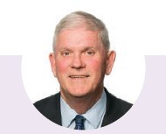 Logan K. Howlett, JP, His Worship the Mayor
Logan has been the Mayor of Cockburn since 2009, serving five terms. He and his wife Pat, have been active community members for decades, deeply committed to Cockburn’s history, diversity and future.
Logan’s role involves extensive community engagement and a focus on achieving positive outcomes for the growing community. He prioritises trust, respect, honesty, integrity, inclusiveness, and personal engagement in his work.
Logan is passionate about Cockburn’s development and is committed to maintaining its strong reputation for service delivery and community wellbeing. He believes that strong community connections are essential for building resilience, sustainability and peace of mind.
Mayor since: September 2009 | Term ends: October 2025
Phone: 0407 337 650 | Email: EMoffice@cockburn.wa.gov.au
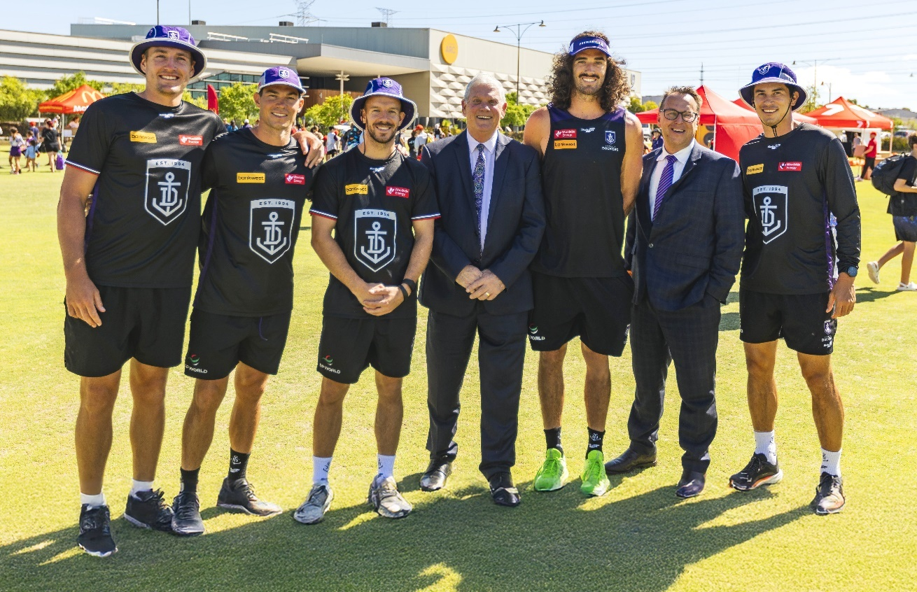
Photo: Footy Splash event - January 2024. (Left to Right) Fremantle Dockers players - Brennan Cox, Jaeger O’Meara and Sam Switkowski; Mayor Logan Howlett, City of Cockburn; Alex Pearce, Fremantle Dockers player; Daniel Simms, City of Cockburn CEO; and Bailey Banfield, Fremantle Dockers player.

Cockburn Wards and Elected Members
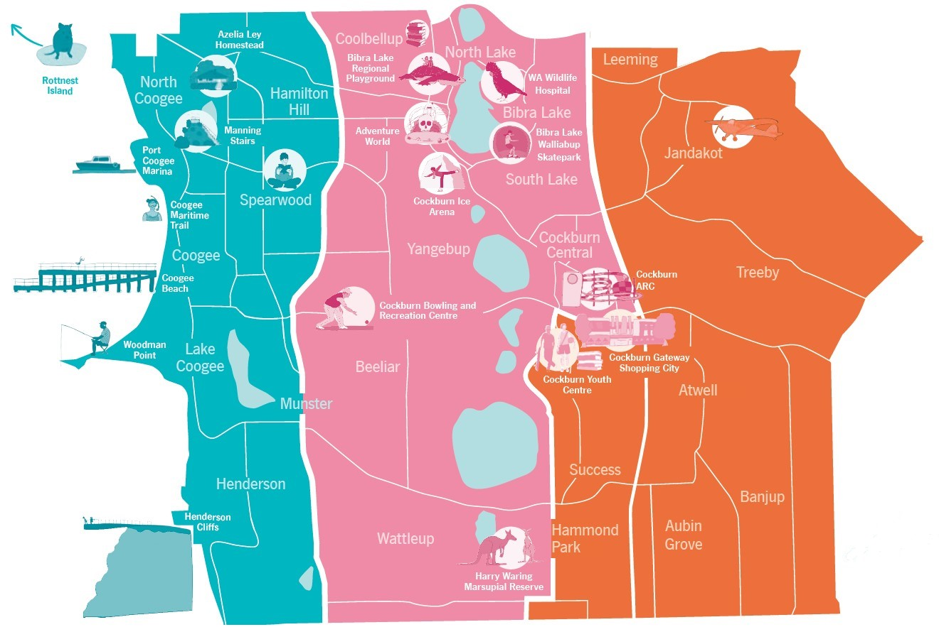
Transcriber’s Note: The map above is of the City of Cockburn, divided into three colour-coded wards. Please contact City of Cockburn for more information or clarification.
West Ward is highlighted in blue on the map. It includes the suburbs of North Coogee, Coogee, Lake Coogee, Henderson, Munster, Spearwood, and Hamilton Hill, as well as Rottnest Island off the coast of Western Australia. Landmarks in West Ward include Azelia Ley Homestead, Manning Stairs, Port Coogee Marina, Coogee Maritime Trail, Coogee Beach, Woodman Point, and Henderson Cliffs.
Elected members representing West Ward: Cr Kevin Allen; Cr Michael Separovich; and Cr Phoebe Corke.
Central Ward is highlighted in pink on the map. It includes the suburbs of Coolbellup, North Lake, Bibra Lake, South Lake, Yangebup, Hamilton Hill, Spearwood, Beeliar, Munster, Wattleup, and Cockburn Central. Landmarks in Central Ward include Bibra Lake Regional Playground, Adventure World, WA Wildlife Hospital, Bibra Lake Walliabup Skatepark, Cockburn Ice Arena, Cockburn Bowling and Recreation Centre, Cockburn ARC, Cockburn Youth Centre, Cockburn Gateway Shopping City, and Harry Waring Marsupial Reserve.
Elected members representing Central Ward: Deputy Mayor, Cr Chontelle Stone; Cr Philip Eva, JP; and Cr Tom Widenbar.
East Ward is highlighted in orange on the map. It includes the suburbs of Jandakot, Leeming, Treeby, Atwell, Success, Hammond Park, Aubin Grove, and Banjup. Landmarks in East Ward include Jandakot Airport.
Elected members representing East Ward: Cr Carol Reeve-Fowkes; Cr Tarun Dewan; and Cr Carol Zhang.
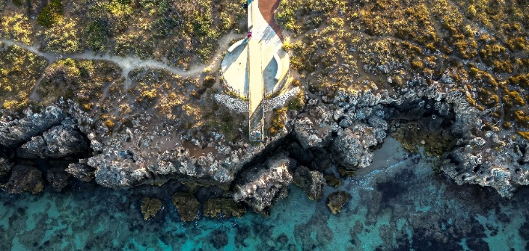 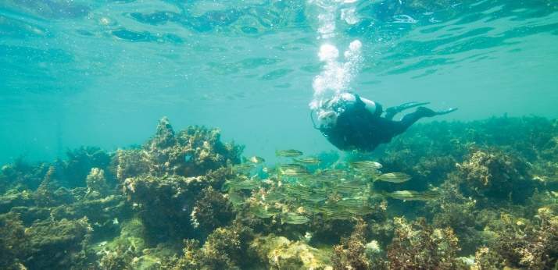 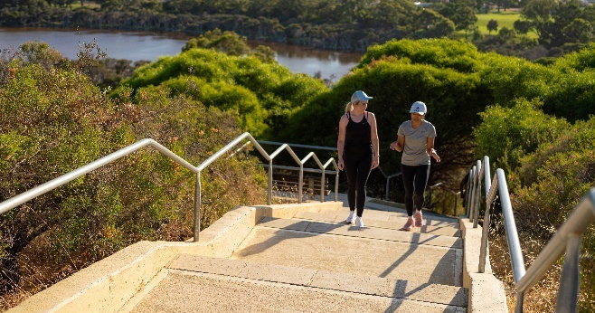
Photos: 1. Henderson Cliffs. 2. Coogee Maritime Trail. 3. Manning Stairs.

Central Ward
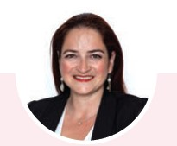 Chontelle Stone, Deputy Mayor and Councillor, Central Ward
Chontelle is a dedicated community leader with a background in business and a passion for environmental sustainability, social justice and equality. She has been serving on Cockburn City Council since 2017 and has a proven track record of improving services and infrastructure in her community.
As a councillor, Chontelle has been actively involved in various committees and reference groups, focusing on governance, organisational performance, and expenditure review. She has also chaired the Cockburn Bushfire Advisory Reference Group and is involved in several other community organisations.
Chontelle’s commitment to her community is evident in her dedication to improving public safety, supporting local businesses, and advocating for equity and justice. With her experience, vision, and passion, she is committed to continuing to make a positive impact in Cockburn.
Term ends: October 2025 | Phone: 0411 612 382 | Email: cstone@cockburn.wa.gov.au
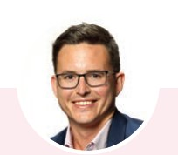 Tom Widenbar, Councillor, Central Ward
Tom has a passion for environmental management and public service. Tom was first elected in 2019, and Deputy Mayor in 2021 for a two-year period. Tom brings experience from his corporate role as an environmental professional along with his his board experience as Deputy Chair of Perth in Natural Resource Management (NRM). Tom is deeply involved in a number of community initiatives aimed at improving the local environment while fostering a sense of place. He is committed to advocating for better infrastructure, promoting youth development programs, and supporting local businesses. Tom is a resident of Beeliar and is actively involved in various community groups and sporting activities. He is dedicated to making Cockburn the best place to be and is committed to serving the community with passion and dedication.
Term ends: October 2025 | Phone: 0437 002 021 | Email: twidenbar@cockburn.wa.gov.au
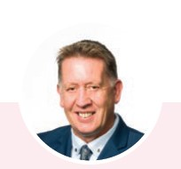 Philip Eva, JP, Councillor, Central Ward
Philip has been serving the City of Cockburn since 2014 and is an enthusiatic community leader. He has a strong background in public service and community involvement, having previously worked in the building industry and served as a senior advisor in the Department of the Premier and Cabinet.
As a Justice of the Peace, Philip has contributed significantly to the community by providing legal services and volunteering with the South Coogee Volunteer Bush Fire Brigade. He is also actively involved in various local organisations, including the Cockburn Wetlands Centre, Cockburn RSL, and Spearwood Dalmatinac Sport and Community Club.
Throughout his time on the Council, Philip has been dedicated to advocating for the residents of Cockburn. He has been actively involved in all Council committees and continues to serve the community through his committee work and community engagements.
Term ends: October 2027 | Phone: 0410 274 000 | Email: peva@cockburn.wa.gov.au

East Ward
 Carol Reeve-Fowkes, Councillor, East Ward
Carol has been a committed Councillor for Cockburn since 2007, she served as Deputy Mayor for two terms. A Cockburn local for the last 32 years, educated in London, UK, she brings a grounded and balanced approach to Council meetings and decision making.
Currently serving on the Governance Committee, Audit and Risk Committee and Expenditure Review Committee, with particular interest in Local Emergency Management and Bush Fire Prevention, Carol brings tangible local knowledge to her position, based on experience including roles with WA Police and South Metropolitan Health Department.
Carol is a strong advocate for our community, this is evident in her involvement with multiple residents’ associations and environmental groups. Carol remains focused on ensuring a better, safer and sustainable future for Cockburn families, while maintaining a responsible budget.
Term ends: October 2027 | Phone: 0435 900 236 |
Email: creevefowkes@cockburn.wa.gov.au
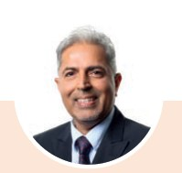 Tarun Dewan, Councillor, East Ward
Tarun is a dedicated full-time East Ward Councillor who works full time to serve the needs of Cockburn residents and businesses. With his engineering background, he uses his analytical skills to help the Council make smart decisions and ensure the City provides the best policies and services for everyone.
He puts the interests of residents first, working closely with various community groups to listen to their concerns and find solutions. Tarun has been elected as a Presiding Member for several key committees, including the Joint Development Assessment Panel and the Expenditure Review Committee.
Known for his thorough preparation, Tarun actively shares his views and concerns during meetings to support better decision-making for the community.
Term ends: October 2025 | Phone: 0433 875 350 | Email: tdewan@cockburn.wa.gov.au
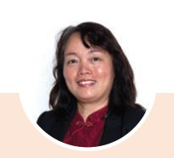 Carol Zhang, Councillor, East Ward
Carol has a strong background in nursing and healthcare and is devoted to supporting our community. She has been actively involved in various community initiatives, including volunteering and organising local events.
Her experience as a healthcare professional brings a unique perspective to her role as a Councillor, allowing her to approach issues with analytical thinking and evidence-based decision-making.
Carol is committed to working collaboratively with the Mayor, fellow councillors, and community members to address local concerns such as traffic congestion, antisocial behaviour, and improving community infrastructure.
Term ends: October 2027 | Phone: 0411 738 554 | Email: czhang@cockburn.wa.gov.au

West Ward
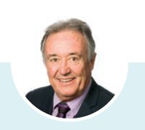 Kevin Allen, Councillor, West Ward
Kevin is a longstanding resident of Cockburn and has been actively involved in community issues for over 40 years. He has served as a West Ward Councillor since 2000 and was also employed in the private sector as a State Manager in the financial industry.
Prior to his election to Council, Kevin was actively involved in community initiatives, serving as President of the Coogee Beach Progress Association and representing the community on the State Government’s Coogee Master Plan committee. He is passionate about all things sports, especially encouraging and developing junior sports, and encouraging business and employment opportunities into Cockburn.
Term ends: October 2025 | Phone: 0419 901 735 | Email: kallen@cockburn.wa.gov.au
 Michael Separovich, Councillor, West Ward
Michael is a lifelong resident of Cockburn and has been serving on Council since 2017. He has a strong connection to the West Ward community through his family’s involvement in local businesses and education.
As a councillor, Michael has been actively involved in various committees, including those focused on policies, audit, strategic finance, CEO performance and is the presiding member of the Governance Committee. He also represents the City on external committees related to environmental issues and development.
Michael is committed to ensuring that the City operates efficiently and effectively, with a focus on responsible use of ratepayer funds, high-quality services, and fair and reasonable policies and procedures.
Term ends: October 2025 | Phone: 0432 653 369 | Email: mseparovich@cockburn.wa.gov.au
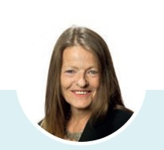 Phoebe Corke, Councillor, West Ward
Phoebe has strong commitment to sustainability, cultural heritage, and community wellbeing. She has been serving on Council for several years and is actively involved in numerous community groups and committees.
As a councillor, Phoebe prioritises protecting the natural environment, preserving canopy and biodiversity, acknowledging and respecting culture and heritage and looking after residents’ interests by improving safety, services and facilities while maintaining low rates. She is known for her responsiveness to community concerns, her strong work ethic and her commitment to ethical and transparent governance.
With a background in journalism, arts, and law, Phoebe – currently working as a tutor at Notre Dame University – brings a wealth of knowledge and experience to her role as a councillor.
Term ends: October 2027 | Phone: 0407 606 696 | Email: pcorke@cockburn.wa.gov.au

Elected Members' demographics

Gender
4 Female 
6 Male 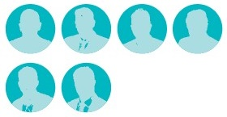

Age
- 25-34 years: 2
- 35-44 years: 2
- 45-54 years: 0
- 55-64 years: 4
- Over 64 years: 2

Linguistic background
8 English 
1 Mandarin 
1 Hindi 
1 identifies as Aboriginal and Torres Strait Islander 

Country of birth
5 Australia
1 China 
1 India
3 England

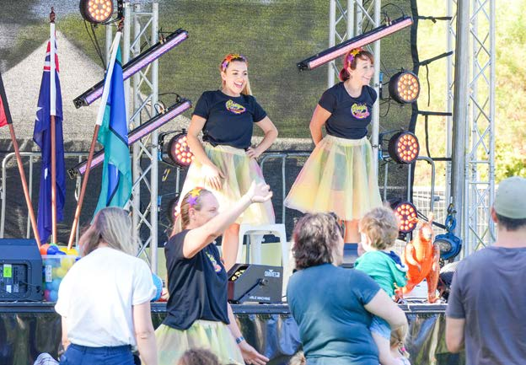 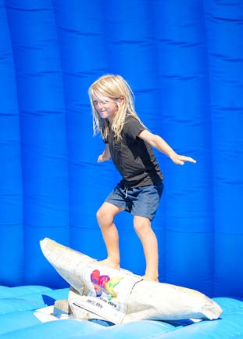 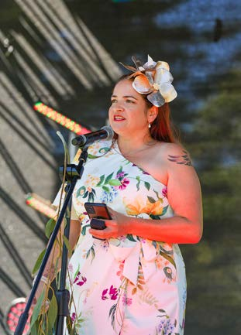 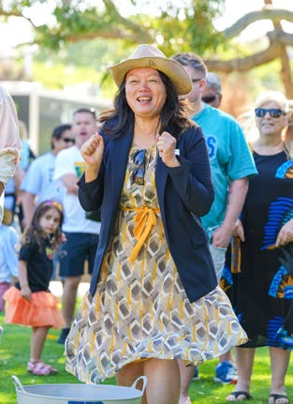 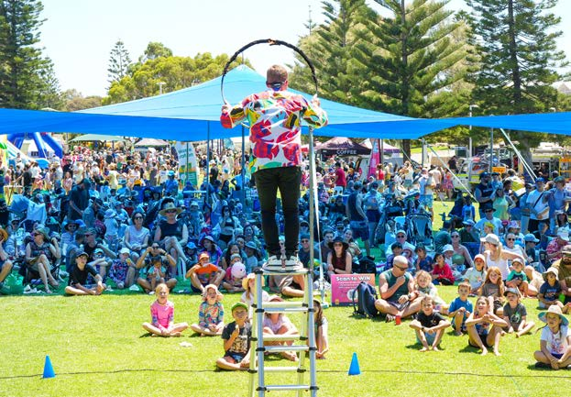 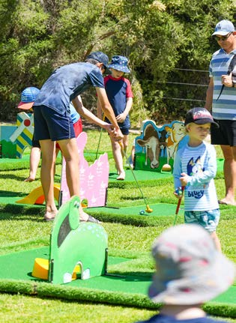
Photos: Coogee Beach Festival - January 2024. Photo 3: Deputy Mayor Cr Chontelle Stone. Photo 4: Cr Carol Zhang.
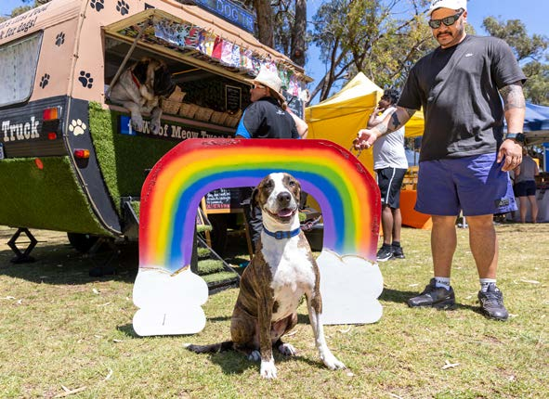 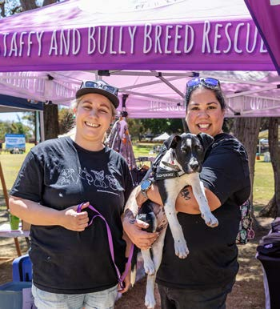 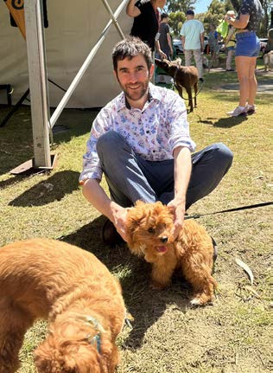
Photos: Fur Run - October 2023. Photo 3: Cr Michael Separovich.

Elected Member attendance
This section outlines the attendance rates of all Councillors at Council meetings and Committee meetings. This information is essential for ensuring that our elected representatives are fulfilling their roles effectively and representing the interests of our community.

Council (total of 11 held)
Elected Members | Attended | Electronic attendance | Apology | Leave of absence
Mayor Logan Howlett | 10 | N/A | 1 | N/A
Deputy Mayor Chontelle Stone | 9 | N/A | N/A | 2
Cr Kevin Allen | 9 | N/A | 2 | N/A
Cr Michael Separovich | 11 | N/A | N/A | N/A
Cr Phoebe Corke | 11 | N/A | N/A | N/A
Cr Carol Reeve-Fowkes | 9 | 1 | 1 | N/A
Cr Carol Zhang  (Term commenced October 2023) | 6 | N/A | N/A | 1
Cr Tarun Dewan | 10 | N/A | 1 | N/A
Cr Tom Widenbar | 11 | N/A | N/A | N/A
Cr Phil Eva | 11 | N/A | N/A | N/A

Special Council Meetings (total of four held)
Elected Members | Attended | Electronic attendance | Apology | Leave of absence
Mayor Logan Howlett | 4 | N/A | N/A | N/A
Deputy Mayor Chontelle Stone | 4 | N/A | N/A | N/A
Cr Kevin Allen | 2 | 1 | 1 | N/A
Cr Michael Separovich | 4 | N/A | N/A | N/A
Cr Phoebe Corke | 4 | N/A | N/A | N/A
Cr Carol Reeve-Fowkes | 4 | N/A | N/A | N/A
Cr Carol Zhang  (Term commenced October 2023) | 2 | N/A | N/A | 2
Cr Tarun Dewan | 4 | N/A | N/A | N/A
Cr Tom Widenbar | 4 | N/A | N/A | N/A
Cr Phil Eva | 4 | N/A | N/A | N/A

Committee meetings
There are four Committees that meet five times a year.
- Audit Risk and Compliance Committee (ARC)
- Expenditure Review Committee (ERC)
- Governance Committee (GovCo)
- Organisational Performance Committee (OPCo)
The membership and attendance of Committee meetings are as follows:

Mayor Logan Howlett
Committee | Member | Attended | Electronic attendance | Apology | Leave of absence
ARC | Yes | 2 | N/A | 1 | N/A
ERC | Yes | 2 | N/A | 1 | N/A
GovCo | Yes | 4 | N/A | N/A | 1
OPCo | Yes | 5 | N/A | N/A | N/A

Deputy Mayor Chontelle Stone
Committee | Member | Attended | Electronic attendance | Apology | Leave of absence
ARC | Yes | 2 | N/A | 1 | N/A
ERC | Yes | 4 | N/A | 1 | N/A
GovCo | Yes | 3 | N/A | 1 | 1
OPCo | Yes | 3 | N/A | 1 | 1

Cr Kevin Allen
Committee | Member | Attended | Electronic attendance | Apology | Leave of absence
ARC | Yes | 3 | N/A | 1 | 1
ERC | Non-member | N/A | N/A | N/A | N/A
GovCo | Non-member | N/A | N/A | N/A | N/A
OPCo | Non-member | N/A | N/A | N/A | N/A

Cr Michael Separovich
Committee | Member | Attended | Electronic attendance | Apology | Leave of absence
ARC | Yes | 5 | N/A | N/A | N/A
ERC | Yes | 5 | N/A | N/A | N/A
GovCo | Yes | 4 | N/A | N/A | 1
OPCo | Yes | 4 | N/A | N/A | 1

Cr Phoebe Corke
Committee | Member | Attended | Electronic attendance | Apology | Leave of absence
ARC | Yes | 4 | 1 | N/A | N/A
ERC | Yes | 5 | N/A | N/A | N/A
GovCo | Yes | 5 | N/A | N/A | N/A
OPCo | Yes | 5 | N/A | N/A | N/A

Cr Carol Reeve-Fowkes
Committee | Member | Attended | Electronic attendance | Apology | Leave of absence
ARC | Yes | 3 | N/A | N/A | N/A
ERC | Yes | 5 | N/A | N/A | N/A
GovCo | Yes | 5 | N/A | N/A | N/A
OPCo | Yes | 5 | N/A | N/A | N/A

Cr Carol Zhang
Committee | Member | Attended | Electronic attendance | Apology | Leave of absence
ARC | Non-member | N/A | N/A | N/A | N/A
ERC | Non-member | N/A | N/A | N/A | N/A
GovCo | Yes | 4 | N/A | N/A | N/A
OPCo | Non-member | N/A | N/A | N/A | N/A

Cr Tarun Dewan
Committee | Member | Attended | Electronic attendance | Apology | Leave of absence
ARC | Yes | 1 | N/A | 1 | N/A
ERC | Yes | 4 | N/A | 1 | N/A
GovCo | Non-member | N/A | N/A | N/A | N/A
OPCo | Yes | 5 | N/A | N/A | N/A

Cr Tom Widenbar
Committee | Member | Attended | Electronic attendance | Apology | Leave of absence
ARC | Yes (Not a member effective October 2023) | 1 | N/A | 1 | N/A
ERC | Yes (Not a member effective October 2023) | 1 | N/A | N/A | N/A
GovCo | Yes | 5 | N/A | N/A | N/A
OPCo | Yes | 4 | N/A | N/A | N/A

Cr Phil Eva
Committee | Member | Attended | Electronic attendance | Apology | Leave of absence
ARC | Non-member | N/A | N/A | N/A | N/A
ERC | Non-member | N/A | N/A | N/A | N/A
GovCo | Non-member (Not a member effective October 2023) | N/A | 1 | N/A | N/A
OPCo | Non-member | N/A | N/A | N/A | N/A

Warwick Gately (Independent Member)
Committee | Member | Attended | Electronic attendance | Apology | Leave of absence
ARC | Yes | 3 | N/A | N/A | N/A

Andrew Kandie (Independent Member)
Committee | Member | Attended | Electronic attendance | Apology | Leave of absence
ARC | Yes | 3 | N/A | N/A | N/A

Elected Members, fees, expenses and allowances
In accordance with r29C(2)(f) of the Local Government (Administration) Regulations 1996, the City is required to publish the fees, expenses and allowances paid to Elected Members during the financial year. Below is a list of fees, expenses and allowances that have been paid to the Mayor and Councillors for the 2023-24 financial year.
Elected Members | Mayoral/Deputy Mayoral allowance  ($ AUD) | Annual Meeting Attendance fee  ($ AUD) | Mileage expenses  ($ AUD) | Childcare expenses  ($ AUD) | ICT allowance  ($ AUD) | Other Approved expenses  ($ AUD) | Total  ($ AUD)
Mayor Logan Howlett | 93,380.04 | 49,435.00 | N/A | N/A | 3,500.00 | N/A | 146,315.04
Deputy Mayor Chontelle Stone | 15,627.30 (see Note below) | 32,960.00 | 264.38 | N/A | 3,500.00 | N/A | 52,351.68
Cr Kevin Allen | N/A | 32,960.00 | 174.41 | N/A | 3,500.00 | N/A | 36,634.41
Cr Michael Separovich | N/A | 32,960.00 | 76.83 | N/A | 3,500.00 | N/A | 36,536.83
Cr Phoebe Corke | N/A | 32,960.00 | 2,007.89 | N/A | 3,500.00 | 252.32 | 38,720.21
Cr Carol Reeve-Fowkes | N/A | 32,960.00 | 288.77 | N/A | 3,500.00 | 112.83 | 36,861.60
Cr Carol Zhang | N/A | 22,786.00 | 184.86 | N/A | 1,445.00 | N/A | 24,415.86
Cr Tarun Dewan | N/A | 32,960.00 | 986.67 | N/A | 3,500.00 | 1,401.43 | 38,848.10
Cr Tom Widenbar | 7,717.72 (see Note below) | 32,960.00 | 1,212.94 | 3,988.50 | 3,500.00 | N/A | 49,379.16
Cr Phil Eva | N/A | 32,960.00 | 183.26 | N/A | 3,500.00 | 59.59 | 36,702.85
Note: During the 2023-24 financial year, Cr Tom Widenbar served as Deputy Mayor from July 2023 to October 2023, followed by Cr Chontelle Stone from October 2023 to June 2024.

Our Organisation
The City of Cockburn’s organisational structure is designed to deliver on our vision of creating a vibrant, sustainable, and inclusive city – the best place to live, work, and play.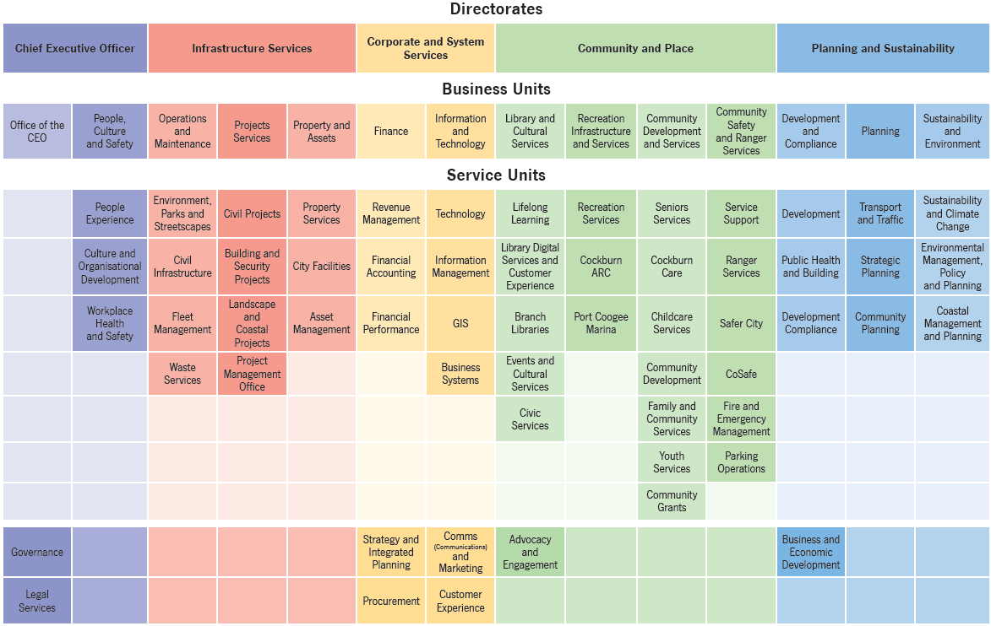
Transcriber’s Note: The hierarchical chart above, which shows an overview of the City of Cockburn’s organisational structure, is described below as a series of bulleted lists. Please contact City of Cockburn for more information or clarification.
Organisational Structure:
At the top of the of the hierarchy are 5 Directorates.
- Chief Executive Officer (purple on chart)
- Infrastructure Services (pink on chart)
- Corporate and System Services (yellow on chart)
- Community and Place (green on chart)
- Planning and Sustainability (blue on chart)
Each of these Directorates has Business Units and Service Units that fall under them.
Chief Executive Officer (Directorate):
- Office of the CEO (Business Unit)
  - Governance
  - Legal Services
- People, Culture and Safety (Business Unit)
  - People Experience (Service Unit)
  - Culture and Organisational Development (Service Unit)
  - Workplace Health and Safety (Service Unit)
Infrastructure Services (Directorate):
- Operations and Maintenance (Business Unit)
  - Environment, Parks and Streetscapes (Service Unit)
  - Civil Infrastructure (Service Unit)
  - Fleet Management (Service Unit)
  - Waste Services (Service Unit)
- Projects Services (Business Unit)
  - Civil Projects (Service Unit)
  - Building and Security Projects (Service Unit)
  - Landscape and Coastal Projects (Service Unit)
  - Project Management Office (Service Unit)
- Property and Assets (Business Unit)
  - Property Services (Service Unit)
  - City Facilities (Service Unit)
  - Asset Management (Service Unit)
Corporate and System Services (Directorate):
- Finance (Business Unit)
  - Revenue Management (Service Unit)
  - Financial Accounting (Service Unit)
  - Financial Performance (Service Unit)
  - Strategy and Integrated Planning
  - Procurement
- Information and Technology (Business Unit)
  - Technology (Service Unit)
  - Information Management (Service Unit)
  - GIS (Service Unit)
  - Business Systems (Service Unit)
  - Communications and Marketing
  - Customer Experience
Community and Place (Directorate):
- Library and Cultural Services (Business Unit)
  - Lifelong Learning (Service Unit)
  - Library Digital Services and Customer Experience (Service Unit)
  - Branch Libraries (Service Unit)
  - Events and Cultural Services (Service Unit)
  - Civic Services (Service Unit)
  - Advocacy and Engagement
- Recreation Infrastructure and Services (Business Unit)
  - Recreation Services (Service Unit)
  - Cockburn ARC (Service Unit)
  - Port Coogee Marina (Service Unit)
- Community Development and Services (Business Unit)
  - Seniors Services (Service Unit)
  - Cockburn Care (Service Unit))
  - Childcare Services (Service Unit)
  - Community Development (Service Unit))
  - Family and Community Services (Service Unit)
  - Youth Services (Service Unit)
  - Community Grants (Service Unit))
- Community Safety and Ranger Services (Business Unit)
  - Service Support (Service Unit)
  - Ranger Services (Service Unit)
  - Safer City (Service Unit)
  - CoSafe (Service Unit)
  - Fire and Emergency Management (Service Unit)
  - Parking Operations (Service Unit)
Planning and Sustainability (Directorate):
- Development and Compliance (Business Unit)
  - Development (Service Unit)
  - Public Health and Building (Service Unit)
  - Development Compliance (Service Unit)
  - Business and Economic Development
- Planning (Business Unit)
  - Transport and Traffic (Service Unit)
  - Strategic Planning (Service Unit)
  - Community Planning (Service Unit)
- Sustainability and Environment (Business Unit)
  - Sustainability and Climate Change (Service Unit)
  - Environmental Management, Policy and Planning (Service Unit)
  - Coastal Management and Planning (Service Unit)

Directorates and Office of the CEO

Chief Executive Officer
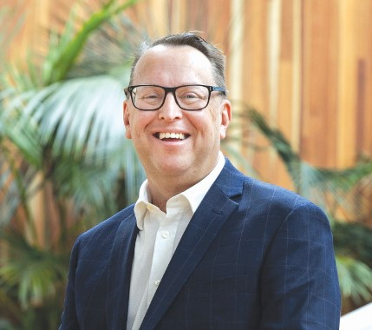 Daniel Simms, Chief Executive Officer

Directorate Purpose
To provide strategic leadership and support to the City of Cockburn, ensuring effective governance, a positive workplace culture, and the delivery of high-quality services to the community.
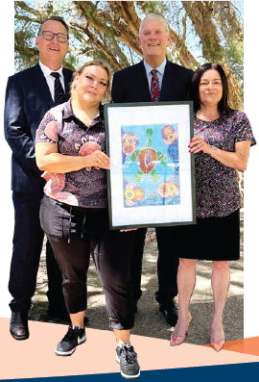
Photo: Fourth Reconciliation Action Plan (RAP) endorsed - January 2024. (Left to Right) Daniel Simms, CEO; Kathleen Turtur, First Nations Community Development Officer; Mayor Logan Howlett; and Fiona Gardener, Community Development Manager. Artwork created by Kathleen Turtur.

Director Summary
Daniel is a proud Western Australian born and bred in Perth. He is passionate about working in local government and believes that partnerships with community, stakeholders and other levels of government are what achieves results.
He has vast experience in local government, having worked in both rural and regional Western Australia, and was CEO at the City of Wanneroo for over a decade before taking up the position of CEO at the City of Cockburn. Daniel enjoys the challenges of working to enable growth council areas to reach their potential and has a keen interest in planning. He is Chairman of the Growth Areas Perth and Peel and is an executive member of the National Growth Areas Alliance.
Local government is the closest level of government to the community and Daniel is a strong advocate for the role local government plays to support the community and local businesses to thrive.
Daniel has strong experience and a keen interest in business investment and the local economy, which he says makes this a very exciting time to be in Cockburn. Cockburn provides around 30 per cent of the employment for the south-west area of Perth and is poised to become a major national and global centre, especially for the shipbuilding and maritime defence industries. Cockburn has a long history and an exciting future.

Chief Executive Officer
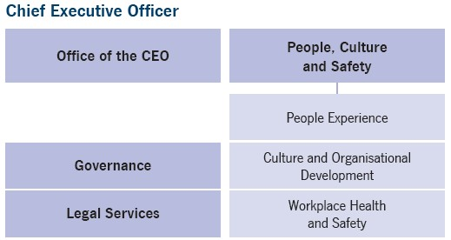
- Office of the CEO
  - Governance
  - Legal Services
- People, Culture and Safety
  - People Experience
  - Culture and Organisational Development
  - Workplace Health and Safety

Team overview

People, Safety, and Culture
The People, Safety, and Culture service units work together to create a positive and supportive workplace. People Experience Services ensures employees are well-supported, while Culture and Organisational Development fosters a positive and inclusive culture. Workplace Health and Safety promotes a safe and healthy work environment, contributing to a strong employer brand and a high-performing workforce.

Governance and Legal
Our Governance and Legal Services teams work collaboratively to ensure the City operates effectively, ethically, and in compliance with all relevant laws and regulations. Governance supports risk management, business continuity, and overall governance practices, while Legal Services provides expert legal advice and representation. Together, these teams help to minimise legal risks, ensure compliance, and facilitate informed decision-making, ultimately supporting the City’s long-term success.

Executive Leadership and Executive Support
The Executive Leadership Team provides strategic direction and management for the City, ensuring that the City’s Vision of ‘Cockburn, the best place to be’ is realised. The Executive Support team provides essential administrative support to the Mayor, Chief Executive Officer, and other key directors, enabling them to focus on strategic issues and decision-making. Together, these teams play a crucial role in the effective and efficient operation of the City’s administration.

Directorate year in review
The City has successfully implemented a Safety Leadership Program, significantly improving employee engagement in safety and completing an Organisational Review. We have developed a Leadership Capability Framework, revised performance competencies, and reviewed employee development programs. While the changing industrial landscape presents challenges, initiatives like the Hearts and Minds Program and Employee Awards Eco System will foster a positive work environment. Continued investment in leadership development will strengthen our organisation’s capabilities. For a comprehensive overview of the City’s accomplishments and progress, please refer to the “Delivering Our Outcomes” section.
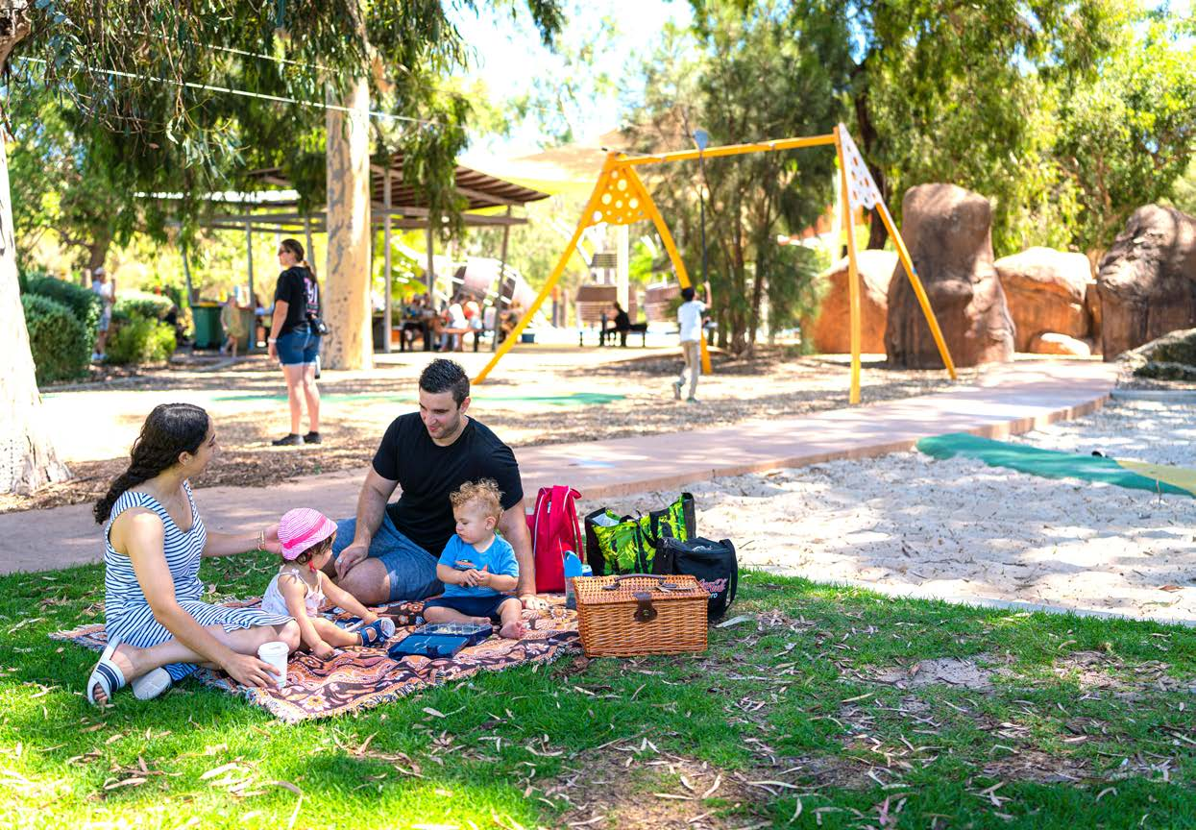
Photo: Bibra Lake Regional Playground, Bibra Lake.

Infrastructure Services
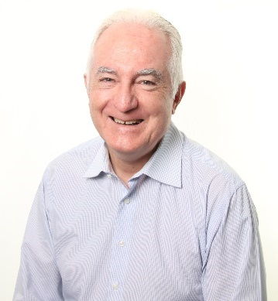 Michael Foley OAM, Acting Director Infrastructure Services

Directorate purpose
To deliver essential infrastructure services that contribute to a thriving community by effectively managing our assets, delivering necessary projects, and ensuring the sustainability of our infrastructure.
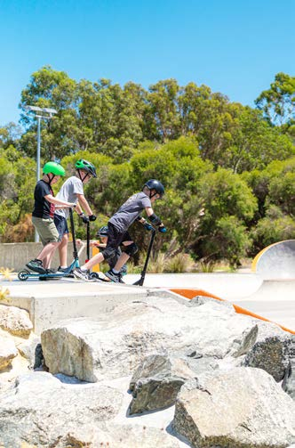 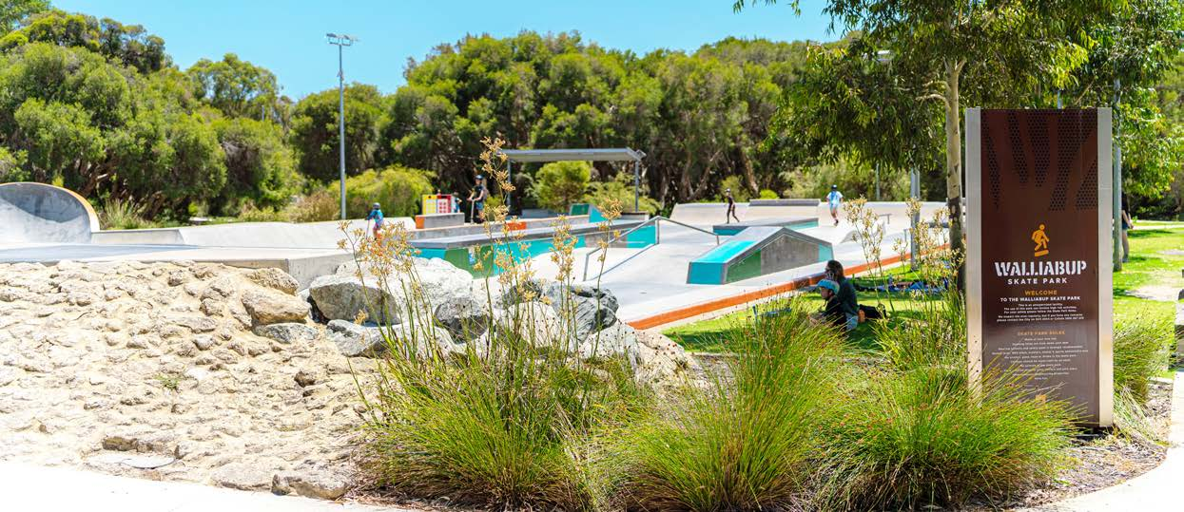
Photos: Walliabup Skate Park, Bibra Lake.

Director Summary
Michael Foley is a highly experienced infrastructure professional with over 50 years of experience in local government. He joined the City of Cockburn in 2024 after a long and distinguished career at the City of Swan, where he was the Chief Executive Officer from 2006 to 2021.
He has a strong technical background, with qualifications in civil engineering and business administration. He is also a member of several professional organisations, including the Institute of Public Works Engineering Australia (IPWEA) and the Australian Institute of Company Directors.
As Acting Director of Infrastructure Services, Michael is responsible for overseeing the City of Cockburn’s roads, parks, drainage, and other infrastructure assets. He is committed to providing high-quality infrastructure services to the community.

Infrastructure Services
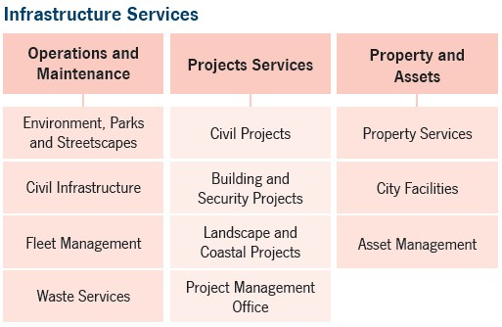
- Operations and Maintenance
  - Environment, Parks and Streetscapes
  - Civil Infrastructure
  - Fleet Management
  - Waste Services
- Projects Services
  - Civil Projects
  - Building and Security Projects
  - Landscape and Coastal Projects
  - Project Management Office
- Property and Assets
  - Property Services
  - City Facilities
  - Asset Management

Team overview

Project Services
The Project Services Business Unit is responsible for delivering a range of capital projects across various domains, including civil works, buildings, security, landscape, and coastal areas. By providing project management expertise and support, the unit ensures that projects are delivered efficiently and effectively, providing high- quality outcomes that align with the City’s strategic objectives. Capital projects contribute to the development and improvement of essential infrastructure, enhancing the quality of life for residents and visitors.

Property and Assets
The Property and Assets Business Unit plays a crucial role in managing the City’s land, buildings, and infrastructure. By working closely with other departments, the unit ensures that property acquisitions and management align with the City’s strategic goals. Additionally, the unit focuses on maximising the value and accessibility of City facilities, while also implementing effective asset management strategies to ensure the long-term sustainability of the City’s infrastructure. These efforts contribute to the overall wellbeing of the community and support the City’s growth and development.

Operations and Maintenance
The Operations and Maintenance Business Unit delivers essential services to the community, including maintaining parks, streetscapes, and natural areas, providing safe transport infrastructure, managing fleet assets, and handling waste disposal. These services contribute to the overall quality of life for residents by enhancing community spaces, ensuring safety, and promoting sustainability. The unit’s efforts support community enjoyment, biodiversity conservation, and efficient waste management.

Directorate year in review
The Infrastructure Services Directorate successfully implemented technology systems, launched a street tree request system, and led waste-reduction initiatives. It completed major projects and established a capital planning process. While there are challenges like plant delays and pest infestations, opportunities exist in service reviews and environmental initiatives. For a comprehensive overview of the City’s accomplishments and progress, please refer to the “Delivering Our Outcomes” section.

Corporate and System Services
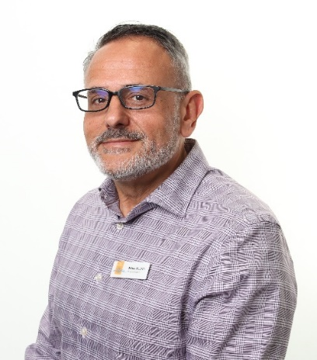 Nelson Mauricio, Acting Director Corporate and System Services

Directorate purpose
To drive operational excellence and support community-facing services by providing effective financial management, technology, corporate strategic planning, communication, and added value to the customer experience.
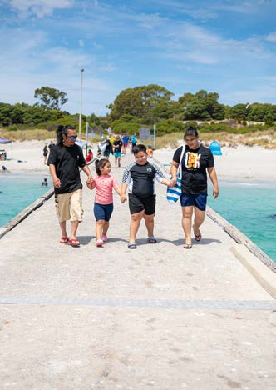 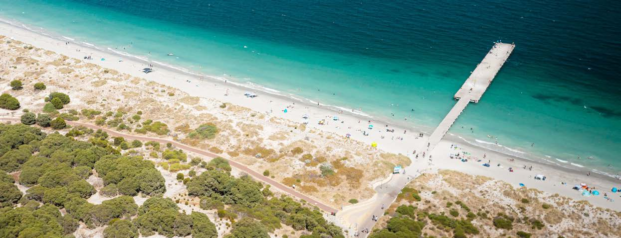
Photos: Woodman Point Ammo Jetty, Coogee.

Director Summary
Nelson Mauricio has dedicated his career to the local government sector, with a focus on financial services. He joined the City of Cockburn in 1994 and has held various positions within finance before his current role as Acting Director.
Nelson has a strong financial background, with qualifications in accounting and business administration. He is also a Chartered Accountant, demonstrating his commitment to professional excellence.
As Acting Director, Nelson is responsible for overseeing the City’s financial management, information technology systems, and corporate services. He is committed to ensuring the City’s financial sustainability and operational efficiency.

Corporate and System Services
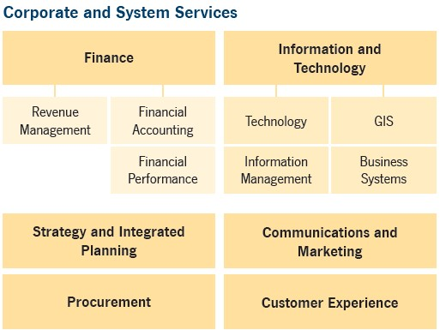
- Finance
  - Revenue Management
  - Financial Accounting
  - Financial Performance
  - Strategy and Integrated Planning
  - Procurement
- Information and Technology
  - Technology
  - Information Management
  - GIS
  - Business Systems
  - Communications and Marketing
  - Customer Experience

Team overview

Finance
The Finance Business Unit is responsible for overseeing the City’s financial operations and ensuring its long-term financial sustainability. The Revenue Management team provides essential services to ratepayers and debtors, assisting them with payments, valuations, and other financial matters. Financial Accounting plays a critical role in maintaining financial compliance and mitigating financial risks through effective systems, controls, and education. Financial Performance monitors and reports on the City’s financial performance, ensuring accountability to stakeholders and supporting informed decision-making. By working together, these teams contribute to the City’s financial health and stability, enabling it to deliver essential services to the community while managing its resources responsibly.

Information and Technology
The Information and Technology Business Unit plays a vital role in supporting the City’s operations by providing technology solutions, information management services, spatial data management, and business improvement support. By delivering technology infrastructure, records management, GIS capabilities, and business systems, the unit enables the City to deliver efficient and effective services to the community, make informed decisions, and meet regulatory requirements. The unit’s expertise and commitment to innovation ensure that the City remains well-equipped to address the evolving technological landscape.

Strategy and Integrated Planning
The Strategy and Integrated Planning Service Unit plays a crucial role in aligning the City’s operational activities with its strategic direction. The unit is responsible for implementing the City’s Integrated Planning and Reporting framework and facilitates effective allocation of the City’s resources.

Communications, Marketing and Customer Experience
Communications and Marketing works to ensure that the City’s residents and stakeholders are informed, engaged, and satisfied with the services provided. Communications and Marketing promotes the City’s vision, programs, and facilities, while Customer Experience delivers high-quality customer service and support.

Procurement
The Procurement Business Unit ensures that the City’s purchasing activities are conducted efficiently and transparently, minimising risks and maximising cost-effectiveness.

Directorate year in review
The Corporate and System Services Directorate achieved significant milestones, including winning the National Accessible Website of the Year award and the WA Parks and Leisure Australia Award. The directorate initiated a Memorandum of Understanding with the City of Canning for staff resource sharing, revised the Council’s Procurement Policy, and revitalised the City’s long-term financial planning. While there are challenges such as budget constraints and supply chain issues, opportunities exist in service reviews and staff device refreshes to enhance efficiency and service delivery. For a comprehensive overview of the City’s accomplishments and progress, please refer to the “Delivering Our Outcomes” section.

Community and Place
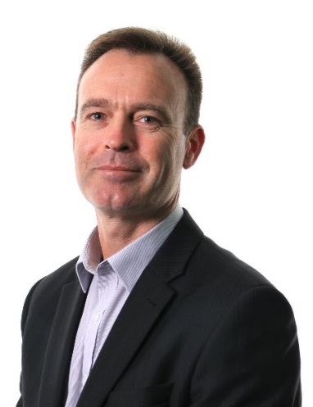 Anton Lees, Acting Director Community and Place

Directorate purpose
To foster a vibrant, inclusive, and resilient community by providing exceptional services, fostering cultural enrichment, promoting active lifestyles, ensuring public safety, and advocating for the needs of our residents and visitors.
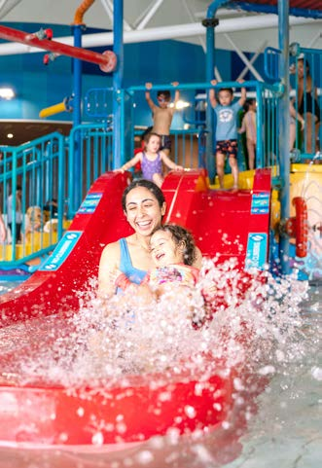
Photo: Cockburn ARC, Cockburn Central.

Director Summary
Anton Lees brings over 25 years of local government experience to his role as Acting Director of Community and Place. He joined the City of Cockburn in 2010 and has since been instrumental in delivering a range of community programs and services.
Anton has a diverse background, with qualifications in business administration, management, accounting, and horticulture. His experience in the private sector has also provided him with valuable insights into management and service delivery.
As Acting Director, Anton is responsible for overseeing a wide range of community initiatives, including recreation, arts, culture, and social services. He is committed to creating a vibrant and inclusive community for all residents.

Community and Place
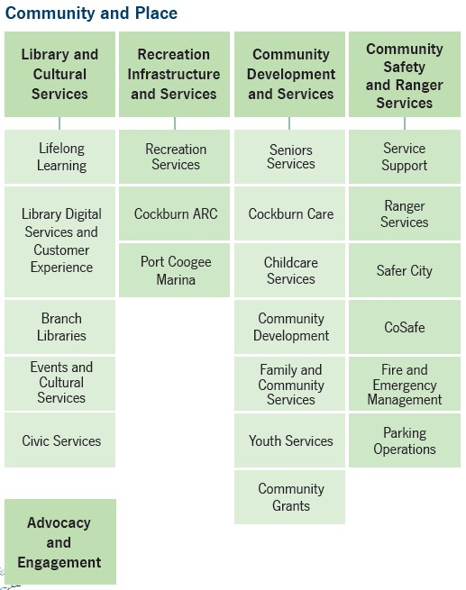
- Library and Cultural Services
  - Lifelong Learning
  - Library Digital Services and Customer Experience
  - Branch Libraries
  - Events and Cultural Services
  - Civic Services
  - Advocacy and Engagement
- Recreation Infrastructure and Services
  - Recreation Services
  - Cockburn ARC
  - Port Coogee Marina
- Community Development and Services
  - Seniors Services
  - Cockburn Care
  - Childcare Services
  - Community Development
  - Family and Community Services
  - Youth Services
  - Community Grants
- Community Safety and Ranger Services
  - Service Support
  - Ranger Services
  - Safer City
  - CoSafe
  - Fire and Emergency Management
  - Parking Operations

Team overview

Library and Cultural Services
The Library and Cultural Services Business Unit plays a vital role in enriching the community by providing vibrant libraries, cultural opportunities, and civic events. The Library Services promotes community engagement, learning, and creativity through access to information, digital resources, and community programs. Events and Cultural Services preserves history, celebrate diversity, and foster community bonds through arts and cultural initiatives. Civic Services recognise and celebrate community achievements and milestones, while also ensuring the security and amenity of the City’s Administration Building. Together, these services contribute to the overall wellbeing of the community and enhance its sense of identity and belonging.

Recreation Infrastructure and Services
The Recreation Infrastructure and Services Business Unit provides a range of recreational facilities and programs to the community, promoting active lifestyles and community engagement. The Recreation Services team supports local sporting clubs, develops community infrastructure, and administers recreation events, while Cockburn ARC offers a variety of aquatic, sports, and fitness facilities to cater to the needs of residents. Port Coogee Marina provides marina services, facilities, and access to recreational activities, ensuring a safe and enjoyable experience for customers. These services contribute to the overall wellbeing of the community and promote a healthy and active lifestyle.

Community Development and Services
The Community Development and Services Business Unit plays a vital role in supporting the community’s wellbeing and development. Seniors Services provides recreational, educational, and social programs for older adults, while Cockburn Care offers in-home care and support to help individuals maintain their independence. Childcare Services ensures quality early childhood education and care for families, while Community Development fosters community engagement and connection. Family and Community Services provides support services to individuals and families, and Youth Services offer programs and facilities for young people. Finally, Community Grants supports community-led projects and events, empowering individuals and organisations to make a positive impact on the community. These services collectively contribute to the overall health and vitality of the community.
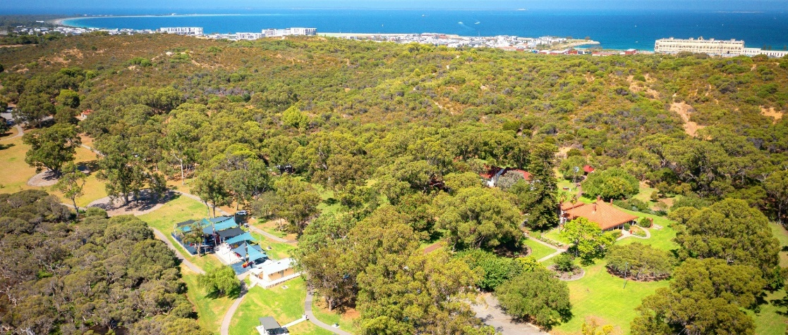
Photo: Manning Park, Hamilton Hill.

Community Safety and Ranger Services
The Community Safety and Ranger Services Business Unit plays a vital role in ensuring the safety and wellbeing of the community. Ranger Services patrols public areas, enforces regulations, and provides animal-related services. Safer City Services promotes community safety through education, advocacy, and crime prevention initiatives. CoSafe provides 24/7 mobile patrols to address community safety concerns, deter crime, and promote a safer community all year round. Fire and Emergency Management develops and coordinates actions to support community disaster resilience and ensure compliance with emergency management frameworks. Finally, Parking Operations ensures a safe and equitable parking experience for all road users. These services collectively contribute to a safer and more secure community.

Advocacy and Engagement
Advocacy and Engagement connects the City with its community and stakeholders. It seeks their input to inform decisions and advocates for the City’s interests. This fosters stronger relationships and collaboration.

Directorate year in review
The Community and Place Directorate achieved significant milestones, including launching new initiatives, supporting community programs, and advocating for local interests. While facing challenges such as funding constraints and staffing shortages, the directorate successfully implemented numerous projects and initiatives, fostering a vibrant and inclusive Cockburn. Key achievements include the establishment of new programs, increased library usage, successful community events, and enhanced safety initiatives. For a comprehensive overview of the City’s accomplishments and progress, please refer to the “Delivering Our Outcomes” section.
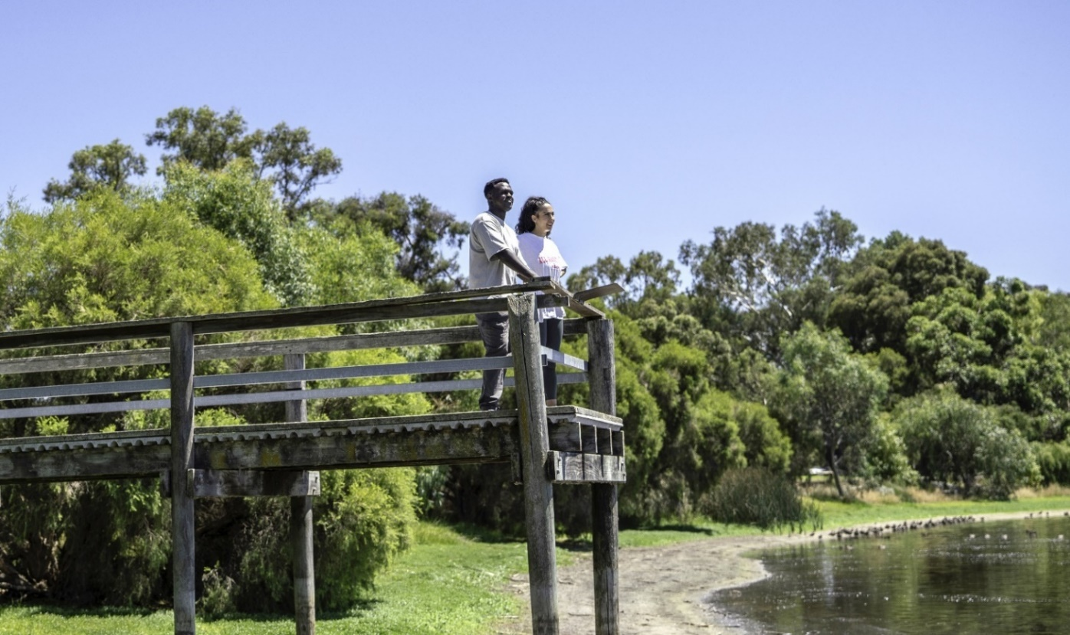
Photo: Bibra Lake Reserve, Bibra Lake.

Planning and Sustainability
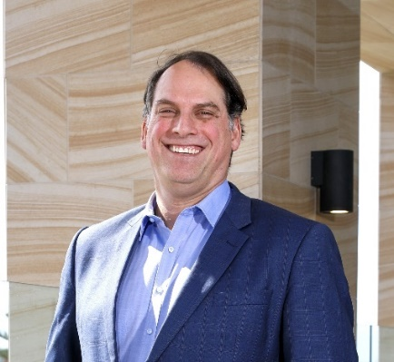 Dan Arndt, Director Planning and Sustainability

Directorate purpose
To shape a sustainable, resilient, and thriving Cockburn by encouraging responsible development, protecting the environment, and promoting economic prosperity, ensuring that our city remains a desirable place to live, work, and play.
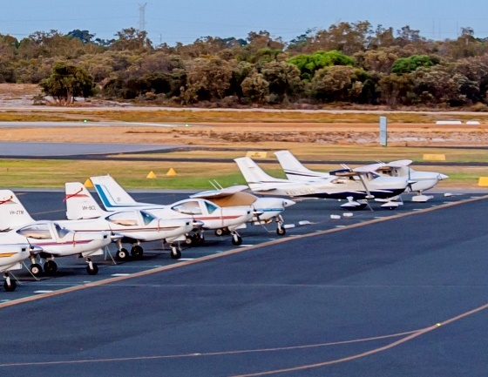 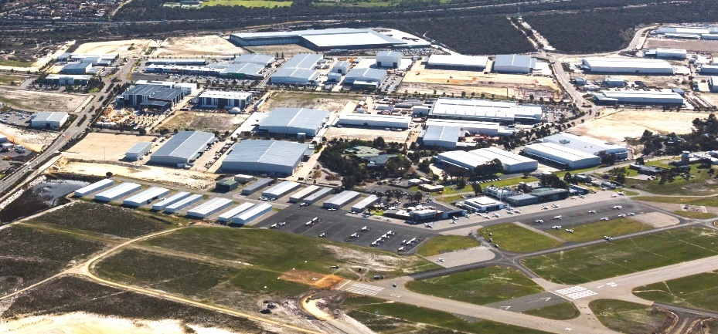Photo: Jandakot Airport, Jandakot.

Director Summary
Dan Arndt has been a driving force in Cockburn’s planning and development for over 15 years. As the Director of Planning and Sustainability, he plays a key role in shaping the City’s future.
With a career in local government spanning over three decades, Dan has a wealth of experience in managing urban growth and development. He has worked in several metropolitan councils, including Swan, Armadale, Mandurah, Fremantle, and Nedlands, gaining valuable insights into the challenges and opportunities facing our region.
Dan is passionate about creating sustainable communities and has been instrumental in developing Cockburn’s long-term plans. He is a Fellow of the Planning Institute of Australia and has a strong understanding of urban planning principles.
As the Director of Planning and Sustainability, Dan oversees the City’s ongoing development, transportation planning, coastal and environmental initiatives, and its economic growth. He is committed to ensuring the City is the best place to live, work and invest.

Planning and Sustainability
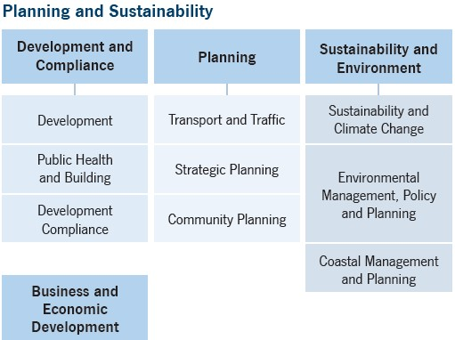
- Development and Compliance
  - Development
  - Public Health and Building
  - Development Compliance
  - Business and Economic Development
- Planning
  - Transport and Traffic
  - Strategic Planning
  - Community Planning
- Sustainability and Environment
  - Sustainability and Climate Change
  - Environmental Management, Policy and Planning
  - Coastal Management and Planning

Team overview

Development and Compliance
The Development and Compliance Business Unit plays a vital role in ensuring the City’s development aligns with planning frameworks and public health regulations. The Development team assesses and processes planning applications, providing guidance and support to applicants throughout the process. The Public Health and Building team provides oversight and support for public health and building matters, ensuring that the built environment is safe and protects public health. Finally, Development Compliance ensures that building, site, and development regulations are adhered to, promoting compliance and maintaining high standards.

Planning
The Planning Business Unit plays a vital role in shaping the City’s future by developing and implementing strategic planning frameworks, managing the transport network, and ensuring that development aligns with the community’s vision. Transport and Traffic Services works to improve road safety, traffic flow, and alternative transportation options, while Strategic Planning develops and maintains a local planning framework that guides the City’s growth and development. Community Planning prioritises major capital infrastructure needs, ensuring that the City’s resources are allocated effectively to meet the community’s evolving needs. These services collectively contribute to the sustainable and equitable development of the City, ensuring that it remains a vibrant and desirable place to live and work.

Sustainability and Environment
The Sustainability and Environment Business Unit plays a vital role in protecting the environment and promoting sustainability within the City. The Sustainability and Climate Change team supports the community in mitigating and adapting to climate change through education, initiatives, and resources, while also providing technical advice and support to the City. Environmental Management, Policy and Planning provides guidance on biodiversity protection and environmental asset management, ensuring the preservation of natural areas and promoting sustainable land development. Coastal Management and Planning manages and plans the City’s coastal resources, protecting the coastline from erosion and promoting its sustainable use and enjoyment. Together, these teams contribute to the City’s efforts to create a more sustainable and resilient future for both the environment and the community.

Business and Economic Development
Business and Economic Development supports local businesses, promotes economic growth, and attracts investment. This benefits the community by fostering job creation and prosperity.

Directorate year in review
The Planning and Sustainability Directorate achieved significant milestones, including securing grant funding for road safety projects, establishing a Sustainability and Environment Reference Group, and implementing the Roe 8 Rehabilitation Management Plan. The City was recognised for its commitment to sustainability and environmental initiatives. While facing challenges such as coastal pressures and climate change impacts, the directorate identified opportunities for future growth and development, including new urban areas, partnerships with research institutions, and infrastructure investments. For a comprehensive overview of the City’s accomplishments and progress, please refer to the “Delivering Our Outcomes” section.

Our People

Staff overview
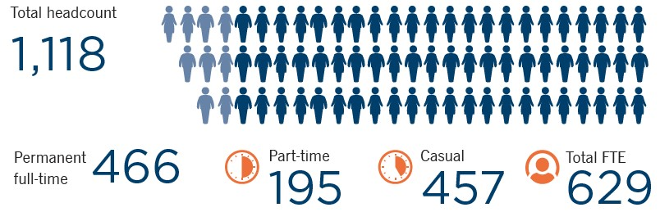
- Total headcount: 1,118
- Permanent full-time: 466
- Part-time: 195
- Casual: 457
- Total full-time equivalent (FTE): 629

Staff age groups
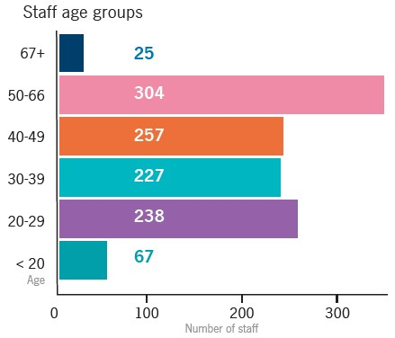
Transcriber’s Note: The bar graph above shows the number of City of Cockburn staff in each age group. This data is presented in the following table.
Age group | Number of staff
Under 20 years | 67
20-29 years | 238
30-39 years | 227
40-49 years | 257
50-66 years | 304
67 years and above | 25

Employees’ gender
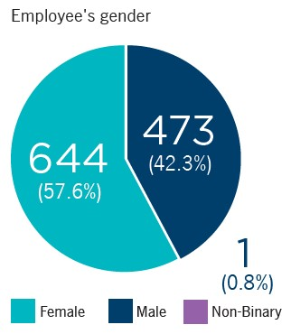
- Female: 644 (57.6%)
- Male: 473 (42.3%)
- Non-Binary: 1 (0.8%)

Length of service (including casuals)
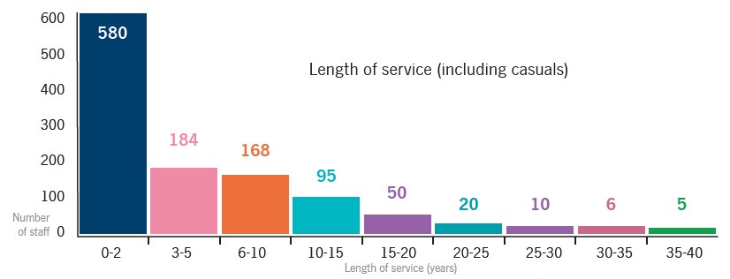
Transcriber’s Note: The bar graph above shows the number of City of Cockburn staff in each age group. This data is presented in the following table.
Length of service | Number of staff
0-2 years | 580
3-5 years | 184
6-10 years | 168
10-15 years | 95
15-20 years | 50
20-25 years | 20
25-30 years | 10
30-35 years | 6
35-40 years | 5

Remuneration of Employees
Number of employees of the City entitled to an annual salary of $130,000 or more.
Annual Salary Range ($) | Number of Employees
130,000 – 139,999 | 26
140,000 – 149,999 | 9
150,000 – 159,999 | 8
160,000 – 169,999 | 7
170,000 – 179,999 | 3
180,000 – 189,999 | 4
190,000 – 199,999 | 4
200,000 – 209,999 | 6
210,000 – 219,999 | 0
220,000 – 229,999 | 2
230,000 – 239,999 | 0
240,000 – 249,999 | 0
250,000 – 259,999 | 1
260,000 – 269,999 | 0
270,000 – 279,999 | 1
280,000 – 289,999 | 1
290,000 – 299,999 | 0
300,000 – 309,999 | 0
310,000 – 319,999 | 0
320,000 – 329,999 | 0
330,000 – 339,999 | 1
340,000 – 349,999 | 0
350,000 – 359,999 | 0
360,000 – 369,000 | 0
370,000 – 379,999 | 0
Chief Executive Officer (CEO)
The remuneration paid to the CEO during 2023-24 was $286,739.06 including superannuation. The Chief Executive Officer, Daniel Simms, commenced at the City on 2 October 2023 with an acting CEO arrangement in place prior to his commencement.

Work Health and Safety
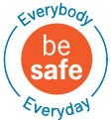
The City is committed to the health and safety of our workers and members of the community. The City has embarked on a program of works that has a renewed focus on training, induction and overall wellbeing, with the aim of building awareness and ownership across the workforce. Specifically:
- The City has developed and deployed a three-phase Safety Leadership Program that acknowledges that our people are at different phases of their development journey and provides dedicated coaching on personal capability opportunities.
- We rebranded safety at the City to be ‘Everybody be safe Everyday’ that aims to redefine the narrative of Work Health and Safety at the City to be one in which safety is the responsibility of everyone.
- A dedicated focus on compliance with the establishment of both internal and external auditing processes, with the aim of continuously improving and educating the workforce.
As a result, the Employee Engagement feedback has indicated a significant shift in safety at the City with:
- an increase engagement in safety from 75 per cent to 81 per cent
- 94 per cent of new employees are reporting that safety is a known priority through the onboarding survey
- 82 per cent of employees, as a rolling 6-month average, who were pulse surveyed report that safety is a priority and have received the necessary training in this space.
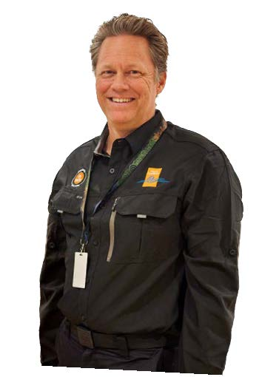
Photo: John Thornton Project Manager - Workplace Health and Safety

Reward and Recognition
Our people are our most important asset and the City ensures that we have the frameworks in place so that our people are invested in, developed and recognised for their dedicated efforts and achievements. These are developed based on the feedback received by the workforce through our Employee Survey platform (onboarding, pulse, engagement and offboarding) that ensures our actions are timely and genuine. During the reporting period we have developed and deployed several new programs and continued to embed others, including:
- Revised Hearts and Minds program that aims to foster a sense of belonging across the organisation through team-building initiatives.
- Revised Employee Awards Eco System to recognise high-performing individuals and teams at an organisational and Directorate level.
- Recognition of achievements at our monthly Executive Leadership Briefings.
- Continuation of the ‘love your work’ program that emphasises the importance of being grateful for day-to-day business activities and achievements.

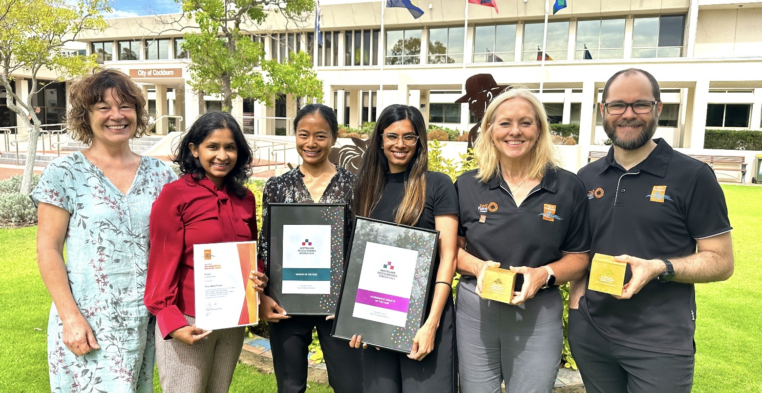
Photo: 2023 Australian Access Awards - Government website of the year - November 2023. (Left to Right) Sam Seymour-Eyles, Communications and Marketing Manager; Dilru Hordagoda, Senior .NET Developer; Leezelle Cornejo, Digital Communications Officer; Deirdre Hewett, Graphic Designer; Sandra Gaskett, Digital Business Analyst; and James Katarski, Strategic Business Systems Manager.

Building Capability
We are aware that as the needs and expectations of our community evolve, so does our workforce. As a result we have an ongoing commitment to building capability. Over the last twelve months we have placed great emphasis on ensuring our workforce is continually developed for our future needs but also that we retain our high performers through career pathway opportunities. Some of our achievements over this time include:
- Development of Leadership Capability Framework that aims to set the leadership competency expectations across the business and build capability of existing leaders. This also creates a mechanism for the development of emerging leaders and the exploration of career pathways across the City.
- Internal opportunities through secondments and promotions for 178 employees.
- Review of Professional Development and Study framework, including the centralisation of training budgets, to ensure a consistent approach to the development and investment of all employees.
- Development and implementation of revised performance competencies and development goals to ensure employees are invested in and can achieve outcomes now and into the future.

Delivering Our Outcomes
The City of Cockburn is a thriving community of over 130,000 residents and 9,500 businesses. Guided by a clear vision outlined in our Strategic Community Plan, we strive to achieve five key outcomes and 15 strategic objectives.
To translate our Strategic Community Plan into action, we have a dedicated team of 629 staff organised into four Directorates, each overseeing specialised Business Units. These Business Units manage 58 Service Units, ensuring services reach everyone.
Our Annual Report provides a comprehensive overview of our achievements aligned with the strategic goals in the Strategic Community Plan and Corporate Business Plan. This year, we focused on 40 key projects that have significantly contributed to shaping Cockburn’s future. Through these initiatives, we have made substantial progress in enhancing our community's quality of life, promoting sustainable development, and fostering a vibrant and inclusive environment.
This graphic illustrates the structured approach we take to make Cockburn a fantastic place to live, work, and play. Discover how we used financial and human resources to deliver impactful projects and activities across our diverse community.
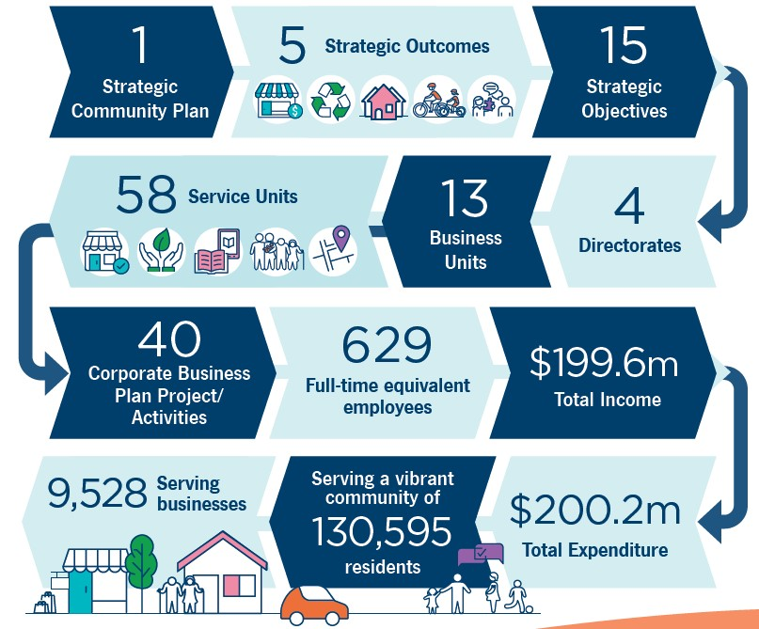
- 1 Strategic Community Plan
- 5 Strategic Outcomes
- 15 Strategic Objectives
- 4 Directorates
- 13 Business Units
- 58 Service Units
- 40 Corporate Business Plan Project/Activities
- 629 Full-time equivalent employees
- $199.6 million Total Income
- $200.2 million Total Expenditure
- Serving a vibrant community of 130.595 residents
- Serving 9,528 businesses

Community Satisfaction
The City of Cockburn is pleased to partner with Place Score, a leader in community perception surveys, to gather insights that shape our community’s future. Place Score’s rigorous data collection and analysis allow us to gauge local sentiment accurately and align our objectives with the values and needs of residents. This collaboration informs our Strategic Community Plan (SCP) and ensures that our planning and investment are guided by what matters most to our community.
In the 2024 Cockburn Liveability Survey, more than 1,800 residents participated, providing over 1,600 ratings on their neighbourhoods and sharing nearly 1,400 ideas for local improvement.
Below is a summary of the key results, with further details and analysis for each outcome provided in the following outcome sections of the Annual Report.
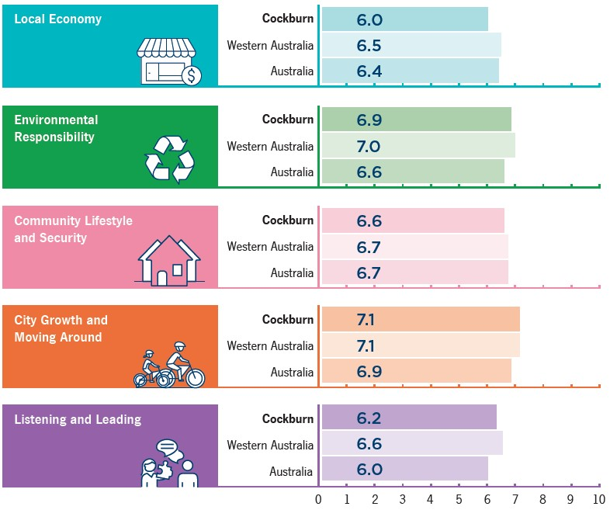
Local Economy:
- Cockburn: 6.0
- Western Australia: 6.5
- Australia: 6.4
Environmental Responsibility:
- Cockburn: 6.9
- Western Australia: 7.0
- Australia: 6.6
Community Lifestyle and Security:
- Cockburn: 6.6
- Western Australia: 6.7
- Australia: 6.7
City Growth and Moving Around:
- Cockburn: 7.1
- Western Australia: 7.1
- Australia: 6.9
Listening and Leading:
- Cockburn: 6.2
- Western Australia: 6.6
- Australia: 6.0
The City’s overall liveability score of 66 aligns closely with state and national averages of 67, demonstrating solid performance across most areas. Environmental Responsibility and City Growth and Moving Around emerged as our strongest outcomes, while Local Economy and Listening and Leading indicate areas for development. These scores reflect alignment with state and national benchmarks, while also highlighting specific opportunities for improvement.

Local Economy Outcomes
Cockburn is dedicated to building a thriving local economy that benefits everyone. Three key objectives guide this commitment: attracting investment and creating jobs, supporting vibrant commercial centres and a flourishing tourism industry, and streamlining processes to make Cockburn a city that’s 'easy to do business with'.
Strategic outcome 1. Local Economy:
A sustainable and diverse local economy that attracts increased investment and provides local employment.
Strategic objectives:
- Increased investment, economic growth and local employment
- Thriving local commercial centres, local businesses and tourism industry
- A city that is ‘easy to do business with’
Key statistics:
- Number of projects: 6
- Number of services: 1
- Full-time equivalent employees: 4
- Total cost: $1.26 million
Services:
- Business and Economic Development
Strategies, Plans and Frameworks:
- Economic Development Framework Action Plan
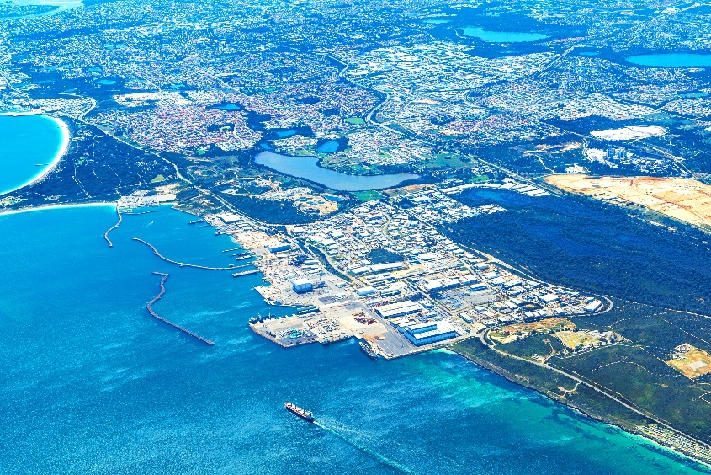
Photo: Henderson Industrial and Commercial Precincts.

Highlights 2023-24
The City of Cockburn continues to make substantial strides in developing a vibrant local economy, fostering innovation, and creating jobs. Through a series of key projects, partnerships and initiatives, the City is reinforcing its position as a vital hub for commercial growth, tourism and international collaboration. These initiatives align with Cockburn's vision to support employment opportunities and economic development across the region, ensuring sustainable growth and prosperity for its communities. This section highlights the key economic developments within Cockburn and the substantial progress made during the financial year.

Surface Fleet Review Announcement
A landmark announcement from the Deputy Prime Minister and Minister for Defence, the Hon Richard Marles MP, has propelled Henderson into a new era as Australia’s premier shipbuilding and maritime precinct. Mayor Logan Howlett welcomed this initiative, which is set to generate approximately 1,200 local jobs over the next decade, reinforcing Henderson’s role as a vital hub for the blue economy. This announcement aligns with the City’s vision to bolster employment opportunities and foster training for future generations in Cockburn and surrounding communities.

Perth Surf Park Development
The forthcoming $100 million Perth Surf Park, scheduled for completion by early 2027, is anticipated to transform Jandakot into a premier tourist destination. Mayor Howlett highlighted the park’s strategic location in Cockburn Central, emphasising its potential to attract adventure seekers from across Western Australia and beyond. The project promises a world-class surfing lagoon and associated amenities that will draw significant foot traffic and tourism to the region.

Amazon Fulfilment Centre
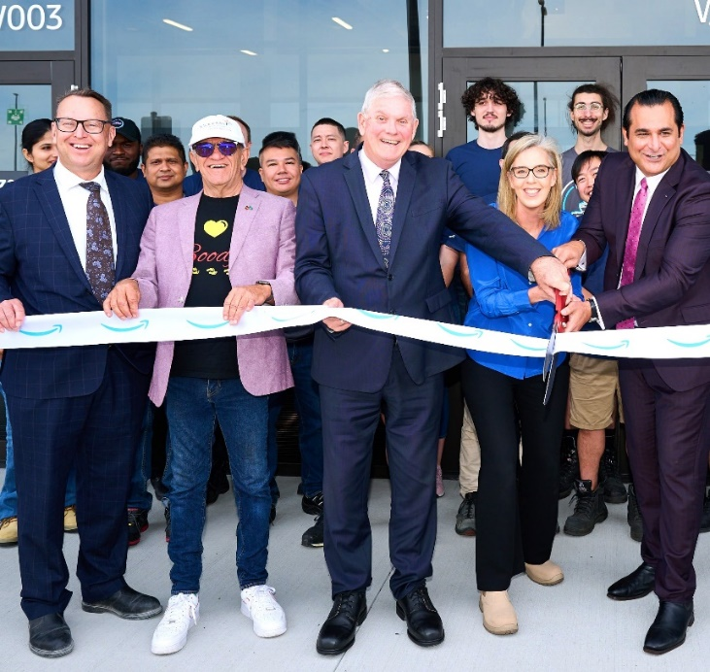
Photo: Amazon opening - November 2023. (Left to Right) Daniel Simms, CEO City of Cockburn; Whadjuk Nyungar Elder Prof Len Collard; Mayor Logan Howlett; Janet Menzies, Amazon Australia Country Manager; and Jandakot MLA Yaz Mubarakai.
In a significant boost for local employment, Amazon Australia has relocated its Western Australian fulfilment centre to the Jandakot Airport commercial precinct, unveiling a $70 million facility that expands its storage capacity in WA by 500 per cent. Mayor Howlett remarked that this development not only enhances Cockburn’s reputation as an investment hotspot but also exemplifies the City’s commitment to fostering innovative commercial enterprises that create jobs and skill opportunities for local residents.

Cockburn Global Conference
Demonstrating its commitment to international engagement, the City of Cockburn successfully hosted the inaugural Cockburn Global conference, connecting local businesses with counterparts in Singapore, Indonesia, and Viet Nam. This conference provided insights into bilateral trade and investment opportunities, fostering valuable connections for local businesses looking to expand into Southeast Asia. Key representatives from each nation shared their perspectives, reinforcing Cockburn's role as a gateway for international collaboration.
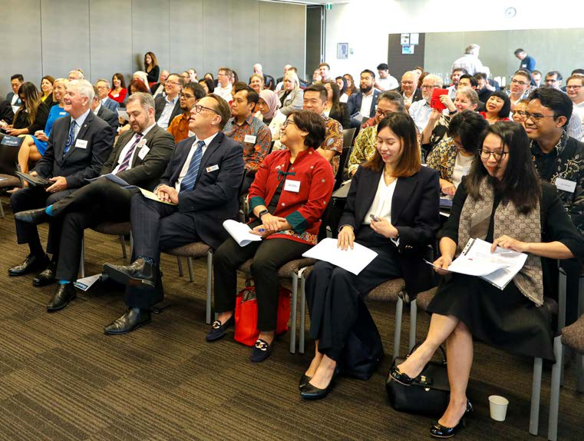
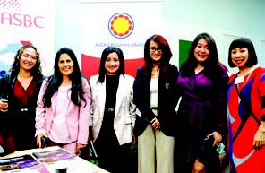 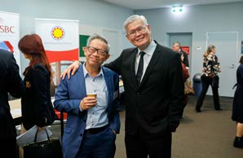 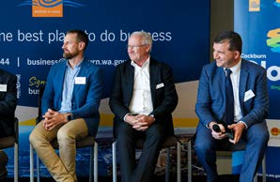
Photos: Cockburn Global - October 2023.

Collaboration for Growth
In collaboration with other outer metropolitan growth councils, Cockburn participated in a visit from the National Growth Areas Alliance (NGAA) to discuss funding for critical infrastructure and services. This visit included tours of significant local projects such as the Waste-to-Energy facility in Kwinana and the Australian Marine Complex, highlighting the City’s ongoing advocacy for the needs of fast-growing communities.

NBN Co Business Fibre Zone Investment
In a pioneering move, the City of Cockburn became the first local government in WA to co-invest in a Business Fibre Zone, providing nearly $80,000 for the establishment of high-speed internet connectivity in Cockburn Central. This initiative will benefit over 1,200 businesses across the area, ensuring that Cockburn remains at the forefront of digital connectivity and economic opportunity.

Key accomplishments 2023-24
The following section offers a comprehensive overview of the City of Cockburn's key accomplishments. We have also included insights into the challenges and opportunities that lie ahead in future financial years, providing valuable information for our community.

Planning and Sustainability Directorate

Cockburn Destination Advisory Group
A dedicated group of ten key operators volunteered to establish the Cockburn Destination Advisory Group. This partnership has facilitated the development of the visitor sector, leading to four meetings held at local venues. The group has successfully finalised the draft City of Cockburn Destination Plan.

Micro Business Networking Group
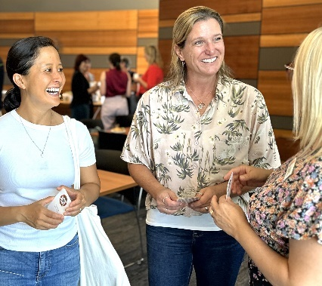
Photo: Micro Business Networking Group - January 2024.
Established 18 months ago, this group celebrated its one-year anniversary in 2024. As a leading networking and learning forum for home- based and startup businesses, it averages 37 registrations per session and has engaged over 280 businesses throughout the year. Attendees consistently rate the group between four and five stars, and sessions include upskilling workshops on relevant topics like LinkedIn strategies and grant applications.
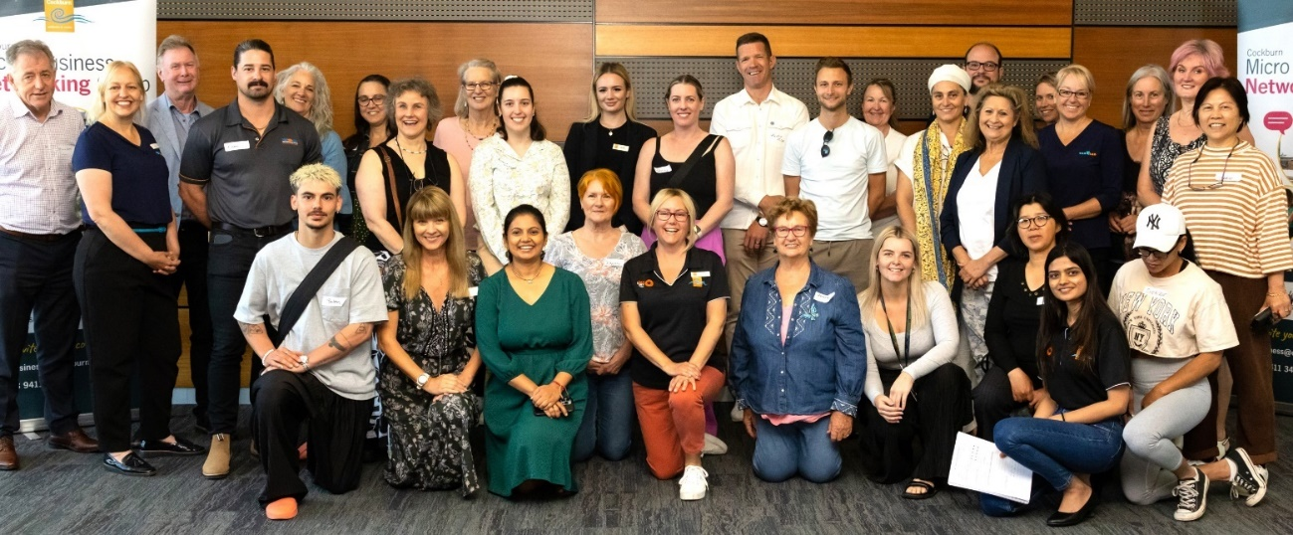
Photo: Micro Business Networking Group - October 2023.

Small Business Grants
The small business grant program supported 35 out of 115 applicants, with a total expenditure of $97,089. This marks a 40 per cent increase in applications compared to the previous funding round. Funded projects focused predominantly on digital technology (57 per cent), training and development (28.5 per cent), and innovative initiatives (14 per cent).

Curtin Ignition Program
In 2023, the City sponsored two scholarships for promising entrepreneurs in a world-class intensive startup program. Record applications were received, and one recipient secured additional funding for affordable housing initiatives targeting Indigenous and remote communities.

Collaboration with the Melville Cockburn Chamber of Commerce (MCCC)
With local businesses now constituting 44 per cent of MCCCs membership, the organisation hosted 39 events in 2023-24, with 60 per cent held within Cockburn. Collaborations have included initiatives such as International Women’s Day and Defence Industry breakfast briefings.

Blue Economy Initiatives

Support for the Blue Gravity Program
As a sponsor of the Blue Gravity Program, the City has facilitated the growth of marine innovations, resulting in local startups attracting nearly $10 million in investment. Key outcomes include diagnostics for Cockburn businesses and support for ventures engaged in the blue economy.

Defence Sector Engagement

Australian Industry and Defence Network (AIDN) Employment Forum
This event connected veterans with defence sector employers and highlighted the City's commitment to supporting the defence industry. It marked the first of its kind in Cockburn, with a second event planned for 2024.

Huntington Ingalls Industries Briefing Event
Held in 2023, this event showcased collaboration within the defence industry, particularly following the AUKUS agreement. It facilitated introductions to HII’s capabilities and encouraged SME engagement in the defence supply chain.

International Engagement

Indonesia Trade Delegation
In March 2023, the City led a delegation to Indonesia, focusing on blue economy and health sectors. Networking events with key government departments and local associations aimed to foster new business relationships.

Cockburn Global Conference
The annual conference on 11 October 2023 brought together local businesses and government representatives to explore bilateral trade and investment opportunities, with a focus on key industry sectors.

Economic Development Framework
Adopted by the Council, this five-year plan guides the City’s economic activities, including international engagement with countries like Singapore and Vietnam, fostering collaboration and prosperity.

Community Engagement

Workshops with Small Business Development Corporation (SBDC)
Monthly upskilling workshops addressing community needs have strengthened local business relationships, with ten sessions offered at no cost, to enhance accessibility.

International Women’s Day 2024
The event experienced a 45 per cent increase in attendance, showcasing over 60 small businesses. Participants engaged in educational experiences that promoted entrepreneurship, work-life balance, and self-improvement.
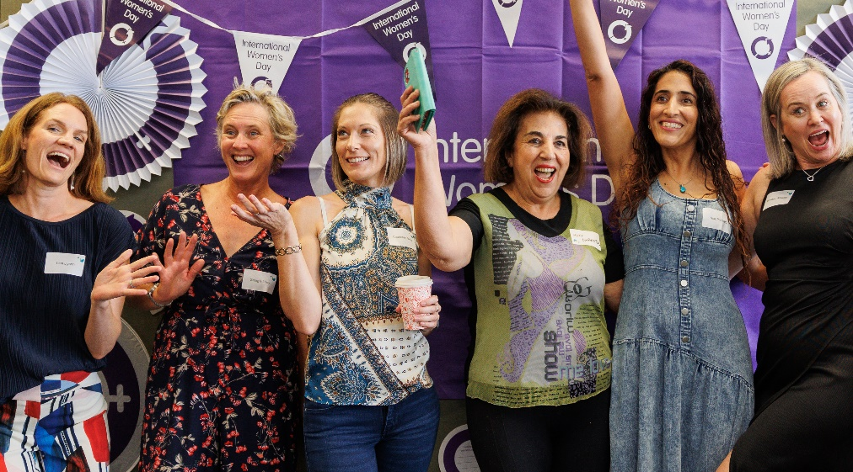
Photo: International Women's Day, Business in Cockburn- March 2024.

Challenges
While the City has made significant progress, challenges remain, including navigating the impacts of global economic trends, maintaining sustainable growth, and addressing the unique needs of local businesses in an evolving landscape.

Opportunities ahead

Memorandum of Understanding with UWA Oceans Institute
This collaboration will strengthen efforts towards sustainable ocean practices and climate resilience, offering economic diversification and job creation.

Collaboration with Henderson Alliance
Building partnerships to support small and medium enterprises in the defence industry will enhance local capabilities and promote sovereign manufacturing.

First Nations Procurement Yarn 2025
This initiative aims to include First Nations businesses in the defence sector, providing competitive advantages through specialised training and networking opportunities.

Destination Plan Development
The upcoming plan aims to position Cockburn as a premier visitor destination, focusing on adrenaline activities and attractions.

Investment Attraction
Ongoing research into major industry sectors and economic trends will inform the development of an investment prospectus and dynamic web presence, enhancing the City’s resilience and ability to meet population growth.
Photo: Adventure World, Bibra Lake.
The City of Cockburn demonstrates a strong commitment to fostering economic growth and creating a vibrant community. Through strategic initiatives, partnerships, and community engagement, the City has successfully positioned itself as a leader in various sectors, including defence, tourism, technology, and international trade. Despite challenges, the City's forward-thinking approach and focus on innovation ensure a promising future. With a strong foundation in place, Cockburn is well-equipped to capitalise on emerging opportunities and continue to thrive as a dynamic and prosperous city.

Community satisfaction
The Local Economy outcome remains a priority for the Cockburn community, with residents expressing appreciation for convenient shopping options but noting a desire for more local businesses that offer unique products and services. There is also a strong community call for an expanded evening economy, with greater opportunities for dining, entertainment, and social activities within Cockburn’s neighbourhoods. The current performance in “things to do in the evening” ranks 10 per cent below the WA average, and the availability of accessible local employment options also scored below community expectations. This feedback has positioned the Local Economy as fourth in importance among Cockburn’s five strategic outcomes.
Residents highlighted the importance of locally owned businesses, with 44 per cent rating them as highly valued. Many respondents also voiced a desire for the presence of more local cafes, bars, and family-friendly venues, indicating that an expanded range of businesses would support Cockburn’s overall economic vibrancy and sense of community.
Local Economy:
- Cockburn: 6.0
- Western Australia: 6.5
- Australia: 6.4
Local Economy outcome metrics | Community satisfaction rating
Local businesses that provide for daily needs (grocery stores, pharmacy, banks, etc.) | 7.2
General condition of private open space (verges, driveways, etc.) | 6.6
Locally owned and operated businesses | 6.5
Local education options (from elementary to adult education) | 6.1
Evidence of recent private investment (renovations, landscaping, painting, etc.) | 6.0
Local employment opportunities (within easy commute) | 5.7
Things to do in the evening (bars, dining, cinema, live music, etc.) | 4.1

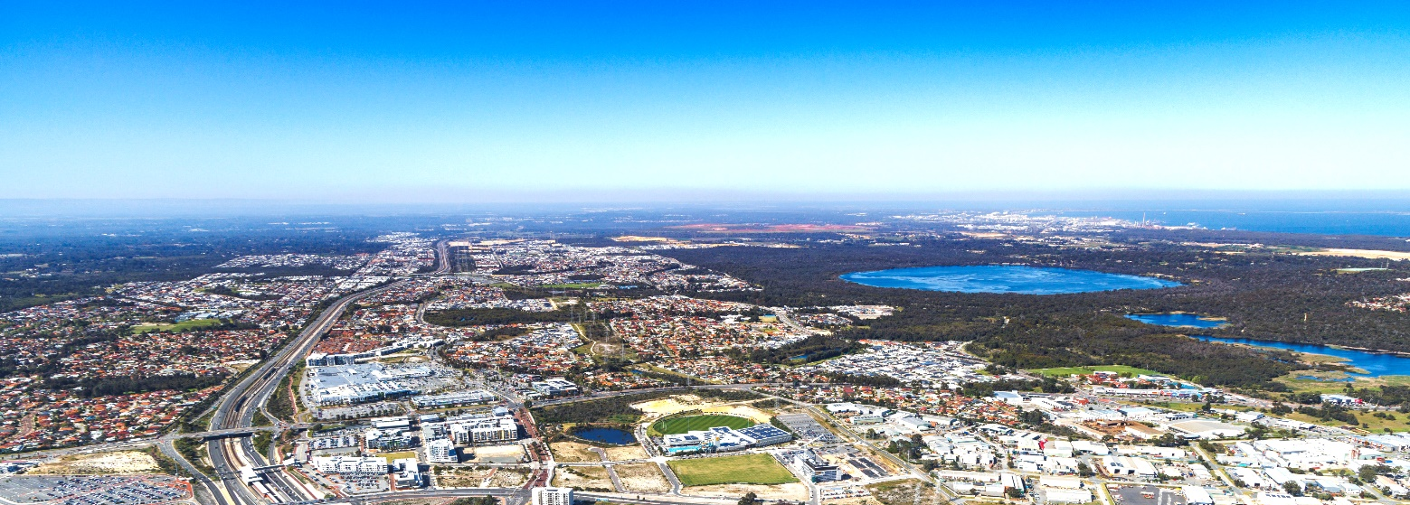
Photo: Cockburn Central.

Local Economy Corporate Business Plan Progress 2023-24
The CBP Progress Report showcases our accomplishments in achieving the objectives set out in the Local Economy outcome. It provides an overview of each project, overall progress status, quarterly milestones, and notes explaining our achievements as of 30 June 2024. These initiatives are essential to making Cockburn, the best place to be.

Local Economy - Projects/activities
Project/activity | Q1 Milestones for 2023-24 | Q2 Milestones for 2023-24 | Q3 Milestones for 2023-24 | Q4 Milestones for 2023-24 | Notes
1.1.2a. Position Cockburn as a leader in the blue economy  Overall progress: Complete | Develop Blue Economy Implementation plan  Complete | Commence activities outlined in Blue Economy Implementation plan  Complete | Project complete  Complete | Project complete  Complete | We’ve successfully established Cockburn as a leader in the blue economy, with all objectives achieved.
1.1.2b. Develop Visitor Economy approach  Overall progress: Complete | Cockburn Visitor Advisory Group established  Complete | Visitor Destination plan scoped  Complete | Visitor Destination Planning commenced  Complete | Visitor Destination plan finalised  Complete | Our Visitor Economy Strategy is now fully developed and ready to drive growth.
1.1.2c. Development of Investment Attraction program and prospectus  Overall progress: Complete | Investment Attraction approach scoped  Complete | Expressions of interest and consultant appointed  Complete | Development of Investment Attraction approach commenced  Complete | Investment Attraction approach finalised  Not on track | The Investment Attraction program is in place, with online resources coming soon due to resource allocation.
1.1.2d. Cockburn Blue Innovation Hub - operationalising  Overall progress: Incomplete | Founding partners secured and Advisory Board established  Not on track | Lease signed and fit-out commences  Not on track | Expressions of interest open  Not on track | Hub operational  Not on track | We are awaiting approval of grant funding from the State Government, with a key meeting scheduled.
1.1.2e. Development of the International Engagement program  Overall progress: Complete | International Engagement approach scoped  Complete | International Engagement event held in Cockburn  Complete | Ongoing International Engagement  Complete | Ongoing International Engagement  Complete | Our International Engagement program is fully operational, with strong connections established with target countries.
1.1.2f. Development of Strategic Partnership program  Overall progress: Complete | Steering groups in place for all strategic partnerships  Complete | Project complete  Complete | Project complete  Complete | Project complete  Complete | We’ve formalised strategic partnerships through MoUs, further strengthening our collaboration efforts.

Environmental Responsibility Outcomes
Protecting our natural environment is a top priority for the City of Cockburn. A comprehensive approach to environmental responsibility focuses on preserving natural areas, promoting sustainable resource management, and addressing the challenges of climate change.
Strategic outcome 2. Environmental Responsibility:
A leader in environmental management that enhances and sustainably manages our local areas and natural resources.
Strategic objectives:
- Protection and enhancement of our natural areas
- Sustainable resource management including waste, water and energy
- Address Climate Change
Key statistics:
- Number of projects: 3
- Number of services: 6
- Full-time equivalent employees: 151.4
- Total cost: $70.3 million
Services:
- Coastal Management and Planning
- Environment, Parks and Streetscapes Services
- Environmental Management, Policy and Planning
- Landscape and Coastal Projects
- Sustainability and Climate Change
- Waste Services
Strategies, Plans and Frameworks:
- Climate Change Strategy 2020-2030
- Coogee Beach Foreshore Management Plan 2020-2070
- Natural Area Management Strategy 2012-2022
- Urban Forest Plan 2018-2028
- Waste Strategy 2020-2030
- Waterwise Council Action Plan 2021-2026

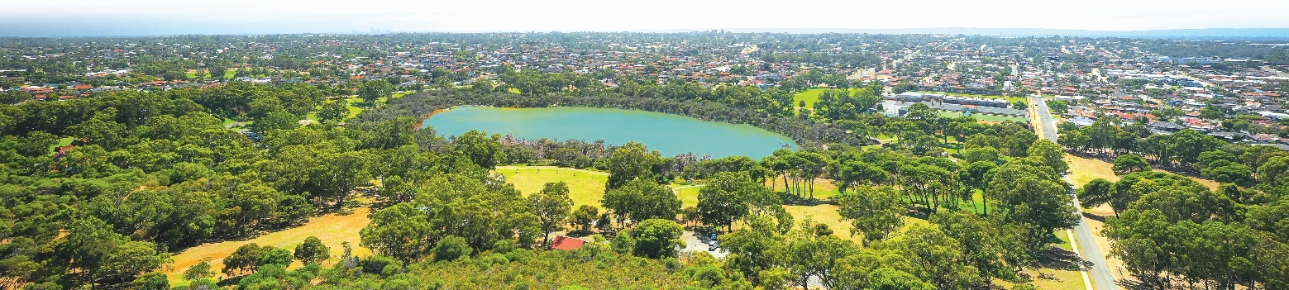Photo: Manning Park, Hamilton Hill.

Achievements 2023-24
The City of Cockburn has demonstrated a strong commitment to environmental responsibility throughout the 2023-24 financial year. Despite the challenges posed by record-breaking heat and below-average rainfall, the City's dedication to sustainable practices and community engagement has been evident. This section highlights the key environmental initiatives undertaken, the significant achievements made, and the ongoing efforts to address emerging challenges.

Water Management
During the 2023-24 summer, the City of Cockburn experienced its hottest summer on record, marked by significantly below-average rainfall throughout Western Australia. Despite these extreme weather conditions, the Parks team worked diligently to manage water resources effectively, ensuring that the City remained within its groundwater allocation.
With approximately 400 parks and reserves under the team’s management — including both nature reserves and sporting facilities — the challenge of maintaining green spaces during such a dry season was considerable. The team’s efforts not only underscore Cockburn's prestigious Gold Waterwise Council status but also reflect the City’s commitment to implementing sustainable water management practices. These practices incorporate innovative irrigation techniques and water conservation initiatives, resulting in reduced environmental impact and significant cost savings for the community.

Biodiversity Initiatives

Bird Watering Station Installation
In a significant partnership with Murdoch University, the City installed a four-metre-high bird watering station at Manning Park as part of the Keep Carnaby's Flying project. This state-of- the-art watering station is equipped with four large troughs at varying heights and angles, designed to accommodate various bird species while facilitating access for both juvenile and adult birds. Additionally, the station features timber rungs that serve as perches and provide opportunities for beak sharpening, crucial for maintaining healthy bird populations.
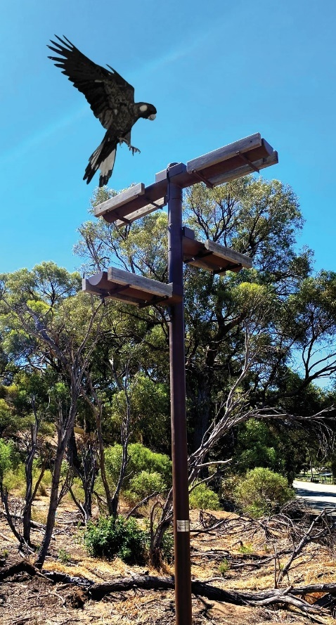
Photo: Watering station at Manning Park.

Community Involvement in Habitat Restoration
The installation of the watering station was complemented by a community-driven revegetation project, which involved the planting of Banksia sessilis to create additional foraging habitat for Carnaby’s cockatoos. This effort saw collaboration from local volunteers, the Friends of Manning Park Ridge, and organisations such as SERCUL and Perth NRM. By enhancing the ecological integrity of the area, the project aims to bolster the survival of Carnaby's cockatoos and other native species, addressing threats to their habitats in the Perth-Peel region.

Coastal Protection

Advocacy Against Illegal Shark Fishing
The City of Cockburn has taken proactive steps to address the issue of illegal shark fishing, which poses a significant risk to both swimmers and responsible anglers along its beaches. The City actively advocated for stronger regulations, resulting in the announcement of a ban on the use of wire trace fishing lines from the shore. This ban, announced by the Honourable Don Punch, Minister for Fisheries, alongside local representatives, aims to deter irresponsible fishing practices that threaten marine life and to ensure the safety of beachgoers.
The new regulation reinforces the message that fishing for sharks off the shore is unacceptable, providing a safer environment for both the community and the local ecosystem. Responsible anglers who follow ethical fishing practices will not be adversely affected by this change.

Community Engagement on Coastal Erosion
The City’s commitment to community engagement in environmental management was recognised when it won the Smart Budget Award at the International Association for Public Participation (IAP2) Australasia 2023 Core Values Awards. This accolade was awarded for the City's comprehensive approach to engaging the community in discussions about coastal erosion and developing solutions to this pressing issue.
Erosion Reduction Reef Trial
As part of this initiative, the City implemented a trial of a modular concrete erosion reduction reef at C.Y. O'Connor Beach. This innovative project is designed to reduce wave energy and minimise beach erosion, which has become a critical concern for local coastal areas. The community engagement process involved more than 300 participants, employing creative strategies to facilitate discussions and gather input on the project.
The absence of a predetermined outcome allowed community values and aspirations to shape the project’s direction, ensuring that the final design reflected the needs and concerns of local residents. The reef's effectiveness will be closely monitored by The University of Western Australia’s Oceans Graduate School, allowing for ongoing assessment and adaptation of coastal management strategies.
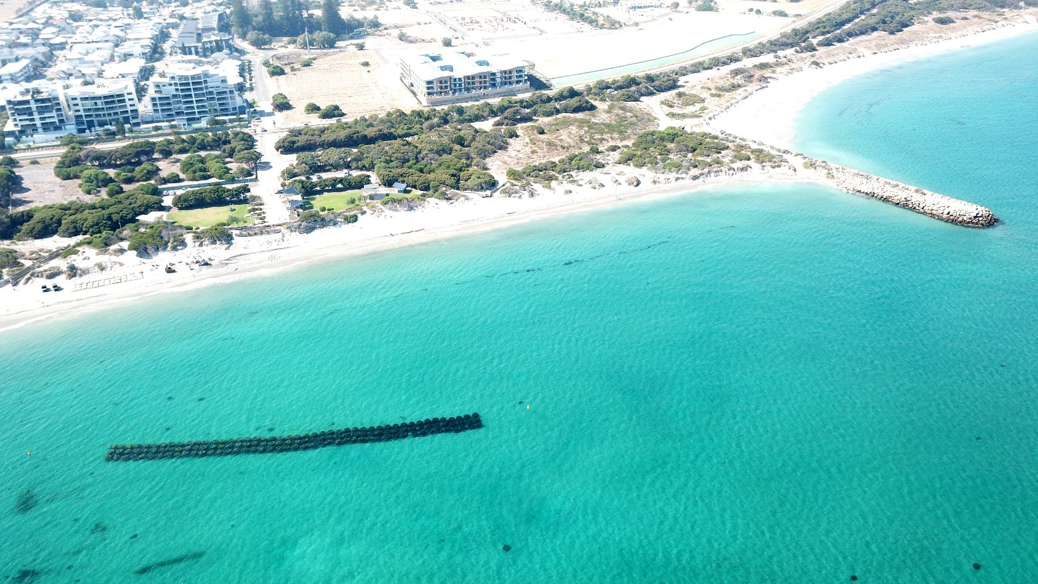
Photo: Catherine Point, North Coogee.

Key accomplishments 2023-24
The following section offers a comprehensive overview of the City of Cockburn's key accomplishments and achievements across its various directorates. We have also included insights into the challenges and opportunities that lie ahead in future financial years, providing valuable information for our community.

Infrastructure Services Directorate
The City of Cockburn is dedicated to promoting environmental responsibility through a series of strategic initiatives that prioritise waste reduction, community engagement, and sustainability. This section outlines the key activities undertaken during the 2023-24 financial year.

Waste Management Initiatives
- Waste Wise Events Policy Implementation: In a pioneering move, the City launched its new Waste Wise Events Policy for the 2023-24 events season. This initiative aimed to drastically reduce waste produced during community events, setting an industry standard for sustainability. Through collaboration with event partners, the City established guidelines that prioritised the use of reusable and compostable materials.
- Cockburn LIVE Events Impact: At the conclusion of the events season, extensive data analysis revealed the significant impact of the Waste Wise policy:
  - 56,000 reusable and compostable items were utilised, effectively replacing single-use plastics and demonstrating a shift towards sustainable consumption.
  - Waste Diversion Metrics: Only 400kg of waste was sent to landfill, averaging a mere 5 grams per person, a testament to the City’s successful waste diversion strategies. Additionally, 500kg of organic waste was processed through WRITE Solutions for composting, averaging 7 grams per person.
  - Community Engagement through Refund Initiatives: The City facilitated the return of 10,000 containers to refund points, which resulted in a $1,000 donation to local charities, enhancing community engagement and supporting local causes.
  - Resource Recovery Improvements: The City achieved a remarkable improvement in its resource recovery rate, rising from 30 per cent to more than 70 per cent. This increase was made possible through strategic infrastructure enhancements, education programs, and increased participation from the community.

Community Engagement and Education
- Waste Sorted Grant Utilisation: The City secured a Waste Sorted Grant of approximately $8,000 to conduct a series of workshops focused on textile waste reduction. This funding facilitated the purchase of equipment that community members can hire for free, encouraging local residents to actively participate in textile recycling efforts.
- Reusable Sanitary Product Rebate Uptake: The City noted a significant uptake in the reusable sanitary product rebate program, reflecting a growing community commitment to sustainable practices and reducing waste in personal hygiene products.
- Reclaim The Void Project: The Waste Education Team successfully hosted the Reclaim The Void Project, which fostered community involvement in waste education and sustainable practices. The project was well-received, showcasing the City’s commitment to collaboration and education in waste management.

Planning and Sustainability Directorate
In the realm of planning and sustainability, the City of Cockburn has made significant strides towards innovative environmental management and community involvement, positioning itself as a leader in sustainable practices.

Sustainability Initiatives
- Establishment of the Sustainability and Environment Reference Group (SERG): In 2023-24, the City established the SERG, providing a platform for community and industry representatives to advise the Council on strategic matters relating to environmental sustainability. This initiative fosters collaboration and ensures that diverse perspectives are included in decision-making processes.
- Owl Friendly Declaration: The City of Cockburn proudly became the first large Perth Council to declare itself ‘Owl Friendly’. This declaration restricts the use of certain types of rat poisons known to be lethal to native birds of prey and household pets by the City, showcasing its commitment to protecting local wildlife.

Rehabilitation and Environmental Programs
- Roe 8 Rehabilitation Management Plan: A three-year extension to the Services Agreement for the rehabilitation of the Roe 8 Corridor is currently being negotiated with Main Roads. This agreement ensures ongoing commitment from both agencies to transform the land cleared for Stage 8 of the Roe Highway into a thriving ecological corridor, supporting biodiversity and ecosystem recovery.

Partnerships for Sustainability
- Collaborative Initiatives: In 2023-2024, the City partnered with various organisations to enhance the implementation of its Climate Change Strategy, including:
  - Australian Urban Design Competition: This partnership aims to research how houses can be designed to be more comfortable in a warming climate, addressing the impacts of climate change on residential living.
  - Western Power: Collaborating to provide battery-stored solar energy solutions to residential homes, encouraging the adoption of renewable energy sources.
  - Fremantle Dockers Football Club: Working together to revegetate Bibra Lake with native plants, enhancing local biodiversity and community engagement.
  - Coogee Maritime Trail Volunteer Program: The City launched the Coogee Maritime Trail Volunteer Program to equip volunteers with the skills necessary to protect the fragile Omeo Shipwreck. Volunteers are stationed onsite during peak summer months to inform snorkellers about the history of the trail and promote responsible snorkelling practices.
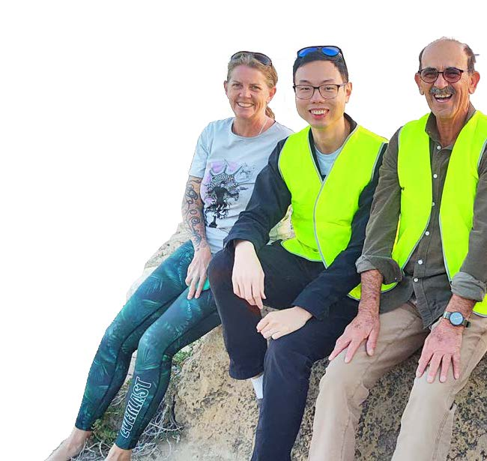
Photo: Coogee Maritime Trail Volunteer Program.

Environmental Events and Community Engagement
- Environmental Calendar: A comprehensive calendar of environmental events was made available to the community in 2023-24. Highlights included:
  - Pop-Up Forest at Coogee Live: A unique event that raised awareness about local flora and encouraged community participation in conservation.
  - Nature Discovery Days: Family-friendly events that fostered connection to nature and environmental education.
  - Inaugural Biodiversity Month Celebrations: A month-long series of activities focused on promoting biodiversity awareness within the community.
  - Sustainable House Day: An event that showcased sustainable living practices and innovations in home design.
- Revegetation Efforts: Approximately 270 volunteers participated in planting 8,000 seedlings at Coogee Beach and Manning Park over three weekends during winter. These efforts were further supplemented by revegetation events involving local school children, fostering environmental stewardship among younger generations.

Challenges

Drought Impact
The impacts of climate change were particularly pronounced in 2023-24, as Perth experienced its driest summer on record. Ensuring seedling survival in revegetation projects has become increasingly challenging, with the extended dry spell resulting in receding water levels in wetlands. This decline has led to reduced habitat availability for aquatic animals and heightened vulnerability to predation.

Urban Forest Management
The dual challenges of reduced annual rainfall and the spread of the Polyphagous Shot Hole Borer have emerged as significant threats to maintaining a thriving urban tree canopy. The City is actively monitoring and addressing these issues to ensure the health of its urban forests.
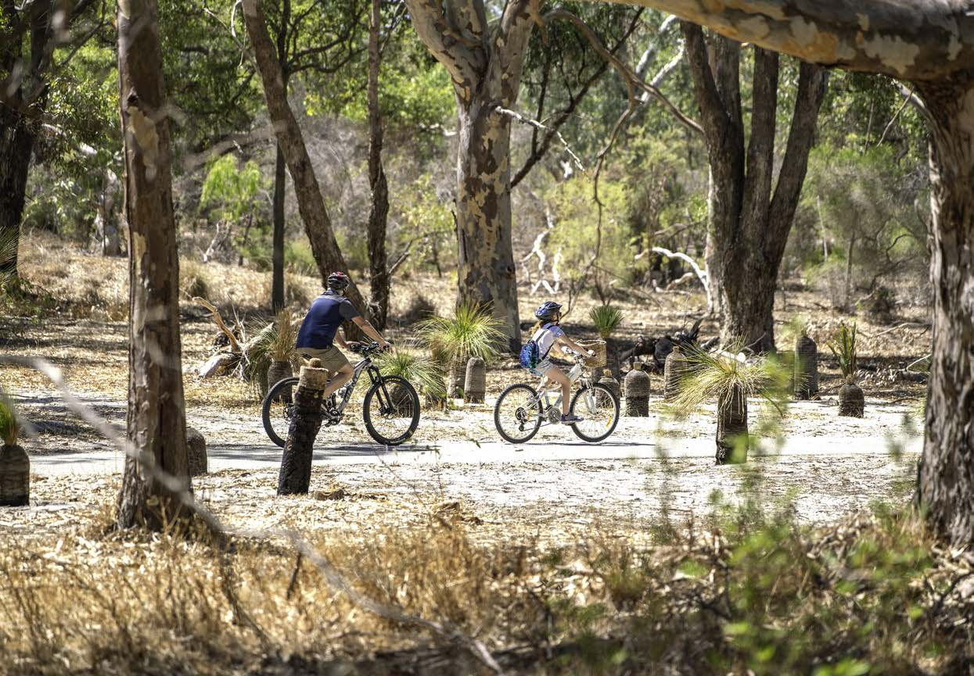
Photo: Bibra Lake Reserve, Bibra Lake.

Opportunities ahead
The City of Cockburn is proactive in identifying and capitalising on future opportunities for enhancing environmental stewardship and community engagement.

Voluntary Landcare
The passion and commitment shown by City of Cockburn residents towards caring for the local environment continues to be remarkable. Volunteers play a crucial role in activities such as revegetation, turtle tracking, and hand-weeding in natural areas. The City will continue to empower the community by providing resources, training, and opportunities to engage in environmental stewardship.

Water and Habitat Protection
The City is collaborating with the State Government to investigate the feasibility of supplementing local wetlands with excess stormwater from other areas. This project aims to retain more water in wetlands during dry months, thereby providing additional habitat protection for aquatic animals and improving drought tolerance for fringing vegetation.

Coastal Management
Coastal Hazard Risk Management and Adaptation Plan: The preparation of this strategic plan will equip the City with a comprehensive approach to dealing with worsening coastal conditions. The plan will outline measures to mitigate against the impacts of sea-level rise, coastal erosion, and inundation, ensuring the resilience of Cockburn’s coastal areas.

Beach Nourishment
The City has been awarded grant funding from the Department of Transport to investigate available sand supplies in the region. This research will inform future beach nourishment projects, ensuring the sustainability and protection of Cockburn’s beaches against erosion.

Environmental Offsets
With the increasing demand for environmental offset sites, the City has a unique opportunity to direct investments from private entities towards enhancing the condition of the 93 conservation reserves under its management. This approach will contribute to biodiversity conservation and ecological restoration efforts.
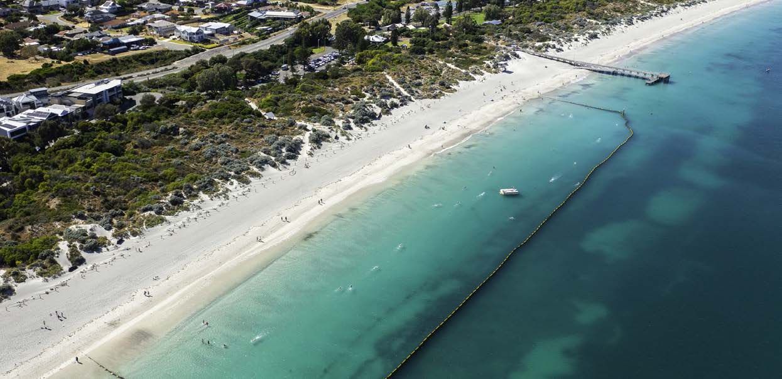
Photo: Coogee Jetty and swimming enclosure, Coogee Beach.
The City of Cockburn's environmental efforts have yielded significant results, from preserving biodiversity to promoting sustainable waste management. The City's commitment to community engagement, partnerships, and innovative solutions has been instrumental in addressing environmental challenges and securing a more sustainable future. As the City continues to navigate the impacts of climate change, its proactive approach and focus on long-term planning will be crucial in ensuring a resilient and environmentally responsible community.

Community satisfaction
The Environmental Responsibility outcome is closely aligned with the community’s vision for a sustainable future, with local residents placing great value on the protection of natural areas, the quality of public open spaces, and the addition of green landscaping throughout Cockburn. In the 2024 Liveability Survey, residents ranked natural elements such as vegetation, water, and wildlife as their top priority (74 per cent), and 68 per cent identified well-maintained public spaces — parks, footpaths, and verges — as essential for their ideal neighbourhood.
The City’s current performance reflects positive efforts in these areas, yet there are key opportunities to enhance the community’s connection to the natural environment and foster long-term sustainability. Recommendations include expanding tree canopies, increasing the number of street trees, and preserving native flora and fauna to further enrich Cockburn’s outdoor spaces. Sustainable urban design initiatives are also encouraged, with younger demographics (ages 25-44) showing strong interest in projects that support climate resilience, energy efficiency, and water conservation.
Cockburn’s Environmental Responsibility outcome ranks second in importance among the community’s five strategic outcomes, reinforcing the City’s commitment to an environmentally sustainable future. By responding to the community’s call for nature-focused spaces and sustainability projects, Cockburn can enhance the liveability of its neighbourhoods while protecting and nurturing its natural resources for generations to come. This ongoing investment in our environment supports not only ecological health but also the wellbeing of all Cockburn residents.
Environmental Responsibility:
- Cockburn: 6.9
- Western Australia: 7.0
- Australia: 6.6
Environmental Responsibility outcome metrics | Community satisfaction rating
Amount of public space (footpaths, verges, parks, etc.) | 7.7
Elements of natural environment (natural features, views, vegetation, topography, water, wildlife, etc.) | 7.3
Quality of public space (footpaths, verges, parks, etc.) | 7.2
General condition of public open space (street trees, footpaths, parks, etc.) | 7.1
Landscaping and natural elements (street trees, planting, water features etc.) | 7.0
Neighbourhood spirit/resilience (from external impacts, storms, economic downturns, etc.) | 7.0
Protection of the natural environment | 6.9
Sustainable behaviours in the community (water management, solar panels, recycling, etc.) | 6.5
Sustainable urban design (water sensitive design, transport- oriented design, sustainable building design, density, etc.) | 5.7

Environmental Responsibility Corporate Business Plan Progress 2023-24
The CBP Progress Report showcases our accomplishments in achieving the objectives set out in the Environmental Responsibility outcome. It provides an overview of each project, overall progress status, quarterly milestones, and notes explaining our achievements as of 30 June 2024. These initiatives are essential to making Cockburn, the best place to be.

Environmental Responsibility - Projects/activities
Project/activity | Q1 Milestones for 2023-24 | Q2 Milestones for 2023-24 | Q3 Milestones for 2023-24 | Q4 Milestones for 2023-24 | Notes
2.2.1a. EV chargers at all City infrastructure with solar  Overall progress: Incomplete | Develop consultancy brief  Complete | Commence consulting/ feasibility work  Complete | Complete consulting/ feasibility work  Complete | Present to Council  Not on track | The EV chargers research work has been completed, and we’ll present to council in the first quarter of FY2025.
2.2.2a. Cockburn Resource Recovery Park Redevelopment Stage 2  Overall progress: Incomplete | Design commence  Complete | Project progressing  On track | Design finalised  Not on track | Market Engagement (Tender) and Award  Not on track | We’ve prioritised other essential works at the Cockburn Resource Recovery Park, including reviewing our Waste Strategy, leachate pond construction, and setting up a Community Drop-off.
2.3.1b. Implement Climate Change Strategy 2020-2030  Overall progress: Complete | Annual progress report for previous financial year completed  Complete | Project progressing  On track | Midyear progress updates provided  Complete | Annual progress report for current financial year commenced  Complete | Our Climate Change Strategy is on track, with ongoing action from multiple service units, and progress is being closely monitored.

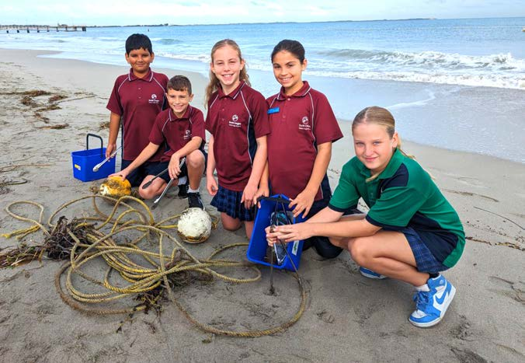 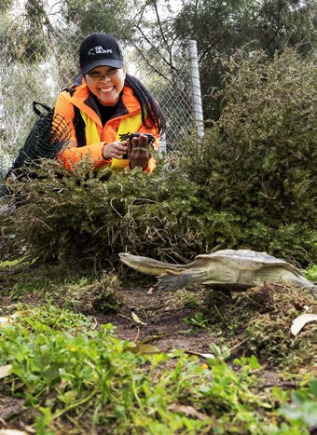 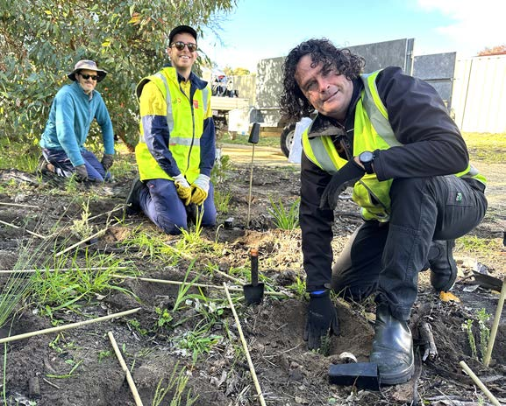
Photo 1: Planting Day with South Coogee Primary School - June 2024. Photo 2: Turtle tracker Joyce Gadalon - September 2023. Photo 3: Staff Planting Day at Boodjar Mooliny Reserve - June 2024 (Left to Right) Robert Peck, Rory Garven, and Adam Harris.

Community, Lifestyle and Security Outcomes
Cockburn envisions a safe, healthy, and inclusive community where everyone feels welcome. Key objectives include fostering accessible and well-maintained community facilities, promoting a safe and secure environment for all residents, and celebrating the rich cultural heritage of Aboriginal and Torres Strait Islander communities. This fosters a strong sense of community spirit and belonging for all.
Strategic outcome 3. Community, Lifestyle and Security:
A vibrant, healthy, safe, inclusive and connected community.
Strategic objectives:
- Accessible and inclusive community, recreation and cultural services and facilities that enrich our community
- A safe and healthy community that is socially connected
- Aboriginal and Torres Strait Islander cultures and heritage are recognised and celebrated
Key statistics:
- Number of projects: 18
- Number of services: 19
- Full-time equivalent employees: 216.4
- Total cost: $58.7 million
Services:
- Building and Security Projects
- Childcare Services
- Cockburn ARC
- Cockburn Care
- Community Development
- Community Grants Services
- Community Safety Support
- CoSafe
- Event and Cultural Services
- Family and Community Services
- Fire and Emergency Management
- Library Services
- Port Coogee Marina
- Public Health and Building Services
- Ranger Services
- Recreation Services
- Safer City Services
- Seniors Services
- Youth Services
Strategies, Plans and Frameworks:
- Age Friendly Strategy 2016-2021
- Animal Management Exercise Plan 2020-2025
- Bushfire Risk Management Plan 2023-2028
- Community Development Strategy 2021-2025
- Community Safety and Crime Prevention Plan 2022-2027
- Disability Access and Inclusion Plan 2023-2028
- Grant and Fee Funded Human Services Strategic Plan 2013-2018
- Library Service Strategy 2020-2025
- Local Emergency Management Arrangements
- Masterplans and Revitalisation Strategies
- Public Health Plan 2013-2018
- Public Open Space Strategy 2014-2024
- Reconciliation Action Plan 2023-2025
- Volunteer Strategy 2021-2025
- Youth Services Strategy 2017-2022

Achievements 2023-24
The City of Cockburn's dedication to fostering a vibrant, inclusive, and secure community is evident in the numerous initiatives undertaken in the past year. From technological advancements to community events and infrastructure improvements, the City has strived to enhance the quality of life for its residents. This section highlights key achievements in community, lifestyle, and security outcome, demonstrating the City's commitment to creating a thriving and welcoming environment for all.

Award for best use of technology
The City of Cockburn, in collaboration with SpacetoCo, received the prestigious ‘Best Use of Technology’ award at the 2024 Parks and Leisure Australia (WA) Awards for Excellence. This accolade celebrates the innovative advancements made to enhance community recreation facility utilisation while significantly streamlining administrative tasks. The new technology has transformed the booking process for community and sporting facilities, allowing residents to quickly and efficiently locate and reserve venues. Since the new technology's implementation, facility bookings have surged by 25 per cent, and customer service calls to the recreation team have plummeted by 62 per cent. Mayor Logan Howlett highlighted that the success of this initiative reflects the City’s ongoing commitment to finding efficiencies through technology, not merely focusing on the award itself.

Cockburn Live event series
The City of Cockburn's event series, Cockburn Live, witnessed an impressive 75 per cent increase in attendance compared to the previous year. This surge in participation underscores the popularity of the new event format. Building on the sustainability efforts of Coogee Live 2023, all 12 Cockburn Live events achieved carbon neutrality and waste-wise practices. A diverse range of activities were offered, including comedy nights, the unique Fur Run, and festive celebrations such as Christmas on the Coast. Cockburn Live will return with an exciting new line-up for the financial year 2024-25, and residents can subscribe to the Soundings newsletter for updates or visit the website.

Volunteer recognition
During National Volunteer Week, the City celebrated its outstanding volunteers, with Jean Coles of Feed It Forward Inc named the 2024 Volunteer of the Year. The Returned and Services League City of Cockburn Sub-branch received the Volunteer Organisation of the Year award, while Maureen Fisher-Sim from Friends of the Community was honoured with the Mayor’s Volunteer Award. These recognitions highlight the significant contributions of volunteers, with 74 nominations representing over 40 organisations in Cockburn.
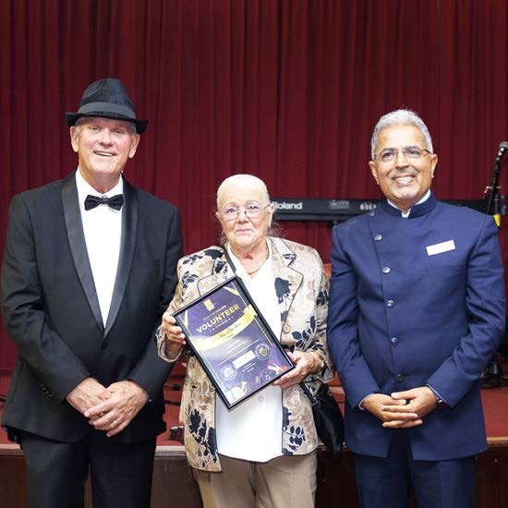
Photo: Cockburn Volunteer Awards - May 2024. (Left to Right) Mayor Logan Howlett; Jean Coles, 2024 Volunteer of the Year; and Cr Tarun Dewan.

Health and Social Benefits of Cockburn ARC
A recent study revealed that the health and fitness opportunities provided by Cockburn ARC resulted in nearly $30 million in health cost savings for the community over the 2021-22 and 2022-23 financial years. These savings stemmed from reduced risks of serious health conditions such as mental health disorders, cardiovascular disease, and cancer, demonstrating the substantial social value of the facility.

Santich Park Upgrades
The City has awarded a $1.76 million tender to Ertech Pty Ltd for the upgrade of Santich Park in Lake Coogee. This project aims to meet the growing needs of local sporting clubs, including Little Athletics and AFL. The first stage will focus on optimising sporting grounds through additional lighting, improved parking facilities, and enhanced space functionality. Future stages will address further building upgrades, with funding primarily sourced from the City of Cockburn and the State Government’s Community Sporting and Recreation Facilities Fund (CSRFF).

CCTV Program and Community Safety
The City has completed the first stage of its ambitious $1.6 million, five-year CCTV program, which will eventually encompass over 1,400 cameras across Cockburn to enhance community security. Currently, 23 cameras have been installed in Coolbellup, significantly increasing the overall sense of safety for residents and businesses. The City also promotes individual security through its CCTV Home Rebate Program, offering residents up to 50 per cent off the installation or upgrade of home CCTV systems, with a maximum rebate of $500. In addition, a Seniors Security Rebate Program is available to support a wider range of security measures. Collaborations with the WA Police Force enhance efforts in maintaining a secure environment.
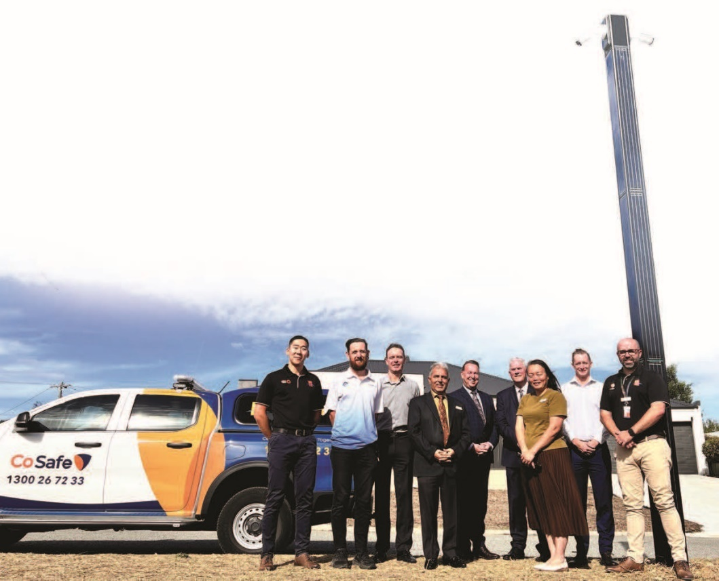
Photo: CCTV Program and Community Safety announcement - June 2024. (Left to Right) William Wu, Community Safety Manager; Cliff Johnson, Blueforce; Anton Lees, City of Cockburn; Cr Tarun Dewan; Daniel Simms, CEO; Mayor Logan Howlett; Cr Zhang; Mike Emery, Head of Community Safety and Ranger Services; and Luke Scott, CoSafe Manager.

Cockburn ARC Expansion
A major expansion of Cockburn ARC, known as the ARC Evolution, has begun. This expansion has been funded through a partnership with the Fremantle Dockers and State Government contributions, amounting to $16.2 million. Scheduled for completion in mid 2025, the upgrades will include increased gym space, a revamped mind and body studio, and a multipurpose function space, significantly enhancing community access to world-class recreational facilities.

Active Reconciliation with First Nations people
Since 2011, the City has prioritised reconciliation with First Nations people, culminating in the endorsement of its fourth Reconciliation Action Plan (RAP), for 2023-25. This plan aims to enhance employment outcomes for Aboriginal and Torres Strait Islander individuals and strengthen partnerships with local Aboriginal organisations. Achievements from previous RAPs include cultural competency training and the installation of signage featuring the Nyungar language across various City facilities.

Community Development and Engagement
The annual Cockburn Community Development Group dinner showcased the efforts of 15 resident groups, some dating back to 1958, emphasising the importance of collaboration and community spirit. The event featured a friendly 'Battle of the Wards' competition, where representatives from each ward shared their local achievements and community pride.

Coogee Live Festival
The sixth edition of Coogee Live, a two-day festival, promised a celebration of local culture and arts, with a theme of ‘Metamorphosis’. Supported by a $70,000 Lotterywest grant, the festival transformed 1.2 km of the coastline into three engaging hubs for community exploration.
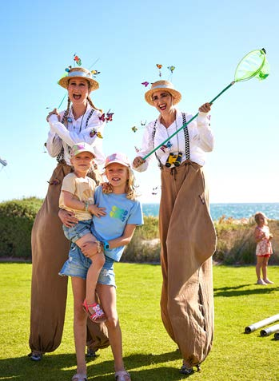 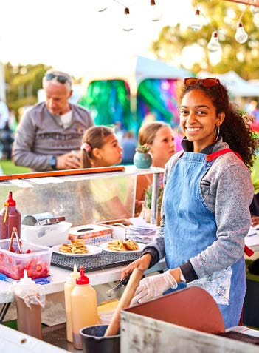 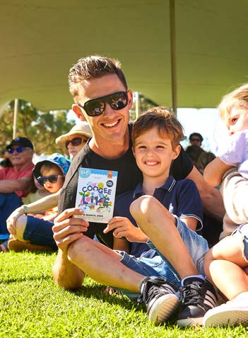
Photos: Coogee Live - March 2024.

Community Safety and Crime Prevention Plan
The City unveiled its Community Safety and Crime Prevention Plan, created in collaboration with multiple stakeholders, including the WA Police Force and Neighbourhood Watch WA. Key initiatives include the installation of CCTV cameras, AI-assisted monitoring for vulnerable individuals, and educational workshops for residents. The plan aims to empower the community and enhance overall safety.

Emergency Services Volunteer Dinner
The City hosted its annual Volunteer Emergency Services Dinner to recognise the invaluable contributions of local emergency services volunteers. This event included a Welcome to Country by Nyungar Elder Marie Taylor and acknowledged the dedicated efforts of local brigades and services in keeping the community safe.

Malabar Park BMX Facility Redevelopment
Cockburn Council endorsed a $6.88 million tender (construction cost) for the redevelopment of the Malabar Park BMX facility, aimed at creating a venue capable of hosting national-level events. The new racing track and clubroom will serve the local BMX community and broader public, with completion expected in early 2025.

Sports Hall of Fame Inductions
The City welcomed 14 new inductees into its Sports Hall of Fame, celebrating a diverse array of athletes and administrators. This induction ceremony highlighted the accomplishments of local sports people and the vital role of junior clubs in developing talent at both national and international levels.
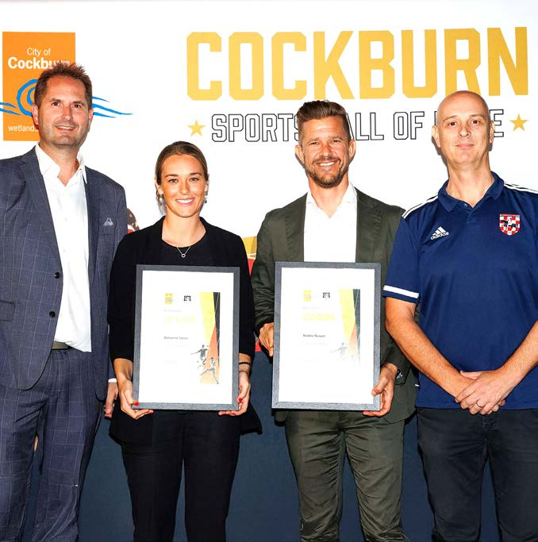
Photo: Sports Hall of Fame (SHoF) - April 2024. (Left to Right) Alan Pecotic, Western Knights Soccer Club; Marianna Tabain, Soccer SHoF; Robbie Gaspar, Soccer SHoF; and Dean Zlendic, Western Knights Soccer Club.

Key accomplishments 2023-24
The following section offers a comprehensive overview of the City of Cockburn's key accomplishments and achievements across its various directorates. We have also included insights into the challenges and opportunities that lie ahead in future financial years, providing valuable information for our community.

Community and Place Directorate
- Family Day Care (FDC): Cockburn’s Family Day Care services have earned significant recognition at the national level. The service was nominated for Service of the Year at the Family Day Care Australia Awards, reflecting the City’s commitment to providing high-quality childcare. In addition, two FDC Coordinators were nominated for Coordinators of the Year, and 18 dedicated educators received nominations for Educator of the Year, underscoring the excellence and professionalism within the service.
- Seniors Centre: The Friendship Group from the Seniors Centre was celebrated at an international level, receiving praise at a World Health Organisation webinar, highlighting the Centre’s role in fostering social connections for older residents. New initiatives at the Seniors Centre included the introduction of seven new activities such as Tai Chi, Chair Yoga, and the highly successful Friendship Group, enhancing both physical and social wellbeing for seniors in the community.
- New Initiatives: The City launched several important community initiatives this year:
  - Resident Groups Grant Program: Re-envisioned to better support local groups, the program aims to empower residents to actively engage with their communities and lead local projects.
  - Women’s Networking Events: This new platform was established to facilitate connections and opportunities for women across the City, promoting leadership, support and collaboration.
  - Volunteer Appreciation Program: Acknowledging the vital role volunteers play in the community, this program was launched to recognise and celebrate their contributions.
  - Mosaic Festival 2024: Held for the first time in April, this multicultural celebration brought together residents from diverse backgrounds to showcase the rich tapestry of cultures in Cockburn, enhancing community cohesion.
- Cockburn Care: The City’s aged care and disability support service, Cockburn Care, passed the National Disability Insurance Scheme (NDIS) midterm audit with zero noncompliances. This achievement demonstrates Cockburn’s commitment to providing high-quality, compliant services for people with disabilities, ensuring that the service meets the stringent standards of the NDIS.
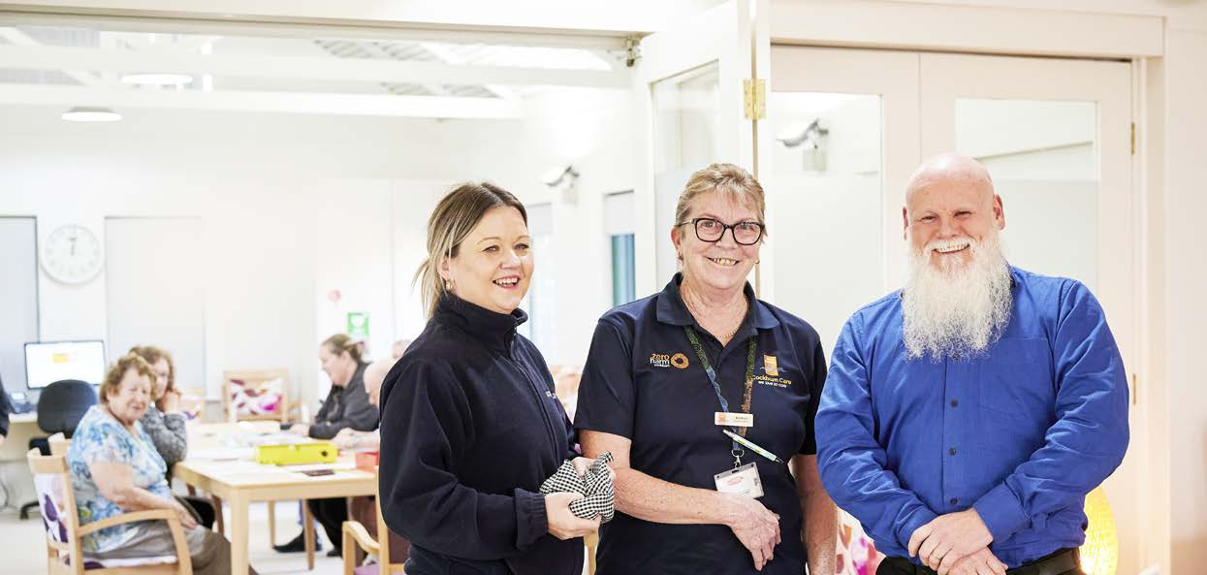
Photo: Cockburn Care. (Left to Right) Narelle Brunalli, Activities Officer; Kathryn George, Activities Officer; and Paul Norlin, Social Club Coordinator.

Youth services in Cockburn have seen notable developments and recognitions this year.
- Collaboration with Youth Affairs Council of WA: The City partnered with the Council to develop a new five-year service level plan, ensuring that youth services continue to meet evolving community needs.
- Youth Development Officer Award: The City’s Youth Development Officer received a midyear recognition award in the "Inclusive" category, acknowledging their efforts to foster inclusivity and create opportunities for all young people.
- International Recognition: The City’s own Dungeon Master won the international CRIT Award for tabletop and role-play games, furthering Cockburn’s reputation for innovation in youth engagement.
- Youth Diversity Inc.: This group was a semifinalist in the prestigious 7NEWS Young Achiever Awards, highlighting their contributions to promoting diversity and inclusion among young people.
- Youth Advisory Collective: A member of this group was a finalist for the Charmaine Dragun Memorial Award, recognising their leadership and advocacy for young people in the community.
- Cockburn Youth Outreach Program: A successful three-year review of the program was conducted by the Department of Communities, confirming the program’s positive impact on vulnerable youth.
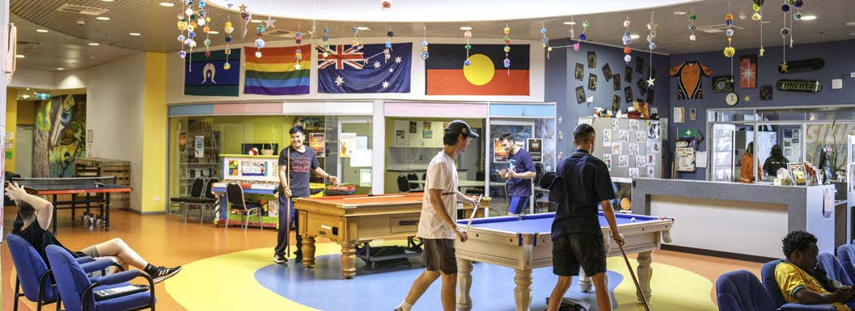 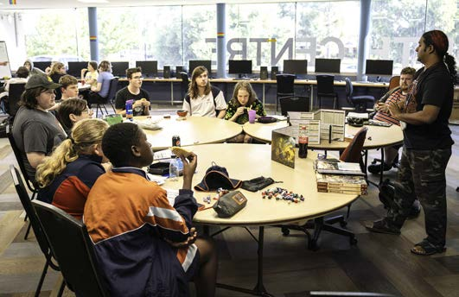 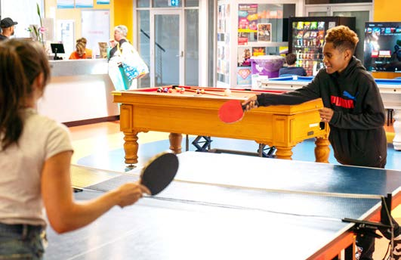
Photos: Cockburn Youth Centre, Success.

Events and Culture
- Coogee Live 2023: The City’s popular festival was nominated for the National Australian Event Awards, a testament to its success in engaging the community and providing high-quality entertainment.
- Cockburn Live: This new event platform was established, with 12 successful events delivered across the season, resulting in a 75 per cent increase in attendance and an impressive 80 percent+ satisfaction rating from attendees.
- Memorial Hall Activations: Arts and culture activations at the Memorial Hall increased by 50 per cent, reflecting the growing community interest in cultural events.
- Azelia Ley Museum: The museum celebrated its 40th anniversary, with nearly 2,000 visitors attending throughout the year. Our Local History team recorded 14 Oral Histories and reviewed over 8,000 images for inclusion in the local history collection, preserving Cockburn’s rich heritage for future generations.
- Citizenship Ceremonies: The City hosted 12 citizenship ceremonies, welcoming new Australian citizens and celebrating the growing diversity of the local population.
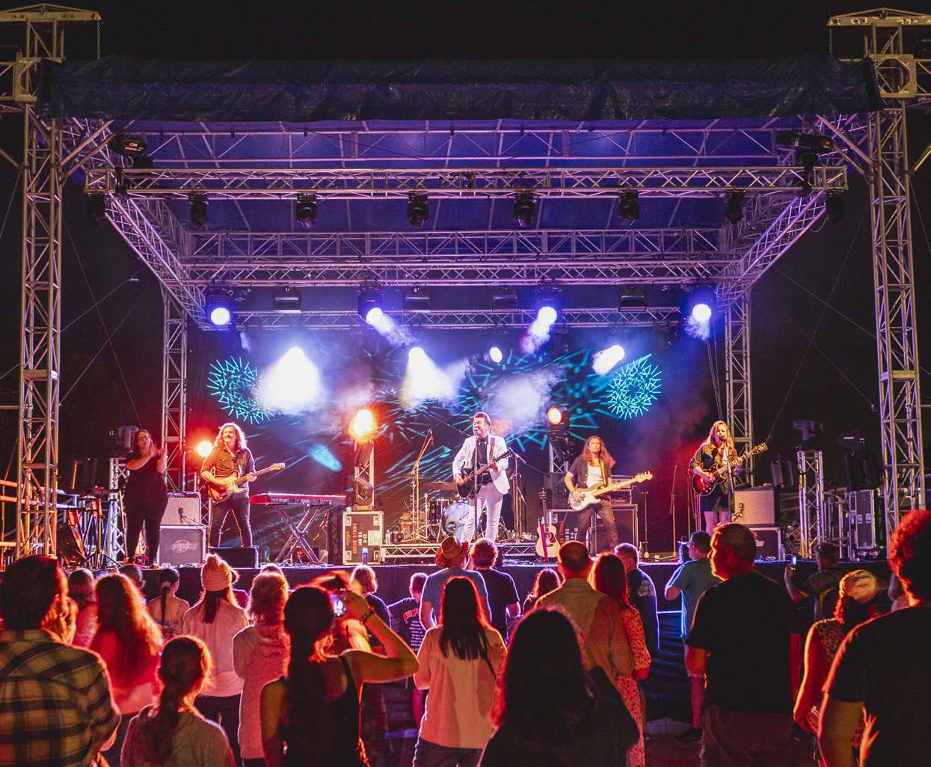
Photo: Beeliar Sun Sets at Nicholson Reserve, Yangebup - November 2023. Kav Temperley performance.

Library Services
Cockburn’s library services have continued to expand, meeting the growing demand from the community:
- Loans: Total material loans increased from 628,069 to 664,830 year on year, with e-loans now comprising 24 per cent of all loans, reflecting the growing trend towards digital media.
- Library Visits: The City’s three libraries saw a rise in visits, reaching 358,293 visitors, up from 326,664 the previous year.
- Community Engagement: More than 38,000 people participated in library events and programs, a notable increase from the previous year’s 22,357. Additionally, 7,368 new members joined the libraries in 2023-24, further emphasising the importance of library services to the community.
- Coolbellup Library Refurbishment: Completed within budget, this refurbishment rejuvenated the Coolbellup Hub precinct, creating flexible spaces for programs and events.

Community Safety and Ranger Services
The City made significant strides in enhancing safety and security for residents:
- Bushfire Risk Management: The Cockburn Bushfire Risk Management Plan (2023-2028) was adopted, ensuring a proactive approach to mitigating fire risks across the community.
- CCTV Home Rebate Program: Two successful rounds of the program were completed, providing $100,000 in rebates for CCTV installations in 200 households, improving home security.
- Ranger Services: A review of ranger-related procedures led to a significant increase in proactive animal patrols, from 808 in 2022-23 to 2,147, ensuring public spaces are safe and well-managed.
- Parking Operations: The City’s parking team was runner-up in the Parking Australia Awards for Excellence in Technology and Innovation, recognising Cockburn’s forward-thinking approach to parking management.

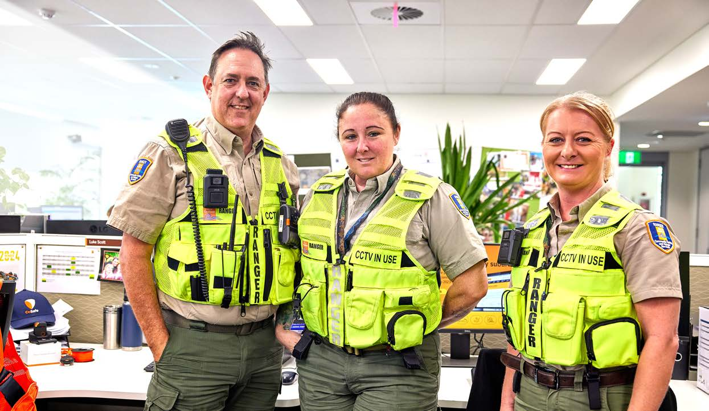
Photo: City of Cockburn Rangers. (Left to Right) Peter Callaghan; Carrie Catlin; and Emily Jasper.

Recreation Infrastructure and Services
Cockburn’s focus on recreation and infrastructure has led to several important developments:
- Leisure Institute Award: The City won the Leisure Institute of Western Australia Safety Award, setting a new safety benchmark for leisure services with a 98.41 per cent rating.
- Port Coogee Marina: The marina maintained an impressive 80-90 per cent occupancy, surpassing projected targets. Efficiencies were introduced in licence and invoice administration, and a Business and Operations Review was completed to ensure long-term sustainability.

Financial Counselling Services
176 clients were assisted with issues ranging from debt management to consumer rights, with the team securing $153,290 in debt waivers.

Children’s Development
Teddy Bear’s Picnic attracted over 10,000 attendees, and participation in Froggy’s Fun on the Green doubled.

Cockburn Parenting Service
276 families benefited from free parent education workshops and support, with 98 per cent of parents reporting that the programs helped them better understand their children’s needs.

Cockburn Support Service
210 clients received free counselling, with a 100 per cent satisfaction rate with the service.

Community Grants
Community Grants Program provided $1.45 million in grants, donations, sponsorship, and subsidies for the local community.

Infrastructure Services Directorate

Irrigation Initiatives
The City has initiated ongoing irrigation installations at Manning Park and Beeliar Reserve, aiming to improve the sustainability and health of local green spaces.

Innovative Trials
A trial involving soil moisture sensors and controlled-release fertiliser has been implemented at Legacy Park to optimise plant growth while mitigating environmental impacts. The application of slow-release nitrogen fertiliser in active reserves and fenced dog parks has also proven effective in maintaining healthy green areas.

Collaboration with Educational Institutions
An agreement with the Department of Education has been developed for shared-use sites, reflecting the City’s commitment to collaborative partnerships that benefit the community.

Challenges
Ongoing recruitment challenges in Cockburn Care impacted service delivery.
Rising costs put additional pressure on community services, including the Seniors Centre, where increased food prices have created challenges in maintaining menu variety.

Opportunities ahead
Despite these challenges, Cockburn has several exciting opportunities ahead.

Supporting female sporting facilities
The City aims to secure federal funding to support the development of female sporting facilities and expand youth mental health services in collaboration with the Youth Affairs Council of WA.

Baby Makes 3 program
The program will be expanded, with a grant of $400,000 allowing the delivery of First Nations-specific and culturally and linguistically diverse (CALD) versions, further supporting families in the community.
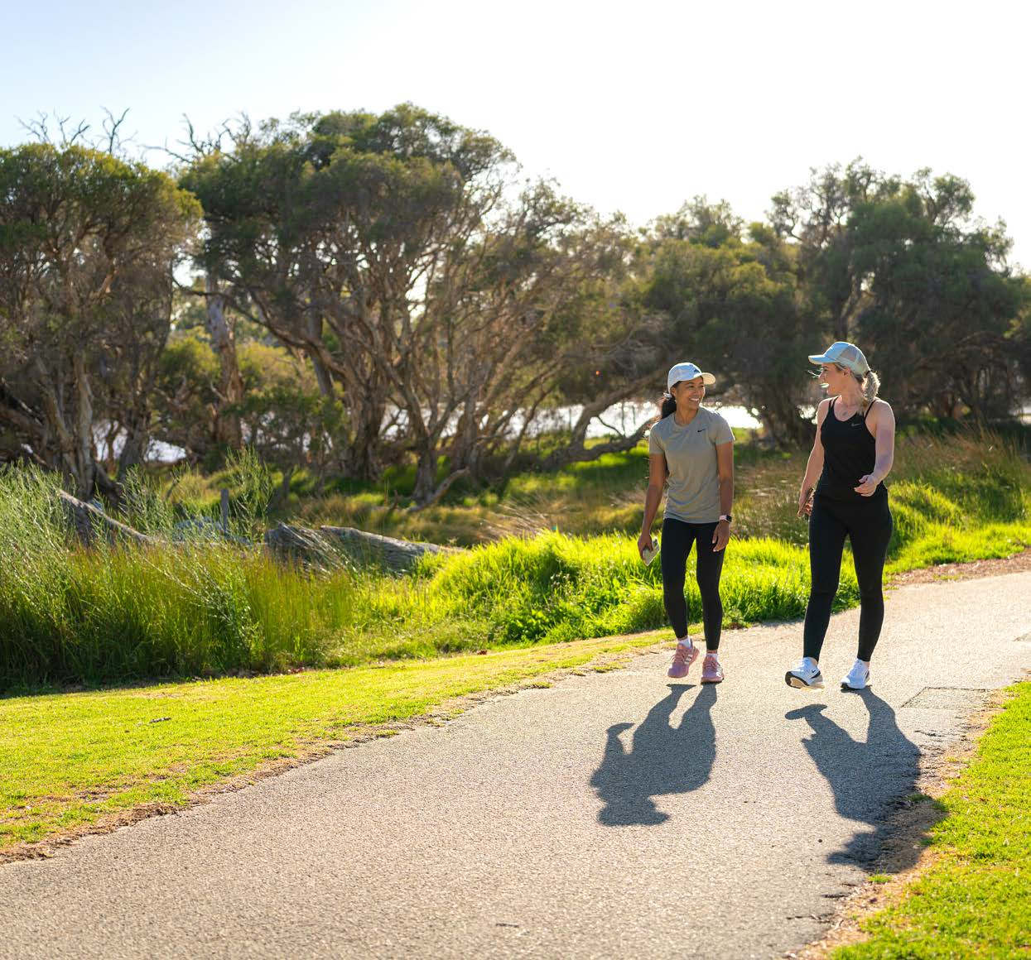
Photo: Manning Park, Hamilton Hill.
The City of Cockburn remains committed to fostering a vibrant, safe, and inclusive community. Through innovative initiatives and strategic collaborations, the City continually seeks new avenues to enhance the quality of life for residents. The emphasis on community engagement, infrastructure development, and safety measures underscores Cockburn's dedication to creating a thriving environment where all community members can prosper.

Community satisfaction
The Community, Lifestyle, and Security Strategic Outcome is of utmost importance to the Cockburn community, reflecting its commitment to safety, belonging and vibrant communal spaces. Residents place a high value on having accessible areas for activities such as dog parks, BBQs and exercise, which foster connections among neighbours.
Feedback from the community highlights a strong desire for enhanced neighbourhood safety and personal security, both of which are critical to improving liveability. Currently, the metrics related to these areas are below the desired levels. Addressing these concerns through improved security measures and expanded social infrastructure, such as recreational facilities and community programs, will help create a safer and more inclusive environment for all residents. Through collaborative efforts and targeted initiatives, we can enhance the community's overall quality of life and sense of security.
Community Lifestyle and Security:
- Cockburn: 6.6
- Western Australia: 6.7
- Australia: 6.7
Community, Lifestyle and Security outcome metrics | Community satisfaction rating
Welcoming to all people | 7.7
There are people like me (age, gender, interests, ethnic backgrounds, etc.) | 7.6
Mix or diversity of people in the area | 7.4
Spaces suitable for specific activities or special interests (entertainment, exercise, dog park, BBQs, etc.) | 7.4
Free places to sit comfortably by yourself or in small groups | 7.2
Spaces for group or community activities and/or gatherings (sports, picnics, performances, etc.) | 7.0
Sense of belonging in the community | 6.9
Access to shared community and commercial assets (library, bike/car share, sport facilities/gyms, etc.) | 6.8
Spaces suitable for play (from toddlers to teens) | 6.7
Sense of connection to/feeling support from neighbours or community | 6.7
Physical comfort (including noise, smells, temperature, etc.) | 6.6
Child services (child care, early learning, after school care, medical, etc.) | 6.5
Sense of personal safety (for all ages and genders, day or night) | 6.5
Local community groups and organisations | 6.4
Family and community services (aged, disability and home care, protection and support services, etc.) | 6.2
Evidence of community activity (volunteering, gardening, art, community-organised events, etc.) | 6.1
Sense of neighbourhood safety (from crime, traffic, pollution, etc.) | 6.0
Cultural and/or artistic community | 5.3
Local history, historic buildings or features | 4.8
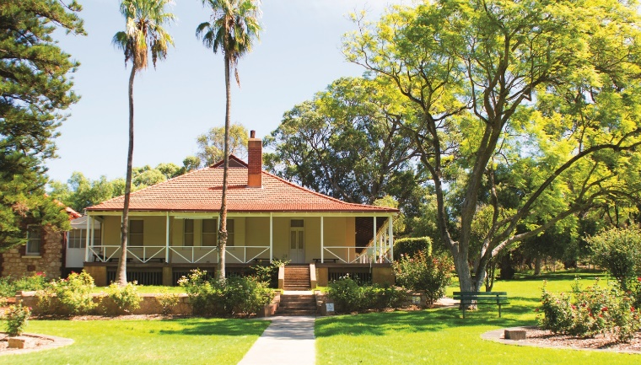 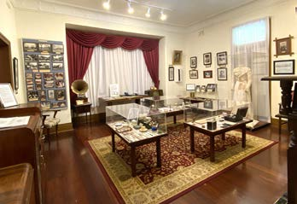
Photos: Azelia Ley Homestead Museum, Manning Park, Hamilton Hill.

Community, Lifestyle and Security Corporate Business Plan Progress 2023-24
The CBP Progress Report showcases our accomplishments in achieving the objectives set out in the Community, Lifestyle and Security outcome. It provides an overview of each project, overall progress status, quarterly milestones, and notes explaining our achievements as of 30 June 2024. These initiatives are essential to making Cockburn, the best place to be.

Community, Lifestyle and Security - Projects/activities
Project/activity | Q1 Milestones for 2023-24 | Q2 Milestones for 2023-24 | Q3 Milestones for 2023-24 | Q4 Milestones for 2023-24 | Notes
3.1.1b. Development of new Youth Plan  Overall progress: Incomplete | Complete plan brief, commence plan review  Complete | Stakeholder engagement underway  Complete | Stakeholder engagement complete  Not on track | Draft submitted to Council  Not on track | We’re preparing a review of the Youth Services Strategy 2017-2022, which will be presented to the Council in Q1 FY2025.
3.1.2a. Development of new Arts and Culture Strategy  Overall progress: Reforecast | Commence RFQ process  Not on track | Consultation engaged  Not on track | Stakeholder engagement phase underway  Not on track | Stakeholder engagement phase underway  Complete | The Arts and Culture Strategy is on track for completion in February 2025, with timelines aligned with our Long-term Financial Plan.
3.1.2b. Develop Public Art Masterplan  Overall progress: Reforecast | Stakeholder engagement phase underway  Not on track | Stakeholder engagement phase underway  Not on track | Stakeholder engagement phase underway  Complete | Stakeholder engagement phase underway  Complete | We’re waiting on the findings of stakeholder engagement to proceed with the Public Art Masterplan.
3.1.3a. Review Public Health Plan 2013-2018  Overall progress: Complete | Commence review of Public Health Plan (PHP)  Not on track | Publish Public Health Plan  Not on track | PHP Action Table to be updated to reflect new structure, operational outcomes and actions as described by Service Unit Managers  Not on track | Complete review and close out of Public Health Plan 2013-2018 and close out report submitted to council  Complete | The review of our previous Public Health Plan is complete.
3.1.4a. Commence Malabar BMX Park Redevelopment  Overall progress: Incomplete | Construction Commencement  Not on track | Project progressing  On track | Construction Commenced  Complete | Construction Complete  Not on track | The BMX Park redevelopment is now scheduled for completion in Q2 FY2025.
3.1.4b. Beale Park Redevelopment  Overall progress: Incomplete | Refer to Expenditure Review Committee  Not on track | Project progressing  On track | Project progressing  On track | Market Engagement (Tender) and Award  Not on track | The Beale Park redevelopment program is a multiyear project which is ongoing, with new milestones set for FY2025.
3.1.4d. Wally Hagan Recreation Centre Redevelopment business case  Overall progress: Incomplete | Stakeholder engagement, needs and site assessment  Not on track | Stakeholder engagement and revised concept plan  Not on track | Initial stakeholder engagement, concept design and feasibility  Complete | Draft Needs Assessment, Concept Design and Feasibility Study presented to Council (internal business case)  Not on track | The business case for Wally Hagan Recreation Centre is under development, with the Council expected to review it in Q1 FY2025.
3.1.4e. Cockburn ARC – Health and Fitness Expansion (Commence works)  Overall progress: Complete | Market Engagement (Tender) and Award  Not on track | Construction Commencement  Not on track | Construction Commenced  Complete | Project progressing  Complete | Work on the Cockburn ARC expansion has started and is scheduled to finish by June 2025.
3.1.4f. Coogee Golf Course Review  Overall progress: Complete | Project progressing  On track | Project progressing  On track | Flora and Fauna Study complete. Continue Aboriginal and Historic Heritage due diligence  Complete | Continue Aboriginal and Historic Heritage due diligence  Complete | Key environmental and heritage surveys are complete, with further work scheduled for FY2025.
3.1.4g. Beeliar Reserve Redevelopment  Overall progress: Incomplete | Concept design and community engagement – phase 2  Not on track | Feasibility study complete  Not on track | Continue needs assessment and feasibility study  Complete | Submit needs assessment and feasibility study to Council  Not on track | The Beeliar Reserve project is progressing, although delayed, with adjustments made to the project plan and external expertise being brought in.
3.1.4h. Tempest Park Redevelopment  Overall progress: Incomplete | Concept design and community engagement – phase 2  Not on track | Feasibility study complete  Not on track | Continue needs assessment and feasibility study  Complete | Submit needs assessment and feasibility study to council  Not on track | Tempest Park's redevelopment is advancing, although delayed, with revised timelines and external support.
3.1.4i. Santich Park – Upgrade  Overall progress: Complete | Project progressing  Complete | Market engagement (Tender) and award  Not on track | Market engagement (Tender) and award  Not on track | Construction commenced  Complete | The upgrade to Santich Park is on track, with completion expected by November 2024.
3.1.4k. Review the Community, Sport and Recreation Facilities Plan 2018-2033  Overall progress: Complete | Strategic principles adoption  Not on track | Draft plan presented to Council, further engagement  Not on track | Project progressing  On track | Reviewed Community, Sport and Recreation Facilities Plan 2018- 2033 submitted to Council for endorsement for community engagement  Complete | Our Draft Community Infrastructure Plan has been endorsed by Council, and public feedback will be gathered in FY2025.
3.1.4m. Commence Omeo Public Amenities and Shelters Development  Overall progress: Incomplete | Project progressing  Complete | Design finalised  Complete | Market engagement (Tender) and award  Not on track | Construction commenced  Not on track | The construction for this project is expected to take around 26 weeks. It’s part of a multi-year plan, with updated milestones set for the 2024-25 financial year. We're on track for completion by April 2025.
3.1.4n. Development of new Age-friendly plan  Overall progress: Complete | Complete plan brief, commence plan review  Complete | Stakeholder engagement underway  Not on track | Review engagement requirements  Complete | Present close out review of Age-friendly Strategy 2016-2021 to Council  Complete | Council reviewed the Age-friendly Strategy 2016-2021 in June 2024. Instead of moving forward with a new plan right away, we’re taking time to review our existing strategies and plans to ensure they align with the community's needs before developing a new Age-friendly plan.
3.2.1b. Development of the Bushfire Risk Management Plan  Overall progress: Complete | Document drafting  Not on track | Bushfire Risk Management Plan submitted to Council  Not on track | Bushfire Risk Management Plan submitted to the Office of Bushfire Risk Management (DFES)  Complete | Commence implementation of the management plan  Complete | The Bushfire Risk Management Plan is complete and ready for implementation.
3.3.1a. Aboriginal Cultural and Visitors Centre Development  Overall progress: Complete | Finalise the scope and seek Council direction  Not on track | Project progressing  On track | EMSBF presentation (pending ARG meeting end January)  Complete | Project progressing  Complete | The Aboriginal Cultural and Visitors Centre project is moving forward, with new milestones set for FY2025 and additional funding being sought.
3.3.1b. Review the Reconciliation Action Plan 2018-2021  Overall progress: Complete | Reconciliation Plan 2023- 2026 submitted to Council for adoption  Not on track | Project complete  Complete | Project complete  Complete | Project complete  Complete | Our Reconciliation Action Plan has been endorsed and is now in the implementation phase.

City Growth and Moving Around Outcomes
As Cockburn continues to grow, strategies ensure the City's infrastructure keeps pace. Key objectives include developing an attractive and connected built environment, establishing Cockburn Central as a major regional hub, and implementing an integrated and accessible transportation network.
Strategic outcome 4. City Growth and Moving Around:
A growing City that is easy to move around and provides great places to live.
Strategic objectives:
- An attractive, socially connected and diverse built environment
- Cockburn Central as the capital of the South Metro Region
- An integrated, accessible and improved transport network
Key statistics:
- Number of projects: 5
- Number of services: 9
- Full-time equivalent employees: 93.8
- Total cost: $46.4 million
Services:
- Civil Infrastructure Services
- Civil Projects
- Community Planning
- Development Compliance
- Development Services
- Parking Operations
- Property Services
- Strategic Planning Services
- Transport and Traffic Services
Strategies, Plans and Frameworks:
- City Wide Infrastructure Plan 2024–2025
- Housing Affordability and Diversity Strategy 2018
- Integrated Transport Strategy 2020–2030
- Local Commercial and Activites Centres Strategy
- Local Planning Strategy
- Local Planning Scheme
- Masterplans and Revitalisation Strategies
- Parking Plan 2018–2028
- Road Safety Strategy 2014–2020
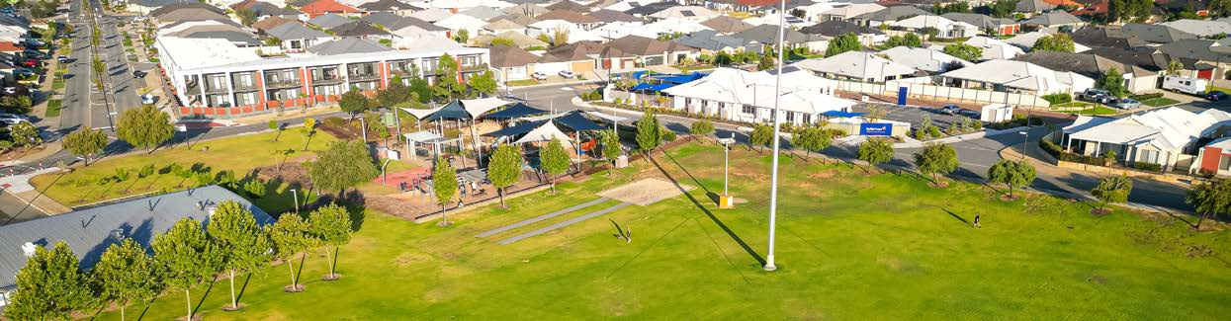
Photo: Botany Park, Hammond Park.

Achievements 2023-24
The City of Cockburn's commitment to sustainable growth and development is evident in the various initiatives undertaken in the past year. From infrastructure improvements to strategic planning, the City has strived to address the challenges associated with rapid urbanisation and ensure a high quality of life for its residents. This section highlights key achievements in city growth and moving around, demonstrating the City's dedication to creating a developed and well-connected community.

Hammond Road upgrades and new initiatives
The City of Cockburn is actively addressing traffic congestion challenges, working alongside State and Federal Governments to improve the transport network and offer sustainable transportation options that better connect local communities.
A key achievement has been the $22.6 million upgrade of Hammond Road in Success, transforming a 1.7km stretch between Branch Circus and Bartram Road. This project now features two lanes in both directions, three new roundabouts, and improved footpaths, significantly easing travel to and from Cockburn Central for residents and commuters.
In a push towards sustainability, the project utilised 13,500 tonnes of crushed recycled concrete, covering 30,000m² — one of Perth's largest examples of sustainable road construction by a local government.
The project was funded through a joint effort by the City, the State Government's Metropolitan Regional Roads Program (MRRP), the Australian Government's Roads to Recovery Program, the Local Roads and Community Infrastructure (LRCI) Program, and developer contributions. The LRCI Program specifically supports local councils in delivering critical infrastructure projects, helping boost local economies and recovery from the COVID-19 pandemic.
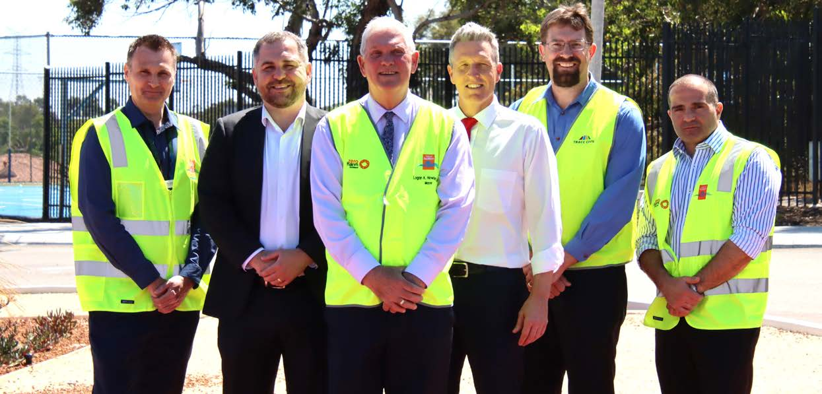
Photo: Hammond Road upgrades announcement - November 2023. (Left to Right) Terry Green, Head of Projects; David Scaife, MLA; Mayor Logan Howlett; Josh Wilson, MP; Frank Janssen, Tracc Civil; and Ali Afashang, Manager Civil Projects.

Key accomplishments 2023-24
The following section offers a comprehensive overview of the City of Cockburn's key accomplishments and achievements across its various directorates. We have also included insights into the challenges and opportunities that lie ahead in future financial years, providing valuable information for our community.

Infrastructure Services Directorate
The City of Cockburn has made significant strides in infrastructure improvements and service delivery over the past year, addressing community needs and preparing for future growth.

Customer Requests and Graffiti Management
The Facilities Team attended to and closed out 4,900 customer requests, with 200 of these related to graffiti. This demonstrates the City’s commitment to maintaining public spaces and responding to community concerns promptly.

Stratton Street Drainage Upgrades
The City commenced the construction of critical drainage upgrades on Stratton Street to mitigate flooding risks and ensure the area’s sustainability during extreme weather events.

Design and Market Engagement for Edeline Street and Hobley Way Drainage Improvements
The design phase and market engagement for drainage improvements along Edeline Street and Hobley Way have been completed. This sets the stage for future upgrades to improve water management and infrastructure resilience.

Telecommunication Tower for Treeby/Jandakot
A telecommunication tower site has been secured for the Treeby and Jandakot suburbs, addressing a significant dead spot in the area. This initiative will improve mobile connectivity and enhance communication services for residents and businesses.
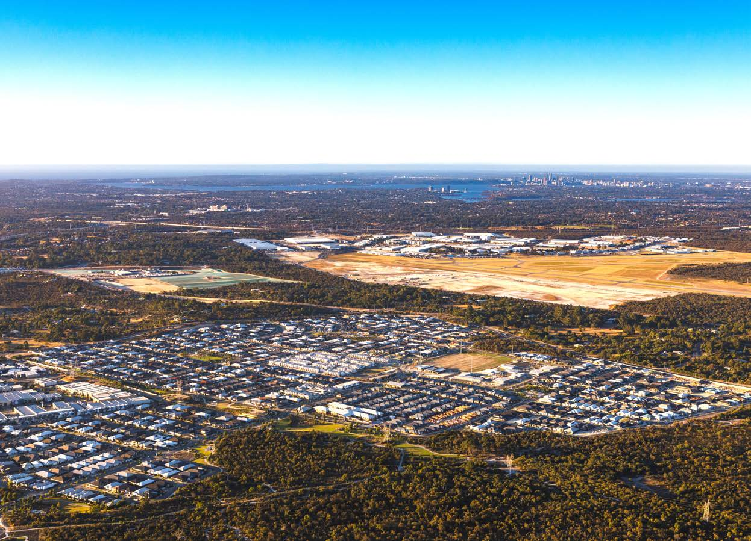
Photo: Treeby and Jandakot.

Planning and Sustainability Directorate
The City of Cockburn continues to prioritise sustainable growth and development while securing external funding to mitigate financial pressures on the community.

Grant Funding for Road Safety Projects
The City successfully secured grants for several road safety projects, reducing the financial burden on local ratepayers. These grants enable the City to improve road safety across Cockburn while ensuring cost-effective project delivery.

Rehabilitating Roe 8 Signage Plan
The implementation of the Rehabilitating Roe 8 Signage Plan was completed, with fourteen corten steel signs installed in the bushland corridor. These signs provide wayfinding and interpretive information, complete with QR codes linked to the Beeliar Woodland Walks website, promoting environmental education and public engagement.

Local Planning Strategy and Scheme
The City made considerable progress in its strategic planning initiatives to guide future growth and development.

Local Planning Strategy (LPS)
The City’s Local Planning Strategy reached a key milestone with the submission of the strategy to the State for approval, following community consultation and adoption by the Council. This is the first update since the late 1990s, marking an important step in Cockburn’s urban planning framework.

Local Planning Scheme
In conjunction with the LPS, the Council adopted a draft Local Planning Scheme, which will act as the practical tool for implementing the strategy’s objectives. The scheme is awaiting the Minister for Planning’s consent for public advertising.

Development Contributions and Housing Supply

Development Contributions
Development Contribution Plans (DCPs) are crucial in managing the infrastructure needs of growing communities without placing excessive financial strain on existing ratepayers. Over 500 new lots were added to Perth’s housing supply within Cockburn in FY2023-24, contributing to development funds for future infrastructure projects. These funds are strictly allocated to specific projects, ensuring responsible management and financial transparency.
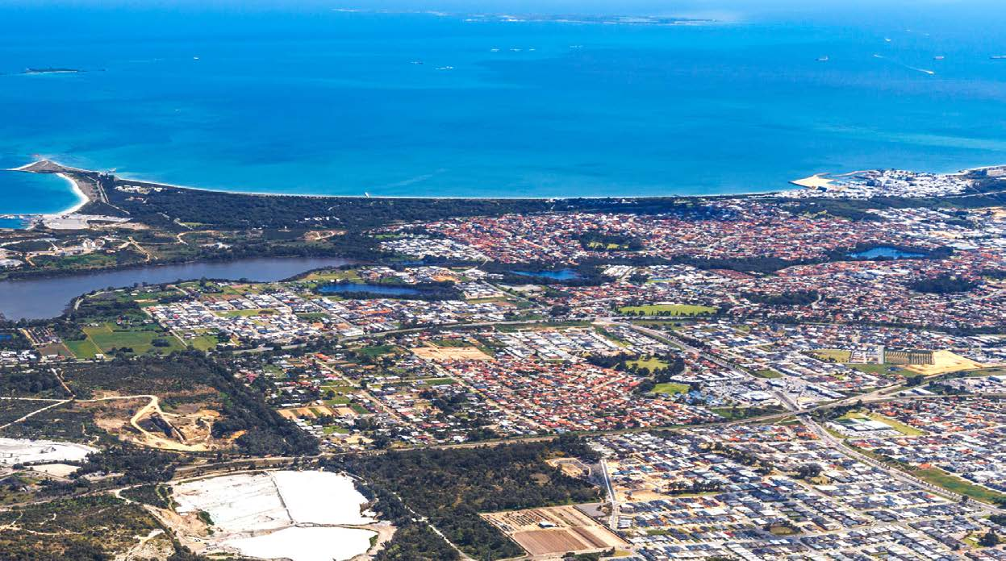
Photo: Beeliar and Lake Coogee.

Transport and Traffic Management

District Traffic Study
The City made significant progress in reviewing its District Traffic Study, a strategic assessment that models the impacts of various transport network investments. The study will help guide future infrastructure investments and behaviour-changing programs aimed at improving traffic flow and safety across Cockburn.

Addressing Pressures in Growth and Sustainability

Building and Construction Industry Pressures
Despite significant planning efforts, the building and construction industry faces challenges due to rising costs and project delays, particularly in higher-density developments like apartment buildings. The City remains focused on addressing these issues while contributing to Perth’s housing supply.

Coastal Erosion and Sand Nourishment
Climate change and coastal erosion pose ongoing challenges for maintaining the City’s beaches. To combat these effects, the City has imported sand to nourish affected areas, ensuring that beach user amenity is preserved. However, finding reliable sand sources is becoming increasingly difficult, necessitating careful future planning.

Strategic Planning for Growth

Coogee Beach Masterplan Review
The City conducted a thorough review of the Coogee Beach Masterplan, gathering community insights to shape the future of this treasured coastal area. The masterplan aims to balance environmental sustainability with community values, addressing coastal pressures and ensuring the area remains a vibrant part of the community.

Urban Growth in Treeby and Jandakot
The City received confirmation from the Minister for Planning regarding the future urban development of land in Treeby and Jandakot. This strategic area requires a district-level structure plan to integrate key infrastructure such as schools, parks, and road connections, ensuring the area develops cohesively.

Roe 8 and 9 Highway Reservation Removal
The formal processes to remove the Roe 8 and 9 highway reservation have been initiated by the State government. This step will enable continued rehabilitation of the corridor and allow for future planning schemes that focus on creating green ecological links in the area.
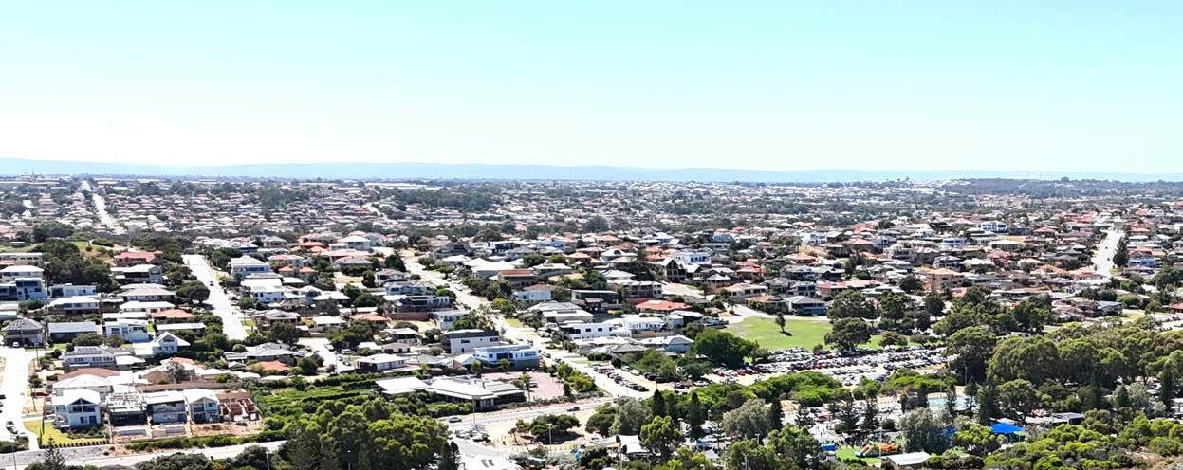
Photo: Coogee and Spearwood.

Opportunities ahead
As the City of Cockburn continues to grow, the focus remains on sustainable development, community safety, and infrastructure resilience. The strategic plans and projects outlined for FY2025 provide a strong foundation for future success, ensuring that Cockburn remains a thriving, well-connected and sustainable community.
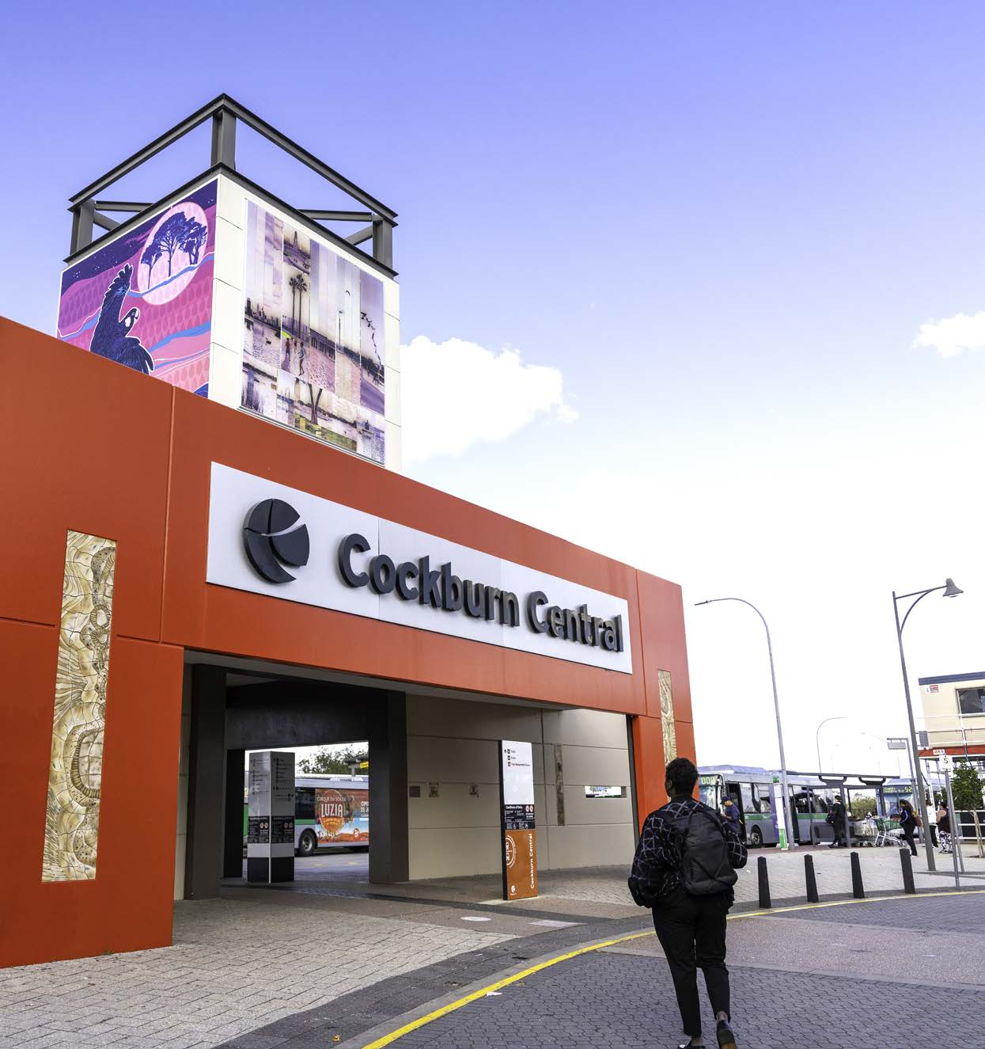
Photo: Cockburn Central Station.
The City of Cockburn has made significant progress in addressing the challenges associated with city growth and transportation. Through infrastructure improvements, strategic planning and community engagement, the City has created a more sustainable and liveable environment for its residents. As the City continues to grow and evolve, it is essential to maintain a focus on these areas to ensure a thriving and well-connected community for generations to come.

Community satisfaction
The City Growth and Moving Around Strategic Outcome is vital to the Cockburn community, which highly values safe, accessible and well-connected neighbourhoods. While residents appreciate their proximity to local amenities and existing active transport options, there is a clear need for improved and safer access to both active and public transport. Overall, the community's feedback indicates that this outcome generally meets expectations, yet nurturing the existing strengths will further enhance ease of movement throughout the area.
Community engagement has highlighted the importance of specific attributes within this outcome, ranking it third out of five strategic priorities. Four out of the nine liveability metrics associated with this outcome were identified as key indicators of an ideal neighbourhood, with access to neighbourhood amenities and the safety of transport options being particularly valued. By acting on these insights and fostering ongoing community engagement, we can create a more liveable and connected Cockburn, enhancing the overall quality of life for all residents.
City Growth and Moving Around:
- Cockburn: 7.1
- Western Australia: 7.1
- Australia: 6.9
City Growth and Moving Around outcome metrics | Community satisfaction rating
Connectivity (proximity to other neighbourhoods, employment centres, shops, etc.) | 7.6
Ease of driving and parking | 7.5
Range of housing types and sizes (houses, terraces, flats; number of bedrooms, etc.) | 7.5
Walking/jogging/bike paths that connect housing to communal amenity (shops, parks, etc.) | 7.4
Access to neighbourhood amenities (cafes, shops, health and wellness services, etc.) | 7.4
Quality of buildings (design and construction of homes, shops, schools, etc.) | 7.0
General condition of housing and other private buildings | 7.0
Access and safety of walking, cycling and/or public transport (signage, paths, lighting, etc.) | 7.0
Range of housing prices and tenures (low to high $, buy or rent, etc.) | 6.1

City Growth and Moving Around Corporate Business Plan Progress 2023-24
The CBP Progress Report showcases our accomplishments in achieving the objectives set out in the City Growth and Moving Around outcome. It provides an overview of each project, overall progress status, quarterly milestones, and notes explaining our achievements as of 30 June 2024. These initiatives are essential to making Cockburn, the best place to be.

City Growth and Moving Around - Projects/activities
Project/activity | Q1 Milestones for 2023-24 | Q2 Milestones for 2023-24 | Q3 Milestones for 2023-24 | Q4 Milestones for 2023-24 | Notes
4.1.1b. Local Planning Scheme Review (Commence Preparation)  Overall progress: Complete | Project progressing  Complete | Project progressing  Complete | Local Planning Scheme drafting and testing complete  Complete | Draft Local Planning Scheme presented to Council (consider adoption for advertising)  Complete | We've completed all milestones for the Local Planning Scheme, which is now ready for the next steps.
4.1.1c. Preparation of Coogee Beach Masterplan  Overall progress: Complete | Site analysis completed  Complete | Document drafting (Role and Vision)  Not on track | Community engagement plan submitted for consideration (internal process)  Complete | Complete site analysis phase  Complete | The Coogee Beach Masterplan is progressing, with initial public feedback being compiled for further consideration.
4.1.2c. Civic facilities planning  Overall progress: Incomplete | Complete high-level review with consultant  Complete | Prepare and present briefing to Council  Complete | Commencement of feasibility  Complete | First draft of feasibility complete  Not on track | The planning for new/upgraded civic facilities is delayed, with further feasibility assessments scheduled for FY2025.
4.3.1a. Review and update the City’s District Traffic Study 2018  Overall progress: Incomplete | Project progressing  Complete | Draft City District Traffic Study complete  Not on track | Draft City District Traffic Study received from consultant for internal review  Complete | Updated City District Traffic Study endorsed by Council  Not on track | The updated Traffic Study will be presented to the Council in Q3 2024, following a briefing session in July.
4.3.2c. Phoenix and Rockingham Rd Roundabout (Commence works)  Overall progress: Complete | Detailed design  Complete | Relocating underground services  Not on track | Detailed design  Complete | Detailed design, specification development and safety auditing  Complete | Detailed design work on the Phoenix and Rockingham Rd roundabout has begun, with completion expected by June 2025.

Listening and Leading Outcome
The City of Cockburn is committed to good governance and effective communication with residents. Best practices in governance and partnerships, high-quality community engagement, and fostering a culture of innovation and excellence within the City are core objectives.
Strategic outcome 5. Listening and Leading:
A community focussed, sustainable, accountable and progressive organisation.
Strategic objectives:
- Best practice governance, partnerships and value for money
- High-quality and effective community engagement and customer service experiences
- Employer of choice focusing on equity, innovation and technology
Key statistics:
- Number of projects: 8
- Number of services: 23
- Full-time equivalent employees: 163.4
- Total cost: $21.9 million
Services:
- Advocacy and Engagement
- Asset Management Services
- Business Systems
- City Facilities Services
- Civic Event Services
- Communications and Marketing
- Culture and Organisational Development
- Customer Experience Services
- Executive Support and Executive Group
- Financial Accounting
- Financial Performance
- Fleet Management Services
- GIS Services
- Governance
- Information Management Services
- Legal Services
- People Experience Services
- Procurement Services
- Project Management Office
- Rates and Revenue Management Services
- Strategy and Integrated Planning
- Technology Services
- Workplace Health and Safety
Strategies, Plans and Frameworks:
- Asset Management Strategy 2017–2024
- City Asset Management Plans
- Strategic Communications Framework
- Recordkeeping Plan 2022
- ICT Strategies
- Information Governance Framework

Achievements 2023-24
The City of Cockburn's commitment to listening to and leading its community is evident in the various initiatives undertaken in the past year. From community events and awards to strategic planning and leadership development, the City has strived to foster a culture of engagement, inclusivity and excellence. This section highlights key achievements in listening and leading, demonstrating the City's dedication to serving its residents and creating a thriving community.

International Women’s Day Event
On 8 March, the City of Cockburn celebrated International Women’s Day with over 65 inspiring business and professional women. The event featured a Welcome to Country and a warm welcome from Mayor Logan Howlett. Keynote speaker Kate Gibson, founder of The Hike Collective, encouraged attendees to embrace vulnerability and dream big. The engaging World Café activity facilitated discussions on self- doubt, entrepreneurial mindset, and balancing personal and professional life, fostering a strong sense of community and collaboration.

Accessibility Recognition
Cockburn received a Highly Commended accolade at the 2023 Most Accessible Community of Western Australia (MACWA) Awards, recognising its commitment to improving accessibility through its Disability Access and Inclusion Plan 2023-2028. Mayor Howlett highlighted efforts to maximise communication accessibility, including corporate templates and staff training. Additionally, the City’s website was awarded the title of Australia’s most accessible website at the 2023 Australian Access Awards, demonstrating a commitment to inclusivity for all community members.

Australia Day Community Citizen Awards
The City of Cockburn honoured local heroes at the annual Australia Day Community Citizen of the Year Awards. Soa Palelei, a mental health and family violence ambassador, received the overall title. Other awardees included youth advocate Mackinlee Tibbits as Youth Community Citizen of the Year, and Maureen Stevens, the Senior Community Citizen of the Year. The Historical Society of Cockburn won the Active Citizenship – Group or Event award for their longstanding contribution to the community.
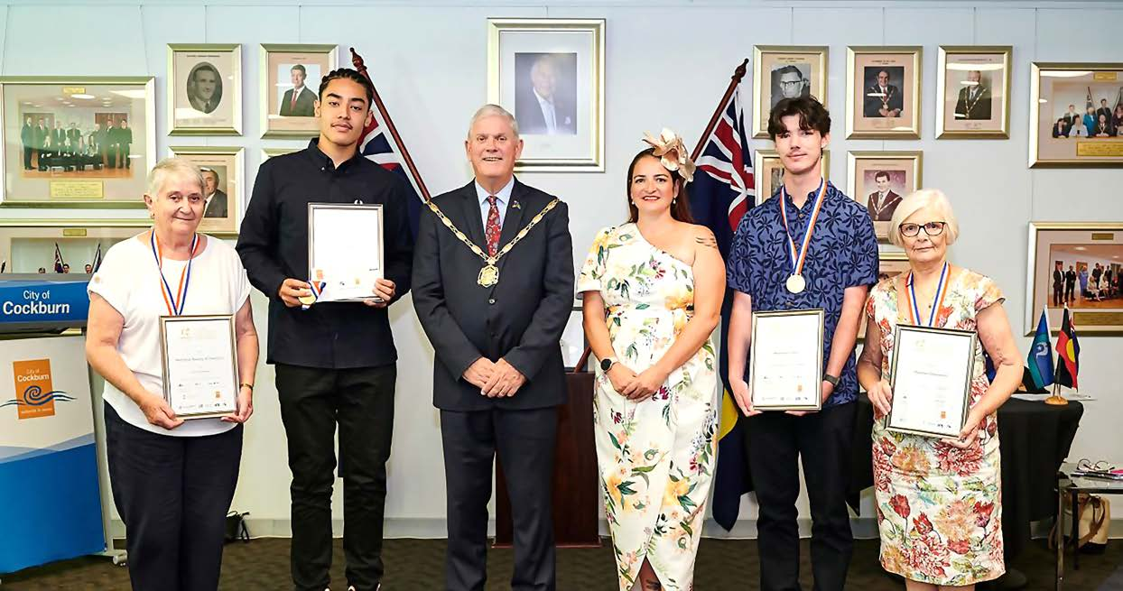
Photo: Australia Day Community Citizen of the Year Awards - January 2024. (Left to Right) Helen Greer, President of the Historical Society of Cockburn; Jonah Palelei, accepting the award on behalf of his father Soa; Mayor Logan Howlett, Deputy Mayor Chontelle Stone; Mackinlee Tibbits; and Maureen Stevenson.

Sister City Anniversary
The City of Cockburn celebrated the 25th anniversary of its Sister City relationship with Split, Croatia. A delegation from Split, including Mayor Ivica Puljak, visited Cockburn, exploring local attractions and engaging in cultural exchange. This partnership continues to enrich both communities through shared experiences and mutual understanding.

Leadership Transition
The City welcomed new CEO Daniel Simms, who brings many years’ experience in local government, including the last 20 years at the City of Wanneroo. Daniel is a seasoned local government professional with a passion for community engagement. He has a proven track record of leading growing councils and driving economic development, making him well-suited to lead Cockburn towards a prosperous future.

Budget and Financial Management
The City of Cockburn adopted its 2024-25 Budget, maintaining some of the lowest rates in Perth. Mayor Howlett emphasised a commitment to balancing quality community services with infrastructure development amid economic pressures. The budget includes significant capital works projects, focusing on asset renewals and community needs, ensuring the City’s financial stability while planning for future growth.

Local Government Election
Following the recent Local Government election, Cockburn welcomed one new Councillor, Carol (LeChun) Zhang, and three re-elected Councillors. Mayor Howlett congratulated the Councillors on their election, emphasising the importance of their role in making decisions that impact the daily lives of residents in Cockburn. The Council have elected a Deputy Mayor and appointed committee memberships.
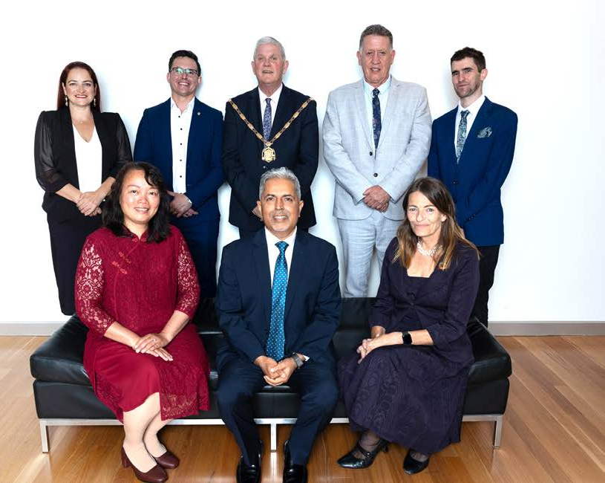
Photo: Swearing In Ceremony - October 2023. (Left to Right) Deputy Mayor Cr Chontelle Stone; Cr Carol Zhang, Cr Tom Widenbar; Mayor Logan Howlett; Cr Tarun Dewan; Cr Philip Eva JP; Cr Phoebe Corke; and Cr Michael Separovich.

Not in photo: Cr Carol Reeve-Fowkes and Cr Kevin Allen.

Key accomplishments 2023-24
The following section offers a comprehensive overview of the City of Cockburn’s key accomplishments and achievements across its various directorates. We have also included insights into the challenges and opportunities that lie ahead in future financial years, providing valuable information for our community.

Office of the CEO Directorate

Organisational review and improvement plan
The City completed a detailed review of its operations against the Australian Business Excellence Framework. This comprehensive assessment led to the development of a three-year organisational improvement plan aimed at boosting operational efficiency, enhancing service delivery, and ensuring a high level of employee engagement and professional growth.

Enhanced employee feedback system
The City implemented a revised employee survey mechanism that provides monthly insights to the Executive Leadership Team. This system analyses pulse surveys, exit surveys and onboarding feedback, delivering actionable recommendations to improve employee engagement and retention.

Revised Performance Competencies
The City overhauled its performance review process, establishing new competencies and development goals for employees. This ensures that staff are equipped with the tools and resources needed to succeed, contributing to the City’s long-term objectives while promoting personal growth and achievement.

Professional Development Framework
A review of the Professional Development and Study framework led to the centralisation of training budgets. This allows for a more consistent and equitable approach to employee development, ensuring that all staff have access to the resources they need for professional growth.

Changing industrial landscape
As the City approaches negotiations for the Enterprise Agreement in 2025, it faces potential challenges due to changes in the industrial landscape. These changes may impact the bargaining process, requiring flexibility and innovative approaches to ensure a fair and equitable outcome for both employees and the organisation.
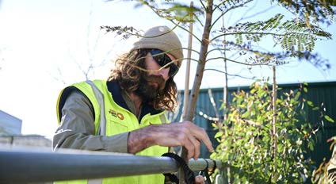 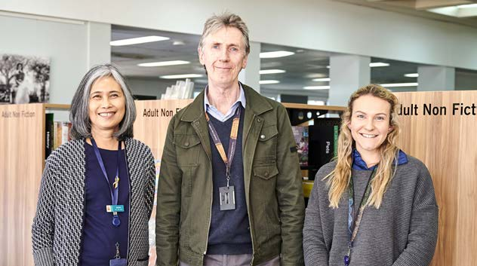
Photo 1: Logan Vickers, Parks Supervisor. Photo 2: Spearwood Library staff. (Left to Right) Sandra Swann; Clive Crocker; and Jessica Williams.

Infrastructure Services Directorate

Technology systems implementation
Infrastructure Services has implemented advanced technology systems across the business, resulting in increased operational efficiencies. These systems have streamlined processes, enabling the City to deliver services more effectively and meet community needs with greater agility.

Online street tree request system
The launch of the online street tree request system has seen a surge in resident engagement, with more requests being submitted for tree planting. This initiative reflects the City’s commitment to environmental sustainability and enhancing green spaces in the community.
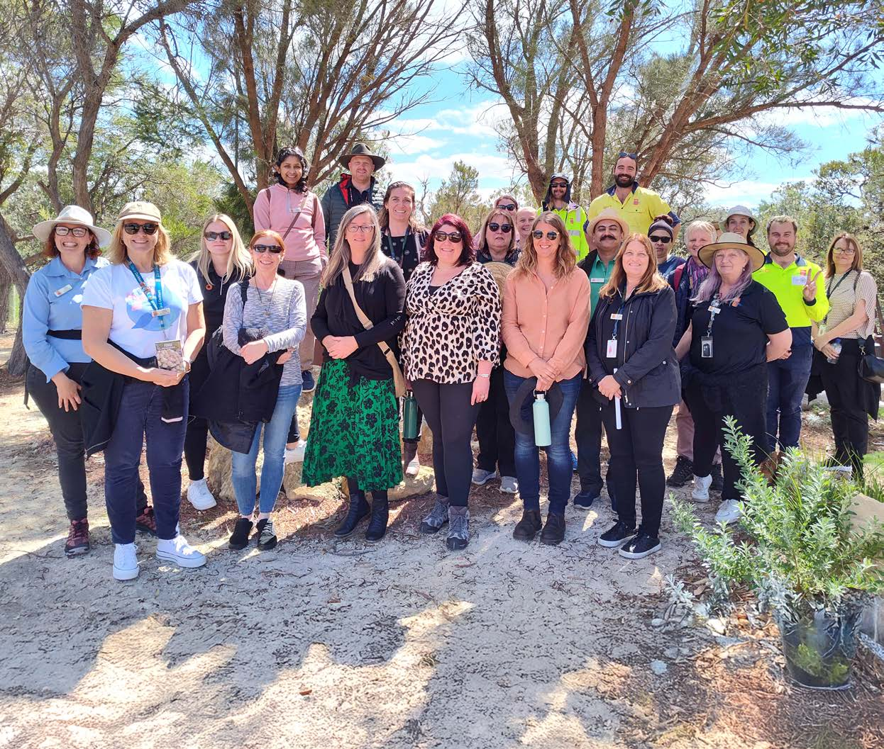
Photo: Wildflower Adventures City of Cockburn Staff Tour of Denis de Young Reserve in Banjup - September 2023.

Community and Place Directorate

Advocacy and Engagement

Smart Budget Award
The City received the IAP2 Judges' Encouragement Award in the Smart Budget category, recognising its innovative approach to community engagement in the budget process. This award highlights the City’s commitment to transparency and active public participation in financial decision-making.

Community Engagement Policy
A new Community Engagement Policy was developed, alongside improved internal processes and frameworks aimed at enhancing customer experience and reducing project delivery timelines. These changes reflect the City’s focus on efficiency and its ongoing efforts to better meet the needs of residents.

Submission to Local Government Inquiry
The City made a significant submission to the Parliamentary Inquiry into Local Government Sustainability, contributing valuable insights and advocating for the interests of local governments across the region.

Animal Management Plan Consultation
In response to the Animal Management Exercise Plan review, the City engaged over 700 community members in a consultation regarding dogs-off-lead areas. This high level of participation reflects the City’s commitment to community involvement in decision-making.

Skydiving Leisure Licence Consultation
The City developed and conducted a consultation process for a skydiving leisure trading licence, ensuring that community feedback was incorporated into the decision-making process.

National Growth Area Alliance Forum
In partnership with the City of Gosnells, Cockburn hosted the National Growth Area Alliance WA forum, bringing together stakeholders to discuss growth challenges and opportunities across the region.

Roof Colour Ban Advocacy
The City successfully advocated for a ban on dark-coloured roof materials, with the motion being adopted by the Australian Local Government Association’s General Assembly, marking a significant achievement in environmental advocacy.

Politics and Business Events
In partnership with Business News, the City delivered a series of Politics and Business events featuring Parliamentarians Roger Cook, John Carey, and Libby Mettam, providing a platform for business leaders and government representatives to discuss key issues affecting the region.
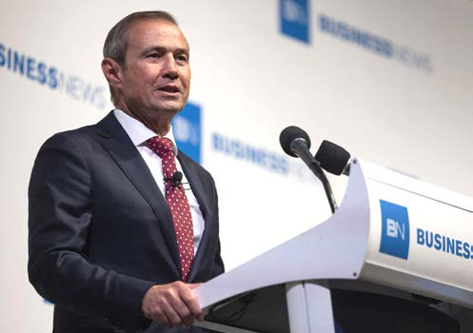
Photo: Business News event - January 2024. Hon. Roger Cook, MLA, WA Premier.

Corporate and System Services Directorate

Staff Secondment Agreement
The City initiated a Memorandum of Understanding with the City of Canning to facilitate staff resource sharing through secondments. This agreement fosters collaboration between local governments and supports workforce development.

Procurement Policy Revision
The City revised its procurement policy to improve efficiency and governance, ensuring that the procurement process is transparent and aligned with best practices.

Long-term Financial Planning
The City revitalised its Long-term Financial Planning and Funding Framework, positioning itself for financial stability and resilience in a challenging economic environment.

Managing cost-of-living challenges
In response to the cost-of-living crisis and high inflation, the City worked diligently to balance its budget while maintaining essential services and minimising the impact on residents.

Supply chain constraints
The City faced challenges due to a constrained supply market, impacting service delivery. However, efforts to mitigate these impacts ensured the continued provision of high-quality services to the community.

Staff device refresh
The City initiated a staff device refresh, replacing outdated 'Zero Client' virtual desktop computers with modern laptops, dual 27-inch screens and wireless keyboards and mice. This upgrade, starting in October 2024, will enhance mobility and efficiency for desk-based employees.

Modernising workstation infrastructure
The City is also modernising its server and desktop infrastructure, enabling staff to work from anywhere, enhancing software compliance, and improving cybersecurity. The long-term goal is to phase out the VMWare Horizon View system, streamlining operations and improving performance.

Cloud transition for TechnologyOne
The City is migrating its TechnologyOne software suite to a cloud-based platform, improving access, business continuity, and operational efficiencies. This shift aligns with the City’s broader digital transformation strategy, ensuring that its technological infrastructure remains cutting-edge and resilient.
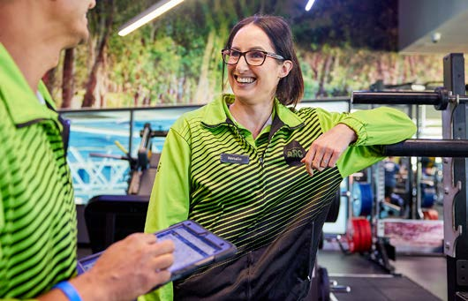 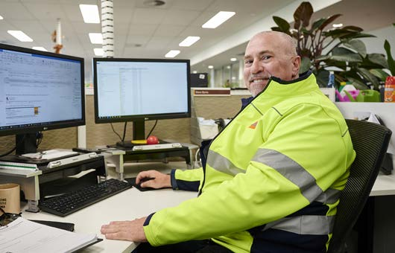
Photo 1: Cockburn ARC - Natalie Forycki. Photo 2: Road Construction Services - Steven Byrne.

Opportunities ahead

Leveraging technology
Continued investment in technology will enable the City to further streamline operations, improve service delivery and enhance community engagement.

Service reviews
The City is conducting service reviews aimed at refining operational processes and aligning them more closely with community needs. These reviews will provide valuable insights into how services are delivered, enabling the City to enhance efficiency and improve the overall service experience for residents.

Strengthening community partnerships
Fostering stronger partnerships with community groups, businesses and other stakeholders will drive innovation and address local needs.

Developing a skilled workforce
Investing in employee development and training will ensure the City has a skilled and motivated workforce to meet future challenges.
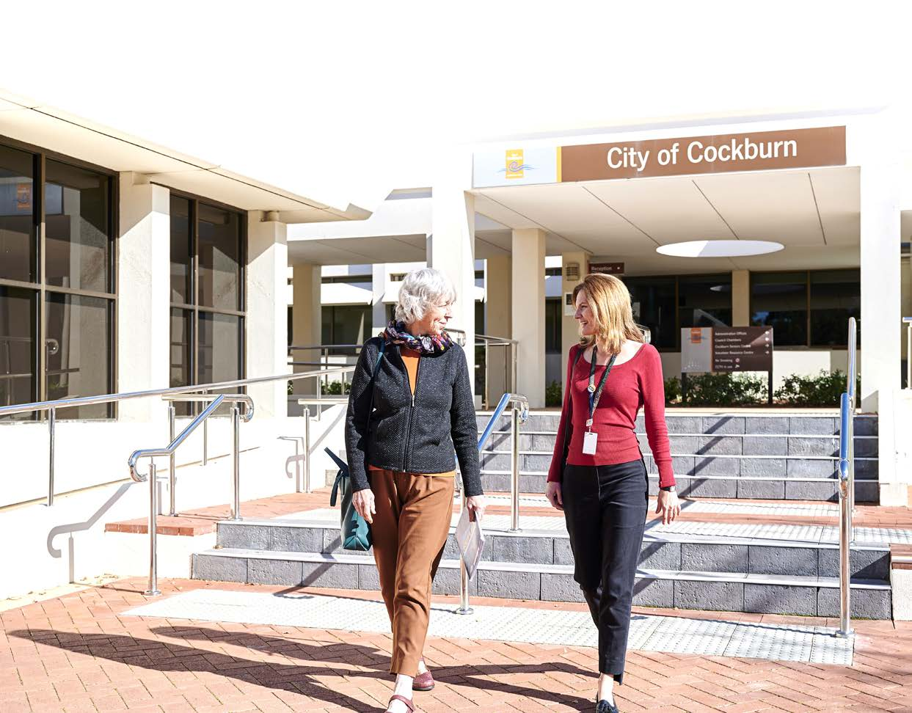
Photo: Administration Building, Spearwood. Barbara Freeman, Reconciliation Lead and Lisa Dyson, Internal Communications Officer.

The City of Cockburn's dedication to listening to and leading its community has been instrumental in fostering a thriving and vibrant environment. By prioritising community engagement, recognising outstanding individuals, and implementing strategic initiatives, the City has demonstrated its commitment to serving the needs of its residents. As the City continues to grow and evolve, it is essential to maintain this focus on listening and leading.

Community satisfaction
The Listening and Leading Strategic Outcome currently holds a lower priority within the Cockburn community, primarily due to a limited number of associated metrics. While the community may not rank this outcome highly, there remains a clear need for regular maintenance activities, such as street cleaning and signage upkeep. Transparent communication regarding ongoing and completed infrastructure projects would also enhance community trust and engagement. In the overall assessment, this outcome was rated fifth out of five, reflecting its lesser significance compared to other strategic outcomes.
Despite the lower prioritisation, the community’s feedback indicates opportunities for improvement. The average score for metrics under this outcome stands at 6.2, which is 4 per cent below the WA average. The current metrics, while performing above 6.0, do not rank among the top 15 values shared by residents, suggesting there is a disconnect between community expectations and the perceived effectiveness of council initiatives. Key areas for focus include enhancing public satisfaction with governance and ensuring financial accountability practices.
Listening and Leading:
- Cockburn: 6.2
- Western Australia: 6.6
- Australia: 6.0
Listening and Leading outcome metrics | Community satisfaction rating
Evidence of Council/government management (signage, street cleaners, etc.) | 6.5
Evidence of recent public investment (roads, parks, schools, etc.) | 6.0
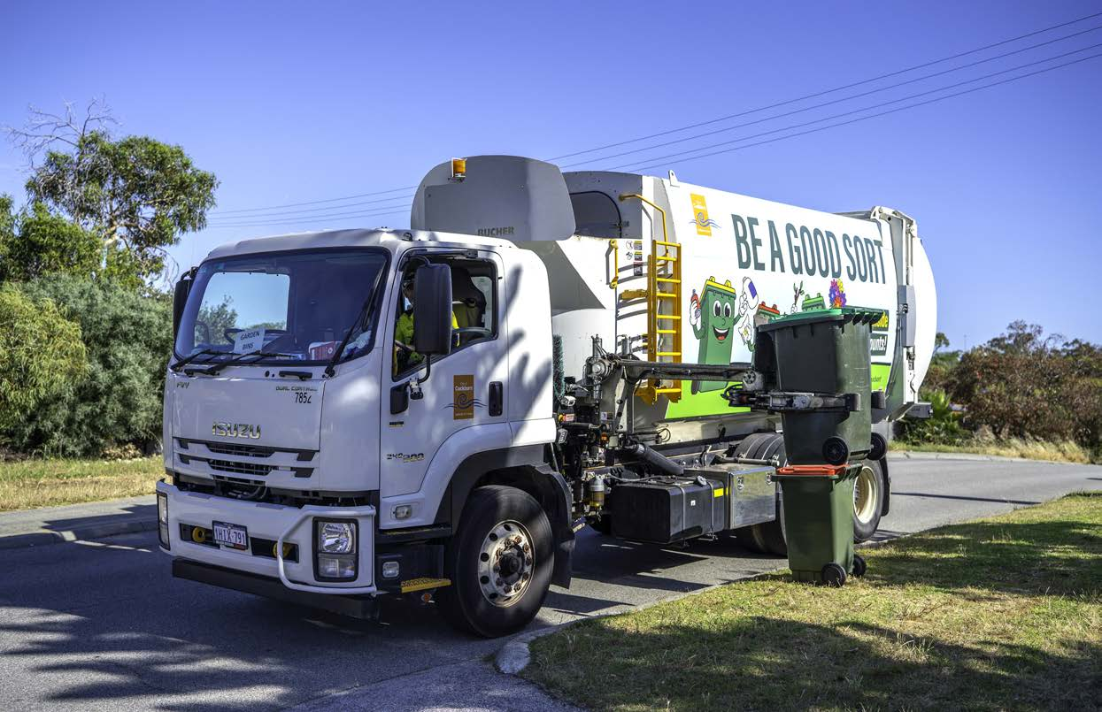
Photo: Waste Collection Services.

Listening and Leading Corporate Business Plan Progress 2023-24
The CBP Progress Report showcases our accomplishments in achieving the objectives set out in the Listening and Leading outcome. It provides an overview of each project, overall progress status, quarterly milestones, and notes explaining our achievements as of 30 June 2024. These initiatives are essential to making Cockburn, the best place to be.

Listening and Leading - Projects/activities
Project/activity | Q1 Milestones for 2023-24 | Q2 Milestones for 2023-24 | Q3 Milestones for 2023-24 | Q4 Milestones for 2023-24 | Notes
5.1.1e. Local Law review  Overall progress: Incomplete | Parking local law submitted to joint standing committee  Not on track | Completion of parking local law review, commencement of bushfire local law review  Complete | Commencement of consolidated local law review  Complete | Bush fire local law submitted to joint standing committee  Not on track | The Local Law review is ongoing and will continue into the next financial year.
5.1.1f. Risk maturity improvement program delivery  Overall progress: Complete | Procurement of services to deliver risk maturity improvement activities  Complete | Project progressing  On track | Project progressing  On track | Delivery of year one actions complete  Complete | We're enhancing our risk management practices, with key components of the Risk Maturity Improvement Plan already in place.
5.1.3a. Major Strategic Review Program - CBP, SCP, LTFP, WFP (Commence program)  Overall progress: Complete | Service plan review commenced. Review any interferences with changes to Integrated Planning and Reporting requirements following changes from the Local Government Amendment Bill 2023  Complete | Environmental Scanning complete  Complete | Project progressing  On track | FY2025-FY2029 CBP adopted at OCM  Complete | The Corporate Business Plan, Service Plans, Project Plans, including the Workforce Plan and Long-term Financial Plan, have been adopted, with priority-setting workshops scheduled for October 2024. These key corporate documents are available on our website.
5.1.3b. Develop approaches for the implementation of changes to the Integrated Planning and Reporting Framework as part of Local Government Reform  Overall progress: Complete | Analysis of Local Government Amendment Bill 2023 and identification of impacts for the City  Complete | Project progressing  On track | Project progressing  On track | Cross organisational engagement to implement required changes to City processes  Complete | All necessary changes under the Local Government Reform have been implemented successfully.
5.2.1a. Implementation of Customer Experience (CX) Improvement Program  Overall progress: Complete | Improvement plan scoped and agreed  Complete | Improvement activities implementation commenced  Complete | Project complete  Complete | CX Improvement project ends March 2024  Complete | The Customer Experience Improvement Program was completed in March 2024, with ongoing enhancements now integrated into our operations.
5.3.1a. WHS compliance program  Overall progress: Complete | Implementation of actions resulting from WHS audit planned for Q1  Complete | Implementation of actions resulting from WHS audit planned for Q2  Complete | Implementation of actions resulting from WHS audit planned for Q3  Complete | 100 per cent completion of action items resulting from WHS audit  Complete | We've met all our Workplace Health and Safety (WHS) obligations, with one item carried forward due to project complexity.
5.3.1b. SaaS migration to the cloud  Overall progress: Incomplete | Scope and program determined  Not on track | To be reviewed based on final scope  Complete | Testing environment developed  Integration Proof of Concept completed  Communications Plan prepared  Complete | Integrations development  Change management plan  Testing plan  Not on track | Delays to be remediated. Project is still on track and within budget for November Go Live.
5.3.3e. IT Personnel Hardware Refresh (previously called Staff Mobility Enablement (Zero Client Desktop Replacement))  Overall progress: Incomplete | On track | Scoping and programming commenced  Complete | Procurement plan and sourcing commenced  Not on track | Rollout plan developed (resources, schedule)  Rollout in progress  Not on track | The hardware refresh will begin in early FY2025, pending supply availability from the vendor.

Awards and Achievements
Award/agency and category | Outcome/project and description
International Association for Public Participation (IAP2) Core Values Awards 2023  Awards recognising innovative and best practice work in community engagement.  Category: Environment: Smart Budget Award | Winner: Smart Budget Award for community engagement on C.Y. O’Connor Beach Erosion Consultation.  Genuine and early engagement laid the foundation for a unique and innovative way of responding to erosion challenges at C.Y. O’Connor Beach, with an artificial fringing reef trial.
Urban Development Institute of Australia (UDIA) Awards 2023  Recognising achievements in the urban development industry.  Category: Social and Community Infrastructure | Finalist: Frankland Park Sports and Community Facility  This facility is sought after by a growing population of young families in Hammond Park with about seven groups and 1,500+ regular weekly users enjoying a range of opportunities for sporting and community activities.
Australian Event Awards 2023  Recognising excellence in event delivery.  Category: Best Community Event | Finalist: Coogee Live 2023  Coogee Live is the City’s flagship community event, attracting over 20,000 visitors for a free weekend of entertainment and fun. A program of over 180 free activities brought together in a stunning coastal location.
Leisure Institute of WA (LIWA) Annual WA Aquatic Recreation Industry Awards 2023  Awards recognising efforts leading the industry in aquatic safety and excellence.  Category: Aquatic Facility Safety | Winner: Sarahjayne Westberg - Cockburn ARC  Finalist: Cockburn ARC  Sarahjayne Westberg, Cockburn ARC’s Infrastructure and Operations Coordinator, received the individual Safety Award in recognition of her successful implementation of the pilot assessment program in the centre. Her dedication to the program saw Cockburn ARC achieve an exceptional overall safety rating of 98.41 per cent out of 100 per cent.
Planning Institute Australia (PIA) WA  Planning Excellence Awards.  Category: Local Government Team (Band 1) | Nominee: City of Cockburn’s Built and Natural Environment Team (artificial reef project)  Collaboration with universities enables the City to develop the next generation of urban planners, with the City’s marine engineers working to design and install the 100m artificial reef at C.Y. O’Connor Beach.
Centre For Accessibility Australia - Australian Access Awards 2023  Celebrating Digital Accessibility.  Category: Government Website of the Year  Category: Overall Website of the Year | Winner: Government Website of the Year (City of Cockburn Website)  Joint winner: Overall Website of the Year (City of Cockburn Website)  Up against high-calibre national competitors, the City was named joint winner of the Overall Website of the Year, sharing the honour with Deafblind Information Australia, and also took the Government Website of the Year title.
Most Accessible Community in WA Award (MACWA) – offered by the Regional Capital Alliance and Sponsored by the WA Local Government Association (WALGA).  Awards for innovative and creative approaches to ensuring accessibility.  Category: Accessible Communications | Highly Commended: Communications Strategies for Accessibility  "The City uses a suite of tools to maximise the accessibility of its communications, including having corporate templates that have been assessed for accessibility, corporate style guides that have guidelines for accessibility and a range of training opportunities for staff such as Auslan workshops and writing in plain English.  Cockburn is committed to improving accessibility for its community and employees,” City of Cockburn Disability Access and Inclusion Officer Ben Rowe said.
2024 WA Men's Wellbeing Award, Richmond Wellbeing  Recognising inspiring contributions to improving men’s mental wellbeing in the WA community.  Category: Community Support Award | Nominee: Joint Winner: Community Support Award, Kicking Goals For Life (KGFL)  Kicking Goals For Life is a social soccer program that helps men aged 18+ lose weight, get fit and healthy, make new friends, and stay connected with their mates. To date, more than 280 participants have lost approximately 302kg across seven seasons of social soccer games as part of Cockburn’s program.
National Growth Areas Alliance (NGAA) Awards 2024  These awards are not just accolades but a testament to the dedication and hard work of councils striving to enhance the quality of life in our fast-growing outer metropolitan cities and suburbs.  Category: Partnerships – Building Connections | Finalist: Partnerships, Collaboration for Success in the Blue Economy  The City of Cockburn is a leader in the blue economy, demonstrated by the establishment and management of a working group consisting of 25 diverse members including defence, heavy manufacturing, research, shipbuilding, ocean sustainability, and educational institutions. By facilitating a collaborative and dynamic approach to economic development in the marine space, the City can maximise opportunities for residents, and maintain environmental health.
Park and Leisure Australia (WA) Awards of Excellence 2024  Celebrating the outstanding initiatives and innovative efforts of 'the people behind the places.'  Category: Best use of Technology | Winner: Joint Submission City of Cockburn with SpacetoCo  The award-winning project harnesses SpacetoCo's cutting-edge technology to streamline the booking process for community and sporting facilities, making it easier and faster for residents to find and book local venues. The City has seen a remarkable 25 per cent increase in facility bookings since implementing this technology. This surge in recreation bookings highlights the efficiency and ease of use of the system, contributing to a more active and engaged community.
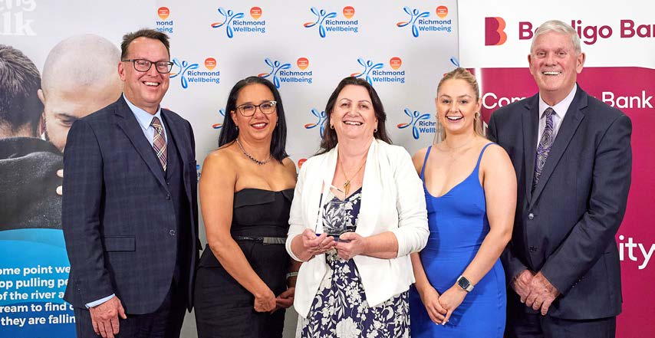 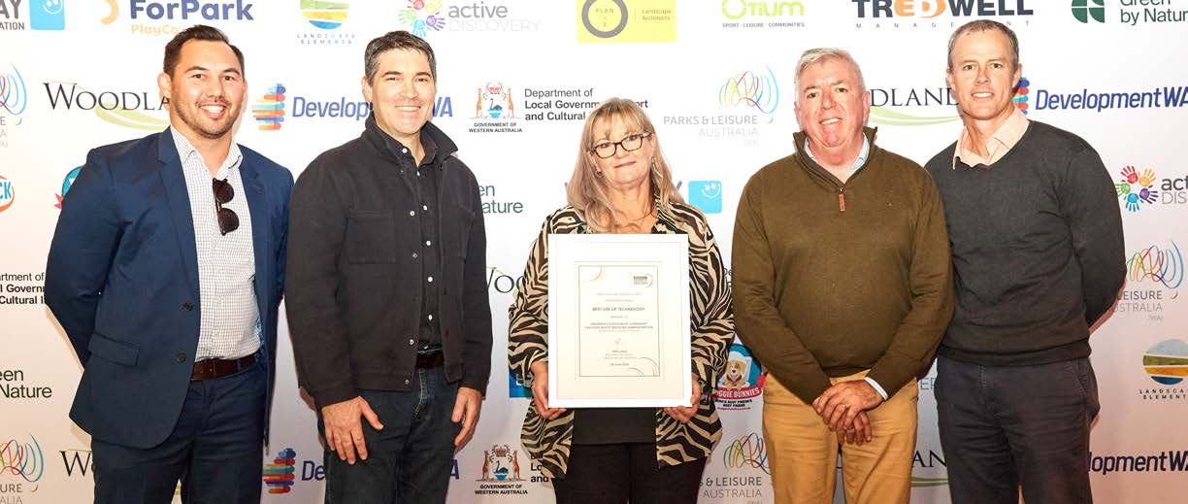
Photo 1: 2024 WA Men's Wellbeing Award, Richmond Wellbeing, Nominee: Joint Winner: Community Support Award, Kicking Goals For Life - June 2024. (Left to Right) Daniel Simms, CEO; Patricia Orr, Manager Health and Building Services; Gloria Askander, Health Promotion Officer; Ellen-Rose Ward, Technical and Administrative Assistant; and Mayor Logan Howlett.
Photo 2: Park and Leisure Australia (WA) Awards of Excellence 2024, joint winner: Best use of Technology - June 2024. (Left to Right) Dean Burton, Recreation Services Manager; Jeremy Hurst, Co-Founder - SpacetoCo; Kylie Santich, Community Venues; Andrew Wynne, Woodlands and Doggie Dunnies; and Nathan Johnston, Lead Community Venues Officer.

Capital Grants, Subsidies and Contributions
As per regulation 19BE of the Local Government (Administration) Regulations 1996, below are the amounts of capital grants, subsidies and contributions received by the City of Cockburn in the last three financial years for replacing and renewing assets.
- Financial year 2023-24: $23,421,660
- Financial year 2022-23: $18,950,495
- Financial year 2021-22: $11,713,792
- Financial year 2020-21: $18,950,495

Trading Undertakings
There is no information about trading undertakings to be included in the Annual Report in accordance with regulation 19BB of the Local Government (Administration) Regulations 1996.

Land Transactions
There is no information about land transactions to be included in the Annual Report in accordance with regulation 19BC of the Local Government (Administration) Regulations 1996.
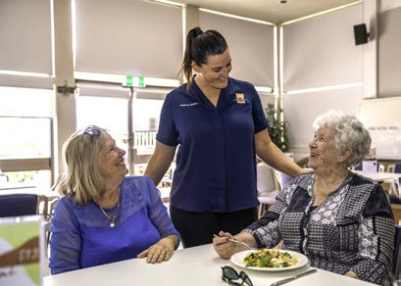 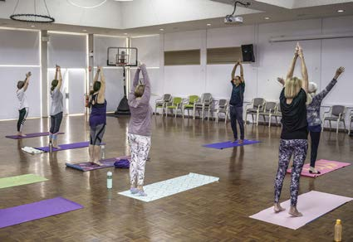
Photo 1: Kayla Maloney, Senior Centre Programs Booking Officer, with residents. Photo 2: Yoga classes at Cockburn Senior Centre, Spearwood.
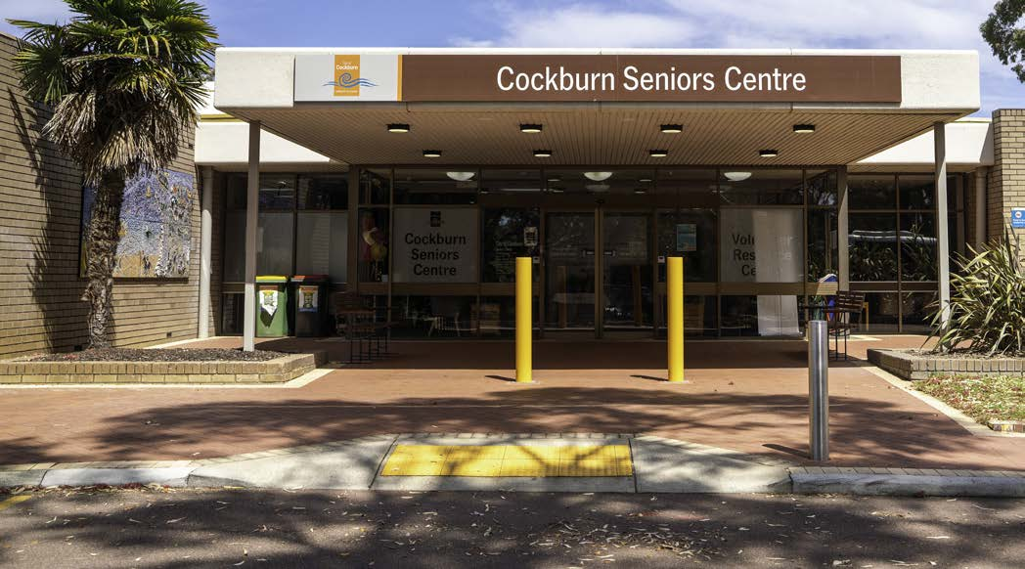

Building and Development Applications
Building permit numbers in FY2024 for the City of Cockburn, while lower than the peak in FY2021, remained robust compared to pre-pandemic levels in FY2020. The value of building permits in FY2024 experienced a significant increase, surpassing the previous year and reaching the highest level since FY2021. This growth is primarily driven by residential and other categories, indicating strong demand in these sectors. The increase in fees collected reflects the higher value of permits issued.
Building permit facts:
- 2,251 building permits issued
- Total value of building works: $635 million
Average issuance time for a building permit in 2023-24:
- 8 working days - Certified Building Permits
- 22 working days - Uncertified Building Permits

Year ending | Number of permits | $million Value | $million Fee | Residential | Commercial | Industrial | Other
30 June 2020 | 2,247 | 349 | 0.71 | 1,076 | 80 | 14 | 1,169
30 June 2021 | 3,444 | 616 | 1.24 | 1,993 | 121 | 9 | 1,321
30 June 2022 | 2,554 | 502 | 0.97 | 1,132 | 129 | 18 | 1,276
30 June 2023 | 2,167 | 410 | 1.42 | 832 | 225 | N/A | 1,054
30 June 2024 | 2,251 | 635 | 2.58 | 1,014 | 118 | 14 | 1,105
During the 2023-24 financial year, the Building Services team processed Certified Building Permits in an average of 8 working days and Uncertified Building Permits in 22 working days. Despite the significant staff shortages that are felt industry-wide, the City’s Building Services team were able to meet the mandatory timeframes under the Building Act 2011 of 10 days for Certified and 25 days for Uncertified.
While the majority of building permits were processed within the designated timeframe, a small percentage experienced delays. Specifically, 141 out of 1653 (8.5 per cent) of Certified Building Permits and 48 out of 327 (14.7 per cent) of Uncertified Building Permits were not processed on time.
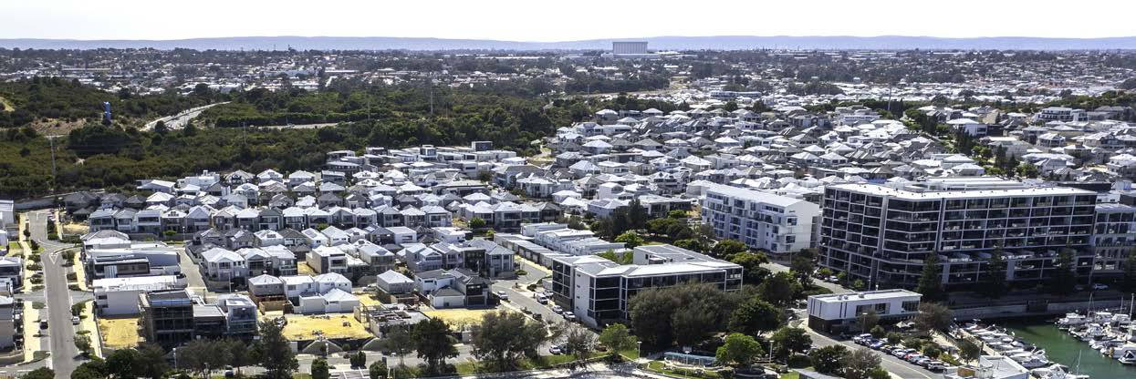
Photo: North Coogee.

Development applications
- 910 development applications received, a 12.48 per cent increase from the previous year
- 740 new lots were approved (green title, survey strata and built strata), an increase of 34 per cent from the previous year
- 599 applications were required to be determined within 60 days. The City determined 82.20 per cent of those applications within 60 days (7.2 per cent improvement on 2022-23)
- 144 applications were required to be determined within 90 days. The City determined 71.53 per cent of those applications within 90 days (6.1 per cent improvement on 2022-23)
- Total estimated development value of applications received: $312,518,797
The number of planning approvals granted has increased by 12 per cent compared to the previous financial year. This growth is primarily driven by an increase in subdivision approvals, suggesting that the City can anticipate a rise in development applications and building permits for residential dwellings in the coming years.
The estimated total value of development approvals decreased slightly from the previous financial year. This decrease can be attributed to the fact that the Jandakot Surf Park project, which had an estimated value of $100 million and was one of the highest-value development applications the City has received, was awarded in financial year 2022-23. When excluding the Jandakot Surf Park from the previous year's total, the estimated total value of development approvals in the 2023-24 financial year increased by 40 per cent compared to the previous year.
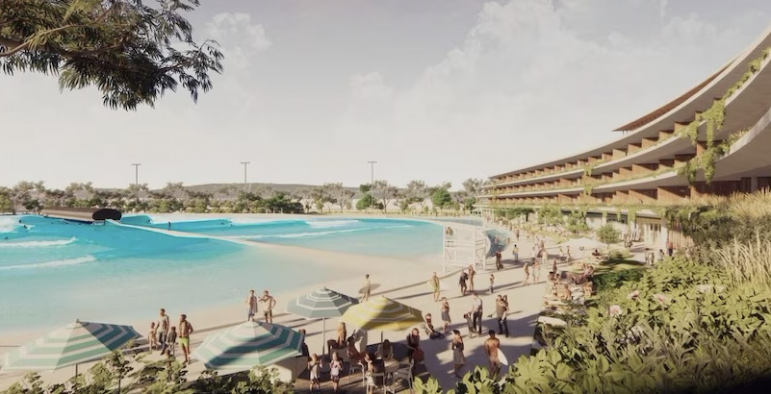 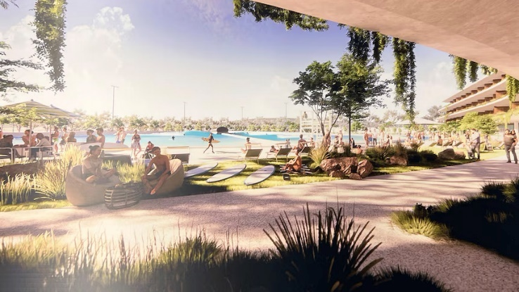
Photos: Jandakot Surf Park project - artist impression.
Development Facts:
Zoning Statements:
We saw a robust property market in Cockburn, with an 11 per cent increase in zoning statements processed to 3,898. This means nearly 4,000 properties changed hands in the City during the year.
Fees Collected:
$1,101,116.66 in fees were collected, encompassing a wide range of applications from development approvals to liquor licenses.
Development Approvals:
Our commitment to efficient development is evident in our approval rates. A remarkable 98.51 per cent of all development applications (DAs) were given the green light.
99.55 per cent of DAs were determined through delegation. Only a small fraction required Council review.

Our Capital Investment
The City of Cockburn is committed to investing in our community’s future. Each year, we allocate significant funds to capital works projects that enhance our infrastructure, public spaces, and community facilities. These investments are designed to improve the quality of life for our residents and businesses. In FY2024 the City spent a total of $56 million on capital works.
As you can see in the chart below, the City has consistently invested in a range of projects over the past four years.
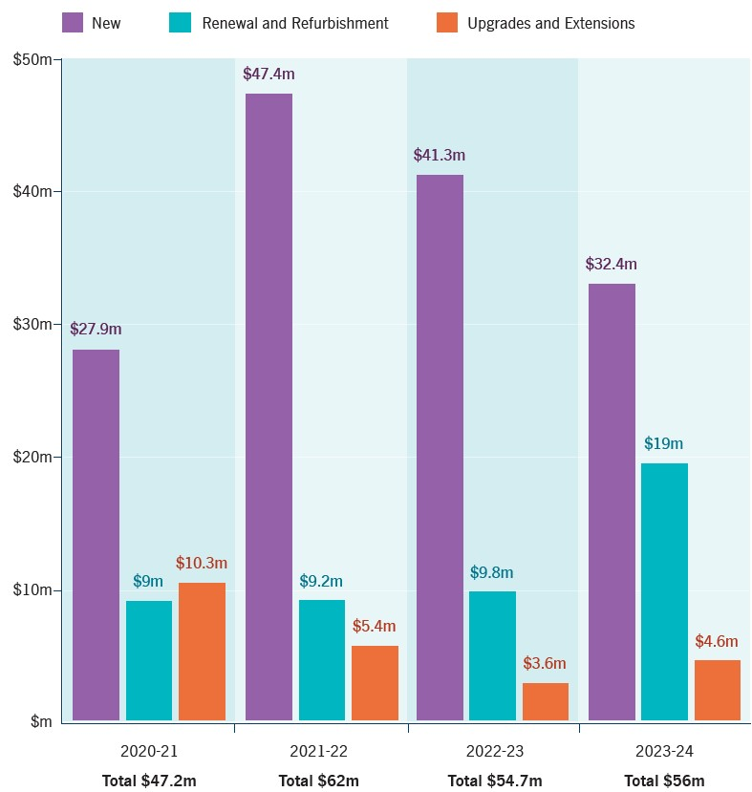
Transcriber’s Note: The bar graph above shows City of Cockburn’s investment in capital works projects. The data in this graph is presented below as a table. Please contact City of Cockburn for more information or clarification.
Financial year | New works | Renewal and Refurbishment | Upgrades and Extensions | Total ($)
2020-21 | $27.9 million | $9 million | $10.3 million | $47.2 million
2021-22 | $47.4 million | $9.2 million | $5.3 million | $62 million
2022-23 | $41.3 million | $9.8 million | $3.6 million | $54.7 million
2023-24 | $32.4 million | $19 million | $4.6 million | $56 million

Our Assets
The City of Cockburn thrives on a strong foundation of infrastructure. From the roads we travel to the parks we enjoy, our assets are essential for maintaining a high quality of life for residents and businesses.
The City takes a proactive approach to asset management, ensuring these assets are well-maintained, function efficiently, and deliver long-term value.
We’ve compiled key highlights about our City’s assets with a replacement value of over $2.4 billion. A pie chart accompanying this section provides a visual breakdown of asset value by class.
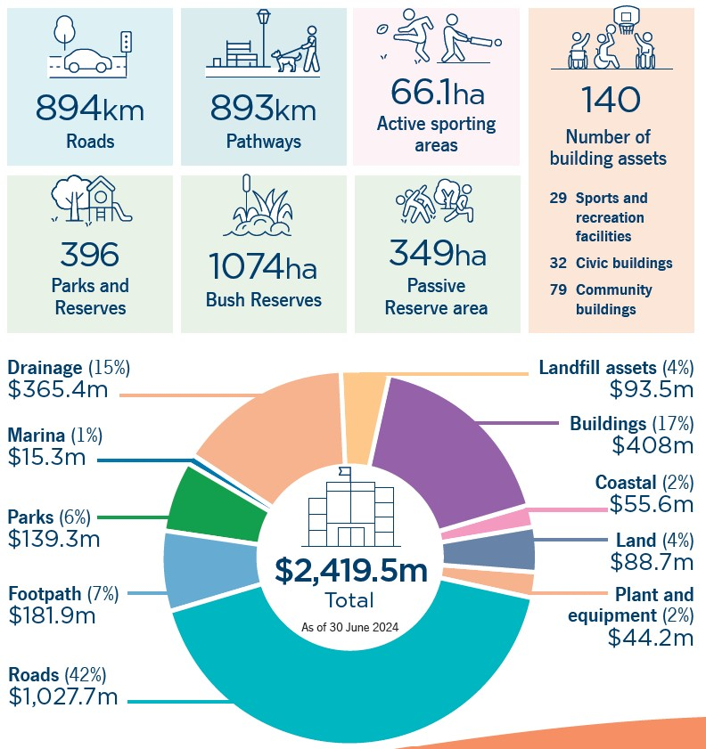
Transcriber’s Note: The data in the infographic and pie chart above is presented as a list below. Please contact City of Cockburn for more information or clarification.
- Roads: 894km
- Pathways: 893km
- Active sporting areas: 66.1ha
- Parks and Reserves: 396
- Bush Reserves: 1074ha
- Passive Reserve area: 349ha
- Number of building assets: 140
  - 29 Sports and recreation facilities
  - 32 Civil buildings
  - 79 Community buildings
- Asset values:
  - Drainage (15%): $365.4 million
  - Marina (1%): $15.3 million
  - Parks (6%): $139.3 million
  - Footpath (7%): $181.9 million
  - Roads (42%): $1,027.7 million
  - Landfill assets (4%): $93.5 million
  - Buildings (17%): $408 million
  - Coastal (2%): $55.6 million
  - Land (4%): $88.7 million
  - Plant and equipment (2%): $44.2 million
  - Total (as of 30 June 2024): $2,419.5 million

Our Budget

How services are funded
The City of Cockburn is committed to delivering high-quality services to our community. To achieve this, we rely on a diverse range of funding sources. Our primary revenue comes from property rates, which contribute significantly to the overall budget. However, other sources, such as fees and charges, grants, and interest earnings, play a crucial role in supporting our operations.
As you can see in the following chart, our actual revenue for FY2024 exceeded the adopted budget. This is largely due to increased revenue from fees and charges and interest earnings.

FY2024 Adopted budget (on 1 July 2023)
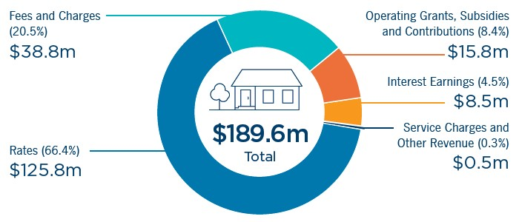
FY2024 adopted budget:
- Fees and Charges (20.5%): $38.8 million
- Rates (66.4%): $125.8 million
- Operating Grants, Subsidies and Contributions (8.4%): $15.8 million
- Interest Earnings (4.5%): $8.5 million
- Service Charges and Other Revenue (0.3%): $0.5m
- Total: $189.6 million

FY2024 Actual budget (on 30 June 2024)
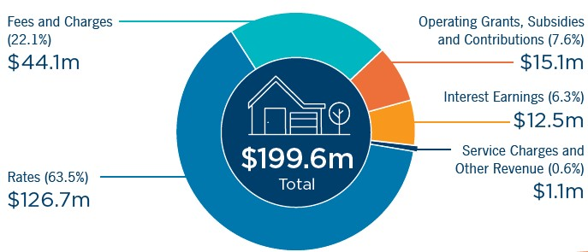
FY2024 actual budget:
- Fees and Charges (22.1%): $44.1 million
- Rates (63.5%): $126.7 million
- Operating Grants, Subsidies and Contributions (7.6%): $15.1 million
- Interest Earnings (6.3%): $12.5 million
- Service Charges and Other Revenue (0.6%): $1.1 million
- Total: $199.6 million

How your money is spent
The City of Cockburn is dedicated to providing essential services and enhancing the quality of life for our community. Your rates and fees contribute to a diverse range of services, from maintaining our parks and roads to supporting local events and programs. As you can see in the chart below, the City's spending priorities align with the needs of our community. While the majority of our budget is allocated to core services like Recreation and Culture and Community Amenities, we also invest in areas such as Governance and Transport to create a vibrant and connected city.
It's important to note that the City's actual expenditure for FY2024 exceeded the adopted budget. This is primarily due to increased costs in areas such as Community Amenities and Recreation and Culture.

FY2024 Adopted budget (on 1 July 2023)
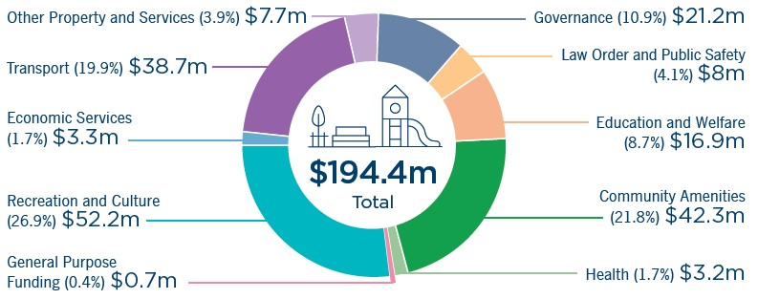
FY2024 adopted budget allocation:
- Transport (19.9%): $38.7 million
- Economic Services (1.7%): $3.3 million
- Recreation and Culture (26.9%): $52.2 million
- General Purpose Funding (0.4%): $0.7 million
- Health (1.7%): $3.2 million
- Community Amenities (21.8%): $42.3 million
- Education and Welfare (8.7%): $16.9 million
- Law Order and Public Safety (4.1%): $8 million
- Governance (10.9%): $21.2 million
- Other Property and Services (3.9%): $7.7 million
- Total: $194.4 million

FY2024 Actual budget (on 30 June 2024)
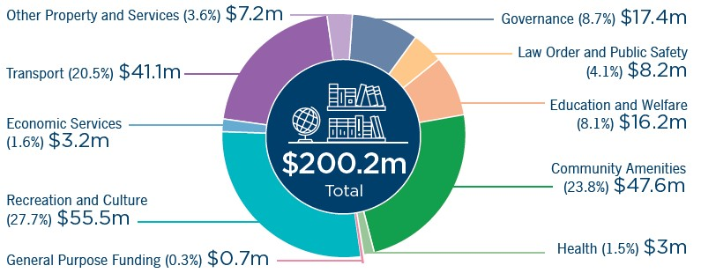
FY2024 actual budget allocation:
- Transport (20.5%): $41.1 million
- Economic Services (1.6%): $3.2 million
- Recreation and Culture (27.7%): $55.5 million
- General Purpose Funding (0.3%): $0.7 million
- Health (1.5%): $3 million
- Community Amenities (23.8%): $47.6 million
- Education and Welfare (8.1%): $16.2 million
- Law Order and Public Safety (4.1%): $8.2 million
- Governance (8.7%): $17.4 million
- Other Property and Services (3.6%): $7.2 million
- Total: $200.2 million

Risk Management
The Australian Standard AS ISO 31000:2018 Risk Management - Guidelines defines risk as the effect of uncertainty on objectives.
Risk is a mathematical product of likelihood and consequence. The Australian Standard defines these two elements as:
- Consequence: Outcome of an event affecting objectives.
- Likelihood: Chance of something happening.
Local government legislation requires the City of Cockburn to ensure that risks, opportunities and other information that may impact the achievement of the City’s goals and objectives in delivering good governance to the community are identified and managed. The City has in place a Risk Policy and Risk Management Framework that are aligned with the Australian Standard.
The City’s five highest ranked risks are climate-change related and tree canopy decline as a result of the polyphagous shot-hole borer infestation in City trees. The elevated ranking of climate-related risks is replicated across Australian local governments, with Disaster, Catastrophic Events and Climate Change and Adaptation ranked in the top 10 risks impacting local government. [JLT Public Sector Risk Report, JLT Risk Solutions Pty Ltd].
Moore Australia conducted a risk maturity review of the City’s Risk Management Framework. The City has drafted a plan to implement opportunities for improvement identified in the review.
A review of the City’s business continuity management has led to the drafting of a new Business Continuity Plan to reduce the impact of disruptions on the delivery of critical services. The new plan will be subjected to testing to ensure the adopted plan serves the City should a disruptive event be realised.

Risk Profile 2023-24
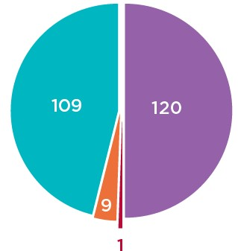
Low risks 46% (109)
These are managed with adequate controls and pose minimal uncertainty to the City’s objectives.
Moderate risks 50% (120)
These are managed with adequate controls and could pose some disruption to the City’s objectives.
Substantial risks 3.6% (9)
These are managed with adequate controls and pose minimal uncertainty to the City’s objectives.
High risk <1% (1)
These are the least common risks, subject to at least quarterly review, and have the potential to cause critical consequences.

Governance Report

Compliance
The Compliance Audit Return (CAR), mandatory for all local governments in Western Australia since 2000, was submitted to the Department of Local Government, Sport and Cultural Industries on 27 March 2024. There were no identified non- compliances from the City’s 94 responses to the questionnaire.
At the invitation of the City, the Public Sector Commission visited the City in November 2023 to present the workshop ‘Preventing Misconduct – Spotting and Responding to Red Flags’ to the Senior Leadership Team. This is a proactive drive by the City to raise awareness amongst its staff of misconduct, fraud and corruption, and how to monitor, report and prevent instances of these activities at the City.
The City utilises an online compliance management system for statutory forms such as financial disclosures, gifts, travel contributions and delegated authorities.

Freedom of information
The Freedom of Information Act 1992 (FOI) gives members of the public the right to access documents held by local governments, subject to limitations. The City prepared, as required by section 96 of the FOI Act, an up-to-date information statement and made it available to the public. The City received 39 FOI requests during the 2023-24 financial year.

Elected Member breaches/complaints
During FY2024 there were no minor breach complaints and no complaints to be reported.
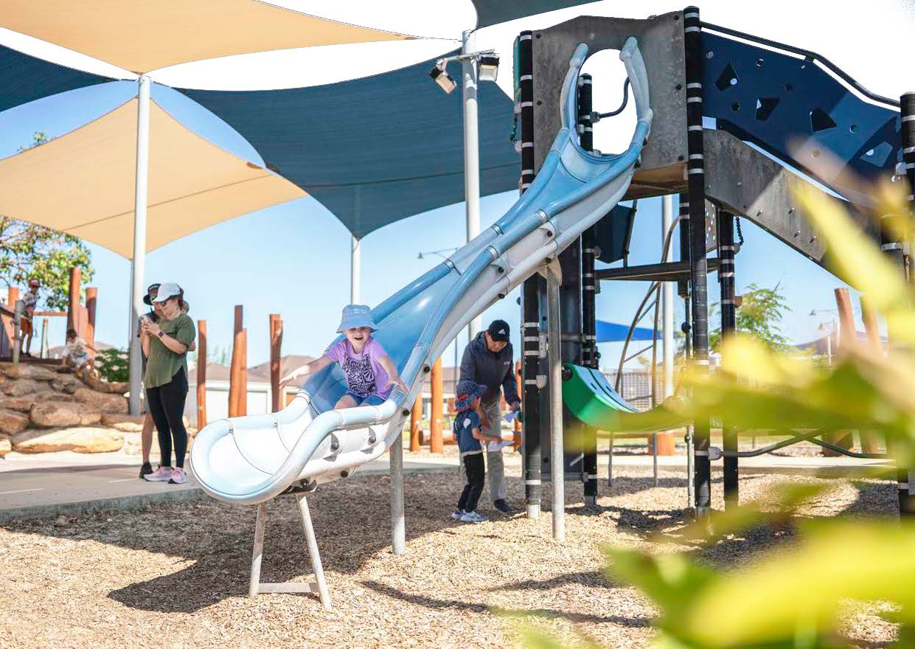
Photo: Botany Park, Hammond Park.

Disability Access and Inclusion Plan (DAIP)

Implementation Report
The Disability Services Act 1993 (WA) requires all WA local governments to develop a DAIP. The progress of the DAIP is reported annually to the Department of Communities. Please see City of Cockburn website: Disability Access and Inclusion Plan: www.cockburn.wa.gov.au/DAIPlan
The City’s current DAIP 2023-28 shows our commitment to creating an accessible and inclusive community for everyone. The DAIP provides a framework for addressing six outcome areas:
- Services and events
- Facilities and buildings
- Information
- Customer service
- Complaints and public consultation
- Employment opportunities

Outcome 1:
People with disability have the same opportunities as other people to access the services of, and any events organised by, the City of Cockburn.
Initiative | Action
International Day of People with Disability | The City of Cockburn continues to celebrate International Day of People with Disability (IDPwD). In keeping with community feedback from previous years, the event shifted to focusing on people with disability coming together with their community to celebrate their strengths. On Saturday 2 December 2023, a performance event was held, displaying live music and dance performances from local artists and community groups comprising people with disability.
Wicked Wednesdays | The City offers an inclusive music program that continues to grow, with group members enjoying the opportunity to build their strengths in song writing and production.
Wondermums | In late 2023, the Community Development Team and the Disability Access and Inclusion Officer collaborated to establish a new community-led peer-to- peer group to support mothers of children with disability.
Major events | The City continues to provide Auslan interpreters at flagship events such as Cockburn Live, Beeliar Sunsets Live Music, and Stitches comedy show.

Outcome 2:
People with disability have the same opportunities as other people to access the buildings and other facilities in the City of Cockburn.
Initiative | Action
New infrastructure | The City continues to ensure new buildings and facilities, including significant upgrades, exceed minimum disability access requirements where possible. The City’s Disability Reference Group was engaged in 2023 to provide feedback on the draft Community Infrastructure Plan 2024-41.
Bibra Lake Regional Playground | The City continues to expand the accessible facilities in the City of Cockburn including accessible playgrounds, changing facilities and storage facilities for mobility devices. In 2023-24 the City purchased an accessible carousel which is located at Bibra Lake Regional Playground, with plans to add an additional accessibility play piece in 2024-25.
Accessible playgrounds | The City partnered with the project team from three universities that is researching ‘Developing Accessible Playgrounds for Children with Vision Impairment.’ The City engaged Connecting Community for Kids to have parents of blind or low-vision children audit City playgrounds due for renewal or maintenance in 2025-26. The project continues, and the outcomes will be shared with the relevant internal teams.

Outcome 3:
People with disability receive information from the City of Cockburn in a format that will enable them to access the information as readily as other people.
Initiative | Action
Accessible information | The City was excited to win the award for Australia's most accessible website award in 2023 through the Centre of Accessibility Australia. The City was recognised as the leader in best practices for website accessibility and was fortunate to also win the top government organisation website category. Being highly commended for its commitment to accessible communications was an acknowledgment of the City's dedication to this space.

Outcome 4:
People with disability receive the same level and quality of service from the staff of the City of Cockburn as other people.
Initiative | Action
Learning and development | Learning and development opportunities to build the capacity of our staff to provide quality service to all members of a community remain a focus. Staff continue to enjoy opportunities to complete disability awareness training, including access to an eight-week Auslan course. The City is investigating ways to reinforce Auslan learning by providing opportunities for staff to meet to maintain their skills regularly.  The staff were also encouraged to participate in a new workshop on neurodiversity delivered by Spectrum Space.

Outcome 5:
People with disability have the same opportunities as other people to provide feedback, make complaints and participate in any public consultation at the City of Cockburn.
Initiative | Action
Community Engagement Framework | The City has revised its Community Engagement Framework to specifically address a broader range of considerations when engaging community.  This Framework provides guidelines and considerations for engaging with people with a disability, including who should be consulted and consideration on how to respect and compensate people for sharing their lived experience. The Framework also provides a list of considerations for physical and functional accessibility and has additional resources, including a co-design toolkit.

Outcome 6:
People with disability have the same opportunities as other people to obtain and maintain employment with the City of Cockburn.
Initiative | Action
Diversity and Inclusion | The City’s Inaugural Diversity and Inclusion Plan was endorsed in June 2024. The plan shows our commitment to creating and sustaining a diverse and inclusive culture.
Customised employment | The City is currently exploring employment opportunities for people with disability in the City through traineeships, job carving and role creation.
Volunteering | The City’s Volunteer and Resource Centre works from a person-centred perspective, working 1:1 with people with disability to create a customised role that is matched to their strengths and interests. The City has experienced remarkable success with this approach, with volunteers moving from being supported in the role to working independently.

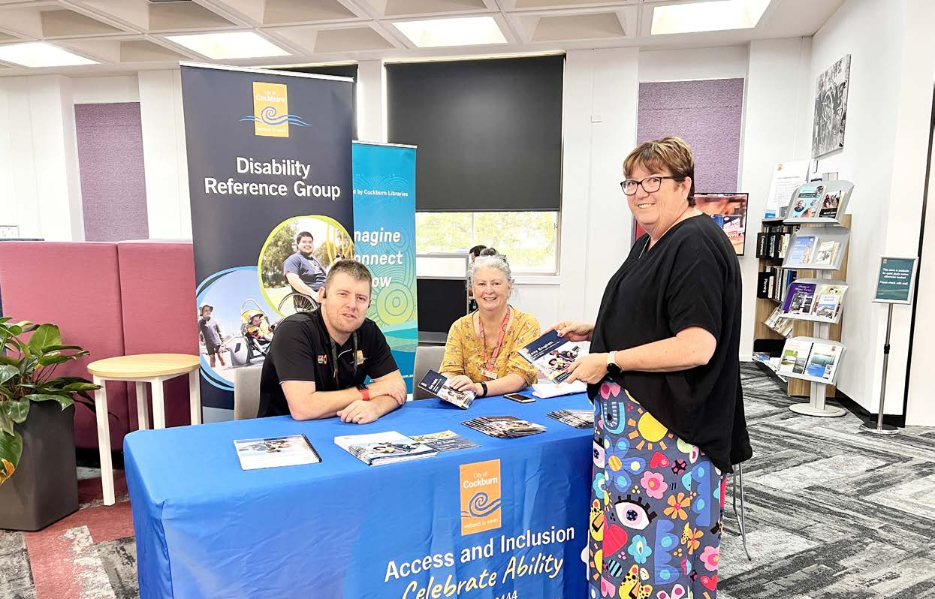
Photo: Spearwood Library. (Left to Right) Ben Rowe Disability Access and Inclusion Officer; Geraldine Stanton, Parenting Service Officer; and Sonia Farr, Administration Officer.

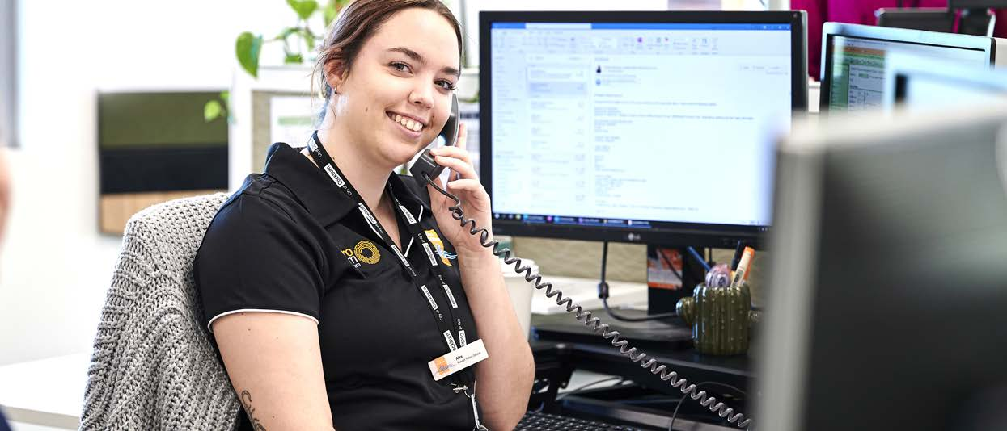
Photo: Alex Harris, Workforce Scheduler.

Recordkeeping

Evaluation of recordkeeping systems
Work was undertaken with the organisation’s Family and Community Development team to review their recordkeeping practices through the Knowledge Management project. This resulted in a number of changes to processes to improve recordkeeping within the team and reduce the amount of information stored outside the recordkeeping system. The City’s Records Management Policy was also reviewed, updated and subsequently adopted by Council on 14 September 2023.

Recordkeeping training program
All new staff are required to complete an online Records Awareness Training (RAT) course. The interactive course outlines the recordkeeping roles and responsibilities of all employees at the City of Cockburn.
Participants must undertake and pass a short assessment at the completion of the course.
An online course outlining the specific recordkeeping responsibilities of managers and supervisors has also been implemented.
Regular training for new and existing staff is held on the use of the organisation’s electronic document and records management system, called ECM.
A new online training module for the City’s Information Governance Framework was also rolled out to all relevant staff in December 2023 to ensure the organisation’s information is stored, used and managed in a consistent, secure and accessible way.

Evaluation of the recordkeeping training program
All participants who attend ECM training are asked to complete a training feedback form. The feedback forms are regularly reviewed and suggestions for improvements are incorporated into the training program.

Recordkeeping induction program
New staff must complete the Records Awareness Training (RAT), and where relevant ECM training, as part of their induction. New managers/supervisors are also required to complete the online Recordkeeping Training for Managers and Supervisors.

Community Engagement

Community engagement at the City of Cockburn
Everything we do as a local government affects the people who live, work and recreate in Cockburn. From big picture planning to delivering programs and services, all our work is done on behalf of the community. As such, we have an ever increasing need to ensure quality community engagement so that all people have the opportunity to participate in the decisions that affect their lives.
The City’s dedicated community engagement team has delivered a range of projects over the past twelve months to invite the community into decision-making and encourage policies, plans and projects to be guided by the views of the people they seek to serve.
Community engagement projects are hosted on the City’s online community engagement platform, Comment on Cockburn; however, a range of communication methods are undertaken to ensure broad and widespread awareness of opportunities to give feedback. This includes letters to neighbouring houses, social media posts, signage, email newsletters and flyers in libraries, youth centres and other well-frequented areas.
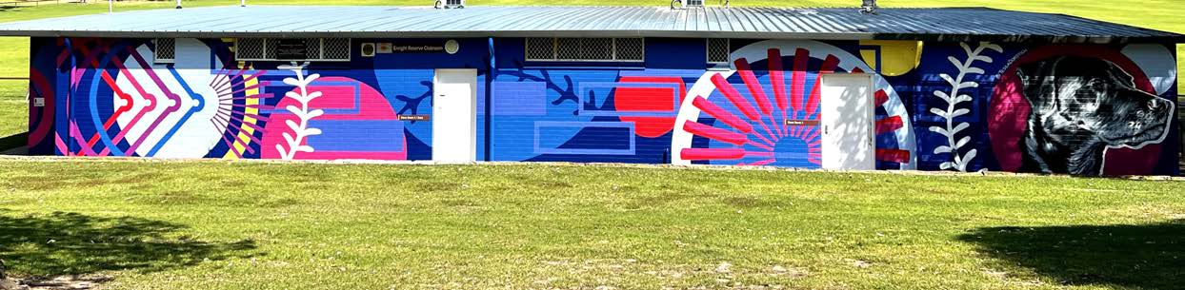
Photo: Enright Reseve clubrooms, Hamilton Hill; Artwork mural by Tessa Dorotich - Artist; Hami Helps, Connecting Hamilton Hill; and the Hamilton Hill Community Group.

Key accomplishments 2023-24

Delivering for the Community
Successfully completed 35 projects across a diverse range of areas, including:
- Pool fencing inspection processes
- Enhanced parking facilities
- New infrastructure development
- Strategic policy initiatives
- Arts and cultural programs.

Strengthening Community Engagement
Developed a comprehensive Community Engagement Framework and internal journey map to guide best practices and improve engagement outcomes.

Digital Engagement Highlights
Recorded 72,876 site views and gained 1,689 new registrations on the Comment on Cockburn platform.

Top engaged projects
- Revitalising Coogee: Help us plan the future of Coogee Beach Precinct!
- Reducing bushfire risks: Comment on the draft plan
- Let’s talk public toilets and pooch paw-sibilities: Macfaull Park, Spearwood
- Port Coogee Vehicle Parking Project.

Climate Change and Sustainability Snapshot

Climate Change Strategy
Endorsed by Council in September 2020, the Climate Change Strategy 2020-30 is informed by the Climate Change Risk Assessment 2020 and community consultation. The Strategy’s Climate Resilience Road Map has 14 objectives and aspirational targets which are supported by a detailed action plan.

Vision
The City of Cockburn will continue to be a leader in climate resilience and sustainability. We aim to be a carbon neutral City and take pride in working together to adapt to our changing climate, now and into the future.

Climate Resilience Roadmap
Transcriber’s note: This section includes progress pie charts without specific numerical data; approximate percentages have been listed instead. Please contact City of Cockburn for more information or clarification.

Objective/Target 1. Strong Leadership 
Progress: 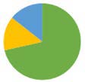
- ≈ 20% ongoing
- ≈ 60% complete
- ≈ 20% in progress
Achievements:
- Reserve fund for climate mitigation is ongoing
- Fossil fuel free investment was 30 per cent of portfolio
- Promotions included: articles for WA Local Government Association (WALGA) EnviroNews and Department of Biodiversity, Conservation and Attractions (DBCA) Bushland News, radio and TV interviews, and eight resident association presentations.

Mitigation: Objective/Target 2. Net Zero Emissions 
Progress: 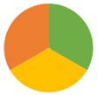
- ≈ 33.3% complete
- ≈ 33.3% in progress
- ≈ 33.3% to be commenced
Achievements:
- 12 per cent decrease in corporate emissions (2022-23), including a 25 per cent decline in streetlighting emissions
- Journey to Net Zero 2030 report completed
- Developing new rewards program for residents
- Planning new programs for the business community to incentivise emissions reductions.

Mitigation: Objective/Target 3. 100% Renewable Energy 
Progress: 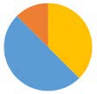
- ≈ 50% ongoing
- ≈ 40% in progress
- ≈ 10% to be commenced
Achievements:
- 10 per cent renewable energy (2021-22), installation ongoing
- All-electric facility transitions ongoing
- Replacing fuel powered tools with electric batteries
- WALGA negotiated Power Purchase Agreement (PPA) continues (includes 25 per cent renewables in 2024-25), participating in working group to negotiate the next contract.

Mitigation: Objective/Target 4. Zero Waste to Landfill 
Progress: 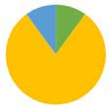
- ≈ 10% ongoing
- ≈ 10% complete
- ≈ 80% in progress
Achievements:
- Voluntary National Greenhouse and Energy Reporting Scheme (NGERS) report 2022-23 complete
- 1.4 per cent decrease in tonnes of waste to landfill
- 24 per cent increase of recovered materials
- Waste Wise Events Policy delivered successful waste reduction and recovery at the City’s summer events
- Community Resource Recovery Park in progress.

Mitigation: Objective/Target 5. Reduce Energy Consumption 
Progress: 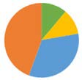
- ≈ 35% ongoing
- ≈ 12.5 complete
- ≈ 12.5% in progress
- ≈ 40% to be commenced
Achievements:
- Biodiversity offsets for City’s program of events
- Energy monitoring continued via integrated platform
- Streetlighting upgrades now addressed by Western Power’s Public Lighting Asset Management Strategy.

Mitigation: Objective/Target 6. Zero Emission Fleet 
Progress: 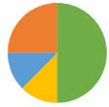
- ≈ 12.5% ongoing
- ≈ 50% complete
- ≈ 12.5% in progress
- ≈ 25% to be commenced
Achievements:
- Maintained a zero emission fleet with two EV and three hybrid fleet vehicles, one hybrid truck and biodiversity offsets for residual emissions
- Improved fleet emission data analysis
- Low emission staff travel promotions.

Mitigation: Objective/Target 7. Smart City Innovation 
Progress: 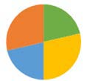
- ≈ 20% ongoing
- ≈ 20% complete
- ≈ 30% in progress
- ≈ 30% to be commenced
Achievements:
- Supporting Western Power’s community battery installations for excess rooftop solar PV energy – one in Coogee and a second being planned
- Pursuing third-party supplier for EV charging on City land.

Objective/Target 8. Education and Collaboration 
Progress: 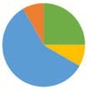
- ≈ 55% ongoing
- ≈ 25% complete
- ≈ 10% in progress
- ≈ 10% to be commenced
Achievements:
- Sustainability and environment community programs continue e.g. Home Eco Audits
- Waterwise Verge and Waste rebates
- New programs including Nature Discovery Days and a community climate action workshop
- Sustainability grants continue to be awarded.

Adaptation: Objective/Target 9. Waterwise City 
Progress: 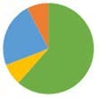
- ≈ 20% ongoing
- ≈ 65% complete
- ≈ 7.5% in progress
- ≈ 7.5% to be commenced
Achievements:
- Retained Gold Waterwise Council and Gold Waterwise Aquatic Centre status
- Implementing Coogee Surf Club water audit recommendations
- 39 Waterwise Verge Rebates provided and one waterwise verge workshop delivered.

Adaptation: Objective/Target 10. Conserve Biodiversity 
Progress: 
- 100% complete
Achievements:
- Natural Area Management Strategy implemented
- Fauna and vegetation condition surveys complete
- Landowner Biodiversity Grants awarded
- Education delivered, citizen science supported.

Adaptation: Objective/Target 11. Coastal Adaptation 
Progress: 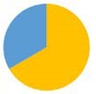
- ≈ 30% ongoing
- ≈ 70% in progress
Achievements:
- New Coastal Hazard Risk Mapping and Adaptation Planning (CHRMAP) in development
- 2023 coastal monitoring report complete
- Monitoring the engineered fringing reef and commenced installation of stage two
- Breakwaters and revetment walls surveyed.

Adaptation: Objective/Target 12. Increase the Urban Forest 
Progress: 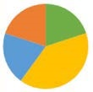
- ≈ 20% ongoing
- ≈ 20% complete
- ≈ 40% in progress
- ≈ 20% to be commenced
Achievements:
- Planted about 1,250 trees, and 65,000 seedlings
- Investigating further tree protections through developing a local planning policy or other planning measures.

Adaptation: Objective/Target 13. Protect Community Infrastructure 
Progress: 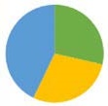
- ≈ 40% ongoing
- ≈ 30% complete
- ≈ 30% in progress
Achievements:
- City facilities comply with Building Code of Australia (BCA), and when required Bushfire Attack Level (BAL) Assessments and Bushfire Management Plan
- Facility asset condition assessments and upgrades ongoing.

Adaptation: Objective/Target 14. Enhance Health and Wellbeing 
Progress: 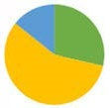
- ≈ 10% ongoing
- ≈ 30% complete
- ≈ 60% in progress
Achievements:
- Bushfire Risk Management Plan adopted
- Public Health Plan updated to include climate change risks
- Commenced internal heatwave response project.

Action Plan Progress 2023-24
During 2023-24 several actions have progressed to either ‘in progress’ or ‘complete’. The actions that were scheduled for either ‘now’ or in the short term have seen the most progress.
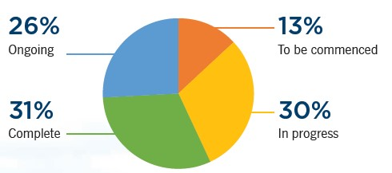
- Ongoing: 26%
- Complete: 31%
- In progress: 30%
- To be commenced: 13%

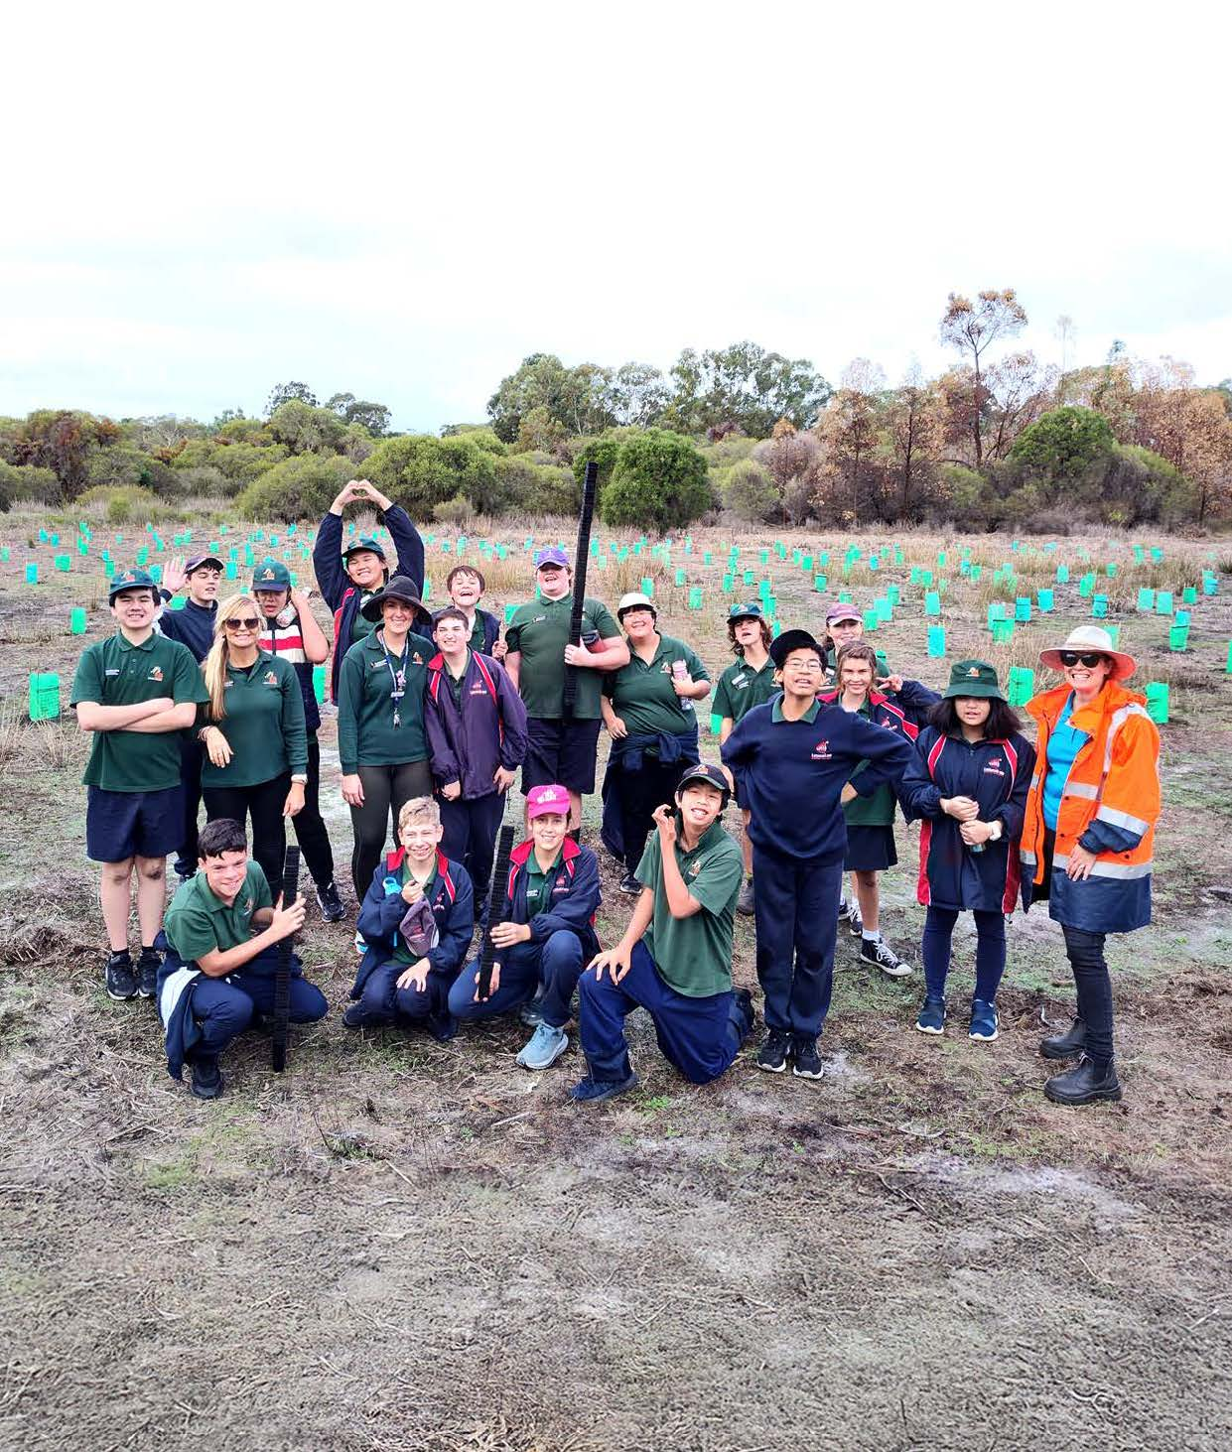
Photo: Leeming Senior High School, Tree Planting Day - June 2024.

The Year Ahead
As we look ahead to FY2025, the City of Cockburn remains committed to delivering innovative and impactful projects that enhance our community's quality of life. The following projects represent our strategic priorities for the upcoming year, aligned with our long-term vision. For more information about these projects and their associated milestones, please refer to our Corporate Business Plan 2024-2028: www.cockburn.wa.gov.au/Strategies-and-Plans

Local Economy Projects/activities 2024-25
1A.01 International Engagement
- Deliver Program
- This program connects local businesses with international partners and investors through trade delegations, expanding market reach, forging partnerships, and attracting investment.
1A.02 Investment Attraction Plan
- Develop Plan
- This collaborative informing strategy targets investments in key industries to create a sustainable local economy with job growth and positions Cockburn as a business-friendly location.
1B.01 Business Engagement Plan
- Deliver Plan
- The Business Engagement Plan outlines the next 12 months of activities and engagement priorities for the Micro, Small, and Medium Enterprises business sector.
1B.02 Cockburn Blue Innovation Hub
- Fund and Deliver Hub
- The Cockburn Blue Innovation Hub will empower 40 startups and growing businesses to develop solutions in ocean sustainability and defence supply chain (including AUKUS).
1B.03 Destination Plan
- Develop Plan
- To establish Cockburn as a premier visitor destination.

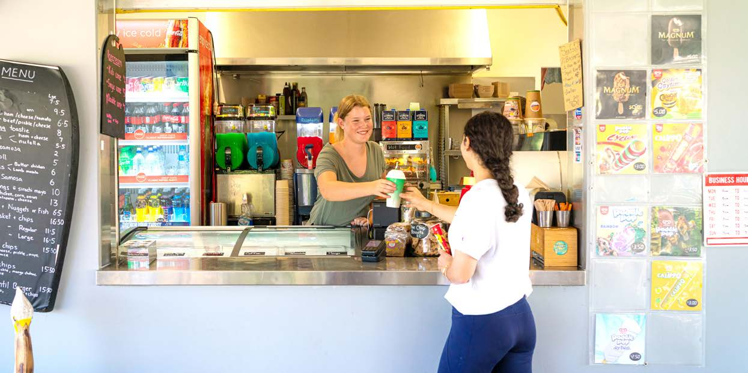
Photo: Woodman Point Beach Kiosk, Coogee.

Environmental Responsibility Projects/activities 2024-25
2A.01 Clementine Reserve Orchid Monitoring
- Implement Monitoring
- As part of our ongoing commitment to protecting our natural environment, the City is undertaking an orchid monitoring project at Clementine Reserve.
2A.02 C.Y. O’Connor Reef Stage 2 - Installation and Monitoring
- Install Reef
- Stage 2 of the C.Y. O’Connor eco-friendly fringing reef expands its size and monitors marine life colonisation and coastal protection.
2A.03 Manning Park Playground Upgrade
- Plan and Design Upgrade
- Manning Park playground is undergoing a revamp with new, inclusive play equipment to ignite imaginations for all ages and abilities.
2A.04 Urban Forest Tree Planting Program
- Implement Program
- The Urban Forest Tree Planting Program is a significant initiative to beautify our streets and neighbourhoods with a canopy of new trees.
2B.01 Cockburn Resource Recovery Redevelopment
- Implement Upgrades
- Cockburn is modernising its Resource Recovery Precinct with planning for sustainable waste management and essential upgrades like leachate ponds, landfill capping, and transfer station relocation.
2C.01 Edeline Street - Drainage Improvements
- Install Drainage
- The City of Cockburn is installing a brand new drainage improvement project for Edeline Street.
2C.02 Hobley Way - Drainage Improvements
- Install Drainage
- The City of Cockburn is installing a brand new drainage improvement project for Hobley Way.
2C.03 Marvell Avenue #5 - Drainage Improvements
- Install Drainage
- The City of Cockburn is installing a brand new drainage improvement project on Marvell Avenue.
2C.04 Stratton Street - Drainage Upgrade
- Install Drainage
- The City of Cockburn is installing a brand new drainage improvement project on Stratton Street.

Community, Lifestyle and Security Projects/activities 2024-25
3A.01 Beale Park Redevelopment
- Design and Implement Upgrade
- Transform Beale Park into a modern, amenity-rich hub for a wider range of sports and activities, while prioritising environmental responsibility.
3A.02 Beeliar Reserve Redevelopment
- Plan Upgrade
- Explore the viability of improvements through a feasibility and concept design phase in 2024-25, considering technical, financial and logistical factors.
3A.03 Cockburn ARC Expansion
- Implement Expansion
- Joint expansion with Fremantle Football Club, adding a bigger gym, studios, spectator seating and community facilities for all.
3A.04 Davilak Park Redevelopment
- Plan Revitalisation
- The Davilak Park Revitalisation Project identifies community needs and explores options for a vibrant, sustainable park catering to all.
3A.05 Malabar BMX
- Deliver Upgrades
- Malabar Park upgraded to a regional BMX facility with a competition- standard track, pump track, playground, and new clubhouse.
3A.06 Port Coogee Southern Amenities Project (Omeo Park)
- Deliver Amenities
- New restrooms, changing rooms and a shade shelter at Omeo Park for visitors exploring the Omeo Wreck and coastal surrounds.
3A.07 Santich Park - Parking Upgrade and New Lighting
- Deliver Upgrades
- Energy-efficient floodlighting for extended play, a larger car park on Shelley Way, and improvements to existing parking.
3A.08 Tempest Park Floodlighting
- Deliver Floodlighting
- Energy-efficient floodlighting for extended play and a wider range of activities, with minor landscaping and goal upgrades.
3A.09 Tempest Park Redevelopment
- Plan Redevelopment
- Finalise the business case including feasibility and concept design for Tempest Park redevelopment.
3A.10 Wally Hagan Redevelopment
- Plan Upgrade
- Finalise business case for upgrading Wally Hagan into a premier basketball facility.
3A.11 Stage 4 Marina Expansion Business Case
- Plan Expansion
- Explore financial viability, market demand for Marina expansion including berth optimisation, industry trends, and community engagement.
3B.01 Memorial Hall Centenary Celebration and Arts Hall of Fame
- Implement Celebration
- Cockburn celebrates its Memorial Hall’s centenary by establishing an Arts Hall of Fame to honor local artists and their contributions.
3B.02 Smart Buildings Project (Project BETTI)
- Install System
- Project BETTI utilises digital building access and expanded CCTV to streamline facility access, deter vandalism and improve efficiency.
3C.01 Aboriginal Cultural and Visitors Centre
- Finalise Design, Commence Delivery
- The Aboriginal Cultural and Visitor Centre is being built to honour traditions, share knowledge and provide a welcoming community hub for Cockburn’s First Nations people.
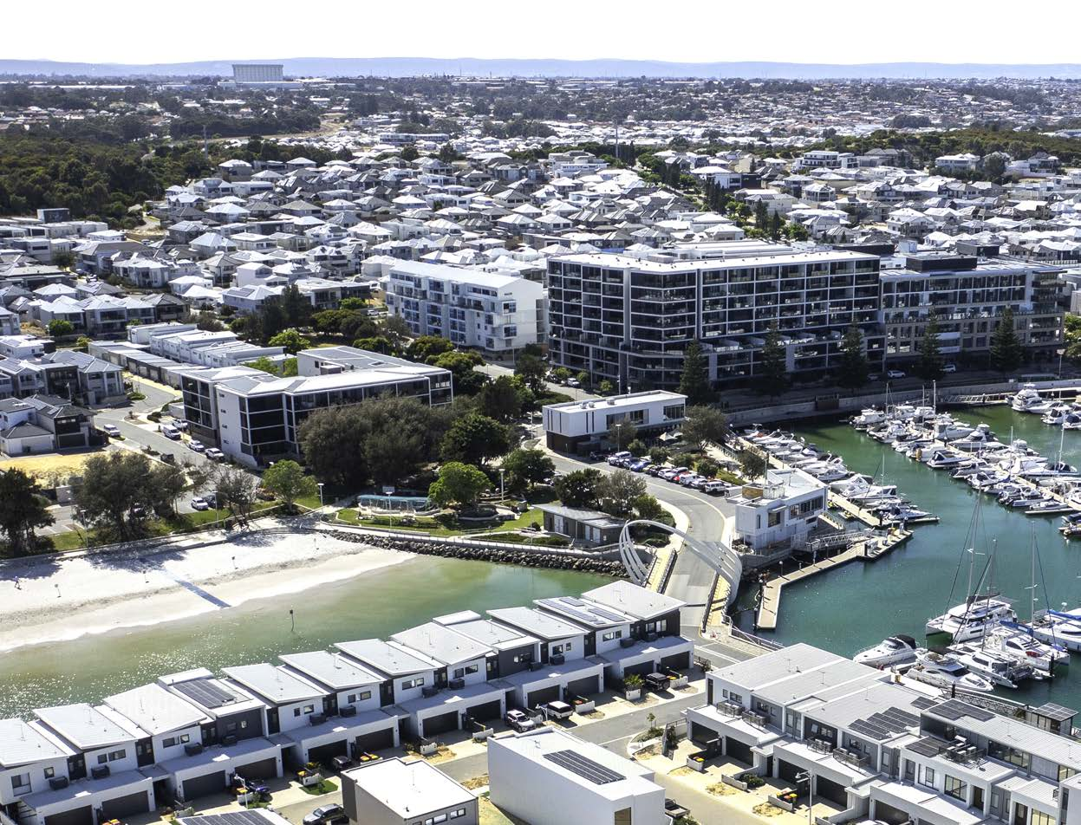
Photo: Port Coogee Marina North Coogee.

City Growth and Moving Around Projects/activities 2024-25
4A.01 Coogee Beach Master Plan Review
- Review Master Plan
- Review of the landscape master plan and a strategic vision for Coogee Beach, including former railway land and Cockburn Road upgrades.
4A.02 Public Open Space Strategy Review
- Review Strategy
- The Cockburn Public Open Space Strategy guides future park investments and improvements to create a connected network of green spaces for a healthy and active community.
4C.01 Banjup Local Area Traffic Management (LATM)
- Deliver Traffic Management
- The Banjup LATM project improves traffic flow and safety by discouraging cut-through traffic.
4C.02 Carrington Street and Forrest Road (Black Spot Project)
- Deliver Improvements
- Funded by the Australian Black Spot Program, the Carrington Street and Forrest Road intersection upgrade improves safety with new signals, lighting, crossings, and a raised platform.
4C.03 Hammond Road Duplication - Russell Road to Rowley Road
- Plan Improvements
- The City of Cockburn plans upgrades to Hammond Road aiming to improve traffic flow, safety, and amenity.

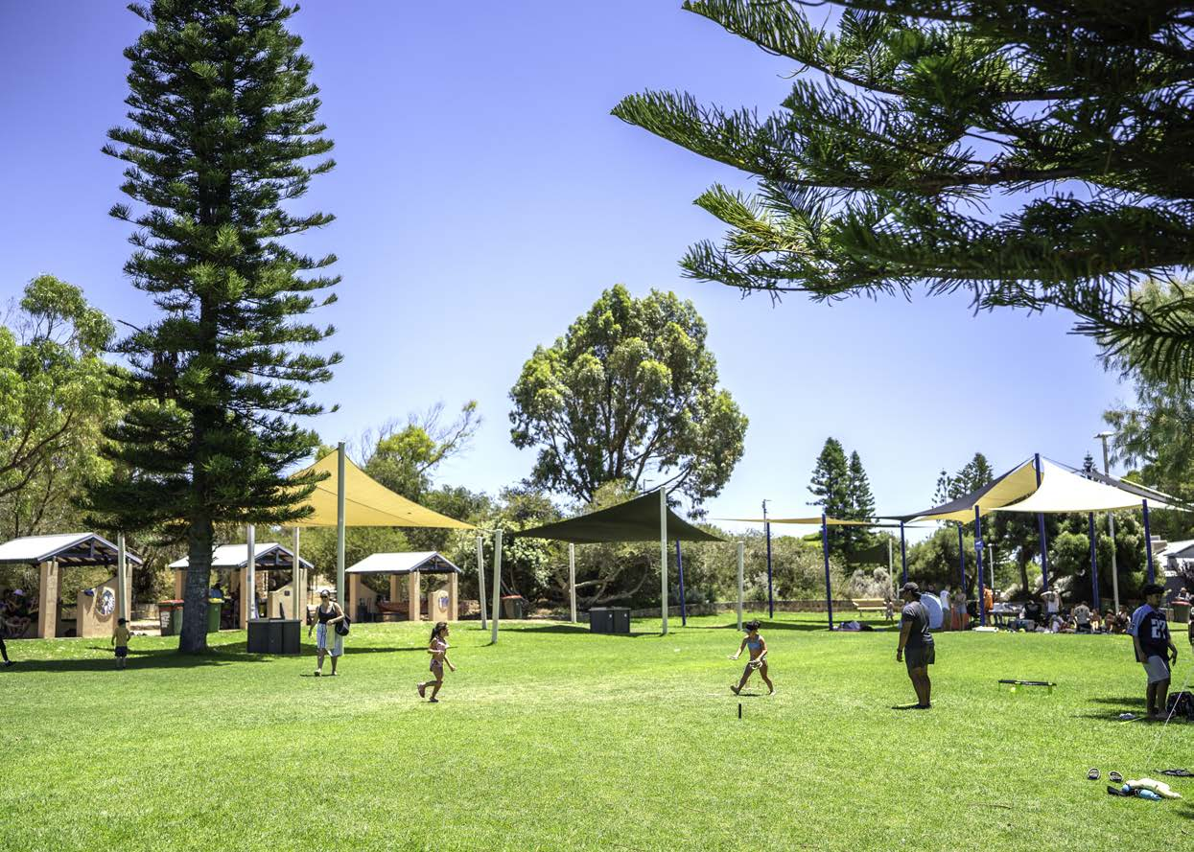
Photo: Coogee Beach Reserve, Coogee.
4C.04 Mid Term Review - City Drainage Management Strategy
- Review Strategy
- Reviews Drainage Management Strategy to ensure continued efficiency, flood risk reduction and adaptation for future growth.
4C.05 New signals: Beeliar Drive/ Dunraven Drive (Black Spot Project)
- Plan Signal Upgrades
- Planning for new traffic signals to enhance safety after a history of crashes.
4C.06 Rockingham Road and Spearwood Avenue (Black Spot Project)
- Install Signal Upgrade
- The Rockingham Road and Spearwood Avenue intersection, a known crash zone, receives upgraded traffic signals with designated turn lanes, improved pedestrian crossings, and cyclist considerations to improve safety.
4C.07 Rockingham Road/Phoenix Road Roundabout
- Install Roundabout
- Rockingham Road and Phoenix Road intersection gets a roundabout and lighting upgrades for improved safety and traffic flow.
4C.08 Rockingham Road Improvement - Coleville Crescent to Phoenix Road
- Design Road Improvement
- The Rockingham Road Revitalisation Project improves traffic flow, pedestrian and cyclist safety, and streetscape aesthetics for a vibrant and functional corridor.

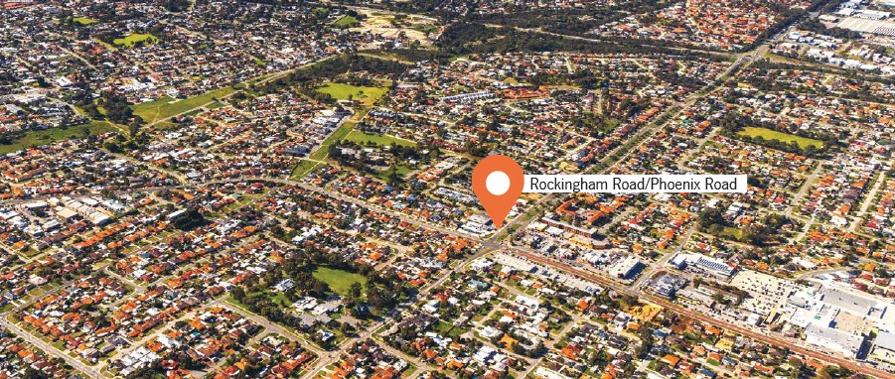

Listening and Leading Projects/activities 2024-25
5A.01 Spearwood Administration Building Audit
- Building Assessment
- The Spearwood Administration Building will undergo an assessment to identify short, medium, and long-term maintenance requirements.
5A.02 Fixed Licence Plate Recognition Parking Monitoring - Investigation Project
- Trial Technology
- The City of Cockburn trials Fixed Licence Plate Recognition (LPR) technology for parking management at the Community Health Building to improve efficiency and ensure fair access.
5A.03 Service Review
- Deliver Program
- The City of Cockburn is reviewing City services to optimise resource allocation and service delivery for a growing community.
5C.01 TechOne SaaS Migration
- Upgrade Technology
- The City of Cockburn is upgrading its core TechOne software to a cloud-based SaaS model for improved service and minimal disruption.
5C.02 Zero Client Replacement
- Deliver New Hardware
- To enhance service delivery and staff flexibility, the City of Cockburn is replacing its Zero Client desktops with laptops and desktops, creating a mobile-focused work environment.
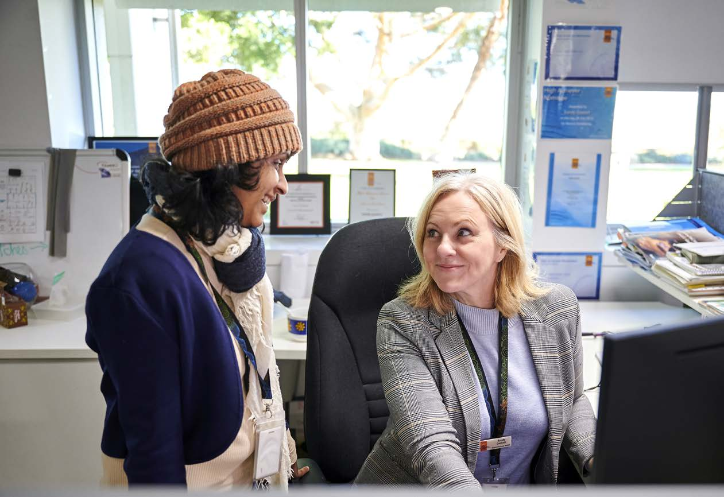
Photo: Spearwood Administration Building. Dilru Hordagoda, Senior .NET Developer; and Sandy Gaskett, Digital Business Analyst.

Plan for the Future
The City of Cockburn’s future is shaped by a complex mix of global and local environmental, social, economic, and technological trends. These elements directly influence the five strategic outcomes set out in the City’s Strategic Community Plan, reflecting Cockburn’s unique aspirations and challenges.

Local Economy
A vibrant and resilient local economy requires proactive adaptation to both regional and global economic shifts. Politically, evolving geopolitical relations — such as those involving China, the US, and the broader Indo-Pacific region — impact Australia’s trade policies and local economies. These relations introduce new considerations for Cockburn, particularly in industries like resources and education that are sensitive to international partnerships and export demands. Additionally, trends toward economic regionalisation and the reshoring of production are shifting local supply chains, creating new opportunities for businesses to serve community needs locally.
From an economic perspective, Cockburn’s economy faces pressures from national inflation, interest rate fluctuations, and an uncertain global economy, which impact employment, consumer spending, and business growth. While global inflation is expected to decrease gradually, economic slowdown could challenge the pace of growth for local businesses. Conversely, Cockburn can capitalise on trends like increased consumer demand for sustainable products and services, supporting the growth of green sectors and small businesses focusing on sustainable solutions.
Social trends also play a role, with a rise in localism and the prioritisation of ethically produced goods. As consumers increasingly choose locally sourced and eco-friendly products, Cockburn’s businesses may benefit from catering to these preferences. Technologically, advancements in digital infrastructure, e-commerce, and AI-powered business tools help local businesses reach new markets and streamline operations, creating efficiencies that are critical in a competitive economy. In this landscape, Cockburn’s economic resilience will also depend on leveraging these technologies to support business innovation and sustainable practices.
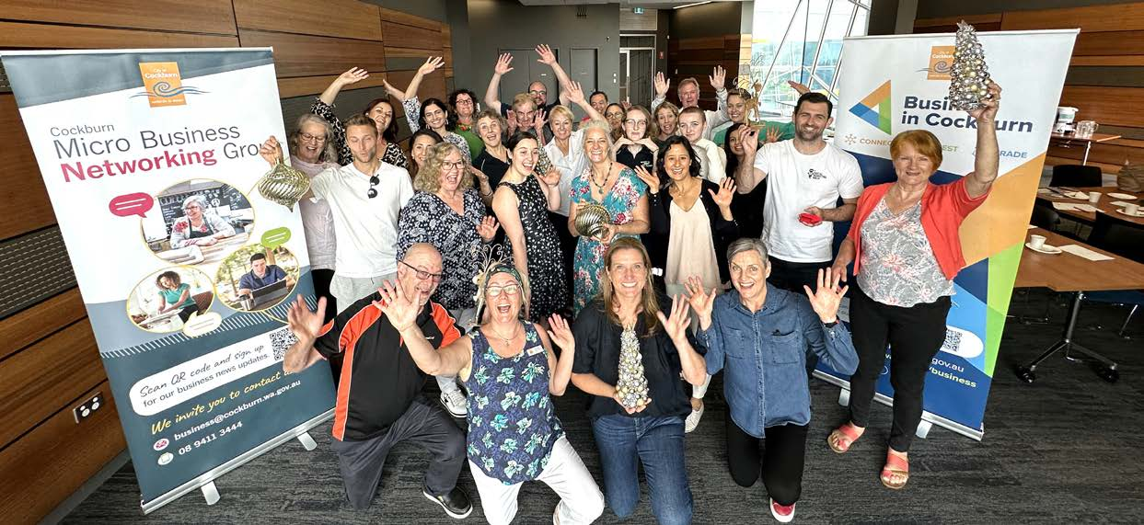
Photo: Micro Business Networking Group - November 2023.

Environmental Responsibility
Cockburn’s commitment to environmental responsibility is increasingly critical in the face of growing environmental risks and regulatory changes aimed at combating climate change. Political factors on a global and national level underscore the need for immediate environmental action, with governments worldwide committing to stringent climate policies and emissions targets. Nationally, legislative attention on environmental regulation, emissions reductions, and clean energy initiatives directly impacts the City’s environmental management strategies and necessitates ongoing alignment with these goals.
Economically, the cost of transitioning to renewable energy and green infrastructure presents both challenges and opportunities. The rise in energy costs and a focus on sustainable investment could affect Cockburn industries reliant on traditional energy sources. However, Cockburn stands to benefit from growth in the green economy, which brings funding opportunities for renewable projects, sustainable building practices and green technologies. This shift also aligns with a rising social focus on environmental advocacy, where individuals and organisations seek active involvement in sustainability initiatives and look for eco-friendly options in housing, transportation and business practices.
On the technological front, advancements in renewable energy technologies, waste management systems and energy-efficient infrastructure can support Cockburn’s sustainability goals. From smart energy grids to water-saving technologies and AI-powered climate risk management, these innovations offer new ways to enhance resource efficiency and environmental monitoring. These technologies help Cockburn adapt to legal requirements, including those governing emissions, water use and waste management, ensuring compliance and a commitment to best practices. Altogether, these trends reinforce the City’s pursuit of a resilient and environmentally responsible future.
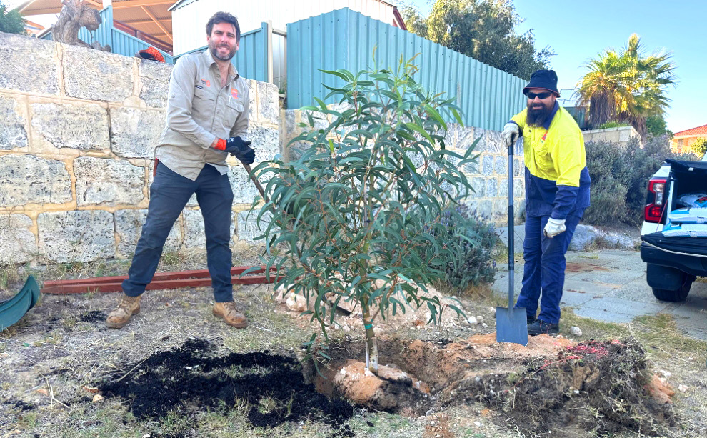
Photo: Street tree planting. Steven Millios, Urban Forest Officer; and Simon Follington, Parks Leading Hand Landscape.

Community, Lifestyle and Security
Cockburn’s community is shaped by evolving social dynamics, which bring both opportunities for enrichment and challenges to ensure community wellbeing. Political factors such as immigration policy changes and state funding allocations influence demographic shifts and community resources. Population growth, especially with an aging demographic, necessitates an increase in health, recreation and social services to meet changing community needs. Politically, there is also increasing pressure to address social inequities, accessibility and inclusivity, prompting governments at all levels to support a wider range of community services and inclusive policies.
The economic landscape also impacts community lifestyle and security, as cost-of-living pressures and inflation affect residents’ quality of life. Rising housing prices and income disparities increase the demand for affordable housing, support services and financial assistance. Cockburn must balance these needs against broader economic pressures, while encouraging social equity and economic resilience within the community. Social factors, such as changing family structures, urban migration, and greater diversity, shape expectations around recreational services, cultural programs, and local facilities.
Technologically, innovations in public safety, health services, and community engagement provide new ways to strengthen community ties and promote security. Cockburn can explore the integration of AI and connected technology for enhanced safety measures, predictive emergency management and accessible public health services. Technology also enhances Cockburn’s ability to deliver and monitor social services and facilitates transparent communication and connection with residents. In line with legal trends, there is an increasing emphasis on data security and privacy standards, ensuring that community services and technologies uphold residents’ rights and foster trust.
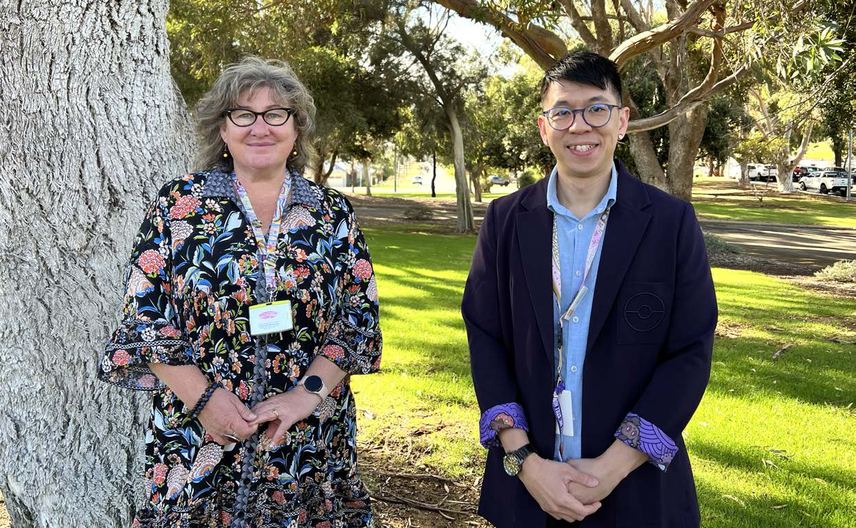
Photo: Cockburn Financial Counselling Service. Colleen Crowley, Coordinator Cockburn Financial Counselling; and Andre Chung-Wei Chan, Financial Counsellor.

City Growth and Moving Around
Cockburn’s future growth will depend on sustainable urban planning and innovative transport solutions, both of which are influenced by external political, economic and environmental factors. Politically, Federal and State infrastructure funding priorities will shape transport and development projects in Cockburn. Policies encouraging urban densification and efficient land use guide growth in Cockburn’s urban core. Additionally, international and national commitments to reduce emissions affect transportation policies, such as the integration of low-emission vehicles, bike-sharing programs and pedestrian-friendly infrastructure.
Economic considerations, including housing market trends and funding for transportation infrastructure, play a significant role in shaping the City’s urban development. Housing affordability continues to be a challenge, driven by rising demand and limited supply, which impacts the availability of affordable housing options. Investment in infrastructure is crucial, as it not only supports population growth but also promotes efficient movement within the City and reduces congestion. Smart infrastructure investment, such as public transit expansion and road upgrades, is essential for supporting the City’s anticipated growth.
Technologically, Cockburn can benefit from advancements in mobility and urban planning, including the use of autonomous vehicles, electric public transport, and smart traffic management systems. These technologies can reduce travel times, improve safety and decrease environmental impact. Environmental considerations underscore the importance of sustainable development and transport systems, as Cockburn seeks to reduce emissions and protect green spaces amid urban expansion. Legal trends in building codes, emissions standards and safety regulations shape the frameworks within which the City operates, ensuring that growth aligns with sustainability and accessibility goals.
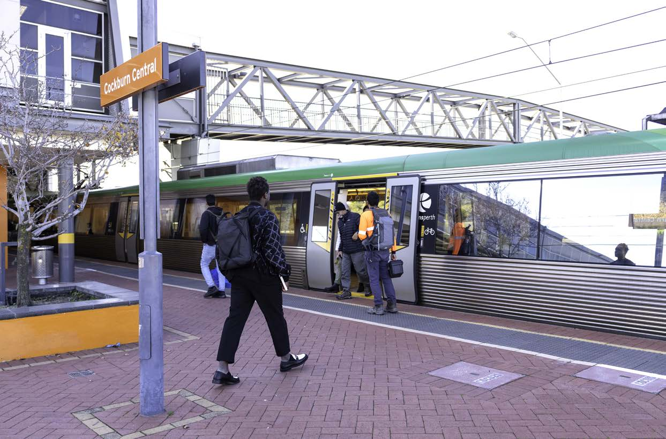
Photo: Cockburn Central Station.

Listening and Leading
The City of Cockburn’s leadership role depends on its ability to respond effectively to emerging trends and engage its community transparently. Political dynamics and a heightened focus on governance at all levels call for Cockburn to prioritise accountability and maintain strong community relationships. These influence expectations around the City’s decision-making processes, encouraging more participatory governance and opportunities for community input.
Economically, financial stewardship and sustainable funding sources are essential for continued responsiveness and adaptability. Cockburn’s leaders face the dual challenge of managing budgetary constraints while investing in areas that drive community value. Additionally, Cockburn must anticipate potential economic fluctuations, which may require adjustments in resource allocation to ensure the sustainability of services and programs.
Social trends point to an increased demand for participatory governance and inclusive engagement, especially among younger generations and diverse populations. Cockburn can leverage this interest through expanded community consultation and improved feedback mechanisms, ensuring all voices are heard in shaping the future. Technologically, tools like AI-driven insights, online engagement platforms, and data analytics enable the City to better understand community needs, streamline services and increase public participation. These tools offer Cockburn opportunities to tailor services based on real-time feedback, fostering greater transparency and aligning services with community priorities.
Legal considerations reinforce the importance of maintaining strong governance frameworks and data protection standards, with a growing focus on digital security and residents’ rights. Staying compliant with national and international regulations around privacy and cybersecurity not only strengthens Cockburn’s governance but also ensures trust in the City’s digital transformation initiatives.
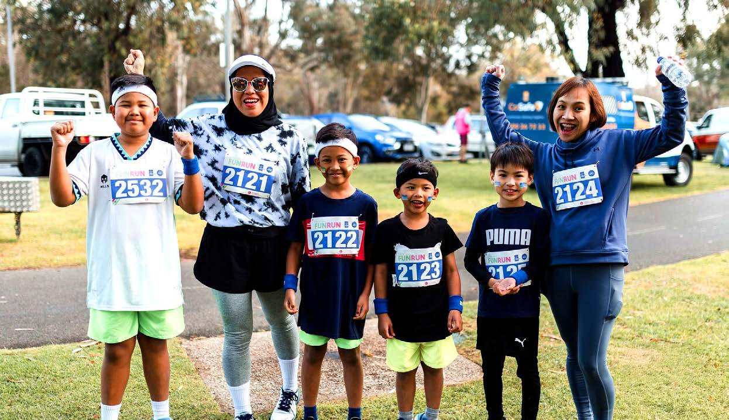
Photo: Bibra Lake Fun Run - September 2023.

Annual Financial Report
To delve deeper into the City of Cockburn's financial performance for the 2023-24 financial year, please visit our website: Corporate Strategic Planning page – Annual Financial Report: www.cockburn.wa.gov.au/Strategies-and-Plans
The 2023-24 Annual Financial Report will be available on the City's website once it has been formally adopted by Council.
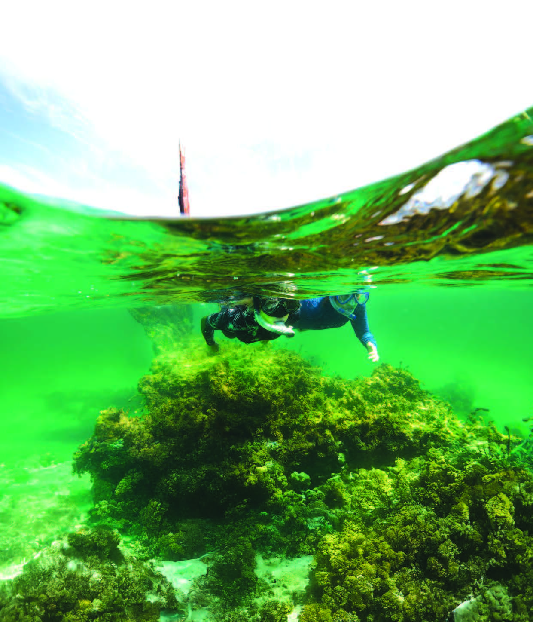
Photo: Coogee Maritime Trail, North Coogee.
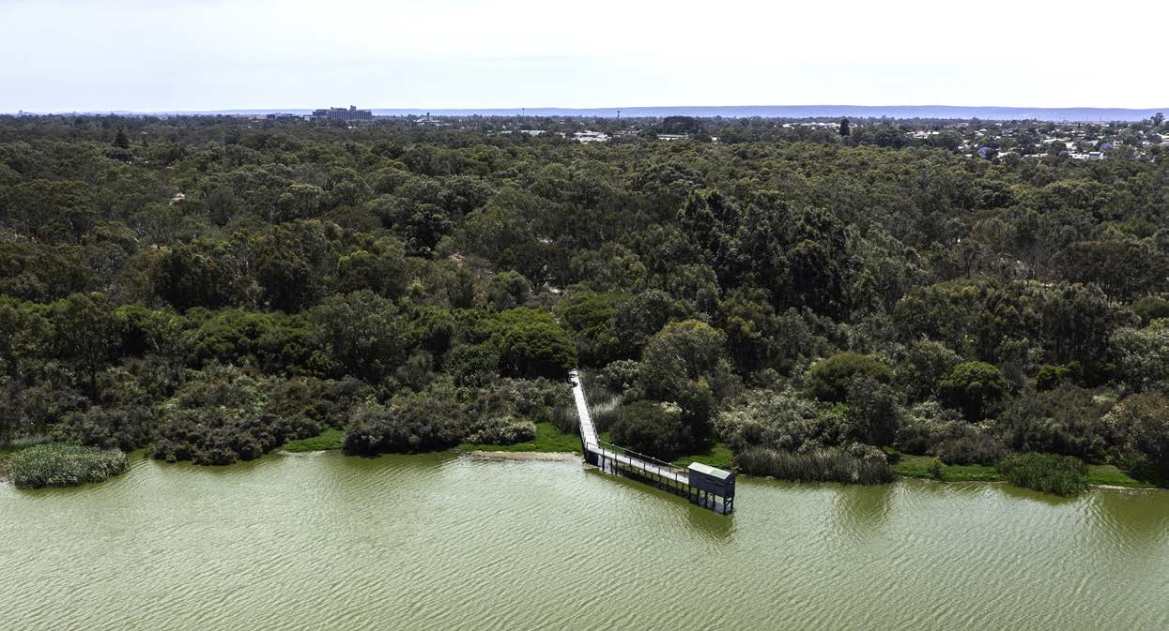
Photo: Bibra Lake Boardwalk and Bird Hide.

Contact Us
Strategy and Integrated Planning
City of Cockburn
Whadjuk Boodja
9 Coleville Crescent, Spearwood WA 6163
PO Box 1215, Bibra Lake DC WA 6965
Telephone: 08 9411 3444 | Email: customer@cockburn.wa.gov.au
City of Cockburn website: www.cockburn.wa.gov.au

 City of Cockburn Facebook: www.facebook.com/CityOfCockburn
 City of Cockburn Instagram: www.instagram.com/cityofcockburn
 City of Cockburn YouTube: www.youtube.com/CityOfCockburn
 City of Cockburn LinkedIn: www.linkedin.com/company/city-of-cockburn

This information is available in alternative formats upon request.

