Tender Title: |  | CONCRETING SERVICES  Footpaths, Shared Use Paths etc (In Situ Construction)
Request ID: |  | 63513
Tender Description: |  | The intent of this Tender is to select a qualified and experienced Concreting contractor to provide in-situ concreting requirements, including but not limited to  footpaths, shared use paths, driveways/crossovers, concrete pads/footings (for bus shelters, barbecues, shade shelters sheds etc.) at locations throughout the Principal  municipal area.
Advert Approval: |  | Decision to Advertise: Director Infrastructure Services  Decision Date: Monday, 19 May 2025
Closing Date and Time: |  | 2:00PM (AWST) Wednesday, 11 June 2025
Opening Date and Time: |  | 2:00PM (AWST) Wednesday, 11 June 2025
 | Tenderer’s Name:
1 | Axiis Contracting (Axiis Contracting Pty Ltd)
2 | CONCITY (After Builder Pty Ltd)
3 | Dowsing (Dowsing Group Pty Ltd)
4 | Miraplex (Miraplex Group Pty Ltd)
5
6
7
8
9
10

Advertisement
Method 1: City of Cockburn website | Method 2: City of Cockburn Libraries Public Noticeboards
Method 3:  The Western Australian, Saturday, 24 May 2025 2025 | Tender Awarded by:
Copy of Statewide Notice:  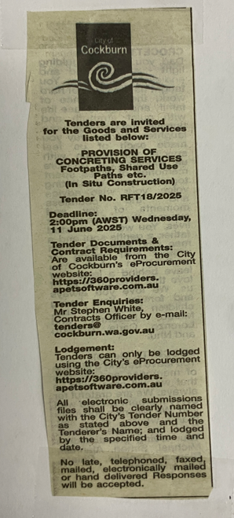 | OCM  Choose an item.  Tuesday, 8 July 2025
 | Date of Council Meeting:
Date: 08 July 2025
Minutes: 0136
Item No. 14.3.4
Name of Successful Tenderer(s): | Axiis Contracting Pty Ltd
Amount of Successful Tender(s): (ex GST) | $5,290,125 (Ex GST)

