6 September 2018
$1.2m upgrade for Coogee Beach café and surrounds: Have your say
Our iconic Coogee Beach has a special place in the hearts of locals Emma and Randall Tapp – it’s where they first met in the summer of 2002.
Their family uses the beach, reserve and café at least weekly year round, which means they care about what happens there.
And it’s why they are urging other locals to have their say about a proposed $1.2m upgrade to Coogee Beach café and surrounds.
You can complete a survey at the City’s public consultation webpage Comment on Cockburn until Tuesday, 18 September, and on the same day, attend a public workshop 6-9pm at Coogee Community Hall on Arlington Loop.
Some of the Coogee Beach Masterplan ideas up for discussion include:
- Parking issues, school bus drop-off facilities and improved alignment of the cycling route
- Security issues affecting the cafe
- Incorporating the reserve's interesting and colourful history into the design of the park's features
- Improved beach and cafe access for people with disability
- Ways in which the café might be made more useful – beach lockers and hire of beach equipment such as umbrellas, paddle boards and beach chairs.
The cafe is owned by the City and leased to a private operator, and the first two stages of the upgrade have been completed, with power lines placed underground and a new car park built at the nearby surf club.
Once the City has received community input for improvement works and gathered more comment on final plans, tenders will be let later this year. Works will be staged to minimise disruption to beach goers and café visitors.
The Tapp family said it used Coogee Beach very frequently in the summer months, and the children had jumped of the jetty’s lower section as recently as last week, something they loved to do despite the wintry weather.
“I swim train twice a week in summer inside the shark barrier as I know the distance I’m swimming and feel safe,” Emma said.
“When we have family visiting from interstate or overseas, we often go down for a picnic or a barbecue on the grassed area.
“My husband and I have coffee and cake at the cafe after a swim or kayak pier to pier which we really enjoy.
“We think all local residents need to have their say if they have any ideas about the upgrade. Ultimately it is a beach for all of us.”
Complete the survey at Comment on Cockburn here: https://comment.cockburn.wa.gov.au/coogee-beach-upgrade
Caption (pic below): Randall and Emma Tapp love Coogee Beach – it’s where they first met in 2002 – and encourage other locals to participate in community consultation about proposed upgrades to the café and reserve. Picture: Conor McGrath.
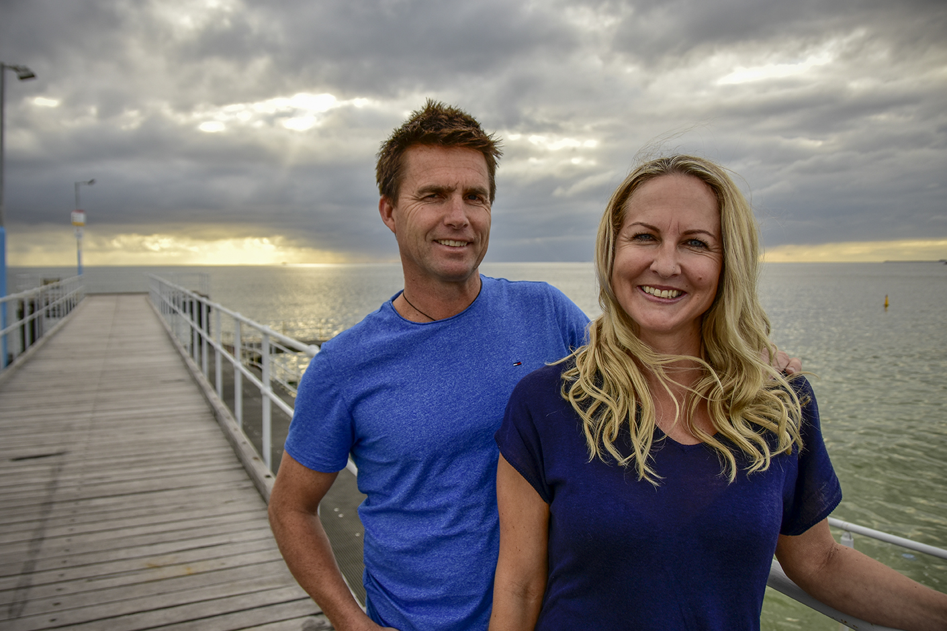

______
ENDS

For more information contact:
Media and Communications Officer
City of Cockburn
T: 08 9411 3551
E: media@cockburn.wa.gov.au

