Tender Title: |  | RFT 22/2020  Consultancy Services Green Hydrogen Feasibility Study (Project Management)
Request ID: |  | 36701
Tender Description: |  | For the examination of the use of renewable hydrogen as a zero-emissions transport fuel for its waste collection and light vehicle fleets.
Advert Approval: |  | Decision to Advertise: Director of Finance & Corporate Services  Decision Date: Wednesday, 23 September 2020
Closing Date and Time: |  | 2:00pm (AWST) Tuesday, 27 October 2020
Opening Date and Time: |  | 2:00pm (AWST) Tuesday, 27 October 2020
 | Tenderer’s Name:
1 | RPS AAP CONSULTING PTY LTD t/a RPS AAP Consulting Pty Ltd (Project Management)
2 | APPLIED NANO TECHNOLOGIES PTY LTD t/a ANT Energy Solutions (Head Office)
3 | GHD PTY LTD t/a GHD Pty Ltd (Western Australian Operating Centre)
4 | HYDROGEN ENERGY PTY LTD t/a Hydrogen Energy Pty Ltd (Projects)
5 | LYCOPODIUM PROCESS INDUSTRIES PTY LTD t/a Lycopodium Process Industries Pty Ltd
6 | NS PROJECTS PTY LTD t/a NS Projects Ltd Pty (Perth)
7 | ARUP PTY LIMITED t/a Arup Australia Pty Ltd (Perth Office)
8 | AURECON AUSTRALASIA PTY LTD t/a Aurecon Australasia Pty Ltd  (Australia / Advisory)
9 | 1 RACECOURCE ROAD PTY LTD t/a Bill Marchbank Waste Management Services (Green Hydrogen)
10

Advertisement
Method 1 : City of Cockburn | Method 2 :
Method 3 :  The West Australian – Saturday 26 September 2020 – Page 145 | Tender Awarded by:
Copy of Statewide Notice:  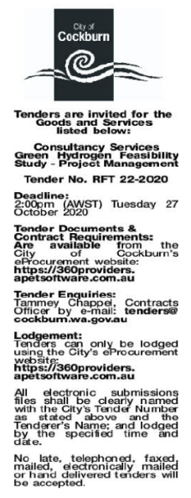 | Director of Engineering & Works  Choose an item.  Thursday, 14 January 2021
 | Date of Council Meeting:
Click here to enter a date. or
Not applicable
Item No:
Name of Successful Tenderer(s): | GHD Pty Ltd
Amount of Successful Tender(s): (ex GST) | $247,360

